Engineering Technology Design Project  
ENG 20010

Assignment Report: Washing Machine User Interface VI

Student Name: Harry

Student ID: 103517299

Introduction

This report details the design and implementation of a User Interface (UI) for a washing machine using LabVIEW. The UI allows users to turn the washing machine on/off, select different washing modes, and start the washing process. It also provides real-time feedback on the current washing stage and time remaining for each mode.

Design

To create the washing machine UI, I followed a structured approach:

1. Main While Loop: The core of the program is a main While Loop. Inside this loop, I implemented the user interface and control logic.

2. User Interface Components:

- Turn On/Off Button: A Boolean control button that toggles the washing machine's power.

- Start Button: Another Boolean control button used to initiate the washing process.

- Enum for Mode Selection: This allows the user to choose from three modes: Colorful, Intensive, and Quick Wash.

3. Control Logic:

- I used boolean logic gates to control the flow of the program. The Turn On/Off button is connected to a NOT gate, and the Start button is connected to an OR gate. The output of the OR gate is used as a loop condition, ensuring the program runs only when the machine is turned on.

4. Case Structure:

- Inside the main While Loop, I implemented a Case Structure with three cases: Colorful, Intensive, and Quick Wash. This structure manages the different washing modes.

5. Timing:

- For each washing mode, I configured the timing using Add and Subtract functions to calculate the time remaining. The time for each stage (pre-rinse, main wash, final spin) is based on the mode selected and matches the provided specifications.

6. Feedback Display:

- I used a String Indicator to display the current washing stage (pre-rinse, main wash, final spin) and a Numeric Indicator to show the time remaining in seconds. When the cycle is completed, it displays "Washing Done".

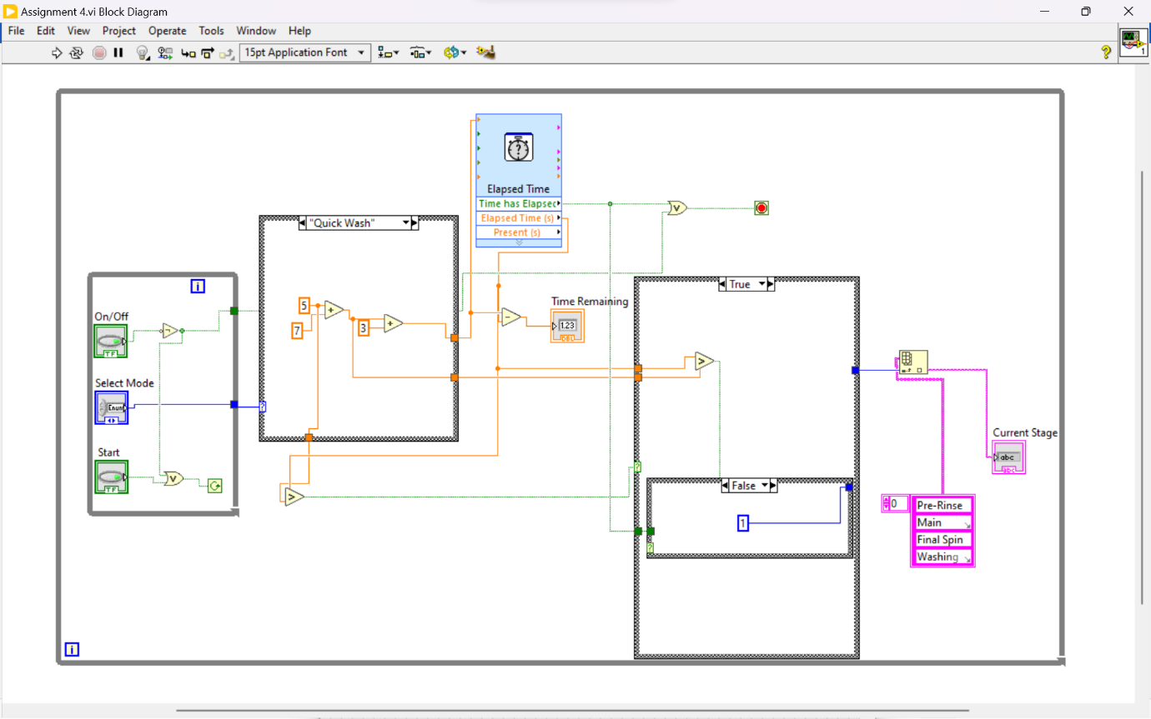

Implementation

The LabVIEW VI was implemented as follows:

- The Turn On/Off button controls the power state, ensuring that the washing machine operates only when turned on.

- The Start button initiates the washing cycle, and the program enters the selected washing mode based on the Enum input.

- In each washing mode case, I used Add and Subtract functions to manage the timing of each stage and calculate the time remaining.

- I created nested Case Structures to manage the different stages within each washing mode, including pre-rinse, main wash, and final spin.

- Feedback to the user is provided through String and Numeric Indicators, displaying the current stage and time remaining.

- When the washing cycle is complete, the program displays "Washing Done."

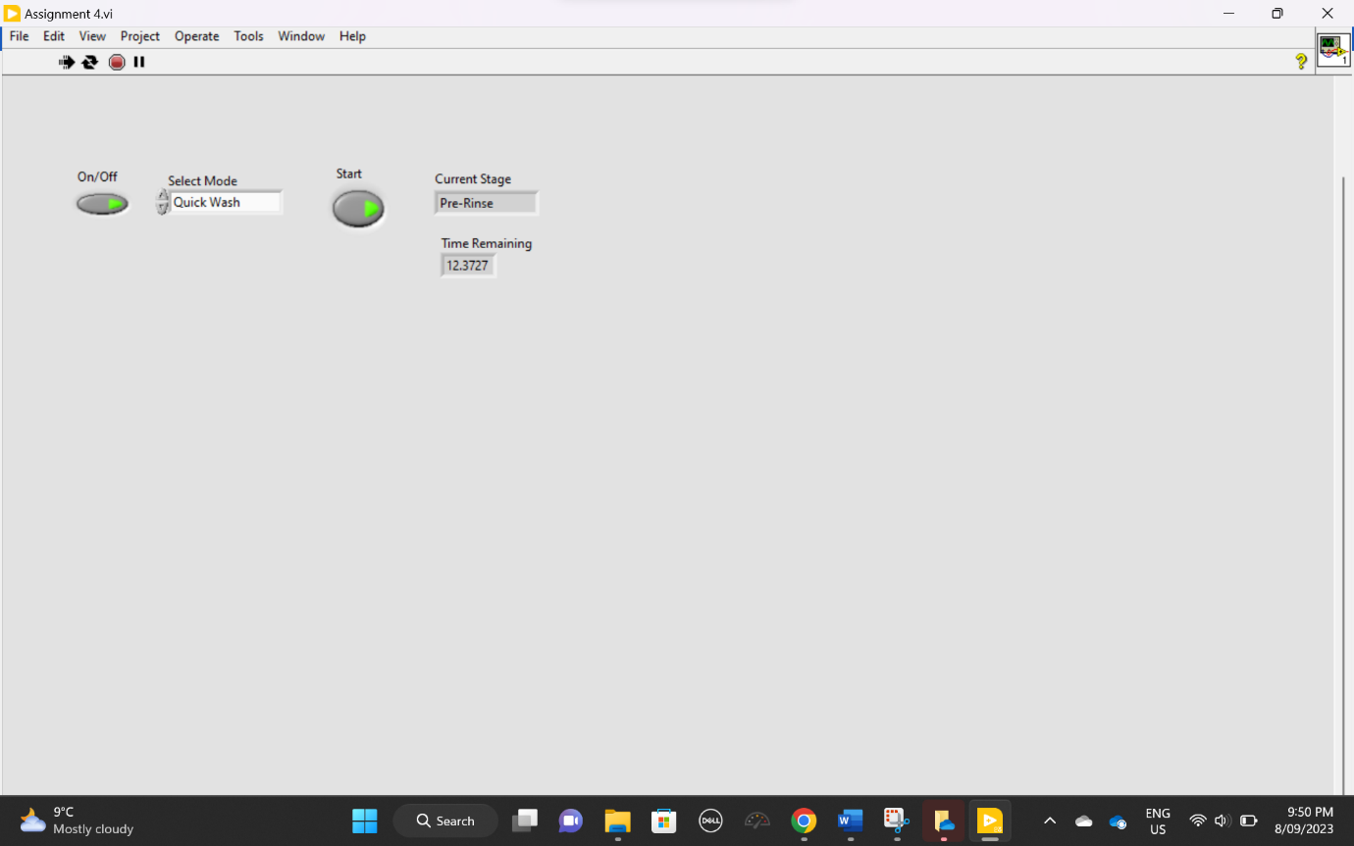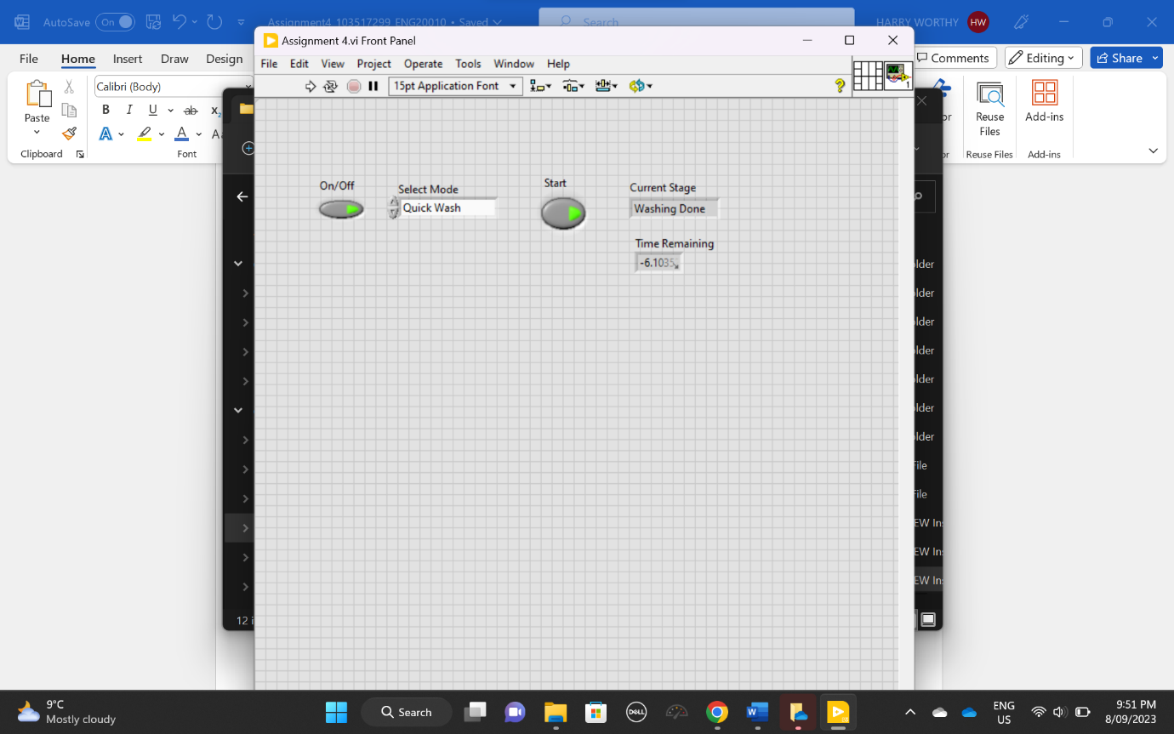

Conclusion

The LabVIEW VI successfully implements a user-friendly washing machine UI that allows users to select different modes and monitor the washing process in real-time. The program incorporates timing logic and feedback displays, adhering to the provided specifications. Users can turn the machine on/off, select a washing mode, and start the cycle with ease.

This VI demonstrates effective control logic and user interface design, making it a practical and functional solution for a washing machine UI.