**ENG 20010**

**Engineering Technology Design Project**

**Assignment 5 Report:** Designing a Two-Way Traffic Light System using LabVIEW and NI-DAQ

Student Name: Harry  
Student ID: 103517299

**Introduction:**

The objective of this assignment was to design a two-way traffic light system using LabVIEW and the NI-DAQ system. The system was required to run continuously, following specific cycle times for each traffic light colour: 10 seconds for Red, 3 seconds for Amber, and 7 seconds for Green.

**Design Overview:**

The traffic light system was implemented on LabVIEW, a graphical programming environment. The following steps were undertaken to design and implement the system:

Front Panel Design:

Six LED lights were placed on the front panel of the LabVIEW application, representing the two-way traffic system. These LEDs visually indicated the state of each traffic light: Red, Amber, and Green in both directions.

Block Diagram Design:

The block diagram implemented the traffic light system's core logic. A detailed description of the block diagram follows:

1. Main While Loop:

- A primary while loop was used to ensure that the program ran continuously.

2. Flat Sequences:

- Inside the while loop, two flat sequences were created, each controlling the traffic lights in one direction.

3. Frame Configuration:

- Each flat sequence contained three frames, corresponding to the Red, Amber, and Green states.

4. Timing Configuration:

- For each frame, a time delay was set based on the cycle times provided in the assignment brief:

- Red: 10 seconds

- Amber: 3 seconds

- Green: 7 seconds

5. Traffic Light Control:

- Each frame controlled the LEDs representing the Red, Amber, and Green lights for the respective direction.

- The LEDs for each frame were wired with a Boolean T/F condition to simulate the changing traffic light.

- In each frame, the selected light was wired with True while the other two lights Red and Amber were connected with False.

6. Boolean Array and Output:

- The boolean conditions for each frame were combined into a boolean array.

- This array was then connected as an output to the NI-DAQ.

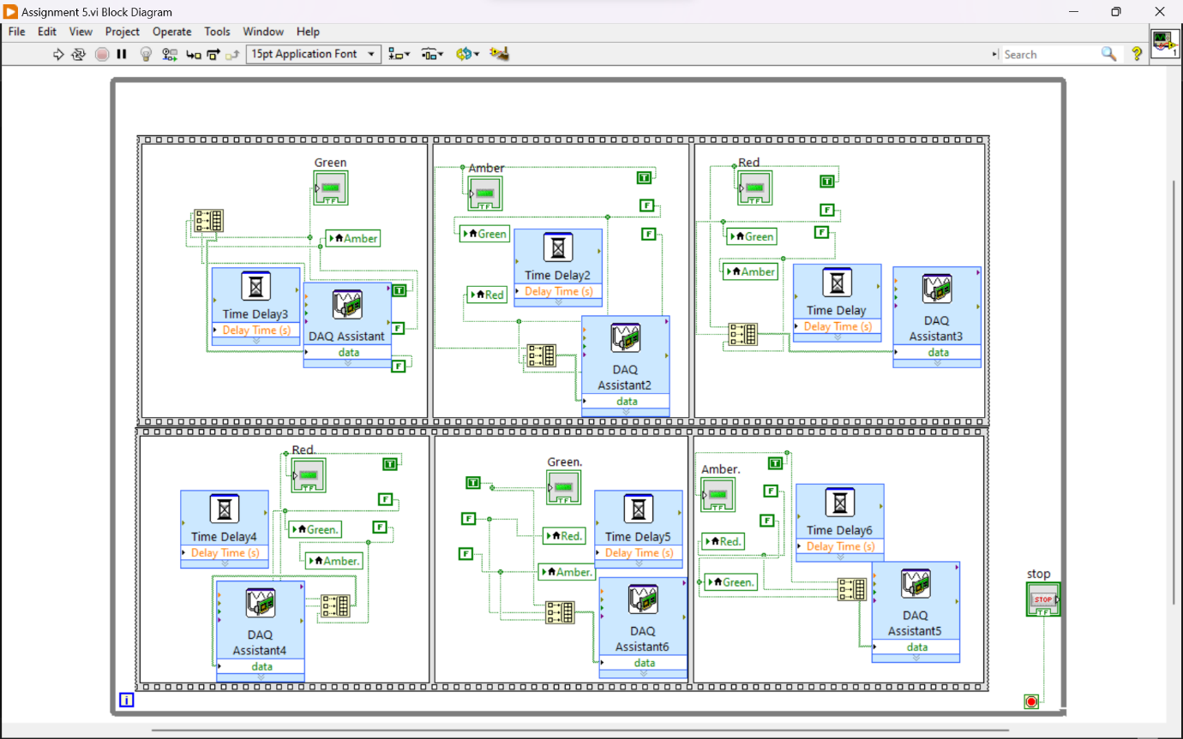

**NI-DAQ Configuration:**

The NI-DAQ system was configured to interface with the LabVIEW program. The assignment submission provided a video demonstration of the NI-DAQ configuration. The following configuration specifics were mentioned:

- For the first sequence (Green, Amber, Red), the port lines 1, 2, and 3 were configured.

- For the second sequence (Red, Green, Amber), the port lines 4, 5, and 6 were configured.

**Conclusion:**

In conclusion, the assignment successfully achieved the goal of designing a two-way traffic light system using LabVIEW and the NI-DAQ system. The LabVIEW program implemented a continuous cycle of traffic lights with precise timing, adhering to the specified cycle times for Red, Amber, and Green lights. The integration with the NI-DAQ system allowed for real-world control of LED lights, simulating a functioning traffic light system. The submission included a video demonstration of the NI-DAQ configuration, providing clear evidence of the successful implementation of the assignment's requirements. This assignment allowed for hands-on experience in programming and hardware integration, contributing to a better understanding of control systems and data acquisition.