**Finding a Good Location for Gourmet Pizza Places in Cuyahoga County**

**IBM Data Science Professional Capstone Project**

**April 2019**

**1. Introduction**

Basilico Pizzeria, a local gourmet pizza chain in the Cleveland, Ohio area, wants to open 2 new restaurants. They want to open them in cities without a lot of competition and where the population and median income are high enough to support the business. The restaurant business is very competitive, so the owners want to base their 2 new ventures on some solid data.

**2. Data acquisition and cleaning**

I obtained a download of latitude and longitude for all US cities at the following location: <https://simplemaps.com/data/us-cities>. I removed the non-Ohio locations and uploaded the CSV. See header below.

|  |  |  |  |  |
| --- | --- | --- | --- | --- |
| **city** | **county** | **lat** | **lng** | **population** |
| Dunkinsville | Adams | 38.8559 | -83.4713 | NaN |
| Cherry Fork | Adams | 38.8862 | -83.6146 | 155 |
| Peebles | Adams | 38.9463 | -83.4094 | 1753 |
| West Union | Adams | 38.7917 | -83.5441 | 3074 |
| Manchester | Adams | 38.6902 | -83.6053 | 1978 |

I next obtained Ohio median income data from <https://www.cleveland.com/datacentral/2016/12/median_family_income_household.html> and converted it to a CSV and uploaded it. See header below.

|  |  |
| --- | --- |
| **city** | **median_income** |
| New Albany | $214,850 |
| Indian Hill | $211,795 |
| Pepper Pike | $186,765 |
| Powell | $146,442 |
| Dublin | $144,005 |

Next, merge the dataframes and filter dataframe to include only cities in Cuyahoga County. See header below.

|  |  |  |  |  |
| --- | --- | --- | --- | --- |
| **city** | **lat** | **lng** | **population** | **median_income** |
| University Heights | 41.4948 | -81.5348 | 13126.0 | 84594.0 |
| Lakewood | 41.4824 | -81.8008 | 50279.0 | 70448.0 |
| Richmond Heights | 41.5589 | -81.5029 | 10421.0 | 63029.0 |
| Shaker Heights | 41.4744 | -81.5496 | 27448.0 | 107938.0 |
| Brecksville | 41.3079 | -81.6193 | 13425.0 | 121974.0 |

Before starting our analysis, lets look at our cities on the map. Folium was used to create the map below.

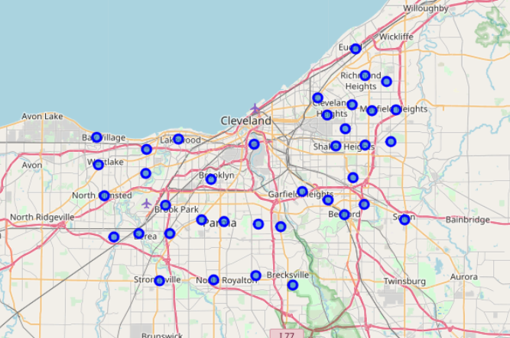

**3. Data Analysis**

Let’s begin by looking at the summary statistics.

|  |  |  |  |  |
| --- | --- | --- | --- | --- |
|  | **lat** | **lng** | **population** | **median_income** |
| **count** | 38.0000 | 38.0000 | 38 | 38 |
| **mean** | 41.4375 | -81.6611 | 67026 | 80272 |
| **std** | 0.0731 | 0.1576 | 277729 | 30601 |
| **min** | 41.3079 | -81.9315 | 6198 | 30466 |
| **25%** | 41.3848 | -81.8115 | 12780 | 58253 |
| **50%** | 41.4356 | -81.6289 | 18711 | 76733 |
| **75%** | 41.4844 | -81.5228 | 27791 | 102063 |
| **max** | 41.5904 | -81.4401 | 1731637 | 186765 |

We will use the population and median income statistics as a factor in our decision making. Particularly we will be looking for population and median income near the 75 percentile.

Next, we will use the K Means method to cluster the cities. We must first remove population and median income before clustering. Below is the dataset we will use to cluster.

|  |  |  |  |
| --- | --- | --- | --- |
| **city** | **county** | **lat** | **lng** |
| University Heights | Cuyahoga | 41.4948 | -81.5348 |
| Lakewood | Cuyahoga | 41.4824 | -81.8008 |
| Richmond Heights | Cuyahoga | 41.5589 | -81.5029 |
| Shaker Heights | Cuyahoga | 41.4744 | -81.5496 |
| Brecksville | Cuyahoga | 41.3079 | -81.6193 |

Next we need to look at the competition. We’ll use Foursquare to get venues in our cities. Our query returned 417 venues and 129 unique categories. Below is the header.

|  |  |  |  |  |
| --- | --- | --- | --- | --- |
| **city** | **Venue** | **Venue Latitude** | **Venue Longitude** | **Venue Category** |
| University Heights | Bialy's Bagels | 41.4979 | -81.5360 | Bagel Shop |
| University Heights | Geraci's Restaurant | 41.4982 | -81.5368 | Restaurant |
| University Heights | HomeGoods | 41.4985 | -81.5363 | Furniture / Home Store |
| University Heights | Peter's Tailor Shop | 41.4983 | -81.5361 | Tailor Shop |
| University Heights | Quagmire's | 41.4934 | -81.5402 | Bar |

Next let’s filter the data frame to look at only pizza places. Below is the result.

|  |  |  |  |  |
| --- | --- | --- | --- | --- |
| **city** | **Venue** | **Venue Latitude** | **Venue Longitude** | **Venue Category** |
| Strongsville | Pizza Hut | 41.3121 | -81.8346 | Pizza Place |
| Lyndhurst | Tasty Pizza | 41.5199 | -81.4956 | Pizza Place |
| Lyndhurst | Vicinato Pizzeria | 41.5194 | -81.4969 | Pizza Place |
| Garfield Heights | Papa John's Pizza | 41.4164 | -81.6059 | Pizza Place |
| Garfield Heights | Pizza Pan | 41.4214 | -81.6091 | Pizza Place |
| North Olmsted | Little Caesars Pizza | 41.4180 | -81.9192 | Pizza Place |
| Berea | Marco's Pizza | 41.3716 | -81.8689 | Pizza Place |
| Berea | Romeo's Pizza | 41.3725 | -81.8680 | Pizza Place |
| Parma Heights | Pizza Hut | 41.3867 | -81.7690 | Pizza Place |
| Parma Heights | Godmother's Pizza & Subs | 41.3856 | -81.7611 | Pizza Place |
| East Cleveland | Happy's Pizza | 41.5292 | -81.5826 | Pizza Place |
| North Royalton | Marco's Pizza | 41.3135 | -81.7492 | Pizza Place |
| Solon | Domino's | 41.3846 | -81.4394 | Pizza Place |
| Solon | Papa John's Pizza | 41.3871 | -81.4415 | Pizza Place |
| Solon | Pizza Hut | 41.3854 | -81.4364 | Pizza Place |
| Solon | Antonio's Pizza Solon | 41.3840 | -81.4362 | Pizza Place |
| Fairview Park | Domino's | 41.4460 | -81.8550 | Pizza Place |

Next, let’s get the counts by city with the groupby function. Below is the result.

|  |  |
| --- | --- |
| **city** | **counts** |
| Berea | 2 |
| East Cleveland | 1 |
| Fairview Park | 1 |
| Garfield Heights | 2 |
| Lyndhurst | 2 |
| North Olmsted | 1 |
| North Royalton | 1 |
| Parma Heights | 2 |
| Solon | 4 |
| Strongsville | 1 |

I'm surprised there aren't more pizza places listed. I'm sure they have a lot of chain and carryout pizza places that aren't reported as much on Foursquare, but that's not our market anyway. This does tell us we don't want to open up our pizza place in Solon!

Next, one hot encoding was used to get the frequency of venue categories in each city. Below is the result for Bay Village.

|  |  |
| --- | --- |
| **Category** | **Frequency** |
| Italian Restaurant | 0.25 |
| Soccer Field | 0.25 |
| Gym / Fitness Center | 0.25 |
| Park | 0.25 |
| Rest Area | 0 |

This reminds us we should be looking at Italian Restaurants as competition also.

Next, let's use the K Means method to cluster the cities to see if it yields any insights. We used the elbow method to find the optimum number of clusters. The graph below shows the optimum number is 13.

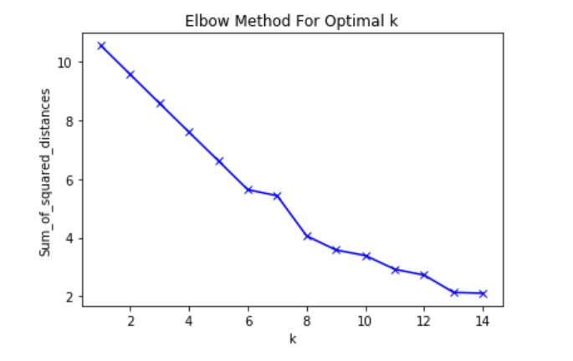

The map below shows the 13 clusters.

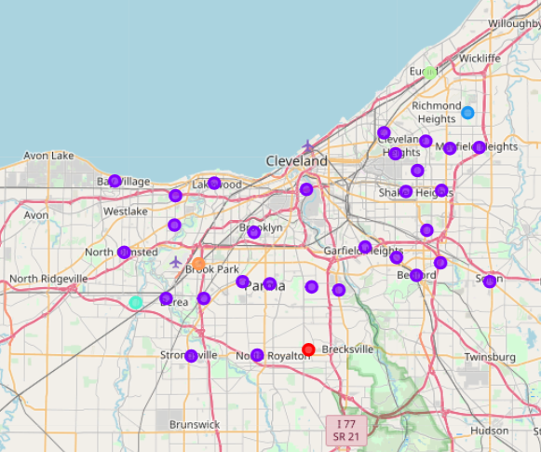

Below is the resulting clusters dataframe.

|  |  |  |  |  |
| --- | --- | --- | --- | --- |
| **city** | **Cluster** | **1st Most Common Venue** | **2nd Most Common Venue** | **3rd Most Common Venue** |
| University Heights | 0 | Restaurant | Bar | Furniture / Home Store |
| Lakewood | 0 | Sandwich Place | Salon / Barbershop | Mobile Phone Shop |
| Shaker Heights | 4 | Light Rail Station | Women's Store | Football Stadium |
| Bedford Heights | 8 | Home Service | Rest Area | Intersection |
| Strongsville | 0 | American Restaurant | Shoe Store | Bank |
| Cleveland | 0 | Pub | Molecular Gastronomy Restaurant | Bus Station |
| Lyndhurst | 0 | American Restaurant | Pizza Place | Shipping Store |
| Cleveland Heights | 0 | ATM | Pool | Park |
| Parma | 0 | Convenience Store | Sandwich Place | Golf Course |
| Seven Hills | 7 | Baseball Field | Pool | Women's Store |
| Middleburg Heights | 0 | Automotive Shop | American Restaurant | Community Center |
| Mayfield Heights | 0 | Sandwich Place | Women's Store | Men's Store |
| South Euclid | 0 | Ice Cream Shop | Bar | Flower Shop |
| Euclid | 6 | Pet Store | Women's Store | Convenience Store |
| Maple Heights | 0 | Sandwich Place | Convenience Store | Deli / Bodega |
| Garfield Heights | 0 | Pharmacy | Fast Food Restaurant | Pizza Place |
| North Olmsted | 0 | American Restaurant | Sandwich Place | Fast Food Restaurant |
| Olmsted Falls | 2 | Flower Shop | Women's Store | Hot Dog Joint |
| Bay Village | 10 | Soccer Field | Gym / Fitness Center | Italian Restaurant |
| Brooklyn | 10 | Park | Football Stadium | Soccer Field |
| Berea | 0 | Pizza Place | Ice Cream Shop | Sandwich Place |
| Brook Park | 1 | Beach | Convenience Store | Deli / Bodega |
| Broadview Heights | 5 | Gym | Women's Store | Food Truck |
| Bedford | 0 | Bar | Hot Dog Joint | CafÃ© |
| Beachwood | 12 | Intersection | Bakery | Women's Store |
| Parma Heights | 0 | Pizza Place | Bar | Chinese Restaurant |
| East Cleveland | 0 | Mobile Phone Shop | Mattress Store | American Restaurant |
| Warrensville Heights | 0 | Gym / Fitness Center | Discount Store | Fast Food Restaurant |
| North Royalton | 9 | Pool | Gym / Fitness Center | Pizza Place |
| Rocky River | 10 | Gym / Fitness Center | Pub | Playground |
| Highland Heights | 3 | Concert Hall | Hot Dog Joint | Cosmetics Shop |
| Independence | 11 | Theater | Sandwich Place | Art Gallery |
| Solon | 0 | Pizza Place | Grocery Store | Sandwich Place |
| Fairview Park | 0 | Ice Cream Shop | Italian Restaurant | Donut Shop |

We have an interesting finding. Category 0 has the most members it's members appear to have more pizza places and other restaurants. Let's remove category 0 and merge with median income data. This will be the dataset from which we will pick our 2 new locations for Basilico Pizzaria.

|  |  |  |  |  |  |  |
| --- | --- | --- | --- | --- | --- | --- |
| **city** | **population** | **median_income** | **Cluster** | **1st** | **2nd** | **3rd** |
| Brook Park | 18691 | 60571 | 1 | Beach | Convenience Store | Deli / Bodega |
| Olmsted Falls | 8890 | 79699 | 2 | Flower Shop | Women's Store | Hot Dog Joint |
| Highland Heights | 8397 | 114792 | 3 | Concert Hall | Hot Dog Joint | Cosmetics Shop |
| Shaker Heights | 27448 | 107938 | 4 | Light Rail Station | Women's Store | Football Stadium |
| Broadview Heights | 19197 | 99286 | 5 | Gym | Women's Store | Food Truck |
| Euclid | 47360 | 49668 | 6 | Pet Store | Women's Store | Convenience Store |
| Seven Hills | 11655 | 92235 | 7 | Baseball Field | Pool | Women's Store |
| Bedford Heights | 10555 | 51591 | 8 | Home Service | Rest Area | Intersection |
| North Royalton | 30247 | 90771 | 9 | Pool | Gym / Fitness Center | Pizza Place |
| Bay Village | 15328 | 109673 | 10 | Soccer Field | Gym / Fitness Center | Italian Restaurant |
| Brooklyn | 10828 | 54293 | 10 | Park | Football Stadium | Soccer Field |
| Rocky River | 20264 | 100334 | 10 | Gym / Fitness Center | Pub | Playground |
| Independence | 7114 | 105600 | 11 | Theater | Sandwich Place | Art Gallery |
| Beachwood | 11707 | 115536 | 12 | Intersection | Bakery | Women's Store |

**4. Conclusions**

Based on population, median income, and the amount of competition, it looks like Rocky River and Shaker Heights are good locations for our 2 gourmet pizza places. I base this on selecting the 2 cities with over $100k median income and then the highest population among those. This is based on the fact that both population and median incomes are well above the mean for Cuyahoga county. See summary statistics for our dataset below.

|  |  |  |  |  |
| --- | --- | --- | --- | --- |
|  | **lat** | **lng** | **population** | **median_income** |
| **count** | 38.0000 | 38.0000 | 38 | 38 |
| **mean** | 41.4375 | -81.6611 | 67026 | 80272 |
| **std** | 0.0731 | 0.1576 | 277729 | 30601 |
| **min** | 41.3079 | -81.9315 | 6198 | 30466 |
| **25%** | 41.3848 | -81.8115 | 12780 | 58253 |
| **50%** | 41.4356 | -81.6289 | 18711 | 76733 |
| **75%** | 41.4844 | -81.5228 | 27791 | 102063 |
| **max** | 41.5904 | -81.4401 | 1731637 | 186765 |