**ROLE**



**Alif Aditya Ramadhani**

3122522015

D3 PSDKU SUMENEP

**PRODI D3 TEKNIK INFORMATIKA**

**DEPARTEMEN TEKNIK INFORMATIKA DAN KOMPUTER**

**PENS PSDKU SUMENEP**

**1. Create a NOT IDENTIFIED Role**

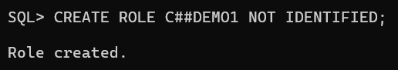

**2. Role with Identified By Password clause**

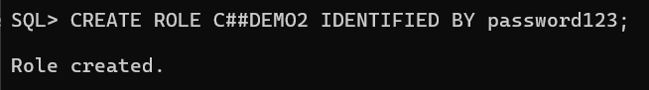

**3. External Role**

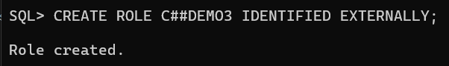

**4. Global Role**

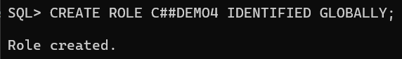

**a. grant System Privilege to a role**

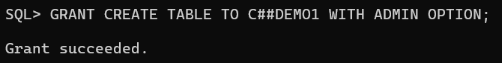

**b. grant Object Privilege to a Role**

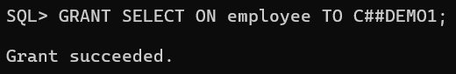

**c. Grant a Role to another Role**

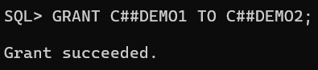

Menetapkan Peran ke Pengguna Database

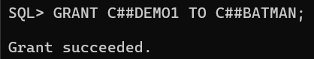

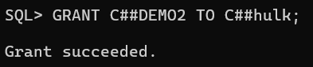

Menggunakan Fungsi SET ROLE

