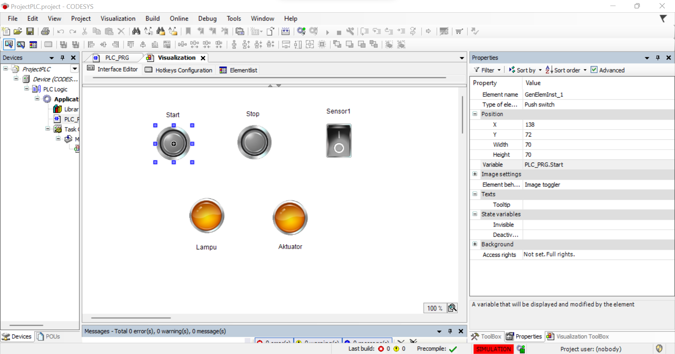

Tombol Start (Tipe Push Switch): PLC_PRG.Start

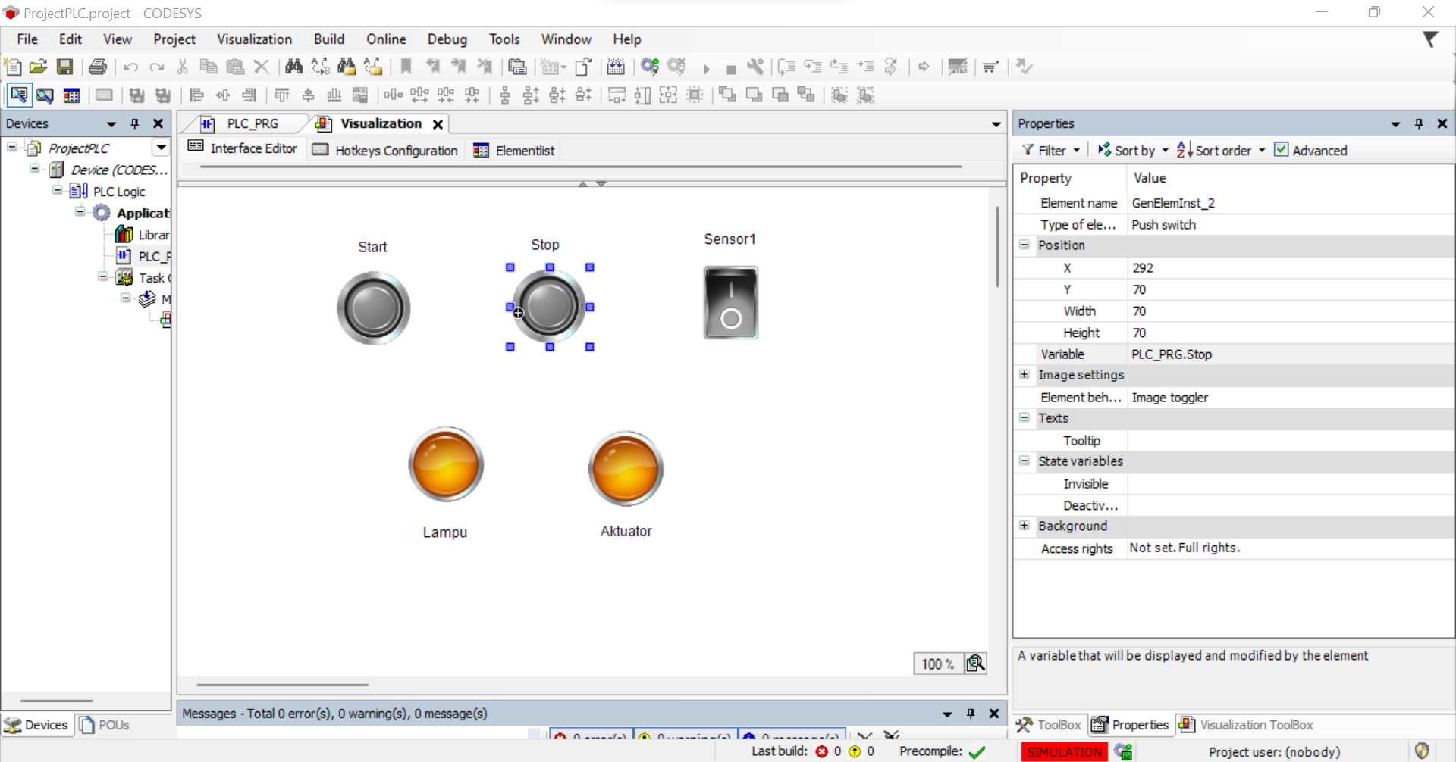

Tombol Stop (Tipe Push Switch): PLC_PRG.Stop

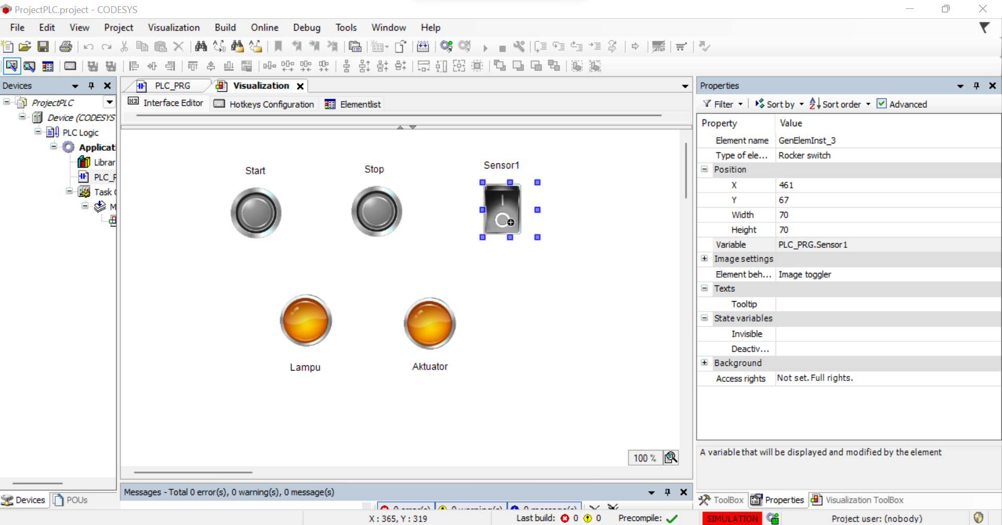

Tombol Sensor1 (Tipe Rocker Switch): PLC_PRG.Sensor1

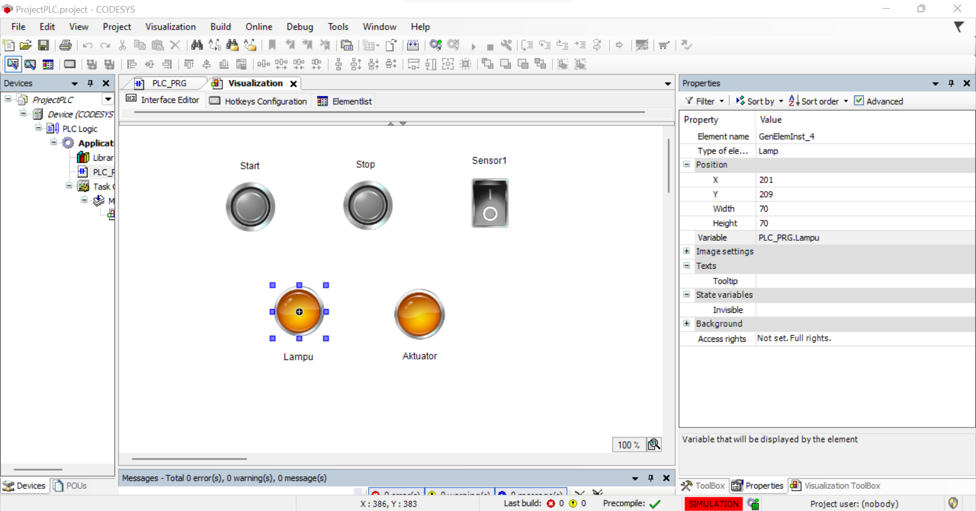

Lamp: PLC_PRG.Lampu

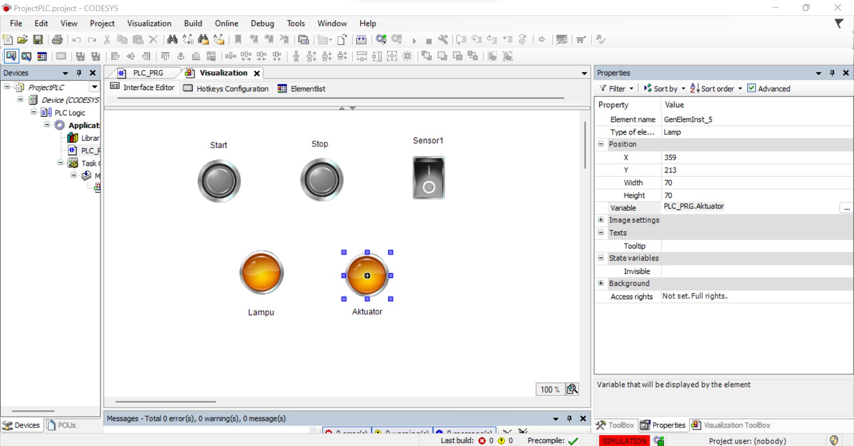

Lamp: PLC_PRG.Aktuator