# Sound

This is the documentation covering everything sound related such as Text-to-Speech, Sound Effects, and Background Noise for the Auditory Ace application.

## Volume Check

### Overview:

This documentation outlines the structure and functionality of the Volume Check screen in a Godot project.The volume check sound can be found at [E-Lot - An ending theme. - Free Music Archive](https://freemusicarchive.org/music/e-lot/single/an-ending-theme/).

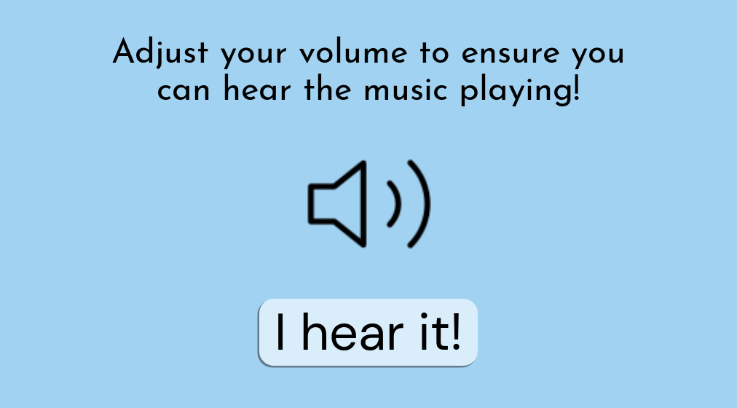

Volume Check as of 3/10/24

### Scene Information:

* Scene File: VolumeCheckScene.tscn
* Load Steps: 9
* Format Version: 3
* Unique Identifier: uid://ckjmnkj2oto1g

### External Resources:

1. Script Resource:

* Path: res://Scripts/volume_check.gd
* ID: 1_2vm7i

1. Font Files:

* DMSans Font:
  + Path: res://Fonts/DMSans_24pt-Regular.ttf
  + ID: uid://bslnk4jwc4au1
* JosefinSans Font:
  + Path: res://Fonts/JosefinSans-Regular.ttf
  + ID: uid://dayil4h078ps1

1. Audio Stream:

* Path: res://Audio/E-Lot - An ending theme..mp3
* ID: uid://dpoy1i487e2j4

1. Texture 2D:

* Path: res://Icons/volume-2.svg
* ID: uid://cfisr5yjh2ob1

### StyleBoxFlat Subresources:

1. StyleBoxFlat_dvl4f:

* Background Color: 0.854902, 0.929412, 0.980392, 1
* Corner Radius (All): 20
* Shadow Color: 0.129412, 0.129412, 0.129412, 0.486275
* Shadow Size: 1
* Shadow Offset: (-2, 2)

1. StyleBoxFlat_2desg:

* Background Color: 0.854902, 0.929412, 0.980392, 1
* Corner Radius (All): 20
* Shadow Color: 0.129412, 0.129412, 0.129412, 0.486275
* Shadow Size: 1
* Shadow Offset: (-2, 2)

1. StyleBoxFlat_w7w1w:

* Background Color: 0.854902, 0.929412, 0.980392, 1
* Corner Radius (All): 20
* Shadow Color: 0.129412, 0.129412, 0.129412, 0.486275
* Shadow Size: 1
* Shadow Offset: (-2, 2)

### Nodes and Components:

1. VolumeCheck (Node2D):

* Script: volume_check.gd (ID: 1_2vm7i)

1. ColorRect:

* Type: ColorRect
* Properties:
  + Offset Right: 1024.0
  + Offset Bottom: 576.0
  + Color: 0.631373, 0.823529, 0.945098, 1

1. Start Button:

* Type: Button
* Properties:
  + Layout Mode: 0
  + Offsets (Left, Top, Right, Bottom): 362.0, 420.0, 662.0, 512.0
  + Text: "I hear it!"
  + Font: DMSans_24pt-Regular.ttf
  + Font Size: 70
  + Theme Overrides:
    - Normal Style: StyleBoxFlat_dvl4f
    - Hover Style: StyleBoxFlat_2desg
    - Pressed Style: StyleBoxFlat_w7w1w

1. Subtext Label:

* Type: Label
* Properties:
  + Offsets (Left, Top, Right, Bottom): 112.0, 60.0, 912.0, 159.0
  + Text: "Adjust your volume to ensure you can hear the music playing!"
  + Font: JosefinSans-Regular.ttf
  + Font Size: 47
  + Horizontal Alignment: Center
  + Autowrap Mode: Word

1. Volume Icon Button:

* Type: Button
* Properties:
  + Offsets (Left, Top, Right, Bottom): 413.0, 190.0, 613.0, 390.0
  + Icon: volume-2.svg
  + Flat: true
  + Icon Alignment: Center
  + Expand Icon: true

1. Audio Player:

* Type: AudioStreamPlayer2D
* Properties:
  + Stream: "E-Lot - An ending theme..mp3"
  + Autoplay: true

### Functionality:

When the "Start" button is pressed, it triggers the _on_start_pressed() function in the script volume_check.gd, which changes the scene to the main menu (res://Scenes/main_menu.tscn).

## Text-to-Speech

### Overview

TextToSpeech.gd manages all functions related to Text-to-Speech and is stored in the Database under Settings as ‘Default’.

### Usage

#### Invoking TTS

**# text: String (Example: Any text to be played via TTS)**

**TextToSpeech.playText(text)**

#### Changing TTS Voice

**# Retrieving list of voices**

**var Voices: Array[String] = TextToSpeech.getVoices()**

**# value: int (Index of voices in Voices array)**

**TextToSpeech.Volume = value**

**Database.updateSetting("Default", "Sound", value)**

#### Changing TTS Volume

**# value: int (Volume level)**

**TextToSpeech.Volume = value**

**Database.updateSetting("TTS", "Volume", value)**

## Sound Effects

### Overview

Audio.gd manages all functions related to Sound Effects

### Usage

#### Playing Sound Effect

**# text: String (Example: name of sound effect file excluding .mp3)**

**Audio.playFX(text)**

#### Changing Sound Effect Volume

**# value : int (Volume level of Sound Effect, ranges from -15 to 10)**

**Audio.changeFXVolume(value)**

## Background Noise

### Overview

Audio.gd manages all functions related to Background Noise. Four levels of background noise are used in the exercises: None, Low, Medium, High. The following table details the level (in decibels) each level of background plays at relative to TTS volume:

| Background Noise Level | Volume (relative to TTS volume) |
| --- | --- |
| Low | 20 db lower |
| Medium | 10 db lower |
| High | Same volume |

### Usage

#### Load Specified Background Noise

**# Intended to be called after entering exercise scene**

**# Loads specific noise file and volume into object**

**# noise: String (Example: name of the background noise file excluding .mp3)**

**Audio.loadBGNoise(noise)**

#### Changing Background Noise Settings

**# Intended to be used in pre-exercise screen**

**# category: String (Name of Setting, Example: Exercise 1)**

**# setting: String (Setting to be changed, Example: Sound, Volume)**

**# value: String (Value of setting)**

**Database.updateSetting(category, setting, value)**

#### Playing/Stopping Background Noise

**# Play**

**Audio.playBGNoise()**

**# Stop**

**Audio.stopBGNoise()**