Appendix B

**Installing Virtual Box and Ubuntu for Windows**

The instructions below describe creation of an Ubuntu Linux Virtual Machine (VM) to serve as the Labtainer host. If you already have a Linux system that can support Dockers, you may use that system and not use this Appendix.

**Installation of the Virtual Box**

You will install VirtualBox from: <https://www.virtualbox.org/wiki/Downloads>.

Choose VirtualBox for Windows hosts and install per the usual procedure (by downloading the .exe file, then selecting it and clicking “Run”).

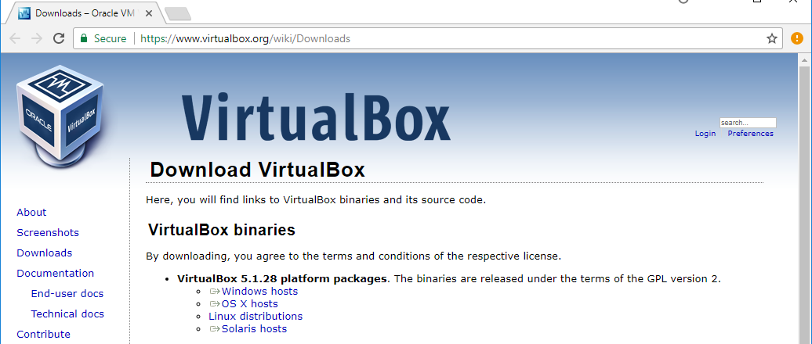

Then follow the setup process keeping all the options set to their default.

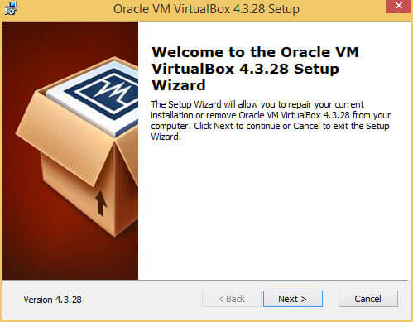

.

**Installation of Ubuntu**

You will download the latest Ubuntu Desktop LTS distribution *.iso image* from <https://www.ubuntu.com/download>. It is important that you download this as an .iso (i.e., as Disk image file) because it will be used to install Ubuntu on the VM you create.

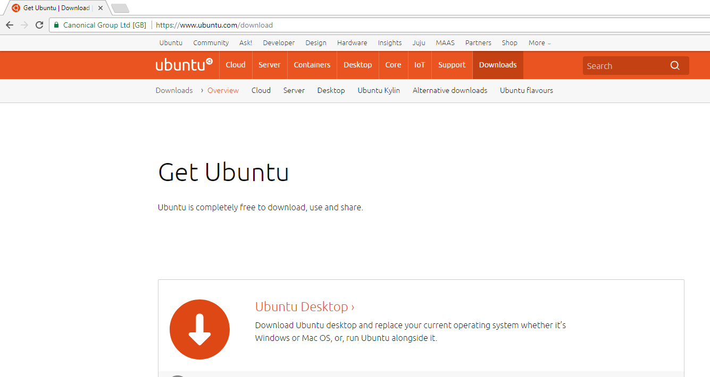

**Creating a new Virtual Machine (VM)**

1. You will use VirtualBox to create a new VM (new hard disk file) by clicking on the “New” button in the top left corner.

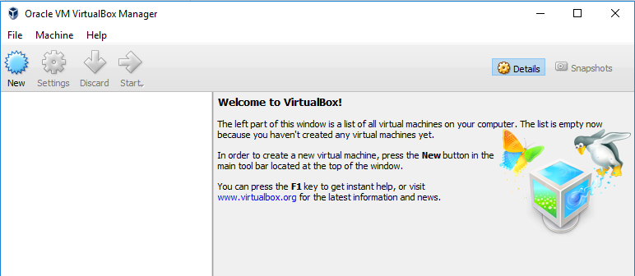

1. Follow the instructions to name your VM and choose what operating system (OS) you will be installing. Choose Linux from the “Type” menu. You must install the 64-bit version of the OS, select Ubuntu 64-bit under Version.

NOTE: If you are using a machine that supports 64-bit but the 64-bit version is not available in this dropdown menu, you may need to go to your PC’s **Windows Features/Control Panel** (on Win10: Control Panel / Programs / Programs and features; then click “Turn Windows features on or off” on the left side of the window), and disable Hyper V, then restart the computer. Also see <https://forums.virtualbox.org/viewtopic.php?f=1&t=62339> for VirtualBox hardware requirements for running 64-bit guests.

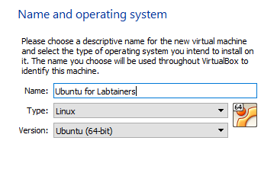

3. Next you need to allocate RAM (memory), disk storage space, create your new hard disk, and allocate a number of CPUs (Central Processing Units) to your new VM:

* Allocate **4 GB RAM when prompted**

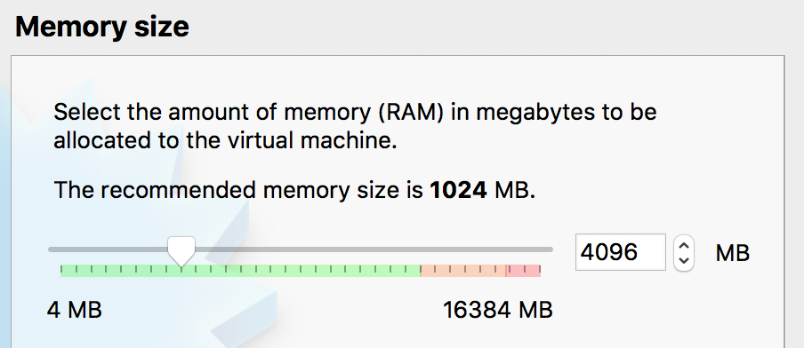

* Create your new virtual hard disk

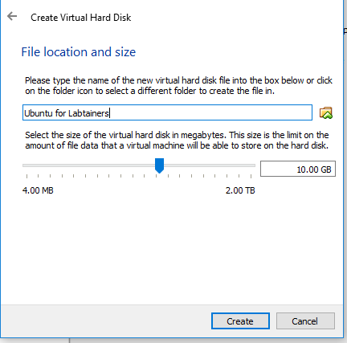

* On the screen that will follow the one on the right (not shown here), accept the default disk file type (**VDI)**
* And on the screen after that one (also not shown), accept “Dynamically allocated”
* Allocate at least **10 GB of disk storage** and click “Create”
* After you click “Create”, you should be taken to the VirtualBox main window

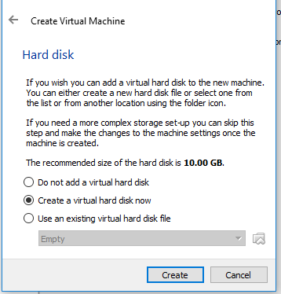

Your new VM is visible in the top left corner. It is currently powered off.

* Select “Settings”, then “System”, then click on the “Processor” tab as shown below and assign 2 CPUs if your system allows.

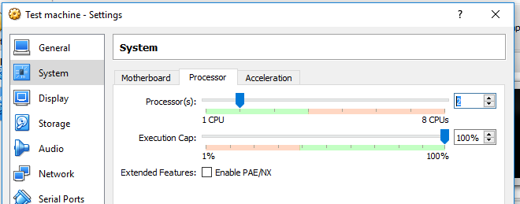

4. Now you need to mount your .iso image (OS, Ubuntu). Please note that the Optical Drive is now shown as “Empty” in your VirtualBox main window. Click on “Storage” as shown below.

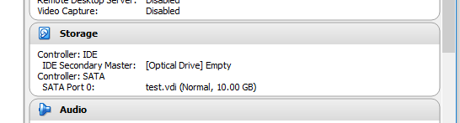

The following window will open (see below). Click to select “Empty” disk on the left under “Controller: IDE” first (not shown). Then make sure that you **check “Live CD/DVD”** as shown below (it is very important that you add your Ubuntu .iso as Live CD/DVD)

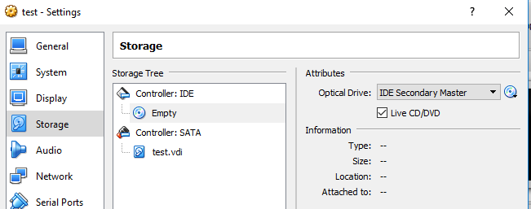Now click on the small disk icon on the right (as shown), select and add the Ubuntu .iso that you downloaded earlier.

Your Optical Drive should now show your Ubuntu .iso image (as shown below)

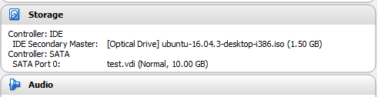

1. Double-click your new VM to power it on. (As an alternative you can click on “Start” and select “Normal start”.)

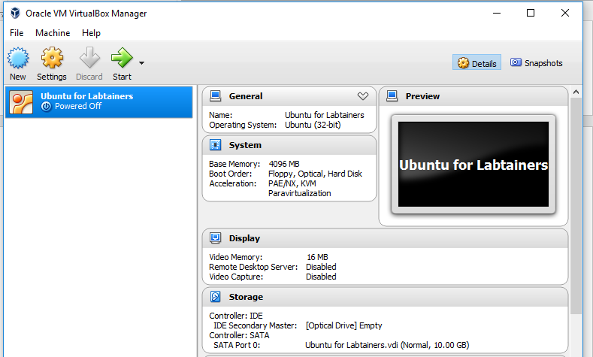

Wait patiently until the Ubuntu Welcome screen (below) appears because the installation will take a few minutes.

Dismiss the notifications about **Auto capture keyboard** and **Mouse pointer integration** when they appear (both shown in the image below). They are merely telling you that your keyboard keystrokes and mouse clicks will be captured by your VM.

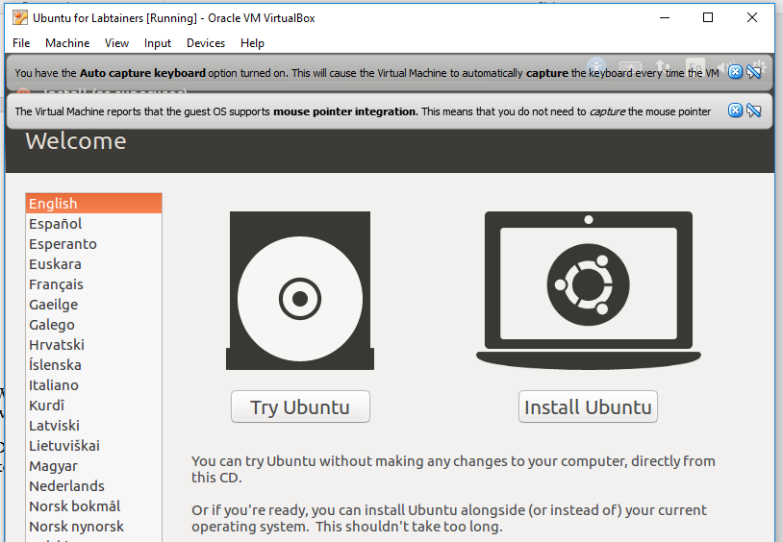

**IF at this point, instead of the above Ubuntu Welcome screen above,** the VirtualBox window shows the following screen, the previous step did not work, so please remount the .iso by selecting the little folder icon to the right and repeating the steps as prompted (i.e., select Ubuntu ISO image in the VirtualBox storage settings, and select ”Live CD/DVD”)

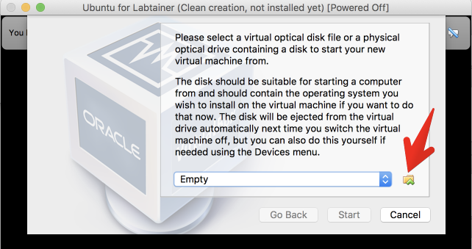

- Once you see the Ubuntu Welcome Screen, you can click on “Install Ubuntu”.

You should be able to install Ubuntu by accepting the default options provided. It is recommended, though not required, that you select the following option: “Download Updates while Installing Ubuntu”

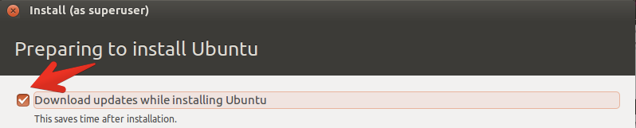

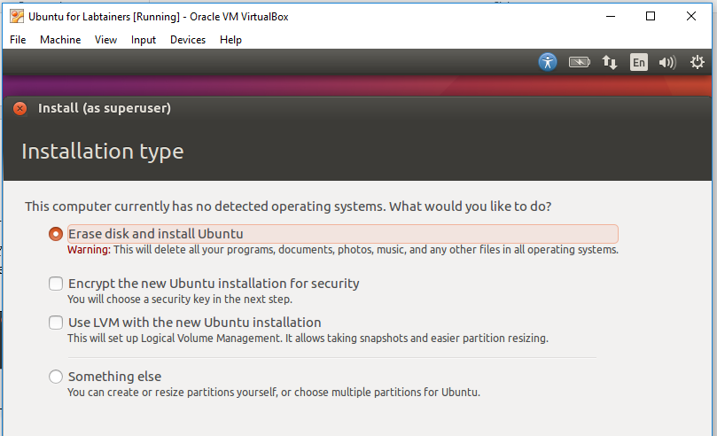- Select “Erase disk” – this will only affect your VM disk space (and will not harm files on your host PC)

* Set your Time Zone to Los Angeles when prompted

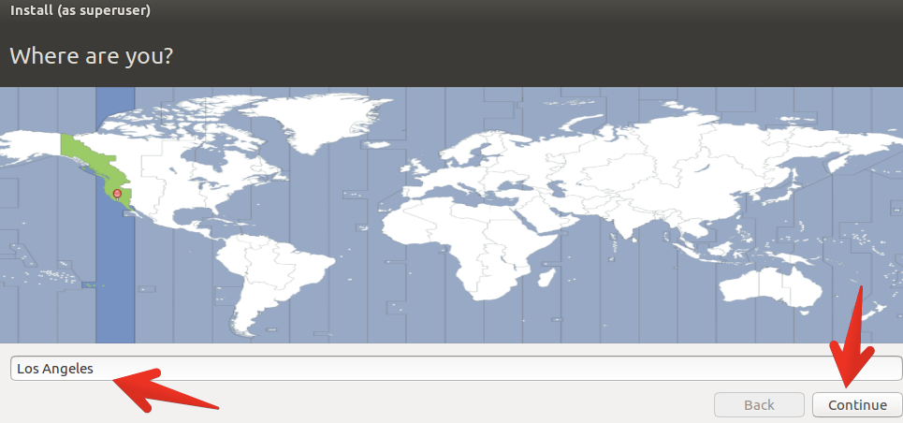

- Select the appropriate language

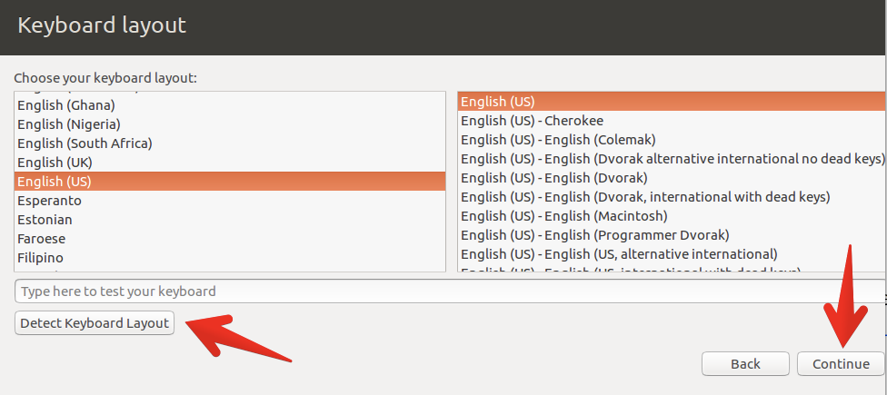

* When prompted, enter a user name and password: “student” is used here in the example, you may use whatever name you like

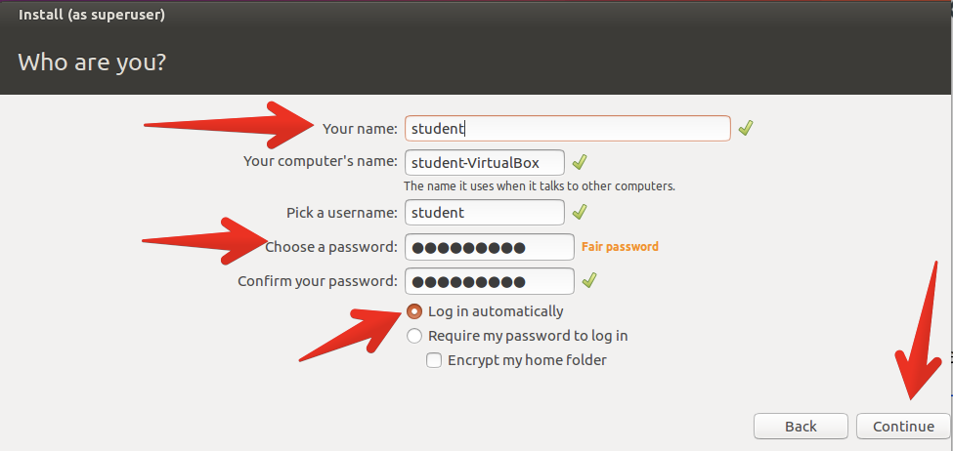

Ubuntu will then install on to your new virtual hard drive (VM).

When the installation is complete, a dialogue box will be displayed instructing you to restart your VM. NOTE: **DO NOT CLICK “Restart Now” before you unmount the .iso image.**

To unmount .iso, select “Devices” in the top menu, then select “Optical Disk”, make sure the Ubuntu .iso image is checked and click “Remove” disk from virtual drive”

**IF** you accidentally click to restart before unmounting the .iso file, you will get the following screen:

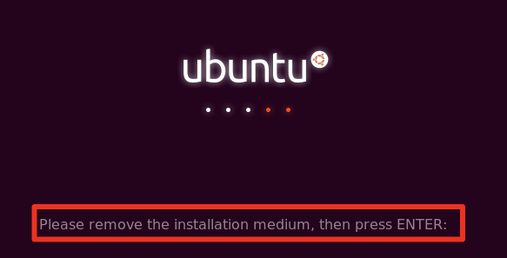

**IF** this occurs, in order to unmount the .iso, just choose the DVD icon in the lower right corner and select **Remove disk from virtual drive** (note if that is greyed out, first click on the ISO line above it then click on “Remove disk from virtual drive”)

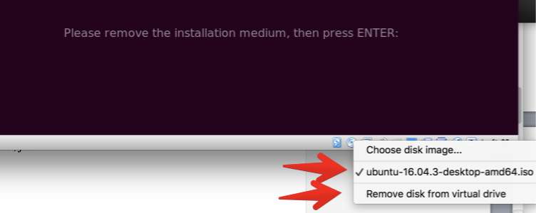

**IF** the small disk icon is itself greyed out, go to the "Devices" menu and then remove it following the instructions above.If asked if it okay to force the unmount, just select the **Force Unmount**.

**Restarting your VM (Virtual Machine)**

* Now click “Restart Now”

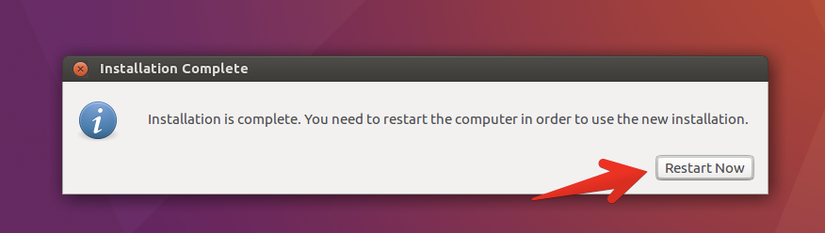

The VM reboot may take a few minutes so you may see a black screen for a while.

**IF** you see the black screen for too long, select “Machine” in the top menu and “Reset”.

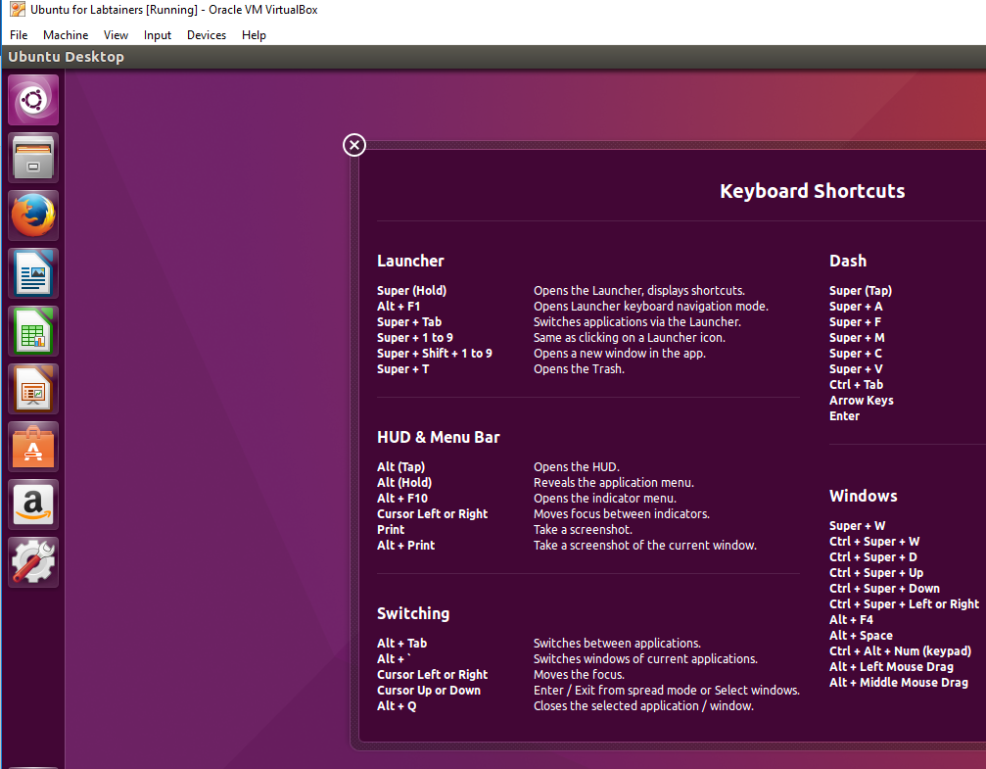**Once the VM reboots/resets, you should have a screen that looks like this:**

NOTE: **IF** your Ubuntu desktop has a DVD icon on it, you did not unmount it correctly and should do it now by right-clicking and ejecting the DVD .iso.

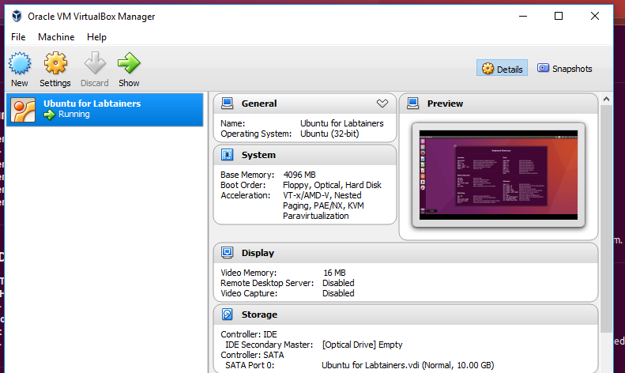This is your VM. The VirtualBox main window should now look like this:

**Setting up file sharing between the host computer and the VM**

You need to create (or identify) a folder on the host machine that will be sharing files with the VM (i.e., guest).

In the VirtualBox main window, go into Settings and select “Shared Folders”.

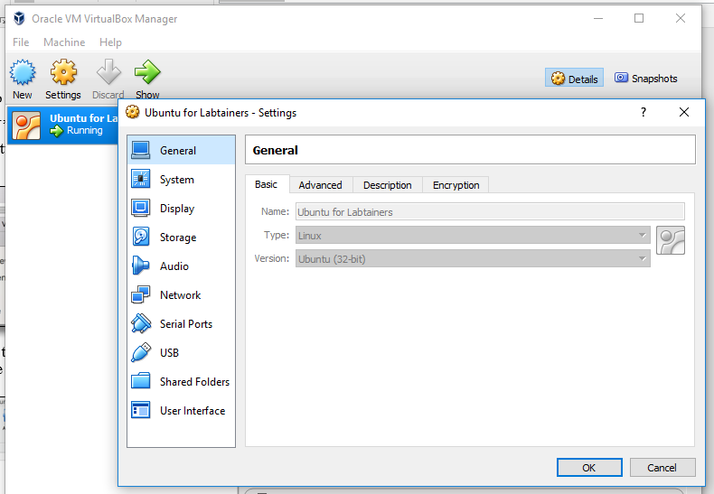

Then select the **add folder** (plus) button on the right, locate and add the folder you created/identified for sharing, making sure to first check **Auto-mount** and **Make Permanent (IF** you have not yet created a folder on the host that will contain shared files, you can do so within this process.)

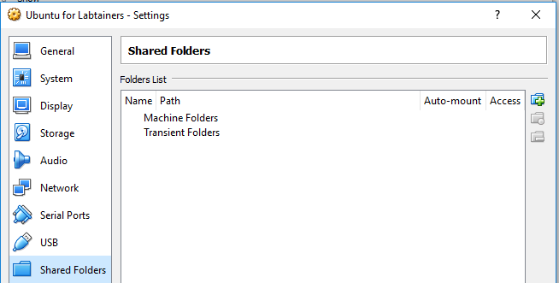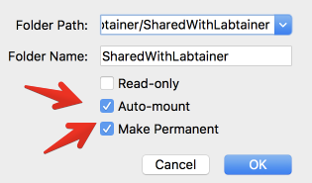

**Installing Add-ons for your VM**

Now that you have identified the shared folder, you need to take the following steps to improve the performance of your new VM. VirtualBox Guest Additions contain device drivers and system applications that optimize the operating system.

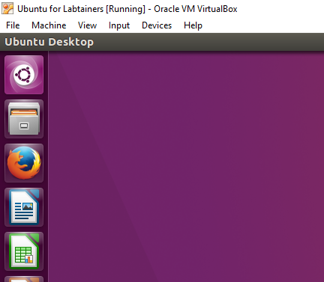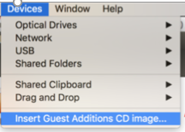In your new VM window, go to “Devices” in the top menu and select **“Insert Guest additions CD Image”**

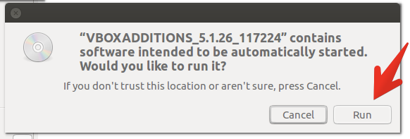

When you see the warning message below, click “Run”.

If you are prompted for “authentication as superuser”, just enter the password you created earlier when you were naming your VM. (Additionally, any time you are away from your VM, you may be asked to enter your password upon return.)

You will see this screen during auto-install. After the guest additions load, you will be asked to hit Return to exit.

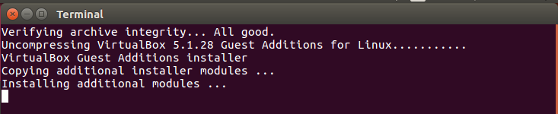

**Enabling sharing of the clipboard**

In order to be able to copy and paste from and to your new VM, lets enable sharing the clipboard. To do this, choose the VirtualBox Manager (main window, NOT the individual VM’s window), go to "Settings", General, Advanced, and allow for Shared Clipboard by choosing “Bidirectional”.

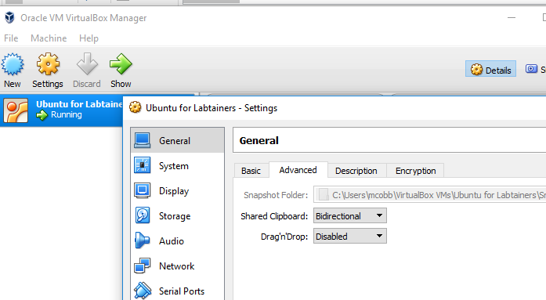(Alternatively, in your individual VM’s window, go to Settings in the top menu and select Shared Clipboard, Bidirectional.)

**Final steps**

* 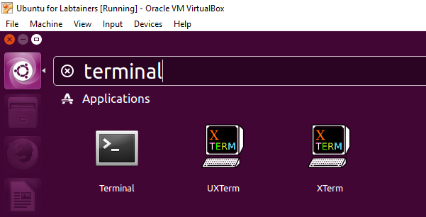You will now open a terminal. Select the Search icon in the top left corner of your VM screen and type “terminal” in the window that will pop up and hit Return.
* After you select “Terminal” under Applications, you will see this screen (it will display the name of your machine):

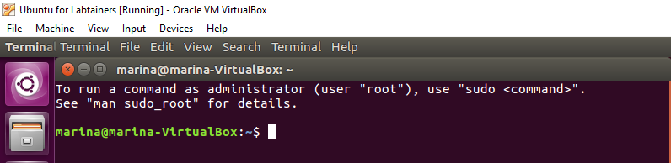

* Run this command (type it at the prompt and press Enter)

**sudo adduser $USER vboxsf**

* When prompted for password, enter the password you created earlier for the VM.
* Then, reboot the guest Linux system by entering the following command:

**sudo reboot**

After reboot, the system should come back to the VM screen.