**Quantum Computing Labtainer**

Disclaimer: This software is provided as is. Use at your own risk. The views expressed herein do not necessarily reflect those of the DoD.

Description: This lab explores two fundamental quantum algorithms: (1) teleportation; and (2) Grover's algorithm. Teleportation uses entanglement to transport a quantum state from one location to another [1], reproducing it at the destination and destroying the original, in accordance with the no-cloning theorem. Grover's algorithm searches an unordered list quadratically faster than a classical computer [2].

**Part 1: Quantum Teleportation**

Step1: Run the teleportation algorithm with the following command:

./run_teleportation.sh

You will see a window appear with a quantum circuit displayed at the top. A red vertical line shows algorithm's progress. Each horizontal line represents one quantum bit (this example uses three quantum bits). In the lower left, you will see a graphical representation of the current quantum state (initially 4, which is 100 in binary). Cyan represents positive real numbers; magenta represents negative real numbers. We will not need imaginary numbers in this lab, but some quantum algorithms like Shor's factoring algorithm use them. In the lower right, you will see a text representation of the current quantum state.

In quantum teleportation, Alice sends a quantum state to Bob. In this example, the upper two lines represent Alice; the lowest line represents Bob. Alice is going to send the state 1 to Bob. Note in the diagram that the initial state of the uppermost quantum bit is 1; the lower two bits are initially 0 (thus the initial state of 100 in binary, i.e., |4> 1.0 + 0.0i).

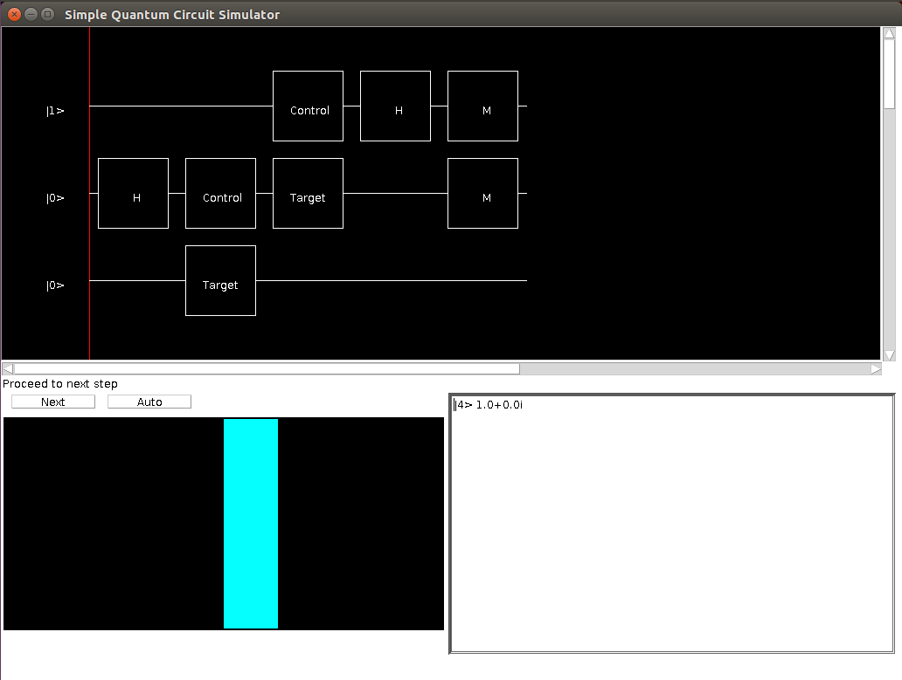

Figure 1. Quantum Teleportation Circuit: Initial State

Step 2: Press the Next button to advance the quantum algorithm by one step. You will notice the red vertical line move one position to the right. You will see the quantum state change in the lower left and lower right. Do not worry if you do not understand the meaning of the quantum gates and the changes in the quantum states; it takes several weeks in a quantum computing course to fully grasp the quantum circuit computational model.

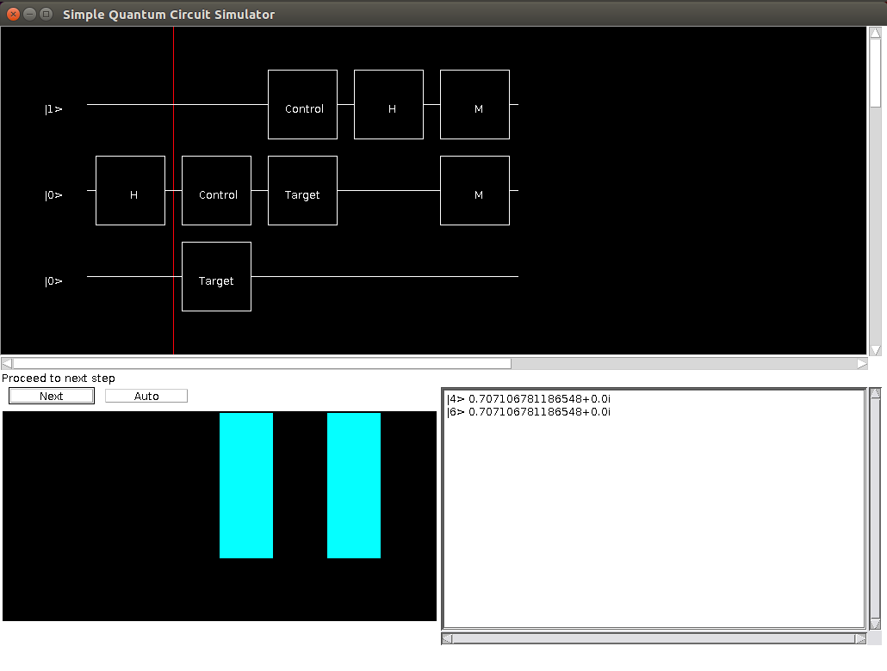

Figure 2. Quantum Teleportation Circuit: State after Appling an H Gate

Step 3: Press the Next button four more times. You will notice the red vertical line move further to the right, and you will also notice additional changes to the quantum state reflected in the lower left and lower right.

Step 4: You have now reached the end of the quantum teleportation algorithm. Make note of the final quantum state in the lower right. Go back to the terminal window in which you launched the quantum simulator and press Control-C to quit the simulator. Printed in the terminal window, you will see one of four possible measurements of the upper two quantum bits (Qubit 0 and Qubit 1): 00, 01, 10, or 11. These four possibilities are programmed to occur randomly with equal probability.

At this point, the quantum portion of the teleportation algorithm is done. Now, Alice calls up Bob (i.e., she communicates with him classically). If Alice measured 00, the final state of the system is 001 (i.e., |1> 1.0 + 0.0i). In this case, Bob has received the correct value of 1. We started out in 100 and ended up in 001. Bob does not need to apply any correction to his bit.

However, if Alice measured 01, the final state of the system is 010 (i.e., |2> 1.0 + 0.0i). In this case, Bob has received the incorrect value of 0 instead of the correct value of one and must therefore apply the appropriate correction (using a Not gate to flip his 0 back to the correct value of 1).

If Alice measured 10, the final state of the system is -5. In this case, Bob has received -1 and must flip the sign to the correct value of +1. This is called a phase flip.

If Alice measured 11, the final state of the system is -6. In this case, Bob has received -0 and must perform both a bit flip and phase flip to achieve the correct value of +1.

Step 5: Repeat from Step 1 (i.e., rerun the simulator on the teleportation circuit) until you experience all four possibilities (00, 01, 10, and 11).

**Part 2: Grover's algorithm**

Suppose you have a function f(x) that equals 1 for one specific value of x but equals 0 for all other values of x. A classical algorithm would take O(n) steps to find this value, known as the element of interest. Grover's algorithm can find the element of interest in O(sqrt(n)) steps. Grover's algorithm has a variety of potential applications, including signal processing, graph theory, error correction, machine learning, number theory, and combinatorics.

Step 1: Run Grover's algorithm with the following command:

./run_grover.sh

You have been randomly assigned one of 8 possible functions based on your email address. You will see the quantum circuit for Grover's algorithm in the upper window. You can scroll down a tiny bit to expose the fourth (lowest) quantum bit.

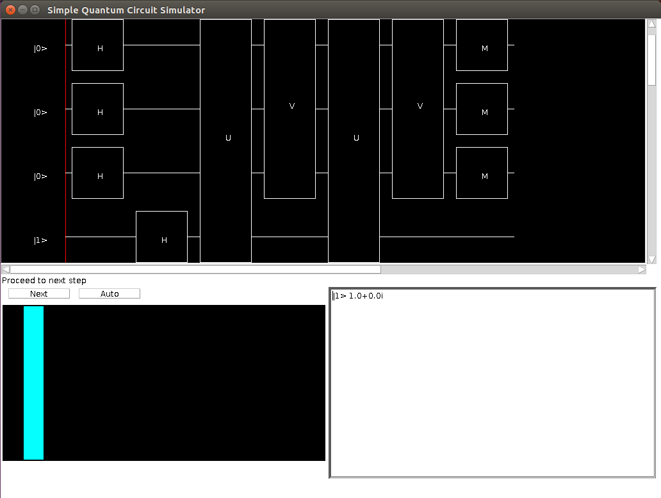

Figure 3. Grover's Algorithm Circuit: Initial State

Step 2: Press the Next button twice; the vertical red line will move two steps to the right. Note the visual representation of the quantum state in the lower left; you will see a regular pattern of alternating cyan and magenta vertical bars.

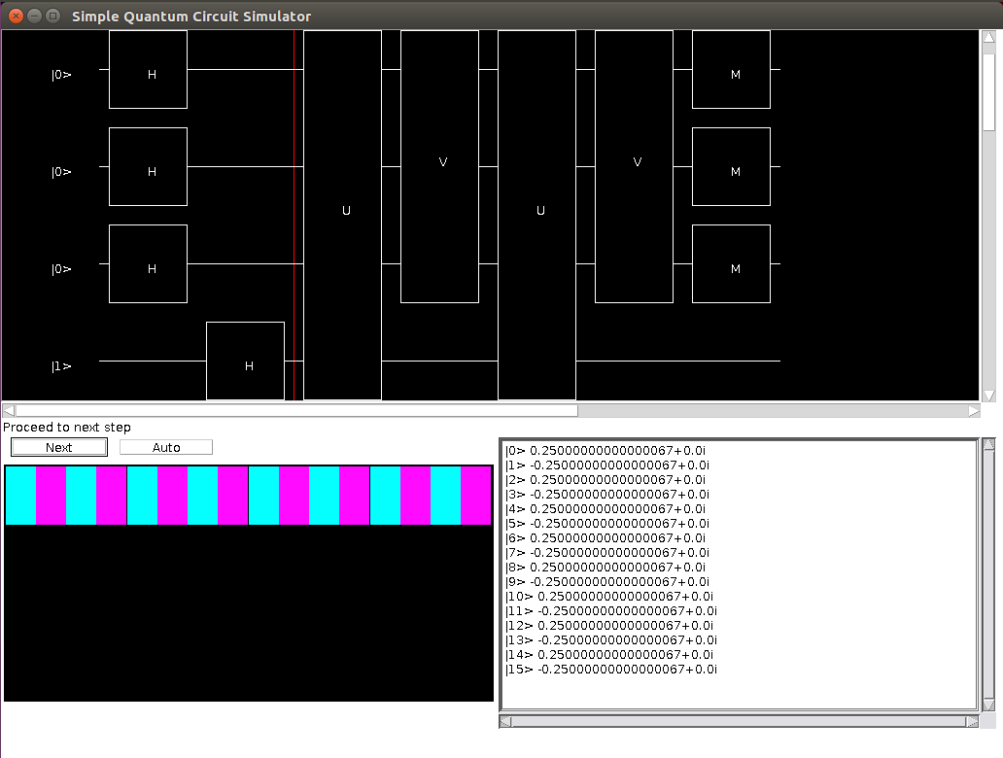

Figure 4. Grover's Algorithm Circuit after Applying H Gates

Step 3: Press the Next button once; you will notice in the lower left that two of the vertical bars have switched positions. This is called phase inversion (a sign flip corresponding to the element of interest).

Step 4: Press the Next button again; you will notice in the lower left that the two vertical bars that swapped positions in Step 3 are now slightly bigger than the others. This is called inversion about the mean.

Step 5: Press the Next button twice; you will notice the longer bars get even longer than before as a result of repeating the phase inversion and inversion about the mean.

Step 6: Press the Next button once. You have now reached the end of the quantum teleportation algorithm. Go back to the terminal window in which you launched the quantum simulator. Press Control-C to quit the simulator. Printed in the terminal window, you will see in binary your specific element of interest reflected in the measured values of the top three quantum bits. One of 8 possibilities was randomly assigned to you based on your email address (000, 001, 010, 011, 100, 101, 110, or 111). This value will also correspond to which pair of vertical bars got longer during the algorithm.

References:

[1] C. H. Bennett, G. Brassard, C. Crépeau, R. Jozsa, A. Peres, W. K. Wootters. Teleporting an Unknown Quantum State via Dual Classical and Einstein-Podolsky-Rosen Channels. Physical Review Letters, Volume 70, Number 13, Pages 1895-1899, 29 March 1993.

[2] Lov Grover. A Fast Quantum Mechanical Algorithm for Database Search. Proc. ACM STOC, May 1996.