1. 
2. Preferred name: Thorne Wolfenbarger
3. Preferred pronouns: he/him/his
4. Ideal job after graduation: Freelance Software Developer
5. Job experience
   1. NOS Technologies | DevOps Intern | Automation and Web Development
   2. Allegiant Airlines | Operations Research Intern | Optimization and Data Analytics
   3. Google | EP Intern | App Development and Microservice Development
6. N/A
7. Learning style

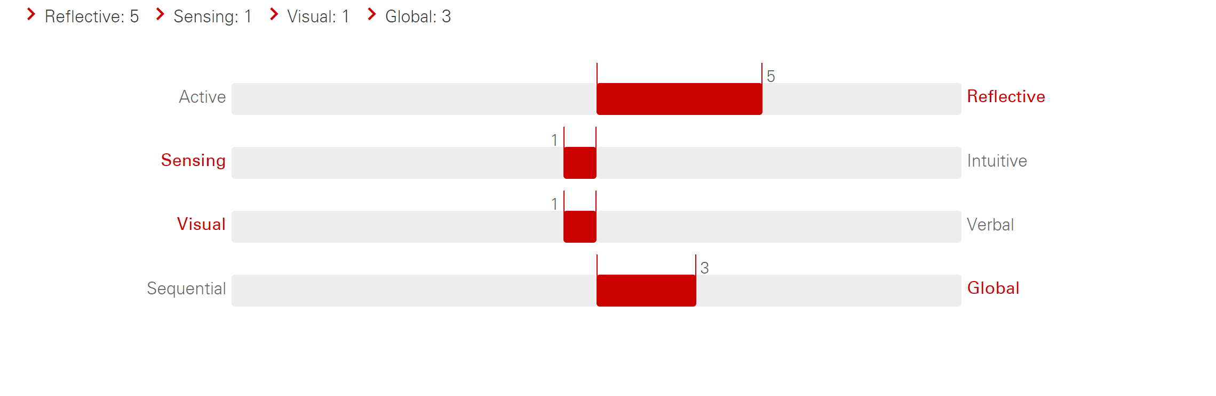

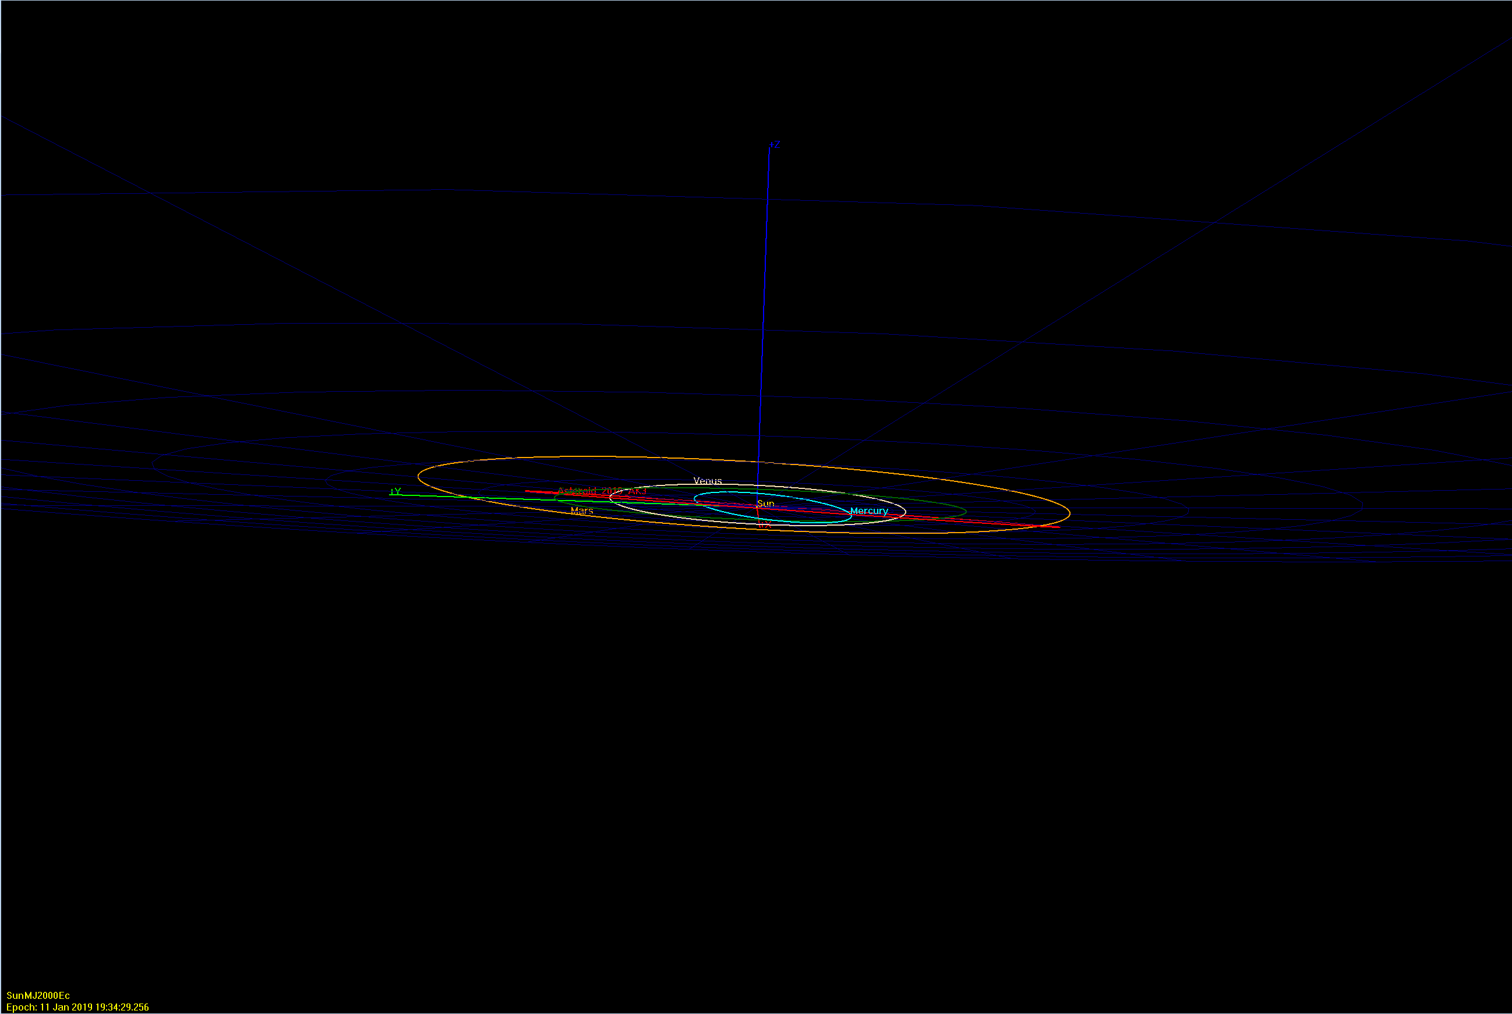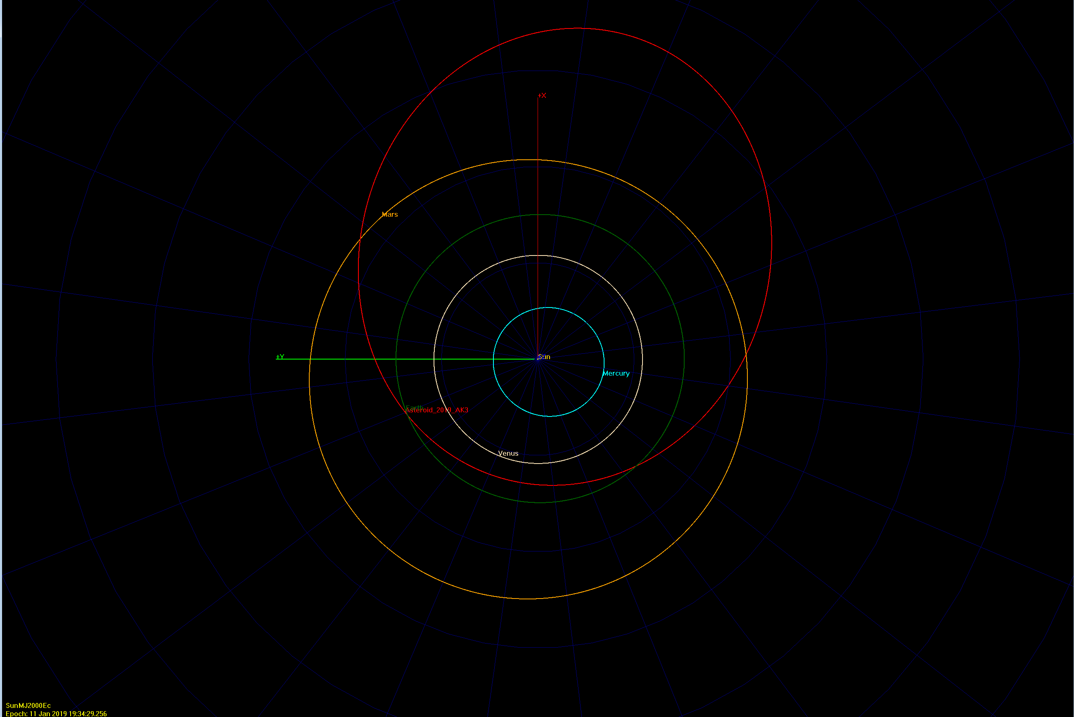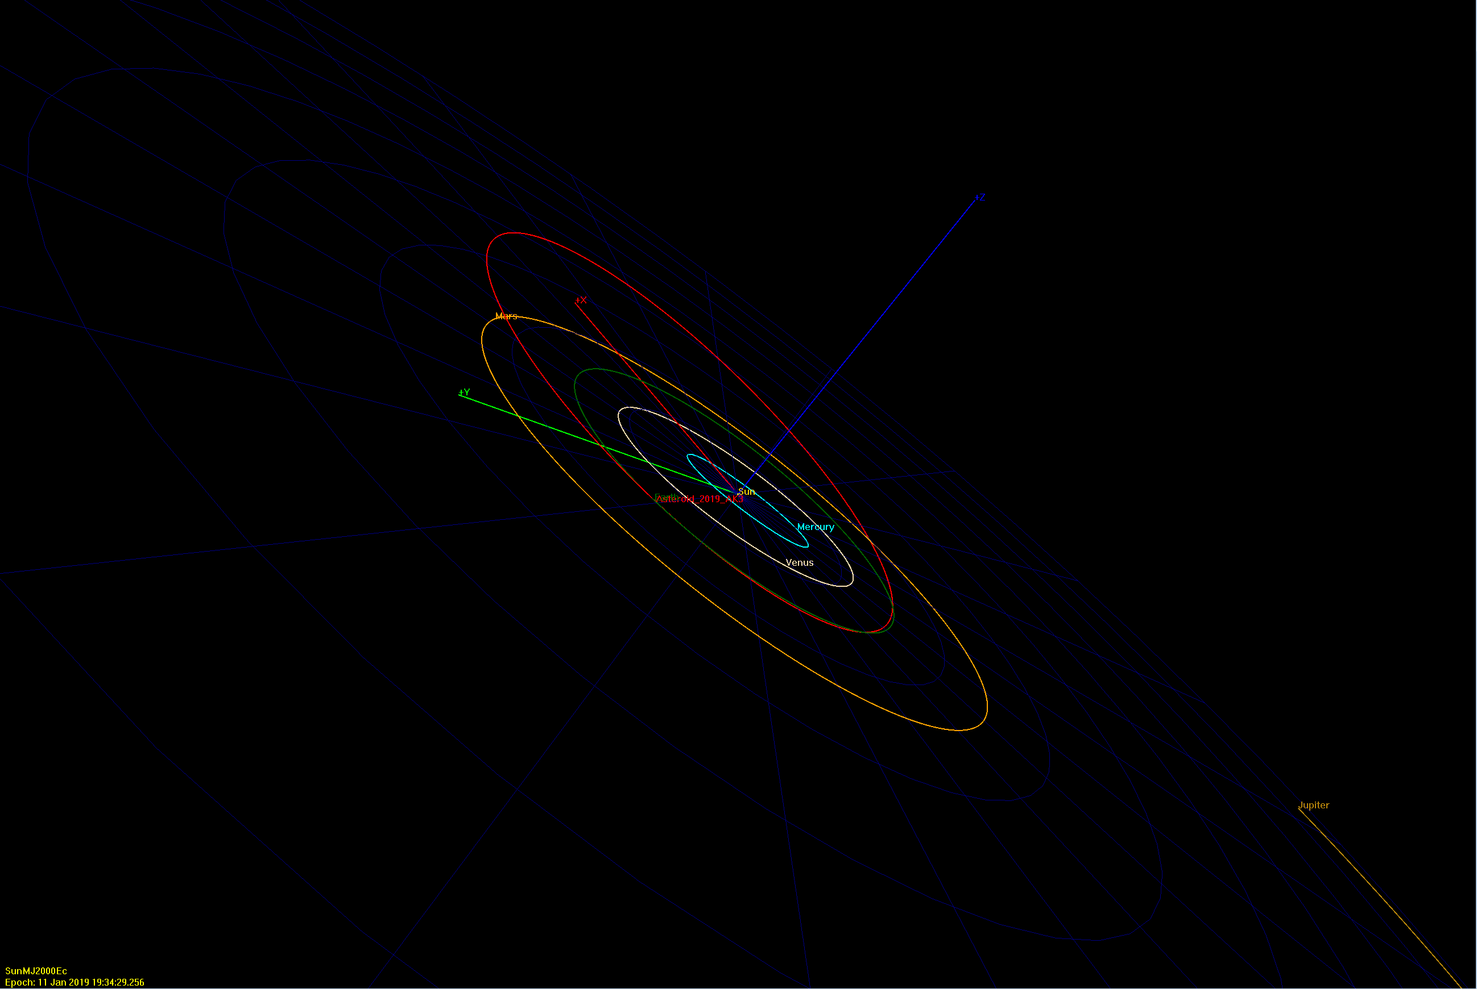

4)

i. How close does the asteroid approach Earth in km? 1872706.81 km

ii. What is the size (diameter) of the asteroid? 10-23 m

iii. What is the period of this asteroid in its orbit? 718.3707 $±$ 1.02 d