2.1)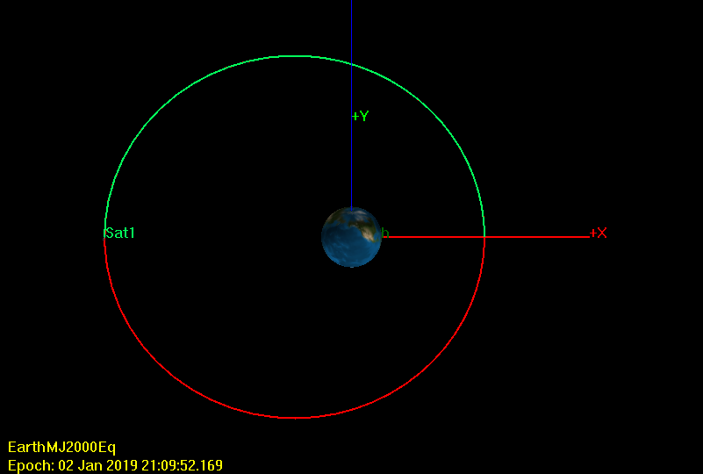

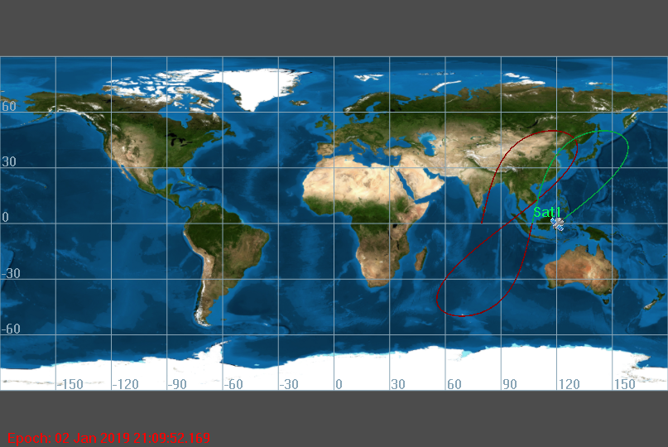

|  |  |  |
| --- | --- | --- |
| RadPer (km) | RadApo (km) | Energy (J) |
| 28000 | 52000 | -4.9825 |
| OrbitPeriod | HMAG | Position (x, y, z) Vel (x, y, z) |
| 79616.11 | 120453.54 | 28000, 0, 0 | 0, 2.765, 3.295 |

2.3)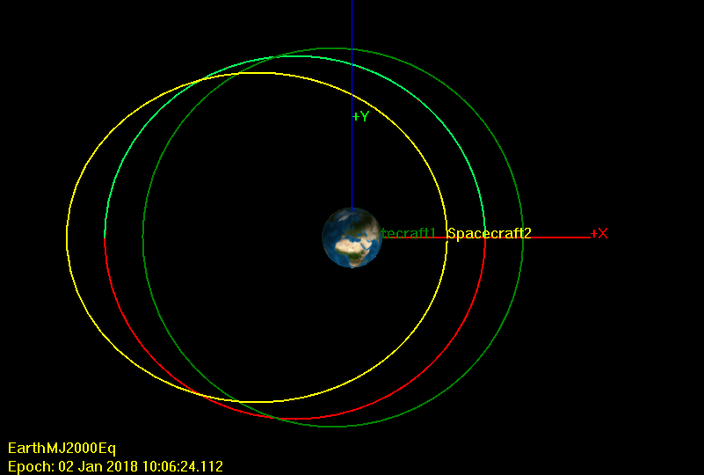

Changing the eccentricity of the orbit caused the orbit to become more elliptical. The higher the value of eccentricity, the more elongated the orbit becomes.

2.4)

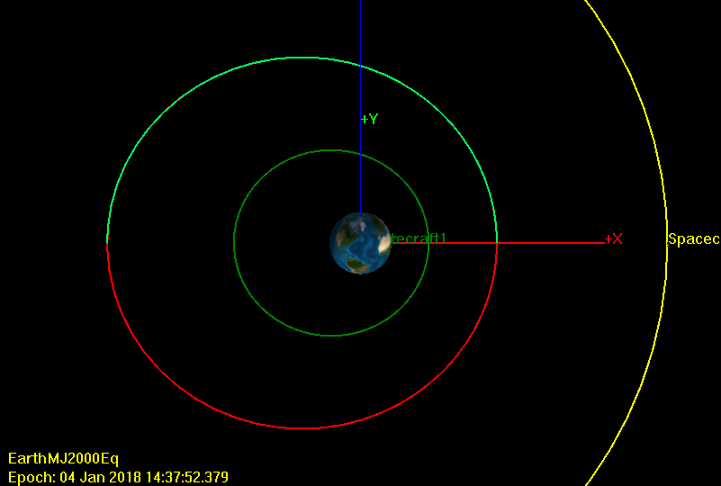

Changing the semi-major axis causes the entire orbit to grow in size. The period increases but the eccentricity stays the same.