AE 313 Homework 3

1.

a)

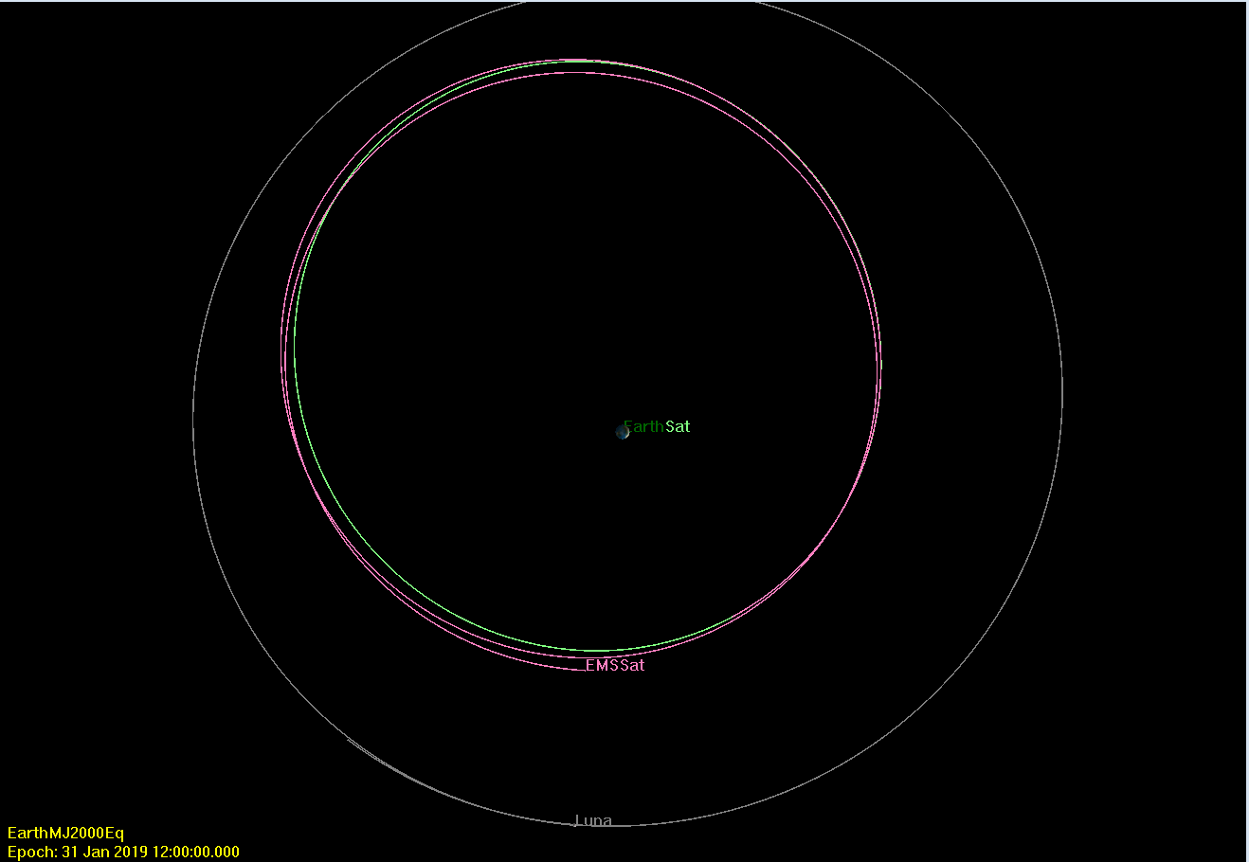

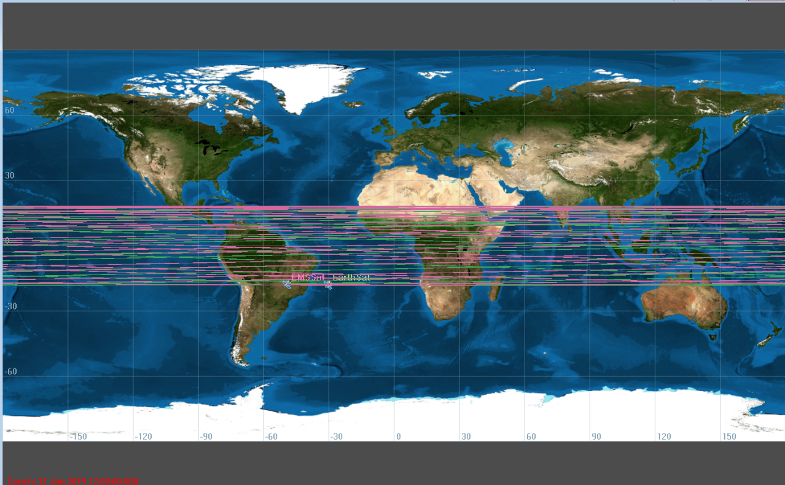

b)

|  |  |  |  |  |  |  |
| --- | --- | --- | --- | --- | --- | --- |
| EO SMA | EO Ecc. | EO Inc. | EO RAAN | EO AOP | EO Period | EO RadApo |
| 2.6e5 | 0.23 | 18.25 | 0 | 300 | 1.319e6 | 3.198e5 |
| EMS SMA | EMS Ecc. | EMS Inc. | EMS RAAN | EMS AOP | EMS Period | EMS RadApo |
| 2.747e5 | 0.1925 | 18.1 | 1.035 | 294.8 | 1.432e6 | 3.275e5 |

c)

When the Moon and the Sun are included in the system they alter the orbit of the satellite and slowly decrease the eccentricity.

2)

a)

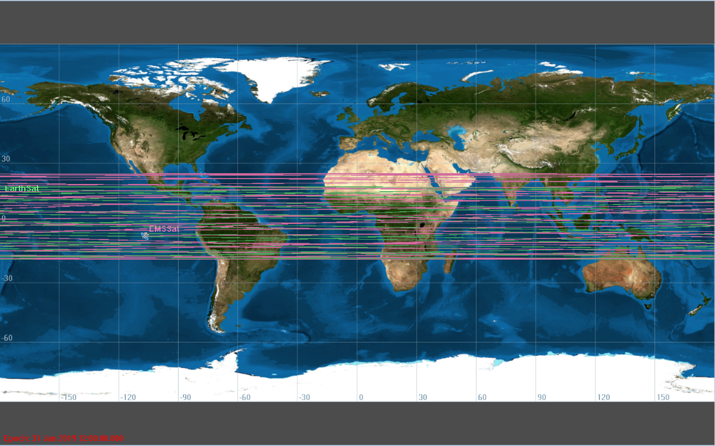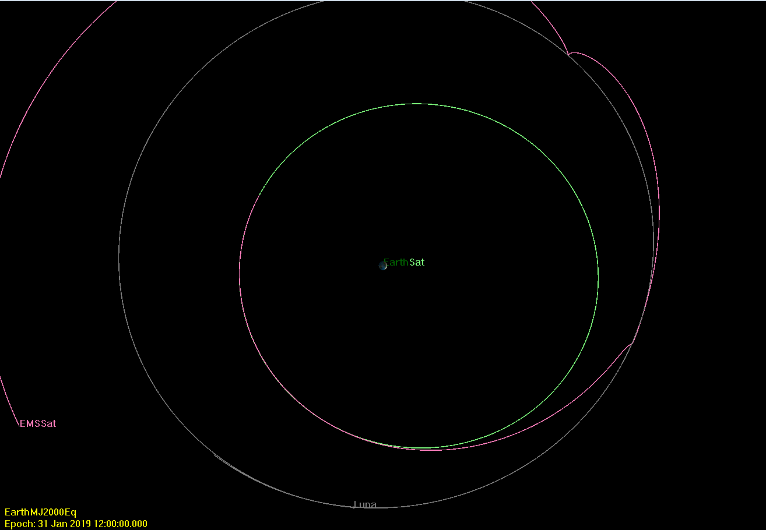

b)

|  |  |  |  |  |  |  |
| --- | --- | --- | --- | --- | --- | --- |
| EO SMA | EO Ecc. | EO Inc. | EO RAAN | EO AOP | EO Period | EO RadApo |
| 2.6e5 | 0.23 | 18.25 | 0 | 150 | 1.319e6 | 3.198e5 |
| EMS SMA | EMS Ecc. | EMS Inc. | EMS RAAN | EMS AOP | EMS Period | EMS RadApo |
| 5.784e5 | 0.1948 | 25.1 | 9.505 | 85.39 | 4.378e6 | 6.911e5 |

c)

Changing ω from 300 to 150 causes the satellite’s orbit to pass close enough to the moon to be captured and enter a collision orbit with the moon. It is essentially the rotation of the orbit around the orbiting body. Changing it rotates the orbit directly into a collision course with he moon.

d)

I would not approve this mission for a moon fly-by due to the fact that the mission causes the satellite to collide with the moon. It does not fly-by successfully.

3)