I did create a dashboard on tableau with four worksheets.

1. For worksheet 1 I used tree map. Two variables are introduced: Day of week and Merch Rev. From this, we can find that the sales of goods are mainly concentrated on Friday, Saturday and Sunday.

2. Worksheet 2 I used a bubble chart. The two variables are Daytype and Average of Duration. We can clearly see that with relatively mild weather such as pretty sunny, overcast, cloudy and pretty cloudy, people stay longer in the park.

3. Worksheet 3 I used a line chart, the two variables are Date and Unique Visitors. We can clearly see that the beginning of the month and the end of the month are the peak times for playing.

4. For worksheet 4 I used stacked bars, the variables are Day of week and various revenue. In order to clearly see the proportion of various incomes in the park, I have introduced multiple dimensions. daily gross rev, lobsterman revenue, Merch Rev, Snack Shack Rev, Gold Zone Rev. We can see that grocery is also the main direction of people's consumption. Friday, Saturday and Sunday are the times of the week when people spend the most money.

1.

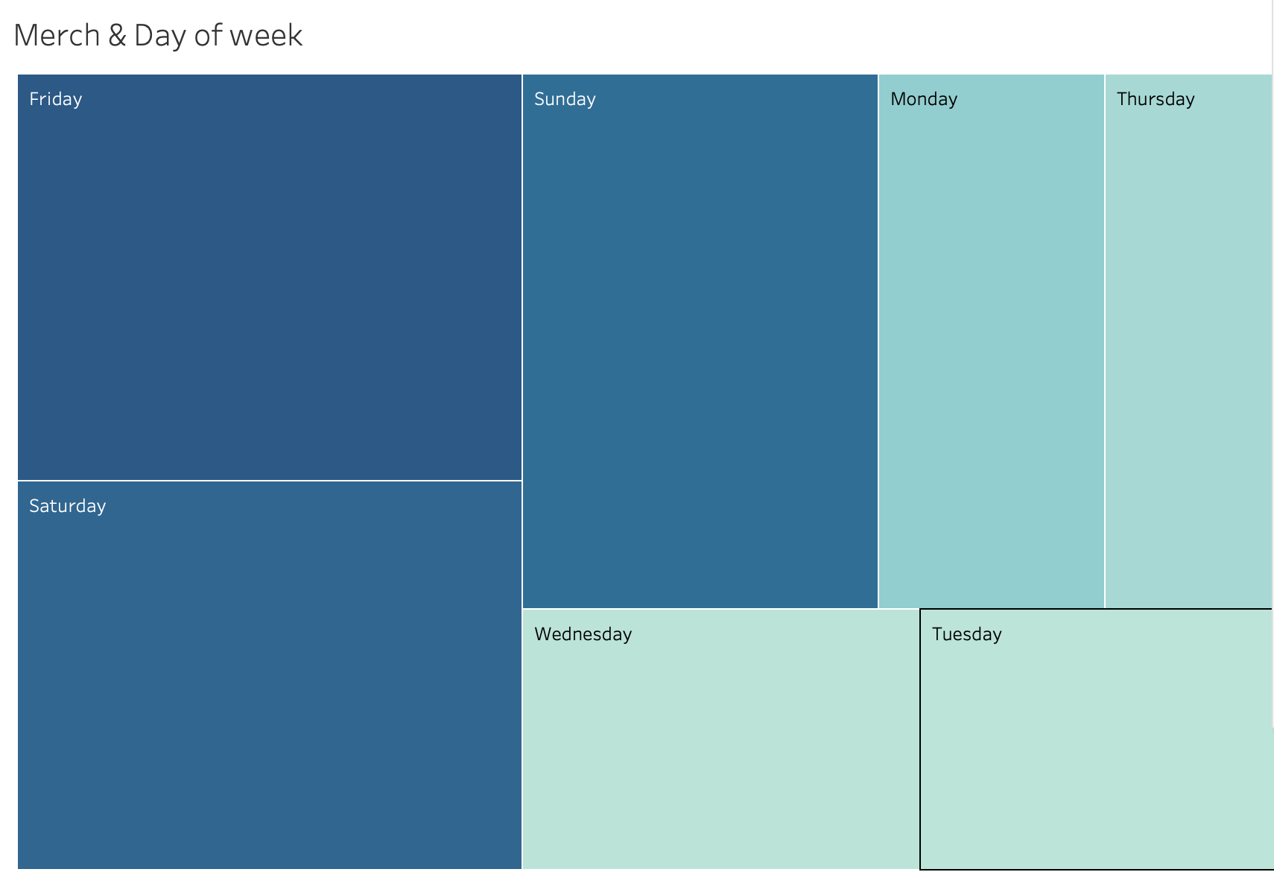

2.

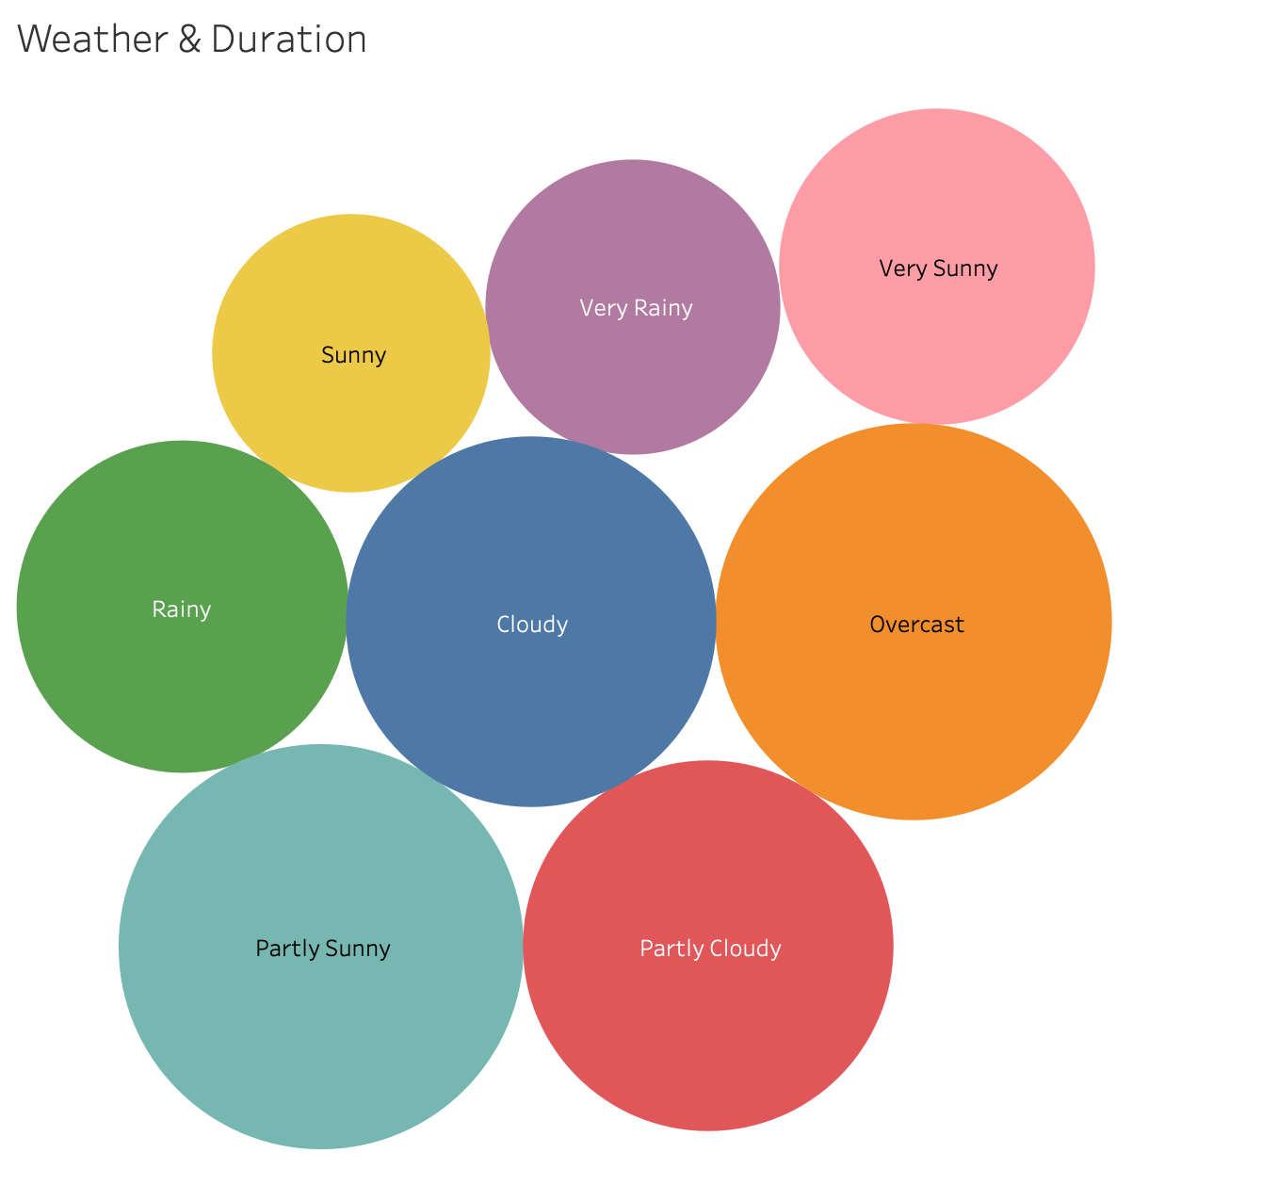

3.

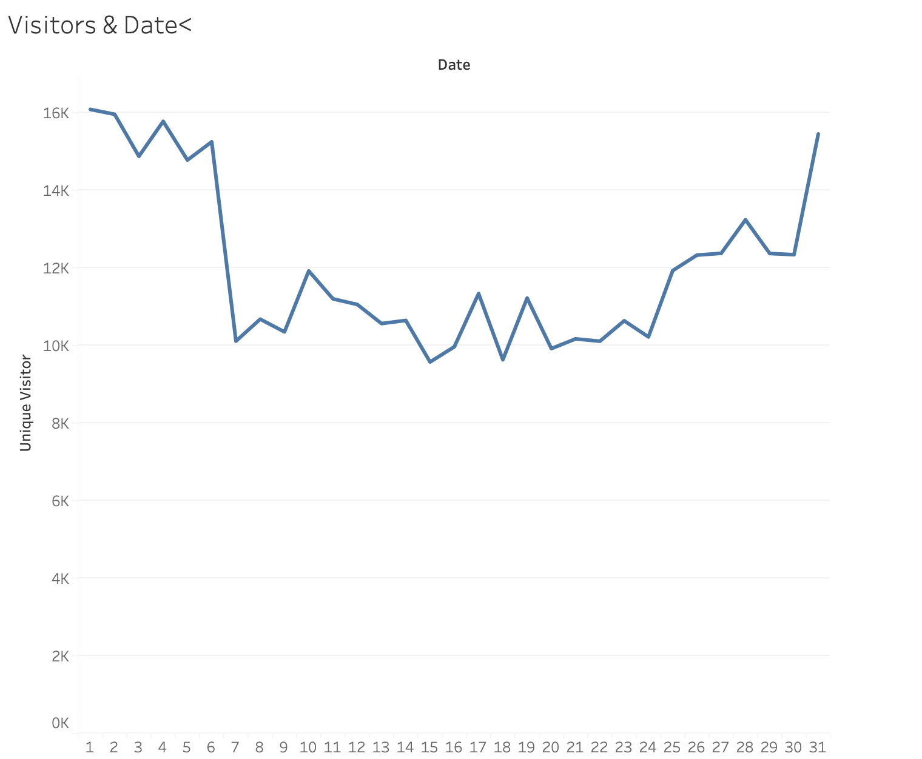

4.

