Projection Profile as used by the authors of "Optical Recognition of
Psaltic Byzantine Chant Notation" [1]

The basic idea is to put a line at a certain degree over the image and count the appearances of black pixels, which lie on that line. Repeat that step for all image-lines in the image and sum up the intermediate results. The actual score for is calculated by summing up the squared absolute differences between neighbouring scan-lines. The greater the result, the better does the angle align with the documents baseline. This approach was described by Postl [2] and offers a useful way to evaluate an angle upon the it's similarity to the baseline skew. In order to overcome the brute-force search within possible angle space the authors in [1] proposed to use a two step approach.

During the first step the document is evaluated with the described method using control samples at a coarse angle resolution. E.g.: in the region of 345 and 15 degree. Evaluate every whole number.
The maximum from earlier selected samples offers the perfect starting point for phase two of the method, where said local maximum and two additional points (depending on the search- window size) offer the base for a golden section search for the actual maximum in the defined search- window. The search converges quite quick and offers usable results.

Our implementation of the described approach yields some interesting results, however it does lack speed. This might be result of the chosen development environment (MATLAB) itself or missing code optimization. Depending on the underlying hardware angle- estimation for one image can take between 7.2 and 18 seconds.

Results:

Data Set | AED | TOP80 | CE
Sample Set | 0.072850 | 0.032883 | 79.292929 %
Benchmark Set | 0.123635 | 0.048251 | 63.677419 %

Figures:

Abbildung 1: projected profile for -ground truth (-14.85 degree)
projected profile for ground truth (-14.85 degree)
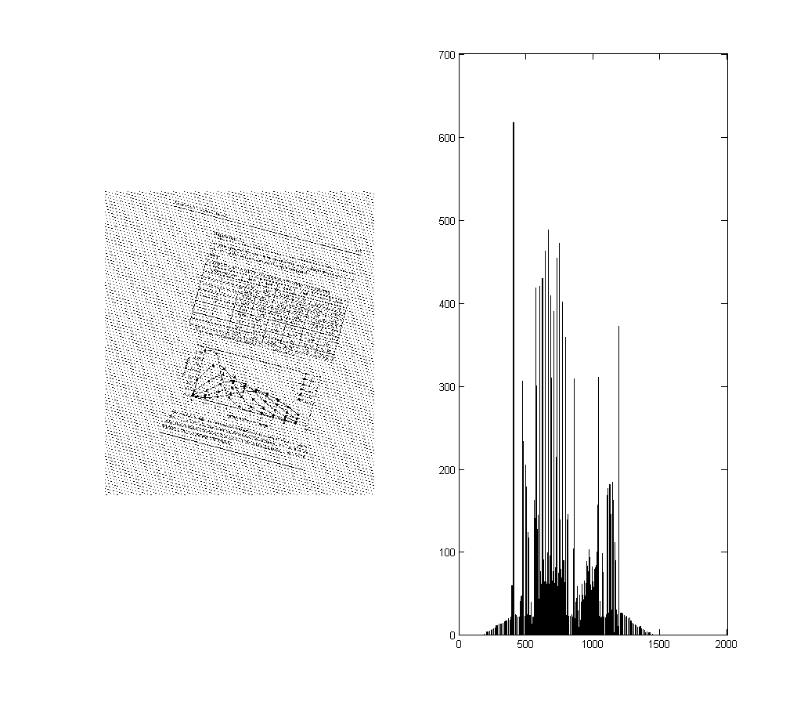

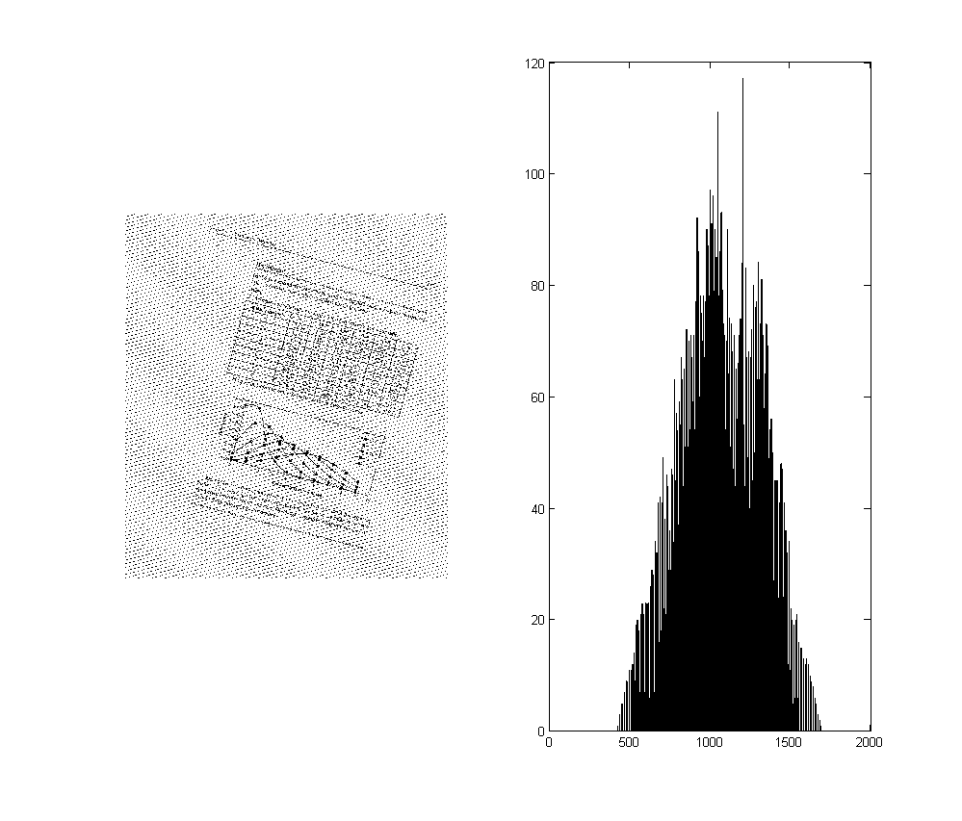projected profile for +15 degree
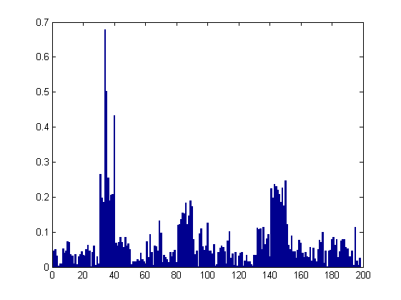Error for Sample Dataset
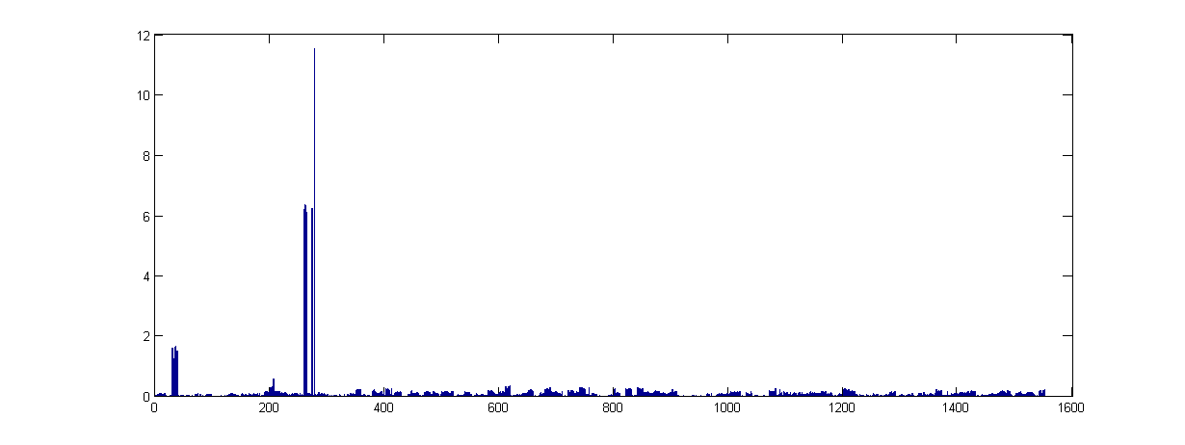Error for Benchmark Dataset
References:

[1] C. Dalitz, G. K. Michalakis and C. Pranzas, "Optical Recognition of Psaltic Byzantine Chant Notation", International Journal of Document Analysis and Recognition 11, pp. 143-158, 2008.

[2] W. Postl, "Detection of linear oblique structures and skew scan in digitized documents", Proc. 8th International Conference on Pattern Recognition, pp. 687-689, 1986

