# Take QREX data

## A. Log into the Pi

1. Log onto Raspberry Pi’s Wifi network “quad-wifi”

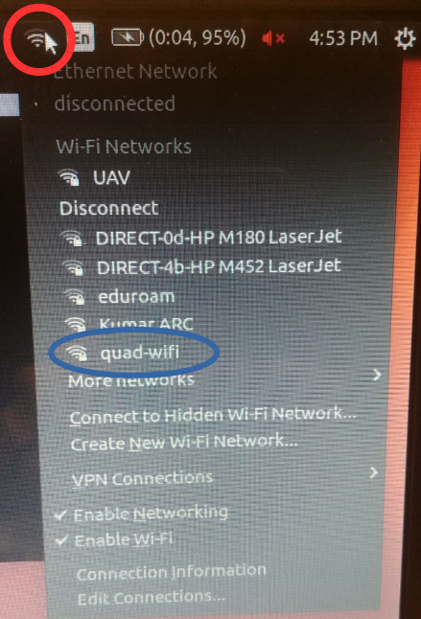

1. Using Ctl+Alt+t, Open two terminals on laptop [T1],[T2]
2. [T1] ssh quad@10.42.0.1
   1. [T1] quad@10.42.0.1’s password: raspberry
   2. [T1] prompt should now be: quad@quad-desktop:~$

4. [T2] ssh quad@10.42.0.1

* 1. [T2] quad@10.42.0.1’s password: raspberry
  2. [T2] prompt should now be: quad@quad-desktop:~$

## B. Launch data acquisition node

1. [T1] roslaunch trims MavProp.launch

Give it ~20 seconds, make sure no fatal red errors print, sometimes yellow warnings print, that’s okay. If you see other red errors or aren’t sure the node is launched type ctl+C, go back to step B.1

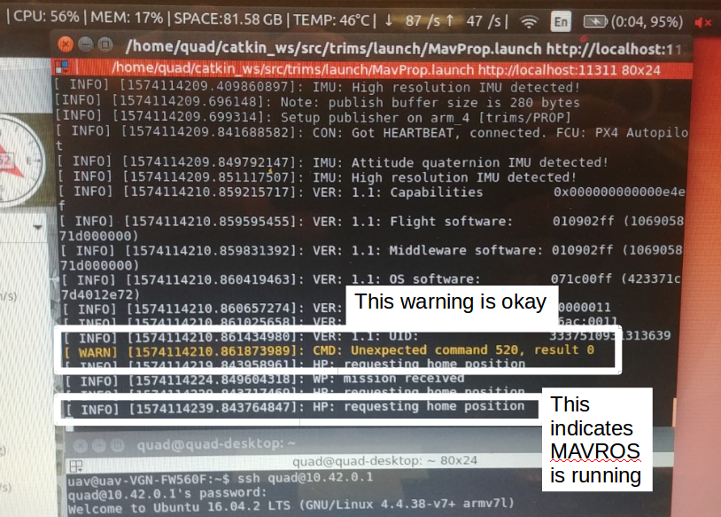

## C. Check that data is being streamed

1. [T2] rostopic echo /arm_4

If it says no topics are being published go back to [T1] and type ctrl+C, now go back to step B.1

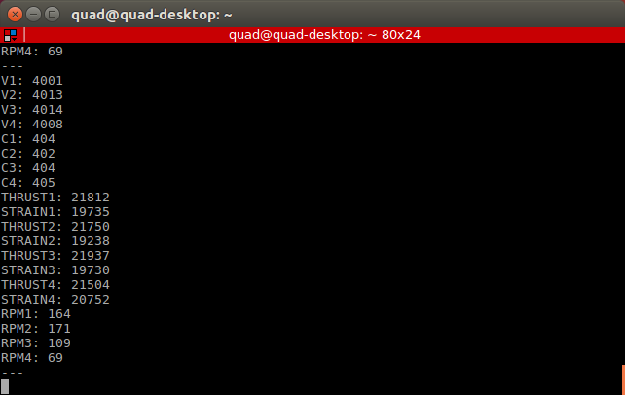

## D. Start logging

1. [T2] cd /bag_files
2. [T2] mkdir <MyBagFolder>
3. [T2] cd MyBagFolder
4. [T2] rosbag record -aO <test_1>

You’re bagging data now...

## E. Run test, take data, stop bagging

1. Fly Maneuvers…
2. When done land, wait about 30 seconds

Properly stop the ROS-bagging in a terminal

1. [T2] ctl+C

## F. Copy bag file from Pi to the laptop

Check to see you have a reasonably sized bag file. 101MB (100M) ~ 10 mins of flight

1. [T2] ls -lh
2. [T2] cd ..
3. [T2] sudo scp -r <MyBagFolder> uav@10.42.0.210:~/bag_files
   1. [T2] quad@10.42.0.1’s password: raspberry
   2. [T2] uav@10.42.0.210’s password: gregory

This could take about 1-10 mins depending on the size

## G. Power off Data logging

When bag file is copied to laptop you can simply pull aircraft’s battery power