Summary of the Process: Simple Calculator Program.

Introduction

I did this project to design, implement and test a simple calculator in Python. The calculator supports simple arithmetic operations, such as addition, subtraction, multiplication and division, and allows the user to use the calculator to perform multiple calculations as many times as they want to, or to exit the calculator anytime they want.

It was divided into four sections: I drew a flow diagram to depict the logic, wrote pseudocode to define the steps, translated the program into Python, and tested the unit tests to ensure that all works, including such cases as a division by a zero value.

Flowchart Design

I used a flowchart to visualize the flow of the program before the coding process. It assisted me in ensuring every potential user engagement was taken into consideration.

The primary process of the flow chart is:

– Start program.
– Display a list of functions: add, subtract, multiply, divide and exit.
– Ask user to pick an operation.
– Prompt for two numbers.
– Carry out the selected operation.
– Show result.
– Question whether they wish to do another calculation or not.
go back to the menu yes or no.

I also included additional logic to divide by 0: in case the user selects division and the second number is 0, the program will give an error and request the user to input again.

The flow chart depicted below indicates that the process alteration and its implementation will be complicated due to the necessity of information sharing among the various divisions within the organization.<|human|>As the flow chart shown below shows, the information sharing between the different divisions that make up an organization will complicate the process change and its implementation.

Pseudocode of the Calculator.

The pseudocode that helped me in implementation is explained below. It presents all the steps in an organized manner, input, process, output.

START
WHILE True:
DISPLAY “Select operation:”
DISPLAY “1. Addition”
DISPLAY “2. Subtraction”
DISPLAY “3. Multiplication”
DISPLAY “4. Division”
DISPLAY “5. Exit”

GET userchoice

IF userchoice == 5:
BREAK

GET firstnumber
GET secondnumber

IF userchoice == 1:
result = firstnumber + secondnumber.
ELSE IF userchoice == 2:
result=firstnumber secondnumber.
ELSE IF userchoice == 3:
result=firstnumber x secondnumber.
ELSE IF userchoice == 4:
IF secondnumber == 0:
DISPLAY Error: cannot divide by zero
CONTINUE
ELSE:
firstnumber/ secondnumber = result.
ELSE:
DISPLAY “Invalid choice”
CONTINUE

DISPLAY “Result: ”, result
END WHILE
DISPLAY “Goodbye!”
END

Python Implementation

I developed the program on a file known as calculator.py. It has individual functions of each operation and a primary loop which deals with user interaction. Error handling was also added to prevent the program to crash when the input is bad or the division by zero.

Key parts of the code:

def add(a, b):
return a + b

def subtract(a, b):
return a - b

def multiply(a, b):
return a * b

def divide(a, b):
if b == 0:
Error: Cannot divide by zero return
return a / b

The key loop prompts the user to select an operation, accepts the numbers, calls the right function and displays the result.

Unit Testing

I tested it with the help of the unittest module of Python. Every arithmetic operation was tested using several cases, such as edge cases, such as division by zero.

Test scenarios:

– Adding of positives, negatives and zero.
– Addition and subtraction of negatives, positives, and zero.
As multiplication, and multiplication by the zero.
– Division, normal division and zero division.
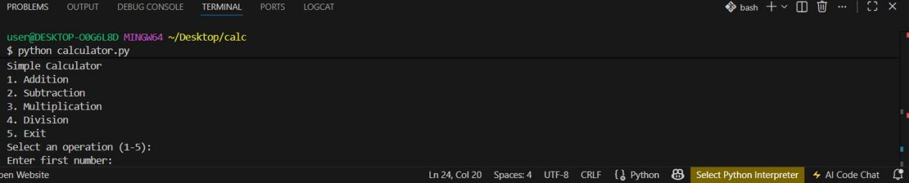

Example test code:

import unittest
import calculator add, subtract, multiply, and divide.

class TestCalculator(unittest.TestCase):

def testadd(self):
self.assertEqual(add(5, 3), 8)
self.assertEqual(add(-2, 2), 0)

def test_divide(self):
self.assertEqual(divide(10, 2), 5)
self.equal(divide (5, 0), “Error: Divisor = 0 should not be divided by 0)

if __name__ == 'main':
unittest.main()

(Include console output of tests and sample calculations that were run)

All tests were passed, as it is proven that the calculator works properly both in the normal and edge cases.

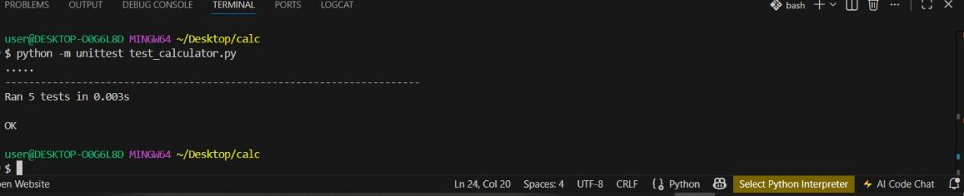

Conclusion

In this project, the way of how to design, code and test a simple calculator is demonstrated. I ensured that the program is dependable, easy to use and resistant to bugs by creating the flowchart, writing pseudocode, coding in Python and executing unit tests. The experience has also enhanced my logical thinking, debugging abilities as well as my capability of adhering to a procedural development of software.

