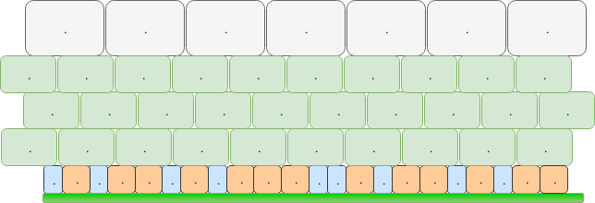

Layer of stem and basal cells

Layers of intermediate cells

Basal membrane

Layer of umbrella cells