**Software Requirements and Design Document**

**For**

**Group <13>**

Version 2.0

**Authors**:

Taj Ali

Harege Abay

Tobechukwu Osakwe

Vinson Thomas

# Overview

We are developing a web platform for fellow game gurus to come together and talk about their passions in a homely environment. Our project is an online platform where anyone can write a review of a video game. After reviews have been written, users can comment on reviews, gain reputation/karma points, or search for other reviews. Users can also manage their public profile, setting a profile picture, biographical information, and a link to a personal website or social media. People can vote at most once on a given review.

Users can even create and join communities centered around special topics of their choice. Though the reviews will come out later than proprietary counterparts, they are more likely to be genuine and thorough.

# Functional Requirements

1. *The base website will run and be seen on a web browser.* *(High Priority)*
2. *The system will be able to register user to the website. (High Priority)*
3. *The system will be able to add a user’s bio and profile picture. (medium Priority)*
4. *The system will be able to give the user the ability to review a video game by entering text and giving the game a rating. (High Priority)*
5. *The system will allow the user to post video reviews. (low Priority)*
6. *The system will allow the user to comment on other user’s reviews. (medium priority)*
7. *The system will allow the user to post video game playthrough (Guides to play through certain areas of a game) that will include text. (High Priority)*
8. *The system will allow for the user to post video playthroughs. (low Priority)*
9. *The system will have a web page displaying the games that are coming soon, which will include a release date and a brief description of what that game entails. (High Priority)*

# Non-functional Requirements

*List the* ***non-functional requirements*** *of the system (any requirement referring to a property of the system, such as security, safety, software quality, performance, reliability, etc.) You may provide a brief rationale for any requirement which you feel requires explanation as to how and/or why the requirement was derived.*

1. Users must login before able to review games.
2. Users will be forced to pass reCAPTCHA verification and create account with reasonably strong password.
3. Users never allowed to review more than once on one game.

# Use Case Diagram

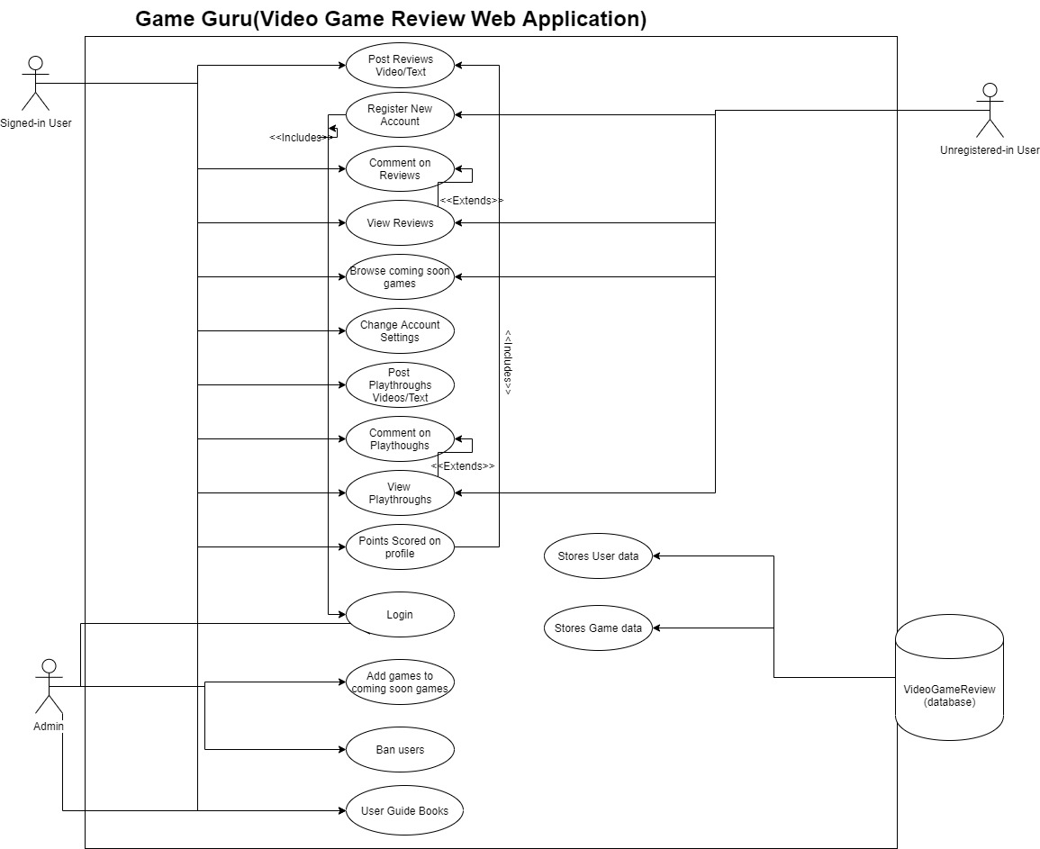

*UML Textual Descriptions*

*UML Use Case Textual Description #1*

1. *Unique Name*

* *Post Reviews Video/Text*

1. *Participating Actors*

* *Signed-in User*

1. *Entry Conditions*

* *Have internet*
* *Be on the Game guru’s website*
* *Be logged into website*
* *Be on create review page*
* *Have a game to review*

1. *Exit Conditions*

* *Uploaded video/text review on page*
* *Rated the game to be reviewed*
* *Submitted to finish review*

1. *Flow of Events*

* *User logs in to website*
* *User finds a game*
* *User goes to create review page*
* *User gives text or video review*
* *User rates game with a star-based rating*
* *User submits review*
* *Information is stored in database*

1. *Special Requirements*

* *None*

*UML Use Case Textual Description #2*

1. *Unique Name*

* *Register New Account*

1. *Participating Actors*

* *Unregistered User*

1. *Entry Conditions*

* *Have internet*
* *Have a working email*
* *Be on the Game guru’s website*

1. *Exit Conditions*

* *Registered information*
* *Can log in to website*

1. *Flow of Events*

* *Unregistered user gets on the internet*
* *User gets on the Game Guru’s website*
* *User goes to sign up page of website*
* *User enters email*
* *User enters a username*
* *User enters a password*
* *User submits information*
* *User information is stored within database*
* *User can now sign in an edit profile*

1. *Special Requirements*

* *none*

*UML Use Case Textual Description #3*

1. *Unique Name*

* *Comment on reviews*

1. *Participating Actors*

* *Signed-in User*

1. *Entry Conditions*

* *Have internet*
* *Be on the Game guru’s website*
* *Be logged into website*
* *Be viewing or have viewed a game review*

1. *Exit Conditions*

* *User makes a comment in text about review*
* *User submitting comment*

1. *Flow of Events*

* *User logs in to website*
* *User finds a game*
* *User looks through reviews on that game*
* *User finds a review and reads it*
* *User gives a comment on the review*
* *User submits comments*

1. *Special Requirements*

* *none*

*UML Use Case Textual Description #4*

1. *Unique Name*

* *View Reviews*

1. *Participating Actors*

* *Signed-in User, unregistered user*

1. *Entry Conditions*

* *Have internet*
* *Be on the Game guru’s website*
* *Have a game review to look at*

1. *Exit Conditions*

* *Unregistered or signed in user viewed a specific review*

1. *Flow of Events*

* *User goes on the Game Guru’s website*
* *User finds a game*
* *User sees reviews for game*
* *User finds a specific review and views it*
* *User finishes and does something else*

1. *Special Requirements*

* *none*

*UML Use Case Textual Description #5*

1. *Unique Name*

* *Browse coming soon games*

1. *Participating Actors*

* *Signed-in User, unregistered user*

1. *Entry Conditions*

* *Have internet*
* *Be on the Game guru’s website*

1. *Exit Conditions*

* *User have looked through the coming soon games that they have wanted to see*

1. *Flow of Events*

* *User goes on the Game Guru’s website*
* *User goes the game webpage*
* *User searches through games and checks through the games that have date beyond the current date*
* *User finishes on does something else*

1. *Special Requirements*

* *none*

*UML Use Case Textual Description #6*

1. *Unique Name*

* *Change Account Settings*

1. *Participating Actors*

* *Signed-in User*

1. *Entry Conditions*

* *Have internet*
* *Be on the Game guru’s website*
* *Be logged into website*
* *Be on profile page*

1. *Exit Conditions*

* *Updated user settings on their personal profile*

1. *Flow of Events*

* *User logs into website*
* *User goes to profile webpage*
* *User makes changes to profile bio and other settings*
* *User submits changes*
* *Database saves those changes*

1. *Special Requirements*

* *None*

*UML Use Case Textual Description #7*

1. *Unique Name*

* *Post Playthroughs Videos/Text*

1. *Participating Actors*

* *Signed-in User*

1. *Entry Conditions*

* *Have internet*
* *Be on the Game guru’s website*
* *Be logged into website*
* *Found a game and on the games page*

1. *Exit Conditions*

* *Posted and submitted a video and text description of playthrough*

1. *Flow of Events*

* *User logs into website*
* *User looks for a game*
* *User use the post a playthrough button*
* *User types the playthrough title*
* *User types in the playthrough description*
* *User types in name of the video*
* *User uploads their video*
* *User submits their playthrough*

1. *Special Requirements*

* *none*

*UML Use Case Textual Description #8*

1. *Unique Name*

* *View Playthrough*

1. *Participating Actors*

* *Signed-in User, unregistered user*

1. *Entry Conditions*

* *Have internet*
* *Be on the Game guru’s website*
* *Have a game playthrough to look at*

1. *Exit Conditions*

* *Unregistered or signed in user viewed a specific review*

1. *Flow of Events*

* *User goes on the Game Guru’s website*
* *User finds a game*
* *User sees the playthroughs for game*
* *User finds a specific playthrough and reads the description and watches a video*
* *User finishes and does something else*

1. *Special Requirements*

* *none*

*UML Use Case Textual Description #9*

1. *Unique Name*

* *Points scored on profile*

1. *Participating Actors*

* *Signed-in User*

1. *Entry Conditions*

* *Have internet*
* *Be on the Game guru’s website*
* *Make a game to review or game to make a playthrough on*

1. *Exit Conditions*

* *User makes a Review or posts a playthrough*

1. *Flow of Events*

* *User goes on the Game Guru’s website*
* *User finds a game*
* *User decides to make a review or post a playthrough*
* *User receives points on their profile for the action that they have made*

1. *Special Requirements*

* *none*

*UML Use Case Textual Description #10*

1. *Unique Name*

* *Login*

1. *Participating Actors*

* *Signed-in User, Admin*

1. *Entry Conditions*

* *Have internet*
* *Be on the Game guru’s website*
* *Have a valid username and password*

1. *Exit Conditions*

* *User is successfully signed into the website*

1. *Flow of Events*

* *User goes on the Game Guru’s website*
* *User goes to log in page*
* *User types in username*
* *User types in password*
* *User gets verified by the re captcha*
* *User is signed in*

1. *Special Requirements*

* *none*

*UML Use Case Textual Description #11*

1. *Unique Name*

* *Add games to coming soon games*

1. *Participating Actors*

* *Admin*

1. *Entry Conditions*

* *Have internet*
* *Be on the Game guru’s website*
* *Have a valid username and password*
* *Have admin privileges*

1. *Exit Conditions*

* *Admin successfully adds a game to coming soon games*

1. *Flow of Events*

* *User goes on the Game Guru’s website*
* *User goes to admin log in page*
* *User types in username*
* *User types in password*
* *User is logged in*
* *User adds a game*
* *User enters a picture of the game*
* *Add the game’s name*
* *Adds a description of the game*
* *Adds the games date of release that is in the future of the current date*
* *Submits information*

1. *Special Requirements*

* *none*

*UML Use Case Textual Description #12*

1. *Unique Name*

* *Ban users*

1. *Participating Actors*

* *Admin*

1. *Entry Conditions*

* *Have internet*
* *Be on the Game guru’s website*
* *Have a valid username and password and admin privileges*

1. *Exit Conditions*

* *Banned a user due to their activity*

1. *Flow of Events*

* *admin goes on the Game Guru’s website*
* *admin goes to admin log in page*
* *admin types in username*
* *admin types in password*
* *admin is logged in*
* *admin views current users*
* *admin view some of their activities including uploaded videos and reviews and comments*
* *if content is found to be unsavory the user will be taken off as an authorized user of the website*

1. *Special Requirements*

* *None*

*UML Use Case Textual Description #12*

1. *Unique Name*

* *User Guide Books*

1. *Participating Actors*

* *Admin*
* *Registered User*

1. *Entry Conditions*

* *Have internet*
* *Be on the Game guru’s website*
* *Have a valid username and password and admin privileges*

1. *Exit Conditions*

* *Uploaded a pdf guidebook*

1. *Flow of Events*

* *user goes on the Game Guru’s website*
* *user logs in*
* *user types in username*
* *user types in password*
* *user is logged in*
* *user goes to guide books web page*
* *user enter the guide book title*
* *user uploads a pdf*

1. *Special Requirements*

# Class Diagrams and/or Sequence Diagrams

*This section presents a high-level overview of the anticipated system architecture using a* ***class******diagram*** *and/or* ***sequence diagrams****.*

*If the main* ***paradigm*** *used in your project is* ***Object Oriented*** *(i.e., you have classes or something that acts similar to classes in your system), then draw the* ***Class Diagram******of the entire system and Sequence Diagrams for the three (3) most important use cases in your system.***

*If the main* ***paradigm*** *in your system is* ***not Object Oriented*** *(i.e., you* ***do not*** *have classes**or anything similar to classes in your system) then only draw* ***Sequence Diagrams****,* ***but for all the use cases of your system.*** *In this case, we will use a modified version of Sequence Diagrams, where instead of objects, the lifelines will represent the functions in the system involved in the action sequence.*

***Class Diagrams*** *show the* ***fundamental objects/classes*** *that must be modeled with the system to satisfy its requirements and* ***the relationships*** *between them. Each class rectangle on the diagram* ***must also include the attributes and the methods of the class*** *(they can be refined between increments). All the* ***relationships between classes and their multiplicity*** *must be shown on the class diagram.*

*A* ***Sequence Diagram*** *simply depicts* ***interaction******between objects*** *(or* ***functions -*** *in our case - for non-OOP systems) in a sequential order, i.e. the order in which these interactions take place. Sequence diagrams describe how and in what order the objects in a system function.*

*Class Diagram:*

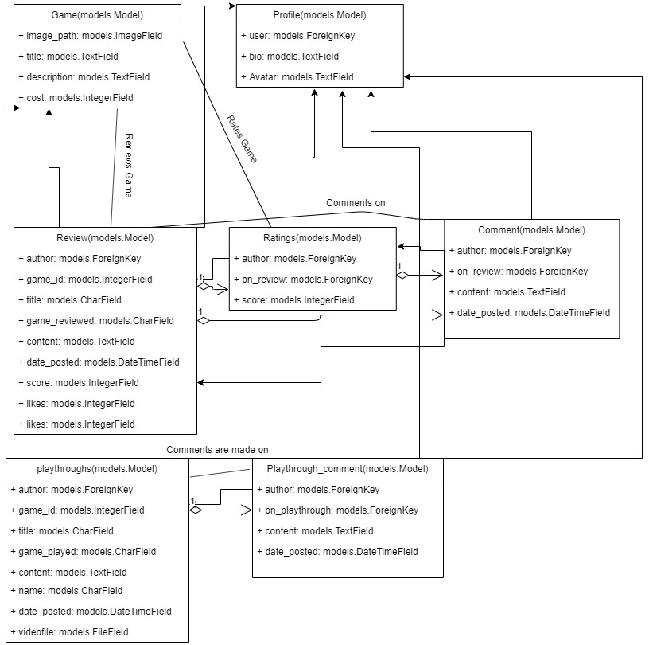

*All classes are used for models in the database.*

*Registering new user use case sequence diagram*

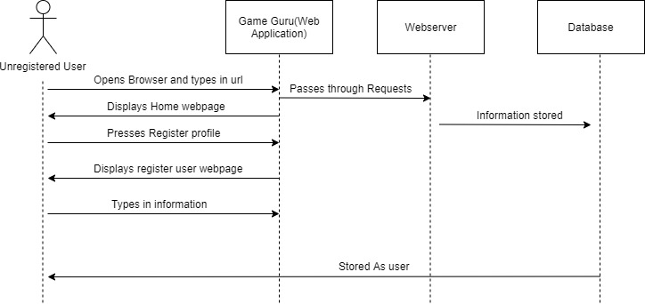

*User Review use case sequence diagram*

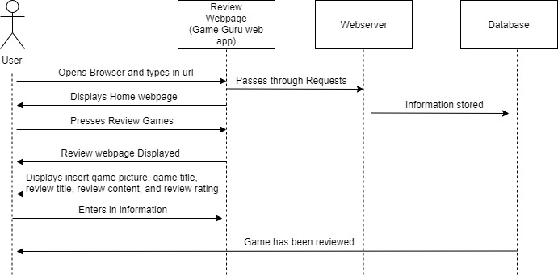

*Playthrough use case Sequence diagram*

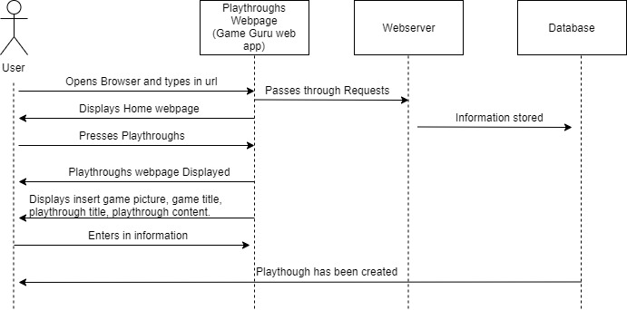

# Operating Environment

*Describe the environment in which the software will operate, including the hardware platform, operating system and versions, and any other software components or applications with which it must peacefully coexist.*

*Software will be pycharm Proffessional and will run in a python environment while also using Django for the web application.*

*Vinson Thomas*

* *Hardware: Windows Laptop running windows 10 Home edition*

*Taj Ali*

* *Hardware: Windows Laptop running windows 10*

*Tobechukwu Osakwe*

* *Hardware: Mac OS Laptop*

*Harege Abay*

* *Hardware: Ubuntu Laptop*

# Assumptions and Dependencies

*We as a group assume that the user has internet and a web browser.*

*We depend on python, Django, Pillow, J-query, and sqlite.*