**REAL ESTATE MANAGEMENT SYSTEM**

BATCH D

Group:

|  |  |
| --- | --- |
| NAME | UID |
| MANAS SINKAR | 2017140057 |
| PARTH THOSANI | 2017140060 |
| JAYDEEP VAGHASIYA | 2017140061 |

**ABSTRACT :-**

The proposed system applies to the normal citizens of the world.

The basic idea is to provide easy access to data of real estate sale and rent and to have direct communication between client and organization.

**DESCRIPTION OF PROBLEM :-**

In real estate world there are various builders who build various buildings in city and they want to sell their flats as they have invested money on project. Due to fierce competition and lack of marketing strategy , they require a lot of time to sell their flats and recover money and profits.

For the normal people, if they want to buy or take a flat on lease they have to visit the site physically which consumes time of customers. Because of this, they cannot explore various option at the same time. If a normal user wants to sell or rent his/her own flat, then they have to invest money for putting an advertisement in newspaper or website. And it doesn’t guarantee adequate response as it involves a lot of efforts and time.

Hence, there is a requirement of database system which keeps track of all the flats and properties in the city. The database will keep information of flats which are listed for rent and for sell. Normal customers and builders can easily upload their description about flats. They can modify the values and update their deal, so the person viewing the deal gets the update information whether the flat is sold or not.

This will not only help the customer in getting more response but also it will be cost efficient.

BENEFITS :-

The major benefit of the system is to eradicate the brokerage/mid-man cost for the clients and seller/leaser. The user can have access to various options at the same time which he/she can view together without actually visiting the site. They can also view

which are the upcoming projects, recent projects by different builders. Also, the user can select the particular area according to his/her preference and filter from various properties and choose the best deal for himself/herself.

**Relational Model:**

NORMAL USER :

|  |  |  |  |  |  |  |
| --- | --- | --- | --- | --- | --- | --- |
| UID | Name | Address | Username | Password | Phone No. | Email ID |

BUILDER :

|  |  |  |  |  |  |  |  |
| --- | --- | --- | --- | --- | --- | --- | --- |
| BID | Licence No. | Name of  Organisation | Address | Username | Password | Phone No. | Email ID |

FLAT :

|  |  |  |  |  |
| --- | --- | --- | --- | --- |
| Address | Location | Area(sq.ft) | Description | Amenities |

SALE :

|  |  |  |
| --- | --- | --- |
| Address | Rate (Cost/sq.ft) | Total Cost |

RENT :

|  |  |  |  |
| --- | --- | --- | --- |
| Address | Rent | Deposit | Time period |

PACKERS AND MOVERS :

|  |  |  |  |  |
| --- | --- | --- | --- | --- |
| PID | Name | Contact | Start Location | End Location |

UPCOMING PROJECTS :

|  |  |  |  |  |
| --- | --- | --- | --- | --- |
| Address | BID | Location | Advanced booking charges | Time |

PAYMENT AND LOAN DETAILS

|  |  |  |  |  |
| --- | --- | --- | --- | --- |
| UID | Payment No. | Bank | Cheque No. | Amount |

**ER Diagram:**

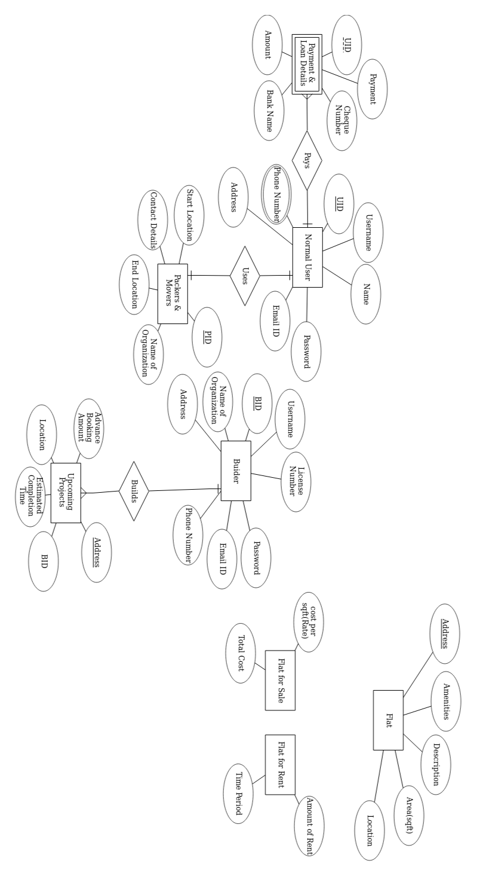

**Schema:**

