An Attention-Based Graph Neural Network for Spam Bot Detection in Social Networks
Malicious users may utilize online Social media to spread fake news or advertisements and this users will employ BOT application to generate fake followings which may allure genuine users to follow them and once they got more followers then they will start spreading fake data. Currently all social media applications utilising Machine Learning or Graph Based algorithms to detect such spammers account. However, with the development of technology, spam bots are becoming more advanced, and identifying bots is still an open challenge. In propose work new semi-supervised graph embedding model based on a graph attention network for spam bot detection in social networks. This approach constructs a detection model by aggregating features and neighbour relationships, and learns a complex method to integrate the different neighbourhood relationships between nodes to operate the directed social graph. The new model can identify spam bots by capturing user features and two different relationships among users in social networks.
Propose GNN (Graph Neural Network) with Attention trained on ‘Twitter Spam Dataset’ and then evaluate its performance in terms of accuracy, precision, recall and FSCORE. Propose GNN Attention algorithm performance is compared with traditional algorithms like Graph-Sage, MLP, Random Forest and many other algorithms. Propose GNN with Attention outperform all existing algorithms.
In propose algorithm all user–retweet sub-graph is generated as a directed graph Gr = (V, Er), wherein each node represents a user in social networks, and each edge represents a retweet relationship in the network. That is, user UI has retweeted user UJ. The user–retweet sub-graph is widely used in social network analysis.
The attention mechanism can allocate more computing resources to the more valuable parts of the representation, that is, certain attributes or instances have higher weights. One of the benefits of attention mechanisms is that they allow the processing of variable-sized inputs, focusing on the most relevant part of the input to make decisions. In simple terms attention will give high weights to features which contains important information and this weight make algorithm in gaining accuracy by predicting maximum records as accurate.
Training all existing algorithms will take more time so we have implemented propose Graph Neural Network with attention and then compare its performance with Random Forest and MLP.
SCREEN SHOTS
We have coded dataset loading, processing, visualization, training and evaluation using JUPYTER notebook and then designed web interface where user can upload test data to predict it as Spam or Genuine account.
Double click on ‘runJupyter.bat’ file to start JUPYTER notebook and then will get below page with code, output and blue colour comments. Run each block to get output
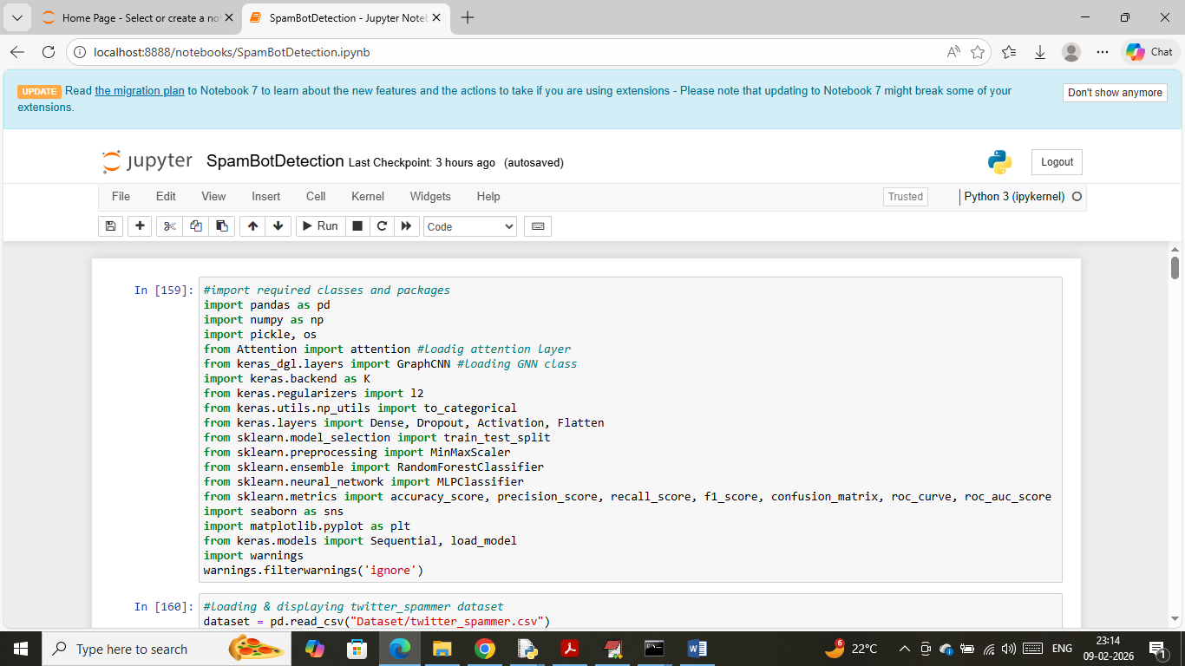
In above screen importing required python classes and packages
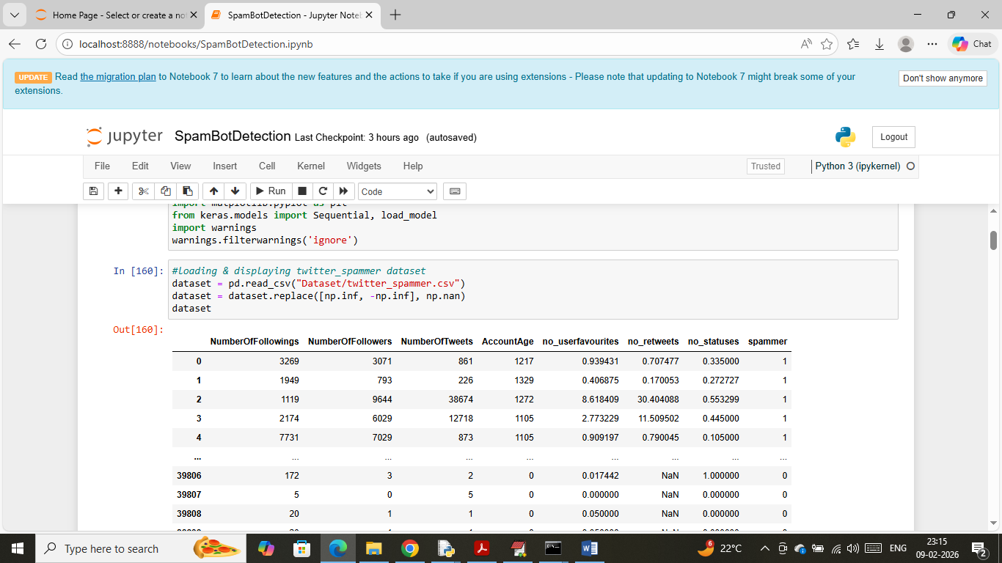
In above screen loading and displaying twitter spam dataset values
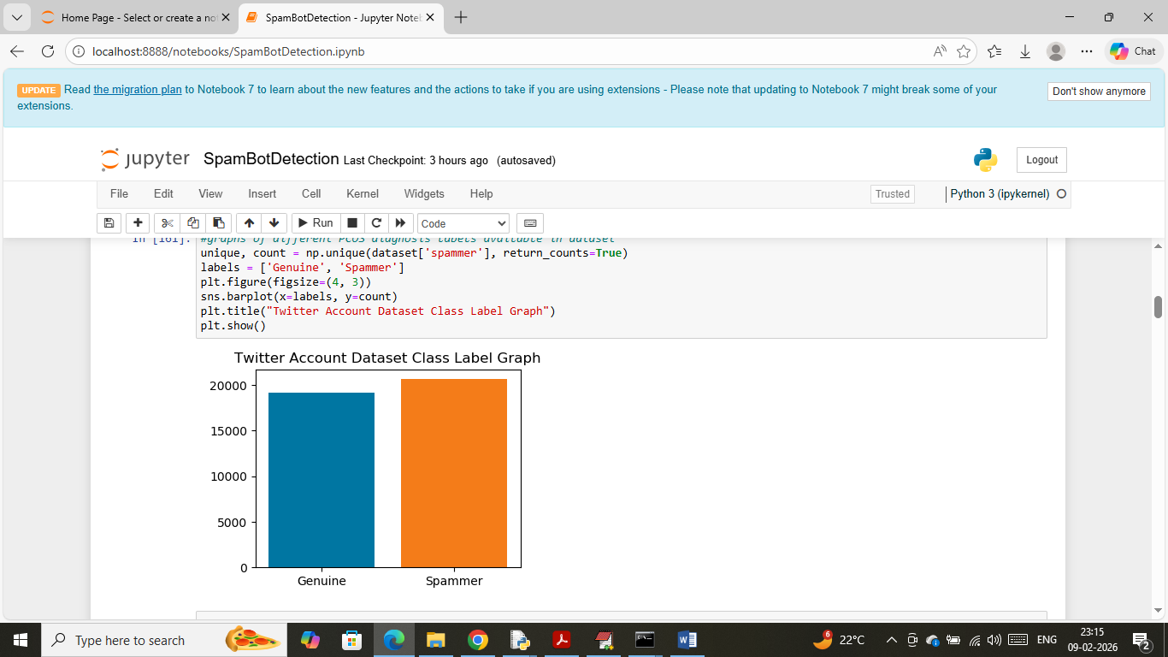
In above screen visualizing graph of Genuine and Spammer accounts available in dataset where x-axis represents account type and y-axis represents counts
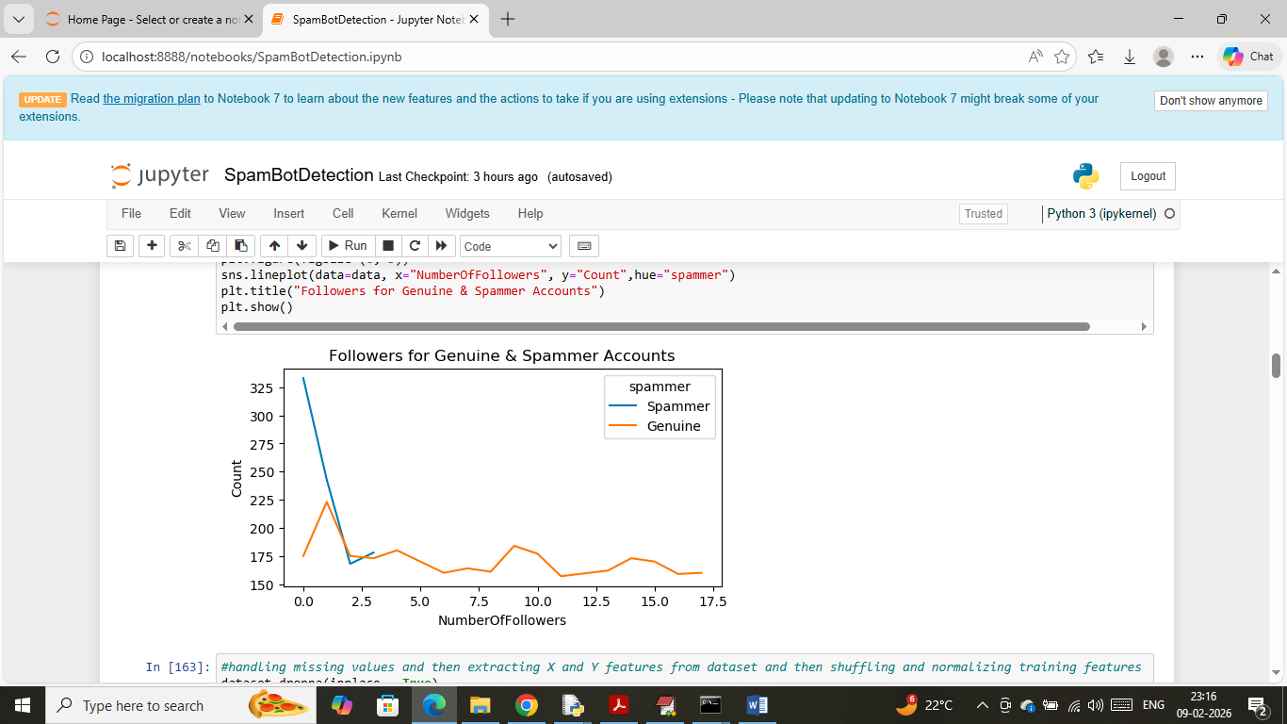
In above screen visualizing graph of followers account for both genuine and spammers account where x-axis represents ‘Total Followers’ and y-axis represents count and then different colour line represents follower counts of spam or genuine accounts. In above graph can see spam account having more followers
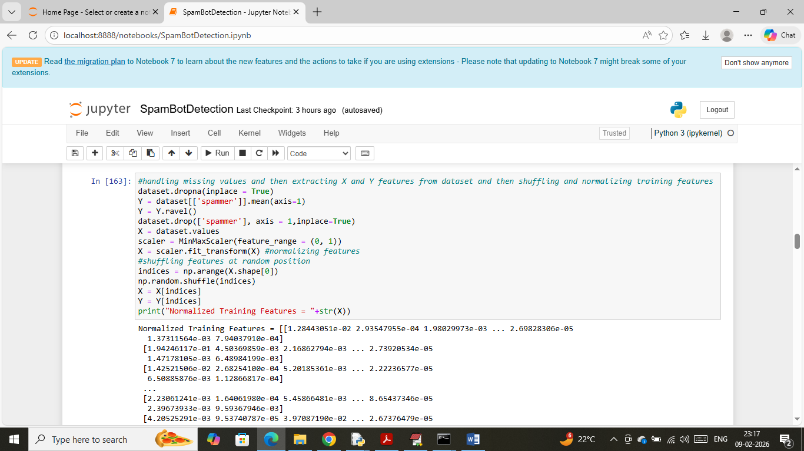
In above screen applying dataset processing techniques such as Extracting X and Y training features, shuffling and normalizing and then displaying normalized dataset values
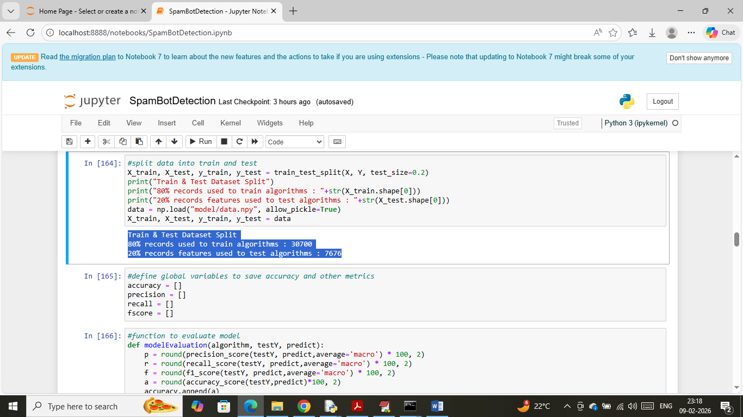
In above screen splitting dataset into train and test where application using 80% data for training and 20% for testing and then in blue text can see train and test data size. In next block defining function to calculate accuracy and other metrics
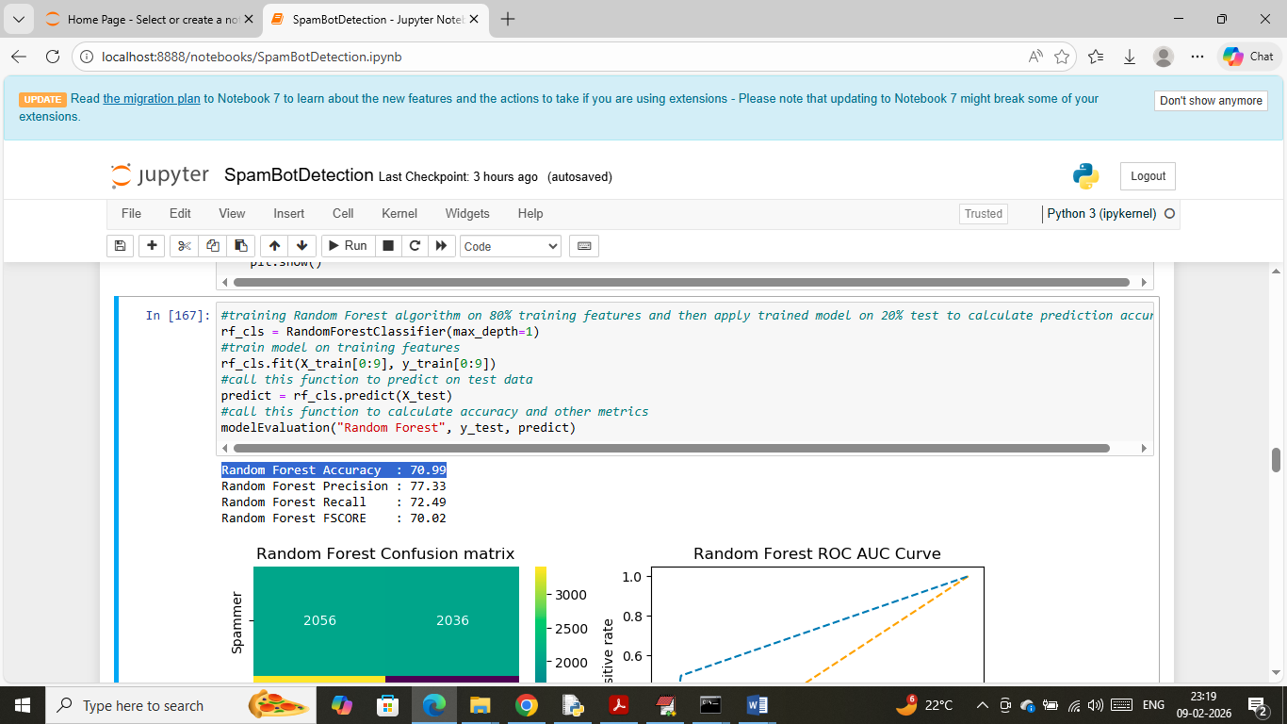
In above screen training Random Forest algorithm on 80% train data and then applying model on 20% test data and then Random Forest got 70% accuracy and can see other metrics also. Below are the prediction graph on test data
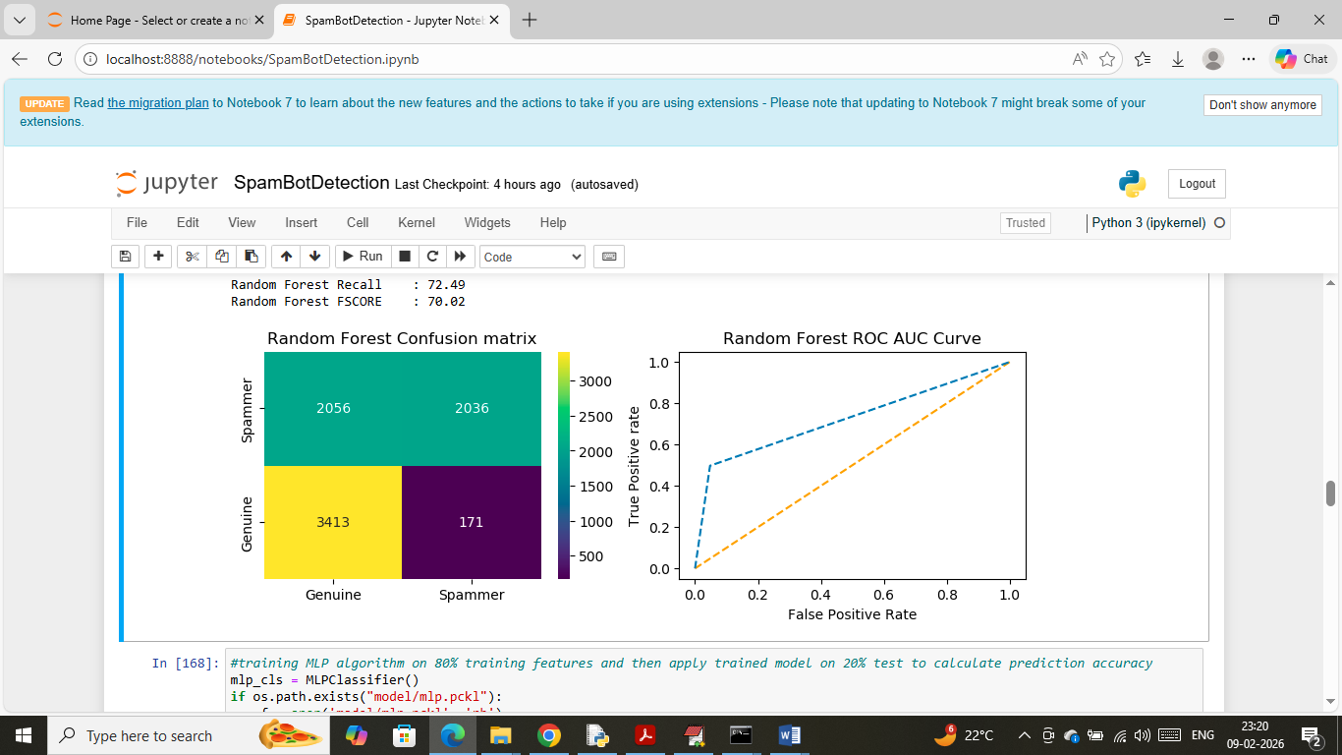
In above Random Forest confusion matrix graph x-axis represents Predicted Labels and y-axis represents True Labels and then yellow and green colour boxes in diagonal represents correct prediction count and blue and green boxes in diagonal represents incorrect prediction count which are very few. In ROC graph x-axis represents False Positive Rate and y-axis represents ‘True Positive Rate’. If blue line comes on top of orange line then all predictions are True else false.
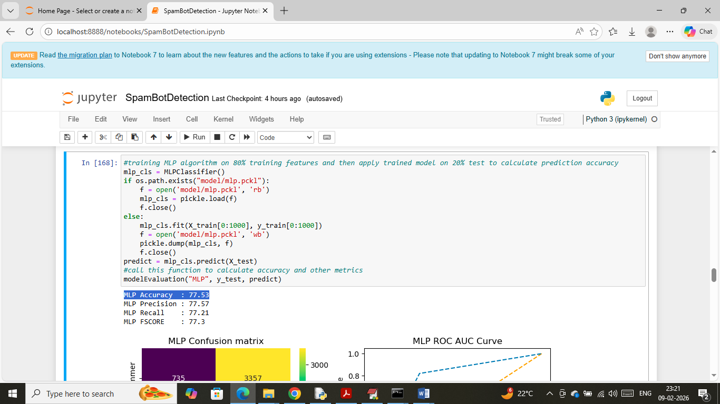
In above screen training MLP algorithm which got 77% accuracy and can see other metrics also
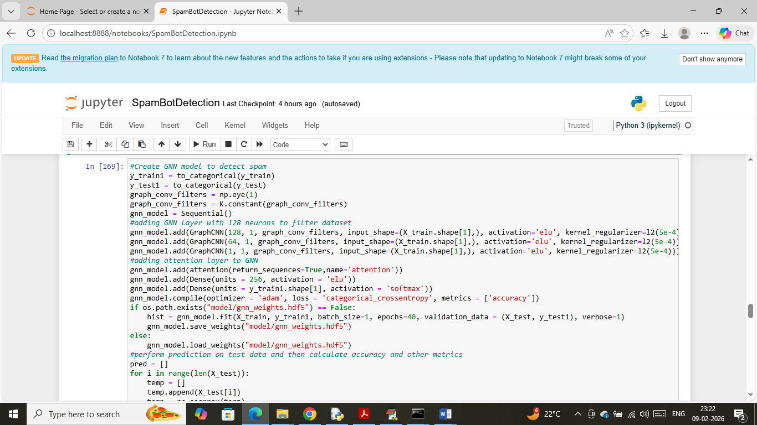
In above screen training GNN algorithm with attention layer and after training will get below output
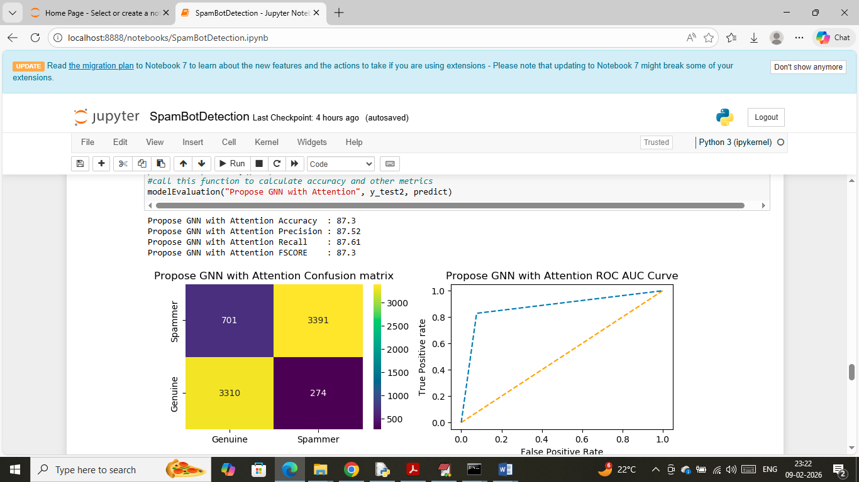
In above screen propose GNN with attention algorithm got 87% accuracy and can see other metrics also
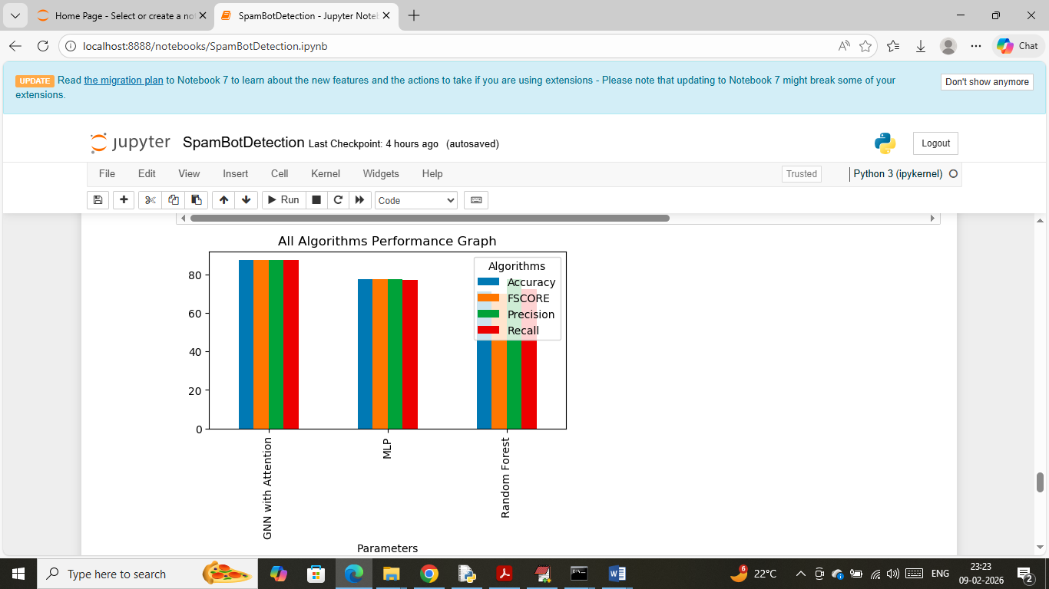
In above screen showing comparison graph between all algorithms where x-axis represents algorithm names and y-axis represents accuracy and other metrics in different colour bars
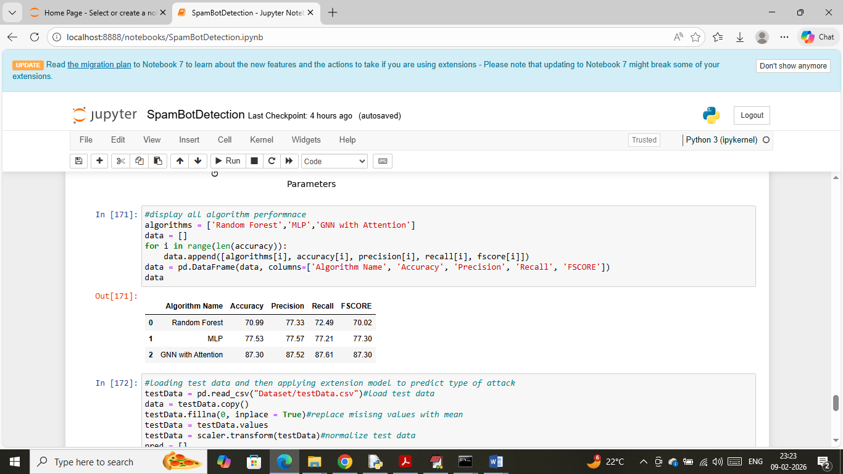
In above screen displaying all algorithms performance in tabular format where Propose GNN with Attention model got high accuracy
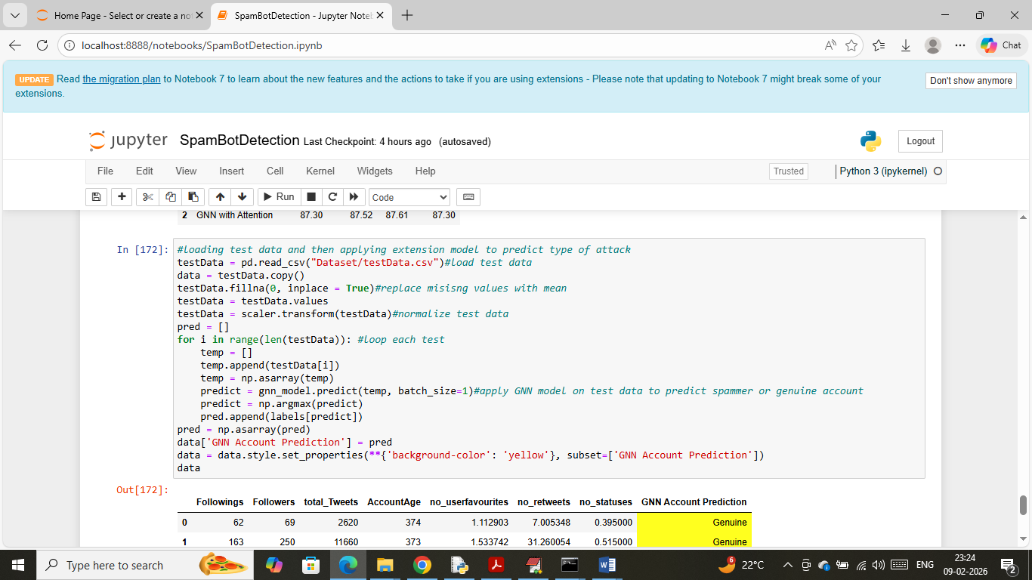
In above screen loading and processing test data values and after applying GNN on test data will get below prediction
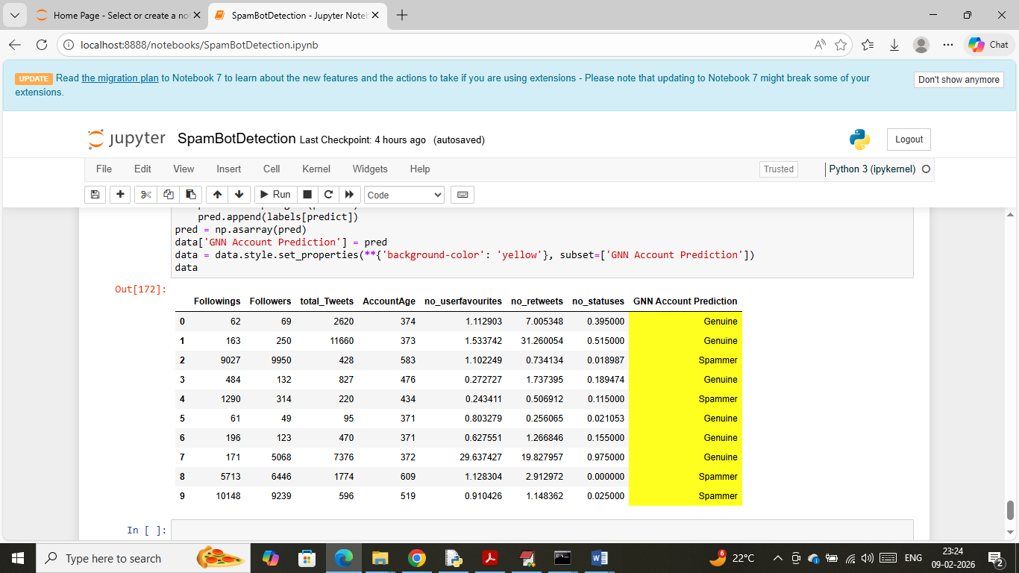
In above prediction output all columns contains test data values and last yellow column contains account prediction output as “genuine or spam”.
WEB Output
To run web flask output double click on ‘runFlask.bat’ file to start web server and then will get below page
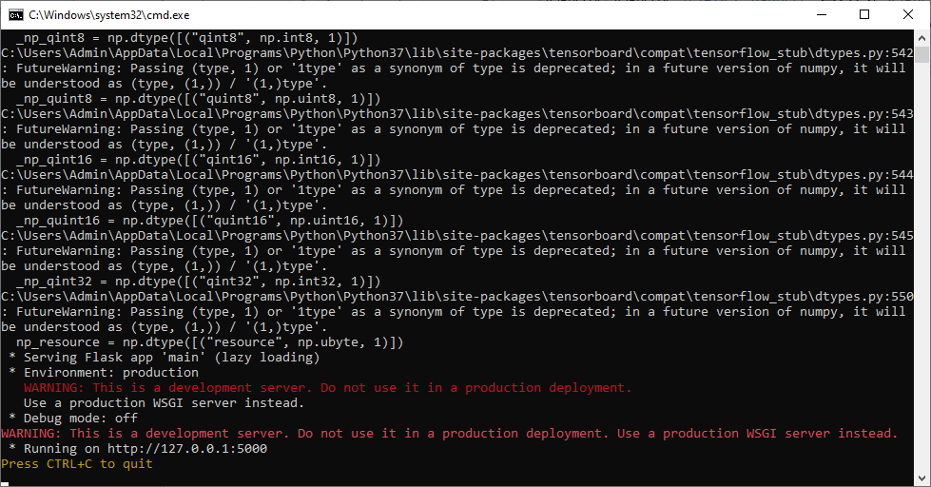
In above screen flask server started and now open browser and enter URL as http://127.0.0.1:5000/index and then press enter key to get below page
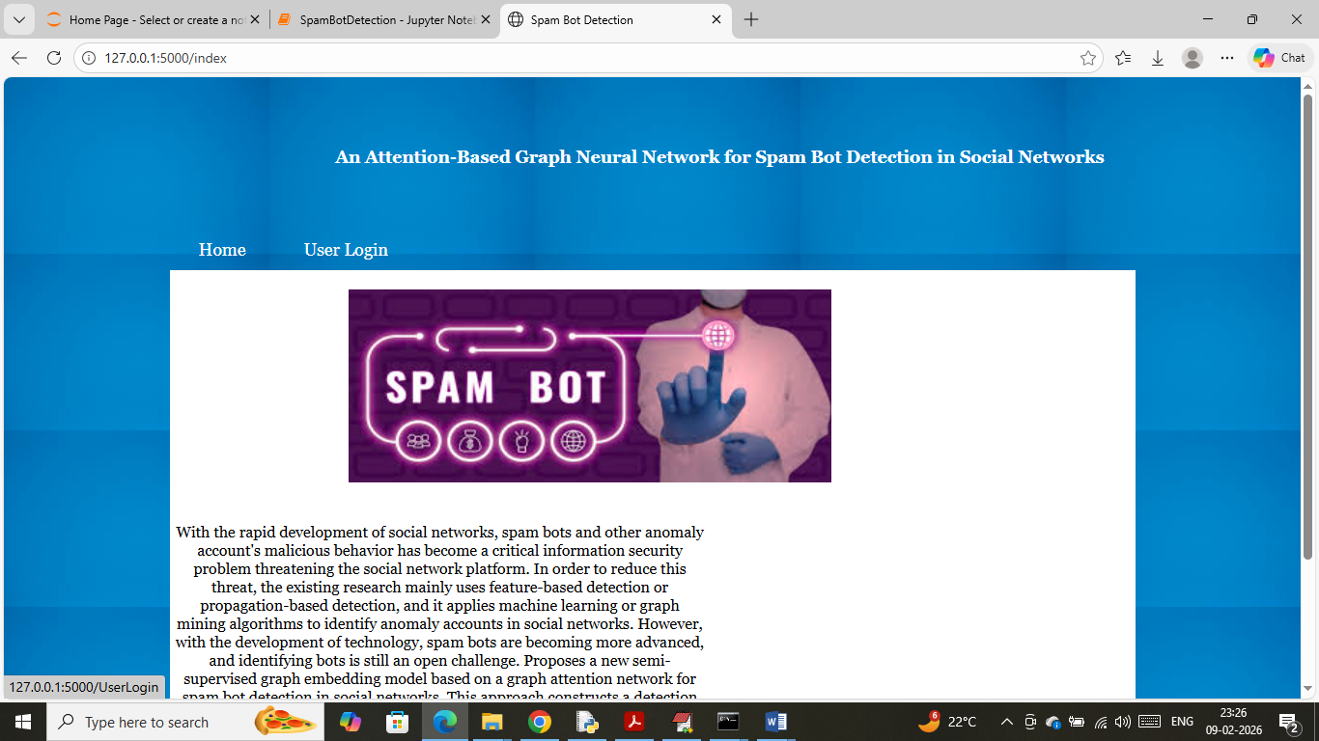
In above screen click on ‘User Login’ link to get below page
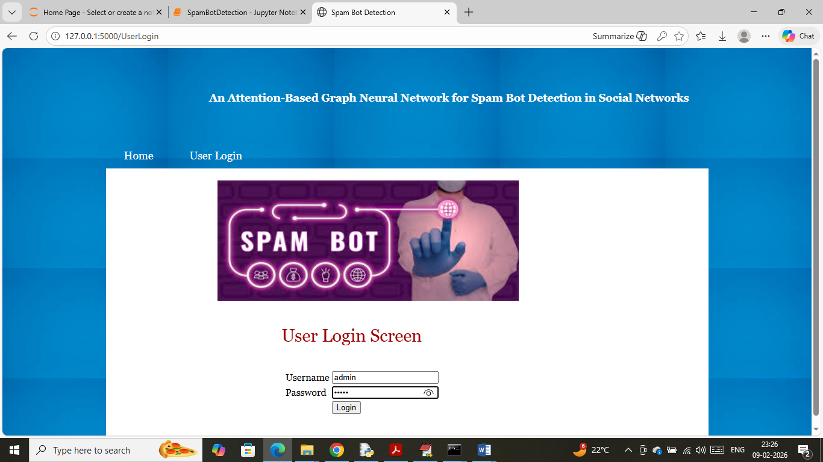
In above screen user can login to system using username and password as ‘admin and admin’ and then will get below page
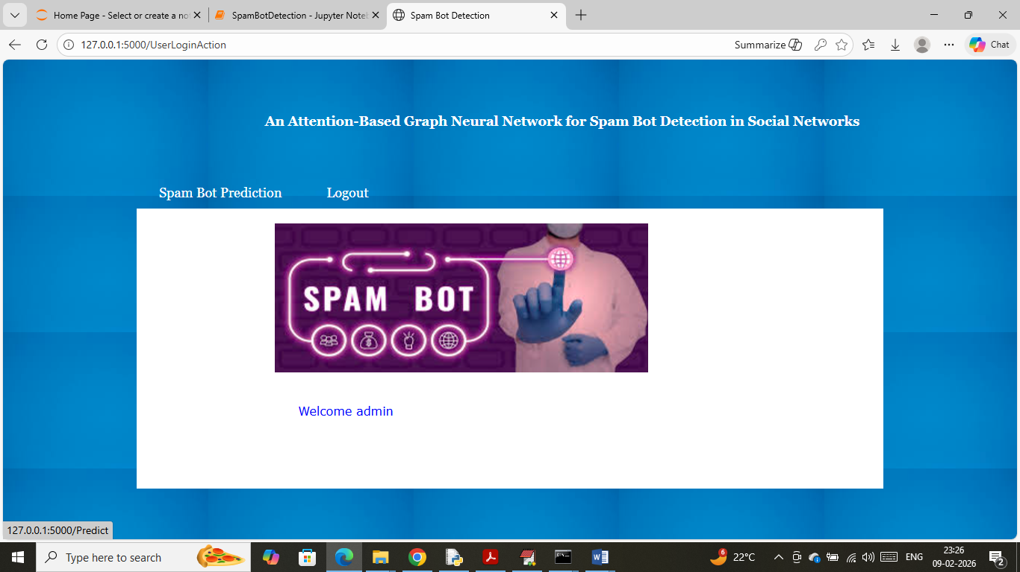
In above screen click on ‘Spam Bot Prediction’ link to get below page
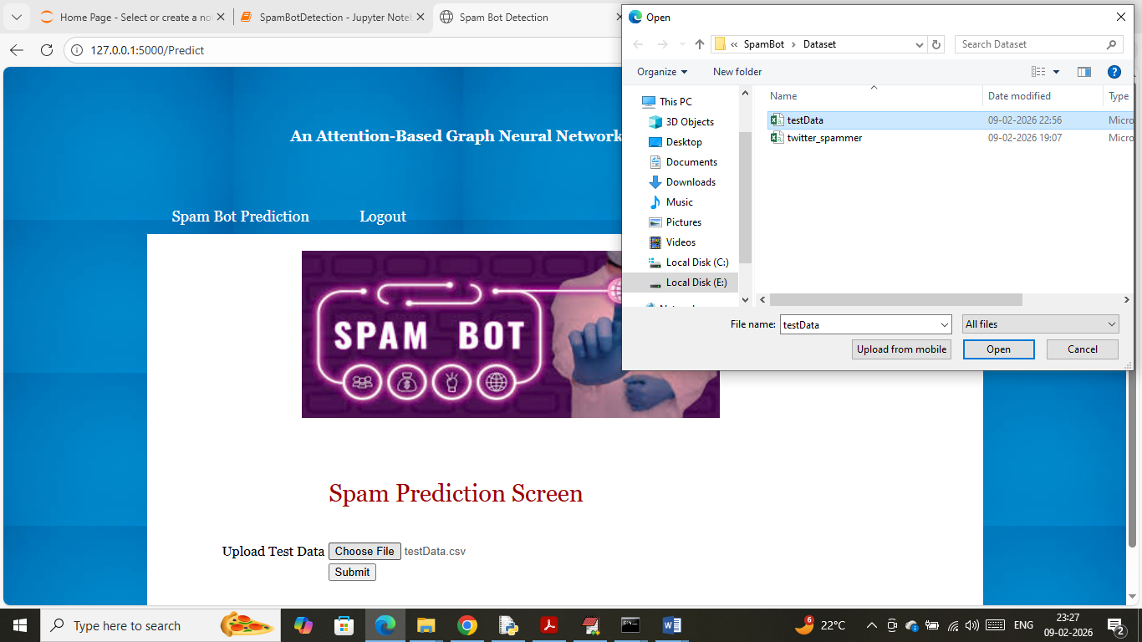
In above screen selecting and uploading ‘testData.csv’ file and then click on buttons to get below output
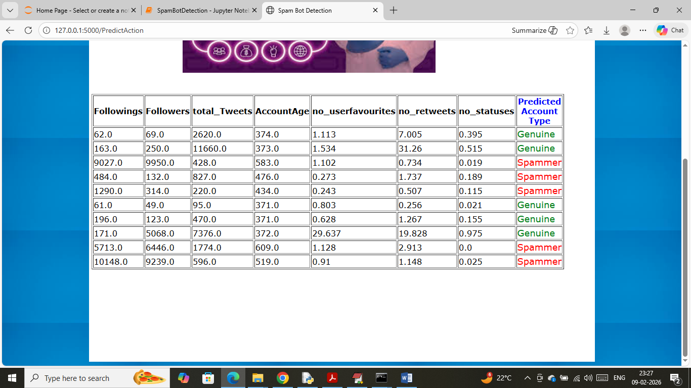
In above screen can see uploaded test data values along with GNN predicted output as spam or genuine accounts.
So above are the output implementation of your project

