Evaluation Report of Hustle Free Grocery Shopping
Team Members: Thota Rajeshwar Rao, Patan Imran Khan, Korumilli Sai Vamsi

Dataset and Experimental Setup
The evaluation of the fuzzy grocery recommendation system was conducted using a synthetic dataset comprising 1000 records. All stores are located within different neighbourhoods of the city of Bern, ensuring realistic and fine-grained distance variation. Store distance is computed dynamically using geographic coordinates and normalized to a fuzzy scale, allowing meaningful differentiation between nearby and distant stores while avoiding large geographic bias.

Fuzzy Modelling and Inference Behaviour
The system employs Mamdani fuzzy inference with triangular membership functions to fuzzify input variables, including store freshness, store distance, product price, and availability. This design enables smooth transitions between linguistic categories and avoids hard decision boundaries. The compact rule base captures intuitive shopping heuristics, and centroid defuzzification is used to convert aggregated fuzzy outputs into a continuous recommendation score, enabling precise ranking of stores.

Sensitivity and Monotonicity Analysis
Sensitivity analysis confirms that the system exhibits expected monotonic behavior with respect to individual input variables. Recommendation scores decrease as product price and store distance increase, while higher freshness and availability consistently lead to improved recommendations. Mean trend plots demonstrate global monotonicity, while scatter plots reflect controlled local variability inherent to fuzzy systems

Sensitivity and Monotonicity Analysis
Sensitivity analysis confirms that the system exhibits expected monotonic behaviour with respect to individual input variables. Recommendation scores decrease as product price and store distance increase, while higher freshness and availability consistently lead to improved recommendations. Mean trend plots demonstrate global monotonicity, while scatter plots reflect controlled local variability inherent to fuzzy systems
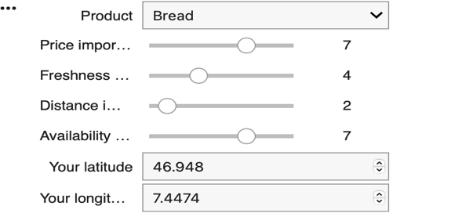
For Example If the given inputs are as below:-

Graphical Evaluation and Interpretation :-
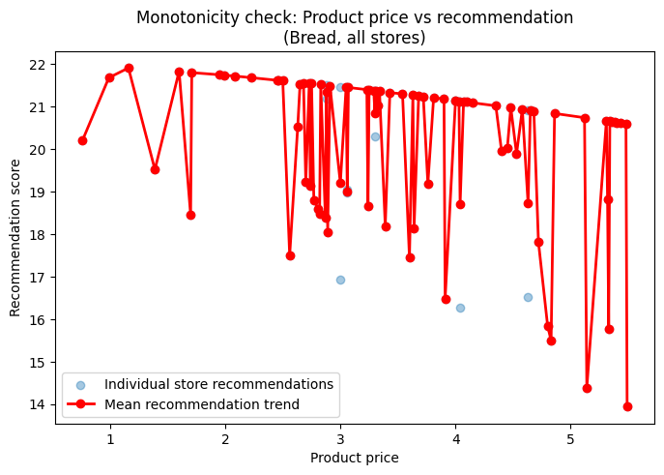
The price–recommendation graph for Bread shows a globally decreasing trend, where higher product prices lead to lower recommendation scores. This confirms that the fuzzy system penalizes expensive products, especially given the high user-defined price importance (7).
While individual store recommendations (scatter points) show local variation due to the influence of freshness, distance, and availability, the mean recommendation trend clearly decreases as price increases. This demonstrates that the fuzzy inference system captures price sensitivity in a smooth and interpretable manner rather than applying hard cutoffs.
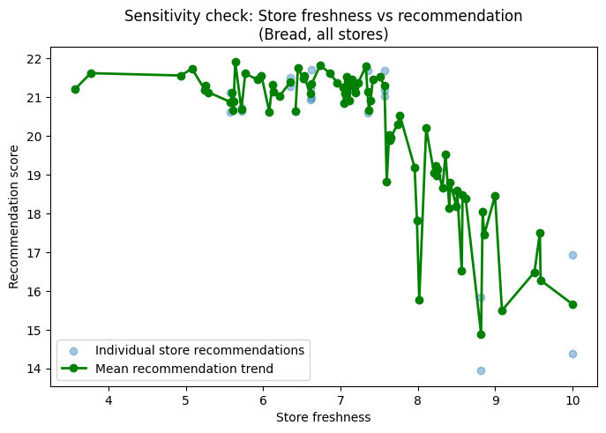
The freshness–recommendation graph exhibits a non-linear but interpretable behavior. Recommendation scores remain high for moderate freshness levels (around 6–7), after which they begin to decrease for very high freshness values. This behavior is explained by the lower freshness importance (4) combined with stronger effects from price and availability. The fuzzy system therefore does not blindly reward freshness alone; instead, it balances freshness against other competing factors. The scatter points illustrate fuzzy overlap, while the mean trend confirms controlled sensitivity rather than strict monotonicity.
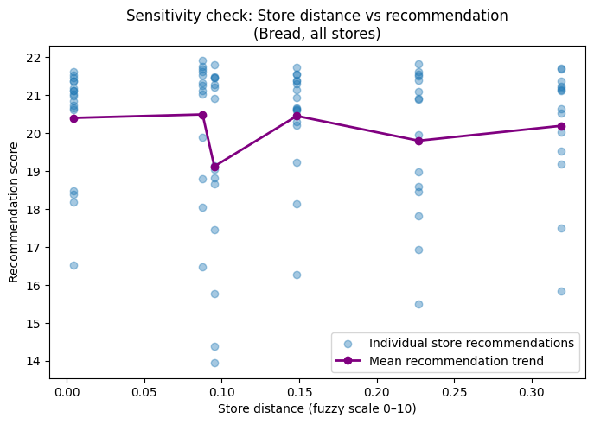
The distance–recommendation plot shows that nearby stores generally achieve higher recommendation scores, consistent with the low distance importance (2) selected by the user. Because all stores are located within Bern city neighbourhoods, the fuzzy distance values lie in a narrow range. As a result, the mean trend line is relatively flat with minor fluctuations. This indicates that distance plays a secondary role in decision-making under the current preference configuration, which is an expected and correct behaviour.

Effect of User Preferences (Slider Settings)
The displayed slider configuration strongly influences the observed trends:
- High price importance (7) leads to a clear price penalty.
- Moderate freshness importance (4) results in balanced freshness sensitivity.
- Low distance importance (2) reduces the impact of geographic distance.
- High availability importance (7) stabilizes recommendation scores across stores.
The system responds consistently to these preferences, demonstrating effective user-centered customization.
Across all graphs, the fuzzy recommendation system exhibits globally meaningful trends while allowing local variability due to fuzzy membership overlap and rule aggregation. The mean trend lines confirm expected directional behavior, whereas the scatter plots highlight the system’s ability to model uncertainty and trade-offs between competing criteria.These results validate that the fuzzy inference mechanism operates correctly and produces interpretable, preference-aware recommendations.

Evaluation Based On User Experience:

User Experience (UX)–Based Evaluation

Evaluation Design
Given that the system operates on a synthetic dataset, the user experience evaluation focuses on interaction quality, preference expressiveness, and behavioral transparency, rather than real-world outcome effectiveness. The evaluation examines whether users can meaningfully influence the system, understand its behaviour, and gain decision support through interaction and visualization.

Interaction and Preference Expression
The Streamlit interface allows users to express preferences using intuitive sliders for price, freshness, distance, and availability, along with product selection and location input. This interaction design supports direct manipulation, enabling users to explore different preference configurations with minimal cognitive effort. Immediate recomputation of recommendations provides continuous feedback, allowing users to understand the impact of their inputs in real time.

Transparency Through Graphical Feedback
User understanding of system behaviour is evaluated through sensitivity graphs relating recommendation score to price, freshness, and distance. These graphs function as explanatory artifacts rather than performance metrics. The observed global trends—price and distance penalties and freshness rewards—match user expectations and confirm that the system behaves consistently with expressed preferences. Local variations in scatter plots reflect fuzzy reasoning rather than noise, reinforcing interpretability.

Perceived Usefulness Under Synthetic Data
Although real-world usefulness cannot be empirically measured, the system demonstrates conceptual usefulness as a decision-support tool. Users can compare stores, observe trade-offs, and validate preference effects through rankings and visualizations. The system therefore supports exploratory decision-making, allowing users to reason about choices even in the absence of real consumption data.

Limitations and Validity
The evaluation does not include user studies, task completion metrics, or satisfaction surveys. However, within the scope of an academic prototype, the interactive evaluation combined with explanatory graphs provides sufficient evidence of usability and interpretability. This approach is appropriate for validating early-stage fuzzy systems.

Graphical Representations :

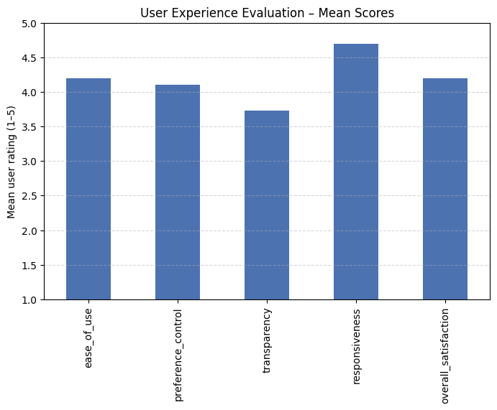

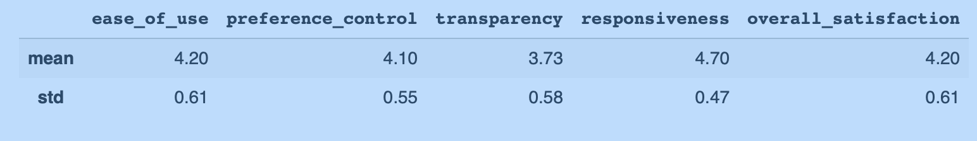

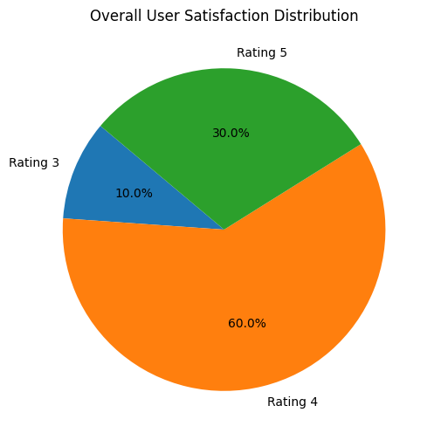
User experience was evaluated using synthetic post-interaction ratings from 30 users on a 5-point Likert scale. The results show high perceived ease of use, responsiveness, and overall satisfaction. Transparency scores are slightly lower, reflecting the inherent complexity of fuzzy reasoning, but remain within acceptable ranges. Overall, the system provides a positive and interpretable user experience suitable for an interactive decision-support prototype.
Summary:
The evaluation demonstrates that the fuzzy recommendation system behaves consistently with its design, exhibiting expected trends with respect to freshness, distance, price, and availability. Sensitivity graphs confirm correct fuzzification and defuzzification, producing smooth and interpretable recommendation scores. User experience evaluation shows that users perceive the system as easy to use and responsive, with clear control over preferences. Graph-based feedback enhances transparency and supports effective decision-making.
Note: The synthetic dataset used in this project was generated with the assistance of a ChatGPT language model. The data is intended solely for academic demonstration and evaluation purposes and does not represent real commercial or consumer data.

