Workflow:
- When you run the app.py you will see Ui as given below:
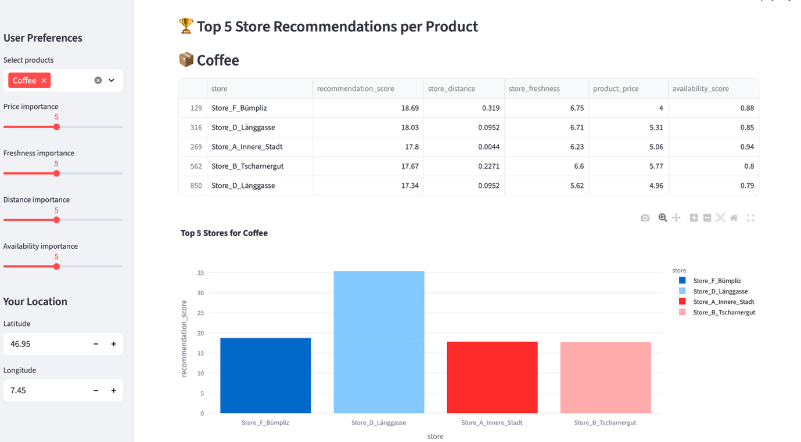

- User must select his product from drop down menu
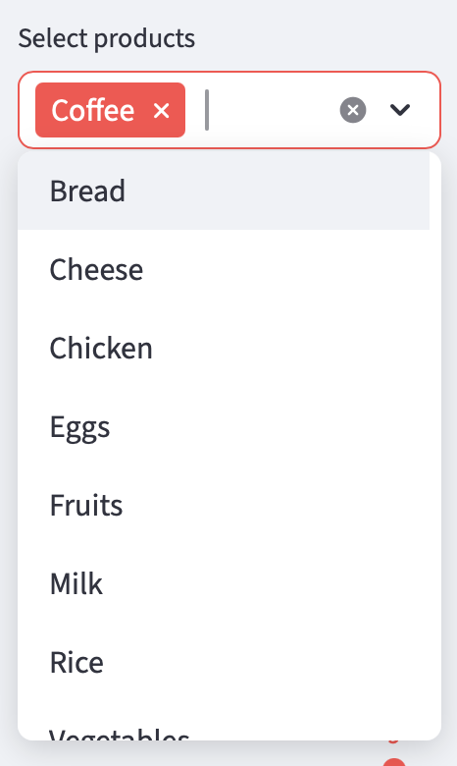

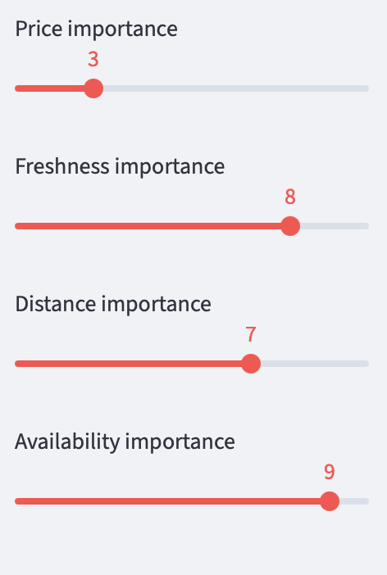
- User can select his inputs on the scale given as below

- Should give location longitude and latitude
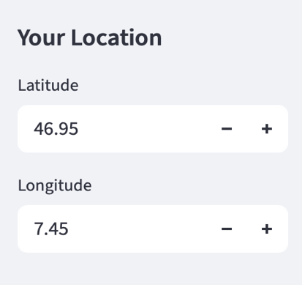

- Below are the recommendation result per product and graphical representation
