**INT219 – FRONT END WEB DEVELOPER**

**PROJECT - ASSIGNMENT**

**PROJECT NAME:**

**- University Website**

**SUBMITTED TO :-**

**PROF.**

**SUBMITTED BY :-**

**NAME:**

**REG. NO. :**

**ROLL NO. :**

**EMAIL :**

**PROJECT GITDHUB LINK :-** https://github.com/thota2020-2000/university-site

(All the codes and structure of my websites uploaded here.)

# ABOUT MY PROJECT :-

* This website let user to know about the university and university systems.
* I used React.Js for this project.

## WEBSITE'S HOMEPAGE

IMAGE - 1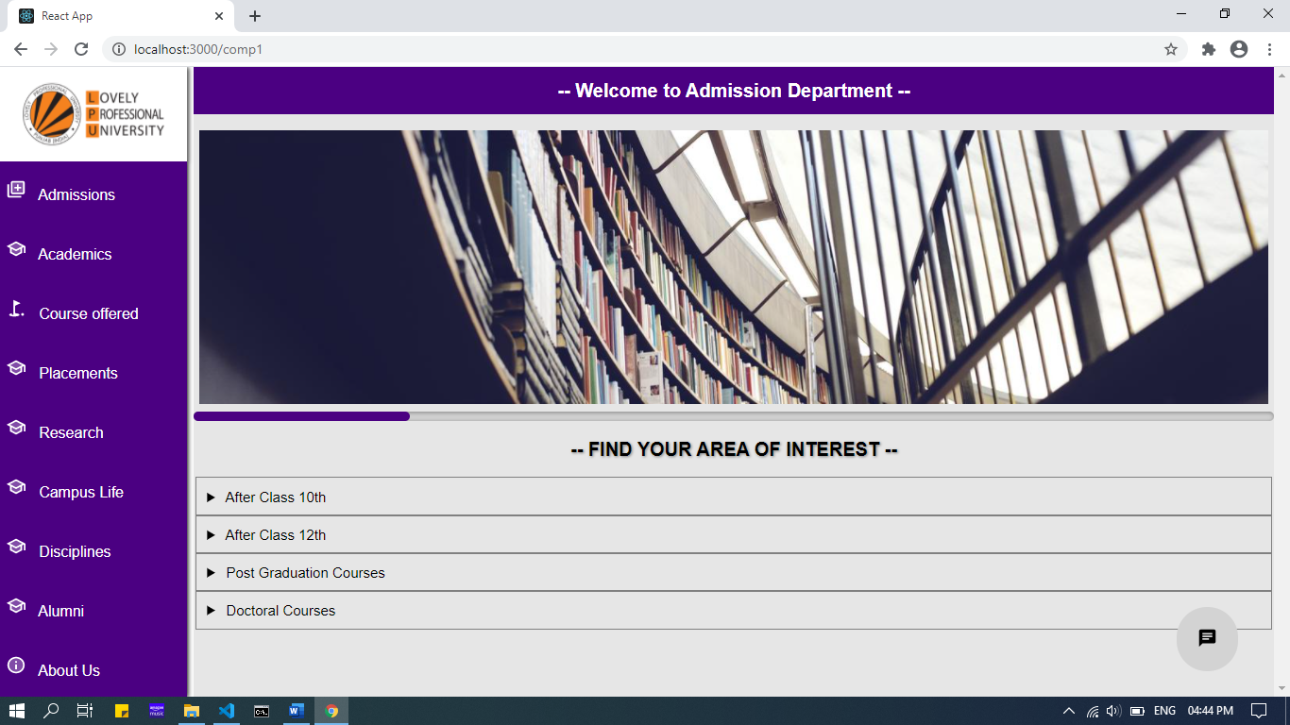



IMAGE – 2 IMAGE - 3

This application is completely responsive and works fine in all kind of devices with any resolution. (might not look good in keypad phones).

GITHUB PAGE LINK:

Github link

CODE:

Index.js

import React from 'react';

import ReactDOM from 'react-dom';

import { BrowserRouter } from 'react-router-dom';

import ComponentIndex from './MyComponents/ComponentIndex';

ReactDOM.render(

    <>

        <BrowserRouter>

            <ComponentIndex />

        </BrowserRouter>

    </>, document.getElementById("root")

);

ComponentIndex.js

import React, { useState } from 'react';

import '../css/index_page_css.css';

import { Switch, Route, NavLink } from 'react-router-dom';

import HomePage from './HomePage';

import CompA from './CompA';

import CompB from './CompB';

import CompC from './CompC';

import logo from '../images/logo.png'

import SchoolTwoToneIcon from '@material-ui/icons/SchoolTwoTone';

import InfoTwoToneIcon from '@material-ui/icons/InfoTwoTone';

import LibraryAddTwoToneIcon from '@material-ui/icons/LibraryAddTwoTone';

import GolfCourseTwoToneIcon from '@material-ui/icons/GolfCourseTwoTone';

import ChatIcon from '@material-ui/icons/Chat';

const ComponentIndex = () => {

    let [x, setX] = useState("jeevan");

    return (

        <>

            <div className="main-div">

                <div id="MainChild1" className="main-div-child1">

                    <div className="main-div-child1-child1" style={{ width: '100%', height: '10rem' }}>

                        <img alt="logo" src={logo} style={{ width: '100%', height: '100%', boxShadow: '1px 1px 5px grey' }} />

                    </div>

                    <div className="main-div-child1-child2">

                        <div> <NavLink to="/comp1" style={{ textDecoration: 'none', fontSize: '1.6rem', color: 'white' }}>  <LibraryAddTwoToneIcon fontSize="large" /> &nbsp; Admissions </NavLink></div>

                        <div> <NavLink to="/comp2" style={{ textDecoration: 'none', fontSize: '1.6rem', color: 'white' }}>  <SchoolTwoToneIcon fontSize="large" /> &nbsp;  Academics </NavLink></div>

                        <div> <NavLink to="/comp3" style={{ textDecoration: 'none', fontSize: '1.6rem', color: 'white' }}>  <GolfCourseTwoToneIcon fontSize="large" /> &nbsp;  Course offered </NavLink></div>

                        <div> <NavLink to="/comp1" style={{ textDecoration: 'none', fontSize: '1.6rem', color: 'white' }}>  <SchoolTwoToneIcon fontSize="large" /> &nbsp;  Placements </NavLink></div>

                        <div> <NavLink to="/comp1" style={{ textDecoration: 'none', fontSize: '1.6rem', color: 'white' }}>  <SchoolTwoToneIcon fontSize="large" /> &nbsp;  Research </NavLink></div>

                        <div> <NavLink to="/comp1" style={{ textDecoration: 'none', fontSize: '1.6rem', color: 'white' }}>  <SchoolTwoToneIcon fontSize="large" /> &nbsp;  Campus Life </NavLink></div>

                        <div> <NavLink to="/comp1" style={{ textDecoration: 'none', fontSize: '1.6rem', color: 'white' }}>  <SchoolTwoToneIcon fontSize="large" /> &nbsp;  Disciplines </NavLink></div>

                        <div> <NavLink to="/comp1" style={{ textDecoration: 'none', fontSize: '1.6rem', color: 'white' }}>  <SchoolTwoToneIcon fontSize="large" /> &nbsp;  Alumni </NavLink></div>

                        <div> <NavLink to="/comp1" style={{ textDecoration: 'none', fontSize: '1.6rem', color: 'white' }}>  <InfoTwoToneIcon fontSize="large" /> &nbsp;  About Us </NavLink></div>

                    </div>

                </div>

                <div className="main-div-child2">

                    <Switch>

                        <Route exact path="/" component={HomePage} />

                        <Route exact path="/comp1" component={CompA} />

                        <Route exact path="/comp2" component={CompB} />

                        <Route exact path="/comp3" component={CompC} />

                    </Switch>

                </div>

            </div>

            <div style={{ borderRadius: '5rem', boxShadow: '0.1rem 0.1rem 0.5rem grey', background: 'lightgrey', padding: '2.2rem', position: 'fixed', bottom: '4%', right: '4%' }}> <ChatIcon fontSize="large" /> </div>

            <button onClick={() => {

                let buttonfixed = document.getElementById("MainChild1");

                console.log(buttonfixed);

                if (x === "jeevan") {

                    buttonfixed.style.left = "0%";

                    setX("mrityu");

                }

                else {

                    buttonfixed.style.left = "-52%";

                    setX("jeevan");

                }

            }} className="hamburger-button" style={{ fontSize: '2rem', position: 'fixed', top: '1%', left: '2%' }}> &#9776; </button>

        </>

    );

}

export default ComponentIndex;

CompA.jsx

import React from 'react';

import '../css/compa_css.css';

import image1 from '../images/image1.jpg';

import image2 from '../images/image2.jpg';

const CompADetails = (props) => {

    return (

        <>

            <details style={{ transition: 'height 2s', fontSize: '1.5rem', outline: '1px solid grey', padding: '1% 1%', margin: '0 0.3rem' }}>

                <summary style={{ outline: 'none', fontWeight: 'bold' }}> {props.summary} </summary><hr />

                <div style={{ display: 'flex', padding: '1% 0%' }}>

                    <div style={{ width: '30rem', height: '20rem', border: '0.05rem solid grey', margin: '0.2rem' }}>1</div>

                    <div style={{ width: '30rem', height: '20rem', border: '0.05rem solid grey', margin: '0.2rem' }}>1</div>

                    <div style={{ width: '30rem', height: '20rem', border: '0.05rem solid grey', margin: '0.2rem' }}>1</div>

                    <div style={{ width: '30rem', height: '20rem', border: '0.05rem solid grey', margin: '0.2rem' }}>1</div>

                </div>

            </details>

        </>

    );

}

const CompA = () => {

    return (

        <>

            <div style={{ display: 'grid', placeItems: 'center', width: '100%', height: '5rem', color: 'white', backgroundColor: 'indigo' }}>

                <h1> -- Welcome to Admission Department -- </h1>

            </div>

            <br />

            <div id="Slider" className="slider">

                <div className="slides"> <img src={image1} alt="image1" /> </div>

                <div className="slides"> <img src={image2} alt="image1" /> </div>

                <div className="slides"> <img src={image1} alt="image1" /> </div>

                <div className="slides"> <img src={image2} alt="image1" /> </div>

                <div className="slides"> <img src={image1} alt="image1" /> </div>

            </div>

            <div style={{ display: 'grid', placeItems: 'center', height: '6rem' }}> <h1 style={{ textShadow: '1px 1px 3px grey' }}> -- FIND YOUR AREA OF INTEREST -- </h1> </div>

            <CompADetails summary="After Class 10th" />

            <CompADetails summary="After Class 12th" />

            <CompADetails summary="Post Graduation Courses" />

            <CompADetails summary="Doctoral Courses" />

        </>

    );

}

export { CompA as default };

index_page_css.css

html{

    font-size: 62.5%;

}

*{

    margin: 0;

    padding: 0;

    box-sizing: border-box;

}

body{

    /*background-color: #f6f6f6;*/

    font-family: 'helvetica', 'sans-serif', 'Arial';

}

.main-div{

    display: flex;

    justify-content: space-between;

    position: relative;

}

.main-div-child1{

    width: 14.5%;

    height: 100vh;

    /*background-color: yellow;*/

    display: flex;

    flex-flow: column;

    box-shadow: 1px 1px 5px black;

    transition: all 0.3s ease;

}

.main-div-child1-child2{

    overflow-y: scroll;

    flex-grow: 1;

    display: flex;

    flex-flow: column;

    justify-content: space-between;

    align-items: center;

    background-color: indigo;

}

.main-div-child1-child2 > div{

    width: 100%;

    padding: 0 3%;

    flex-grow: 1;

    padding: auto;

    display: flex;

    align-items: center;

}

.main-div-child1-child2 > div:hover{

    background-color: rgb(81, 119, 243);

}

.main-div-child2{

    width: 85%;

    height: 100vh;

    background-color: #e6e6e6;

    overflow-y: scroll;

}

.main-div-child1-child2::-webkit-scrollbar{

    display: none;

}

.hamburger-button{

    z-index: 9999999;

    display: none;

}

@media(max-width: 760px){

    .main-div-child1{

        width: 50%;

        position: absolute;

        left: -50%;

        z-index: 99999;

        background-color: white;

    }

    .main-div-child2{

        width: 100%;

    }

    .hamburger-button{

        display: block;

    }

}

Compa_css.css

.slider{

    display: flex;

    width: 100%;

    position: relative;

    overflow-x: scroll;

    scroll-snap-type: x mandatory;

}

.slider::-webkit-scrollbar{

    height: 1rem;

    border-radius: 0.5rem;

}

.slider::-webkit-scrollbar-thumb{

    background-color: indigo;

    border-radius: 0.5rem;

}

.slider::-webkit-scrollbar-track{

    background-color:lightgrey;

    box-shadow: inset 1px 1px 5px grey;

    border-radius: 0.5rem;

}

img{

    width: 100%;

    padding: 0.5%;

}

.slider > div{

    flex-shrink: 0;

    width: 100%;

}

.slides{

    position: relative;

    scroll-snap-align: center;

    scroll-snap-stop: always;

}

.button_right{

    position: absolute;

    right: 5%;

}

@media(max-width: 768px){

    html{

        font-size: 50%;

    }

}

package.json

{

  "name": "university-site",

  "version": "0.1.0",

  "private": true,

  "dependencies": {

    "@material-ui/core": "^4.11.0",

    "@material-ui/icons": "^4.9.1",

    "@testing-library/jest-dom": "^5.11.5",

    "@testing-library/react": "^11.1.0",

    "@testing-library/user-event": "^12.1.10",

    "react": "^17.0.1",

    "react-dom": "^17.0.1",

    "react-router-dom": "^5.2.0",

    "react-scripts": "4.0.0",

    "web-vitals": "^0.2.4"

  },

  "scripts": {

    "start": "react-scripts start",

    "build": "react-scripts build",

    "test": "react-scripts test",

    "eject": "react-scripts eject"

  },

  "eslintConfig": {

    "extends": [

      "react-app",

      "react-app/jest"

    ]

  },

  "browserslist": {

    "production": [

      ">0.2%",

      "not dead",

      "not op_mini all"

    ],

    "development": [

      "last 1 chrome version",

      "last 1 firefox version",

      "last 1 safari version"

    ]

  }

}