Chapter 8 PL/SQL, ADO.net in VS.NET 2012

Learning Objectives:

After completing this chapter, you should be able to:
- Generating Code Automatically
- Using DataReader Class
- Using bind variables (Parameters)
- Using PL/SQL Procedures in .NET application
- Using Dataset Class
- Using Ref Cursors and Packages

1. Generating Code Automatically
Example 1
To explore the content of table DEPARTMENTS under HR schema, we will build a form that uses a simple table query.
- Open VS.NET 2012 and create a new project
- In the templates window, choose Windows Application
- Select the Form1 design view.
- Click Project Menu and select Add New Data Source
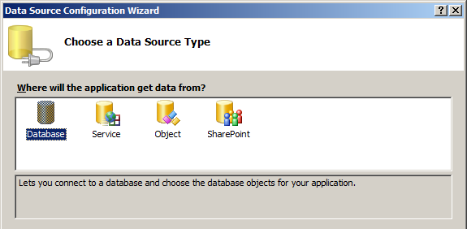

- Select Database and click Next
- Select Dataset and click Next
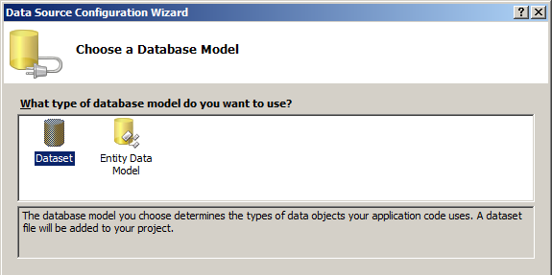

- In the data connection window, select includes sensitive data in the connection, and click Next.
- To save the connection string to the application configuration file, click Next.
- Select the proper database objects you want to include in the dataset. Click finish.
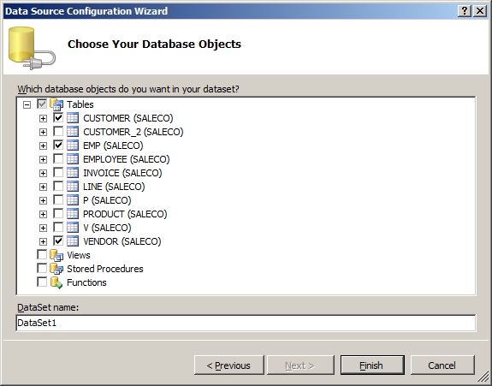
- In Data Source window, Drag and drop VENDORS table onto Form1 in the Designer window.

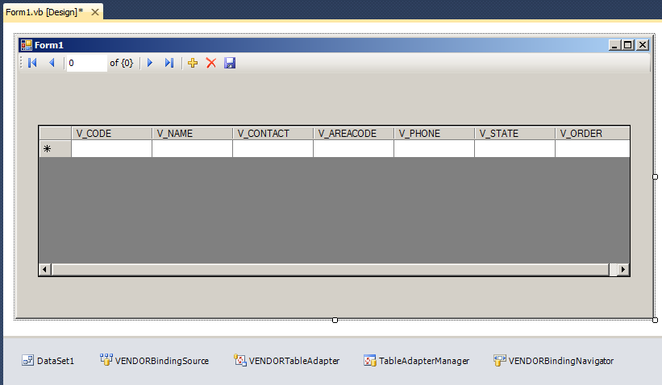

- Below the form, you can see some objects are created. These objects represent automatically generated code for Form1.
- Run the application.
- Close the application.

2. Using the DataReader Class
Generally, when you want to use a datareader to process data, you follow the steps below:
- Adding a Reference
- Add Imports statements before the Public Class declaration
- Adding Controls in Windows Form
- Using the Connection Object
- Using the Command Object
- Access the returned data
- Close and dispose Objects
- Error Handling and closing the Database Connection
- Running the application

Example 2
This example is to show how to retrieve values from employees table under HR schema by using DataReader.
- Click the Create: Project ... button. Alternatively, from the File menu, select New, and then select Project. On the left side of the New Project dialog box under Project Types, select Visual Basic. On the right side of the New Project dialog box under Templates, select Windows Application.
For Name, enter HR_EMP.
Click OK.
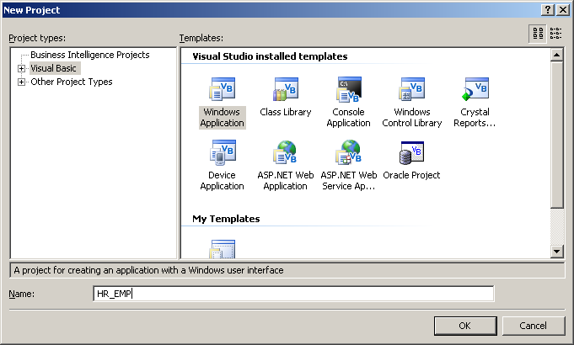
- Open Solution Explorer. In the Solution Explorer, click “Show All files” icon and select the References node, right click and select Add Reference. Alternatively, select Add Reference from the Project menu. Scroll down the list of references (under Component Name), and select Oracle.DataAccess (version 4.102.2.20).
Double click to add the Oracle Data Provider for .NET to your project.
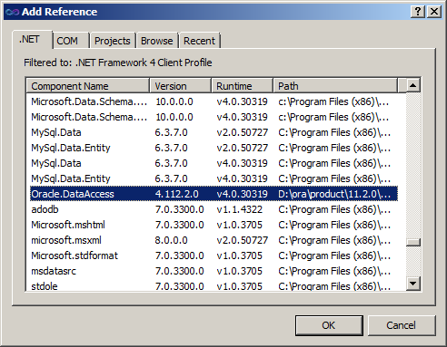
Note that the Solution Explorer window now shows Oracle.DataAccess in the References folder.
3. Visual C# using statements allow you to refer to database objects without using lengthy, fully qualified names. By convention, these statements appear at or near the top of a code file, before the namespace or class declaration. With Form1 active, in View menu select Code. Add the following statements to the top of the file.
using Oracle.DataAccess.Client;
using Oracle.DataAccess.Types;

Adding Windows Form Controls
To create a interface, you must add the necessary displaying and data entry elements to the design form.
- With Form1 active, change to design view. Open Toolbox Window.
- From the Toolbox, under Common Controls, select and drag 1 Label.

Using the Connection Object
The OracleConnection object specifies the Oracle Database used by the application. In this step, we need to define the connection string, associate with a connection object, and then open the connection object. An Oracle connection string is inseparable from Oracle names resolution. Suppose we had a database of ORCL defined in a tnsnames.ora file, we use the following syntax in connection string:
string oradb = "Data Source= orcl;User Id=hr;Password=hr;";

Note: for remote access, the data source is:
data source=host:port/service_name
e.g. data source=madoc300b:1521/orcl.ma.cis.cmsu.edu
e.g. "Data Source=ecdl-csc101-03s:1521/orcl.ucmo.local;

1. Double click the form and add connection strings and objects as following:
string oradb = "Data Source= orcl;User Id=hr;Password=hr";
2. Instantiate a connection object and associate it with the connection string.
OracleConnection conn = new OracleConnection(oradb);
3. Open the connection by using open method.
conn.Open()

Using the Command Object
The OracleCommand class specifies a SQL command, stored procedure, or table name. It creates a database request, sends the request to the database, and returns the result. In this step, we need to define the SQL string, associate it with a command object, and then execute the command object.
1. Create a string that define the SQL statement
string sql = "select Last_name from employees where employee_ID =114";
2. Instantiate a command object and associate it with the connection string and SQL statement, and set its CommandType property to a text command.

OracleCommand cmd = new OracleCommand(sql, conn);
cmd.CommandType = CommandType.Text;

Using DataReader Object and Execute the command
The Command object has methods for executing the command text. Use the ExecuteReader method to execute the command and store the value to a DataReader object. Because OracleDataReader is a forward-only, read-only cursor, it cannot be bound to an updatable or backward scrollable control such as Windows Forms DataGrid control. A DataReader is, however, compatible with a label, textbox, and ListBox controls.
OracleDataReader dr = cmd.ExecuteReader();

Access the returned data
The returned data in the data Reader can be accessed by passing either the column name or zero-based column ordinal to the Item property.
dr.Read();
label1.Text = dr.GetString(0);

Label1.Text = dr.Item(“Last_name”) ' retrieve by column name, Or
Label1.Text = dr.Item(0) ' retrieve the first column, Or
Label1.Text = dr.GetString(0) ' retrieve the first column

If the retrieved value is not a string, there would be a data type mismatch. An explicit cast to integer is shown below:

Label1.Text = dr.Item(dr.GetString(0))
Close and Dispose
Either the connection object's Close or the Dispose method should be called to close the connection to the database. The Dispose method calls the Close method.
conn.Close()
conn.Dispose()

Error Handling
Oracle Data Provider for .NET contains three classes for error handling and support:
- The OracleError class represents a warning or an error reported by Oracle.
- An OracleErrorCollection class represents a collection of all errors that are thrown by the Oracle Data Provider for .NET. In fact, it is a simple ArrayList that holds a list of OracleErrors.
- The OracleException class represents an exception that is thrown when the Oracle Data Provider for .NET encounters an error. Each OracleException object contains at least one OracleError object in the Error property that describes the error or warning.
The .NET languages use Try-Catch-Finally structured error handling. Change the code in Form1 as following:
C# Code
string oradb = "Data Source= orcl;User Id=hr;Password=hr";
OracleConnection conn = new OracleConnection(oradb);
try
{
conn.Open();
string sql = "select Last_name from employees where employee_ID =114";
OracleCommand cmd = new OracleCommand(sql, conn);
cmd.CommandType = CommandType.Text;
OracleDataReader dr = cmd.ExecuteReader();

dr.Read();
label1.Text = dr.GetString(0);
}
catch (Exception ex)
{
MessageBox.Show(ex.Message.ToString());
}
finally
{
conn.Close();
conn.Dispose();
}

VB.NET Code:
Dim oradb As String = "Data Source= orcl;User Id=hr;Password=hr;"
Dim conn As New OracleConnection(oradb)
Try
conn.Open()
Dim sql As String = "select Last_name from employees where employee_ID =114"
Dim cmd As New OracleCommand(sql, conn)
cmd.CommandType = CommandType.Text
Dim dr As OracleDataReader = cmd.ExecuteReader()
dr.Read()
Label1.Text = dr.Item("Last_name")
Catch ex As Exception
MessageBox.Show(ex.Message.ToString())
Finally
conn.Close()
conn.Dispose()
End Try

Although this approach will gracefully capture any errors in attempting to get data from the database, it is not user friendly. A better solution is to add an additional Catch statement to trap the most common database errors and provide user-friendly messages.

Catch ex As OracleException ' catches only Oracle errors
Select Case ex.Number
Case 1
MessageBox.Show("Error attempting to insert duplicate data.")
Case 12545
MessageBox.Show("The database is unavailable.")
Case Else
MessageBox.Show("Database error: " + ex.Message.ToString())
End Select
Catch ex As Exception ' catches any error
MessageBox.Show(ex.Message.ToString())
The Finally code block is always executed regardless of whether or not an error occurred. By placing the connection object's Close or Dispose method call in the Finally code block, the database connection will always be closed after executing the Try-Catch-Finally code block.
Run the application
Before testing this code, make sure the database instance is available. Then run the application.
If you have issues with Oracle.DataAccess because of compatible problem, you may configure the platform target configuration as showing below, then re-compile the application before run it.
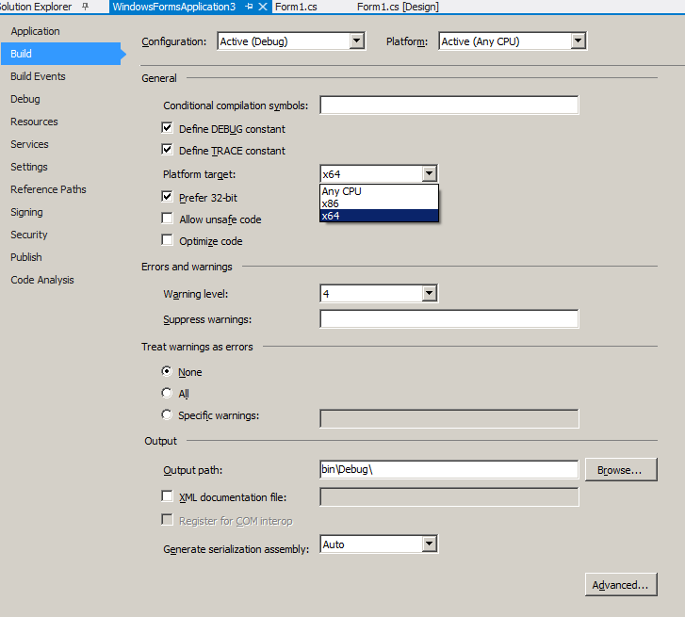

Example 3

This example is to show how to retrieve multiple values using a DataReader.
Using a DataReader object can retrieve values for multiple columns and multiple rows. However, a looping construct is needed to process multiple rows from the DataReader object. Also, a control that can display multiple rows is necessary.

  - In the Form design view, drag and drop a listbox and button from the toolbox.

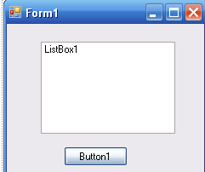

  - Double click the control Button1 and add the following codes
C# Code:

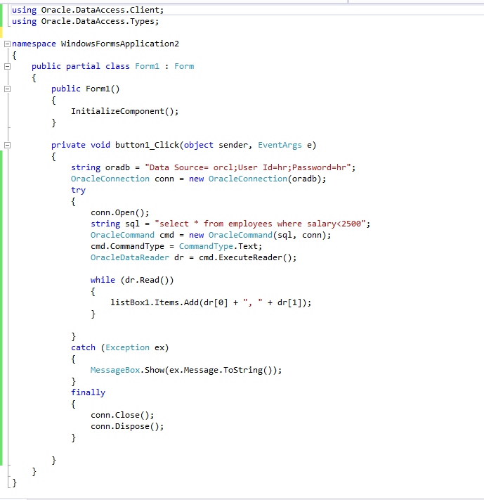

VB.NET Code:
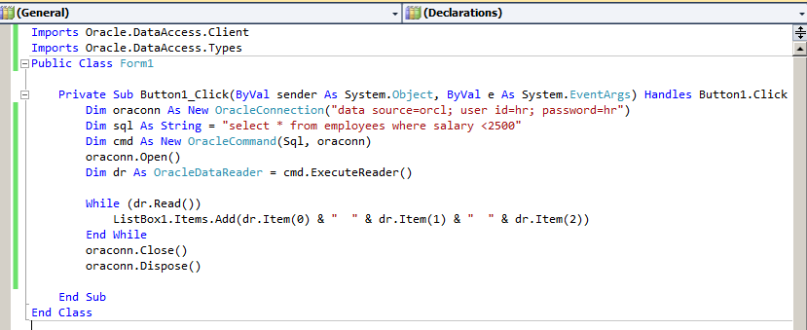

Or you can use coloumn names such as

listBox1.Items.Add(dr["employee_id"]+" "+dr["Last_name"]+", "+dr["First_name"]);

ListBox1.Items.Add(dr.Item("employee_id") & ", " & dr.Item("first_name") & " " & dr.Item("last_name"))

- Run the application. After you connect, the Employees list box shows employee_id, fisrt_name, and last_name.
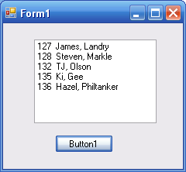
Example 4
This example is to show how to use textbox as input to retrieve value from the emp table under scott schema.
- In the windows design view, drag and drop a textbox, a button and a listbox to the form as shown below.
- Name the textbox as empno and the button as retrieveButton.
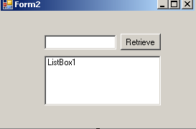
- Double click Retrieve button and type the code as following:
C# Code:

OracleConnection conn = new OracleConnection(Data Source=orcl; User Id=scott; Password=tiger");
try
{
conn.Open();
string sql = "select ename, job,sal from emp where empno="+empnum.Text+"";
OracleCommand cmd = new OracleCommand(sql, conn);
cmd.CommandType = CommandType.Text;
OracleDataReader dr = cmd.ExecuteReader();

while (dr.Read())
{
listBox1.Items.Add(dr[0]+" "+dr[1]+" "+dr[2]);
}

}
catch (Exception ex)
{
MessageBox.Show(ex.Message.ToString());
}
finally
{
conn.Close();
conn.Dispose();
}

VB.NET Code:

Dim conn As New OracleConnection("data source =orcl; user id =scott; password=tiger")
conn.Open()
Dim sql As String = "SELECT ename, job, sal FROM emp WHERE empno =" +empnum.Text+""
Dim cmd As New OracleCommand(sql, conn)
cmd.CommandType = CommandType.Text
Dim dr As OracleDataReader = cmd.ExecuteReader()
dr.Read()
ListBox1.Items.Add(dr.Item(0) & " " & dr.Item(1) & " " & dr.Item(2))

conn.Close()
onn.Dispose()
- Run the application and test it with input 7782. The output should looks like
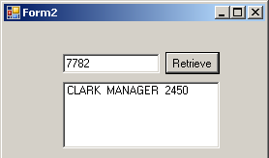
However, this approach of using the variable is not recommended because of the security issue, which is known as SQL injection. The recommend way is to use bind variable and parameters.

3. Using Bind Variables(Parameters)
Bind variables are essentially placeholders in a SQL statement. When a database receives a SQL statement, it checks if the statement has already been executed and stored in memory. If the statement exists in memory, Oracle Database can reuse it and skip the task of parsing and optimizing the statement. When using bind variables, you make the statement reusable with different input values, improve query performance in the server, eliminate the need for special handling of literal quotation marks in the input, and protect against SQL injection attacks.
Typically, we have a SELECT statement like this:
SELECT Last_name, first_name
FROM employees
WHERE department_id = 100
We can replace the numerical value with a bind variable :deptid. The bind variable identifier always begins with a single colon (:) in SQL statements.
SELECT Last_name, first_name
FROM employees
WHERE department_id = :deptid
In .NET, each bind variable is represented by the OracleParameter. The OracleParameterCollection class contains the OracleParameter objects associated with the OracleCommand object for each statement.
You can bind variables by position or by name. The OracleCommand property BindByName (which defaults to false) sets the mode.
When binding by position, you must use the Add() method to add the parameters to the OracleParameterCollection in the same order as they appear in the SQL statement or stored procedure.
If you want to bind by name, you may add the parameters to the collection in any order; however, you must set the ParameterName property for the parameter object to the same name as the bind variable identifier in the stored procedure declaration.
In addition to the binding mode (by position or by name), the following properties are typically set for each parameter object: Direction, OracleDbType, Size, and Value.
Properties | Usage
Direction | the direction of each parameter. The default value of the Direction property is Input.
OracleDbType | whether the parameter is a number, a date, a VARCHAR2, and so on.
Size | the maximum size of the data that the parameter will hold for parameters with a variable length data type, like VARCHAR2.
Value | the parameter value either before statement execution (for input parameters), after execution (for output parameters), or both before and after (for input/output parameters).
Tie together these concepts and use a bind variable in a SELECT statement.

Example 5
This example is to show how to retrieve data using bind variables.
- In the design view, change the input textbox name to deptnum.
- Type the code as following:
C# Code:
OracleConnection conn = new OracleConnection("Data Source= orcl;User Id=scott; Password=tiger");
conn.Open();
string sql = "select ename, job,sal from emp where deptno=:deptnum";
OracleCommand cmd = new OracleCommand(sql, conn);
cmd.CommandType = CommandType.Text;

OracleParameter p_dept =new OracleParameter();
p_dept.OracleDbType=OracleDbType.Int16;
p_dept.Value=int.Parse(deptnum.Text);
cmd.Parameters.Add(p_dept);

OracleDataReader dr = cmd.ExecuteReader();

while (dr.Read())
{
listBox1.Items.Add(dr[0]+" "+dr[1]+" "+dr[2]);
}
conn.Close();
conn.Dispose();

VB.NET Code:

Dim oradb As String = "data source =orcl; user id =scott; password=tiger"
Dim conn As New OracleConnection(oradb)
conn.Open()
Dim sql As String = "SELECT ename, job, sal FROM emp where deptno = :deptnum"
Dim cmd As OracleCommand = New OracleCommand(sql, conn)
cmd.CommandType = CommandType.Text

Dim p_dept_id As OracleParameter = New OracleParameter()
p_dept_id.OracleDbType = OracleDbType.Int16
p_dept_id.Value = CType(deptnum.Text, Integer)
cmd.Parameters.Add(p_dept_id)

Dim dr As OracleDataReader = cmd.ExecuteReader()

While (dr.Read())
ListBox1.Items.Add(dr.Item(0) & " " & dr.Item(1) & " " & dr.Item(2))
End While
conn.Close()
conn.Dispose()
- Run the application and test it with department number 10.
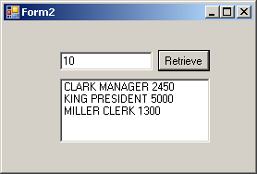
Note: An alternative way to use the parameter is as following:
cmd.Parameters.Add(":deptnum ", OracleDbType.Int16, 4).Value = CType(deptnum.Text, Integer)
Example 6
We have already seen parameterized queries in the previous example. In this example we will see how to use multiple parameters to insert values into the table emp under SCOTT schema.
- In the design view, add the controls to the form as following
- Rename the three textbox as empnumTaxtBox, enameTextBox, and salaryTextBox respectively
- Rename the button as insertbutton
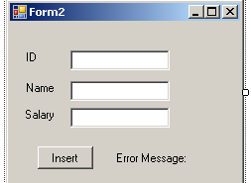
- Type the code as below:
C# Code:

OracleConnection conn = new OracleConnection("Data Source= orcl;User Id=scott; Password=tiger");
try
{
conn.Open();
string sql = "insert into emp(empno,ename,sal) values(:empno,:ename,:sal)";
OracleCommand cmd = new OracleCommand(sql, conn);
cmd.CommandType = CommandType.Text;

cmd.Parameters.Add(":empno",OracleDbType.Int16, 4).Value = int.Parse (empnumTextbox.Text);
cmd.Parameters.Add(":ename", OracleDbType.Varchar2, 10).Value = enameTextbox.Text;
cmd.Parameters.Add(":sal", OracleDbType.Double).Value = Double.Parse (salaryTextBox.Text);
cmd.ExecuteNonQuery();
cmd.Parameters.Clear();
cmd.Dispose();

label4.Text = "The values are successfully inserted.";
}
catch (Exception ex)
{
MessageBox.Show(ex.Message.ToString());
}
finally
{
conn.Close();
conn.Dispose();
}

VB.NET Code:

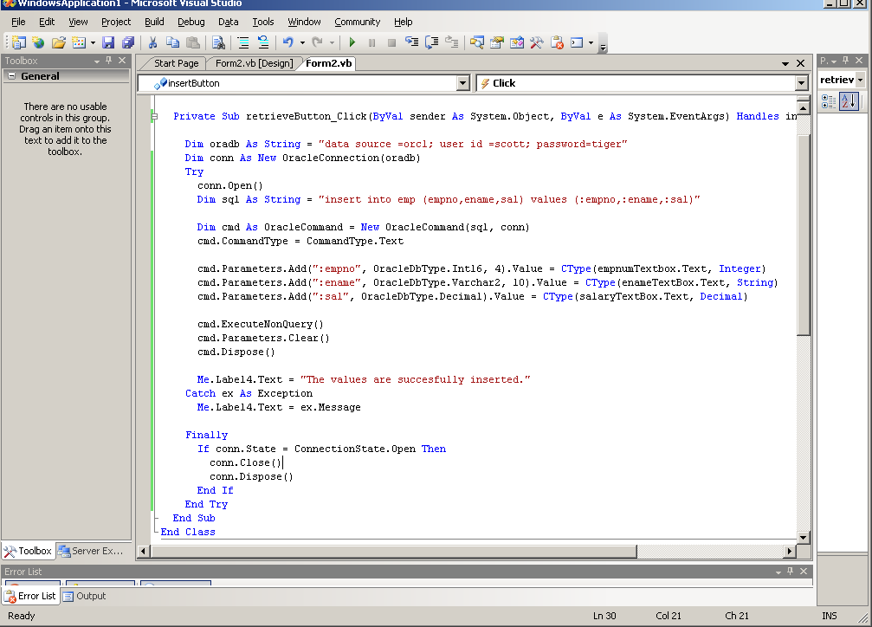
- Run the application and test it with some values.
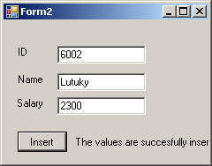
Note that bind variables can also be used with UPDATE, INSERT, and DELETE statements, and also with stored procedures. The following shows how to use bind variables in an UPDATE statement.
UPDATE departments
SET department_name = :department_name
WHERE department_id = :department_id

4. Using PL/SQL Procedures in .NET applications
Stored procedures are one of the most commonly used programs. It is very similar as bind variables because it is also use parameters to pass value from application to database.

Example 7

This example is to show how to use a stored procedure (HR.SELECT_EMP) in .NET application.

1. Ensure the procedure “HR.SELECT_EMP” exists in HR schema. This procedure can retrieve employees’ last name and first name with a given employee ID. It is looks as the following:

PROCEDURE "SELECT_EMP" (
"EMPNO" IN NUMBER,
"FNAME" OUT VARCHAR2,
"LNAME" OUT VARCHAR2,
"SAL" OUT NUMBER) IS
BEGIN
select first_name, last_name, salary into fname,lname, Sal
from employees where employee_id=empno;
END;

In SQL*Plus, after we created this procedure, we could not execute it. We will use it in a Windows application.

2. Create a project, add reference and imports the statements
3. Add a windows form with the following controls as shows in the following picture.
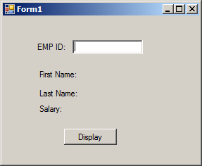
- Rename the controls and then double click the button
- Adding the imports statements
- Type the following codes:

C# Code:
OracleConnection conn = new OracleConnection("User ID=hr;password=hr;Data Source=orCL");

OracleCommand cmd = new OracleCommand("SELECT_EMP", conn);
cmd.CommandType = CommandType.StoredProcedure;
OracleParameter empid = new OracleParameter();

empid.OracleDbType = OracleDbType.Int16;
empid.Value = Convert.ToInt32(txtEMPID.Text);
empid.Direction = ParameterDirection.Input;

OracleParameter Fname = new OracleParameter();
Fname.OracleDbType = OracleDbType.Varchar2;
Fname.Size = 40;
Fname.Direction = ParameterDirection.Output;

OracleParameter Lname = new OracleParameter();
Lname.OracleDbType = OracleDbType.Varchar2;
Lname.Size = 40;
Lname.Direction = ParameterDirection.Output;

OracleParameter sal = new OracleParameter();

sal.OracleDbType = OracleDbType.Double;
sal.Direction = ParameterDirection.Output;

cmd.Parameters.Add(empid);
cmd.Parameters.Add(Fname);
cmd.Parameters.Add(Lname);
cmd.Parameters.Add(sal);

conn.Open();
cmd.ExecuteNonQuery();
conn.Close();

lblFirstName.Text = Fname.Value.ToString();
lblLastName.Text = Lname.Value.ToString();
lblSal.Text = sal.Value.ToString();

VB.NET Code:
Dim conn As New OracleConnection("User ID=hr;password=hr;Data Source=orCL")

Dim cmd As New OracleCommand("SELECT_EMP", conn)
cmd.CommandType = CommandType.StoredProcedure
Dim empid As New OracleParameter
With empid
.OracleDbType = OracleDbType.Int16
.Value = CType(txtEMPID.Text, Integer)
.Direction = ParameterDirection.Input
End With

Dim Fname As New OracleParameter
With Fname
.OracleDbType = OracleDbType.Varchar2
.Size = 40
.Direction = ParameterDirection.Output
End With

Dim Lname As New OracleParameter
With Lname
.OracleDbType = OracleDbType.Varchar2
.Size = 40
.Direction = ParameterDirection.Output
End With

Dim sal As New OracleParameter
With sal
.OracleDbType = OracleDbType.Double
.Direction = ParameterDirection.Output
End With

cmd.Parameters.Add(empid)
cmd.Parameters.Add(Fname)
cmd.Parameters.Add(Lname)
cmd.Parameters.Add(sal)

conn.Open()
cmd.ExecuteNonQuery()
conn.Close()

lblFirstName.Text = Fname.Value.ToString
lblLastName.Text = Lname.Value.ToString
lblSal.Text = sal.Value.ToString

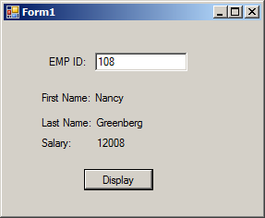

Example 8
Use the procedure created in chapter 5, example 2 to add a new job to the job table in HR schema.
1. Since this procedure has 4 input parameters, we need to design an interface similar to the following
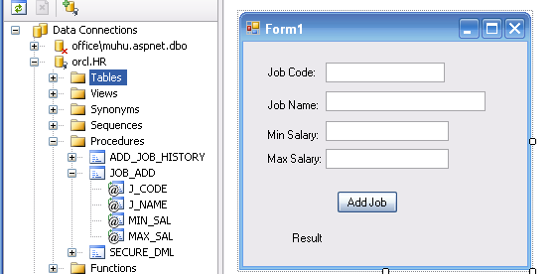
  - Type the code as below:
C# Code:

OracleConnection conn = new OracleConnection("User ID=hr;password=hr;Data Source=ORCL");
OracleCommand cmd = new OracleCommand("JOB_ADD", conn);
cmd.CommandType = CommandType.StoredProcedure;
try
{
cmd.Parameters.Add(":code", OracleDbType.Varchar2).Value = (jobCode.Text).ToString();
cmd.Parameters.Add(":name", OracleDbType.Varchar2).Value = (JobName.Text).ToString();
cmd.Parameters.Add(":minsal", OracleDbType.Varchar2).Value = (MinSal.Text).ToString();
cmd.Parameters.Add(":maxsal", OracleDbType.Varchar2).Value = (MaxSal.Text).ToString();

conn.Open();
cmd.ExecuteNonQuery();
cmd.Dispose();

this.Resultlabel.Text = "The job was added succussfully.";
}
catch (Exception ex)
{
this.Resultlabel.Text = ex.Message;
}
finally
{
if (conn.State == ConnectionState.Open)
{
conn.Close();
conn.Dispose();
}
}
VB.NET Code:

Dim conn As New OracleConnection("User ID=hr;password=hr;Data Source=ORCL")
Dim cmd As New OracleCommand("JOB_ADD", conn)
cmd.CommandType = CommandType.StoredProcedure
Try
cmd.Parameters.Add(":code", OracleDbType.Varchar2).Value = (jobCodeTextBox.Text).ToString
cmd.Parameters.Add(":name", OracleDbType.Varchar2).Value = (jobNameTextBox.Text).ToString
cmd.Parameters.Add(":minsal", OracleDbType.Varchar2).Value = (minSalaryTextBox.Text).ToString
cmd.Parameters.Add(":maxsal", OracleDbType.Varchar2).Value = (MaxSalaryTextBox.Text).ToString

conn.Open()
cmd.ExecuteNonQuery()
cmd.Dispose()

Me.resultLabel.Text = "The job was added succussfully."
Catch ex As Exception
Me.resultLabel.Text = ex.Message
Finally
If conn.State = ConnectionState.Open Then
conn.Close()
conn.Dispose()
End If
End Try
- Run the application and test it the values: CS_PROF, computer science professor, 75000, 130000.
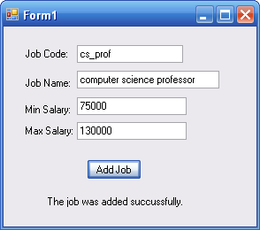

5. Using the DataSet Class with ODP.NET
The DataSet class encapsulates a memory-resident representation of data that provides a consistent relational programming model for multiple data sources. Note that DataSet object requires Data Adaptor object, which provides four properties that represent database commands: SelectCommand, InsertCommand, DeleteCommand, and UpdateCommand.
Example 9
In this example, we will create a windows application that uses datagridview and two buttons to display and save changes of data from department table under HR schema.
- Add a new form.
- In the design view, add a DataGridView to the form and name it as departmentsDataGridView.
- Drag and drop two Buttons onto the Form. Change the text of one button to Retrieve and name to retrieveButton. Change the text of the other textbox to Save and name to saveButton
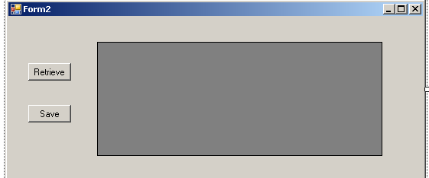
- Add variable declarations to the class variables.
private string oradb = "data source =orcl;user id=hr;password=hr";
private OracleConnection conn;
private OracleCommand cmd;
private OracleDataAdapter da;
private DataSet ds;
- Double click Retrieve button and open retrieveButton_Click method()
C# Code:
public Form1()
{
InitializeComponent();
saveButton.Enabled = false;
}

public void button1_Click(object sender, EventArgs e)
{
conn = new OracleConnection(oradb);
cmd = new OracleCommand("select * from departments", conn);
da = new OracleDataAdapter(cmd);
conn.Open();
retrieveButton.Enabled = false;
ds =new DataSet();
da.Fill(ds);
da.UpdateCommand = new OracleCommandBuilder(da).GetUpdateCommand();

departmentdataGridView.DataSource = ds.Tables[0];
conn.Close();
saveButton.Enabled = true;
}

private void saveButton_Click(object sender, EventArgs e)
{
conn.Open();
da.Update(ds.Tables[0]);
conn.Close();
}

VB.NET Code:
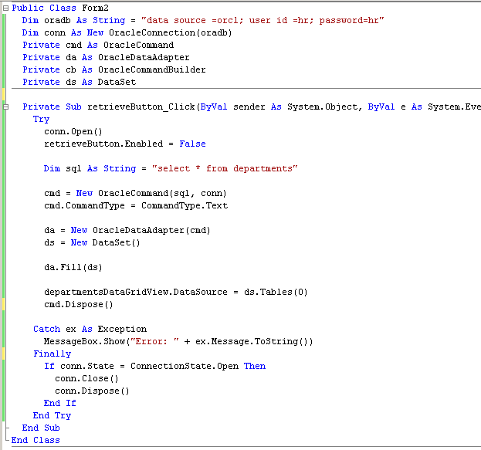
- Run the application and test the code
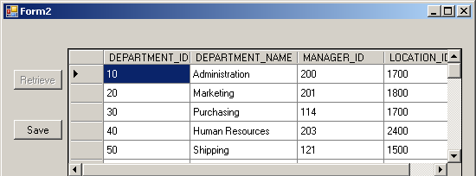
- Double click Save button and open save_Click method()
conn.Open()
da.Update(ds.Tables(0))
conn.Close()
conn.Dispose()
- Run the application
- Remove the connection dispose from retrieveButton_click method and add the following line of code after initiating the DataAdapter
cb = New OracleCommandBuilder(da)
- Save the Form and Run the application using the F5 keyboard shortcut.
Note:
The OracleDataAdapter does not automatically generate the SQL statements required to reconcile changes made to a DataSet associated with the database. However, you can create an OracleCommandBuilder object that generates SQL statements for single-table updates by setting the SelectCommand property of the OracleDataAdapter. Then, the OracleCommandBuilder generates any additional SQL statements that you do not set.

6. Using Ref Cursors and Packages
A ref cursor is a PL/SQL datatype. Using PL/SQL datatypes permits you to work with a single variable that is of the correct datatype for both a table in the database and the programming language being used. If you want to return a result set from PL/SQL code to a client, you should use a ref cursor.
What Is a Ref Cursor?
A Ref Cursor is an address that represents the memory location of a query work area on the database server. In ADO .NET code, it is represented via the OracleRefCursor class, which is exposed by Oracle Data Provider for .NET in the Oracle.DataAccess.Types namespace.
The OracleRefCursor class is a simple class that has no constructor and can not be instantiated in the standard manner. Instead, you create an instance of the OracleParameter class and set the OracleDbType property to a value of RefCursor.
Oracle Server
Ref Cursor
ADO.NET
Application
OracleRefCursor

Example 10

This example is retrieve data from product table in the SaleCo database based upon the input product code from textbox. The procedure will use ref cursor.

1. Create the stored procedure using sys_refcursor as following

PROCEDURE "GROUP1"."PRODUCT_PROCEDURE" (
"CODE" IN VARCHAR2, "P_CURSOR" OUT sys_refcursor) IS
BEGIN
Open P_CURSOR for
select * from product where P_CODE = CODE;
END "PRODUCT_PROCEDURE";

2. Create the user interface
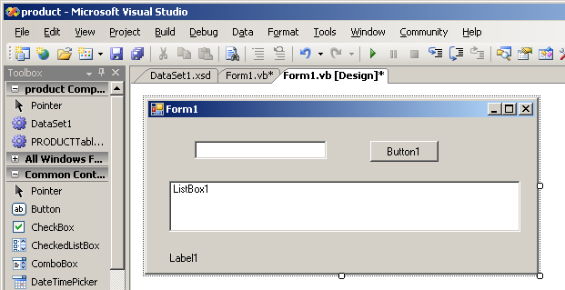
- Coding the program by double-click the button and add the following code.
C# Code:
string oradb = "data source = orcl; user id =mike; password=loin";
OracleConnection conn = new OracleConnection(oradb);
OracleCommand cmd = new OracleCommand("PRODUCT_PROCEDURE", conn);
cmd.CommandType = CommandType.StoredProcedure;

OracleParameter p_code = new OracleParameter();
var _with1 = p_code;
_with1.OracleDbType = OracleDbType.Varchar2;
_with1.Value = Convert.ToString(txtcode.Text);
_with1.Direction = ParameterDirection.Input;

OracleParameter p_cursor = new OracleParameter();
var _with2 = p_cursor;
_with2.OracleDbType = OracleDbType.RefCursor;
_with2.Direction = ParameterDirection.Output;

cmd.Parameters.Add(p_code);
cmd.Parameters.Add(p_cursor);

conn.Open();
OracleDataReader dr = cmd.ExecuteReader();
try {
while ((dr.Read())) {
ListBox1.Items.Add(dr.Item(0) + " " + dr.Item(1) + " " + dr.Item(2) + " " + dr.Item(3) + " " + dr.Item(4) + " " + dr.Item(5));
}
Label1.Text = "success";
} catch (Exception ex) {
Label1.Text = ex.Message;
} finally {
if (conn.State == ConnectionState.Open) {
conn.Close();
conn.Dispose();
}
}

Dim oradb As String = "data source = orcl; user id =mike; password=lion"
Dim conn As New OracleConnection(oradb)
Dim cmd As OracleCommand = New OracleCommand("PRODUCT_PROCEDURE", conn)
cmd.CommandType = CommandType.StoredProcedure

Dim p_code As New OracleParameter()
With p_code
.OracleDbType = OracleDbType.Varchar2
.Value = CType(txtcode.Text, String)
.Direction = ParameterDirection.Input
End With

Dim p_cursor As New OracleParameter
With p_cursor
.OracleDbType = OracleDbType.RefCursor
.Direction = ParameterDirection.Output
End With

cmd.Parameters.Add(p_code)
cmd.Parameters.Add(p_cursor)

conn.Open()
Dim dr As OracleDataReader = cmd.ExecuteReader()
Try
While (dr.Read())
ListBox1.Items.Add(dr.Item(0) & " " & dr.Item(1) & " " & dr.Item(2) & " " & dr.Item(3) & " " & dr.Item(4) & " " & dr.Item(5))
End While
Label1.Text = "success"
Catch ex As Exception
Label1.Text = ex.Message
Finally
If conn.State = ConnectionState.Open Then
conn.Close()
conn.Dispose()
End If
End Try

4. Test the application
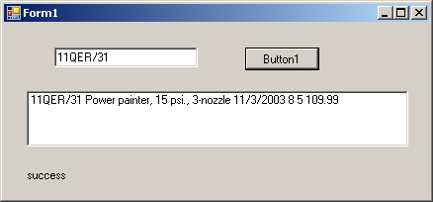
Create a PL/SQL Package
You will be working with the HR sample schema. This sample application will retrieve a subset of the columns and rows in the EMPLOYEES table in the HR schema. You will work with both function return values and output parameters of a procedure. In PL/SQL, sys_refcursor is a built in type.

1. Login iSQL*Plus as HR and create the PL/SQL package and package body.
create or replace package orcl_ref_cursor as
function emp_info return sys_refcursor;
procedure emp_info(p_rc out sys_refcursor);
end;

create or replace package body orcl_ref_cursor as
function emp_info return sys_refcursor is
all_cursor sys_refcursor;
begin
open all_cursor for
select * from employees;
return all_cursor;
end;

procedure emp_info (p_rc out sys_refcursor) is
begin
open p_rc for
select employee_id, last_name, first_name
from employees where last_name like 'A%'
order by last_name, first_name;
end;
end;

Steps to use a Ref Cursor:
1. After creation of the OracleCommand object, an OracleParameter object is created. It is the OracleParameter object that will represent the ref cursor in the .NET code. You set the ParameterDirection property to an appropriate value, based on whether you are calling a function or a procedure in the PL/SQL package you created earlier. The parameter is then added to the collection for the command object and executed.
2. The ref cursor is then accessed as either an OracleDataReader object or a DataSet, by use of the OracleDataAdapter class.
Example 11
The example is designed to invoke the emp_info function in the PL/SQL package.
1. In Visual studio, add a new form with a button and a DataGridView.
2. Type the following codes
Dim conn As New OracleConnection("Data Source=orcl;User Id=hr; Password=hr;")
Dim cmd As New OracleCommand("ORCL_REF_CURSOR.EMP_INFO", conn)
cmd.CommandType = CommandType.StoredProcedure

Dim p_cursor As New OracleParameter
With p_cursor
.OracleDbType = OracleDbType.RefCursor
.Direction = ParameterDirection.ReturnValue
End With
cmd.Parameters.Add(p_cursor)
conn.Open()
Dim da As OracleDataAdapter = New OracleDataAdapter(cmd)
Dim ds As DataSet = New DataSet
da.Fill(ds)
DataGridView1.DataSource = ds.Tables(0)

da.Dispose()
ds.Dispose()
cmd.Dispose()
conn.Close()
3. Run the application

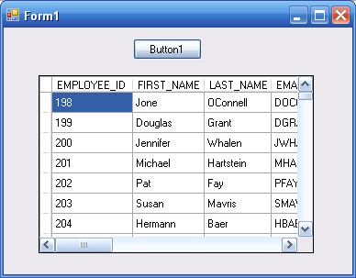
Example 12

This example is to use DataReader for the returned value from a cursor in emp_info procedure.

1. Add a form with a button and a listbox.
2. Enter the code below:

Dim conn As New OracleConnection("Data Source=orcl;User Id=hr; Password=hr;")
Dim cmd As New OracleCommand("ORCL_REF_CURSOR.EMP_INFO", conn)
cmd.CommandType = CommandType.StoredProcedure

Dim p_rc As New OracleParameter
With p_rc
.OracleDbType = OracleDbType.RefCursor
.Direction = ParameterDirection.Output
End With

cmd.Parameters.Add(p_rc)

conn.Open()
Dim dr As OracleDataReader = cmd.ExecuteReader()
While dr.Read()
ListBox1.Items.Add(dr.Item(0) & " " & dr.Item(1) & " " & dr.Item(2))
End While

cmd.Dispose()
dr.close()
conn.Close()
3. Run the application

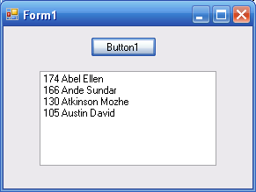

Example 13

This example is to show how to get employee names and their department based on the input parameter employee number under HR schema

- In the Oracle explore window, right click Packages and select New package

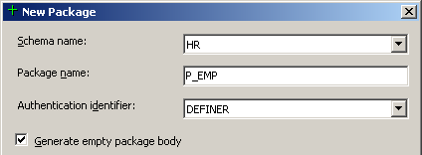

2. Enter the name, check the box “Generate empty package body, and click Add button to add methods (Both functions and procedures are considered methods here)

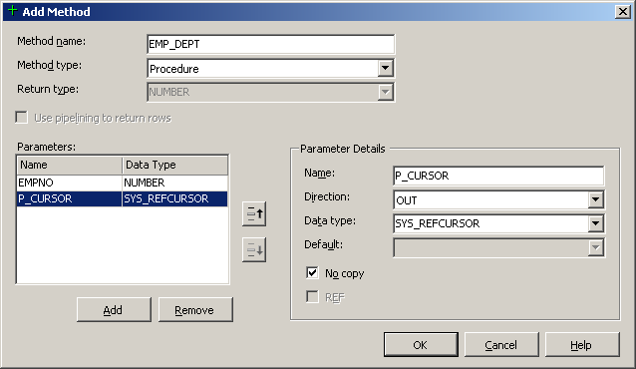

3. Enter the method name and type.
4. Click Add button to add parameters. After enter parameters, click OK
5. Modify the package body as below and save it.
PACKAGE BODY "HR"."P_EMP" IS
PROCEDURE "EMP_DEPT" ("EMPNO" IN NUMBER,
"P_CURSOR" OUT NOCOPY SYS_REFCURSOR) IS
BEGIN
OPEN P_CURSOR FOR
SELECT E.EMPLOYEE_ID, E.FIRST_NAME, E.LAST_NAME, D.DEPARTMENT_ID, D.DEPARTMENT_NAME
FROM EMPLOYEES E, DEPARTMENTS D
WHERE E.DEPARTMENT_ID = D.DEPARTMENT_ID
AND E.EMPLOYEE_ID = EMPNO;
END "EMP_DEPT";

END "P_EMP";

6. To test the package, right click the procedure P_EMP and choose RUN
7. In the value cell of parameter table, input 198 and click the link for detail.
8. In Visual Studio, add a form with a button, a textbox, dataGridView, and a label
9. Add the following code to the Button1_click event:

Dim conn As New OracleConnection("Data Source=orcl;User Id=hr; Password=hr;")
Dim cmd As New OracleCommand("P_EMP.EMP_DEPT", conn)
cmd.CommandType = CommandType.StoredProcedure

Dim p_empno As New OracleParameter
With p_empno
.OracleDbType = OracleDbType.Int16
.Direction = ParameterDirection.Input
.Value = TextBox1.Text
End With

Dim p_rc As New OracleParameter
With p_rc
.OracleDbType = OracleDbType.RefCursor
.Direction = ParameterDirection.Output
End With

cmd.Parameters.Add(p_empno)
cmd.Parameters.Add(p_rc)
Try
conn.Open()
Dim da As New OracleDataAdapter(cmd)
Dim ds As New DataSet
da.Fill(ds)
DataGridView1.DataSource = ds.Tables(0)
Catch ex As Exception
errorLabel.text = ex.Message

cmd.Dispose()
conn.Close()
End Try

9. Run the application

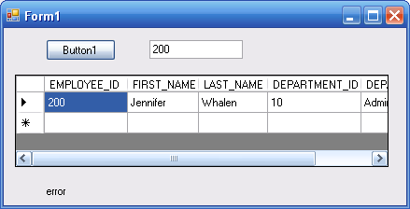

Exercises:

- Create a stored procedure in HR schema that can update the product price in P table.

- Design a Windows form application that uses a stored procedure to retrieve employee’s name, job, and salary from emp table in SCOTT schema. The procedure uses empnum as input parameter.

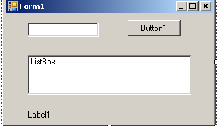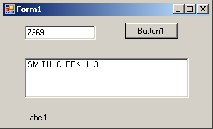

3. Design a Window Form Application using two parameters to execute the stored procedure P_INCREASE_SAL to update the salary of employee’s in scott schema. Using the following interface.

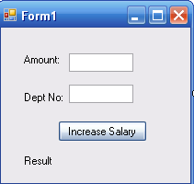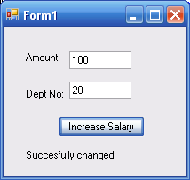

4. Create a package with one stored procedure, which can retrieve information from product table under schema group1 (SaleCo) given the product code. Then create a windows Form application to use this package.

