Project Design Phase-II
Data Flow Diagram & User Stories
Date | 12 February 2026
Team ID | LTVIP2026TMIDS65779
Project Name | Online Payments Fraud Detection using  Machine Learning
Maximum Marks | 4 Marks

Data Flow Diagram (DFD - Level 0)
User Type | Epic | User  Story No. | User Story / Task | Acceptance Criteria | Priority | Release
Online  Customer | Transaction Security | USN-1 | As a user, I can make  online payments securely. | Transaction is classified as fraud or legitimate instantly. | High | Sprint-1
Online | Alerts | USN-2 | As a user, I | Fraudulent | High | Sprint-1
A Level-0 DFD illustrates how data flows between the user, payment system, preprocessing layer, machine learning fraud detection model, and transaction database.
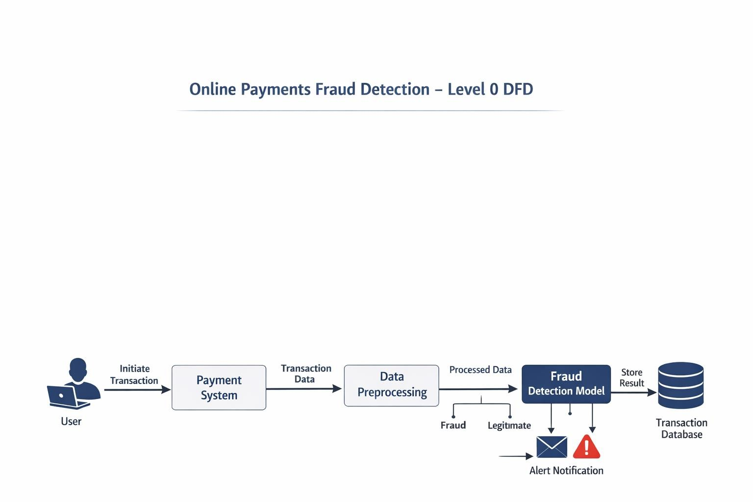

User Stories
Customer |  |  | receive alerts for suspicious transactions. | transactions trigger instant notification.
Fraud Analyst | Monitoring | USN-3 | As an analyst, I can view flagged fraudulent transactions. | Dashboard shows fraud probability and transaction details. | High | Sprint-2
Risk  Manager | Reporting | USN-4 | As a manager, I can view fraud statistics and trends. | System generates daily/weekly  fraud reports. | Medium | Sprint-2
Admin | Model  Management | USN-5 | As an admin, I can update or retrain the ML model. | Updated model deploys without  affecting system performance. | Medium | Sprint-3

