Python Activity-Based Learning
1.
Attendance Recovery Computation: Calculate current attendance percentages and determine the minimum consecutive classes required to reach an eligibility threshold under different future attendance scenarios.
Sol:
Problem statement
Calculate a student's current attendance percentage and determine the minimum number of consecutive classes the student must attend to reach a required attendance percentage.
Objectives
- Calculate attendance percentage.
- Use a loop to find the minimum future classes needed.
- Display a clear eligibility result.
Assumptions
- Classes held and classes attended are non-negative integers.
- Classes attended cannot exceed classes held.
- The required percentage is between 0 and 100.
Algorithm
1. Read classes held, classes attended, and required percentage.
2. Validate the inputs.
3. Calculate current attendance percentage.
4. If the target is already reached, print 0 additional classes.
5. Otherwise, repeatedly add one attended class and one held class until the target is reached.
6. Print the percentage and additional classes needed.
Pseudocode
1. START
2. Read Input held, attended, target
3. if held < 0 OR attended < 0 OR attended > held OR target < 0 OR target > 100:
print Invalid input
4. else:
if held == 0:
current = 0
else:
current = attended / held * 100
5. Set extra = 0
6. Now, while (attended + extra) / (held + extra) * 100 < target:
extra+=1
7. print percentage, extra
8. STOP
Flowchart
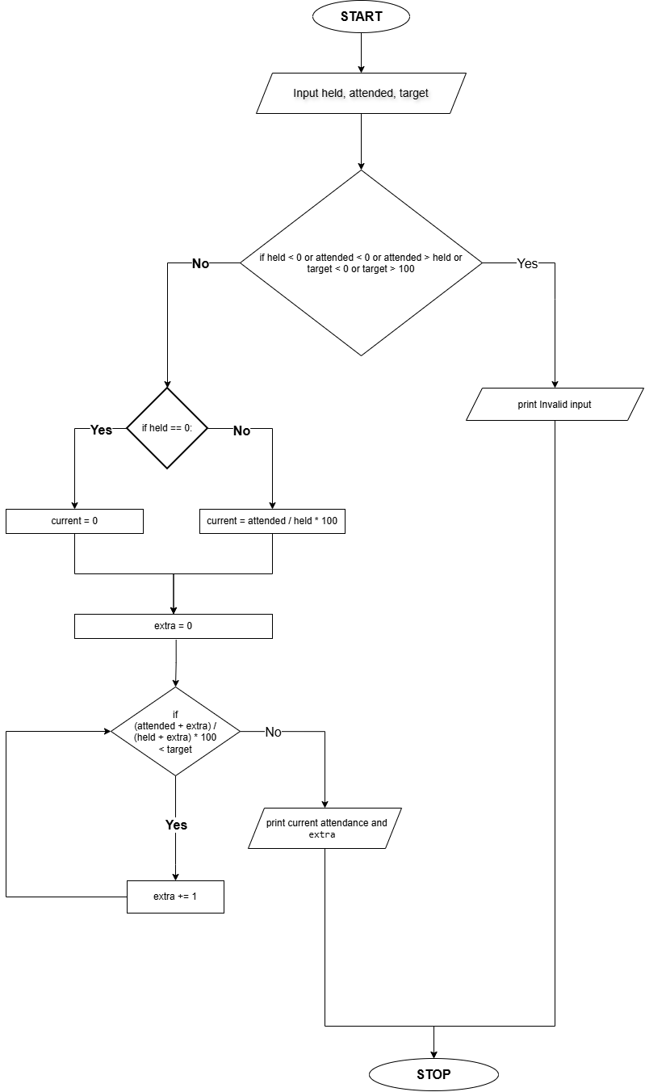
Source Code
held = int(input("Enter total classes held: "))
attended = int(input("Enter classes attended: "))
target = float(input("Enter required attendance percentage: "))

if held < 0 or attended < 0 or attended > held or target < 0 or target > 100:
print("Invalid input.")
else:
if held == 0:
current = 0
else:
current = attended / held * 100
extra = 0
while (attended + extra) / (held + extra) * 100 < target:
extra += 1
print(f"Current attendance: {current:.2f}%")
print("Additional classes to attend:", extra)
Test Cases
➢ Input: 40; 32; 75
o Expected result: Current attendance: 80.0 %; Additional classes to attend: 0
➢ Input: 20; 12; 75
o Expected result: Current attendance: 60.0 %; Additional classes to attend: 12
➢ Input: 10; 10; 75
o Expected result: Current attendance: 100.0 %; Additional classes to attend: 0
Output
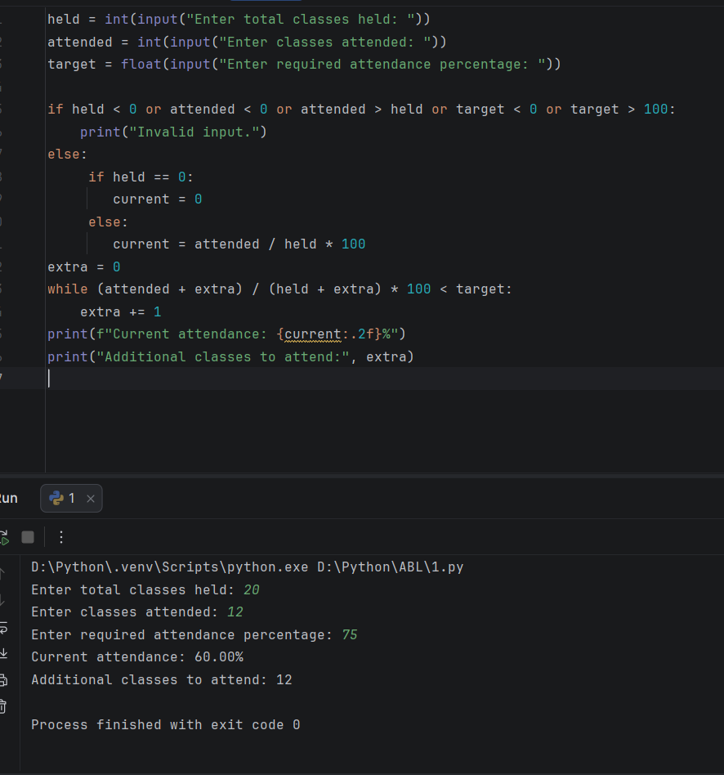
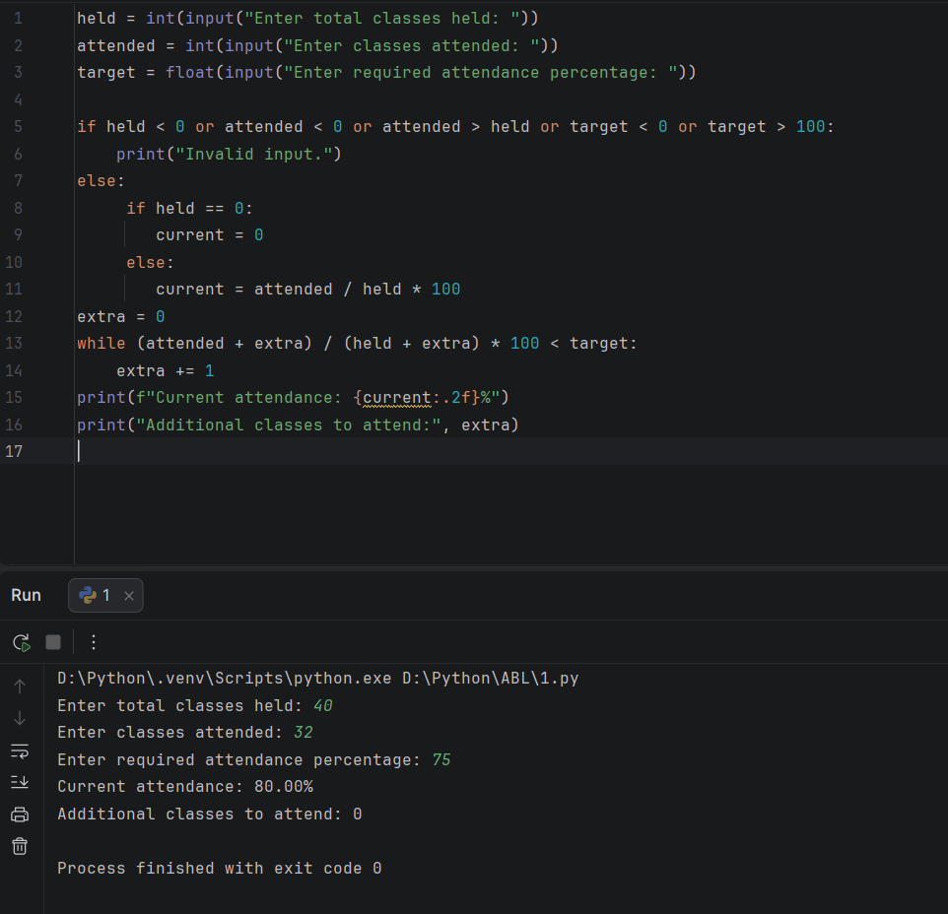
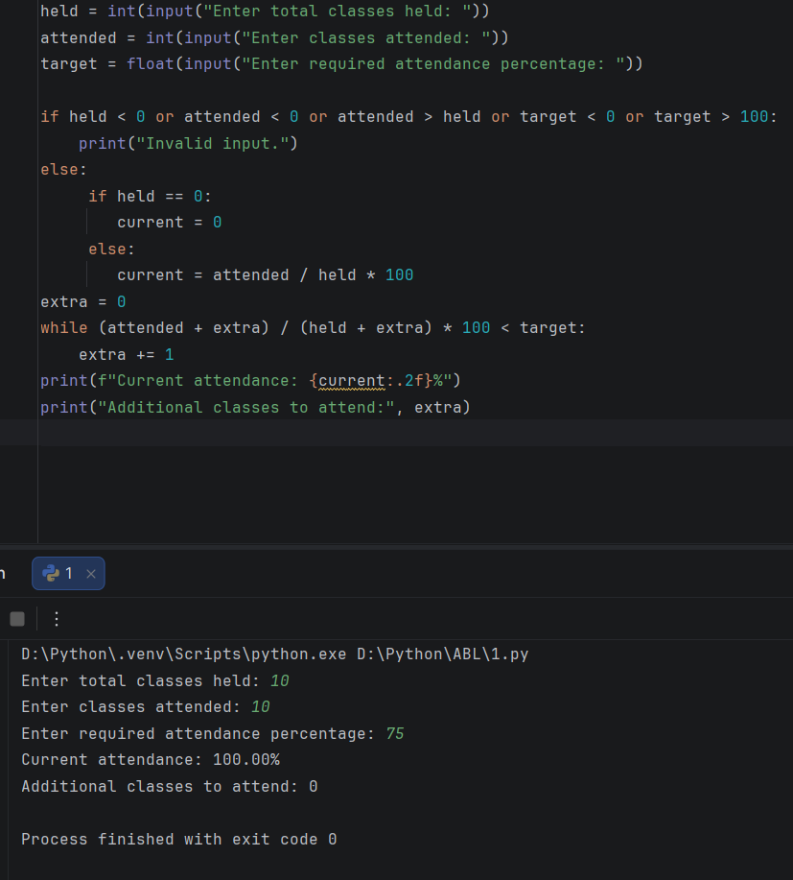
Conclusion
The program calculates attendance and uses repetition to find the minimum number of future classes required to reach the target.
2.
ATM Transaction Sequence Simulation: Process a sequence of deposits and withdrawals, maintain a simulated balance, enforce withdrawal limits, reject invalid transactions, and produce a transaction summary.
Sol:
Problem statement
Develop a Python program that processes a sequence of ATM deposits and withdrawals, updates the account balance, rejects invalid transactions, and displays a transaction summary.
Objectives
- Perform deposits and withdrawals.
- Maintain the current balance.
- Reject invalid or unaffordable transactions.
- Count successful and rejected transactions.
Assumptions
- The starting balance cannot be negative.
- The transaction type is D for deposit or W for withdrawal.
- Each transaction amount must be positive.
- Withdrawals cannot exceed the available balance.
Algorithm
1. Start.
2. Input the starting balance and number of transactions.
3. Set successful and rejected transaction counts to zero.
4. Repeat for each transaction.
5. Input the transaction type and amount.
6. If the transaction is valid, update the balance and successful count.
7. Otherwise, increase the rejected count.
8. Display the final balance and transaction counts.
9. Stop.
Flowchart
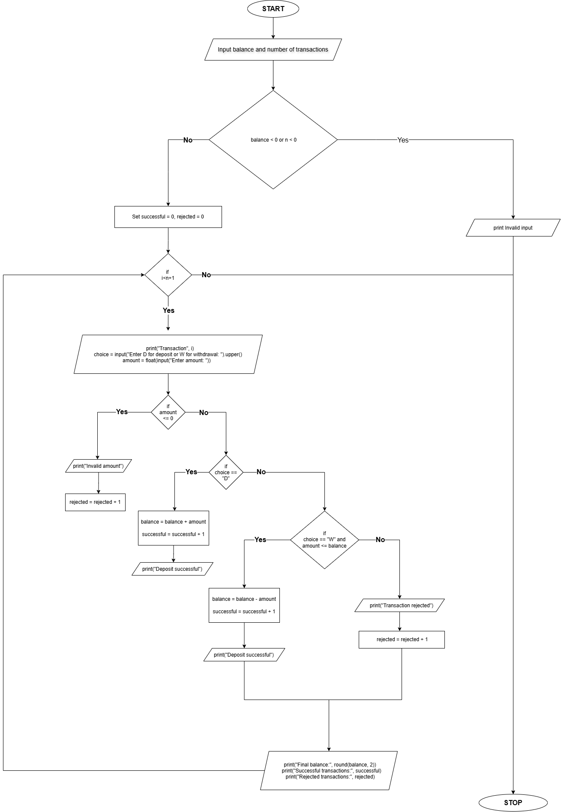
Pseudocode
START
INPUT balance, n
SET successful = 0
SET rejected = 0
REPEAT n times
INPUT type, amount
IF amount <= 0
rejected = rejected + 1
ELSE IF type = "D"
balance = balance + amount
successful = successful + 1
ELSE IF type = "W" AND amount <= balance
balance = balance - amount
successful = successful + 1
ELSE
rejected = rejected + 1
PRINT final balance
PRINT successful transactions
PRINT rejected transactions
END
Source Code
balance = float(input("Enter starting balance: "))
n = int(input("How many transactions? "))
if balance < 0 or n < 0:
print("Invalid input.")
else:
successful = 0
rejected = 0
for i in range(1, n + 1):
print("Transaction", i)
choice = input("Enter D for deposit or W for withdrawal: ").upper()
amount = float(input("Enter amount: "))
if amount <= 0:
print("Invalid amount")
rejected = rejected + 1
elif choice == "D":
balance = balance + amount
successful = successful + 1
print("Deposit successful")
elif choice == "W" and amount <= balance:
balance = balance - amount
successful = successful + 1
print("Withdrawal successful")
else:
print("Transaction rejected")
rejected = rejected + 1
print("Final balance:", round(balance, 2))
print("Successful transactions:", successful)
print("Rejected transactions:", rejected)
Test Cases
1. Enter starting balance: 1000
How many transactions? 2
Transaction 1
Enter D for deposit or W for withdrawal: D
Enter amount: 500
Transaction 2
Enter D for deposit or W for withdrawal: W
Enter amount: 200
Output:
Transaction 1
Deposit successful
Transaction 2
Withdrawal successful
Final balance: 1300.0
Successful transactions: 2
Rejected transactions: 0
2. Enter starting balance: 500
How many transactions? 2
Transaction 1
Enter D for deposit or W for withdrawal: W
Enter amount: 700
Transaction 2
Enter D for deposit or W for withdrawal: D
Enter amount: 200
Output
Transaction 1
Transaction rejected
Transaction 2
Deposit successful
Final balance: 700.0
Successful transactions: 1
Rejected transactions: 1
Output
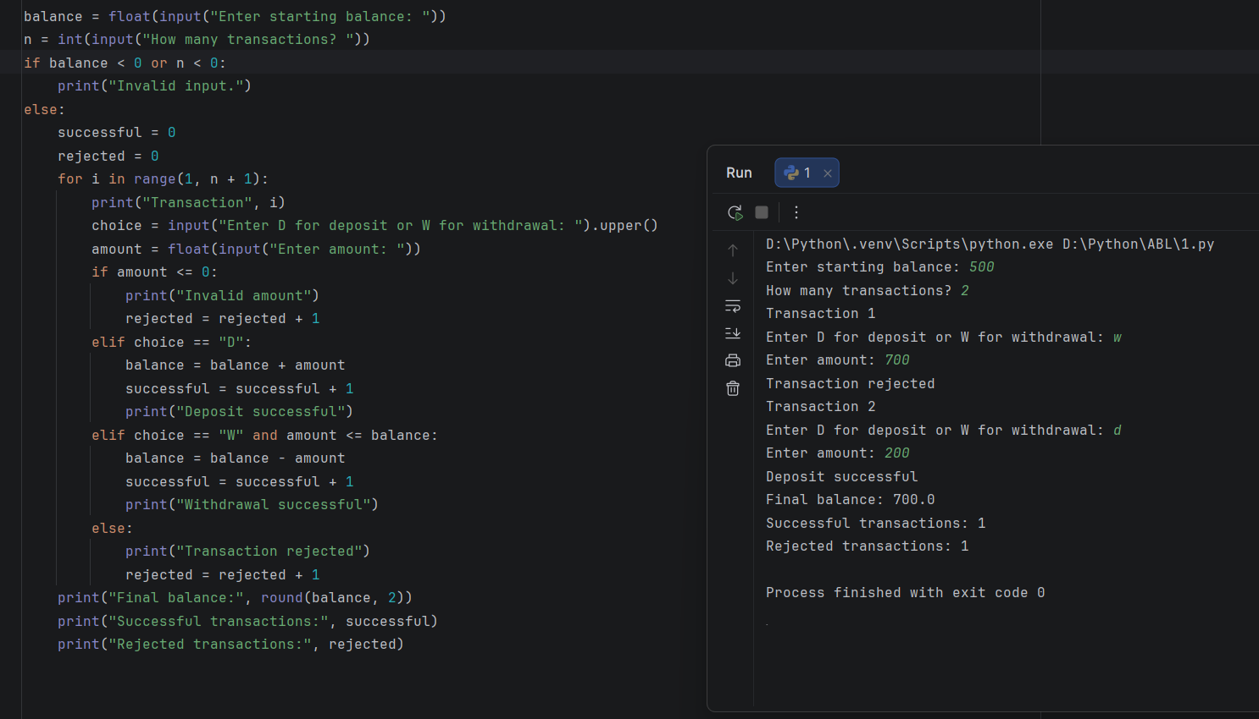
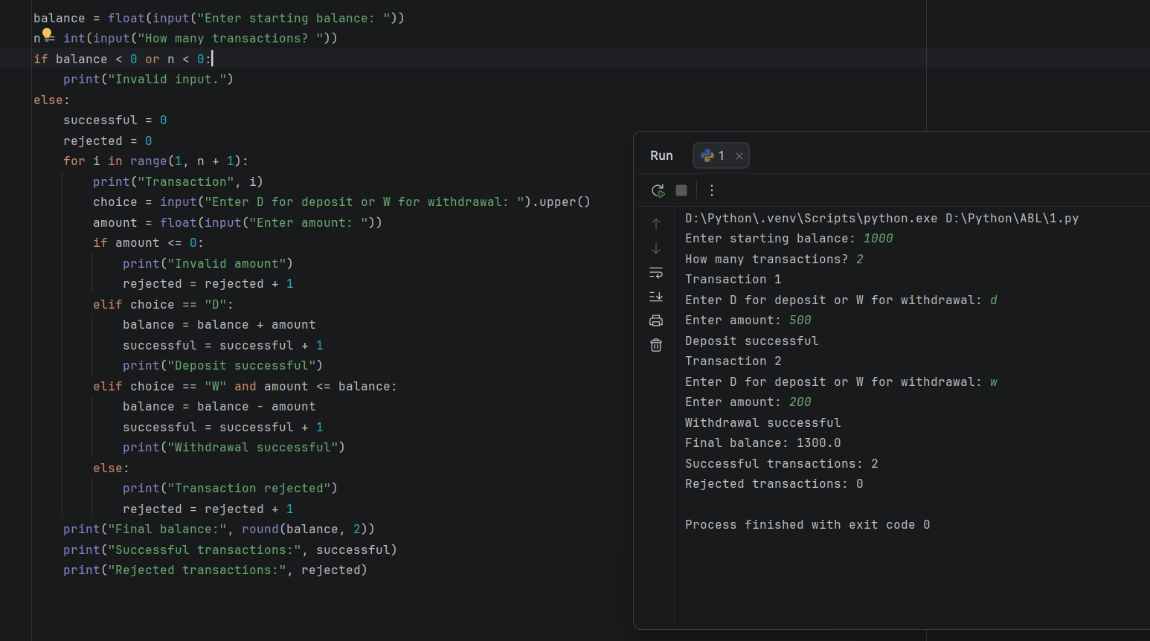
Conclusion
The program simulates ATM transactions using loops, conditions, and arithmetic operations. It also tracks successful and rejected transactions.
3.
Student Performance Trend Analysis: Compare assessment scores across multiple examinations, calculate improvements and declines, identify consistently weak subjects, and classify students according to defined criteria.
Sol:
Problem statement
Compare assessment scores across examinations, calculate improvements and declines, identify weak subjects, and classify students.
Objectives
- Calculate score changes.
- Identify weak subjects.
- Classify performance.
Assumptions
- Three subjects and two examinations are considered.
- Scores range from 0 to 100.
- A subject is weak if the latest score is below 40.
- Average score of 75 or more is classified as Good; otherwise, Needs Improvement.
Algorithm
1. Input the student's name.
2. Input earlier and latest scores for three subjects.
3. Calculate the average latest score.
4. Calculate each subject's score change.
5. Identify weak subjects.
6. Classify overall performance.
7. Display the report.
Flowchart
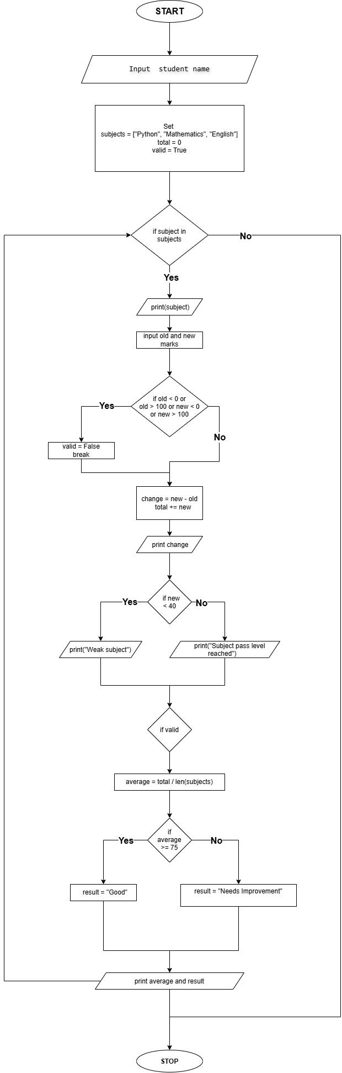
Pseudocode
START
INPUT student name
FOR each subject
INPUT earlier and latest marks
CALCULATE change
CHECK weak subject
END FOR
CALCULATE average
IF average >= 75
classification = Good
ELSE
classification = Needs Improvement
END IF
DISPLAY report
STOP
Source Code
name = input("Student name: ")
subjects = ["Python", "Mathematics", "English"]
total = 0
valid = True
for subject in subjects:
print(subject)
old = int(input("Earlier marks: "))
new = int(input("Latest marks: "))
if old < 0 or old > 100 or new < 0 or new > 100:
valid = False
print("Invalid marks")
break
change = new - old
total += new
print("Change:", change)
if new < 40:
print("Weak subject")
else:
print("Subject pass level reached")

if valid==True:
average = total / len(subjects)
if average >= 75:
result = "Good"
else:
result = "Needs Improvement"
print("Average:", average)
print("Performance:", result)
Test Cases
1. Student name:Mikasa
Python
Earlier marks: 60
Latest marks: 80
Mathematics
Earlier marks: 70
Latest marks: 85
English
Earlier marks: 65
Latest marks: 90
Output
Python
Change: 20
Subject pass level reached
Mathematics
Change: 15
Subject pass level reached
English
Change: 25
Subject pass level reached
Average: 85.0
Performance: Good
2. Student name:Shadow
Python
Earlier marks: 50
Latest marks: 35
Mathematics
Earlier marks: 60
Latest marks: 55
English
Earlier marks: 70
Latest marks: 60
Output
Python
Change: -15
Weak subject
Mathematics
Change: -5
Subject pass level reached
English
Change: -10
Subject pass level reached
Average: 50.0
Performance: Needs Improvement
Output
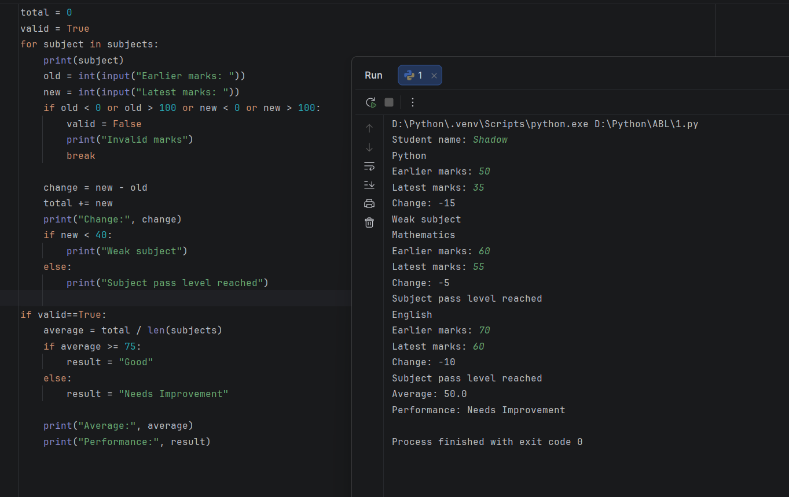
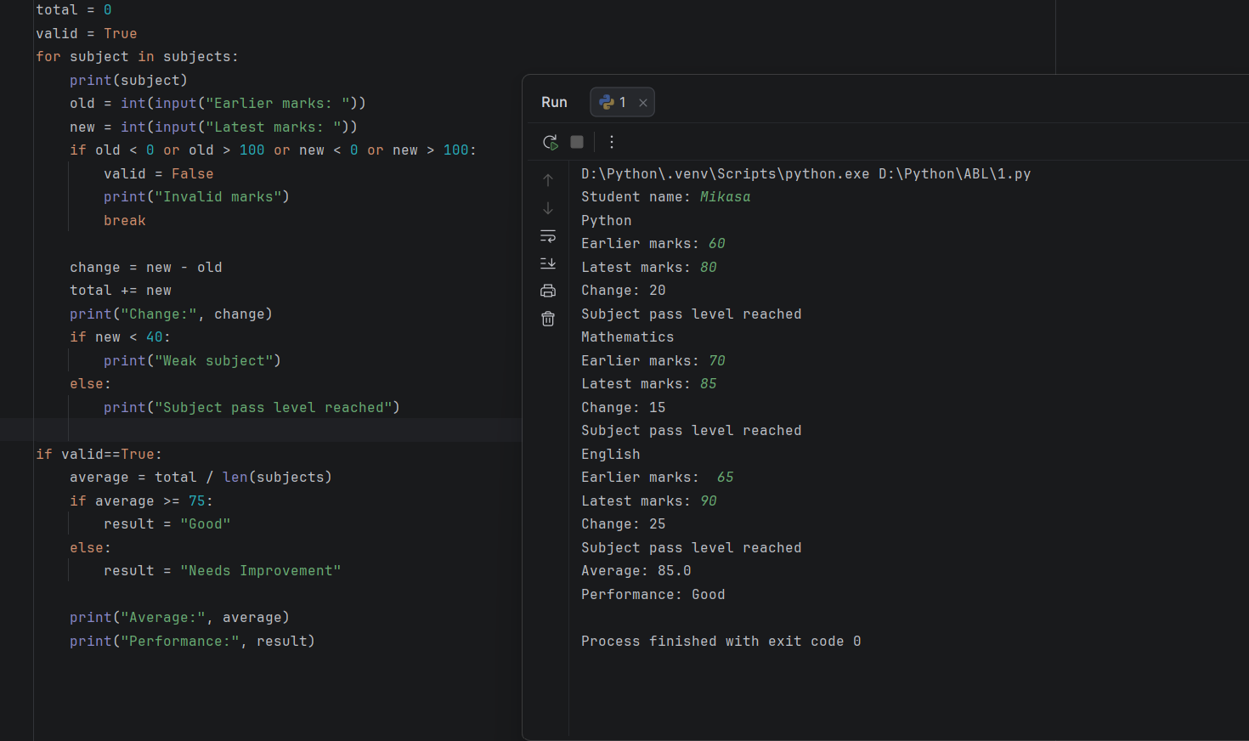
Conclusion
The program analyses student performance across examinations and identifies improvements, declines and weak subjects.
4.
Repeated Transaction Detection: Process transaction identifiers and amounts in a list, detect duplicate transactions, identify threshold violations, and generate a list of suspicious entries.
Sol:
Problem statement
Develop a Python program to store transaction identifiers and amounts in lists, detect repeated transaction IDs or amounts exceeding a specified limit, and display all suspicious transactions.
Objectives
- Read and store transaction identifiers and amounts in lists.
- Detect duplicate transaction identifiers and high-value threshold violations.
- Generate and display a list of suspicious entries.
Assumptions
- The number of transactions and threshold limit must be positive.
- Each transaction amount must be greater than zero.
- A transaction is flagged if its ID has appeared earlier or its amount exceeds the threshold.
Algorithm
1. Start.
2. Read the number of transactions and the high-value threshold.
3. Validate the inputs.
4. Initialize empty lists for seen IDs, amounts, and suspicious entries.
5. For each transaction, read the transaction ID and amount.
6. Check if the ID is already in the IDs list or if the amount exceeds the limit.
7. If either condition holds, append the transaction tuple to the suspicious list.
8. Display the total count and details of suspicious entries.
9. Stop.
Flowchart
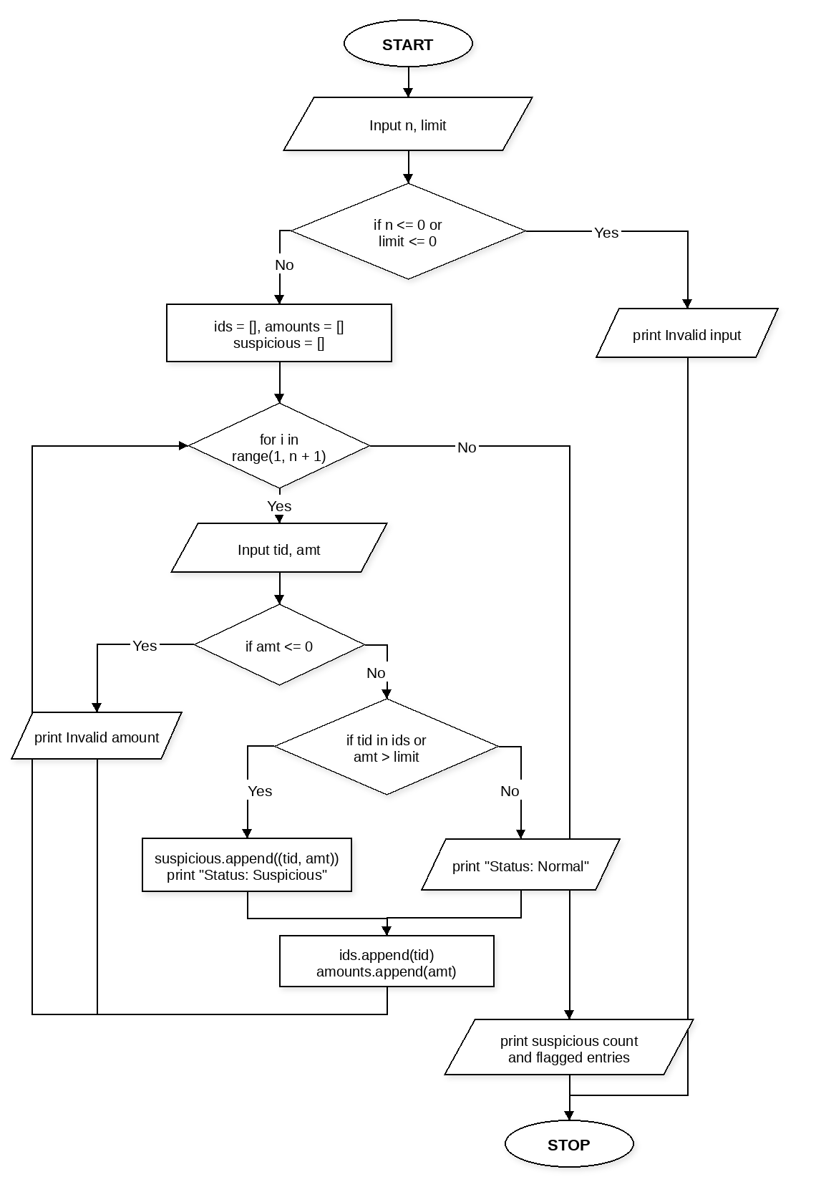
Pseudocode
START
INPUT n, limit
IF n <= 0 OR limit <= 0
PRINT "Invalid input."
ELSE
SET ids = [], amounts = [], suspicious = []
FOR i from 1 to n
INPUT tid, amt
IF amt <= 0
PRINT "Invalid amount"
ELSE
IF tid in ids OR amt > limit
APPEND (tid, amt) to suspicious
PRINT "Status: Suspicious"
ELSE
PRINT "Status: Normal"
APPEND tid to ids
APPEND amt to amounts
PRINT length of suspicious
FOR each (t_id, t_amt) in suspicious
PRINT t_id, t_amt
STOP
Source Code
n = int(input("Enter number of transactions: "))
limit = float(input("Enter high-value threshold: "))
if n <= 0 or limit <= 0:
print("Invalid input.")
else:
ids = []
amounts = []
suspicious = []
for i in range(1, n + 1):
tid = input("Transaction " + str(i) + " ID: ")
amt = float(input("Transaction " + str(i) + " amount: "))
if amt <= 0:
print("Invalid amount")
else:
if tid in ids or amt > limit:
suspicious.append((tid, amt))
print("Status: Suspicious")
else:
print("Status: Normal")
ids.append(tid)
amounts.append(amt)
print("Suspicious count:", len(suspicious))
for item in suspicious:
t_id, t_amt = item
print("Flagged:", t_id, "Rs.", t_amt)
Test Cases
1. Enter number of transactions: 3
Enter high-value threshold: 5000
Transaction 1 ID: TX101
Transaction 1 amount: 1200
Transaction 2 ID: TX101
Transaction 2 amount: 1200
Transaction 3 ID: TX102
Transaction 3 amount: 6500
Output:
Status: Normal
Status: Suspicious
Status: Suspicious
Suspicious count: 2
Flagged: TX101 Rs. 1200.0
Flagged: TX102 Rs. 6500.0
2. Enter number of transactions: 2
Enter high-value threshold: 3000
Transaction 1 ID: TX201
Transaction 1 amount: 800
Transaction 2 ID: TX202
Transaction 2 amount: 1500
Output:
Status: Normal
Status: Normal
Suspicious count: 0
Output
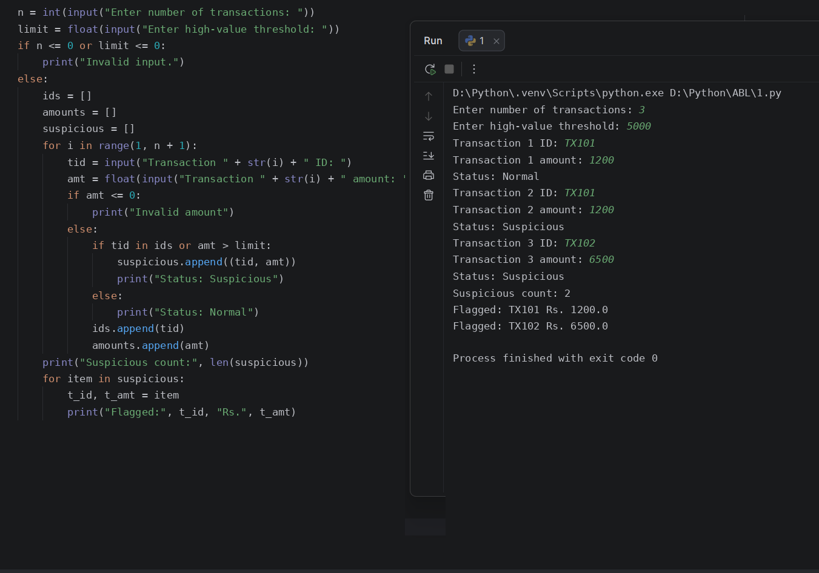
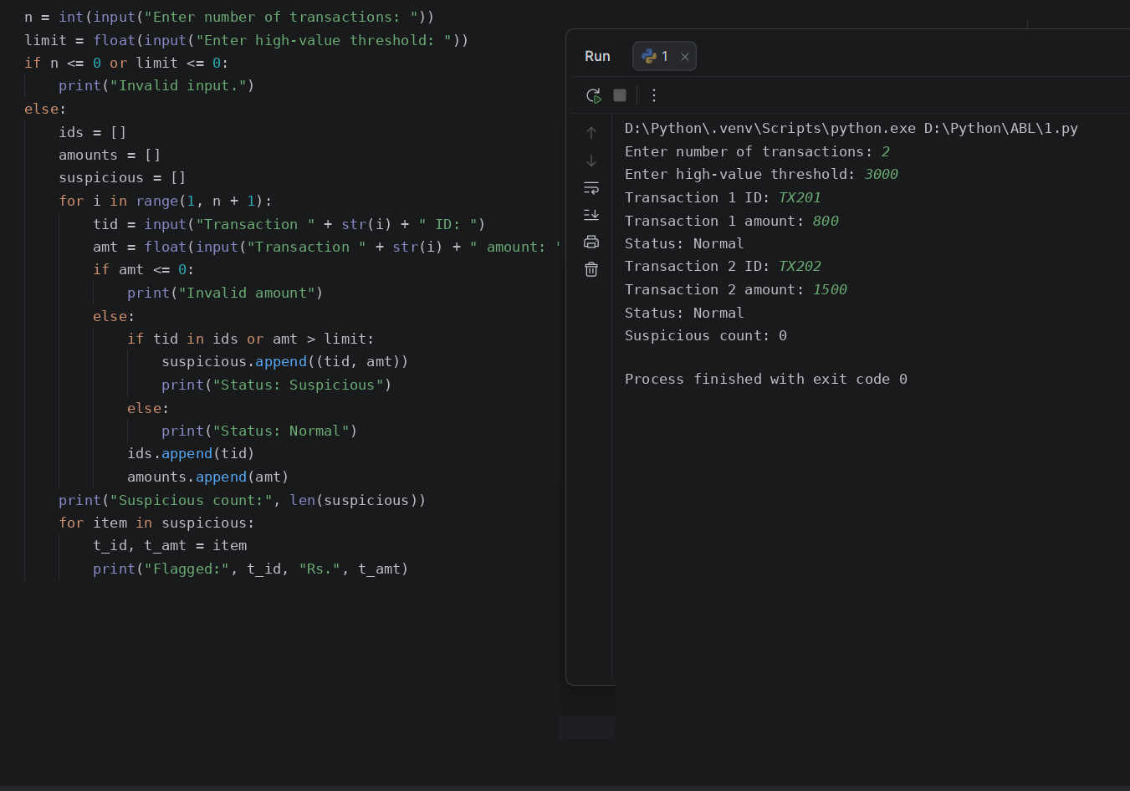
Conclusion
The program processes transaction records using lists and tuples to detect duplicate identifiers and threshold violations.
5.
Food Waste Monitoring System: Compare prepared meals, meals served, and leftovers across several days; calculate wastage percentages and identify days exceeding acceptable limits.
Sol:
Problem statement
Compare the number of meals prepared, meals served, and leftovers over several days; calculate waste percentages and identify days that exceed an acceptable limit.
Objectives
- Calculate leftover meals.
- Calculate waste percentage for each day.
- Identify days above the supplied waste limit.
Assumptions
- Prepared and served meals are non-negative integers.
- Meals served cannot exceed meals prepared.
- Waste percentage is leftovers divided by meals prepared, multiplied by 100.
Algorithm
1. Read the number of days and acceptable waste percentage.
2. For each day, read meals prepared and served.
3. Validate the values.
4. Calculate leftovers and waste percentage.
5. Classify the day as within limit or excessive waste.
6. Display each day's result.
Flowchart
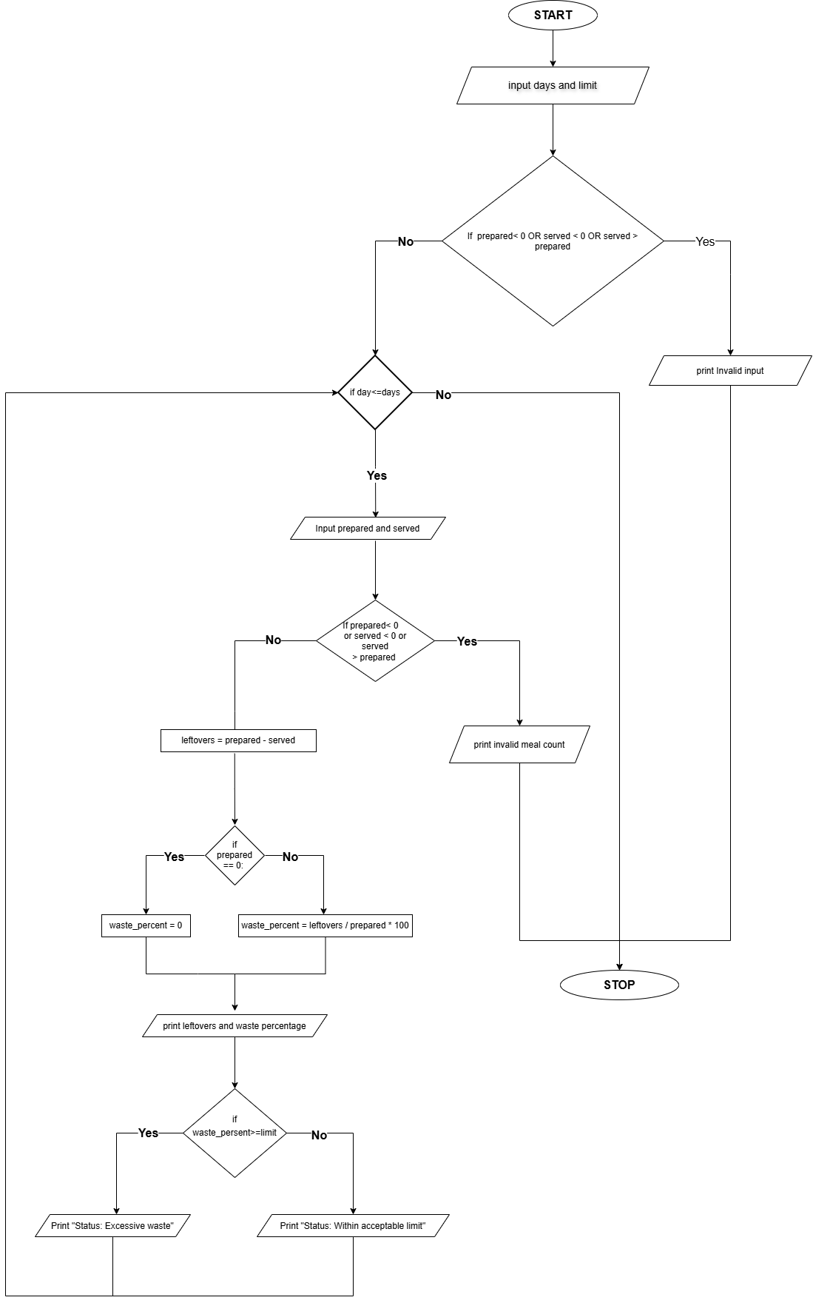
Pseudocode
START
INPUT days, limit
IF days <= 0 OR limit < 0 OR limit > 100
PRINT "Invalid input"
ELSE
FOR each day
INPUT prepared, served
IF prepared < 0 OR served < 0 OR served > prepared
PRINT "Invalid meal counts"
ELSE
leftovers = prepared - served
IF prepared = 0
Waste_persent= 0
ELSE
Waste_persent= leftovers / prepared * 100
PRINT leftovers, waste_persent
IF waste_persent> limit
PRINT "Excessive waste"
ELSE
PRINT "Within acceptable limit"
STOP
Source Code
days = int(input("Enter number of days: "))
limit = float(input("Enter acceptable waste percentage: "))

if days <= 0 or limit < 0 or limit > 100:
print("Invalid input.")
else:
for day in range(1, days + 1):
prepared = int(input("Meals prepared on day " + str(day) + ": "))
served = int(input("Meals served on day " + str(day) + ": "))

if prepared < 0 or served < 0 or served > prepared:
print("Invalid meal counts.")
else:
leftovers = prepared - served
if prepared == 0:
waste_percent = 0
else:
waste_percent = leftovers / prepared * 100

print("Leftover meals:", leftovers)
print("Waste percentage:", round(waste_percent, 2), "%")

if waste_percent > limit:
print("Status: Excessive waste")
else:
print("Status: Within acceptable limit")
Test Cases
1. Enter number of days: 1
Enter acceptable waste percentage: 20
Meals prepared on day 1: 100
Meals served on day 1: 90
Output:
Leftover meals: 10
Waste percentage: 10.0 %
Status: Within acceptable limit
2. Enter number of days: 1
Enter acceptable waste percentage: 15
Meals prepared on day 1: 200
Meals served on day 1: 150
Output:
Leftover meals: 50
Waste percentage: 25.0 %
Status: Excessive waste
Output
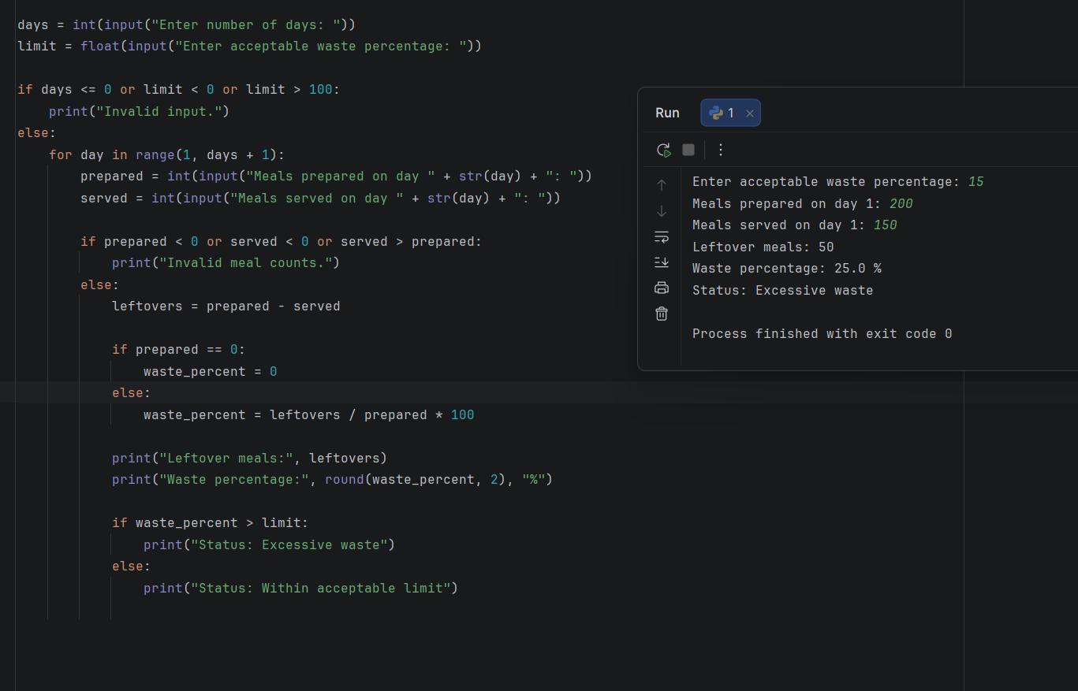
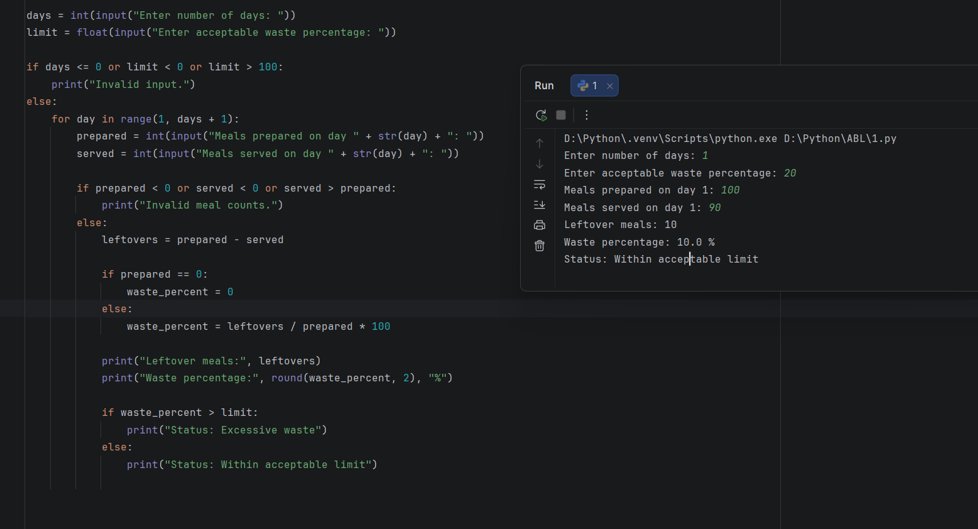
Conclusion
The program uses arithmetic and conditions to monitor leftover food and flag days with high waste.
6.
Student Timetable Conflict Detection: Compare course schedules represented by strings and tuples, detect overlapping periods, identify unavailable rooms, and validate a proposed timetable.
Sol:
Problem statement
Develop a Python program that stores proposed course slots as tuples of course code, day, period, and room, checks for unavailable rooms and overlapping time periods, and validates the timetable.
Objectives
- Represent course schedule entries using strings and tuples.
- Identify unavailable classroom assignments.
- Detect overlapping periods on the same day.
- Display confirmed slots and total conflicts.
Assumptions
- Periods are numbered from 1 to 8 within a day.
- Two courses conflict if they are scheduled on the same day and period.
- Room and day names are compared in uppercase format.
Algorithm
1. Start.
2. Input the number of courses and the unavailable room code.
3. Initialize an empty schedule list and set conflict count to zero.
4. For each course, input the course code, day, period, and room.
5. Validate the period range and check if the room matches the unavailable room.
6. Traverse the confirmed schedule tuples using unpacking to check if the same day and period already exist.
7. If a conflict exists, increment the conflict counter; otherwise, append the tuple to the schedule.
8. Display the number of valid courses and total conflicts.
9. Stop.
Flowchart
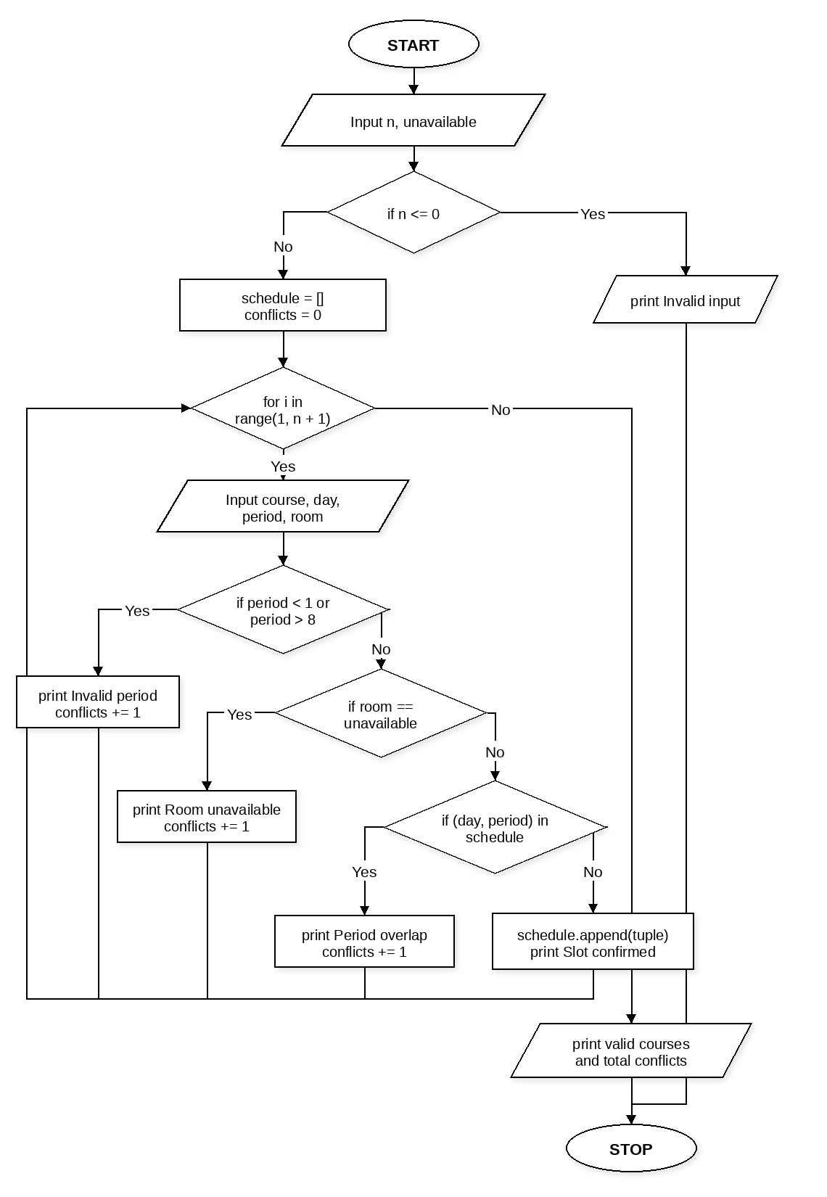
Pseudocode
START
INPUT n, unavailable
IF n <= 0
PRINT "Invalid input."
ELSE
SET schedule = [], conflicts = 0
FOR i from 1 to n
INPUT course, day, period, room
IF period < 1 OR period > 8
PRINT "Invalid period"
conflicts = conflicts + 1
ELSE IF room == unavailable
PRINT "Alert: Room unavailable"
conflicts = conflicts + 1
ELSE
SET clash = False
FOR each (c_code, c_day, c_per, c_room) in schedule
IF c_day == day AND c_per == period
clash = True
IF clash == True
PRINT "Conflict: Period overlap"
conflicts = conflicts + 1
ELSE
APPEND (course, day, period, room) to schedule
PRINT "Slot confirmed"
PRINT length of schedule, conflicts
STOP
Source Code
n = int(input("Enter number of courses: "))
unavailable = input("Enter unavailable room: ").upper()
if n <= 0:
print("Invalid input.")
else:
schedule = []
conflicts = 0
for i in range(1, n + 1):
course = input("Course " + str(i) + " code: ").upper()
day = input("Day: ").upper()
period = int(input("Period (1-8): "))
room = input("Room: ").upper()
if period < 1 or period > 8:
print("Invalid period")
conflicts += 1
elif room == unavailable:
print("Alert: Room unavailable")
conflicts += 1
else:
clash = False
for entry in schedule:
c_code, c_day, c_per, c_room = entry
if c_day == day and c_per == period:
clash = True
if clash:
print("Conflict: Period overlap")
conflicts += 1
else:
schedule.append((course, day, period, room))
print("Slot confirmed")
print("Valid courses:", len(schedule))
print("Total conflicts:", conflicts)
Test Cases
1. Enter number of courses: 2
Enter unavailable room: R105
Course 1 code: CS101
Day: MON
Period (1-8): 2
Room: R101
Course 2 code: MA102
Day: MON
Period (1-8): 2
Room: R102
Output:
Slot confirmed
Conflict: Period overlap
Valid courses: 1
Total conflicts: 1
2. Enter number of courses: 2
Enter unavailable room: R105
Course 1 code: EC101
Day: TUE
Period (1-8): 3
Room: R105
Course 2 code: PH101
Day: WED
Period (1-8): 1
Room: R102
Output:
Alert: Room unavailable
Slot confirmed
Valid courses: 1
Total conflicts: 1
Output
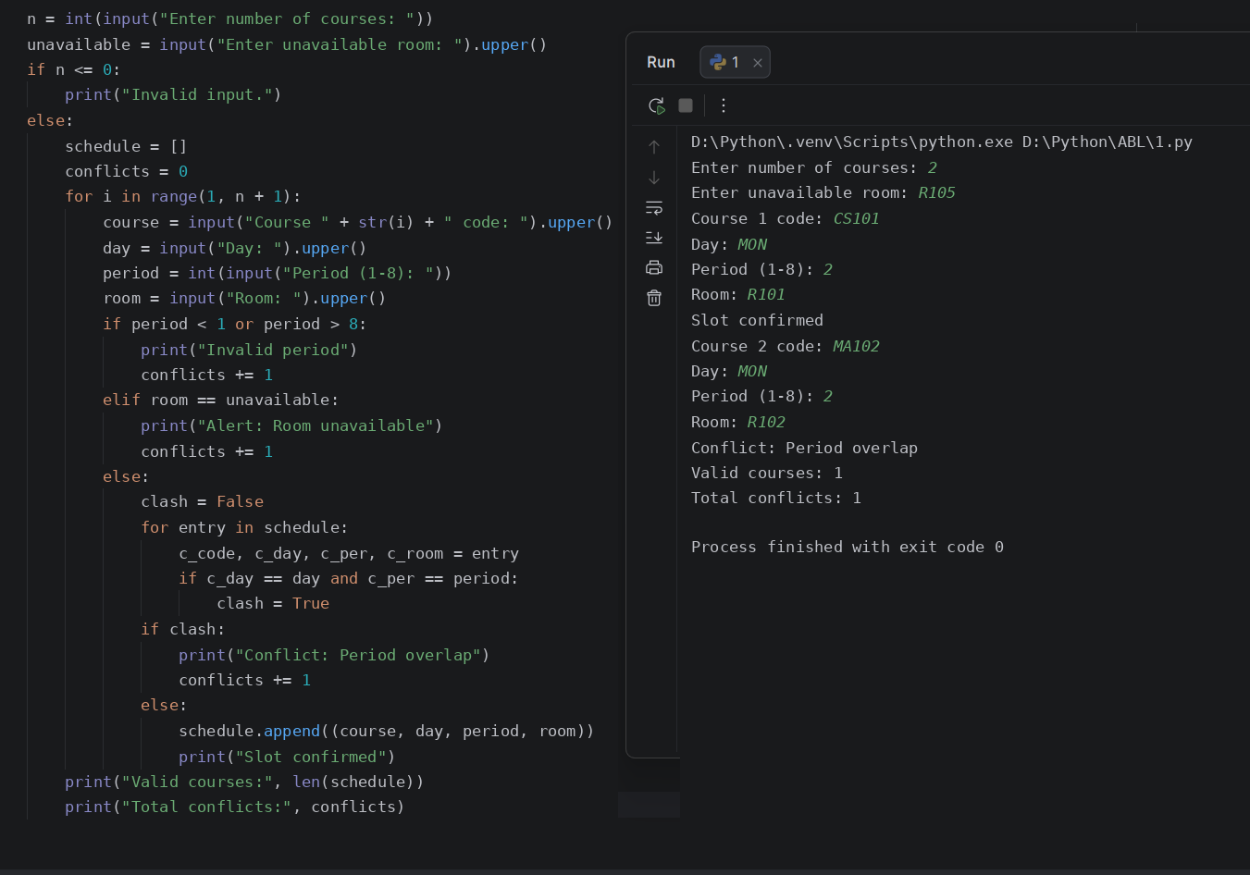
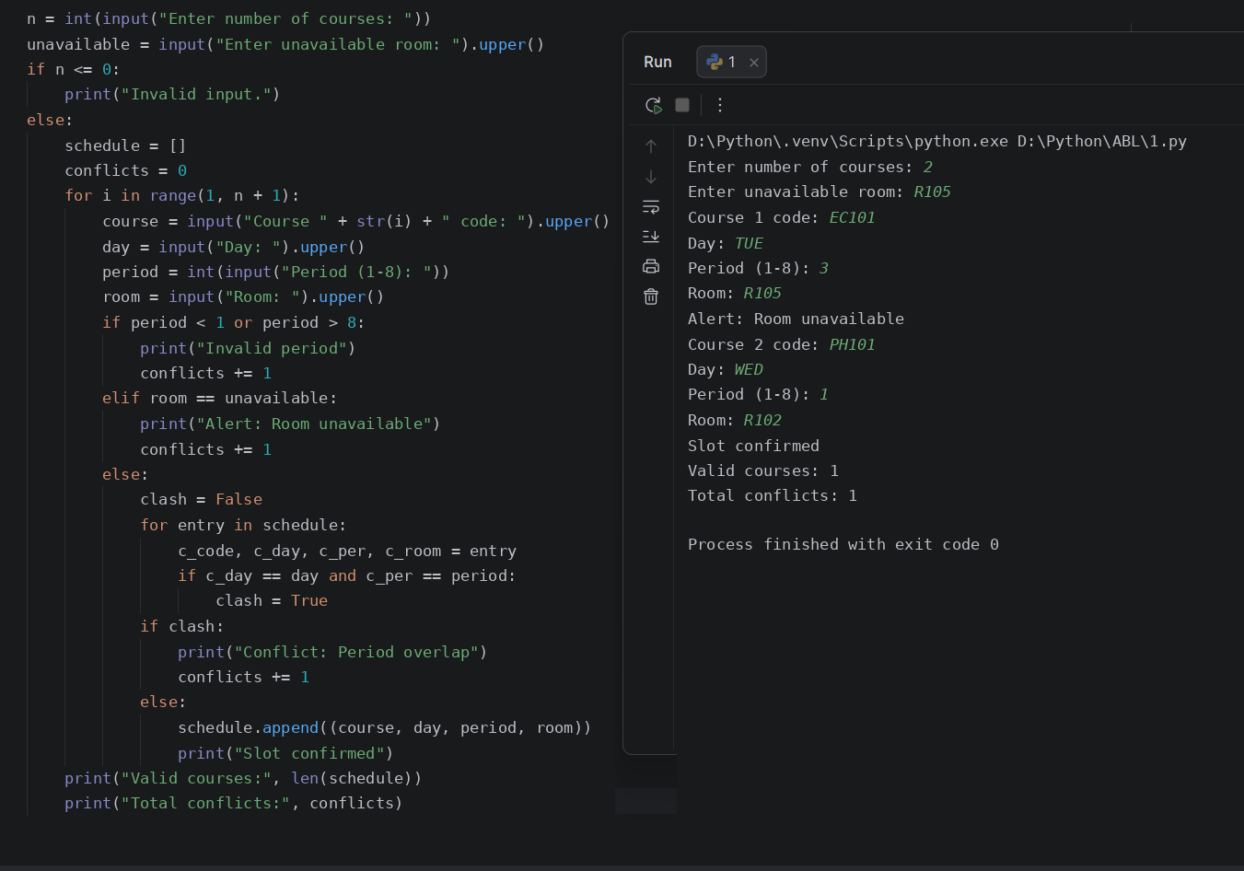
Conclusion
The program validates a student timetable using strings, tuples, and tuple unpacking to catch room restrictions and period clashes.
7.
Student Marks Matrix Analysis: Analyse a matrix of student marks across subjects, calculate row-wise and column-wise statistics, identify top performers, and detect subjects with low average performance.
Sol:
Problem statement
Develop a Python program to store student marks across multiple subjects in a nested list matrix, compute student totals and averages, find the top performer, and flag subjects with an average below 50.
Objectives
- Store student marks in a two-dimensional nested list.
- Calculate row-wise totals and averages for each student.
- Identify the student with the highest total score.
- Calculate column-wise averages to detect low-performing subjects.
Assumptions
- The number of students and subjects are positive integers.
- Marks for each subject are between 0 and 100.
- A subject is flagged as low performing if its class average is below 50.
Algorithm
1. Start.
2. Read the number of students and number of subjects.
3. Validate that both dimensions are positive.
4. Use nested loops to read each student's name and subject marks into a 2D nested list.
5. Traverse each row to calculate the student's total and average, updating the top performer.
6. Traverse each column across all students to calculate subject averages.
7. Display student statistics, the top performer, and any low-average subjects.
8. Stop.
Flowchart
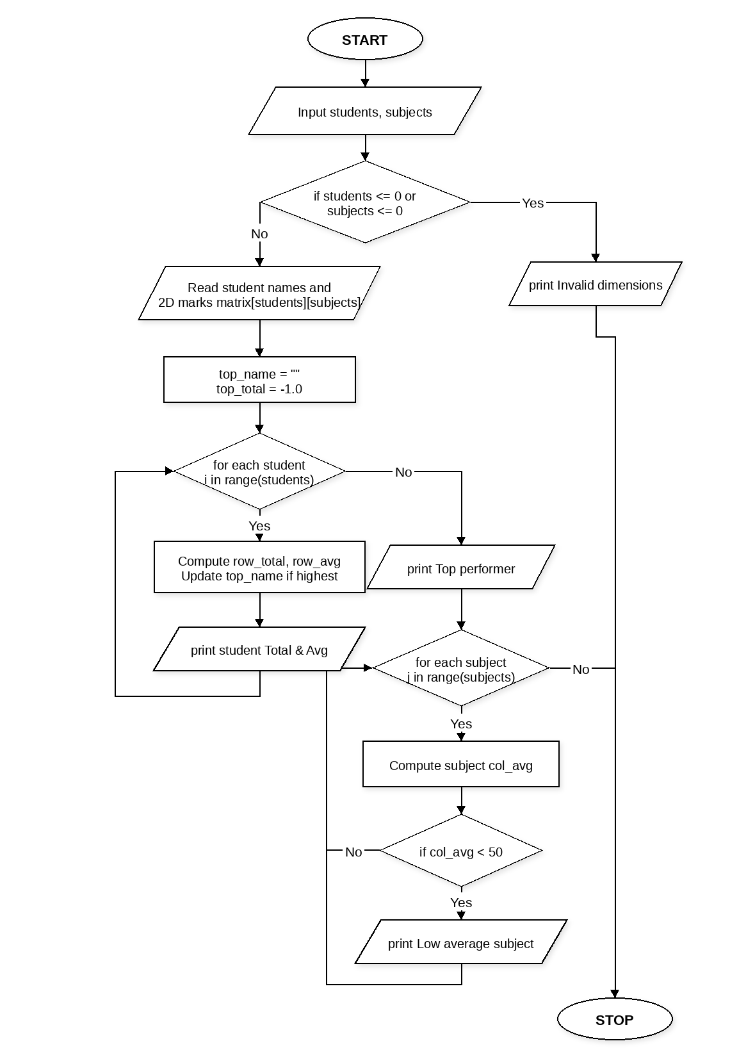
Pseudocode
START
INPUT students, subjects
IF students <= 0 OR subjects <= 0
PRINT "Invalid dimensions."
ELSE
SET matrix = [], names = []
FOR i from 0 to students - 1
INPUT student name and append to names
SET row = []
FOR j from 0 to subjects - 1
INPUT mark and append to row
APPEND row to matrix
SET top_name = "", top_total = -1
FOR i from 0 to students - 1
CALCULATE row_total and row_avg
PRINT names[i], row_total, row_avg
IF row_total > top_total
SET top_total = row_total, top_name = names[i]
PRINT top_name
FOR j from 0 to subjects - 1
CALCULATE col_avg across all students
IF col_avg < 50
PRINT low average subject j + 1
STOP
Source Code
students = int(input("Enter number of students: "))
subjects = int(input("Enter number of subjects: "))
if students <= 0 or subjects <= 0:
print("Invalid dimensions.")
else:
matrix = []
names = []
for i in range(students):
name = input("Student " + str(i + 1) + " name: ")
names.append(name)
row = []
for j in range(subjects):
m = float(input(" Subject " + str(j + 1) + " marks: "))
row.append(m)
matrix.append(row)
top_name = ""
top_total = -1.0
for i in range(students):
row_total = 0.0
for m in matrix[i]:
row_total += m
row_avg = row_total / subjects
print(names[i], "Total:", row_total, "Avg:", round(row_avg, 2))
if row_total > top_total:
top_total = row_total
top_name = names[i]
print("Top performer:", top_name)
for j in range(subjects):
col_total = 0.0
for i in range(students):
col_total += matrix[i][j]
col_avg = col_total / students
if col_avg < 50:
print("Low average in Subject", j + 1, ":", round(col_avg, 2))
Test Cases
1. Enter number of students: 2
Enter number of subjects: 3
Student 1 name: Arjun
Subject 1 marks: 80
Subject 2 marks: 40
Subject 3 marks: 75
Student 2 name: Priya
Subject 1 marks: 90
Subject 2 marks: 50
Subject 3 marks: 85
Output:
Arjun Total: 195.0 Avg: 65.0
Priya Total: 225.0 Avg: 75.0
Top performer: Priya
Low average in Subject 2 : 45.0
2. Enter number of students: 2
Enter number of subjects: 2
Student 1 name: Kiran
Subject 1 marks: 88
Subject 2 marks: 92
Student 2 name: Meera
Subject 1 marks: 76
Subject 2 marks: 84
Output:
Kiran Total: 180.0 Avg: 90.0
Meera Total: 160.0 Avg: 80.0
Top performer: Kiran
Output
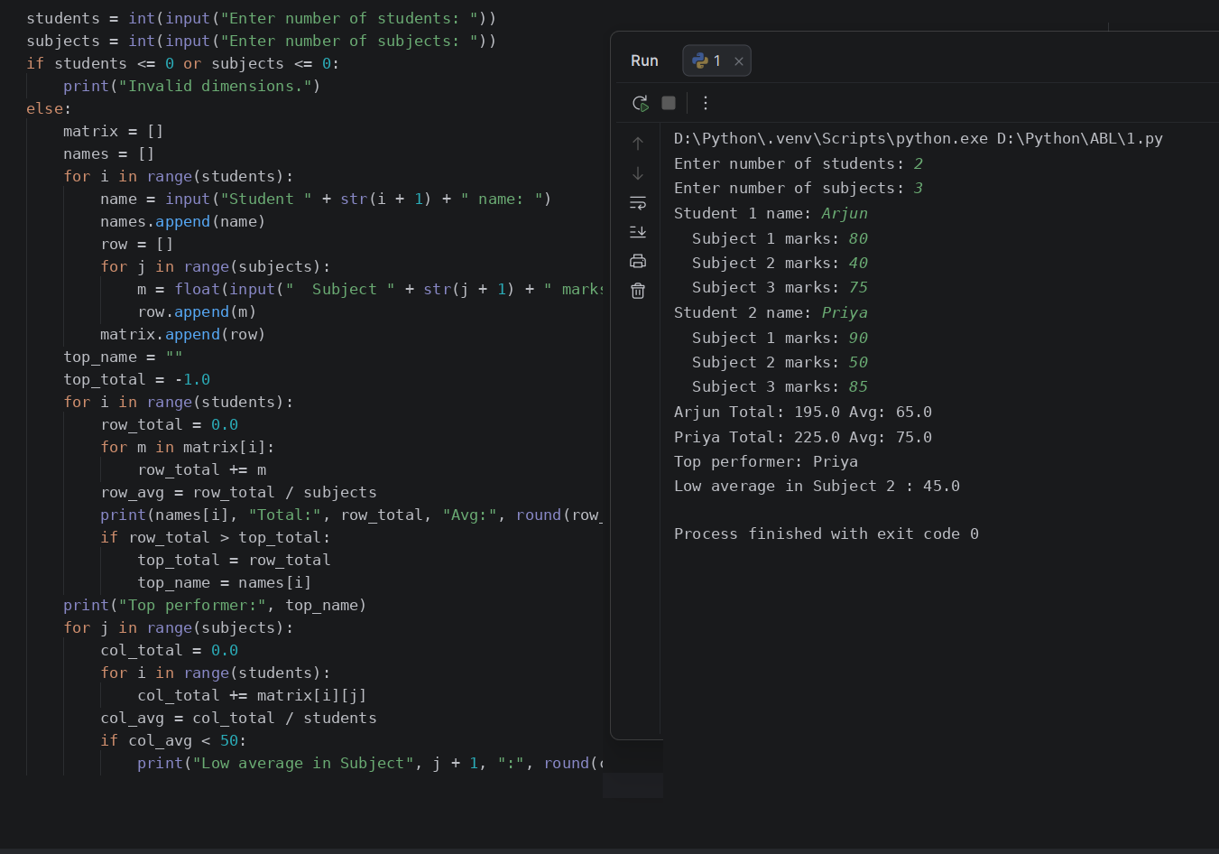
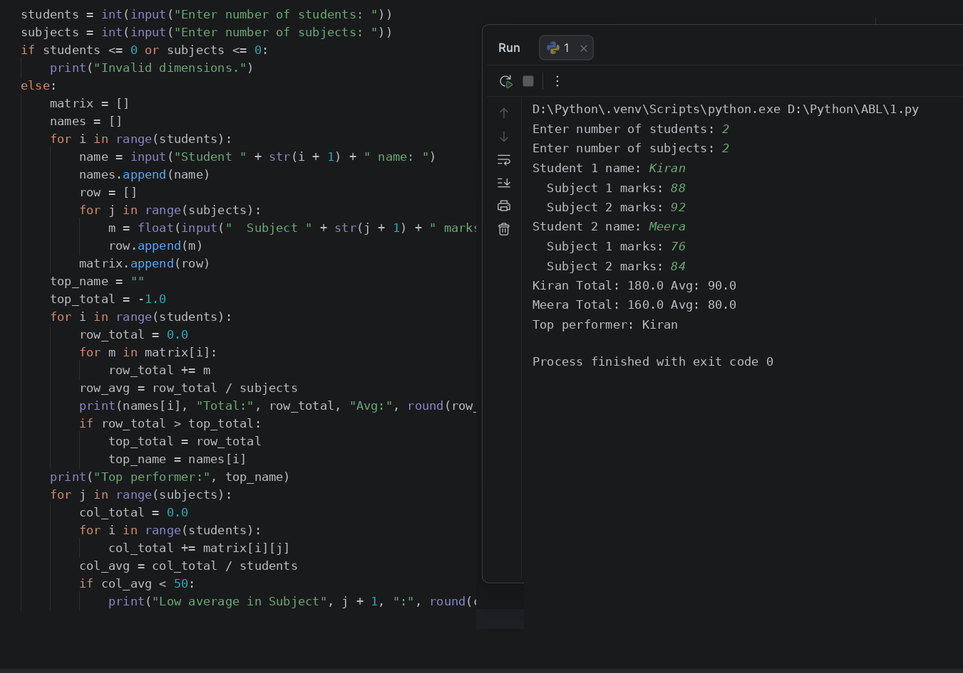
Conclusion
The program uses nested lists and nested loops to compute row-wise and column-wise matrix statistics, identifying top students and weak subjects.
8.
Tuple-Based Product Catalogue Audit: Store product identifiers, prices, and stock quantities in tuples; detect invalid records, calculate inventory values, and identify items requiring replenishment.
Sol:
Problem statement
Develop a Python program that stores product records as tuples of ID, unit price, and stock quantity, flags invalid entries, calculates total inventory value, and lists products below a minimum stock threshold.
Objectives
- Store product catalogue records as tuples inside a list.
- Unpack product tuples to validate price and stock values.
- Calculate individual and total inventory values for valid products.
- Identify products requiring stock replenishment.
Assumptions
- Each product tuple contains (product_id, unit_price, stock_quantity).
- A record is valid if product_id is non-empty, unit_price is positive, and stock_quantity is non-negative.
- Items with valid stock strictly below the minimum threshold require replenishment.
Algorithm
1. Start.
2. Read the number of products and the minimum stock threshold.
3. Read product ID, unit price, and stock quantity for each product and store as a tuple.
4. Initialize total inventory value and invalid record counter to zero.
5. Unpack each product tuple and validate its fields.
6. If valid, compute item value, add to total inventory value, and check if stock is below threshold.
7. Display item values, total inventory value, invalid count, and replenishment list.
8. Stop.
Flowchart
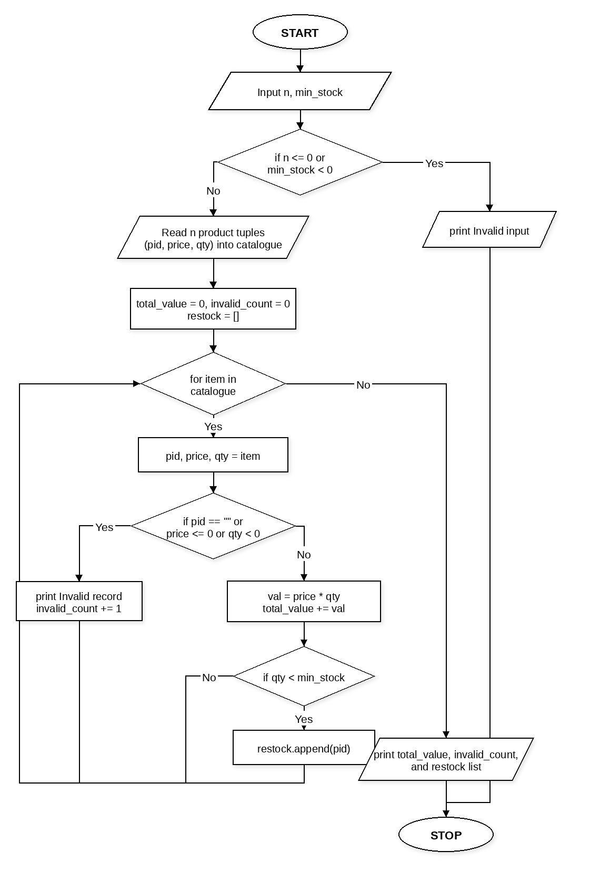
Pseudocode
START
INPUT n, min_stock
IF n <= 0 OR min_stock < 0
PRINT "Invalid input."
ELSE
SET catalogue = []
FOR i from 1 to n
INPUT pid, price, qty
APPEND (pid, price, qty) to catalogue
SET total_value = 0, invalid_count = 0, restock = []
FOR each item in catalogue
UNPACK pid, price, qty = item
IF pid == "" OR price <= 0 OR qty < 0
PRINT pid, "Invalid record"
invalid_count = invalid_count + 1
ELSE
val = price * qty
total_value = total_value + val
PRINT pid, val
IF qty < min_stock
APPEND pid to restock
PRINT total_value, invalid_count, restock
STOP
Source Code
n = int(input("Enter number of products: "))
min_stock = int(input("Enter minimum stock threshold: "))
if n <= 0 or min_stock < 0:
print("Invalid input.")
else:
catalogue = []
for i in range(1, n + 1):
pid = input("Product " + str(i) + " ID: ")
price = float(input("Unit price: "))
qty = int(input("Stock quantity: "))
catalogue.append((pid, price, qty))
total_value = 0.0
invalid_count = 0
restock = []
for item in catalogue:
pid, price, qty = item
if pid == "" or price <= 0 or qty < 0:
print(pid, ": Invalid record")
invalid_count += 1
else:
val = price * qty
total_value += val
print(pid, "Value: Rs.", round(val, 2))
if qty < min_stock:
restock.append(pid)
print("Total inventory value: Rs.", round(total_value, 2))
print("Invalid records:", invalid_count)
print("Replenish items:", restock)
Test Cases
1. Enter number of products: 3
Enter minimum stock threshold: 10
Product 1 ID: P101
Unit price: 250
Stock quantity: 12
Product 2 ID: P102
Unit price: 150
Stock quantity: 5
Product 3 ID: P103
Unit price: -50
Stock quantity: 8
Output:
P101 Value: Rs. 3000.0
P102 Value: Rs. 750.0
P103 : Invalid record
Total inventory value: Rs. 3750.0
Invalid records: 1
Replenish items: ['P102']
2. Enter number of products: 2
Enter minimum stock threshold: 15
Product 1 ID: P201
Unit price: 500
Stock quantity: 20
Product 2 ID: P202
Unit price: 300
Stock quantity: 18
Output:
P201 Value: Rs. 10000.0
P202 Value: Rs. 5400.0
Total inventory value: Rs. 15400.0
Invalid records: 0
Replenish items: []
Output
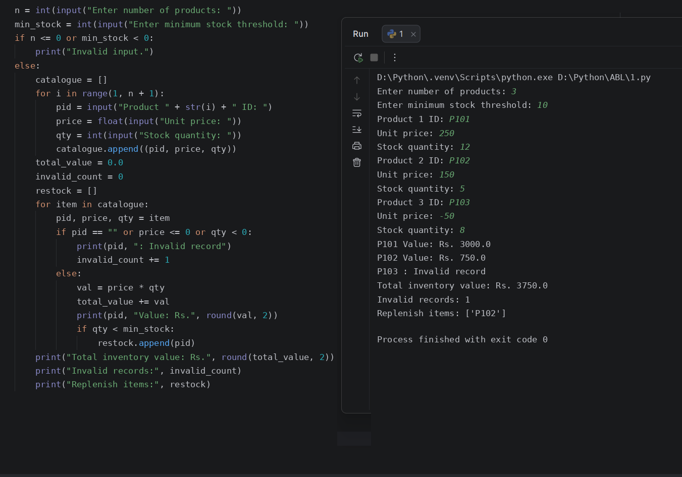
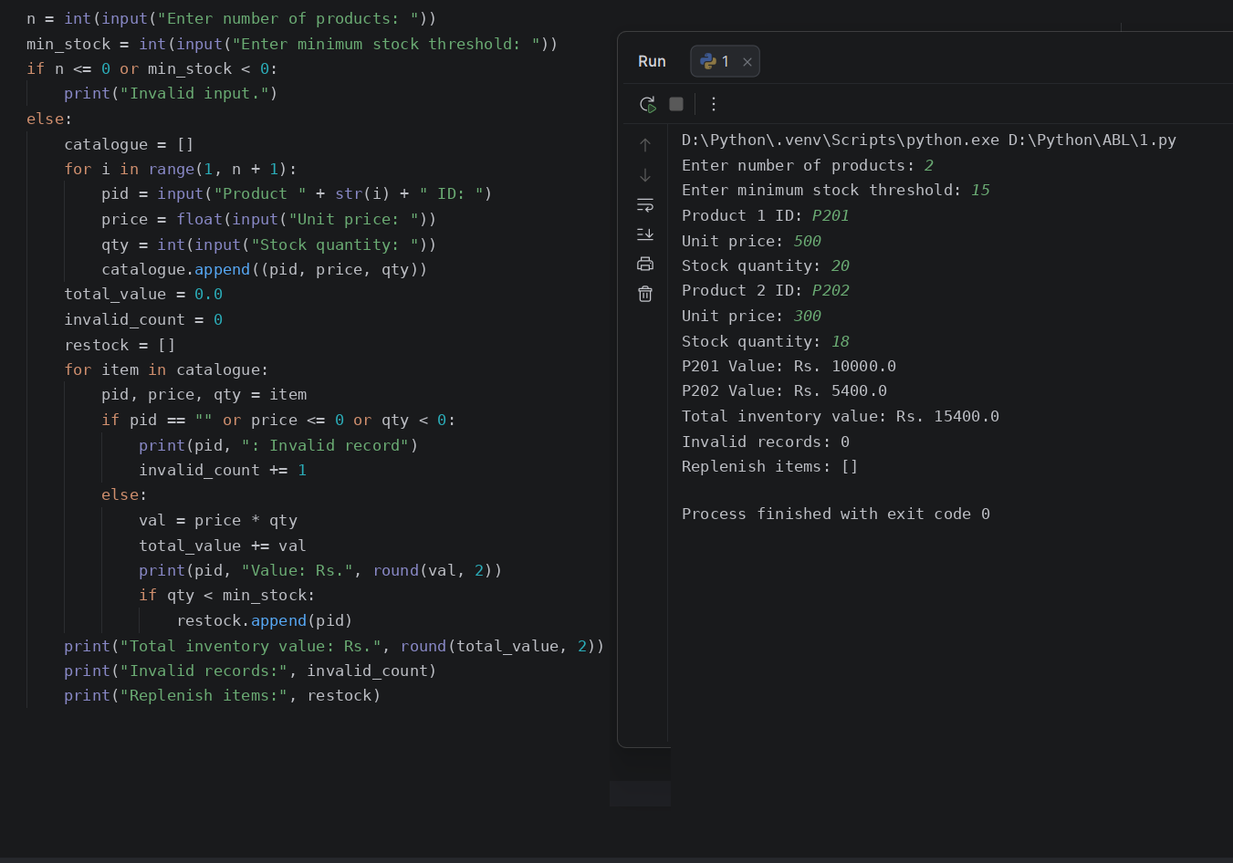
Conclusion
The program audits a tuple-based product catalogue using tuple unpacking, validating inventory records and identifying restock requirements.
9.
Student Academic Risk Classification: Combine lists of marks, attendance, and laboratory scores to classify students into risk categories, identify multiple simultaneous risk factors, and generate a summary.
Sol:
Problem statement
Develop a Python program that combines parallel lists of student exam marks, attendance percentages, and laboratory scores to count simultaneous academic risk factors, classify each student into High, Moderate, or Low Risk, and print a summary.
Objectives
- Maintain parallel lists for student names, exam marks, attendance, and lab scores.
- Evaluate multiple simultaneous risk conditions for each student.
- Classify students into High Risk, Moderate Risk, or Low Risk.
- Generate a category-wise summary count.
Assumptions
- Risk factors are: exam marks below 50, attendance below 75%, and lab score below 50.
- Two or more risk factors classify a student as High Risk; one factor as Moderate Risk; zero factors as Low Risk.
- All scores and percentages are between 0 and 100.
Algorithm
1. Start.
2. Read the number of students and validate that it is positive.
3. Read each student's name, exam marks, attendance percentage, and lab score into respective lists.
4. Initialize counters for High, Moderate, and Low Risk categories.
5. For each student, count how many risk thresholds are violated.
6. Classify the student based on the number of simultaneous risk factors and update the category count.
7. Display each student's risk factor count and classification, followed by the overall summary.
8. Stop.
Flowchart
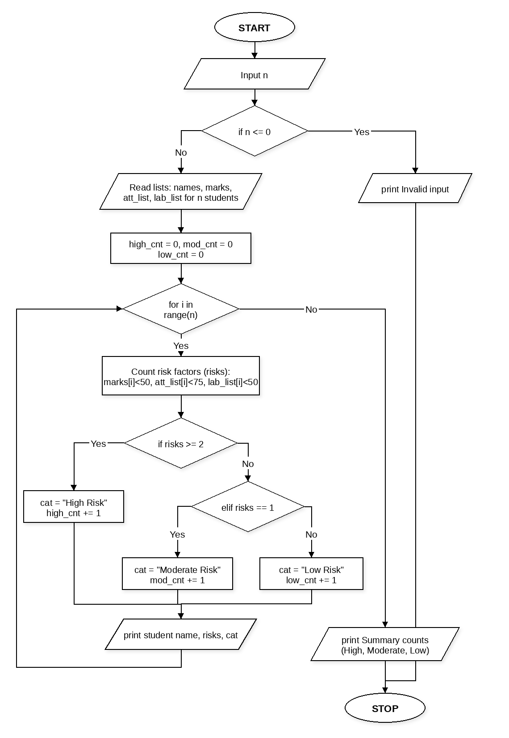
Pseudocode
START
INPUT n
IF n <= 0
PRINT "Invalid input."
ELSE
SET names = [], marks = [], att_list = [], lab_list = []
FOR i from 1 to n
INPUT name, mark, att, lab and append to lists
SET high_cnt = 0, mod_cnt = 0, low_cnt = 0
FOR i from 0 to n - 1
SET risks = 0
IF marks[i] < 50 THEN risks = risks + 1
IF att_list[i] < 75 THEN risks = risks + 1
IF lab_list[i] < 50 THEN risks = risks + 1
IF risks >= 2
cat = "High Risk", high_cnt = high_cnt + 1
ELSE IF risks == 1
cat = "Moderate Risk", mod_cnt = mod_cnt + 1
ELSE
cat = "Low Risk", low_cnt = low_cnt + 1
PRINT names[i], risks, cat
PRINT high_cnt, mod_cnt, low_cnt
STOP
Source Code
n = int(input("Enter number of students: "))
if n <= 0:
print("Invalid input.")
else:
names = []
marks = []
att_list = []
lab_list = []
for i in range(1, n + 1):
names.append(input("Student " + str(i) + " name: "))
marks.append(float(input(" Exam marks (0-100): ")))
att_list.append(float(input(" Attendance % (0-100): ")))
lab_list.append(float(input(" Lab score (0-100): ")))
high_cnt = 0
mod_cnt = 0
low_cnt = 0
for i in range(n):
risks = 0
if marks[i] < 50:
risks += 1
if att_list[i] < 75:
risks += 1
if lab_list[i] < 50:
risks += 1
if risks >= 2:
cat = "High Risk"
high_cnt += 1
elif risks == 1:
cat = "Moderate Risk"
mod_cnt += 1
else:
cat = "Low Risk"
low_cnt += 1
print(names[i], "- Factors:", risks, "-", cat)
print("Summary -> High:", high_cnt, "Moderate:", mod_cnt, "Low:", low_cnt)
Test Cases
1. Enter number of students: 3
Student 1 name: Ravi (Marks: 42, Attendance: 68, Lab: 55)
Student 2 name: Sneha (Marks: 72, Attendance: 70, Lab: 80)
Student 3 name: Vikram (Marks: 85, Attendance: 90, Lab: 88)
Output:
Ravi - Factors: 2 - High Risk
Sneha - Factors: 1 - Moderate Risk
Vikram - Factors: 0 - Low Risk
Summary -> High: 1 Moderate: 1 Low: 1
2. Enter number of students: 2
Student 1 name: Ananya (Marks: 35, Attendance: 60, Lab: 40)
Student 2 name: Dev (Marks: 78, Attendance: 82, Lab: 75)
Output:
Ananya - Factors: 3 - High Risk
Dev - Factors: 0 - Low Risk
Summary -> High: 1 Moderate: 0 Low: 1
Output
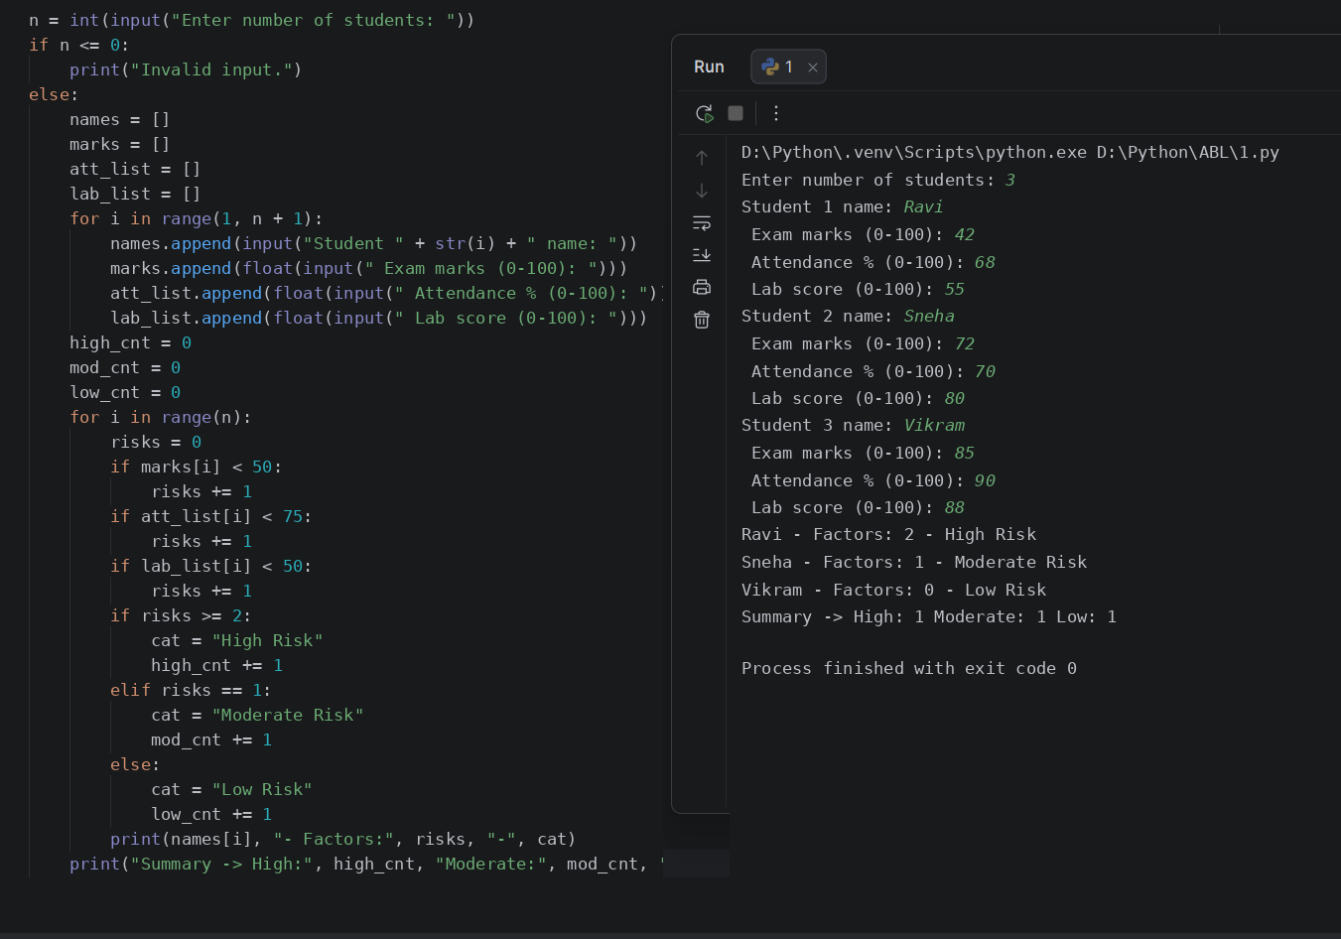
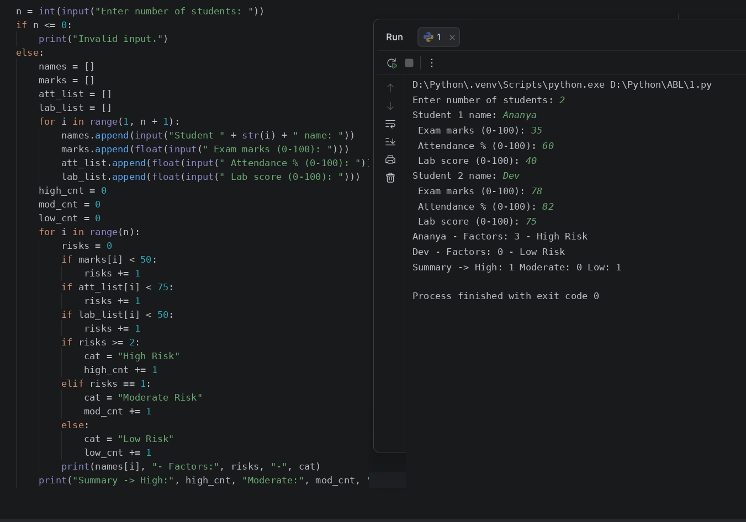
Conclusion
The program combines multiple academic indicators stored in lists to detect simultaneous risk factors and classify students into risk tiers.
10.
Smart Classroom Timetable Allocation: Represent courses, rooms, and periods using lists and tuples; validate classroom capacities, detect clashes, and check whether all courses can be accommodated under the stated constraints.
Sol:
Problem statement
Develop a Python program that stores classroom capacities and course requests using lists and tuples, assigns each course to the first available room that meets capacity without period clashes, and reports whether all courses can be accommodated.
Objectives
- Represent classrooms and capacities as tuples in a list.
- Validate room capacity and check for period clashes before allocation.
- Track allocated course-room-period tuples and unaccommodated courses.
- Determine whether all courses can be accommodated under the given constraints.
Assumptions
- Each room tuple stores (room_name, capacity).
- A room can host at most one course in any given period (1 to 6).
- A course is assigned to the first room in list order that has sufficient capacity and is free in the requested period.
Algorithm
1. Start.
2. Input the number of rooms and number of courses.
3. Read each room's identifier and seating capacity and store as a tuple in the rooms list.
4. Initialize an empty list for allocated slots and set unaccommodated count to zero.
5. For each course, read the course code, enrolled students, and requested period.
6. Iterate through the rooms list using tuple unpacking to find a room with capacity >= enrolled students that is not already booked in that period.
7. If a valid room is found, record the allocation tuple; otherwise, increment the unaccommodated count.
8. Display the allocation result for each course and the final accommodation status.
9. Stop.
Flowchart
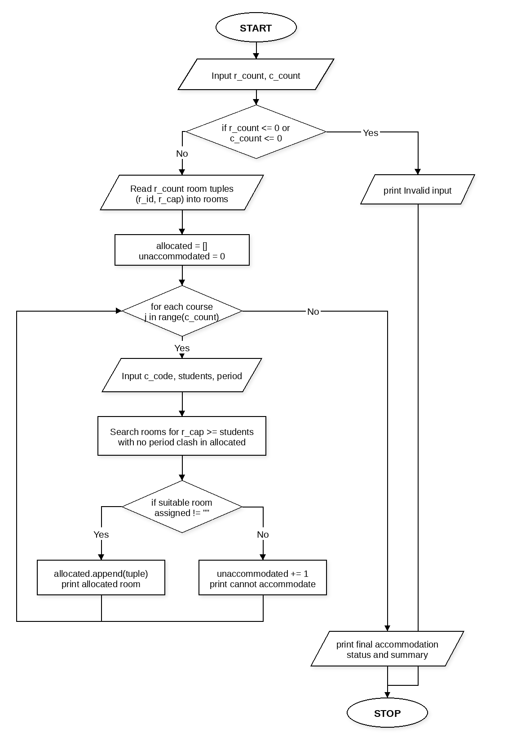
Pseudocode
START
INPUT r_count, c_count
IF r_count <= 0 OR c_count <= 0
PRINT "Invalid input."
ELSE
SET rooms = []
FOR i from 1 to r_count
INPUT r_id, r_cap and append (r_id, r_cap) to rooms
SET allocated = [], unaccommodated = 0
FOR j from 1 to c_count
INPUT c_code, students, period
SET assigned = ""
FOR each (r_id, r_cap) in rooms
IF r_cap >= students AND assigned == ""
CHECK if (r_id, period) is already in allocated
IF not booked THEN assigned = r_id
IF assigned != ""
APPEND (c_code, assigned, period) to allocated
PRINT c_code, "allocated to", assigned
ELSE
unaccommodated = unaccommodated + 1
PRINT c_code, "cannot be accommodated"
IF unaccommodated == 0
PRINT "Result: All courses accommodated"
ELSE
PRINT "Unaccommodated:", unaccommodated
STOP
Source Code
r_count = int(input("Enter number of rooms: "))
c_count = int(input("Enter number of courses: "))
if r_count <= 0 or c_count <= 0:
print("Invalid input.")
else:
rooms = []
for i in range(1, r_count + 1):
r_id = input("Room " + str(i) + " name: ").upper()
r_cap = int(input("Room " + str(i) + " capacity: "))
rooms.append((r_id, r_cap))
allocated = []
unaccommodated = 0
for j in range(1, c_count + 1):
c_code = input("Course " + str(j) + " code: ").upper()
students = int(input("Enrolled students: "))
period = int(input("Requested period (1-6): "))
assigned = ""
for rm in rooms:
r_id, r_cap = rm
if r_cap >= students and assigned == "":
clash = False
for slot in allocated:
al_c, al_r, al_p = slot
if al_r == r_id and al_p == period:
clash = True
if not clash:
assigned = r_id
if assigned != "":
allocated.append((c_code, assigned, period))
print(c_code, "allocated to", assigned)
else:
unaccommodated += 1
print(c_code, "cannot be accommodated")
if unaccommodated == 0:
print("Result: All courses accommodated")
else:
print("Unaccommodated:", unaccommodated)
Test Cases
1. Enter number of rooms: 2 (R101: 40, R102: 60)
Enter number of courses: 3
Course 1: CS101, Students: 35, Period: 1
Course 2: CS102, Students: 50, Period: 1
Course 3: CS103, Students: 45, Period: 1
Output:
CS101 allocated to R101
CS102 allocated to R102
CS103 cannot be accommodated
Unaccommodated: 1
2. Enter number of rooms: 2 (R201: 50, R202: 80)
Enter number of courses: 2
Course 1: AI101, Students: 45, Period: 2
Course 2: DS102, Students: 70, Period: 2
Output:
AI101 allocated to R201
DS102 allocated to R202
Result: All courses accommodated
Output
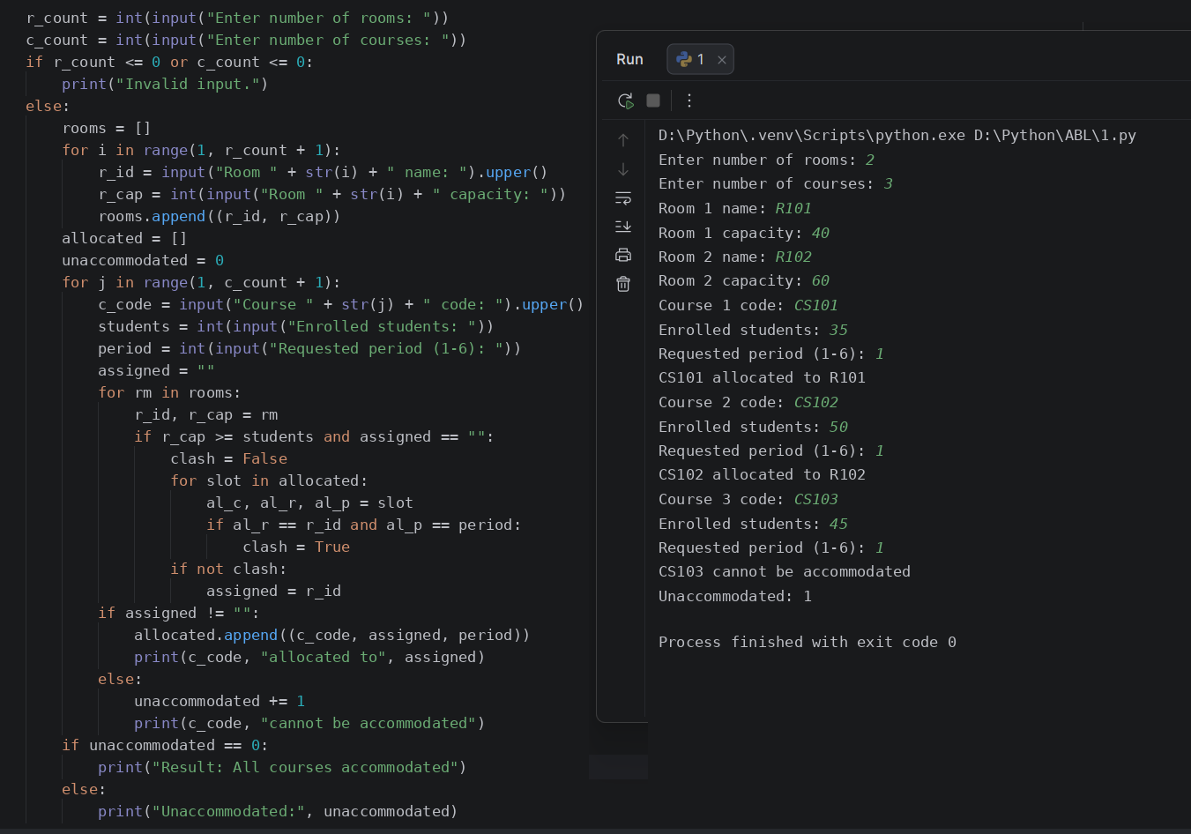
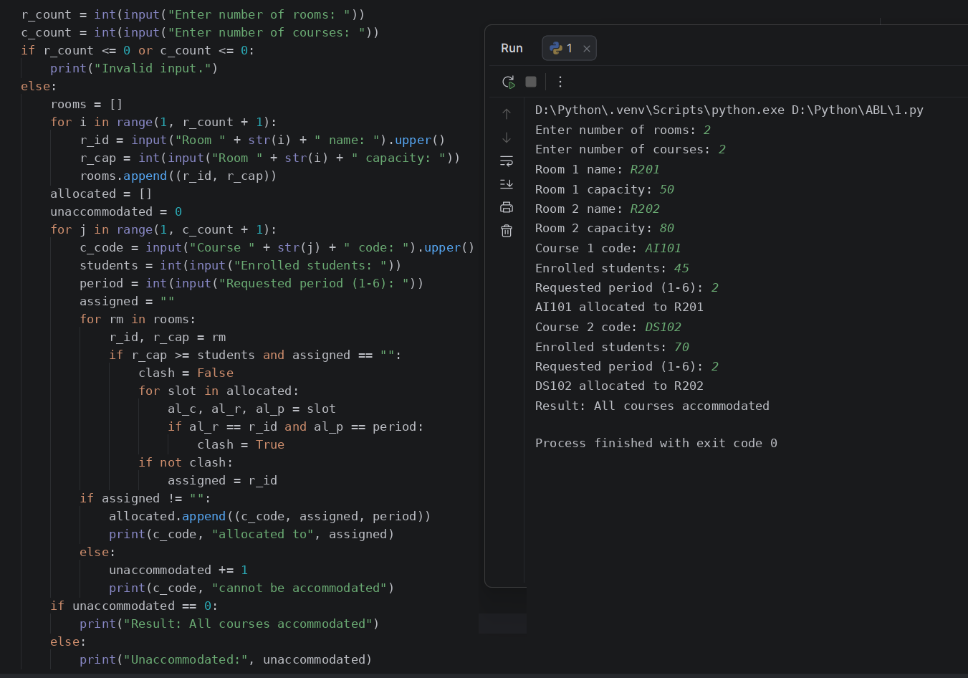
Conclusion
The program allocates classrooms using lists, tuples, and tuple unpacking while enforcing room capacity and period clash constraints.

