WEB DEVELOPMENT
ACTIVITY-BASED LEARNING
NEWS PORTAL WEBSITE
Student Name: Thota Hima Sri
Roll Number: 26001252
College: NRI UNIVERSITY
Branch: CSM
Year: 1st Year
Subject: Web Development

1. Introduction
NewsPortal is a simple news website created using HTML and CSS. It organizes sample news content into sections such as National, International, Sports, Technology, and Business. A featured story is displayed at the top, followed by news cards.

2. Objectives
- To design a simple and attractive news portal webpage.
- To organize news into different categories.
- To display a featured story and latest news cards.
- To use CSS Flexbox and Grid for page layout.
- To make the webpage responsive on tablets and mobile screens.

3. Technologies Used
HTML5: Creates the structure of the page using header, navigation, main, section, article, image, and footer elements.
CSS3: Adds colors, spacing, typography, card layouts, shadows, image sizing, and responsive media queries.

4. Main Features
- Navigation links for five news categories.
- Red breaking-news announcement bar.
- Featured technology story with an image and author/date line.
- Five latest-news cards: National, International, Sports, Technology, and Business.
- Responsive layout: three columns on wide screens, two columns on medium screens, and one column on small screens.

5. Output of the Project
The following preview represents the NewsPortal page structure and styling. The photos in the live webpage are loaded from external image links and require an internet connection.
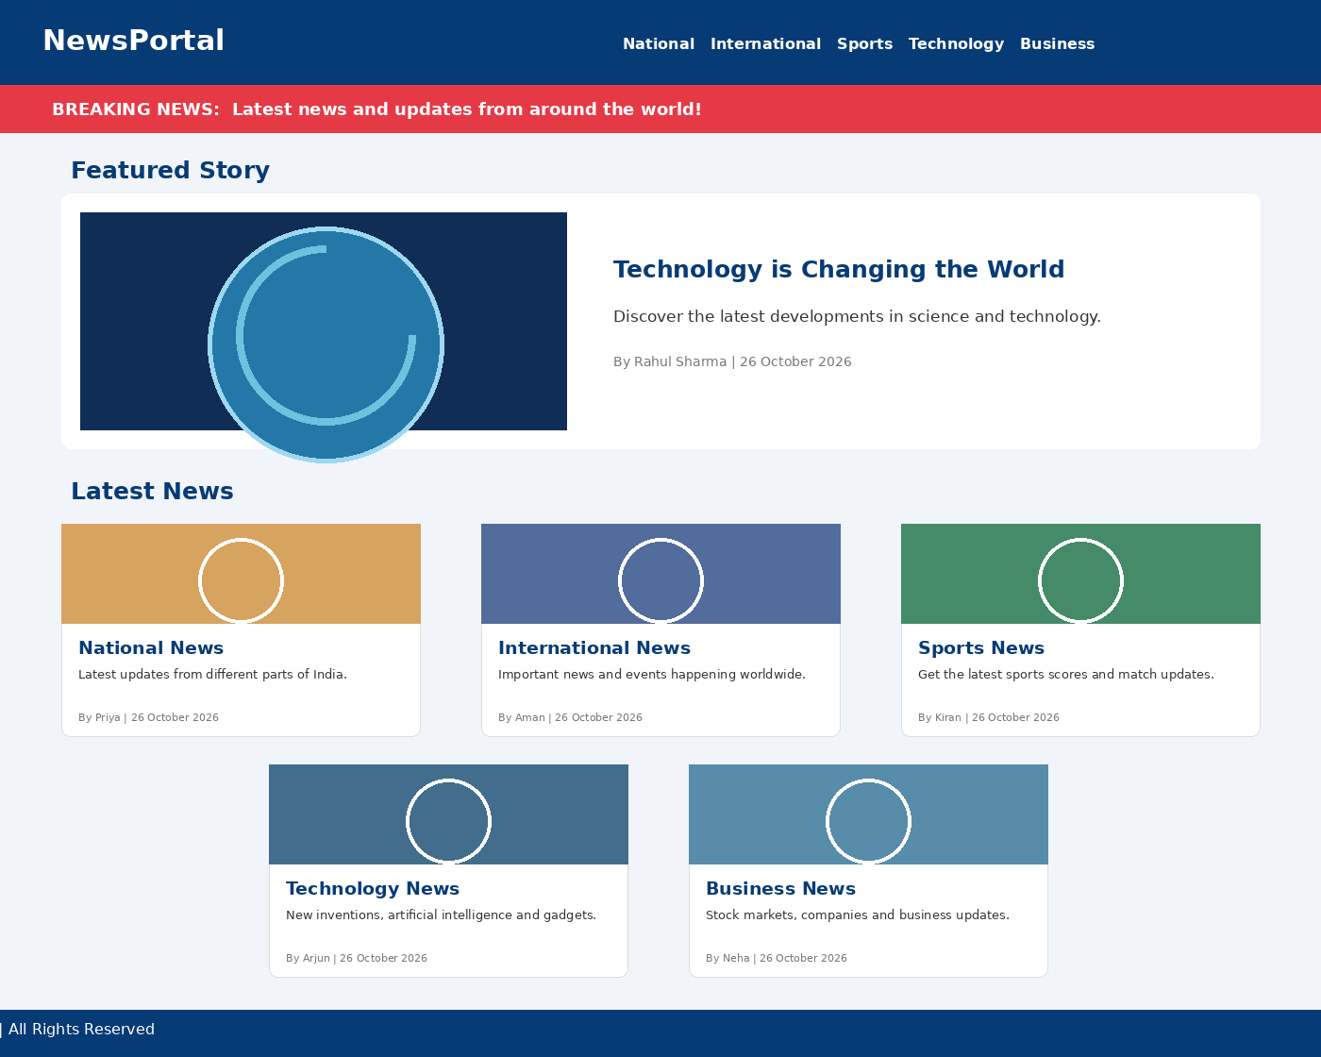
The output shows the blue navigation header, breaking-news bar, featured story, five news cards, and footer.

6. Important File-Link Correction
In the repository, the HTML file is named new.html and the CSS file is named class.css. However, the HTML currently links to style.css. To make the supplied CSS apply, change the stylesheet link in new.html to:
<link rel="stylesheet" href="class.css">
Alternatively, rename class.css to style.css. Keep the HTML and CSS files in the same folder.

7. How to Run the Project
- Download new.html and class.css from the GitHub repository.
- Correct the stylesheet link as explained above, or rename class.css to style.css.
- Keep both files in the same folder.
- Open new.html in a web browser such as Chrome or Edge.
- Connect to the internet to load the external Unsplash images.
GitHub repository: https://github.com/thotahimasri3-jpg/WD-Activity-Based-2

8. HTML Source Code (new.html)
<!DOCTYPE html>
<html lang="en">
<head>
<meta charset="UTF-8">
<meta name="viewport" content="width=device-width, initial-scale=1.0">
<title>NewsPortal</title>
<link rel="stylesheet" href="style.css">
</head>
<body>
<header>
<div class="logo">NewsPortal</div>
<nav>
<a href="#national">National</a>
<a href="#international">International</a>
<a href="#sports">Sports</a>
<a href="#technology">Technology</a>
<a href="#business">Business</a>
</nav>
</header>
<div class="breaking">
<strong>BREAKING NEWS:</strong>
Latest news and updates from around the world!
</div>
<main class="container">
<h2>Featured Story</h2>
<section class="featured">
<img src="https://images.unsplash.com/photo-1451187580459-43490279c0fa?w=900"
alt="Earth from space">
<div>
<h2>Technology is Changing the World</h2>
<p>Discover the latest developments in science and technology.</p>
<p class="author">By Rahul Sharma | 26 October 2026</p>
</div>
</section>
<h2>Latest News</h2>
<section class="news-grid">
<article class="card" id="national">
<img src="https://images.unsplash.com/photo-1524492412937-b28074a5d7da?w=600"
alt="India landmark">
<div class="content">
<h3>National News</h3>
<p>Latest updates from different parts of India.</p>
<p class="author">By Priya | 26 October 2026</p>
</div>
</article>
<article class="card" id="international">
<img src="https://images.unsplash.com/photo-1529107386315-e1a2ed48a620?w=600"
alt="World news">
<div class="content">
<h3>International News</h3>
<p>Important news and events happening worldwide.</p>
<p class="author">By Aman | 26 October 2026</p>
</div>
</article>
<article class="card" id="sports">
<img src="https://images.unsplash.com/photo-1461896836934-ffe607ba8211?w=600"
alt="Sports running">
<div class="content">
<h3>Sports News</h3>
<p>Get the latest sports scores and match updates.</p>
<p class="author">By Kiran | 26 October 2026</p>
</div>
</article>
<article class="card" id="technology">
<img src="https://images.unsplash.com/photo-1518770660439-4636190af475?w=600"
alt="Technology circuit">
<div class="content">
<h3>Technology News</h3>
<p>New inventions, artificial intelligence and gadgets.</p>
<p class="author">By Arjun | 26 October 2026</p>
</div>
</article>
<article class="card" id="business">
<img src="https://images.unsplash.com/photo-1460925895917-afdab827c52f?w=600"
alt="Business analytics">
<div class="content">
<h3>Business News</h3>
<p>Stock markets, companies and business updates.</p>
<p class="author">By Neha | 26 October 2026</p>
</div>
</article>
</section>
</main>
<footer>
<p>© 2026 NewsPortal | All Rights Reserved</p>
</footer>
</body>
</html>

9. CSS Source Code (class.css)
* {
margin: 0;
padding: 0;
box-sizing: border-box;
font-family: Arial, sans-serif;
}
body {
background-color: #f1f4f8;
color: #222;
}
/* Header */
header {
background-color: #063b75;
color: white;
padding: 20px 5%;
display: flex;
justify-content: space-between;
align-items: center;
flex-wrap: wrap;
gap: 15px;
}
.logo {
font-size: 28px;
font-weight: bold;
}
nav a {
color: white;
text-decoration: none;
margin: 10px;
font-weight: bold;
}
nav a:hover {
color: #ffd700;
}
/* Breaking news */
.breaking {
background-color: #e63946;
color: white;
padding: 12px 5%;
}
/* Main container */
.container {
width: 90%;
max-width: 1200px;
margin: 25px auto;
}
h2 {
margin: 20px 0;
color: #063b75;
}
/* Featured story */
.featured {
background: white;
display: flex;
gap: 20px;
padding: 15px;
border-radius: 8px;
margin-bottom: 30px;
align-items: center;
}
.featured img {
width: 45%;
height: 250px;
object-fit: cover;
border-radius: 8px;
}
.featured p {
margin-top: 12px;
}
/* News cards */
.news-grid {
display: grid;
grid-template-columns: repeat(3, 1fr);
gap: 20px;
}
.card {
background: white;
border-radius: 8px;
overflow: hidden;
box-shadow: 0 2px 8px #00000020;
}
.card img {
width: 100%;
height: 180px;
object-fit: cover;
}
.content {
padding: 15px;
}
.content h3 {
color: #063b75;
margin-bottom: 10px;
}
.content p {
line-height: 1.5;
}
.author {
color: #777;
font-size: 13px;
margin-top: 12px;
}
/* Footer */
footer {
background-color: #063b75;
color: white;
text-align: center;
padding: 20px;
margin-top: 30px;
}
/* Responsive design */
@media (max-width: 768px) {
header {
flex-direction: column;
text-align: center;
}
.featured {
flex-direction: column;
}
.featured img {
width: 100%;
}
.news-grid {
grid-template-columns: repeat(2, 1fr);
}
}
@media (max-width: 500px) {
.news-grid {
grid-template-columns: 1fr;
}
nav a {
display: inline-block;
margin: 6px;
}
}

10. Conclusion
The NewsPortal project demonstrates the use of HTML and CSS to build a categorized news webpage. It uses semantic HTML elements, Flexbox, CSS Grid, and media queries to create an organized and responsive layout.

