WEB DEVELOPMENT
ACTIVITY-BASED LEARNING
TRAVELGO – TRAVEL BOOKING WEBSITE
Student Name: Thota Hima Sri
Roll Number: 26001252
College: NRI UNIVERSITY
Branch: CSM
Year: 1st Year
Subject: Web Development

1. Introduction
TravelGo is a sample travel booking webpage developed using HTML and CSS. It allows a user to enter journey details, view sample bus and train services, compare fares, enter passenger details, and select seats.

2. Objectives
- To design a simple travel booking webpage.
- To collect journey details such as source, destination, date, and transport type.
- To display available bus and train services with sample fares.
- To provide a passenger details form and seat selection area.
- To practice HTML forms, tables, CSS Grid, Flexbox, and responsive design.

3. Technologies Used
HTML5: Used to create the webpage structure, navigation, booking form, passenger form, service cards, fare table, seat checkboxes, and footer.
CSS3: Used for colors, spacing, form styling, cards, tables, seat layout, hover effects, and responsive media queries.

4. Main Features
- Navigation links to Book Tickets, Services, and Select Seats.
- Journey form with source, destination, travel date, transport type, and passenger count.
- Passenger details form for name, age, gender, and mobile number.
- Three sample services: Express Bus (₹600), Luxury Bus (₹900), and Express Train (₹450).
- Fare comparison table and eight selectable seat checkboxes.
- Responsive service cards: three columns on large screens, two on medium screens, and one on small screens.

5. Output of the Project
The following is an illustrative preview of the TravelGo webpage based on the repository's HTML and CSS. It represents the page layout and sample content.
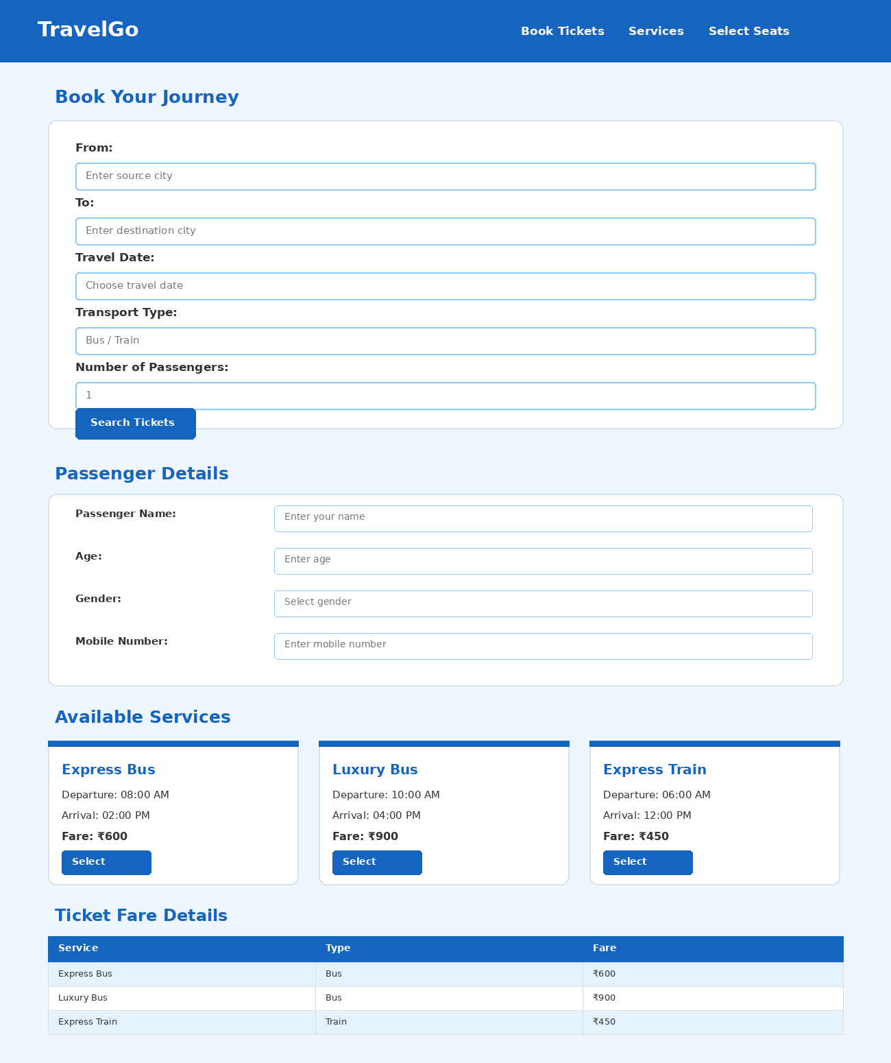
The webpage displays the booking form, passenger details, available services, and ticket fare details. The seat selection section appears further down the page.

6. How to Run the Project
- Download room.html and text.css from the GitHub repository.
- Keep both files in the same folder.
- The HTML file already links to the CSS file using the correct name: text.css.
- Double-click room.html or open it with Google Chrome or Microsoft Edge.
- The TravelGo webpage will appear in your browser.
GitHub repository: https://github.com/thotahimasri3-jpg/WD-Activity-Based-3

7. HTML Source Code (room.html)
<!DOCTYPE html>
<html lang="en">
<head>
<meta charset="UTF-8">
<meta name="viewport" content="width=device-width, initial-scale=1.0">
<title>Travel Booking</title>
<link rel="stylesheet" href="text.css">
</head>
<body>
<header>
<h1>TravelGo</h1>
<nav>
<a href="#booking">Book Tickets</a>
<a href="#services">Services</a>
<a href="#seats">Select Seats</a>
</nav>
</header>
<div class="container">
<h2>Book Your Journey</h2>
<form id="booking">
<div class="form-box">
<label>From:</label>
<input type="text" placeholder="Enter source city" required>
<label>To:</label>
<input type="text" placeholder="Enter destination city" required>
<label>Travel Date:</label>
<input type="date" required>
<label>Transport Type:</label>
<select required>
<option value="">Select Transport</option>
<option>Bus</option>
<option>Train</option>
</select>
<label>Number of Passengers:</label>
<input type="number" min="1" max="6" value="1">
<button type="button">Search Tickets</button>
</div>
<h2>Passenger Details</h2>
<div class="form-box">
<label>Passenger Name:</label>
<input type="text" placeholder="Enter your name">
<label>Age:</label>
<input type="number" placeholder="Enter age">
<label>Gender:</label>
<select>
<option>Select Gender</option>
<option>Male</option>
<option>Female</option>
<option>Other</option>
</select>
<label>Mobile Number:</label>
<input type="tel" placeholder="Enter mobile number">
</div>
</form>
<section id="services">
<h2>Available Services</h2>
<div class="service-grid">
<div class="card">
<h3>Express Bus</h3>
<p>Departure: 08:00 AM</p>
<p>Arrival: 02:00 PM</p>
<p>Fare: ₹600</p>
<button type="button">Select Bus</button>
</div>
<div class="card">
<h3>Luxury Bus</h3>
<p>Departure: 10:00 AM</p>
<p>Arrival: 04:00 PM</p>
<p>Fare: ₹900</p>
<button type="button">Select Bus</button>
</div>
<div class="card">
<h3>Express Train</h3>
<p>Departure: 06:00 AM</p>
<p>Arrival: 12:00 PM</p>
<p>Fare: ₹450</p>
<button type="button">Select Train</button>
</div>
</div>
</section>
<h2>Ticket Fare Details</h2>
<table>
<tr><th>Service</th><th>Type</th><th>Fare</th></tr>
<tr><td>Express Bus</td><td>Bus</td><td>₹600</td></tr>
<tr><td>Luxury Bus</td><td>Bus</td><td>₹900</td></tr>
<tr><td>Express Train</td><td>Train</td><td>₹450</td></tr>
</table>
<section id="seats">
<h2>Select Your Seat</h2>
<div class="seat-box">
<p>Available Seats</p>
<div class="seats">
<label><input type="checkbox"> 1</label>
<label><input type="checkbox"> 2</label>
<label><input type="checkbox"> 3</label>
<label><input type="checkbox"> 4</label>
<label><input type="checkbox"> 5</label>
<label><input type="checkbox"> 6</label>
<label><input type="checkbox"> 7</label>
<label><input type="checkbox"> 8</label>
</div>
<button type="button">Confirm Booking</button>
</div>
</section>
</div>
<footer>
<p>© 2026 TravelGo | Safe Journey, Happy Journey!</p>
</footer>
</body>
</html>

8. CSS Source Code (text.css)
* {
margin: 0;
padding: 0;
box-sizing: border-box;
font-family: Arial, sans-serif;
}
body {
background-color: #f0f6ff;
color: #333;
}
header {
background-color: #1565c0;
color: white;
padding: 20px 5%;
display: flex;
justify-content: space-between;
align-items: center;
flex-wrap: wrap;
}
header h1 { font-size: 28px; }
nav a {
color: white;
text-decoration: none;
margin: 10px;
font-weight: bold;
}
nav a:hover { text-decoration: underline; }
/* Container */
.container {
width: 90%;
max-width: 1100px;
margin: 30px auto;
}
h2 {
color: #1565c0;
margin: 20px 0;
}
/* Form */
.form-box {
background-color: white;
padding: 25px;
border-radius: 10px;
box-shadow: 0 2px 8px #00000015;
margin-bottom: 25px;
}
label {
display: block;
margin-top: 12px;
font-weight: bold;
}
input, select {
width: 100%;
padding: 12px;
margin-top: 7px;
border: 1px solid #90caf9;
border-radius: 5px;
}
button {
background-color: #1565c0;
color: white;
padding: 12px 20px;
border: none;
border-radius: 5px;
margin-top: 18px;
cursor: pointer;
}
button:hover { background-color: #0d47a1; }
.service-grid {
display: grid;
grid-template-columns: repeat(3, 1fr);
gap: 20px;
}
.card {
background-color: white;
padding: 20px;
border-radius: 10px;
border-top: 4px solid #1565c0;
box-shadow: 0 2px 8px #00000015;
}
.card h3 {
color: #1565c0;
margin-bottom: 15px;
}
.card p { margin: 10px 0; }
table {
width: 100%;
border-collapse: collapse;
background-color: white;
margin: 20px 0;
}
th {
background-color: #1565c0;
color: white;
}
th, td {
padding: 14px;
border: 1px solid #ddd;
text-align: center;
}
tr:nth-child(even) { background-color: #e3f2fd; }
.seat-box {
background-color: white;
padding: 25px;
border-radius: 10px;
text-align: center;
}
.seats {
display: grid;
grid-template-columns: repeat(4, 1fr);
gap: 15px;
max-width: 400px;
margin: 20px auto;
}
.seats label {
background-color: #e3f2fd;
color: #1565c0;
padding: 12px;
border: 1px solid #90caf9;
border-radius: 5px;
cursor: pointer;
}
.seats input { width: auto; }
.seats label:has(input:checked) {
background-color: #1565c0;
color: white;
}
footer {
background-color: #1565c0;
color: white;
text-align: center;
padding: 20px;
margin-top: 30px;
}
@media (max-width: 768px) {
header {
flex-direction: column;
text-align: center;
}
.service-grid { grid-template-columns: repeat(2, 1fr); }
}
@media (max-width: 500px) {
.service-grid { grid-template-columns: 1fr; }
nav a {
display: inline-block;
margin: 6px;
}
th, td {
padding: 8px;
font-size: 13px;
}
}

9. Conclusion
The TravelGo project demonstrates how HTML and CSS can be used to build a travel booking interface. It includes forms, service cards, a fare table, and seat selection controls. The project is a front-end demonstration only; it does not connect to a real ticket reservation or payment system.

