A Hardware that can detect and prevent unauthorised use of electric fences
What is unauthorized electric fence?
- An unauthorized electric fence is a fence directly connected to AC mains without using a regulated energizer. These fences produce dangerous, continuous high voltage currents that violate safety standards and pose a serious risk to people and wildlife.
Impact of unauthorized electric fences
- High risk of human fatalities from electrocution.
- Rising wildlife deaths due to unsafe/illegal fencing.
- Lack of monitoring, danger often unnoticed.
THE RECORDED STATISTICS OF ELECTROCUTION CASES
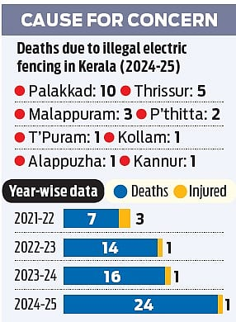
Source: https://www.newindianexpress.com/states/kerala/2025/Jun/17/24-lives-lost-in-a-year-as-illegal-electric-fences-turn-into-deathtraps-in-kerala
GRAPHICAL REPRESENTATION

PROBLEM: To detect lethal unauthorized fences
SOLUTION
PROTOTYPE APPROACH:
Components Required:
- Dual-Copper coil sensor
- JFET BF245A
- LM358
- RC Filters
- Microcontroller
- LEDs
- Battery
Principle:
- The electric fences generally produce electromagnetic field. This detection of electric field is a crucial path to the solution.
- The electric field in our prototype is detected using a copper coil antenna. It acts as a simple inductive coil.
- While the electric field is detected, we can record the fluctuations of electric field due to voltage. This observation leads to finding pulse time interval and frequency of the electric fence.
- There are safety ranges provided for the frequency of the electric fence, when these ranges are violated, the prototype detects the fence being unauthorized.
- In the case of our prototype, while the unauthorized fence gets detected the LED integrated glows giving us the visual understanding.

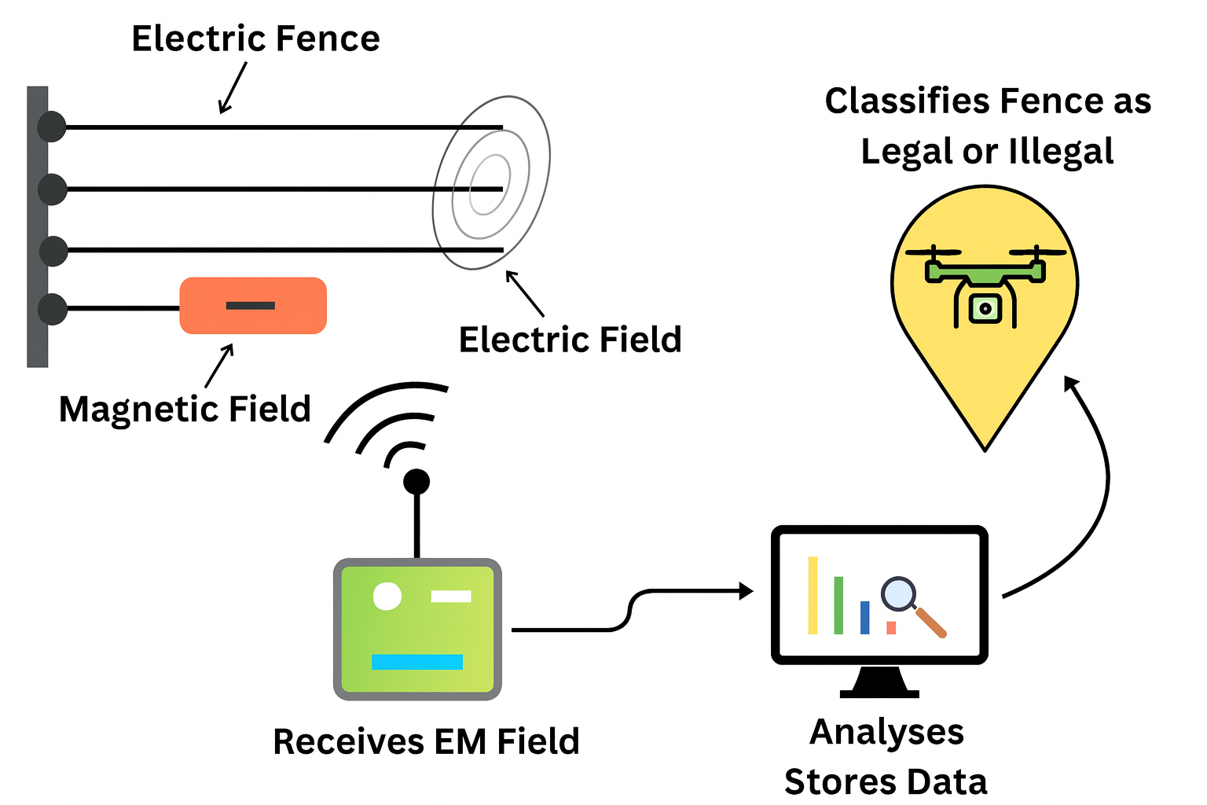

Physical Presence of prototype
- The prototype has two antennas detecting simultaneously providing smart elimination of legal fence when there are two fences in nearby.
- After sensing, the signal is amplified by JFET and LM358.
- Provides the amplified signal to the microcontroller which plays role in decision making whether the fence is legal or illegal. Microcontroller acts as a brain of prototype.
- Once the fence is detected as illegal by understanding that frequency is not within the safety regulated range, the LED glows showing visual understanding of the prototype.
Hence, we can detect unauthorized fences using this prototype.

BLOCK DIAGRAM

ELECTRIC FENCE AC FIELD

COPPER COIL ANTENNA

CAPACITIVE COUPLING SIGNAL

JFET (FIRST SIGNAL PICKUP)

LM358 (AMPLIFICATION)

MICROCONTROLLER

CIRCUIT DIAGRAM

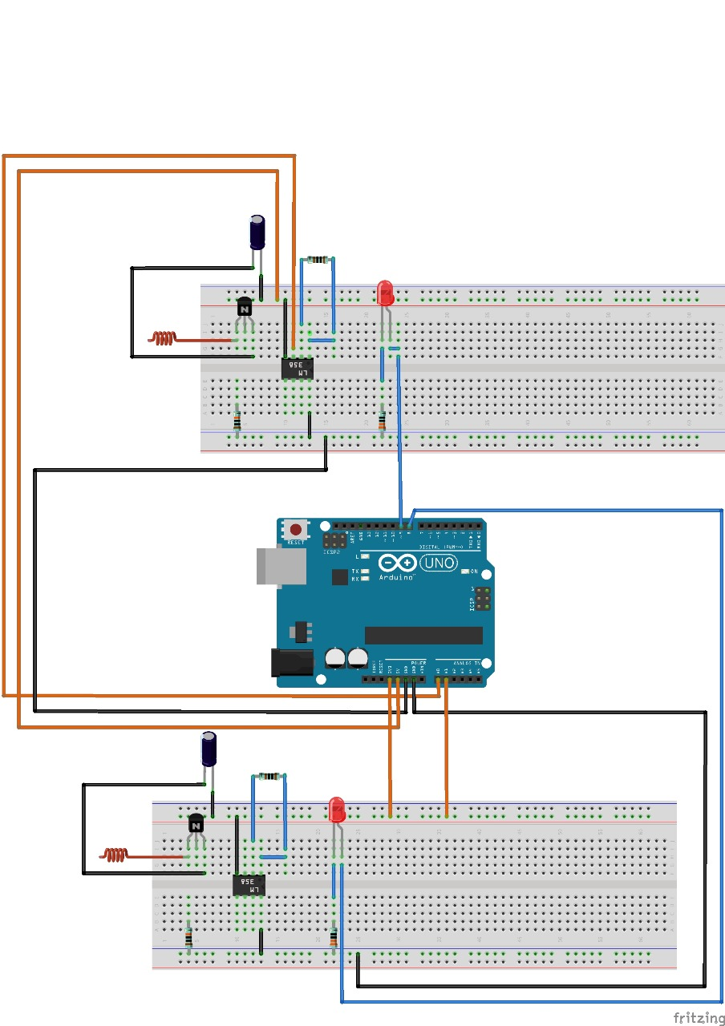

TECHNICAL CONNECTIONS
LEFT
- LM358 (pin 1) 1k ohm LM358 (pin 2)
- LM358 (pin 1) A0
- LM358 (pin 3) JFET (middle)
- LM358 (pin 4) GND
- LM358 (pin 8) 3.3V (breadboard)
- JFET (right) 100k ohm GND
- JFET (right) Capacitor + (10 muF) (Capacitor -)GND
- JFET (right) Antenna
- JFET (left) 100k ohm 3.3V (breadboard)
- LED anode digital pin 9 (Arduino)
- LED cathode 100 ohm GND
RIGHT

- LM358 (pin 1) 1k ohm LM358 (pin 2)
- LM358 (pin 2) A1
- LM358 (pin 3) JFET (middle)
- LM358 (pin 4) GND
- LM358 (pin 8) 5V (breadboard)
- JFET (right) 100k ohm GND
- JFET (right) Capacitor + (10 muF) (Capacitor -)GND
- JFET (right) Antenna
- JFET (left) 100k ohm 5V (breadboard)
- LED anode digital pin 8 (Arduino)
- LED cathode 100 ohm GND

SYSTEM INTEGRATION

Hardware Integration
- Copper coil antenna detects the electric field generated by an energized fence through capacitive coupling.
- The weak signal from the antenna is received by the JFET transistor, which acts as a high-impedance amplifier to prevent signal loss.
- The signal is then passed to the LM358 operational amplifier for further voltage amplification.
- The LM358 output acts as a threshold/comparator signal indicating the presence of an electric field.
- This signal is connected to the ESP32 microcontroller, which processes the detection data.
- An LED indicator is connected to provide visual confirmation when a fence is detected.

Software Integration
- The ESP32 is programmed using Arduino IDE.
- The program continuously reads the signal from the amplifier circuit.
- A threshold value is defined in the code to identify the presence of an electric fence.
- When the signal exceeds the threshold:
  - The LED turns ON.
  - Detection data is sent to the cloud via Wi-Fi.

System Testing
- The antenna is placed near an AC-powered fence or conductor to simulate real conditions.
- The signal amplification stages are checked to ensure proper signal detection.
- The ESP32 processing and LED response are verified.
- Cloud communication is tested to confirm successful data transmission.

Final Integrated System
- Detects electric fields without physical contact.
- Amplifies weak signals using JFET and LM358.
- Processes detection using ESP32.
- Provides visual indication and cloud-based monitoring.
FUTURE ENHANCEMENTS
- While we have to increase the sensitivity and range of detection, the antenna will be upgraded by maintaining the coil diameter 10-15 cm with 200-400 turns and coil thickness of 1-2 cm maximum.
- Copper coil axis is maintained parallel to the ground.
- As the detector has to be taken near the fence for sensing the use of autonomous drone comes into play.
- These drones are similar to the functionality of surveying or farming drones.

