TASK 4 – INCIDENT RESPONSE SIMULATION
Windows Security Event Log Analysis

1. Objective
Analyze suspicious authentication activity in Windows Security logs, identify potential indicators of compromise (IOCs), and document appropriate response and containment actions.

2. Evidence Observed
Windows Event Viewer was filtered for Event ID 4625. Multiple Audit Failure entries were visible under Windows Logs → Security. The selected event states "An account failed to log on," indicating a failed authentication attempt.
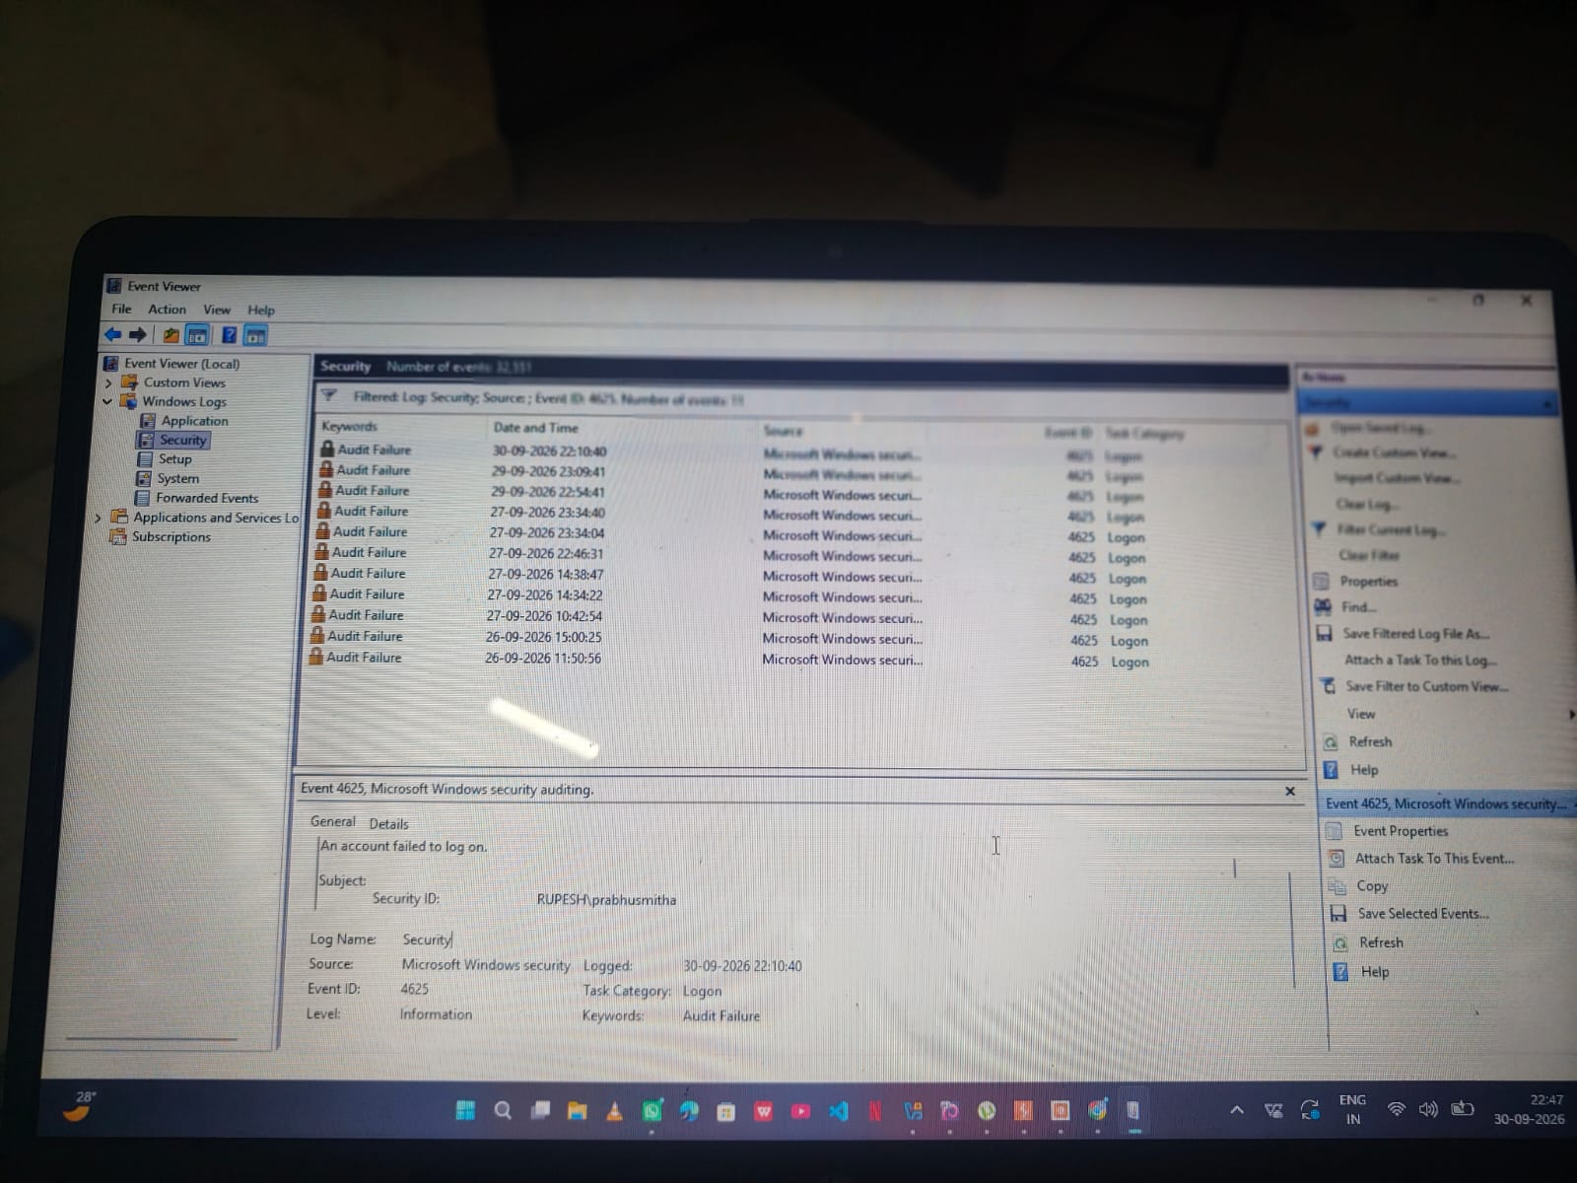
Figure 1 – Windows Security Event ID 4625 evidence

3. Detected Anomalies
- Multiple failed logon (Event ID 4625) entries were observed.
- Repeated authentication failures occurred across different timestamps.
- The activity warrants review to determine whether it represents normal user error or suspicious authentication behavior.

4. Possible Indicators of Compromise (IOCs)
- Repeated Event ID 4625 failed-logon events.
- Unusual frequency or timing of failed authentication attempts.
- Source account, workstation, or source IP associated with repeated failures, if confirmed from the event Details view.
- Any matching suspicious processes, network connections, or account changes found during follow-up investigation.

5. Response and Containment Actions
- Validate the failed-logon activity and identify the affected account.
- Review related Security events around the same timestamps.
- If compromise is suspected, temporarily lock or disable the affected account according to the organization's procedure.
- Reset credentials and enforce stronger authentication where appropriate.
- Review the source workstation/IP and other related authentication activity.
- Preserve relevant logs for further investigation.
- Continue monitoring for repeated failed authentication attempts.

6. Conclusion
The simulated incident analysis identified repeated Windows failed-logon events (Event ID 4625). These events should be investigated in context before concluding that a compromise occurred. The response and containment steps above provide a basic incident-handling workflow.

Note: The report describes the observed Event ID 4625 evidence and treats the exercise as an incident-response simulation; it does not claim that a real compromise occurred.

