TASK 2 – WEB APPLICATION SECURITY BASICS
DVWA / Safe Demonstration Environment

1. Objective
Identify and demonstrate basic web application vulnerabilities in the DVWA safe lab environment, including SQL Injection and Cross-Site Scripting (XSS), and capture HTTP traffic using Burp Suite.

2. SQL Injection Finding
The DVWA SQL Injection page was tested in the local lab environment. The supplied input caused multiple database records to be returned, demonstrating SQL Injection behavior.
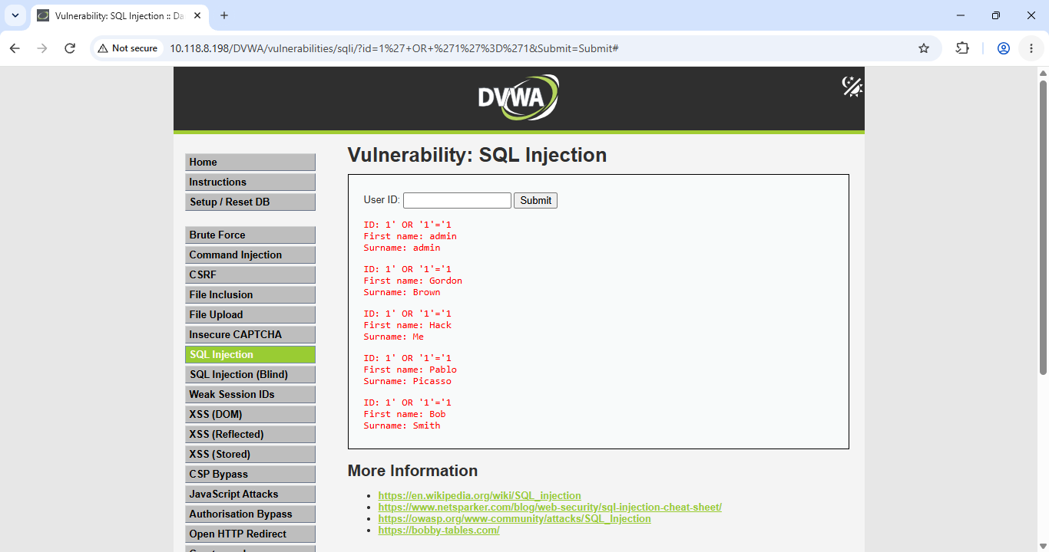
Figure 1 – DVWA SQL Injection finding

3. Cross-Site Scripting (XSS) Finding
The DVWA XSS page was tested in the safe lab environment. A JavaScript alert was successfully triggered, demonstrating reflected XSS behavior.
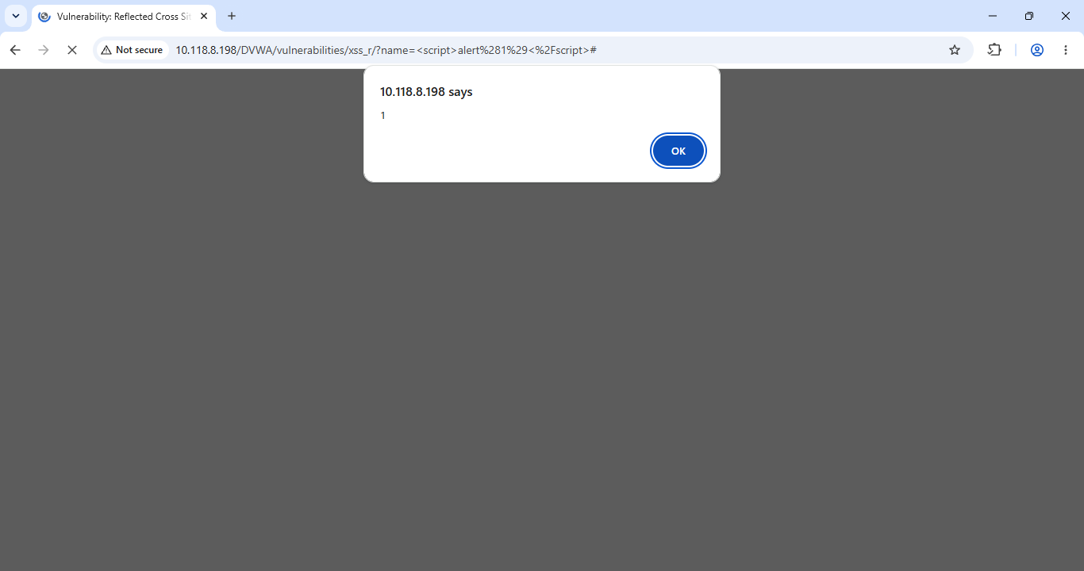
Figure 2 – XSS proof in DVWA

4. Burp Suite Traffic Capture
Burp Suite was configured as a proxy and DVWA HTTP traffic was captured. The HTTP history shows a GET request to the DVWA SQL Injection endpoint, with the request and response available for inspection.
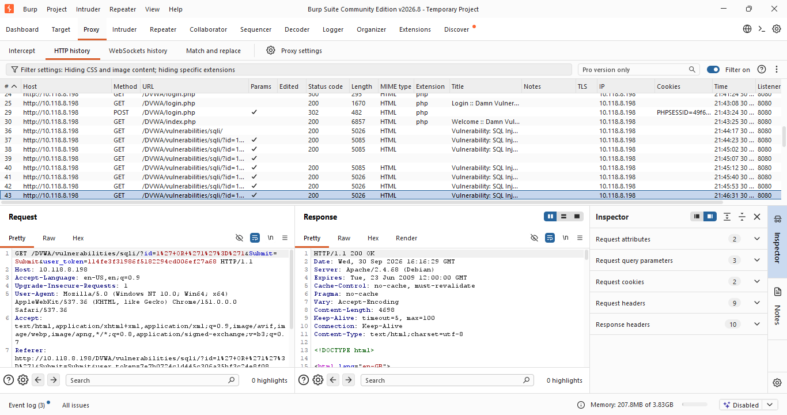
Figure 3 – Burp Suite HTTP request/response capture

5. Mitigation Recommendations
SQL Injection
- Use prepared statements / parameterized SQL queries.
- Validate and constrain user input before processing it.
- Avoid concatenating untrusted input directly into SQL statements.
- Use least-privilege accounts for database access.
XSS
- Validate and appropriately encode untrusted input and output.
- Use context-appropriate output encoding before rendering user-controlled data.
- Deploy a suitable Content Security Policy (CSP).
- Avoid inserting untrusted input directly into HTML or JavaScript.
General Web Security
- Keep application frameworks, libraries, and server software updated.
- Use secure session and cookie settings and follow secure development practices.

6. Conclusion
The DVWA lab demonstrated SQL Injection and XSS behavior, and Burp Suite was used to capture and inspect the related HTTP traffic. The listed mitigations address the identified application-level risks.

