Q1.

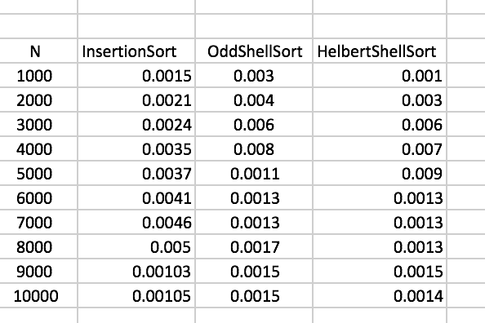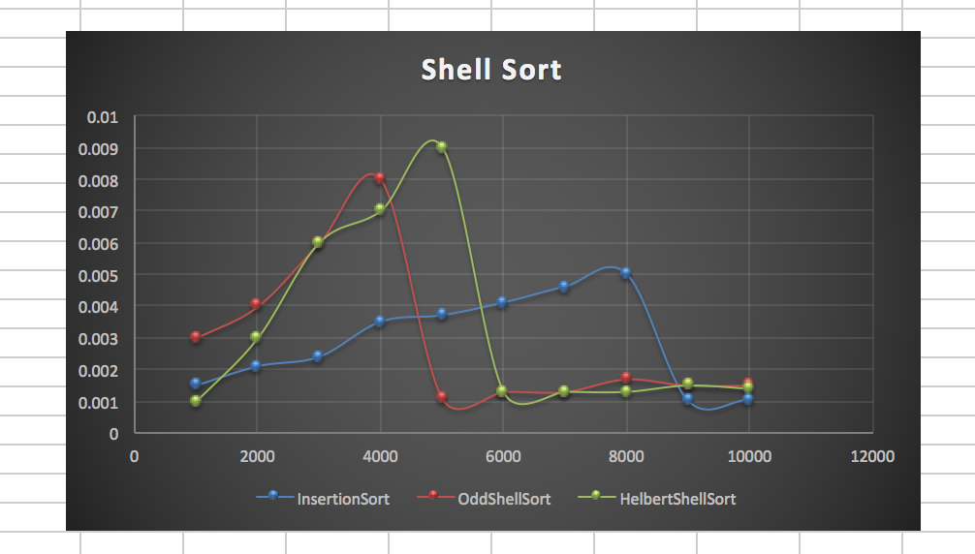

The red line indicated the program run through insertion sort. The green line indicated the program run through Odd shell sort. The blue line indicated the program run through Hilbert shell sort.

All three of O(N^2) as their run time. But, Hilbert shell short looks like the fastest algorithm among the three.

Q2.

(a) Using M.I (Mathematical Induction)

**Basis Step:**

(N - 2) ˃ 0, and for N=3, N-2 =1,

$$F_{1}=1,F_{3}=3$$

$$F_{1}=F_{3}-2=3-2=1$$

When N = 4, (N-2) = 2,

$$F_{1}=1,F_{2}=2,F_{4}=5$$

$$F_{1}+F_{2}=1+2=F_{4}-2=5-2=3$$

Hence, the basis step is proved.

$$\sum_{1}^{2}{F_{i}=F_{4}-2}$$

**Induction hypothesis:** Now let N = k and k - 2 ˃ 0, also think

$$\sum_{i=1}^{k-2}{F_{i}}=F_{k}-2$$

**To prove:** When N=k+1,

$$\sum_{i=1}^{k-1}{F_{i}}=F_{k+1}-2$$

**Proof of induction step:**

$\sum_{i=1}^{k-1}{F_{i}}=\sum_{i=1}^{k-2}{F_{i}}+F_{k-1}=F_{k}-2+F_{k-1}=F_{k+1}-2$,

and $F_{k+1}=F_{k}+F_{k-1}$, therefore N = k+1 is proved for all N.

(b) ${ F}_{N}< Φ^{N}, with Φ=\frac{(1 + \sqrt{5})}{2}$

Again by using M.I,

$$Φ+1={\frac{3+\sqrt{5}}{2}=Φ}^{2}=\frac{1+5+2\sqrt{5}}{4}=\frac{3+\sqrt{5}}{2}$$

Therefore, $Φ^{-1}+Φ^{-2}=1$

**Basis Step:** For N=1,

$${ F}_{1}=1,{F_{1}}^{2}=1^{2} while Φ^{2}=\frac{3+\sqrt{5}}{2}, so F_{1}<Φ^{1}$$

Consider N=2,

$${ F}_{2}=2,{F_{2}}^{2}=4 while Φ^{4}=\frac{9+5+6\sqrt{5}}{4}=\frac{14+6\sqrt{5}}{4},$$

$${Φ }^{4}=\frac{9+5+6\sqrt{5}}{4}=\frac{14+6\sqrt{5}}{4}>\frac{14+6\sqrt{4}}{4}=\frac{14+12}{4}=\frac{26}{4}>$$

${F_{2}}^{2}=4=\frac{16}{4} so F_{2}<Φ^{2}$

Therefore, the basis step is proved.

**Induction hypothesis:** For a constant k >0 , we say that ${ F}_{k}< Φ^{k}$

**To prove: ${ F}_{k+1}< Φ^{k+1}$**

Using the definition,

$$F_{k+1}=F_{k}+F_{k-1}$$

**Proof of induction step:**

Let k-1 > 0, from our hypothesis,

${ F}_{k}< Φ^{k} and { F}_{k-1}< Φ^{k-1}$,

for any constant value k - 1 > 0. So, $$F_{k+1}<Φ^{k}+Φ^{k-1}, since Φ^{-1}+Φ^{-2}=1$$

$$F_{k+1}<{Φ^{-1}Φ}^{k+1}+{Φ^{-2}Φ}^{k+1}=Φ^{k+1}\left({Φ^{-1}+Φ}^{-2}\right)=Φ^{k+1}$$

So, $N=K+1 is proved$. And by mathematical induction, the theorem is proved.