Homework 2

1. Create all relations or tables you identified in part 1.

**Please look at BookStore.txt for the sql code**.

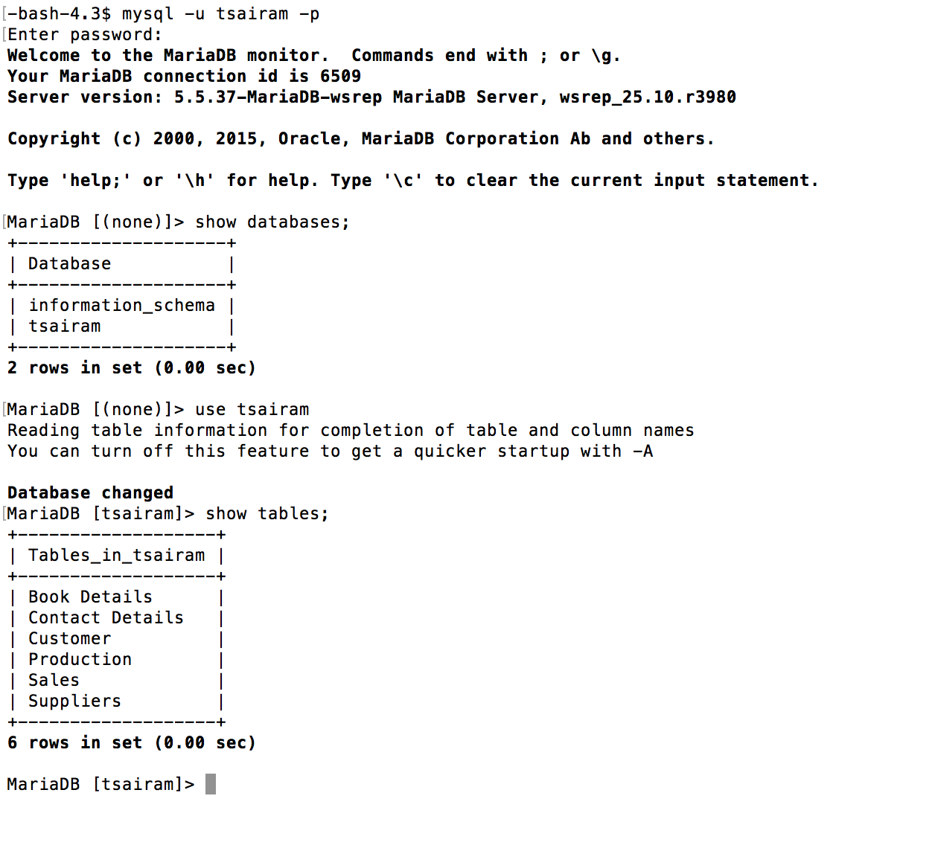

1. **Add data to table**;

INSERT INTO `Suppliers` (`SupplierID`, `SFName`, `SLName`, `CompanyName`, `Phone`, `OrderNumber` ) VALUES

('11265', 'Sam Daniel', 'Thomas', 'Fox Productions', '4055679272', '13');

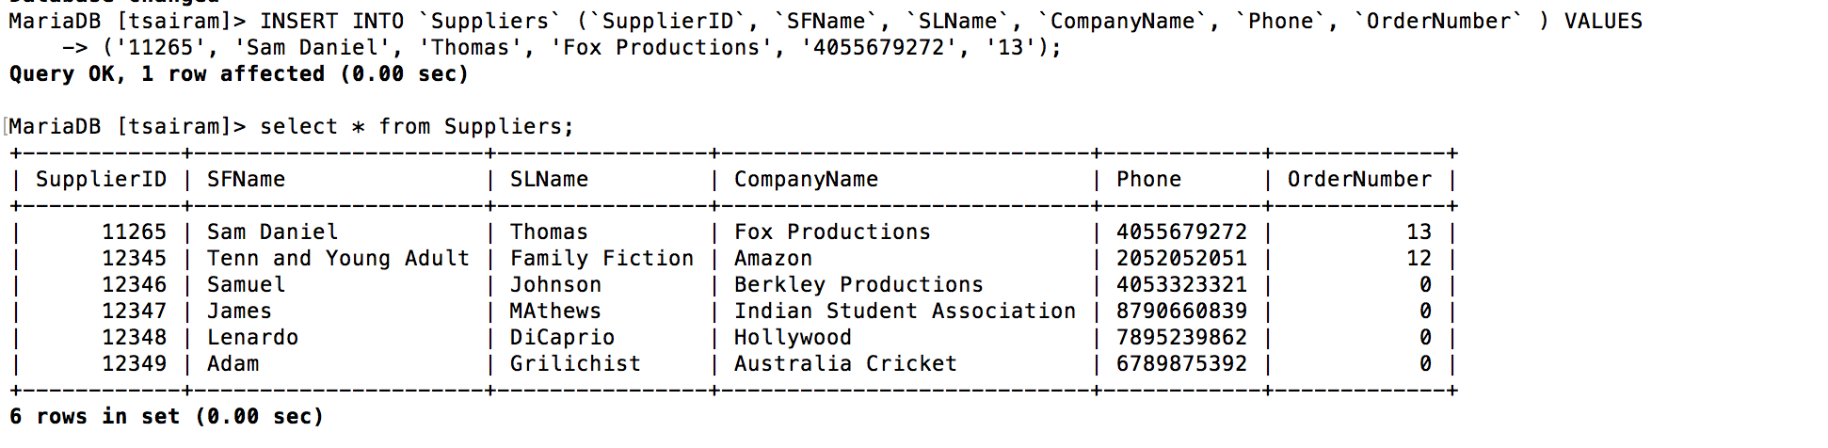

1. **Retrieve data from the table using a simple query**:

SELECT * FROM `Contact Details` WHERE State = “OK”;

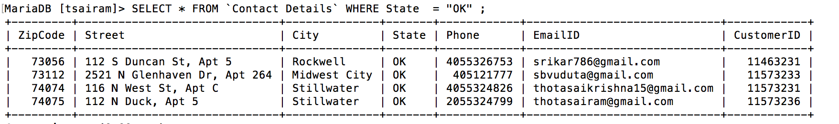

1. **Update data in the table:**



UPDATE `Suppliers`  
SET OrderNumber = 15  
WHERE SupplierID = 12349;

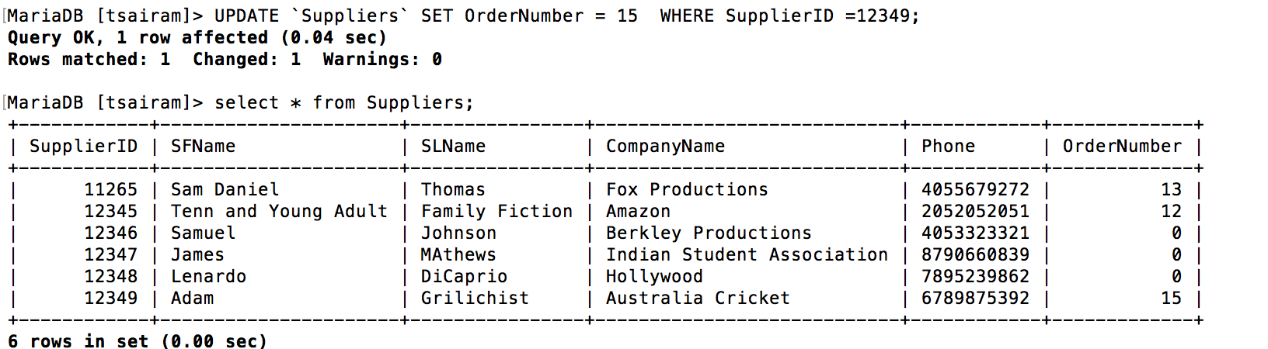

1. **Delete Data in the table**

DELETE FROM Suppliers  
WHERE SupplierID = 11265;

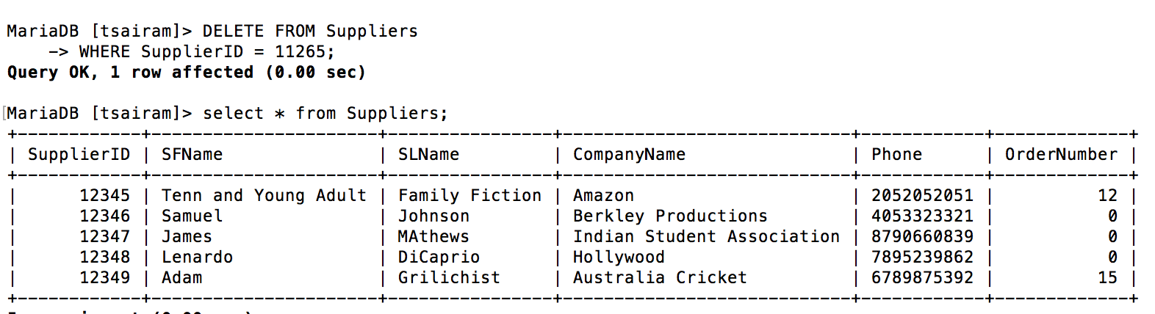

1. **Select and view a single table:**

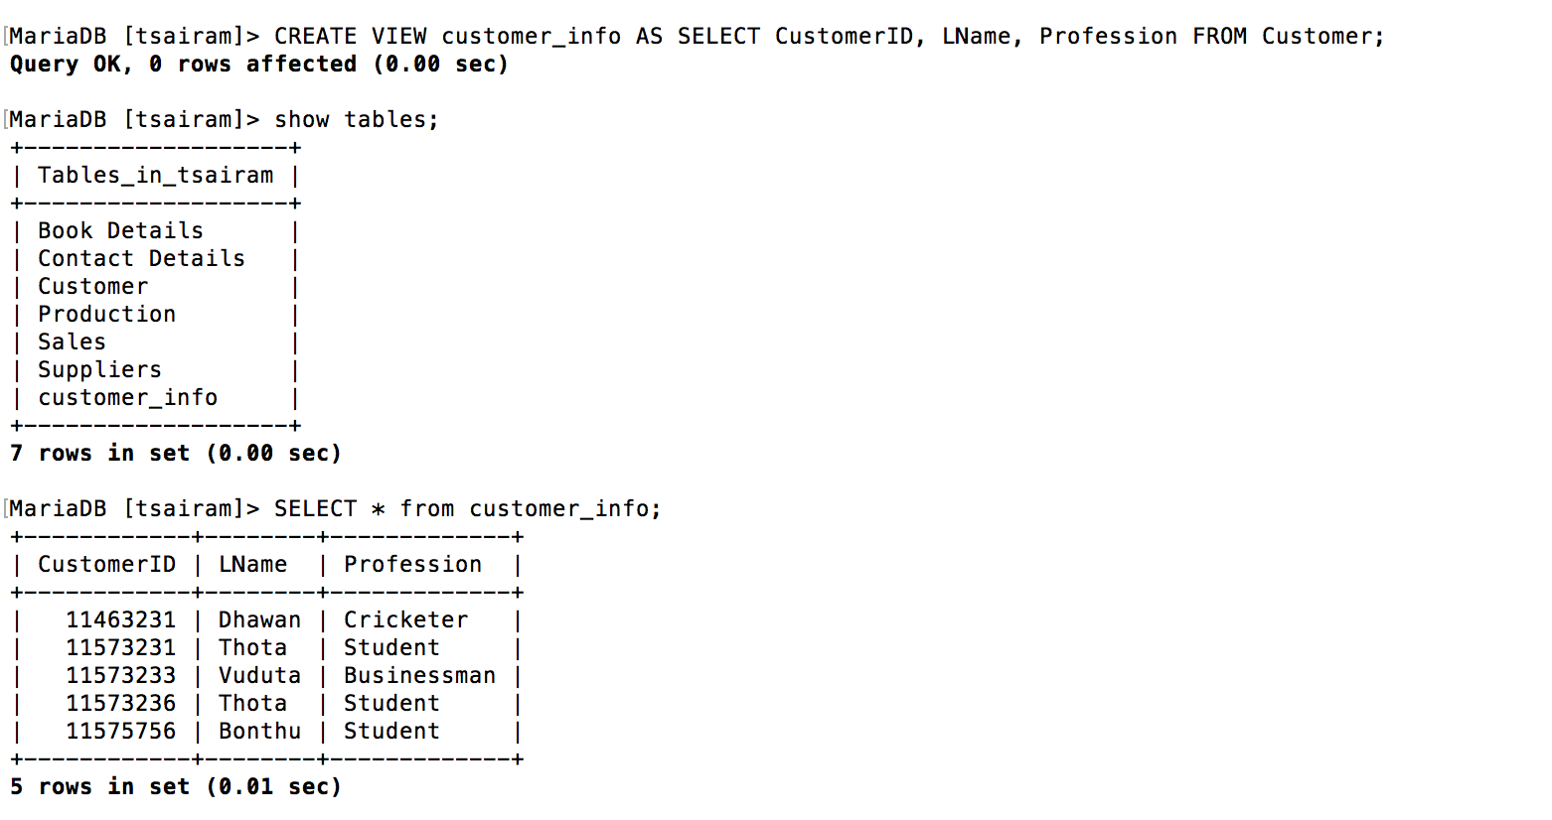

1. **Delete or Remover a table**;

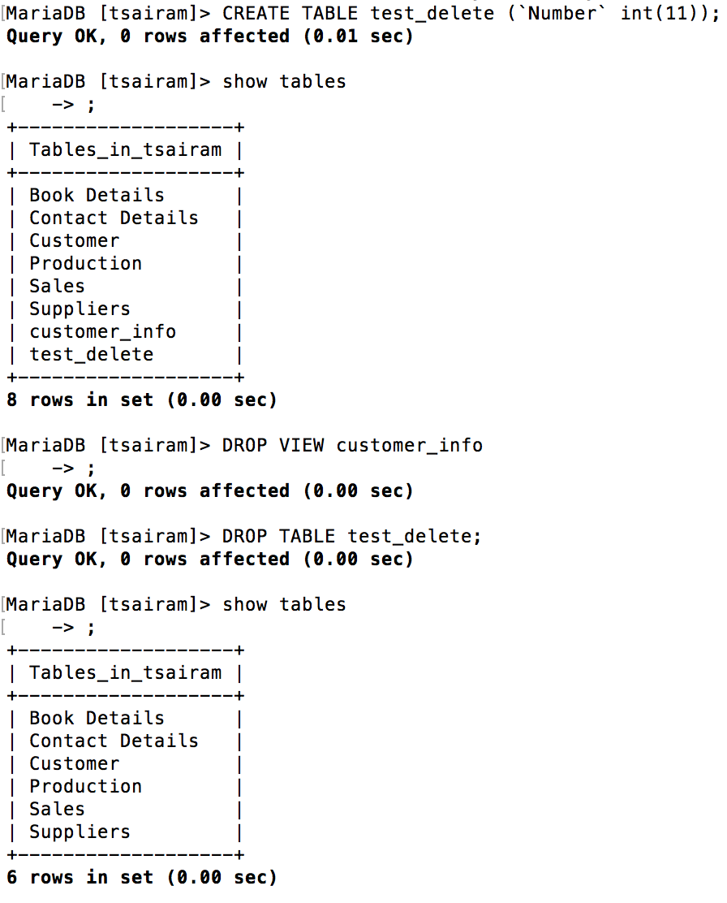

Testing the above database by using php.

* **AddData.html** and **AddData.php**

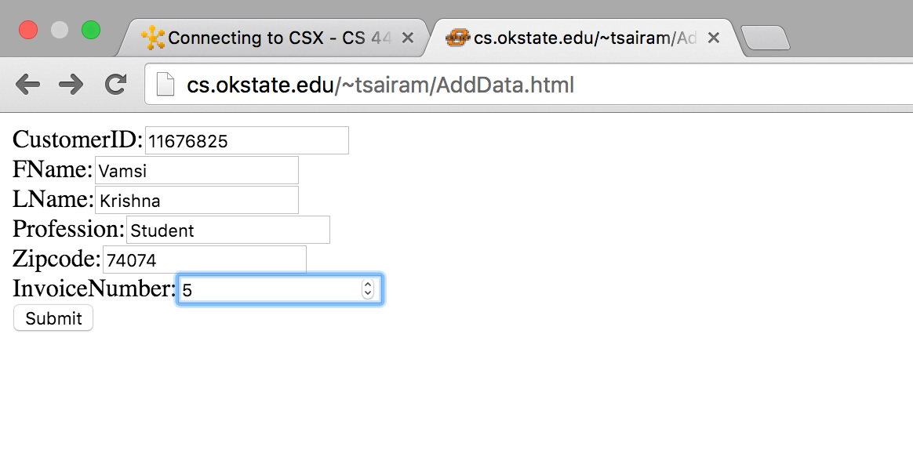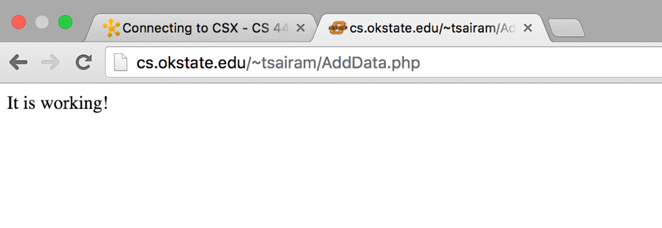

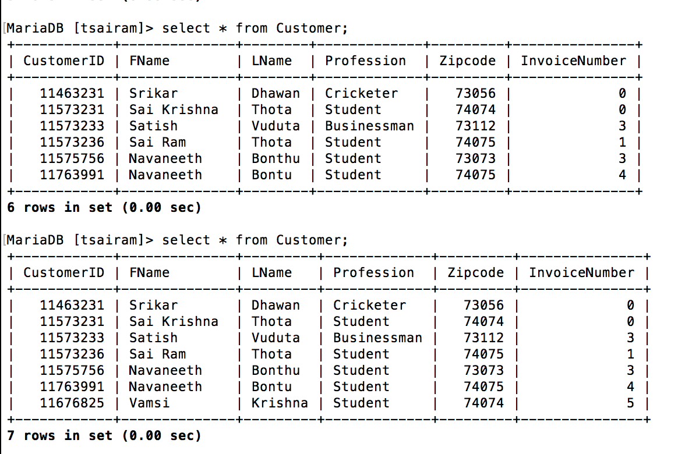

* **DeleteData.php**

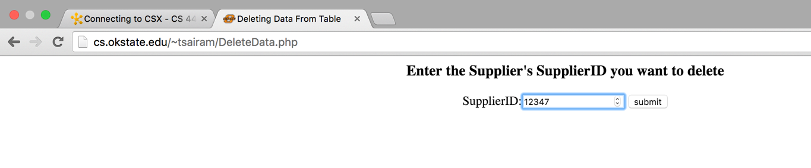

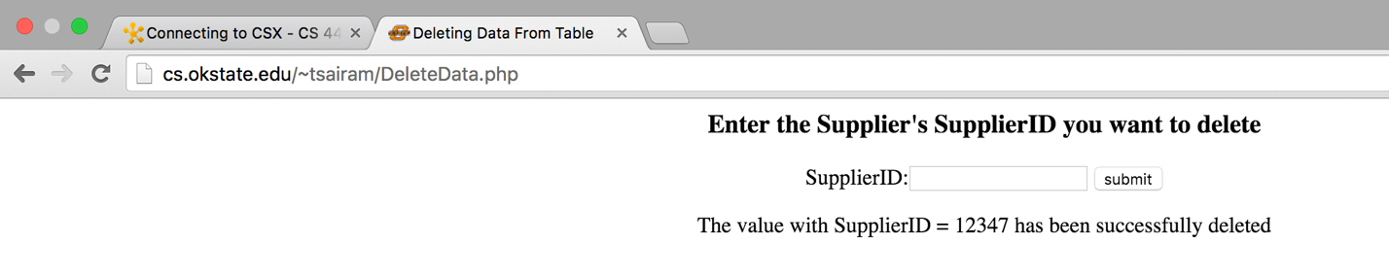

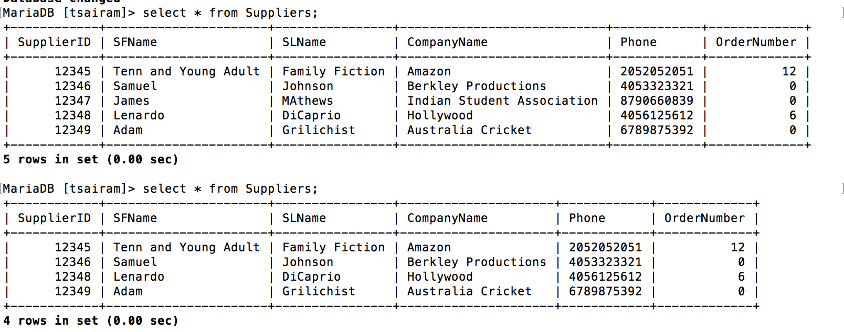

* **UpdateData.html** and **UpdateData.php**

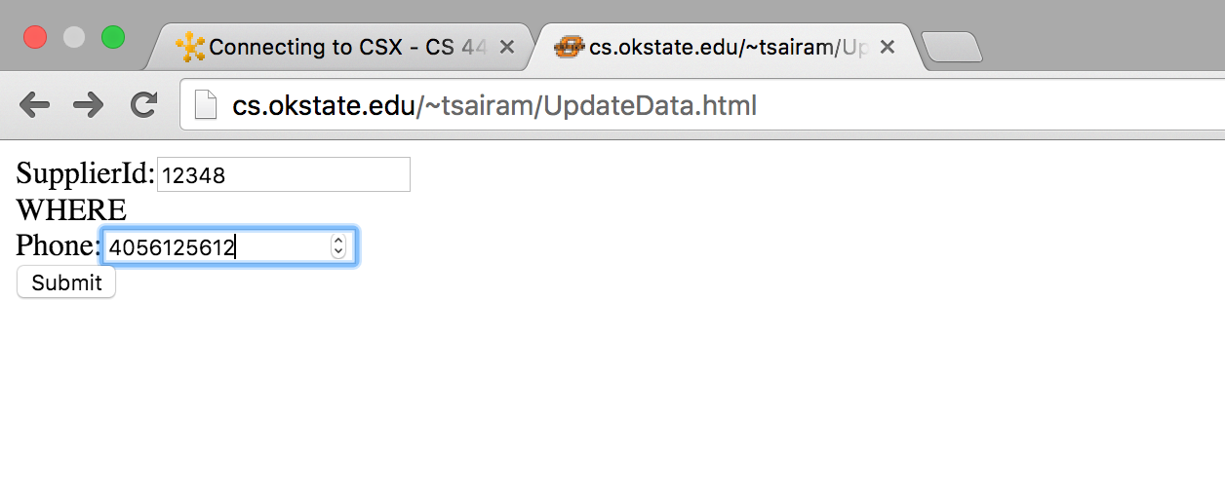

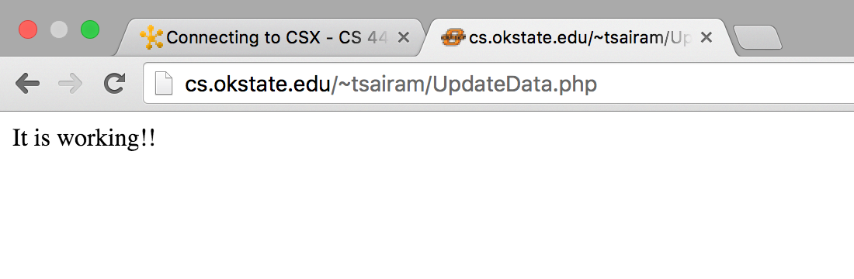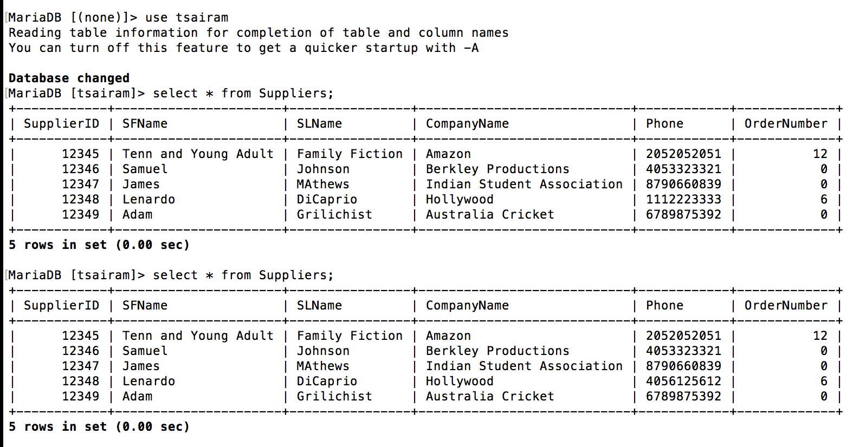

* **SampleQuery.php**

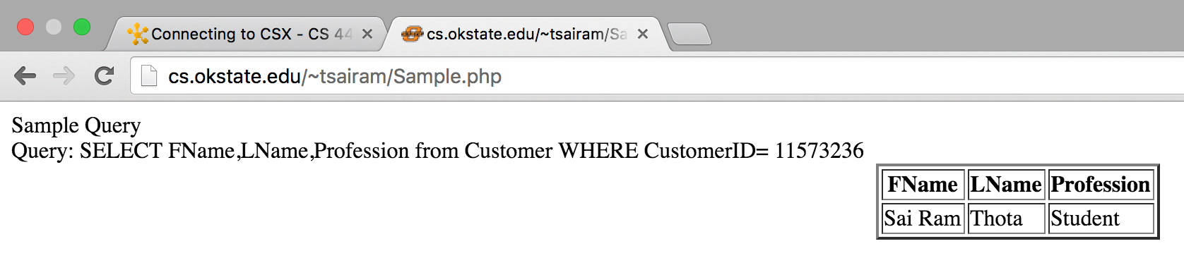

* **ViewTable.php**

