**Requirements Specification**

1. Describe your enterprise.

I’m working on a Book Store database. I’m not using the whole book store department’s database but, I’m working on subset of the book store data. My data concentrates on sales, production, book details, customer details, and supplier details. The main focus is to calculate the sales and production orders, and analyze profit/loss. Cost reduction by calculating the books that are not sold frequently. Help book store’s marketing by calculating the favorite book of month based on month and many more.

1. State clearly who the users of your system will be and how they will use it.

The users of my system is owner, production, customer, and supplier. The owner can access the database directly as he is given all the security passwords for contacting supplier, customer, ordering books, check the profits based on months. Customer can only check the book availability online. Supplier and Production can review their order details.

3) Describe the features and functions of the application. For example, the manager must be able to produce a summary showing: a) Total number of each product sold b) Profit on each product.

This include Identifying forms, reports and queries for your database

The customers can get the book availability in the book store, by entering the ISBN book details online. Production company can receive orders and keep track of their suppliers by entering OrderNumber. Suppliers can review the order by entering OrderNumber. Owner can use the whole data of sales and production for development of the Book Store. This app is more useful to owner. Owner can get the number of books sold per month, year etc., the number of books frequently ordered based on genre, sales, production, supplier, book and customer details by just having details of all the primary keys of my entities such as ISBN number, SupID, OrderNumber, Zipcode, and so forth.

1. Define the security of the system

The security of the system is moderate. The customer can only access the book details. Where as production company can access production and supplier details. And where as Owner gets access to all the data. In other words, book detail is the only entity which is public. Where as contact details, sales, production and customer details is restricted and can be access by owner only. Where as production and supplier details can be accessed by supplier and owner only.

5) Model the data for the enterprise you have selected using Entity-Relation (E-R) diagrams.

There must be a minimum of 6 entities

1

M

**Customer**

**CustomertID (PK)**

**FName**

**LName**

**Profession**

**Zipcode(FK)**

**InvoiceNumber(FK)**

**Book Details**

**ISBN(PK)**

**BName**

**BAuthor**

**PublishYear**

**BPrice**

**Genre**

**Availability**

**Publisher**

**InvoiceNumber(FK)**

**OrderNumber(FK)**

**Sales**

**InvoiceNumber(PK)**

**Date**

**Month**

**Year**

**Time**

**Quantity**

**Price**

**CustomerID(FK)**

**ISBN(FK)**

**Contact Details**

**Zipcode(PK)**

**Street**

**City**

**State**

**Phone**

**EmailID**

**CustomerID(FK)**

**Suppliers**

**SupplierID(PK)**

**SFName**

**SLName**

**CompanyName**

**Phone**

**OrderNumber(FK)**

M

1

M

M

M

M

**Production**

**OrderNumber(PK)**

**Date**

**Month**

**Year**

**Time**

**Quantity**

**Price**

**SupplierID(FK)**

**ISBN(FK)**

1

M

6) Identify the following in your final data model:

Customer

1. Primary Keys: CustomerID

Foreign Key: Zipcode, InvoiceNumber

1. Constraints – Referential integrity:

* Customer.InvoiceNumber references Sales.InvoiceNumber
* Cutomer.ZipCode references ContactDetails.ZipCode

1. Constraints – Constraints on attributes

All the attributes are set to not null.

1. Constraints – Other constraints

Supplier

1. Primary Key: SupplierID

Foreign Keys: OrderNumber

1. Constraints – Referential integrity:

* Supplier.OrderNumber references Production.OrderNumber.

1. Constraints – Constraints on attributes

All the attributes are set to not null.

1. Constraints – Other constraints

Sales

1. Primary Key: InvoiceNumber

Foreign Keys: CustomerID, ISBN

1. Constraints – Referential integrity

* Sales.CustomerID references Customer.CustomerID
* Sales.ISBN references BookDetails.ISBN

1. Constraints – Constraints on attributes:

All the attributes are set to not null.

1. Constraints – Other constraints

Production

1. Primary Keys: OrderNumber

Foreign Keys: SupplierID, IDBN

1. Constraints – Referential integrity:

Production.SupplierID references Supplier.SupplierID

Production.ISBN references BookDetails.ISBN

1. Constraints – Constraints on attributes:

All the attributes are set to not null.

1. Constraints – Other constraints

BookDetails

1. Primary Keys: ISBN

Foreign Key: InvoiceNumber, OrderNumber

1. Constraints – Referential integrity
2. Constraints – Constraints on attributes

All the attributes are set to not null except for InoviceNumber and OrderNumber.

1. Constraints – Other constraints

ContactDetails

1. Primary Keys: Zipcode

Foreign Key: CustomerID

1. Constraints – Referential integrity:

* ContactDetails.CustomerID references to CustomerID.CustomerID

1. Constraints – Constraints on attributes

All the attributes are set to not null.

1. Constraints – Other constraints

**Database Design**

1) Transform the E-R model into relations. There must be a minimum of 6 relations. The

relations must be in BCNF

a) Transform data model into relations. Show initial set of relations

b) Show normalization steps from the initial set of relations

c) Show the final set of BCNF relations

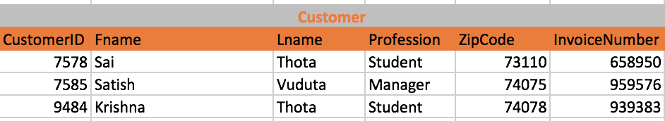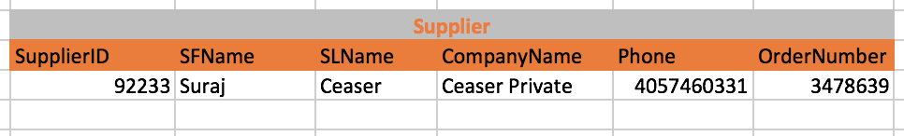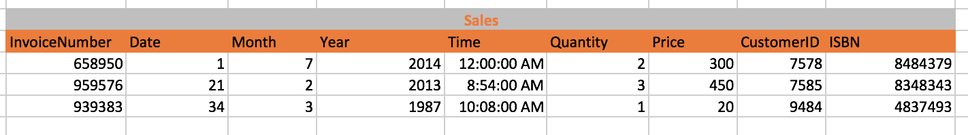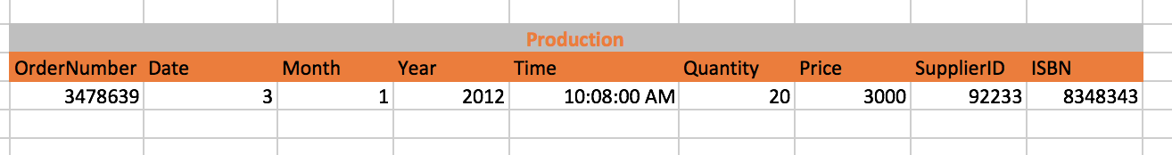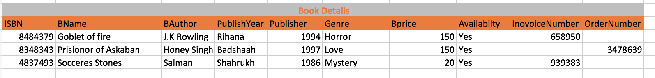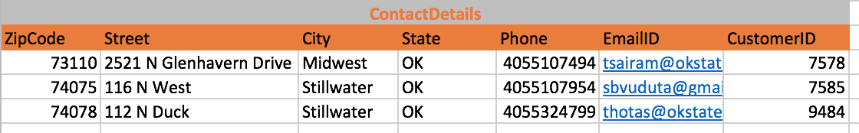

This is a 4 NF relations because:

* It has no multivalued dependencies
* Every column is identified only by the key in the table or relation or no other column (3NF is satisfied)
* All columns that are not the keys are dependent on the key (Satisfies 2 NF)
* Every cell is single valued and every entry is of the same data type and the rows are uniquely identified (thus satisfying 1 NF)