JCIIOT 2026 Web Client User Guide
Last updated: 2026-06-28
Applicable version: v5 (JCIIOT 2026)

1. Launch Method
conda activate JCIIOT2026
cd JCIIOT2026
streamlit run app.py
Open http://localhost:8501 in a browser.
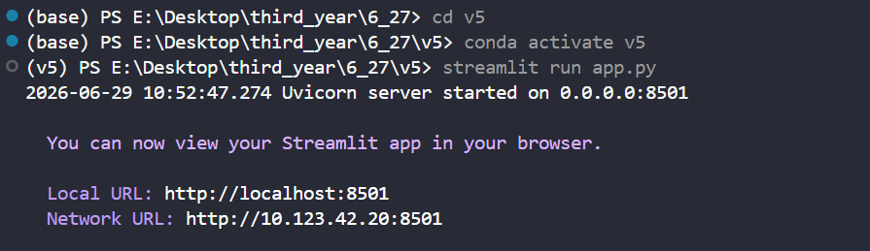

2. Page Layout Overview
The page uses a sidebar + two-column main area layout:
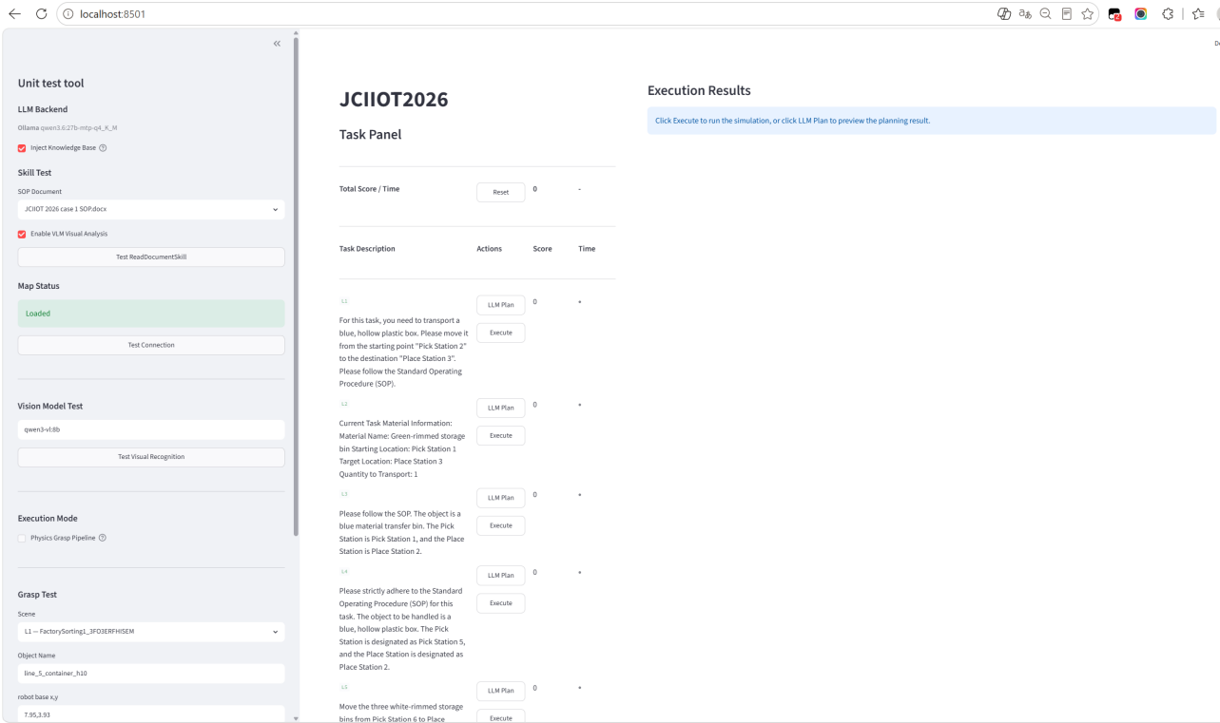

3. Task Panel — Executing Competition Levels

3.1 Total Score Overview Row
The top of the page displays the current cumulative score and total elapsed time.
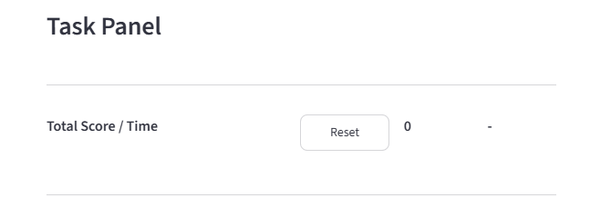

3.2 Task List
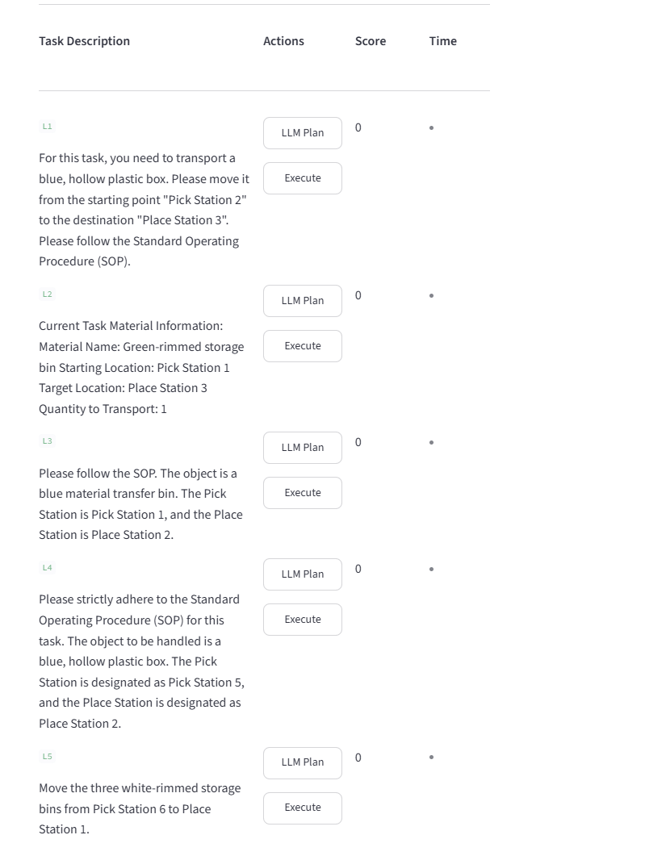
Levels L1 to L5 are arranged vertically, with one row for each level:
Column | Description
Task Description | Level number + natural-language task description
Actions | LLM Plan button + Execute button
Score | Current score for the level (green = score awarded, red = 0 points but executed)
Time | Execution time for the level

3.3 Operation Workflow
Method 1: Execute Directly
- Click the Execute button for the target level.
- A "Task Executing" dialog appears. Wait for the MuJoCo simulation environment to be created.
- After the environment is ready, the dialog closes automatically, and the task runs in the background.
- After completion, the page refreshes automatically and displays the score and replay video.
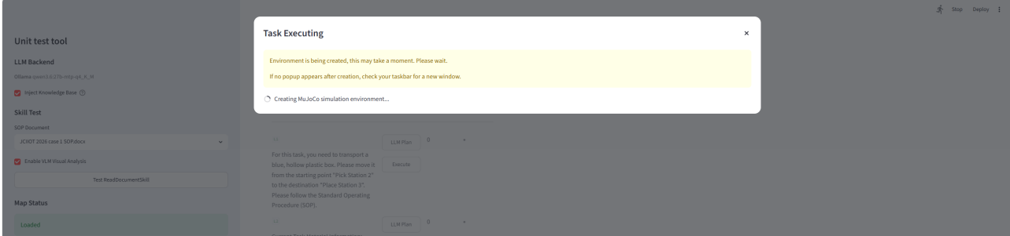

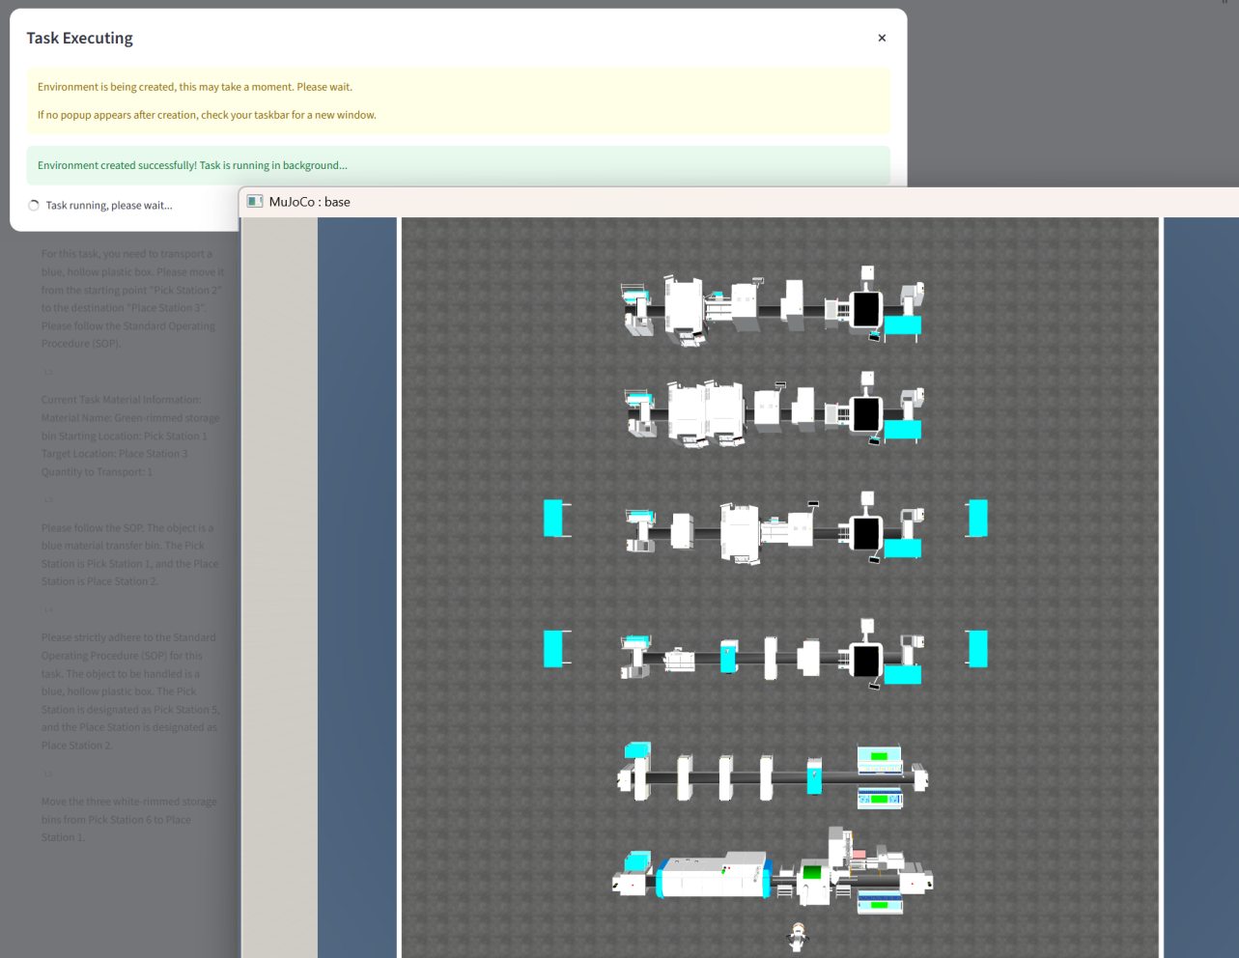

Method 2: View the LLM Plan First, Then Execute
- Click the LLM Plan button.
- The row expands to show the LLM reasoning text (how the model parses the task, matches workstations, and generates steps).
- After confirming that the plan is reasonable, click Execute.
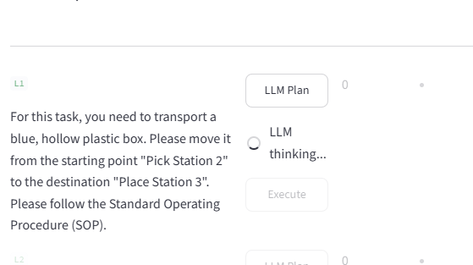

3.4 L1-L5 Level Description
Level | Max | Scene | Task Summary
L1 | 10 | FactorySorting1 | Transport the blue hollow plastic box from Pick Station 2 to Place Station 3
L2 | 15 | FactorySorting3 | Transport the green-framed storage box from Pick Station 1 to Place Station 3
L3 | 20 | FactorySorting5 | Transport the blue material transfer box from Pick Station 1 to Place Station 2
L4 | 25 | FactorySorting7 | Transport the blue hollow plastic box from Pick Station 5 to Place Station 2
L5 | 30 | FactorySorting9 | Transport three white-framed storage boxes from Pick Station 6 to Place Station 1
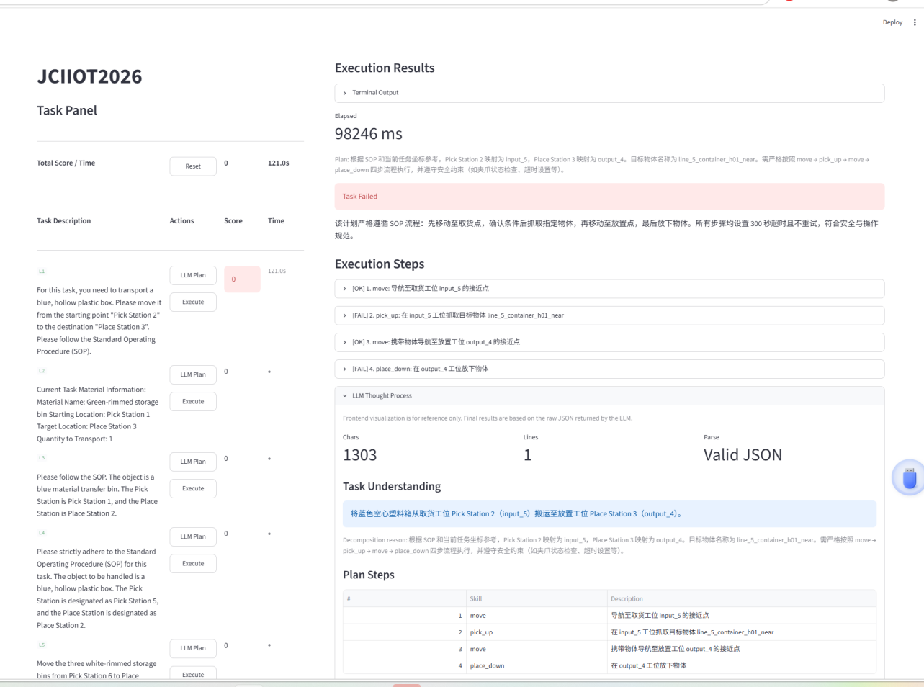

4. Sidebar — Debugging and Test Tools
The sidebar is titled "Unit test tool". From top to bottom, it contains:

4.1 LLM Backend
Displays the address of the currently connected Ollama backend and the model name.
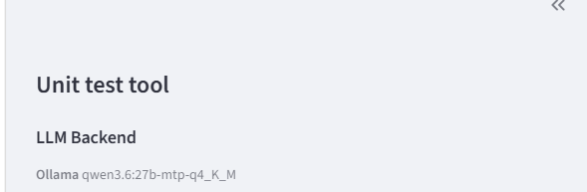

4.2 Inject Knowledge Base
When selected, the LLM loads the SOP knowledge base files under the knowledge/ directory during planning. Enabled by default.
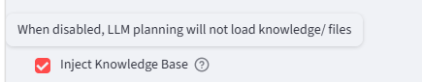

4.3 Map Status
Displays the semantic map loading status. Green "Loaded" means normal; yellow "Not Found" means get_map.py must be run to generate the map.
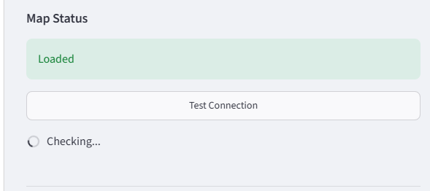

4.4 Connection Test
Click Test Connection to check Ollama service connectivity and model availability.
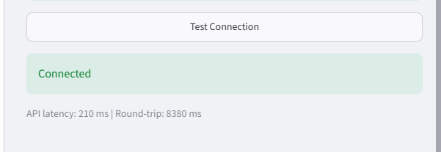

4.5 Vision Model Test
Enter the Vision Model name (default: qwen3-vl:8b), then click Test Visual Recognition to verify that the VLM is available.
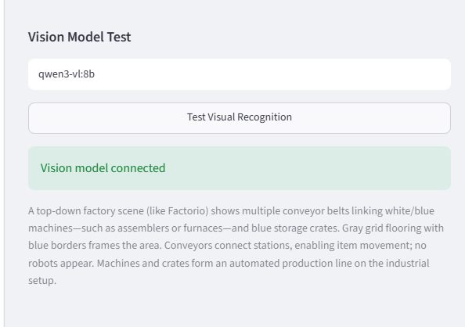

4.6 Grasp Test
Manually test the grasping function:
- Select a scene.
- Enter the object name, robot base coordinates (x, y), and orientation (yaw).
- Click Test Grasp to run the grasping simulation in a new window.
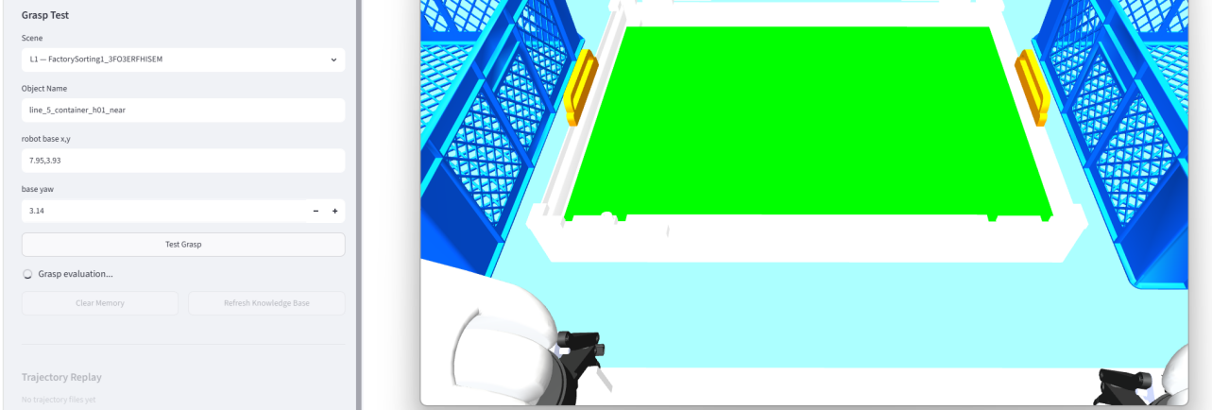

4.9 Quick Actions
Button | Function
Clear Memory | Clear the robot's execution history.
Refresh Knowledge Base | Reload all documents under the knowledge/ directory.

4.10 Trajectory Replay
At the bottom of the sidebar, you can generate a replay GIF from a saved trajectory JSON file:
- Select Trajectory: select a historical trajectory file from the drop-down list.
- Replay Scope: Full Trajectory or Grasp Segment.
- Camera: birdview (top view), robot0_robotview (chest view), or all (generate both viewpoints at the same time).
- Click Replay -> GIF to generate the animation.
