PYTHON

DEEP LEARNING

ICP – 1

Name: Vandith Thotla

Class ID: 25

* In this lesson, we are going to have an introduction to Deep Learning programming on Keras. Before to that, we will introduce some of the applications of the Deep Learning in the area of vision and NLP.

Programming elements: Keras Basics Source

1.Use case in the class:

a. Add more Dense layers to the existing code and check how the accuracy changes.

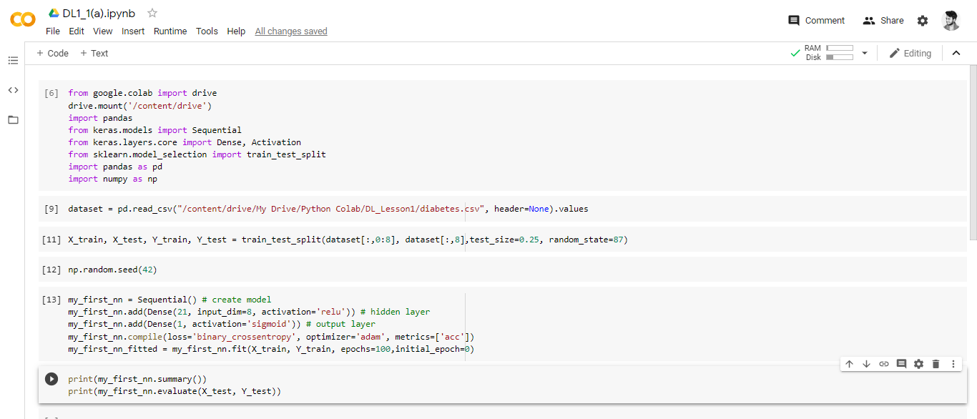

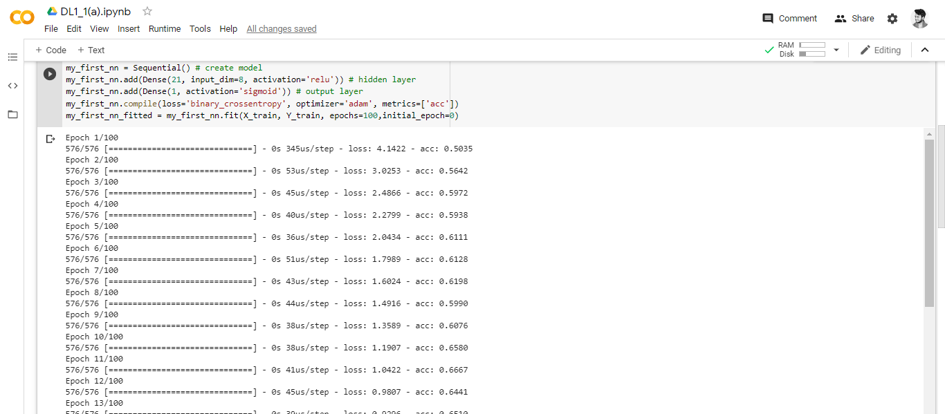

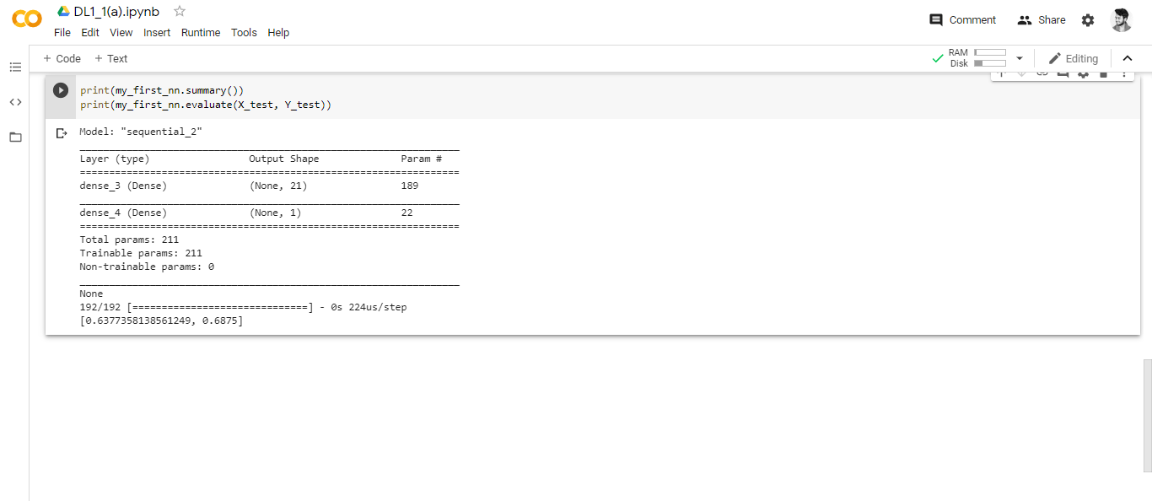

2.Change the data source to Breast Cancer dataset \* available in the source folder and make required changes

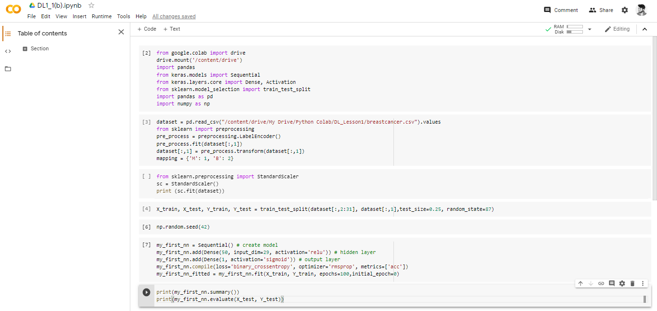

3.Normalize the data before feeding the data to the model and check how the normalization change your accuracy (code given below).fromsklearn.preprocessing importStandardScalersc =StandardScaler()



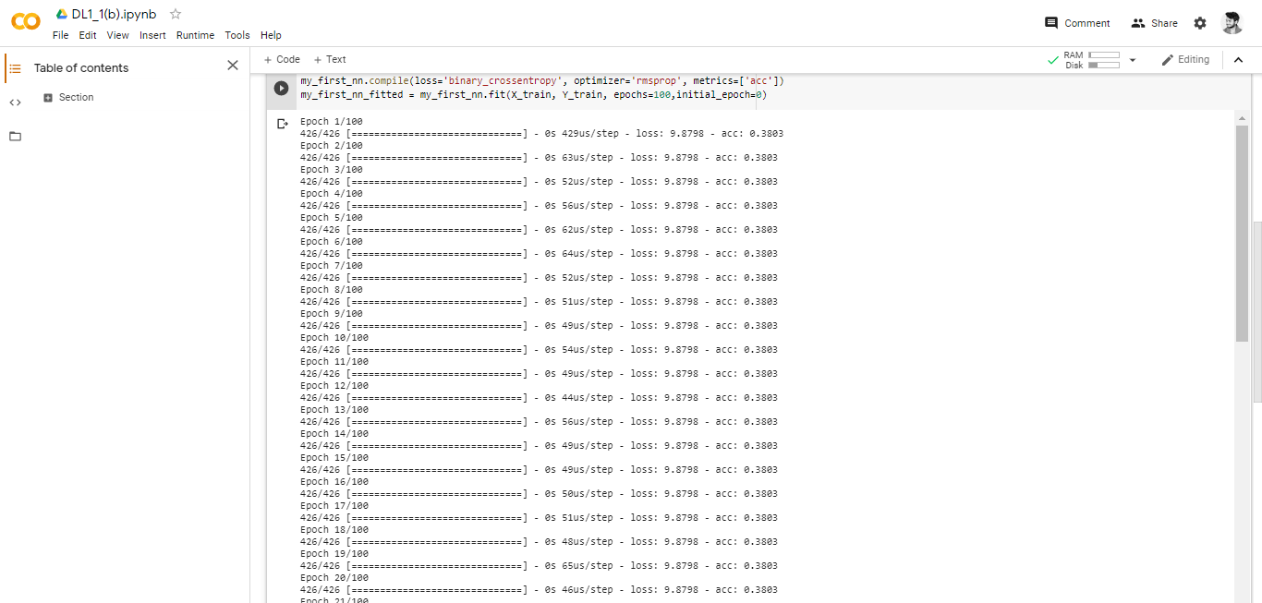

4.Try new different optimizers and report the accuracy for each one. Breast Cancer dataset is designated to predict if a patient has Malignant (M) or Benign = Bcancer



