PYTHON

DEEP LEARNING

ICP – 2

Name : Vandith Thotla

Class ID : 25

**Lesson Overview:**

In this lesson, we are going to discuss Neural Network, Backpropagation, Activation Function, Linear Regression, Cost/Loss Functions, Gradient Descent (Optimization Algorithm) and Learning Rate.

**Use Case Description:**

Image Classification on the hand written digits data set

**In class programming:**

1. Using the history object in the source code, plot the loss and accuracy for both training data and validation data.

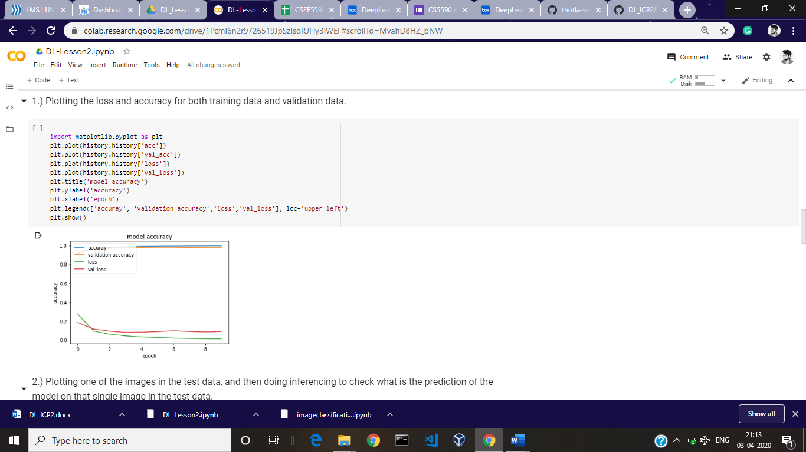

1. Plot one of the images in the test data, and then do inferencing to check what is the prediction of the model on that single image in the test data

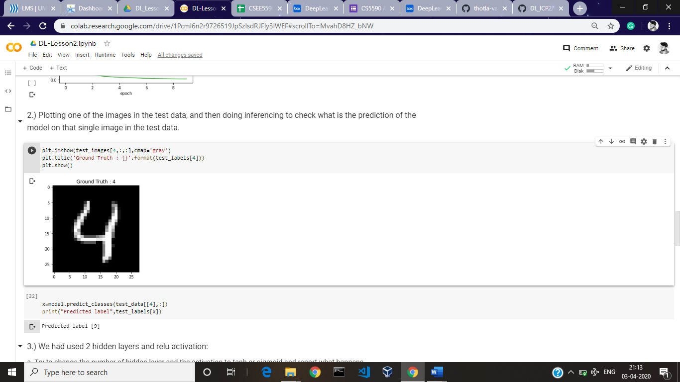

1. We had used 2 hidden layers and relu activation:
2. Try to change the number of hidden layer and the activation to tanh or sigmoid and report what happens.

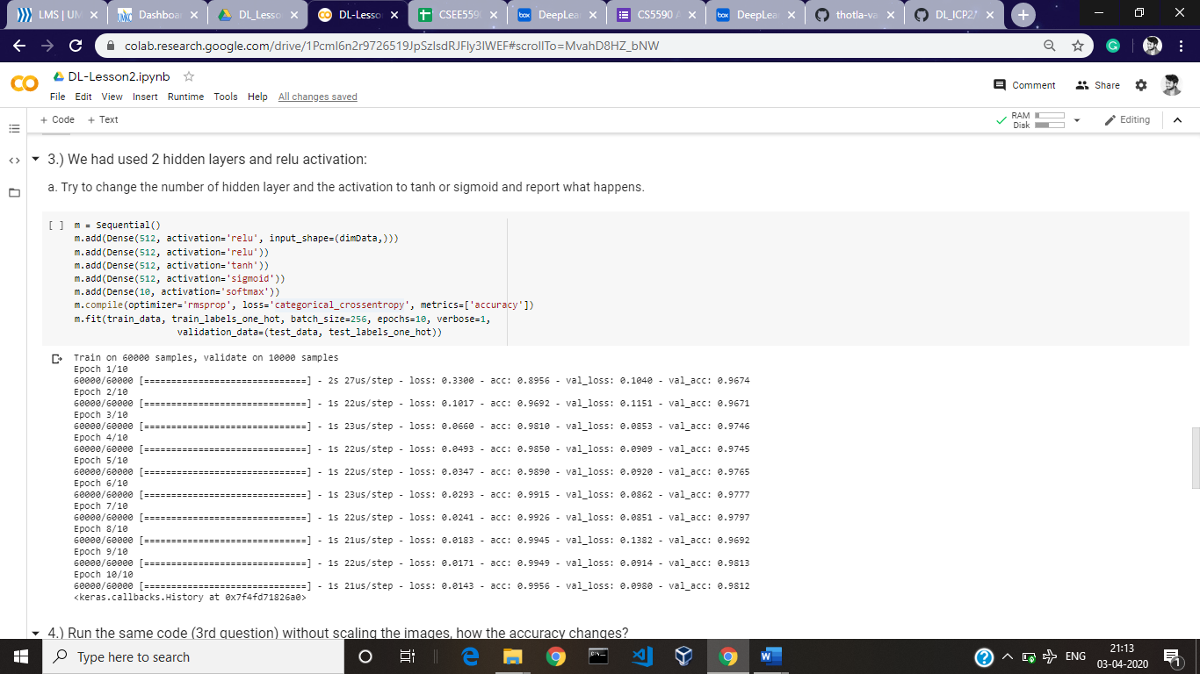

1. Run the same code without scaling the images, how the accuracy changes?

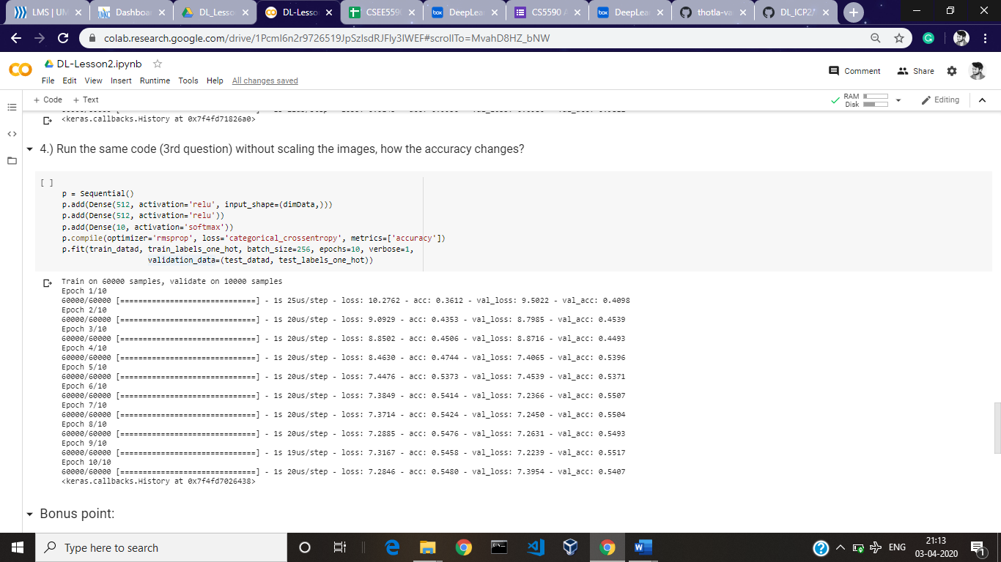

**\*\* Bonus point:**

1. Convert the sequential model to API model.

