1.INTRODUCTION

An airplane crash analysis is a detailed investigation into the cause of an aviation accident. The goal of airplane crash analysis is to identify any factors that contributed to the accident with ultimate goal of improving safety and preventing future accidents.

2.PROBLEM DEFINITION AND DESIGN THINKING

2.1 EMPATHY MAP

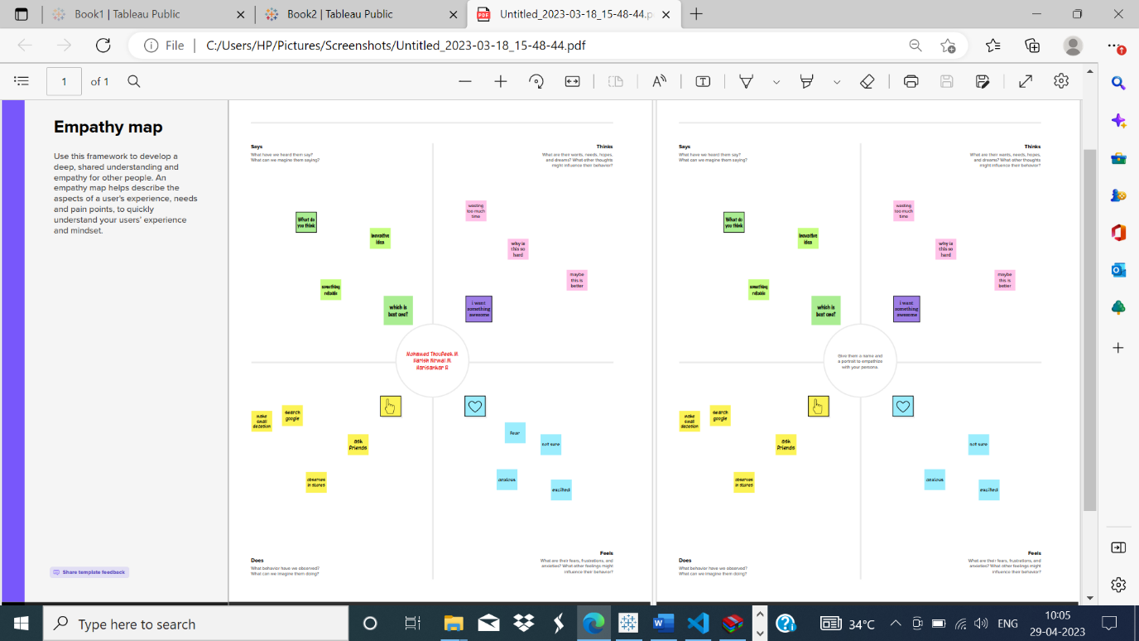

2.2 IDEATION ANA BRAINSTORMING MAP

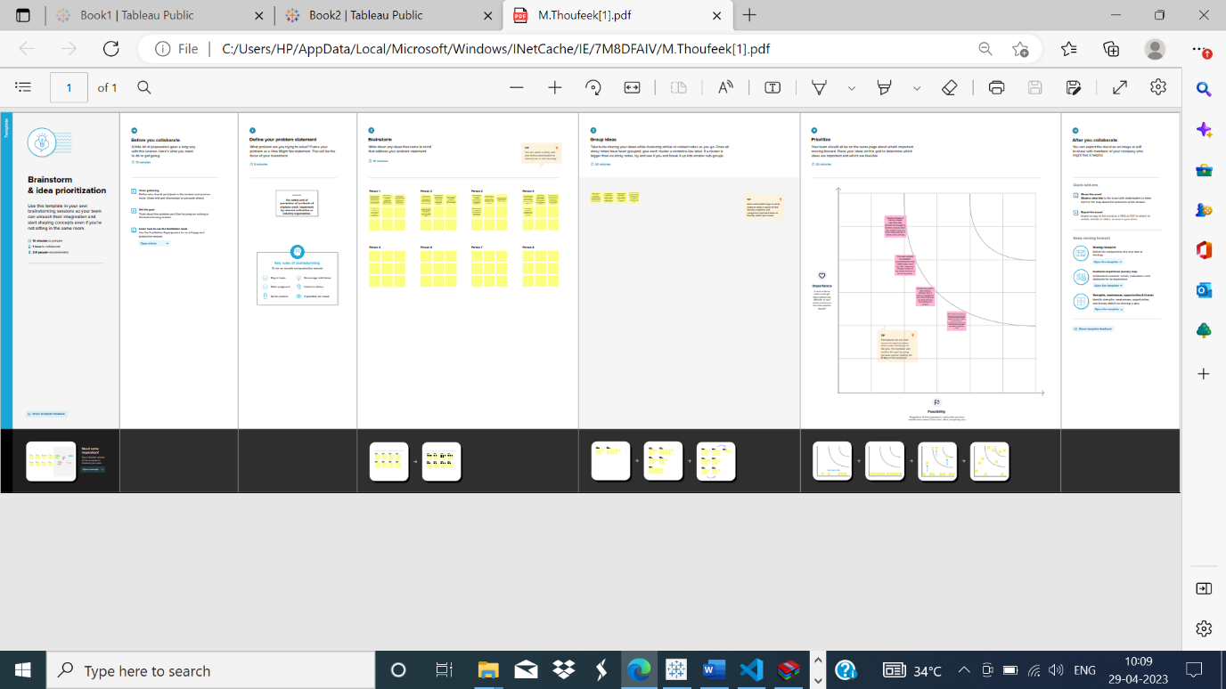

* RESULT

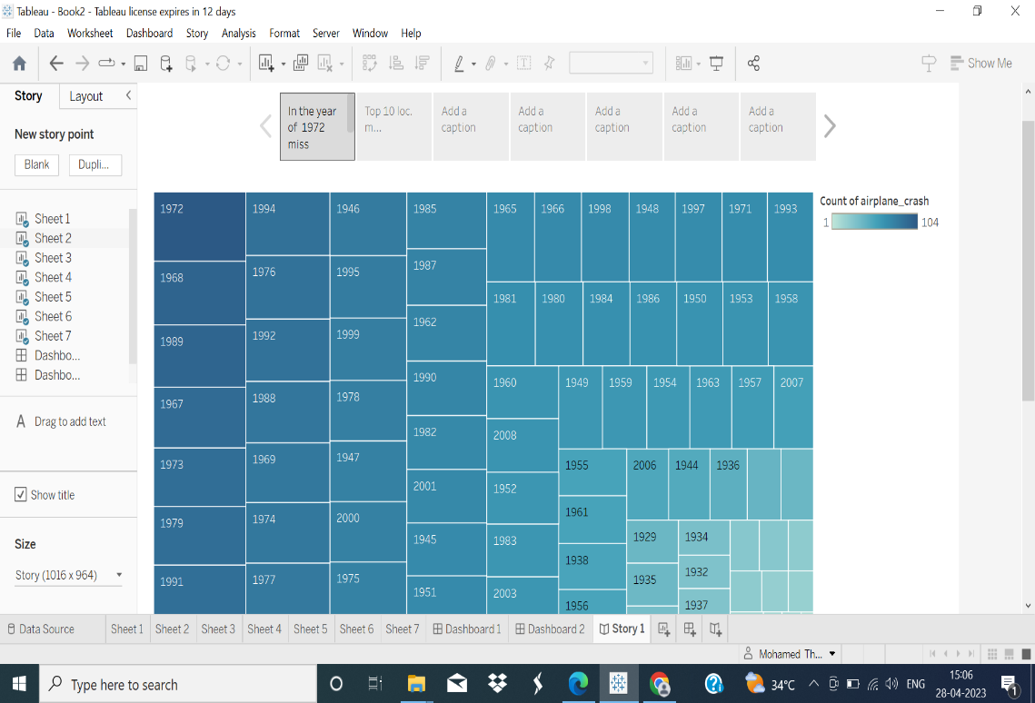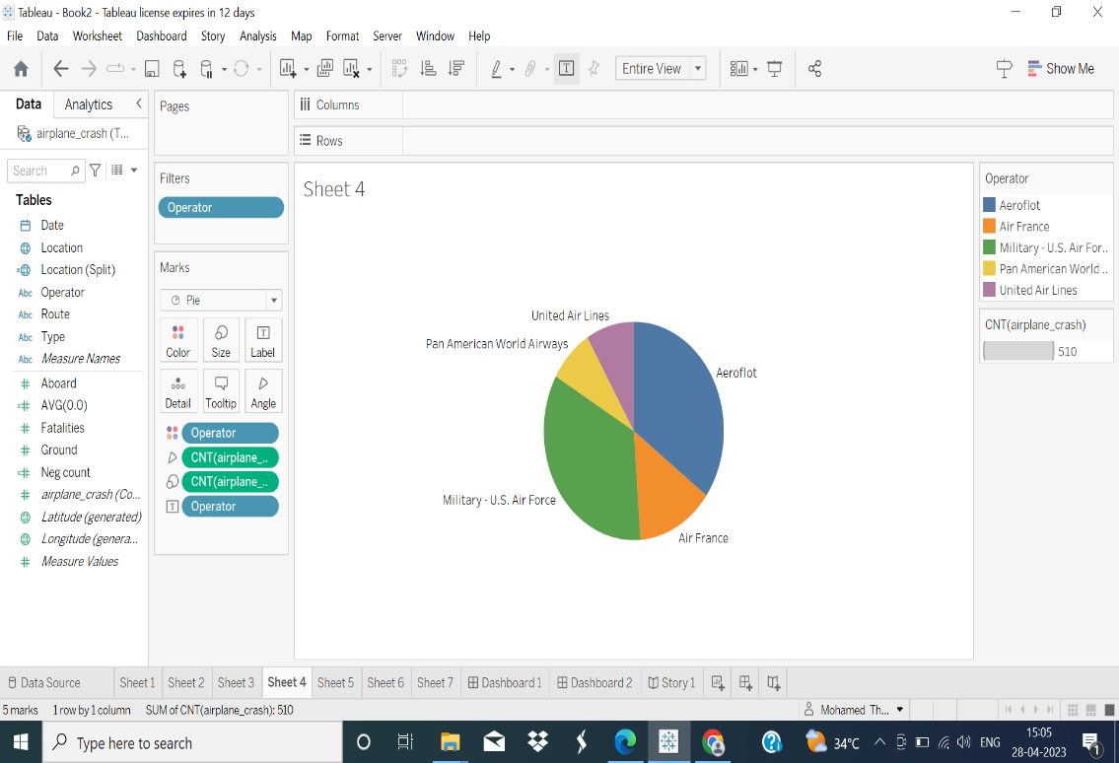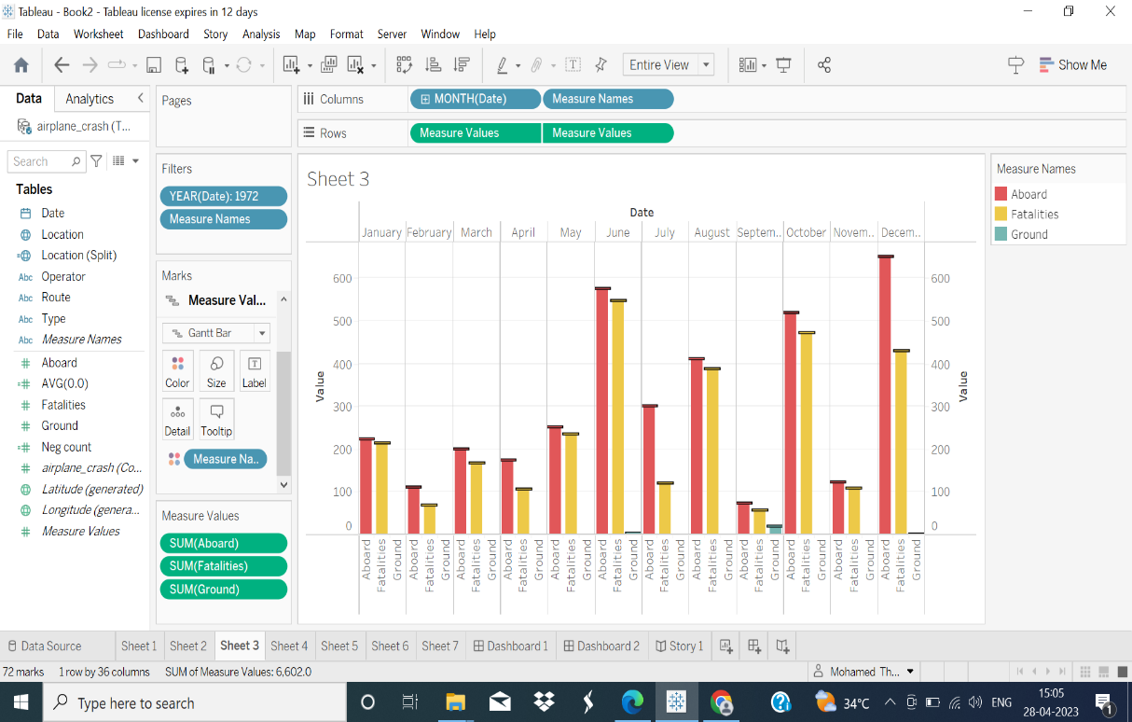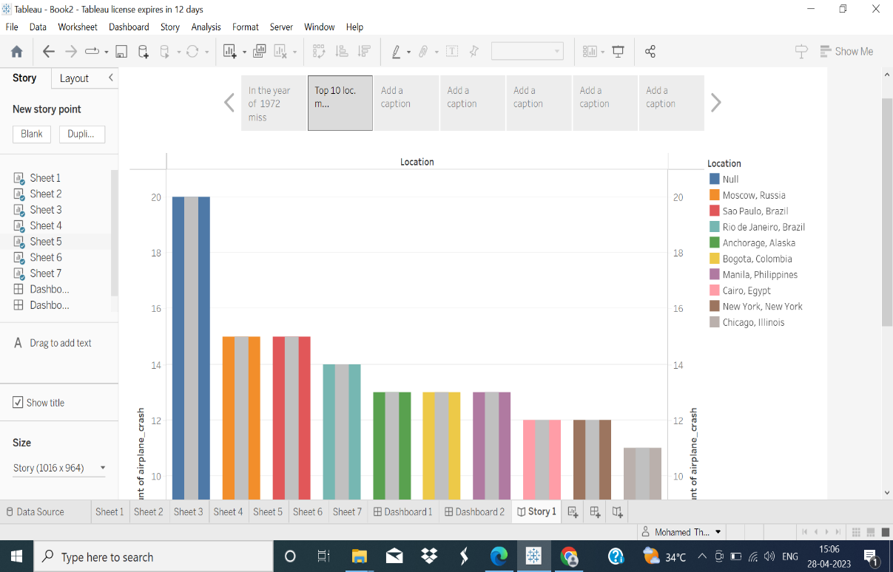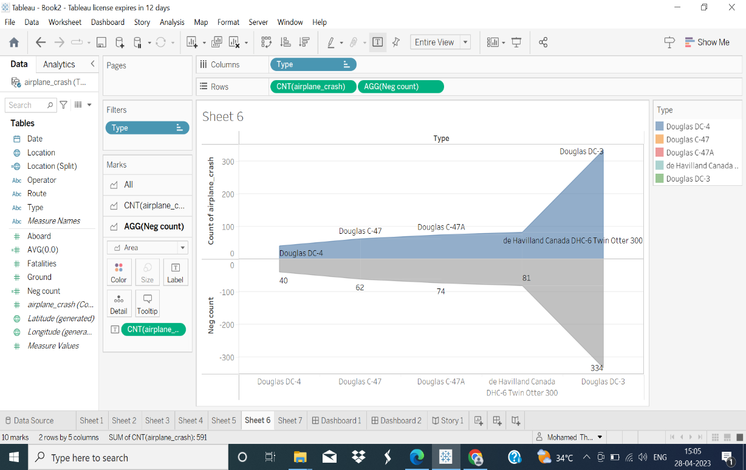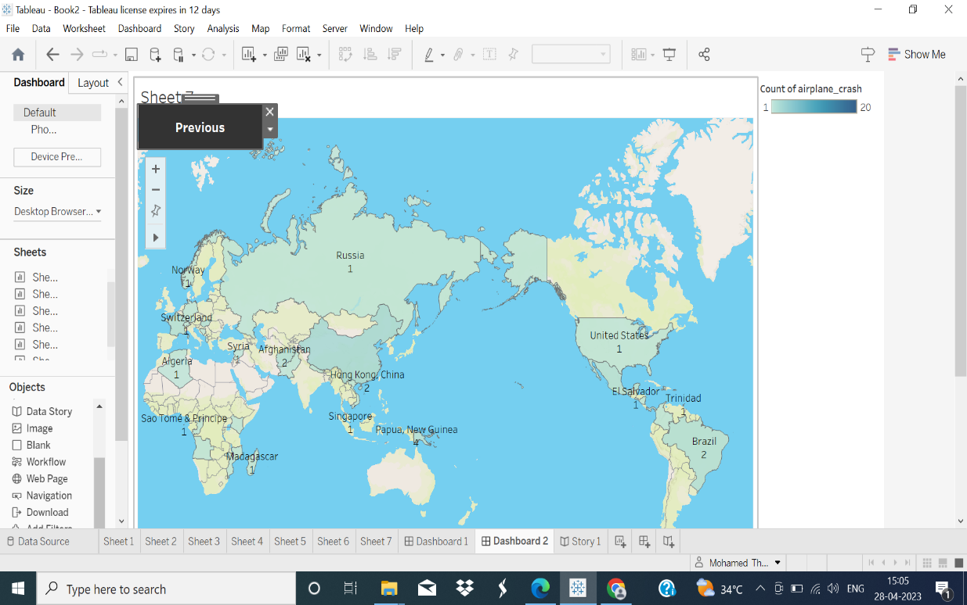

* APPENDIX

1.DASHBOARD:

<https://public.tableau.com/views/Book1_16826734712060/Dashboard1?:language=en-US&publish=yes&:display_count=n&:origin=viz_share_link>

2.STORY:

https://public.tableau.com/views/Book2_16826738559530/Story1?:language=en-US&publish=yes&:display_count=n&:origin=viz_share_link