Python Training

Pre-Class Homework

Prior to the meeting, we ask that you ensure you have software installed (specifically python, pandas and jupyter notebooks) since we plan on using it during the training session. You have four options so please read each choice and follow the one that best matches your needs.

Also, if you ever get stuck or confused, please feel free to contact one of your instructors:

* Erin Butts (erin_butts@fws.gov)
* Brent Frakes (brent_frakes@fws.gov)
* Matt Heller (matthew_heller@fws.gov)
* Nathan Zimpfer ([nathan_zimpfer@fws.gov](mailto:nathan_zimpfer@fws.gov))

**Option #1 – Install ArcPro**

Python, pandas and jupyter notebook are all part of the standard ArcPro distribution. If you are heavy on the GIS usage, this is definitely the recommended choice since all three installations will integrate seamlessly with ArcPro. The downside to using the ArcPro installation is that it doesn’t let you use Python 3.6 or 3.7, which has some nice bells and whistles for advanced users.

ArcPro can be located in the Apps to Go and does not require administrative permissions to install. You will need to VPN in and the install may take awhile and require a computer restart so it is recommended to do towards the end of the day when less users are connected to VPN and you don’t have other programs running.

In Apps to Go select ArcGIS Pro 2.5.1 On Demand 5/28 and install

Once installed to ensure everything is functioning properly, please do the following:

1. From the start menu, type jupyter and select the jupyter notebook app

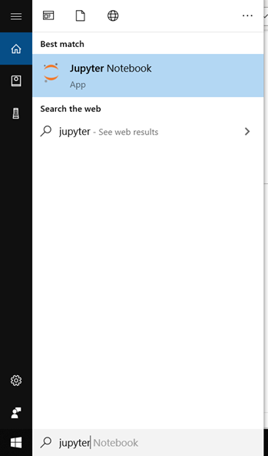

1. This should bring up a dos prompt window similar to the following graphic

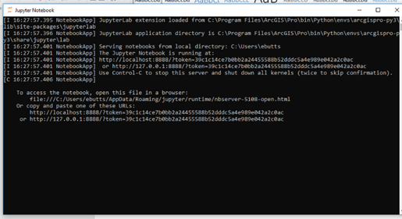

1. No need to type anything. It may take a few moments to bring up a web page, if it looks something like the graphic you see below, then you are ready for the training. If you don’t see this, please contact one of the instructors to help you troubleshoot.

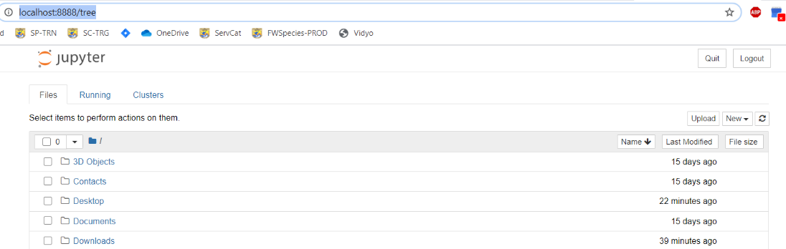

**Option #2 – Download Anaconda**

Python is an open source programming language and has many different distributions. Once of the leading scientific distributions is Anaconda, which contains python, jupyter notebook, pandas plus hundreds of other scientific, statistical and geospatial libraries frequently used by scientists of all types.

The benefit of Anaconda is that it has everything you need with just one install. However, it does includes a lot of other extras you may never need is rather large to download. If your connection is fast and you have administrative permissions to install it, Anaconda is recommended for non-GIS users.

Anaconda can be downloaded here: <https://www.anaconda.com/products/individual#windows>

Choose the 3.7 /64 bit version for Windows (unless you have a Mac or a 32-bit machine)

Once installed, please complete the following steps:

1. From the start menu, type anaconda. This will give you a dos prompt.
2. Type jupyter notebook.

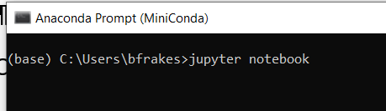

1. If a web page opens up and looks something like the graphic you see below, then you are ready for the jupyter training. If you don’t see this, please contact one of the instructors to help you troubleshoot.



1. Finally, go to the folder where anaconda is installed and search for idle.pyw. When you find it, make a shortcut to it on your desktop. If you have any issues, please contact one of us for help.

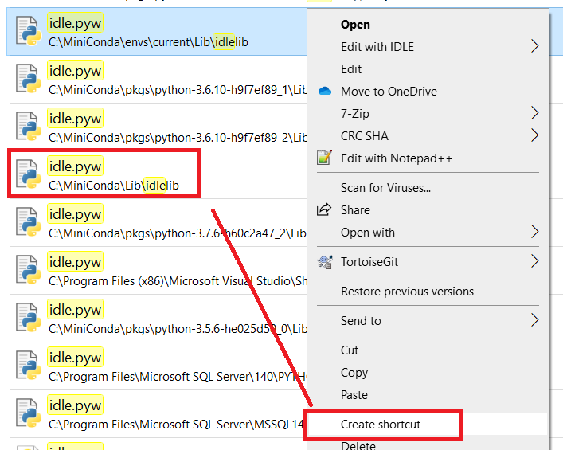

**Option #3 – Download Miniconda**

A feather weight distribution of Anaconda is known as Miniconda. It is really fast to install but does require that you additionally download pandas and jupyter notebook. These two additional downloads are not difficult, but they are extra steps.

Miniconda can be downloaded here: <https://docs.conda.io/en/latest/miniconda.html>

Choose the 3.7 /64 bit version for Windows (unless you have a Mac or a 32-bit machine)

Once installed, please complete the following steps:

1. From the start menu, type anaconda. This will give you a dos prompt.
2. **Make sure you are not using VPN**
3. Type conda install pandas and confirm installation

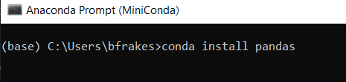

1. Type conda install juypter
2. Type conda install matplotlib
3. Type jupyter notebook.



1. If a web page opens up and looks something like the graphic you see below, then you are ready for the jupyter training. If you don’t see this, please contact one of the instructors to help you troubleshoot.



1. Finally, go to the folder where anaconda is installed and search for idle.pyw. When you find it, make a shortcut to it on your desktop. Again, if you have any issues, please contact one of us for help.



**Option #4 – Don’t Install Anything**

We will have an option to run python and related packages from a web page. If you really aren’t sure you’ll ever want to use python again or are unable to install the software, this choice is right for you.

If you pick this option, please let [nathan_zimpfer@fws.gov](mailto:nathan_zimpfer@fws.gov) know so we can be prepared on our end.

**Final Homework**

Please create a folder on your computer, ideally C:\TEMP and copy all of the course materials there.