|  |  |  |  |  | logo1.png |
| --- | --- | --- | --- | --- | --- |

| Course Name | | Graphic design(canva) | |
| --- | --- | --- | --- |
| College Name | | Mangayarkarasi College of Arts and Science for Women Paravai, Madurai - 625002 | |
| College Code | | MKU251 | |
| Skill Offering Id | |  | |
| Project Title | | Designing A Resume/CV Using Canva | |
| Project Submitted To | | Madurai Kamaraj University ( Naan Mudhalvan Scheme(TNSDC)) | |
| Year | | 2023 | |
| Department | | B.A ENGLISH | |
| Semester | | 5 | |
| Group Number | | 3 | |
| Total Members of the Group | | 4 | |
| Group Members Details | | | |
| Name of the Member | University Register. No | | Student NM ID |
| 1. R.Gowri | mku251C1A17417 | | ACDC607293152C2B7234F4A316441667 |
| 1. S.Afrin | mku251C1A17406 | | 090BBD64781CBFF95454BF674D4F5971 |
| 1. S.Dharshini | mku251C1A17413 | | 0540A6FA673D63D8313412E65645EB33 |
| 1. S.Bala Shobika | mku251C1A17410 | | F5246593C622692BEBA4D02A6B550B20 |
|  |  | |  |
| Under the Guidance | | DR. MEENA | |
| SPOC | | Ms.P.UMADEVI | |

**DESIGNING PROFESSIONAL A RESUME/CV USING CANVA**

**1.Introduction.**

*1.1 Overview*

Canva is cloud-based graphic design tool used to create on brand marketing Content, sales presentations, training videos and more by companies of all sizes.This solutions include features such as drag and drag design and photo editing with custom fonts, frames, shapes, grids and icons.

*1.2 Purpose*

You can create a CV for free using our free visual design platform. We have a gallery filled with hundreds of professionally designed and free CV templates to fit a range of industries, theme, format, or even color schemes.All resume templates measure 21 × 29.7 cm or 8 × 11 inches (A4 size), but you can resize them to whatever document format you prefer. Easily order resumes as printed letterheads through Canva Print and choose between standard (120 gsm) and premium (148 gsm) paper stock types.

Here's a list of 10 Canva alternatives (both paid and free) in 2024 to help you create designs that stand out: Visme, Adobe Express, Design Wizard, Easil, Snappa, Vistacreate, Stencil, PicMonkey, Pixlr X and Fotor. Let's examine each of these tools and see what's the best graphic design solution for you.

1. **Problem Definition and Design Thinking**
   1. Empathy Map

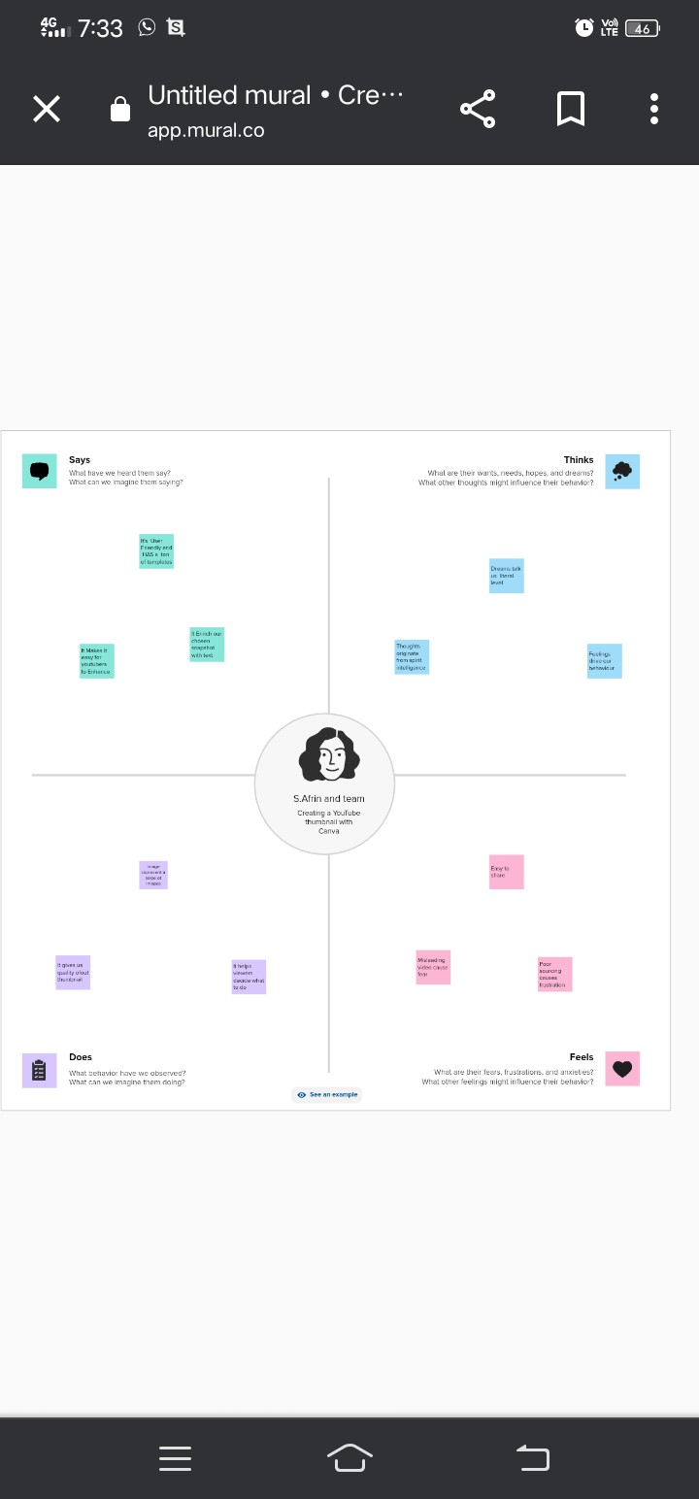

2.2 Ideation and Brainstroming Map

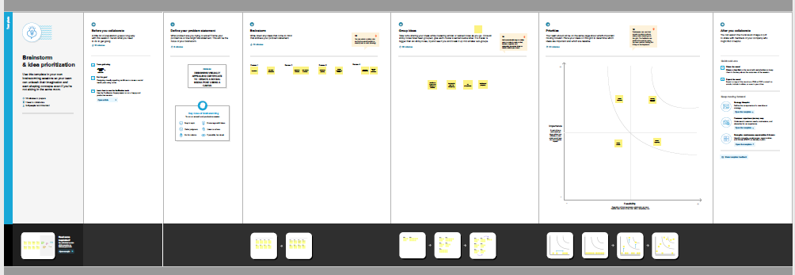

1. Result:

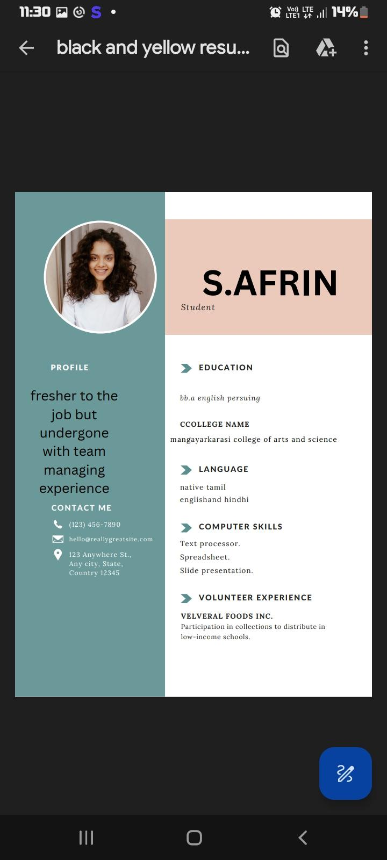

Milestone 1:

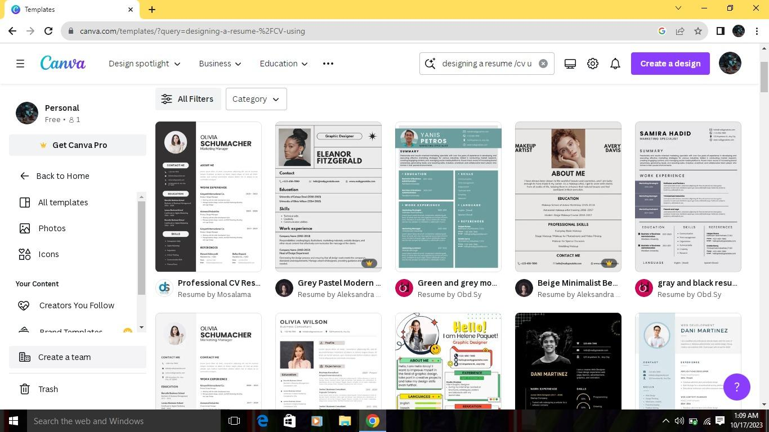

Milestone 2:



Milestone 3:

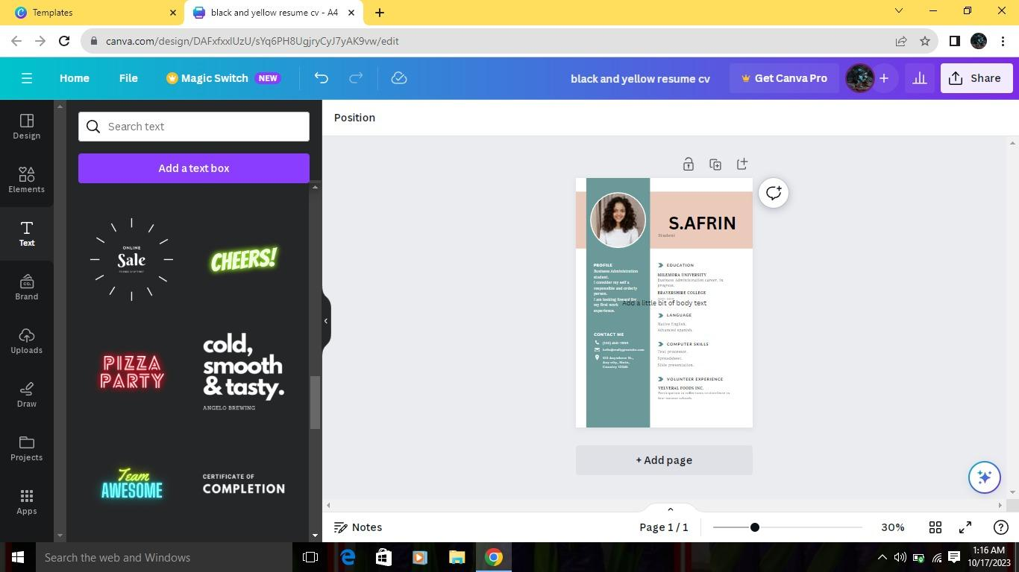

Milestone: 4

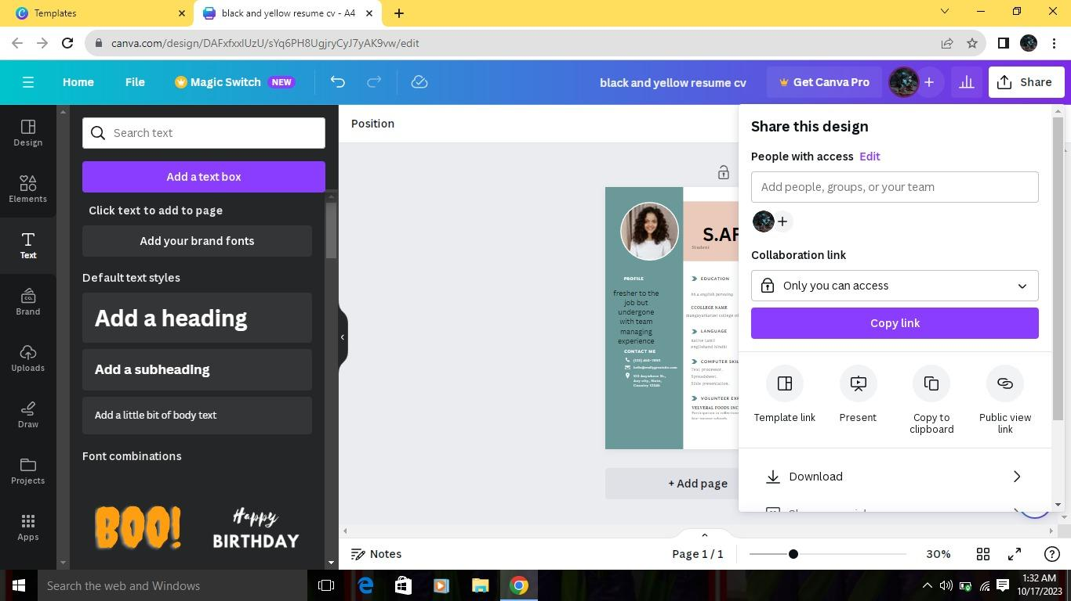

Milestone:5



Milestone:6

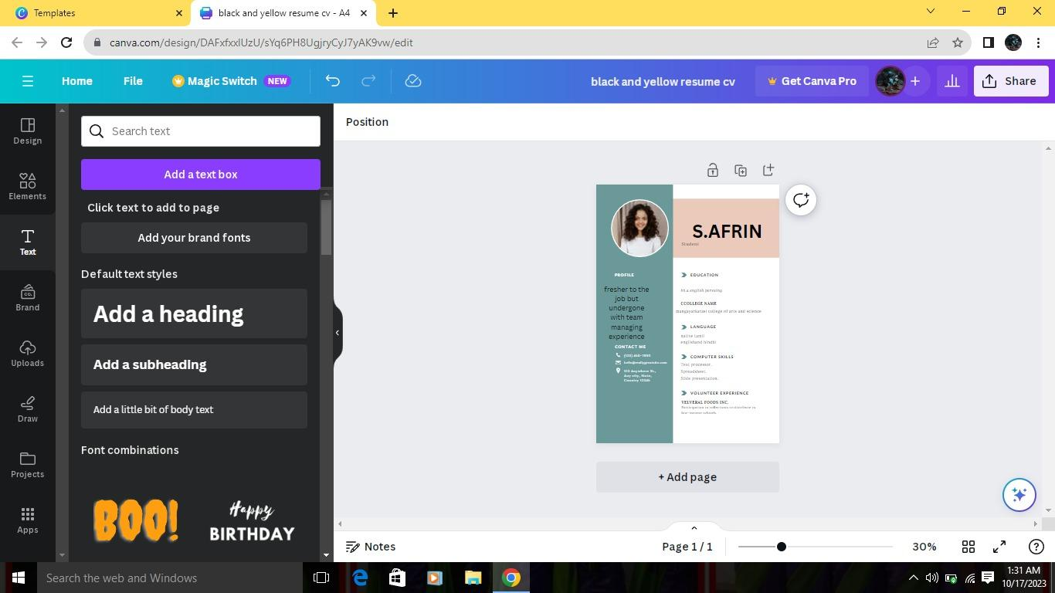

Milestone:7

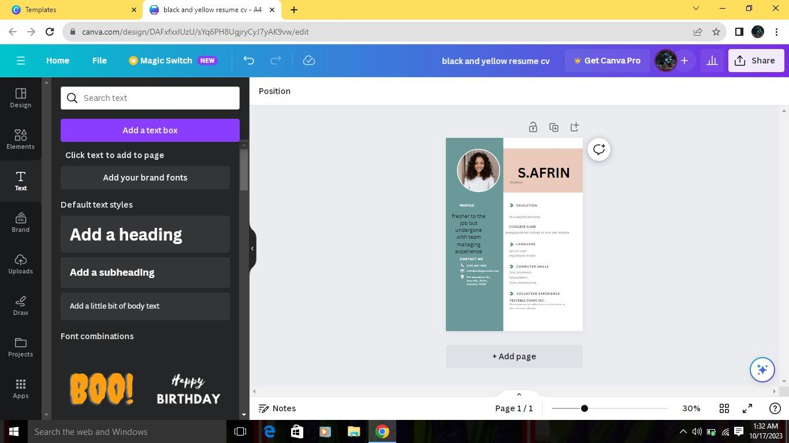

Milestone:8

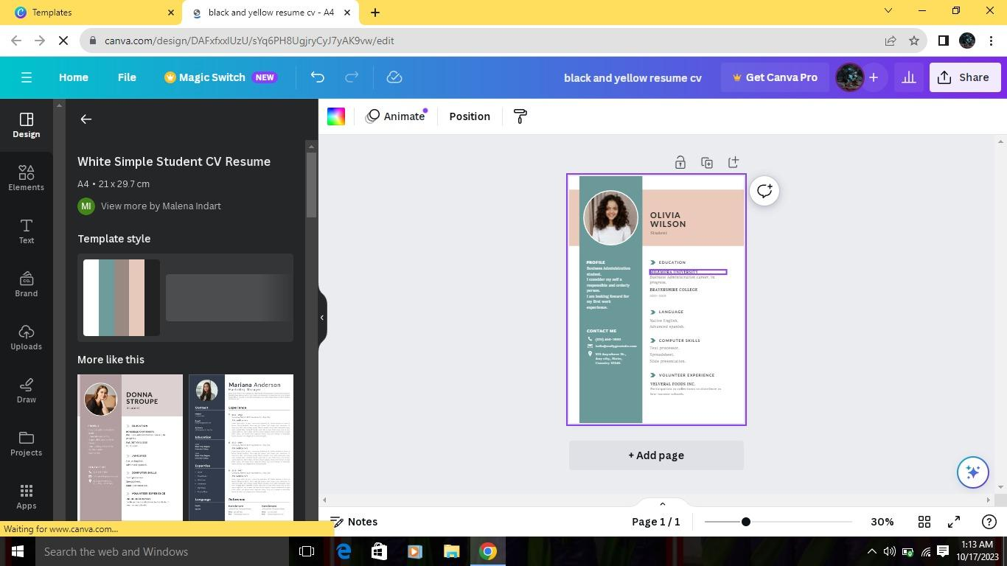

***4.Advandages:***

* + - * Designs to start or know anything about design. from layout of the platform to guide templates, basically a drag and drop design platform.
      * Variety of templates inclusive Facebook banners,LinkedIn banners, YouTube Thumbnail, instagram stories, slide decks and more.
      * Canva guide you with a variety of templates.

**5**.**Disadvantages**

* Canva contribution is growing every month, there is a limitation to templates design and stock photography.
* Intellectual property is ambiguous. .
* You do not own anything, but have usage licenses
* Free version is limited in terms of stock photography, templates.

**6.Conclusion:**

Canva appeal will be different. The benefits cloud outweigh the limitations. If you are a small business owner, start up or professional individual and limited access to a designer. Canva might not be for you.

**7. Future scope:**

Working in various industries such as the fashionbusiness, IT,gaming, advertising, newsmedia,and entertainment.canva future scope will largely depend on the direction that the companytakes.In the future, Canva is a popular, simple online graphic design tool. Users can import images, use templates to design banners and logos, or pay to use Canva's premium stock images/paid templates. All free photos, music, and video files can be used for free for commercial or non-commercial purposes. Career starting help to them.