**What is data modeling?**

When starting to create a new database, the database designer or database administrator needs to carefully plan ahead. Mistakes made in the planning phase could be very costly later on when the database is in the process of being put together and decisions have already been made on what kinds of technologies or formats are to be used.

To minimize the risks, the designer will usually start off by [data modeling](https://www.gleek.io/blog/data-modeling.html). The data model created will provide a blueprint for the finished database, ensure consistency, and make sure that no elements have been forgotten. The models also make it easy to consult with all stakeholders and get feedback on what problems the database should solve.

There are three stages in data modeling: conceptual, logical, and physical. Each stage brings the database closer to reality.

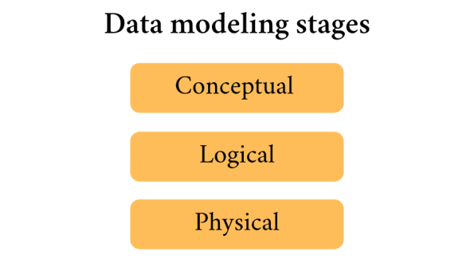

The *conceptual model* sketches out the entities to be represented and determines what kinds of relationships exist between them. It deals with the scope of the database to be created and defines the general rules that need to be considered.

The *logical model* will take these entities a step further and work out the details of how their attributes and relationships. It defines the structure, but does not concern itself with the technical aspects of how the database will be constructed. *Read more*[*about logical data models*](https://www.gleek.io/blog/logical-data-model.html)*.*

The *physical model* moves from abstraction to reality and considers the database management technology to be used, the design of the tables that will make up the actual database, and the keys that will represent the relationships between these tables. *Read more*[*about physical data models*](https://www.gleek.io/blog/physical-data-modeling.html)*.*

**What is the purpose of a conceptual data model?**

The conceptual data model gives the designer the chance to gain an overview of the system to be designed without being concerned with the details of how it will be implemented. This is the time to ask questions, consult with stakeholders, consider the business requirements that the database will solve, and the business processes it has to support. Conceptual data models can be very quick to create, but they can also rapidly highlight faulty assumptions and potential problems. The conceptual model is a simplified diagram of the final database, with the details deliberately ignored so that the big picture can be understood.

**9 characteristics of a good conceptual data model**

The ideal conceptual data model will do all of the following.

1. Provide a high-level overview of the system to be built.
2. Define the scope of the data to be represented.
3. Create a blueprint that can be referred to throughout the project.
4. Diagram entities and relationships rather than attributes.
5. Avoid dealing with technical considerations or terminology.
6. Prevent the model from already being tied to a particular database management system.
7. Be used to get feedback from non-technical stakeholders.
8. Focus on the business requirements the database needs to solve.
9. Provide a solid foundation for creating logical and physical models.

**What is logical data modeling?**

The *logical model* will take these entities a step further and work out the details of how their attributes and relationships. It defines the structure, but does not concern itself with the technical aspects of how the database will be constructed. *Read more*[*about logical data models*](https://www.gleek.io/blog/logical-data-model.html)*.*

**What is physical data modeling?**

Physical data modeling is the**third of three sequential stages in data modeling**. Database designers produce physical data models by elaborating on the models created in the conceptual and logical data modeling stages. The models created at this stage enable managed denormalization and take into account the target technology for deployment.

**The advantages of physical data modeling**

One of the main advantages of creating a physical data model is that the designer greatly reduces the risk of creating a flawed database design. Even an experienced database designer can make mistakes when dealing with a new project. Going through all stages of data modeling provides significant protection against errors, oversights, and costly revisions.