Genetic Conquest: An AI-Client for Thousand Parsec (RFTS ruleset)
Midterm Report
July 12, 2008
Victor Ivri
~~~~~~~~~~~~~~~~~~~~~~~~~~~~~~~~~~~~~~~~~~~~~~~~~~~~~~~~~~~~~~~~~~~~~~~~~~~~

What is Thousand Parsec?

Thousand Parsec is a framework for 4X turn based space empire building games. More you can find on the Official Website, on the Getting Started page, and by talking to community members on irc at: irc.freenode.net / #tp.

Description of my project:

The purpose of my project is to design an AI client for Thousand Parsec, which will play the RFTS ruleset. The interesting part of it all, is that the resulting AI agent's behavior will be governed by a 'genome' that resides on a separate file. This genome will have a 'time-release' mechanism for trait-values, so the behavior will change during the game. It is also my intention to simulate evolution, and collect interesting and successful genomes, as well as provide this tool for future users, so that they'll be able to do so themselves.

“Cool” Screenshot:

Here you can see a graphical result (from another client) of a simple “proof-of-concept” run. The goal here was to plot a route to scout the whole universe, which is internally divided into 9 sectors of equal size. The plotted route starts at the green dot, and visits all star-systems exactly once. It does so by going sector-by-sector. There is an algorithm, which finds a somewhat optimized route to visit all stars in each such sector, but as you can see, it's not exactly optimized to plot a route through the universe as a whole :).
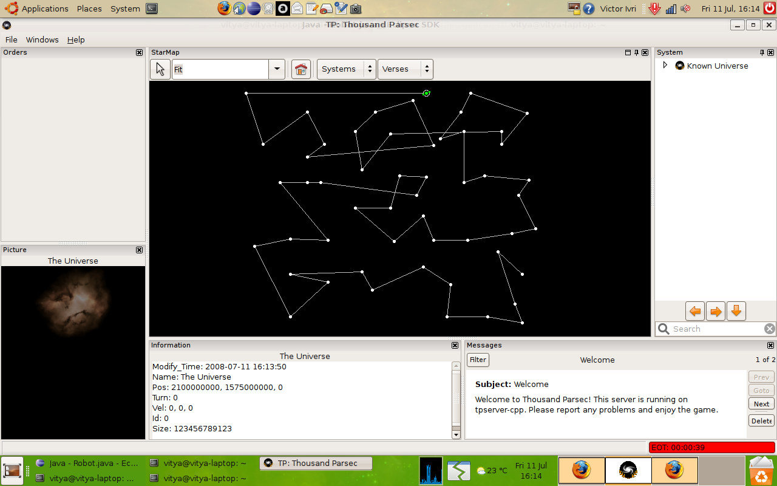

Thoughts about Coding, The Universe and Everything:

In the beginning, the learning curve was very steep and rather painful. First of all, I wasn't very adept in the Linux environment; then it was also setting up and using the devlopment tools (git especially!), which wasn't very straightforward, and at times plain frustrating. Also, getting familiar with TP protocol, and the libtpproto-java code-base wasn't a walk in the park, for the reason that I haven't done any serious client/server programming prior to that.

But I persisted, and slowly got a semi-working client running. Then added some stuff to it... then some more stuff. Then I saw that it wasn't the way to go, so I moved everything around. After a while, the design got stable, I got some momentum, and started having things done quicker; as a result, the code became more readable and of better quality. Now I feel a new confidence in the code that comes out each day, the process is much smoother, and I actually feel as if this project can amount to something successful pretty soon. Another point is that I'm actually enjoying the process of getting things done, as opposed to being in constant terror over code/concepts I cannot comprehend and approaching deadlines.

Overall, I feel that this project has skyrocketed my modest skills as a programmer, and gave me a great deal of confidence. I really hope that this project will have a positive impact on the Thousand Parsec community, and that it will elicit the interest of other developers besides myself.

About moi:

I'm a Computer Science and Cognitive Science major in York University, Toronto, Ontario, Canada. My main interest is in the field of AI. I'm interested in both the practical implementations of various forms of AI, and in the philosophical and psychological underpinnings of it. Other than blankly staring at code, I enjoy wilderness backpacking, downtown at night, and good company.

You can reach me at victor DOT ivri AT google DOT com
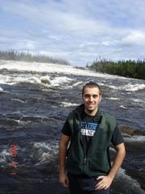

Here's one version of how I look:

