A
PROJECT REPORT
ON
LIBRARY MANAGEMENT SYSTEM
For
Partial Fulfillment of Degree
Master of computer application
Submitted
By
Team: Thousand Times |
秦婉平( Lil Yoroll ) R9J9400181/
吴泽华( Zorn ) R8J9400163 /
冯晓艺( Emma ) R8J9400189/
李彰恒 ( Anthony ) R8J9400186
2019.5.10 - 2019.5.23

Basic Guide External Guide
Hainan University NIIT
Teachers & Classmates Mr.Ashok


Indian Institute of Technology Delhi

PROJECT INDEX

S no. | Particulars | Page no.
1 | About the HLMS, s/w requirement, SDLC | 5-6
2 | About the modules:  Login module  User Information module  Retrieval module  Borrow & Return module | 7-8
3 | Database Design Graph | 9
4 | Use case Diagram/Scenarios View | 10
5 | Logical View | 11
6 | About Developing and Testing | 12-14
7 | Sketch of module and code | 15-16
8 | Cost estimation | 17
10 | Snapshots  Login Module  User Information Module  Retrieval Module  Borrow & Return Module | 18-27
11 | Source code of  Login module  User Information Module  Retrieval Module  Borrow & Return Module | 18-35

TEAM DESCRIPTION & OVERVIEW

What is “Thousand times”?

Even failed nine thousand times, we still will try the next one thousand times.

And we love will love what we love now Three thousand times.

CERTIFICATE



ACKNOWLEDGEMENT
First of all, we are grateful to the each teammate, everyone in this team finish their own part perfectly.
- Qin Wanping Finish the design and coding of the Login Menu
- Fe Xiaoying Finish the part of book retrieving
- Li Zhang Finish the work of the management of the user information
- Wu Zehua Finish the design of the database
Secondly, we wish to express out sincere thanks to the teacher who guide us how to learn and how to work effectively.
We also thank to our classmates and parents who provide us support selflessly. We can’t finish the project so successfully without their help and support.
Finally, we would like thanks everyone who had helped us or made our life so convenient.

PROJECT REPORT

HNU LIBRARY
MANAGEMENT SYSTEM
Every university has numerous types of books, like science, literature, history, biography, etc. A library is the soul of a university. It is very important for a university to keep their library system functional. So an excellent library management is common and important to all university. Their some difficulties to design a library management, for example, the amount of books and users are huge and how can we select or update the information we want quickly? We call our proposed system as HLMS, which has a target to be a high quality Library Management for HNU.

Software Requirements
- JDK 1.8(JDK 10.0 is better)
- MySQL 8.0 or latter
- IntelliJ IDEA(The most recommend choice of IDE)

There is a huge amount of information which needs to be entered, stored and searches thereafter related to large number of students/teachers of a particular university. Due to the limit of time and resource, our HNU Library Management System didn’t reduces the workload of the administration department by automating all the related process electronically. This HLMS needs admin type in the data manually. But we achieve the part of users delicately and make students/teachers feel convenient when they use this Library Management.

SDLC of the Project
This project isn’t a web application and based on Swing and JDBC. Unlike with other web application, this project is much simpler than them. The SDLC of this project will be discussed under the following heads.

Requirement Analysis
Before starting the project, the first thing which should be considered are the requirements. The requirements to be fill filled by the new system can be uncovered through a proper analysis of the existing system for its problems this is known as requirement analysis. Requirement analysis is the most important part to be considered before developing any project as be must be aware of the objective s that be wish to achieve by making this project. This analysis finds out the problems faced by the user or the client and the possible solution to whose problems. We can use some questionnaires to find are the problems are faced by the clients. This system will be helping administrator for doing all the related jobs so the analysis part includes problems faced by the HR administrator and other facilities aspected by him from the new system. The manual handling of all hr functions may produce numerous types of problems such as:
- For Admin:
One of the most important part is recording the time when user borrow and return books.
When user borrows or returns books, we both need to insert a record or update a record. Each book borrowed has a time limit to return, so it is important for Library Management System to check and find the record that exceed time limit automatically and when user return book they should pay the bill of exceeding time limit.

- For User:
The most important part is that they can know where the book is in library by retrieving from HLMS.
The amount of books in library is really large, so it is important to build a retrieving system so that users can find the book they want in library easily.

- For Developer:
The Management System should be high extensible and easy to maintain.
While the library won’t be stable, it is important that a Library Management System should have a high extend ability and easy to maintain. So when we design our library management system, we will reserved a large space for the future extending.

To solve all these problems we can develop a LMS which will help to record the date of user borrow & return books and help users look for the book they want. The requirement analysis can be discussed with a much broader view but this given analysis is enough to put a basic platform to build our new system.

Software Design
Software design is a solution- “how to approach the creation of a new system”. This important phase is composed of several steps. It provides the understanding and procedural details necessary for implementing the system recommended in the feasibility study.

In software design, there are three distinct types of activities:
- External design
- Architectural design
- Detailed design

External Design
External design of software involves conceiving, planning out and specifying the externally observable characteristics of a software product. These characteristics include user displays, report formats, external data sources, functional requirements , performance requirements and high-level process structure for the product.
External design begins during the analysis phase and continues in the design phase.

Internal Design
Internal design involves conceiving, planning out and specifying the internal structure and processing details of the software product. The goals of internal design are to specify internal structure and processing details, to record design decision and indicate why certain alternatives and trade-offs were chosen, to elaborate the test plan, and to provide a blueprint for implementation, testing, and maintenance activities.

Architectural design
Architectural design concerned with refining the conceptual view of the system, identifying internal processing functions, decomposing high-level functions into sub-functions, and defining internal data streams and data stores, and establishing relationships and interconnections among functions, data streams, and data stores.

The software will be designed according to the various modules required to full fill all the requirements uncovered in our requirements analysis. The whole system can be divided into a number of modules. The following modules can be recognized in our project:
- Login module
- Retrieval module
- Display/Change the information of user
- Borrow & Return Book module

Login module
This module makes sure that all access to the system is proper and authenticated. All the links and navigation paths are available for manipulating any kink of information only after an authorized person enters a valid set of user ID and PASSWORD. So this module serve as an entry point for the system and only the authorized person can access it.

Retrieval module
One of the most important module for users. It helps users find the book they want in the library through the millions of books.

User Information module
Users can check and change their information in this module. This module also provide the most basic information for user. Also it can be extended infinitely. It can connect to other information system to get or transport information, too.

Borrow & Return Book module
Users always need to borrow & return book so that they can take book out and read it at home or anywhere else. Admin also can get information about user borrow books from this module. When users borrow a book out of time limit, this module also has the responsibility to remind user.

Database Design
The whole project is in fact an information management system, which interacts with the database having a number of tables. The tables with their column names and data type are as follows. The default charset we chosen is utf8mb4.

BOOK_INDEX
Field Name | Data Type | Size | Primary Key | Null
BOOK_INDEX_ID | Char | 20 | Y | N
BOOK_TITLE | Char | 20
BOOK_AUTHOR | Char | 20
BOOK_PICTURE_LINK | Char | 100
BOOK_COUNT | Int | 10
BOOK_PRESS | Char | 16
BOOK_TYPE | Char | 8

USER_INFOMATION
Field Name | Data Type | Size | Primary Key | Null
USER_ID | Char | 14 | Y | N
USER_NAME | Char | 12
USER_PASSWORD | Varchar | 20
USER_GRADE | Char | 10
USER_MAJOR | Char | 32
USER_CLASS | Int | 4
USER_PHONENUMBER | Char | 12
USER_EMAIL | Char | 24
USER_PHOTO | Char | 120

BOOK_COLLECTION
Field Name | Data Type | Size | Primary Key | Null
BOOK_ID | Char | 20 | Y | N
BOOK_INDEX_ID | Char | 20
IS_INLIB | Int | 2

BORROW_HISTORY
Field Name | Data Type | Size | Primary Key | Null
USER_ID | Char | 14 | Y | N
BOOK_ID | Char | 20
BOOK_STATUES | Int | 2
BORROW_TIME | Date | /
LEVEL_ID | Varchar2 | 10

Use Case diagram/Scenarios View

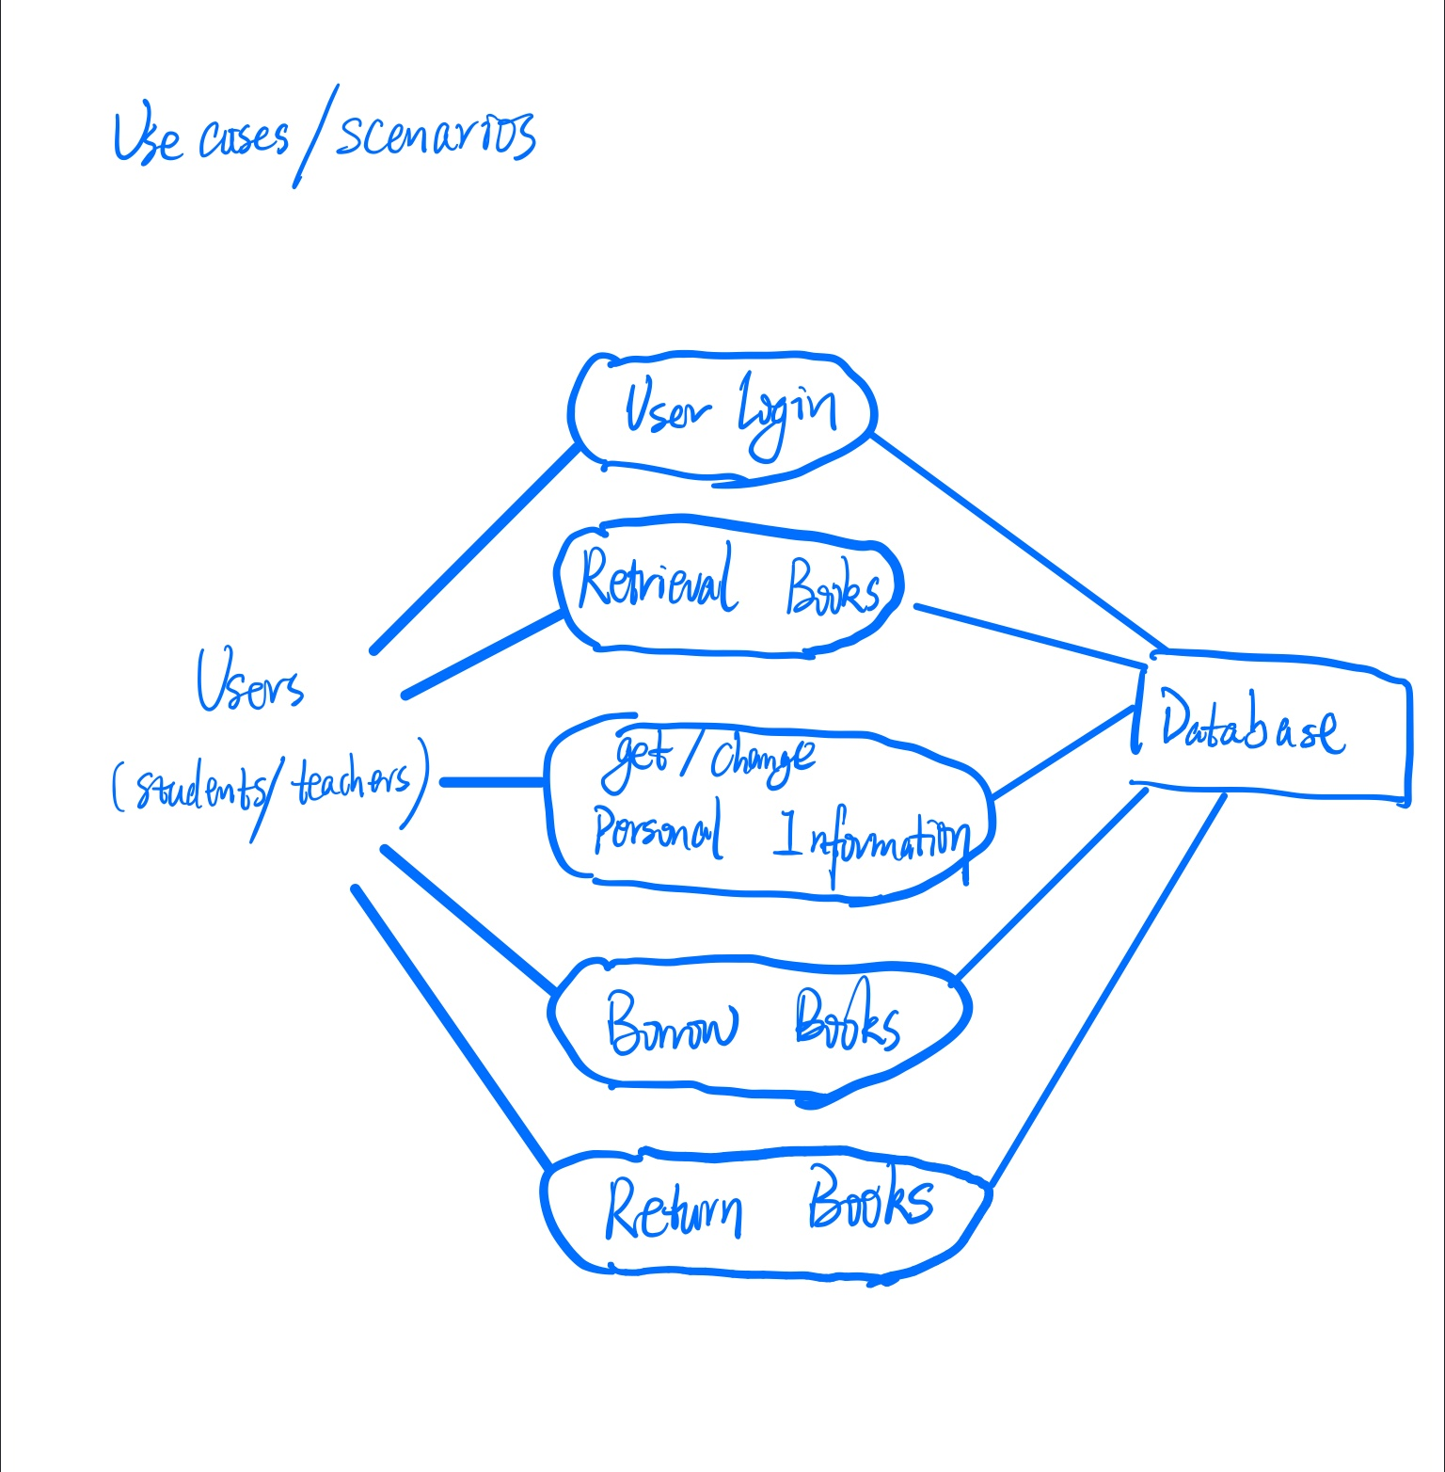

Logical View

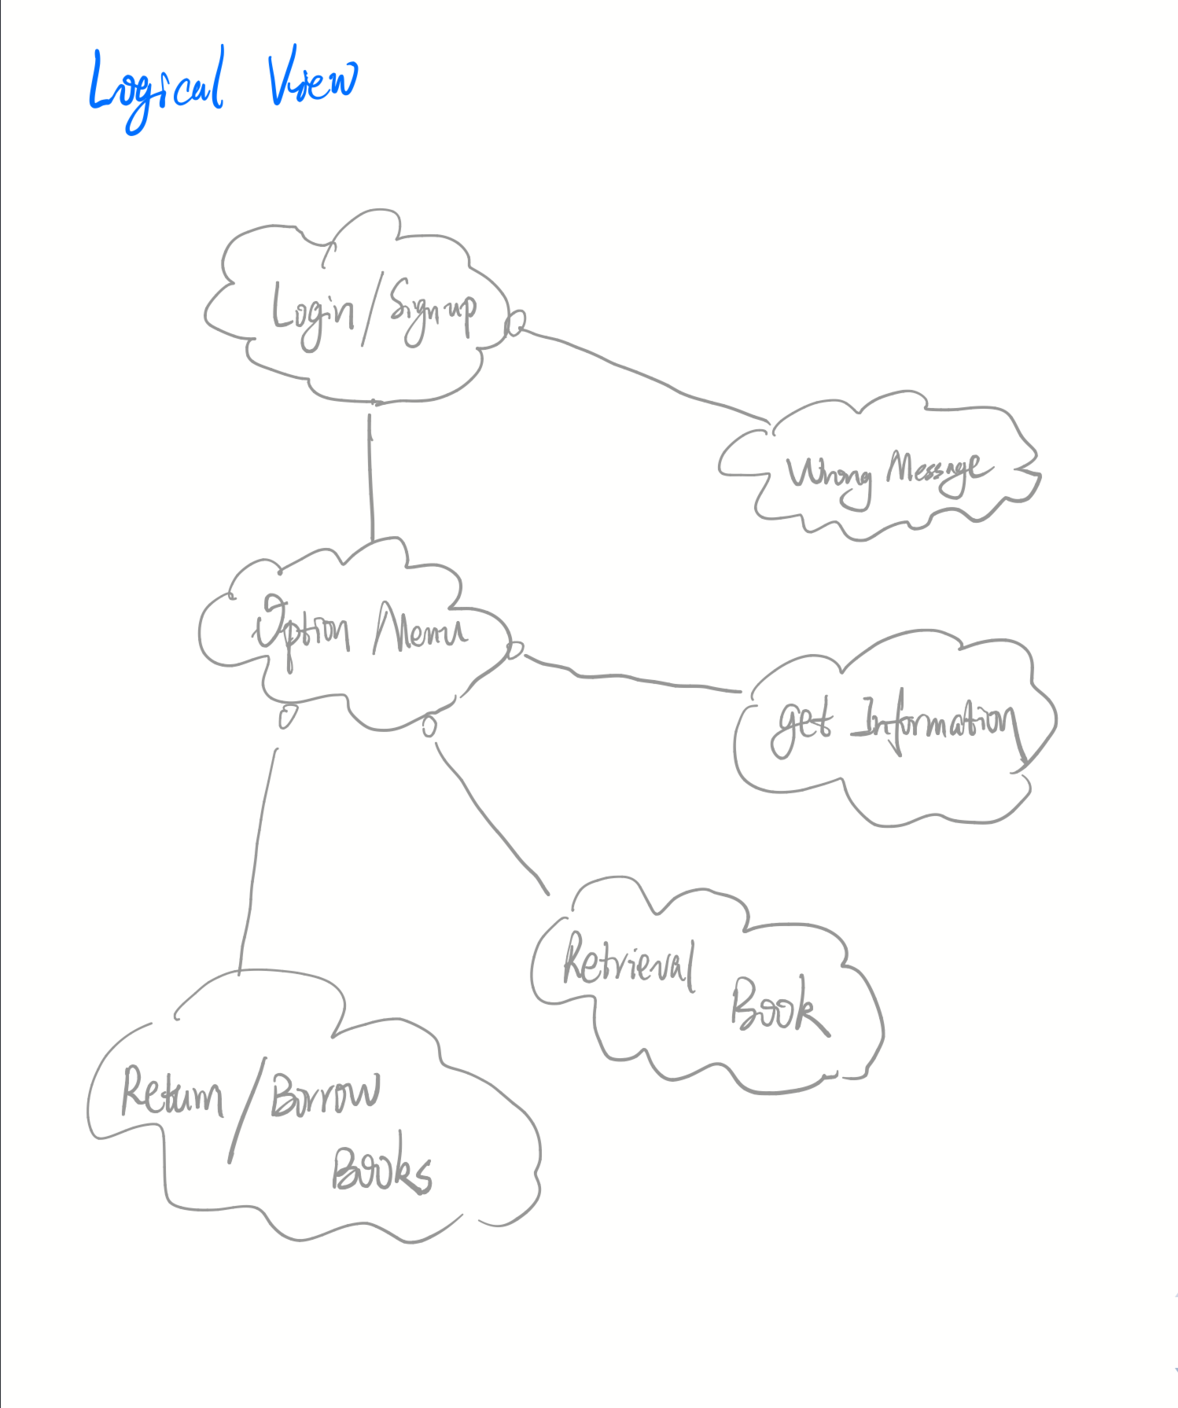

Development
After designing the structures of all the modules and database, the project is began to programming. And after the basic programming, we use more time to completed and accomplish some details of the programming such as decorating the GUI form and optimizing the code of JDBC.

Testing
Before the implementation, functioning of the whole projects need to be tested for insuring proper navigation and valid data entry into the forms and corresponding actions accordingly. This is only after a throughout testing process, when the project is ready to be implemented and to be used by the client in the real environment.
After designing and developing, the application is tested for all logical paths and proper working of all operations. The project is also tested for all navigation links provided in all user interfaces. Finally, the project is tested whether all the requirements listed during requirement analysis are being fulfilled or not.
The approach of testing is illustrated in Figure

Debugging | Unit Testing | Integration Testing

Debugging
Debugging is the process of isolating and correcting the causes of known errors. Commonly used debugging methods include:
- Debugging by induction or deduction
- Debugging by backtracking
Debugging by induction or deduction proceeds as follows:
- Listing the possible causes for the observed failure
- Using the available information to eliminate various hypotheses
- Elaborating the remaining hypotheses
- Proving or disproving each hypotheses
- Determining the appropriate corrections
- Verifying the corrections

Debugging by backtracking involves working backward in the source code from the point where the error was observed in an attempt to identify the exact point where the error occurred.

Traditional debugging techniques include:

Snapshot dumps-which are machine –level representations of the partial or total program state at a particular point in the execution sequence. For example, core dump during execution of a C program. The image of the program along with all registers are dumped to a file(core) at the point of execution error.

Trace Facilities—which list changes in selected state components. In its simplest form, a trace will print all changes in data values for all variables and changes control flow. For example, in Visual Basic 4.0 usage of watch pane is a trace facility.

Traditional breakpoint facility—interrupts program execution and transfers control to the programmer’s terminal when execution reaches a specified break instruction in the source code, for example, inserting breakpoints in a Visual Basic program by using stop keyword.

Unit Testing
A program unit is usually small enough that the programmer who developed it can test it in great detail and certainly in greater detail than will be possible when the unit is integrated into an evolving software product. As mentioned in previous sessions, there are four categories of tests that a programmer will typically perform on a program unit:

- Functional tests-specify operating condition, input values and expected results. For example, for a function written for string copy, the source or destination string can be passed as null argument. The function should be able to take care of that situation.
- Performance tests—should be designed to verify response time, execution time, throughput, primary and secondary memory utilization and traffic rates on data channels and communication links. For example, a query executed takes 5 seconds to display results, is a test for response time. Execution time is the time taken by CPU to execute a program. Throughput is the rate at which data gets transferred from one data source to destination. Primary and secondary memory utilization needs to be optimized. Traffic rates on data channels and communication link testing is applicable for networks.
- Stress tests—are designed to overload a system in various ways. The purpose of a stress test is to determine the limitation of the system. For example, during a sort operation, the available memory can be reduced to see whether the program is able to handle the situation.
- Structural tests—are concerned with examining the internal processing logic of a software system. For example, if a function is responsible for tax calculation, the verification of the logic is a structural test.

System Testing
A system is tested for all operation user or admin may take. We must make sure that the system could run normally in any situation.

There two kind of activities of System testing we use—Integration testing and acceptance testing.

Integration Testing
Bottom-up integration is the traditional strategy used to integrate the components of a software system into a functioning whole. Bottom-up integration consists of unit testing, followed by subsystem testing, followed by testing of the entire system. Unit testing has the goal of discovering errors in the individual modules of the system. The primary purpose of subsystem testing is to verify operation of the interfaces between modules in the subsystem. System testing is concerned with the decision logic, control flow, recovery procedures, and throughput, capacity and timing characteristics of the entire system.

Disadvantages of bottom-up testing include:

- Necessity to write and debug test harnesses for modules and subsystems
- Level of complexity that result from combining modules and subsystems into larger units.
Top-down integration starts with the main routine and one or two immediate subordinated routines in the system structure. Top-down integration offers several advantages:

- System integration is distributed throughout the implementation phase. Modules are integrated as they are developed
- Top-level interfaces are tested first
- The top-level routines provide a natural test harness for lower-level routines
- Errors are localized to the new modules and interfaces that are being added

Automated tools in integration testing include:
- Module drivers
- Test data generators
- Environment simulators
- Library management facility to allow easy configuration and reconfiguration of system elements

Acceptance Testing
Acceptance testing involves planning and execution of functional tests, performance tests and stress tests in order to demonstrate that the implemented system satisfies its requirements.

Tools of special importance during acceptance testing include:

- Test Coverage Analyzer—records the control paths followed for each test case.
- Timing Analyzer—also called a profiler, reports the time spent in various regions of the source code under different test cases. These regions of the code are areas to concentrate on to improve system performance.
- Coding Standards—static analyzer and standard checkers are used to inspect code for deviations from standards and guidelines.

Implementation and Maintenance
This is the last stage in SDLC. The project is implemented for the client in real environment where it can be used. The project then runs in real environment with all the real process executed by the user. The implementation includes the proper deployment of the project onto the server. After the real execution of the project under the real circumstances by the user, some loop holes many be uncovered. It is also possible that after sometime the user may request some changes of report some problems in the working system. The maintenance of a project means updating the project for the required changes in the implemented system.
While design the Library Management System, one of the guideline we observed is the product should be maintained in a easily way. So we are confident about the Implementation and Maintenance. What’s more, we made a lot of test on the Library Management System to ensure that the system could run stable in most situation.

Singleton Pattern
In this project, we use singleton pattern widely, such as JDBC interface.
In software engineering, the singleton pattern is a software design pattern that restricts the instantiation of a class to one "single" instance. This is useful when exactly one object is needed to coordinate actions across the system. The term comes from the mathematical concept of a singleton.
The singleton design pattern describes how to solve such problems:
- Hide the constructor of the class.
- Define a public static operation (getInstance()) that returns the sole instance of the class.
The key idea in this pattern is to make the class itself responsible for controlling its instantiation (that it is instantiated only once).
The hidden constructor (declared private) ensures that the class can never be instantiated from outside the class.
The public static operation can be accessed easily by using the class name and operation name (Singleton.getInstance()).

DEVELOPING A LOGIN MODULE
The Login Module is where users get start with the system. It’s very important for the security of Library Management to design a excellent login module.

The development of this module includes writing code for the following files

- LoginMenu.java
- LoginMenu.form
- OptionMenu.java
- OptionMenu.form

DEVELOPING USER INFORMATION MODULE
Users could get information about themselves in this module. The information in this module always be huge. So it is very important to design a clear module that user can get information easily and the developer could maintain the module easily at the same time.

A profile record for an user is stored in the table USER_INFORMATION. To complete the development of this module we need following files

- PersonalInfo.java
- BorrowHistory.java

DEVELOPING RETRIEVAL MODULE

It is obviously that retrieval module is very important for users. Users can find the book they want more easier with the help of Retrieval Module.

The necessary files to be coded here are as follows.

- ConnCollection.java
- ResultItem.java
- ResultMenu.java
- ResultMenu.form
- QueryMenu.java
- DetailMenu.java

DEVELOPING BORROW & RETURN MODULE

Users need to borrow book so that they can read the book freely. But there is always a limit time for users to return the book. So the Borrow & Return Module should record the time when user borrow and return book. And this module should generate the bill for users if the book is exceed time limit.

The following code files are to be generated for developing this module

- MySQLConn.java
- BorrowMenu.java
- BorrowMenu.form

COST ESTIMATION
Today, software is the most expensive element of virtually a computer - based systems. So it necessary to estimate cost of project for a developer, because
Large cost estimation error can make the difference between profit and loss. Cost overrun can be disastrous for the developer. Rob Thomsett says “In an age of
Outsourcing and increased competition, the ability to estimate more accurate has
Emerged as a critical survival factor for many IT groups”.
Software cost and effort estimation will never be an exact science. Too many variables- human, technical environment,-can affect the ultimate cost of software and effort applied to develop the software.
For cost estimation of this project (RBRS), I carry out the different tasks in
This project according to the time period gives below. First we estimate the
Cost in working hours.

- Analysis carried out one day on 10 May 2019.
- Design carried out one day on 11 May 2019.
- Coding carried out 5 days from 12 May 2019 to 17 May 2019.
- Integration & Testing carried out one day on 18-22 May 2019.
- Report Writing(Documentation of the project) carried out one day on 23 May 2019.

Given Table shows starting and ending date of each work task and total working days. Table also shows concurrency between two or more work tasks. Code generation, Report Working, and Integration & Testing work tasks have been completed in concurrent manner.

Work Done By | Work task | Starting Date | Ending Date | Duration(day)
Zorn | Analysis | 10 May 19 | 11May 19 | 1
Zorn | Design | 11May19 | 12May 19 | 1
Zorn/Emma/Lil Yoroll/Anthony | Code generation | 12May19 | 17JMay19 | 5
Zorn | Integration & Testing | 17May19 | 18 May22 | 5
Zorn | Report Writing | 18May19 | 23 May19 | 1
 |  |  |  | Total Day =13

This software has been developed in 9 days. I work on this project 5 hours a day.
The total hours = 13*5 = 65

Estimated the working cost of manpower is $.10/Hour.
Then the total cost of the project is = 65*10 = 650
So the Estimated Total cost of the Project is 65
0*4 only.

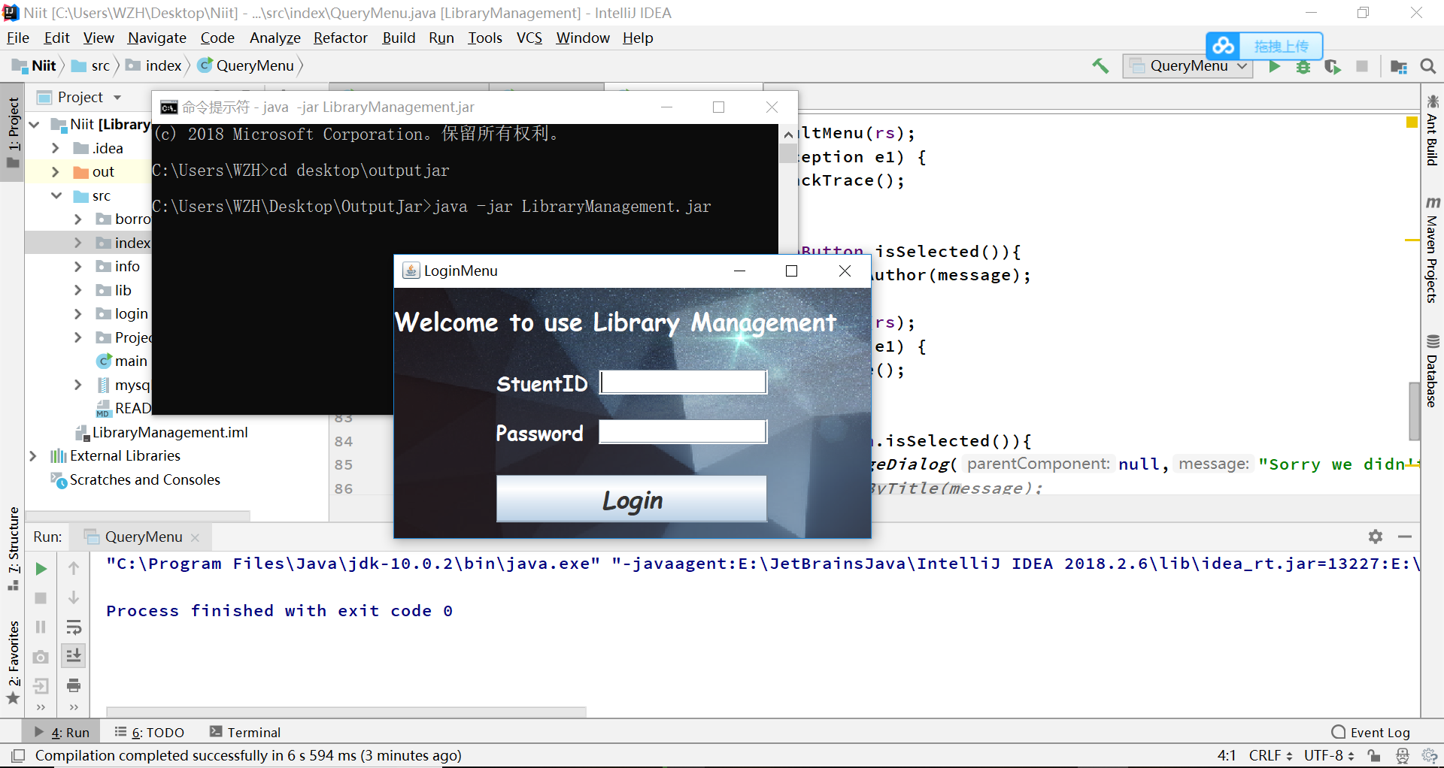

public class main {
public static void main(String[] args) {
LoginMenu lm = new LoginMenu();
}
}

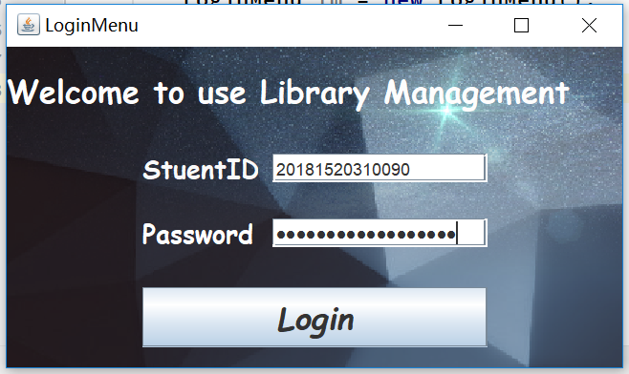
When Enter wrong username or password:
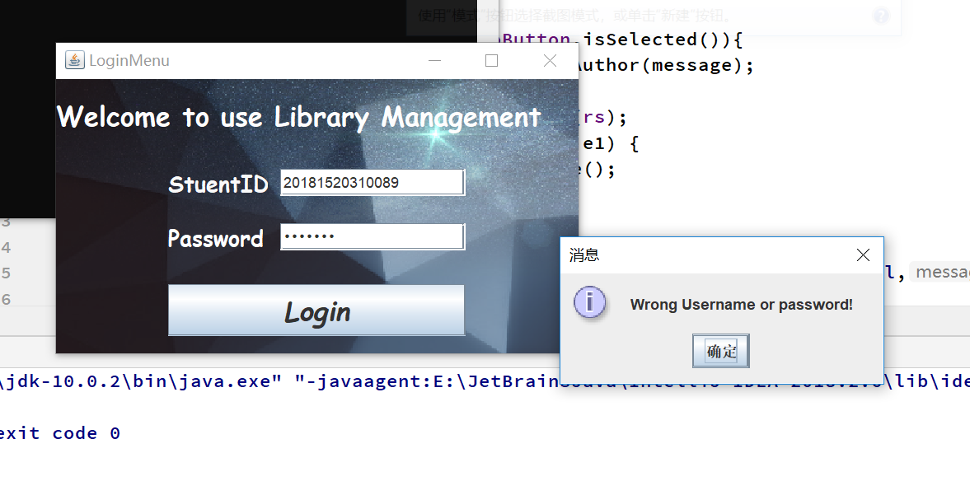

// the code of variables define is omitted here
public LoginMenu() throws HeadlessException {
//set all panel opaque to false
messagePanel.setOpaque(false);
buttonPanel.setOpaque(false);
welcomePanel.setOpaque(false);
setDefaultCloseOperation(DISPOSE_ON_CLOSE);
setVisible(true);
setTitle("LoginMenu");
setSize(430,230);
setLocation(300,200);
CommonOperation co = CommonOperation.getInstance();
co.setDefaultBackground(this,bottomPanel);
setContentPane(bottomPanel);
cs=BigConnectionSet.getInstance();
loginButton.addMouseListener(new MouseAdapter() {
@Override
public void mouseClicked(MouseEvent e) {
super.mouseClicked(e);
String passwd=cs.getPasswd(uField.getText());
if(passwd!=null && passwd.equals(pField.getText())){
dispose();
OptionalMenu om = new OptionalMenu(uField.getText());
}
else {
JOptionPane.showMessageDialog(null,"Wrong Username or password!");
}
}
});
pField.addKeyListener(new KeyAdapter() {
@Override
public void keyPressed(KeyEvent e) {
super.keyPressed(e);
if(e.getKeyChar()=='\n'){
// super.mouseClicked(e);
String passwd=cs.getPasswd(uField.getText());
if(passwd!=null && passwd.equals(pField.getText())){
OptionalMenu om = new OptionalMenu(uField.getText());
dispose();
}
else {
JOptionPane.showMessageDialog(null,"Wrong Username or password!");
}
};
}
});
}

When Login Successfully the following Menu will display:

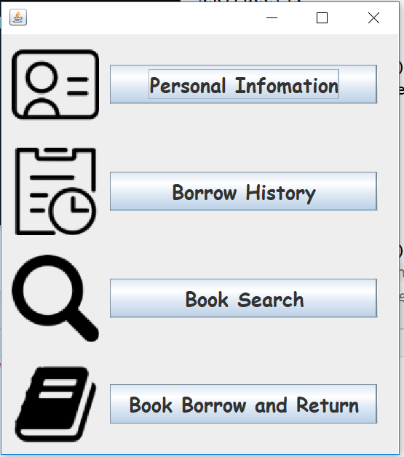
public OptionalMenu(String userID) throws HeadlessException {
this.userID=userID;
setContentPane(bottomPanel);
setDefaultCloseOperation(DISPOSE_ON_CLOSE);
setLocation(300,100);
pack();
setSize(getWidth()+20, getHeight()+50);
setVisible(true);
personalInfomationButton.addMouseListener(new MouseAdapter() {
@Override
public void mouseClicked(MouseEvent e) {
super.mouseClicked(e);
PersonalInfo pi = new PersonalInfo(userID);
}
});
borrowHistoryButton.addMouseListener(new MouseAdapter() {
@Override
public void mouseClicked(MouseEvent e) {
super.mouseClicked(e);
try {
BorrowHistory bh = new BorrowHistory(userID);
} catch (SQLException e1) {
e1.printStackTrace();
}
}
});
bookSearchButton.addMouseListener(new MouseAdapter() {
@Override
public void mouseClicked(MouseEvent e) {
super.mouseClicked(e);
QueryMenu qm = new QueryMenu();
}
});
bookBorrowAndReturnButton.addMouseListener(new MouseAdapter() {
@Override
public void mouseClicked(MouseEvent e) {
super.mouseClicked(e);
BorrowMenu bm = new BorrowMenu(userID);
}
});
}

Every user can check the personal information by click the “Personal Information” Button:
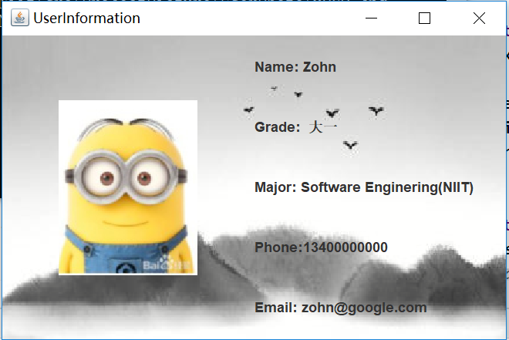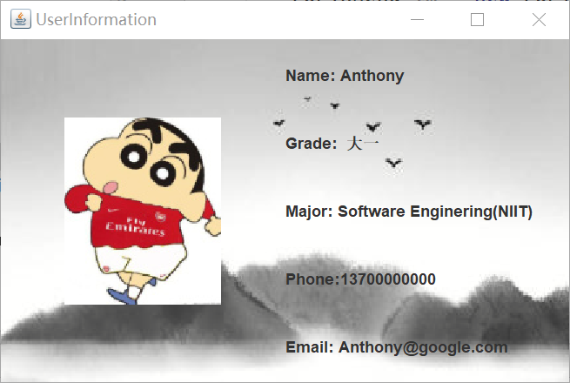
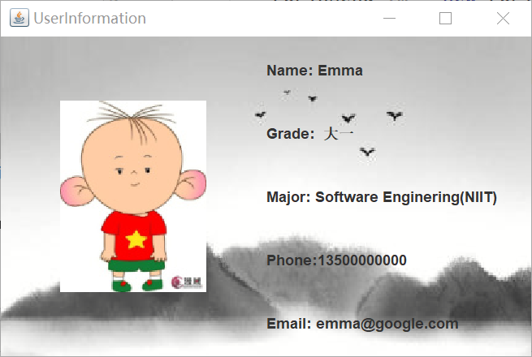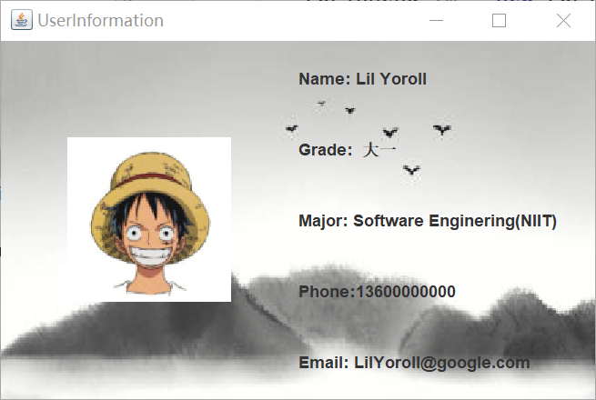

public PersonalInfo(String userID) {
bottomPanel=new JPanel(new GridLayout(1,2));
BigConnectionSet cs=BigConnectionSet.getInstance();
// initialize the frame
setSize(450,300);
CommonOperation co = CommonOperation.getInstance();
co.setUserInfoBackground(this,bottomPanel);
setDefaultCloseOperation(DISPOSE_ON_CLOSE);
setVisible(true);
setLocation(200,200);
setContentPane(bottomPanel);
picLabel=new JLabel(new ImageIcon(cs.getPicPath(userID)));
System.out.println(cs.getPicPath(userID));
bottomPanel.add(picLabel);
setTitle("UserInformation");
letterPanel = new JPanel(new GridLayout(5,1));
letterPanel.setOpaque(false);
bottomPanel.add(letterPanel);
nameLabel=new JLabel("Name: "+cs.getName(userID));
gradeLabel=new JLabel("Grade: "+cs.getGrade(userID));
majorLabel=new JLabel("Major: "+cs.getMajor(userID));
phoneNumberLabel = new JLabel("Phone:"+cs.getPhoneNumber(userID));
emailLabel = new JLabel("Email: "+cs.getEmail(userID));
letterPanel.add(nameLabel);
letterPanel.add(gradeLabel);
letterPanel.add(majorLabel);
letterPanel.add(phoneNumberLabel);
letterPanel.add(emailLabel);
}

Also can Query your borrow history :
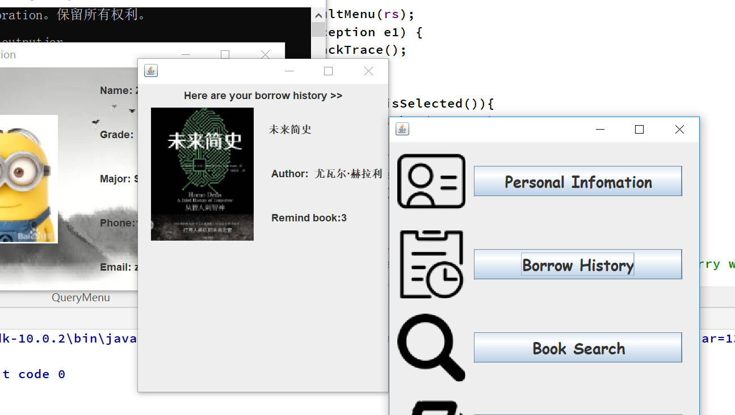

And of course users could retrieval books by the System:

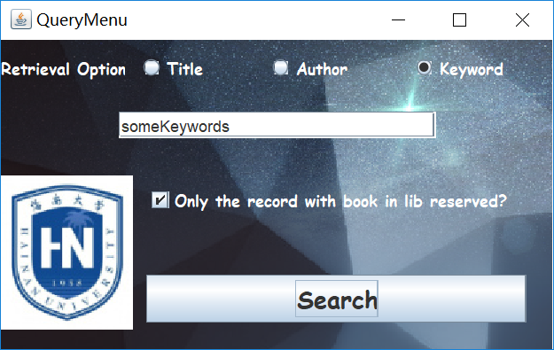
// set all the component with opaque to false
picLabel.setOpaque(false);
lPanel.setOpaque(false);
uPanel.setOpaque(false);
infoPanel.setOpaque(false);
textPanel.setOpaque(false);
onlyBox.setOpaque(false);
titleRadioButton.setOpaque(false);
authorRadioButton.setOpaque(false);
keyWordRadioButton.setOpaque(false);
lowerLeftPanel.setOpaque(false);
lowerPanel.setOpaque(false);
// initial the frame
setSize(430,270);
CommonOperation co = CommonOperation.getInstance();
co.setDefaultBackground(this,bottomPanel);
setContentPane(this.bottomPanel);
setTitle("QueryMenu");
setDefaultCloseOperation(DISPOSE_ON_CLOSE);
setVisible(true);
setLocation(300,200);
ButtonGroup gp1 = new ButtonGroup();
gp1.add(titleRadioButton);
gp1.add(authorRadioButton);
gp1.add(keyWordRadioButton);
searchButton.addMouseListener(new MouseAdapter() {
@Override
public void mouseClicked(MouseEvent e) {
super.mouseClicked(e);
String message=textField.getText();
if(titleRadioButton.isSelected()){
rs =cc.getBookIndexByTitle(message);
try {
rm=new ResultMenu(rs);
} catch (SQLException e1) {
e1.printStackTrace();
}
}
else if(authorRadioButton.isSelected()){
rs =cc.getBookIndexByAuthor(message);
try {
rm=new ResultMenu(rs);
} catch (SQLException e1) {
e1.printStackTrace();
}
}
else if(keyWordRadioButton.isSelected()){
JOptionPane.showMessageDialog(null,"Sorry we didn't offer the server of search by keyword now, we will completed it ASAP");
}
}
});
}

Here is the example of result:
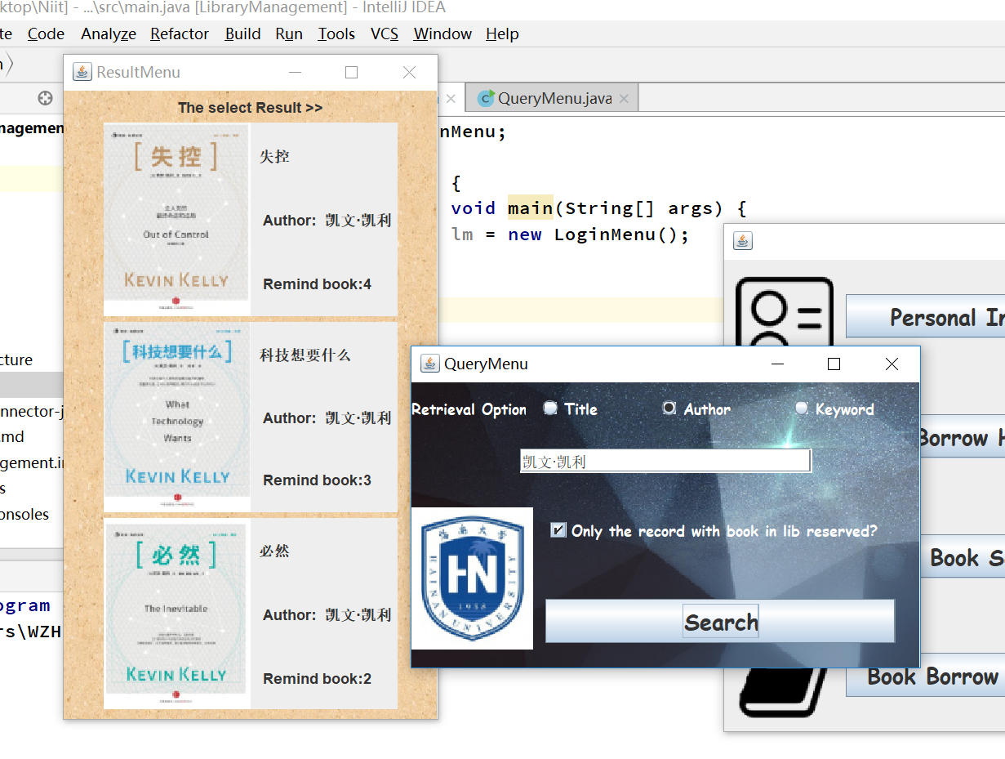

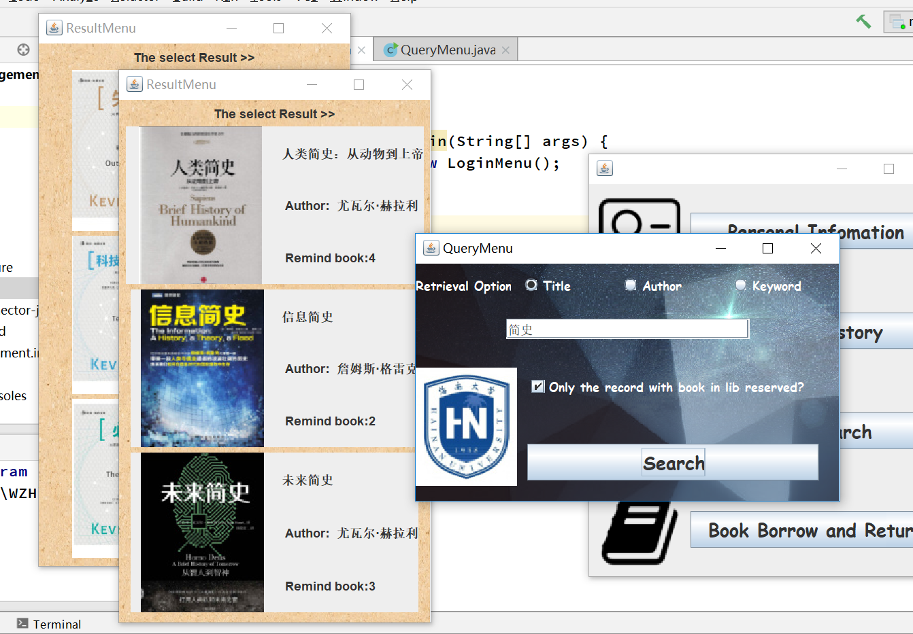

ResultMenu(ResultSet rs) throws SQLException {
ConnCollection cc = ConnCollection.getInstance();
setDefaultCloseOperation(DISPOSE_ON_CLOSE);
setTitle("ResultMenu");
JPanel bottomPanel = new JPanel(new FlowLayout());
//initialize the frame
setSize(320,550);
CommonOperation co = CommonOperation.getInstance();
co.setResultSetBackground(this,bottomPanel);
setContentPane(bottomPanel);
setLayout(new FlowLayout());
setVisible(true);
bottomPanel.add(new JLabel("The select Result >>"));
setLocation(200,50);
int count = 0;
while(rs.next()){
count++;
String index=rs.getString(1);
bottomPanel.add(new ResultItem(cc.getbookTitle(index),
cc.getBookAuthor(index),
cc.getBookPicture(index),
cc.getBookCounter(index),
cc.getBookPress(index),
cc.getBookType(index)));
}
if(count ==0){
add(new JLabel(" Sorry we didn't find any result "));
}
}

And Finally the Borrow & Return Menu:
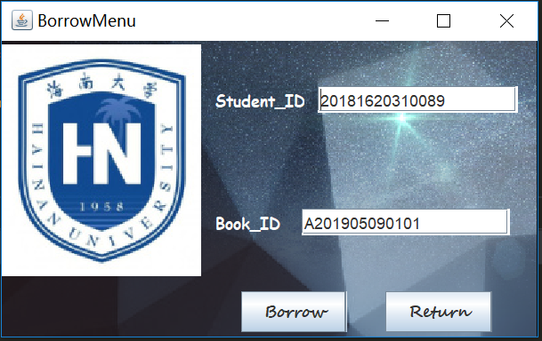
When u borrow a Book it will give the tips if u borrow successfully:
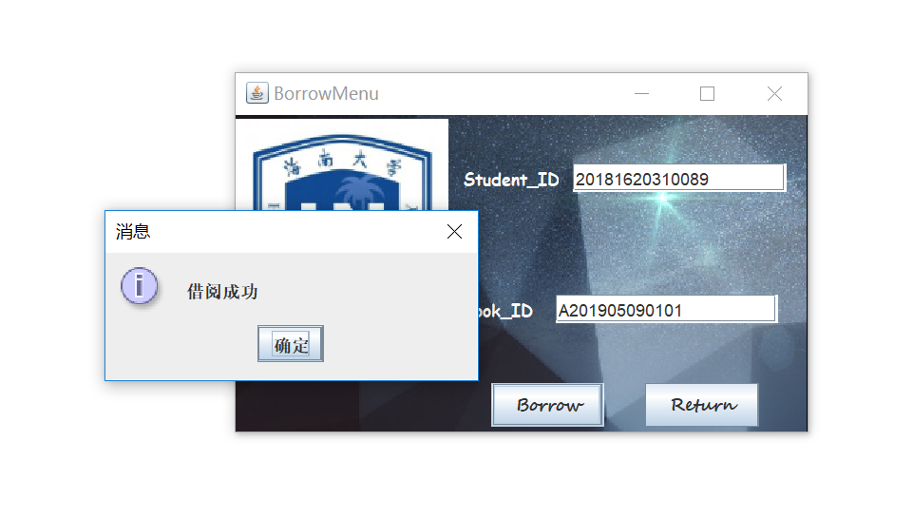
If you’re the Borrow same book again(You will failed):
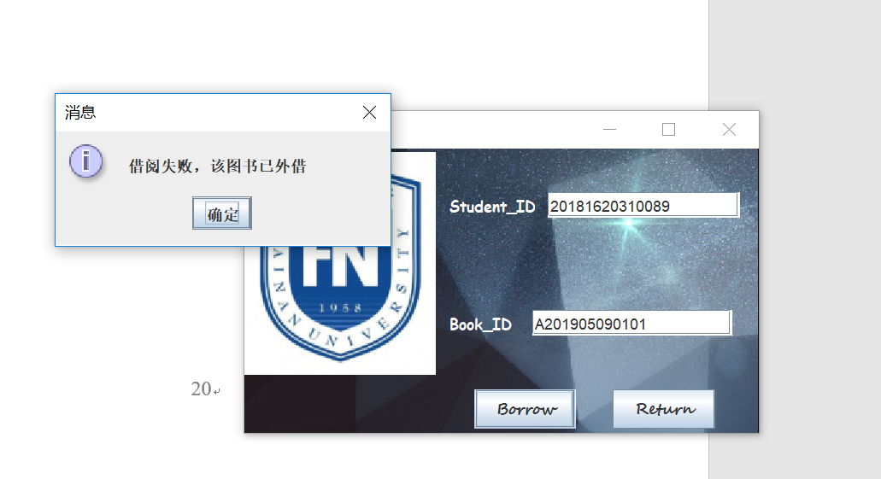

And there are some class about JDBC and others we used in the project (we think add the code of JDBC insert into the main body of code will make the code unreadable and unclear, so we divided them into independent class and use the Singleton Design Pattern to enhance the code):
public class ConnCollection {
private String querySql =null;
private Connection conn = null;
private ResultSet rs= null;
private static ConnCollection uniqueInstance;
private ConnCollection(){
try {
String JDBC_Driver = "com.mysql.cj.jdbc.Driver";
String URL = "jdbc:mysql://localhost:3306/lm?serverTimezone=CTT";
String databaseUser = "root";
String databasePassword = "ThreeThousandTimes";
Class.forName(JDBC_Driver);
conn= DriverManager.getConnection(URL, databaseUser, databasePassword);
} catch (ClassNotFoundException | SQLException e) {
e.printStackTrace();
}
}
public static ConnCollection getInstance(){
if (uniqueInstance==null){
synchronized (ConnCollection.class){
if(uniqueInstance==null){
uniqueInstance=new ConnCollection();
}
}
}
return uniqueInstance;
}
// Book 索引部分
// 根据作者/书名等用户输入信息获得相关book的索引，即BookIndex
ResultSet getBookIndexByAuthor(String bookAuthor){
querySql ="select book_index_id from book_index where book_author regexp ?";
executeQuery(bookAuthor);
return rs;
}
ResultSet getBookIndexByTitle(String bookName){
querySql ="select book_index_id from book_index where book_title regexp ?";
executeQuery(bookName);
return rs;
}
// 根据得到的BookIndex获得书籍相关信息
public String getbookTitle(String bookIndex){
querySql ="select book_title from book_index where book_index_id=?";
executeQuery(bookIndex);
try {
rs.next();
return rs.getString(1);
} catch (SQLException e) {
e.printStackTrace();
}
return null;
}
public String getBookAuthor(String bookIndex){
querySql ="select book_author from book_index where book_index_id=?";
executeQuery(bookIndex);
try {
rs.next();
return rs.getString(1);
} catch (SQLException e) {
e.printStackTrace();
}
return null;
}
public int getBookCounter(String bookIndex){
querySql ="select book_count from book_index where book_index_id=?";
executeQuery(bookIndex);
try {
rs.next();
return rs.getInt(1);
} catch (SQLException e) {
e.printStackTrace();
}
return 0;
}
public String getBookPicture(String bookIndex){
querySql ="select book_picture_link from book_index where book_index_id=?";
executeQuery(bookIndex);
try {
rs.next();
return rs.getString(1);
} catch (SQLException e) {
e.printStackTrace();
}
return null;
}
public String getBookPress(String bookIndex){
querySql ="select book_press from book_index where book_index_id=?";
executeQuery(bookIndex);
try {
rs.next();
return rs.getString(1);
} catch (SQLException e) {
e.printStackTrace();
}
return null;
}
public String getBookType(String bookIndex){
querySql ="select book_type from book_index where book_index_id=?";
executeQuery(bookIndex);
try {
rs.next();
return rs.getString(1);
} catch (SQLException e) {
e.printStackTrace();
}
return null;
}
private void executeQuery(String info){
try {
PreparedStatement ps = conn.prepareStatement(querySql);
ps.setString(1,info);
rs= ps.executeQuery();
} catch (SQLException e) {
e.printStackTrace();
}
}
}

Above JDBC code is mainly about Book Retrieving, following two class of code are mainly about Book Return & Borrow and Login and Get User Information:
class BorrowReturnConn {
private final String databaseUser = "root";
private final String databasePassword = "ThreeThousandTimes";
private int flag = 1;
private Connection conn = null;
private PreparedStatement st1 = null;
private PreparedStatement st2 = null;
private PreparedStatement st3 = null;
private PreparedStatement st4 = null;
private static BorrowReturnConn uniqueInstance =null;
private BorrowReturnConn() {
try {
String jdbcDriver = "com.mysql.cj.jdbc.Driver";
Class.forName(jdbcDriver);
String dbUrl = "jdbc:mysql://localhost:3306/lm?serverTimezone=CTT";
conn = DriverManager.getConnection(dbUrl, databaseUser, databasePassword);
} catch (ClassNotFoundException e) {
e.printStackTrace();
} catch (SQLException e) {
e.printStackTrace();
}
}
public static BorrowReturnConn getInstance(){
if(uniqueInstance==null){
uniqueInstance = new BorrowReturnConn();
}
return uniqueInstance;
}
Boolean bookBorrow(String bookID, String studentID) {
checked(bookID);
if (flag == 0) {
return false;
} else {
// make sure book is in lib
// mark on the book_id
// update borrow history
// count--
String sql1 = "update book_collection set is_inLib = 0 where book_id = ?";
String sql2 = "insert into borrow_history values (?,?,0,?)";
try {
st1 = conn.prepareStatement(sql1);
st1.setString(1, bookID);
st1.execute();
} catch (SQLException e) {
e.printStackTrace();
}
try {
st2 = conn.prepareStatement(sql2);
st2.setString(1, studentID);
st2.setString(2, bookID);
st2.setDate(3, null);
st2.execute();
} catch (SQLException e) {
e.printStackTrace();
}
String sql3 = "select book_index_id from book_collection where book_id = ?";
String sql4 = "update book_index set book_count=book_count-1 where book_index_id=?";
String bookIndex = null;
try {
st3 = conn.prepareStatement(sql3);
st3.setString(1, bookID);
ResultSet rs = st3.executeQuery();
rs.next();
bookID = rs.getString(1);
} catch (SQLException e) {
e.printStackTrace();
}
try {
st4 = conn.prepareStatement(sql4);
st4.setString(1, bookIndex);
st4.execute();
} catch (SQLException e) {
e.printStackTrace();
}
}
return true;
}
Boolean bookReturn(String bookID, String studentID) {
checked(bookID);
if (flag == 1) {
return false;
} else {
// update borrow history
// remark on the bookid
// count++
String sql1 = "update book_collection set is_inLib = 1 where book_id=?";
String sql2 = "update borrow_history set book_status=1 where book_id = ?";
try {
st1 = conn.prepareStatement(sql1);
st1.setString(1, bookID);
st1.execute();
} catch (SQLException e) {
e.printStackTrace();
}
try {
st2 = conn.prepareStatement(sql2);
st2.setString(1, bookID);
st2.execute();
} catch (SQLException e) {
e.printStackTrace();
}
String sql3 = "select book_index_id from book_collection where book_id = ?";
String sql4 = "update book_index set book_count=book_count+1 where book_index_id=?";
String bookIndex = null;
try {
st3 = conn.prepareStatement(sql3);
st3.setString(1, bookID);
ResultSet rs = st3.executeQuery();
rs.next();
bookID = rs.getString(1);
} catch (SQLException e) {
e.printStackTrace();
}
try {
st4 = conn.prepareStatement(sql4);
st4.setString(1, bookIndex);
st4.execute();
} catch (SQLException e) {
e.printStackTrace();
}
}
return true;
}
private void checked(String bookID) {
String sql1 = "select is_inLib from book_collection where book_id = ? ";
flag = 1;
try {
PreparedStatement stCheck = conn.prepareStatement(sql1);
stCheck.setString(1, bookID);
ResultSet rs = stCheck.executeQuery();
rs.next();
flag = rs.getInt(1);
} catch (SQLException e) {
e.printStackTrace();
}
}
}

public class BigConnectionSet {
private final String JDBC_Driver="com.mysql.cj.jdbc.Driver";
private final String URL="jdbc:mysql://localhost:3306/lm?serverTimezone=CTT";
private final String user="root";
private final String passwd="ThreeThousandTimes";
private static BigConnectionSet uniqueInsatance;
Connection conn = null;
PreparedStatement pst = null;
private BigConnectionSet() {
try {
Class.forName(JDBC_Driver);
conn= DriverManager.getConnection(URL,user,passwd);
} catch (ClassNotFoundException | SQLException e) {
e.printStackTrace();
}
}
public static BigConnectionSet getInstance(){
if(uniqueInsatance==null){
synchronized (BigConnectionSet.class){
if(uniqueInsatance==null){
uniqueInsatance=new BigConnectionSet();
}
}
}
return uniqueInsatance;
}
public String getPasswd(String userID){
String sql="select user_password from user_information where user_id = ?";
try {
pst=conn.prepareStatement(sql);
pst.setString(1,userID);
ResultSet rs = pst.executeQuery();
if(rs.next()){
return rs.getString(1);
}
} catch (SQLException e) {
e.printStackTrace();
}
return null;
}
public String getPicPath(String userID){
String sql="select user_photo from user_information where user_id = ?";
try {
pst=conn.prepareStatement(sql);
pst.setString(1,userID);
ResultSet rs = pst.executeQuery();
if(rs.next()){
return rs.getString(1);
}
} catch (SQLException e) {
e.printStackTrace();
}
return null;
}
public String getGrade(String userID){
String sql="select user_grade from user_information where user_id = ?";
try {
pst=conn.prepareStatement(sql);
pst.setString(1,userID);
ResultSet rs = pst.executeQuery();
if(rs.next()){
return rs.getString(1);
}
} catch (SQLException e) {
e.printStackTrace();
}
return null;
}
public String getName(String userID){
String sql="select user_name from user_information where user_id = ?";
try {
pst=conn.prepareStatement(sql);
pst.setString(1,userID);
ResultSet rs = pst.executeQuery();
if(rs.next()){
return rs.getString(1);
}
} catch (SQLException e) {
e.printStackTrace();
}
return null;
}
public String getMajor(String userID){
String sql="select user_major from user_information where user_id = ?";
try {
pst=conn.prepareStatement(sql);
pst.setString(1,userID);
ResultSet rs = pst.executeQuery();
if(rs.next()){
return rs.getString(1);
}
} catch (SQLException e) {
e.printStackTrace();
}
return null;
}
public String getClass(String userID){
String sql="select user_class from user_information where user_id = ?";
try {
pst=conn.prepareStatement(sql);
pst.setString(1,userID);
ResultSet rs = pst.executeQuery();
if(rs.next()){
return rs.getString(1);
}
} catch (SQLException e) {
e.printStackTrace();
}
return null;
}
public String getPhoneNumber(String userID){
String sql="select user_PhoneNumber from user_information where user_id = ?";
try {
pst=conn.prepareStatement(sql);
pst.setString(1,userID);
ResultSet rs = pst.executeQuery();
if(rs.next()){
return rs.getString(1);
}
} catch (SQLException e) {
e.printStackTrace();
}
return null;
}
public String getEmail(String userID){
String sql="select user_email from user_information where user_id = ?";
try {
pst=conn.prepareStatement(sql);
pst.setString(1,userID);
ResultSet rs = pst.executeQuery();
if(rs.next()){
return rs.getString(1);
}
} catch (SQLException e) {
e.printStackTrace();
}
return null;
}
public ResultSet getBookIDResultSet(String userID){
String sql="select book_id from borrow_history where user_id = ?";
try {
pst=conn.prepareStatement(sql);
pst.setString(1,userID);
ResultSet rs= pst.executeQuery();
return rs;
} catch (SQLException e) {
e.printStackTrace();
}
return null;
}
public String getIndexById(String book_id){
String sql = "select book_index_id from book_collection where book_id =?";
try {
pst=conn.prepareStatement(sql);
pst.setString(1,book_id);
ResultSet rs =pst.executeQuery();
rs.next();
return rs.getString(1);
} catch (SQLException e) {
e.printStackTrace();
}
return null;
}
}

And there some other class we packed in order to simplified the operation, For Example, by using the following function code, we could set the background of Jframe easily:
public class CommonOperation {
private static CommonOperation uniqueInstance;
private CommonOperation(){
}
public static CommonOperation getInstance(){
if(uniqueInstance==null){
synchronized (CommonOperation.class){
if(uniqueInstance==null){
uniqueInstance=new CommonOperation();
}
}
}
return uniqueInstance;
}
public void setDefaultBackground(JFrame f,JPanel content){
ImageIcon icon = new ImageIcon("C:\\Users\\WZH\\Desktop\\Niit\\src\\ProjectPicture\\BackGroundPure.png");
Image img = icon.getImage().getScaledInstance(f.getWidth(), f.getHeight(), Image.SCALE_FAST);
JLabel backlabel = new JLabel(new ImageIcon(img));
backlabel.setBounds(0, 0, f.getWidth(), f.getHeight());
f.getRootPane().add(backlabel);
f.getLayeredPane().setOpaque(false);
content.setOpaque(false);
}
public void setUserInfoBackground(JFrame f,JPanel content){
ImageIcon icon = new ImageIcon("C:\\Users\\WZH\\Desktop\\Niit\\src\\ProjectPicture\\UserInfoBackground.png");
Image img = icon.getImage().getScaledInstance(f.getWidth(), f.getHeight(), Image.SCALE_FAST);
JLabel backlabel = new JLabel(new ImageIcon(img));
backlabel.setBounds(0, 0, f.getWidth(), f.getHeight());
f.getRootPane().add(backlabel);
f.getLayeredPane().setOpaque(false);
content.setOpaque(false);
}
}

