**Storyboard**

**Scenario:** Emma decides she wants to view her class schedule on her desktop, additionally, she wants to include her work time in the schedule and view how her schedule would look like if she dropped from one of the classes that conflicted with another, lastly, Emma adds a new class



2. She presses on “login” which takes her to the login page where she inputs her student username and password

1.Emma goes to the scheduling website, she scrolls down to see what’s available and scrolls back up

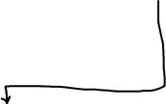



3. Emma enters her login and password and clicks to login where she can see her schedule of classes that she registered for previously



4. Emma notices that she has a time conflict between her classes, she scrolls down to examine further information

5. She decides to hide one of the classes that causes schedule conflict by pressing eye icon next to it, the class disappears from the timetable but remains in the list

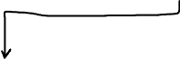

6. Next she decides to add new activity to her schedule, so she presses “add activity” and inputs the necessary info



8. Then Emma decides to add a new course to her schedule, so she presses “course search”

7. As she inputs info, she presses “ADD” and the new activity reflects on her schedule



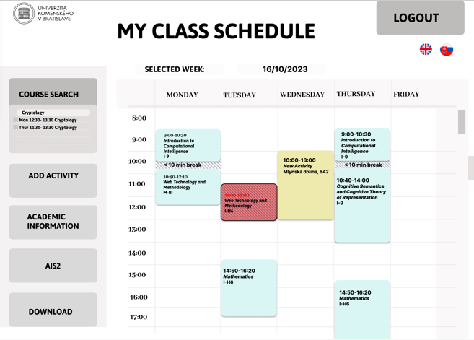



9. Emma types in Cryptology and sees two options offered



10. When Emma clicks next to the class she is interested in, it gets included in her timetable

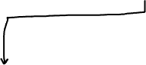

11. Emma decides to download the schedule as a PDF so she clicks on “Download” and then selects “Save as PDF”