Title Page
- Lab Title: Case Study 4 Individual recovered-media and network-traffic investigation
- Student name: Hauwa Haruna Yahaya.
- Student ID: 2025/FWSD/11219.
- Course Name: Computer Forensics Case Studies Instructor Name: Aminu Idris.
- Date Of Submission: 23/05/2026

Executive Summary
This forensic examination analysed a seized USB disk image (RHINOUSB.dd) and three network captures (rhino.log, rhino2.log, rhino3.log) to investigate the illegal possession of rhinoceros imagery. Through filesystem examination and PhotoRec carving, eight unique rhino images were recovered from deleted space. A SHA-256 hash comparison proved a definitive cross-artefact link: the rhino image recovered from the deleted USB space (f0106409.jpg) was binary-identical to the image uploaded via FTP inside an encrypted ZIP archive (rhino2.jpg). Additionally, two JPEGs were flagged by stegdetect as carrying JPHide steganographic payloads, though extraction was hindered by legacy tool compatibility. While the artefacts prove the existence of files, deliberate concealment and network transfers, the technical evidence attributes actions to an IP address and FTP account (137.30.122.253 / gnome), not to a specific human identity.

Lab Objectives
The objective of this lab was to conduct a multi-source digital forensic investigation by correlating disk image artefacts with network traffic. The practical aimed to preserve evidential integrity through SHA-256 hashing, recover deleted files using PhotoRec, detect and attempt extraction of steganographic payload, and reconstruct transferred files from both FTP and HTTP packet captures. A primary goal was to deduplicate recovered media by cryptographic hash to determine whether the seized evidence met the legal threshold of nine unique rhinoceros images, while strictly distinguishing direct technical observations from inferences regarding suspect intent and identity.

Tools and Resources Used
- Forensic Imaging & Analysis: sha256sum, exiftool, file, xxd, stat
- Disk Forensics: Sleuth Kit (mmls, fsstat, fls, icat), PhotoRec
- Steganography: stegdetect, stegbreak, wibo, jpseek.exe
- Network Analysis: Wireshark, tshark, fcrackzip, unzip
- Environment: Kali Linux, rockyou.txt wordlist
- Evidence Package: DFRWS2005-RODEO.zip (RHINOUSB.dd, rhino.log, rhino2.log, rhino3.log)

Methodology

Lab Folder Structure
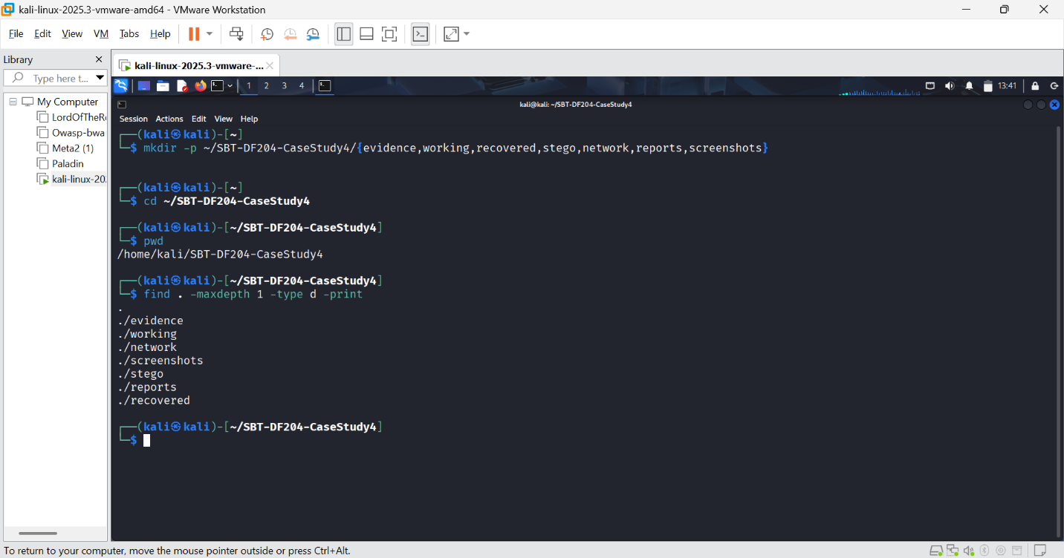FIGURE 1: I created the lab folder structure
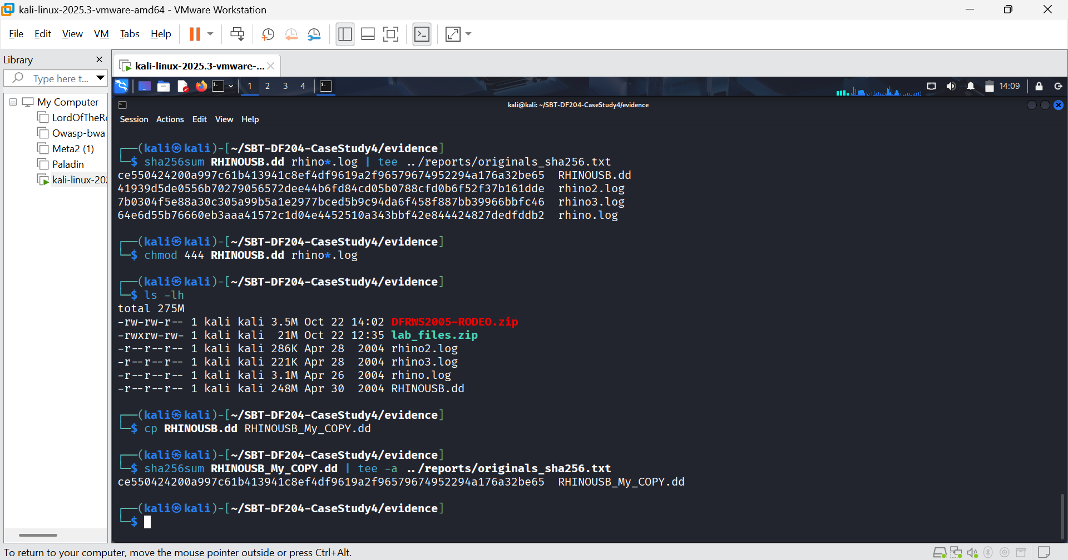FIGURE 2: Extracted files, original and working copy hashes.
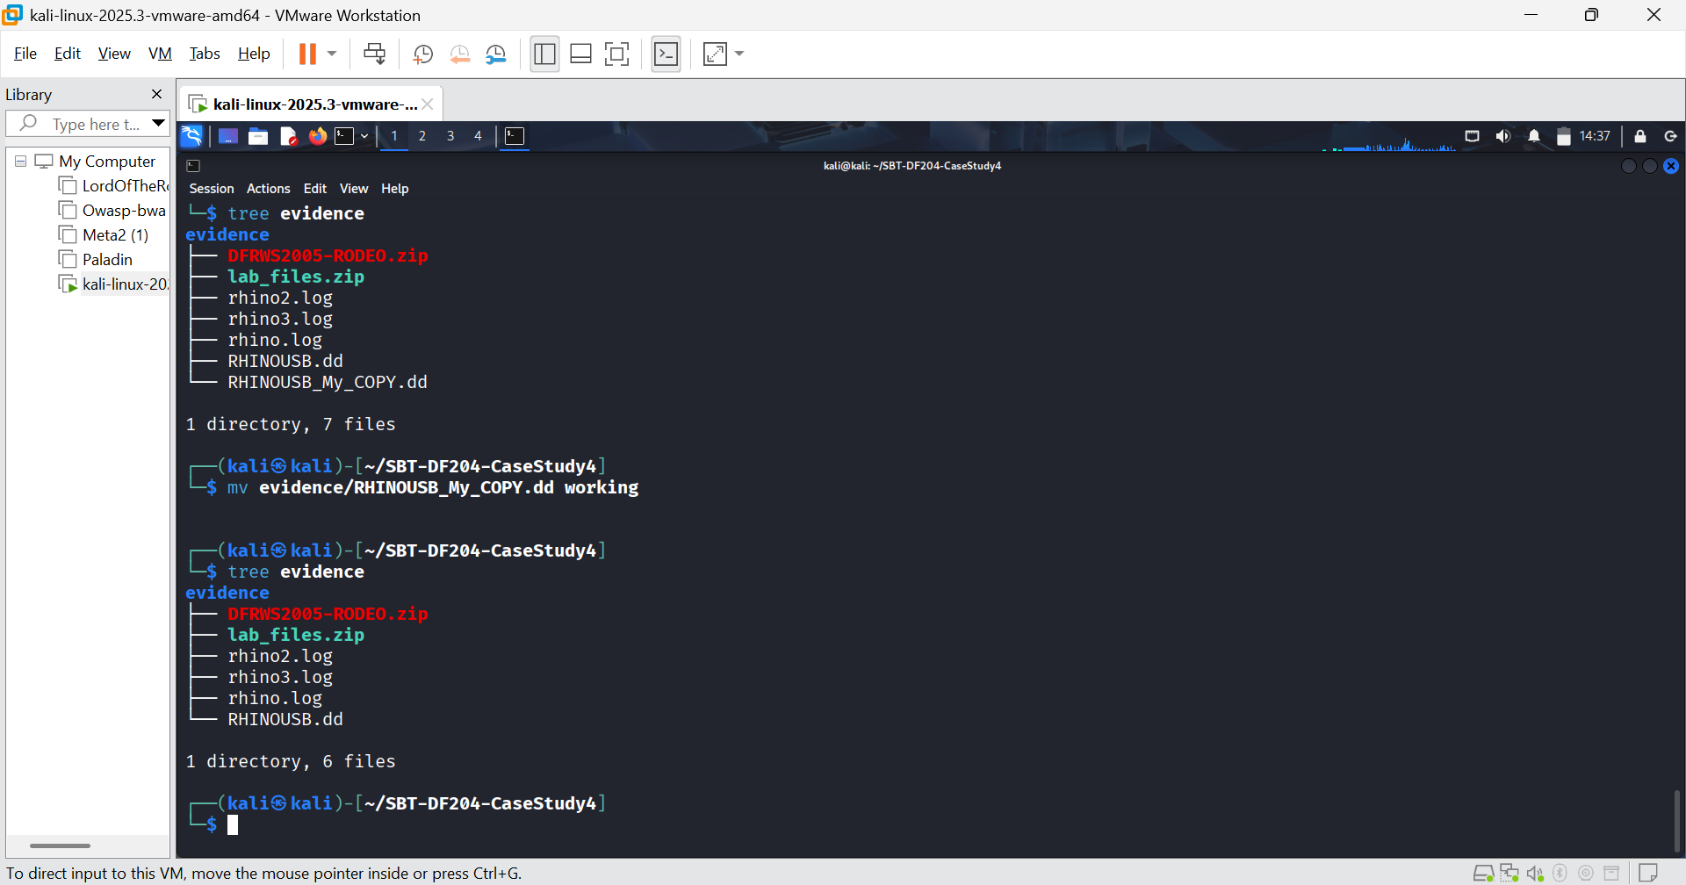FIGURE 3: Working copy moved to working directories

Mini Evidence & Chain-of-Custody Worksheet
Field | Entry
Case ID | SBT-DF204-Case4-FWSD-2025-11219
Trainee name | Hauwa Haruna yahaya
Date and time started | 21/10/2026 6:00pm
Sha256 hash | ce550424200a997c61b413941c8ef4df9619a2f96579674952294a176a32be65
Working-copy sha256 | ce550424200a997c61b413941c8ef4df9619a2f96579674952294a176a32be65
Notes on any changes | The USB image contains 3 files

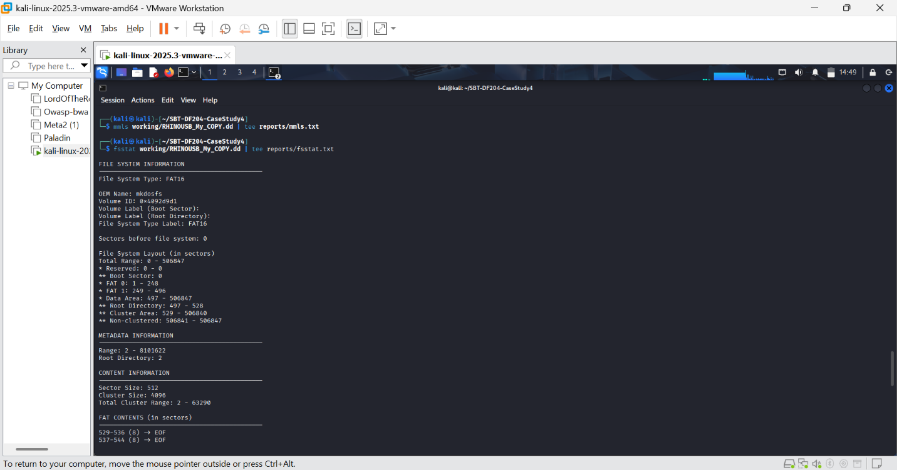FIGURE 4: File system information.
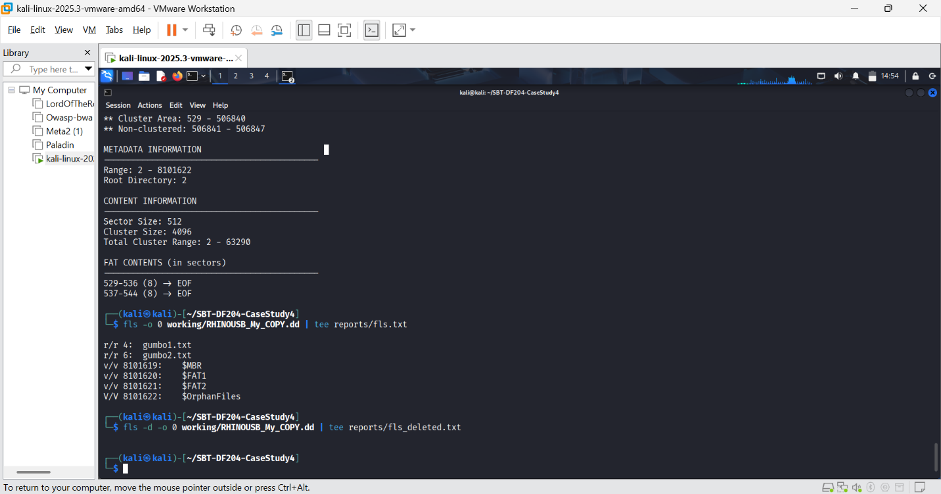FIGURE 5: Directory listing.
The absence of fls -d entries combined with the presence of $OrphanFiles indicates the root directory was rewritten while cluster content remained. This is itself evidence of anti-forensic activity or an incomplete reformat.
FIGURE 6: FAT0 and FAT1 are identical

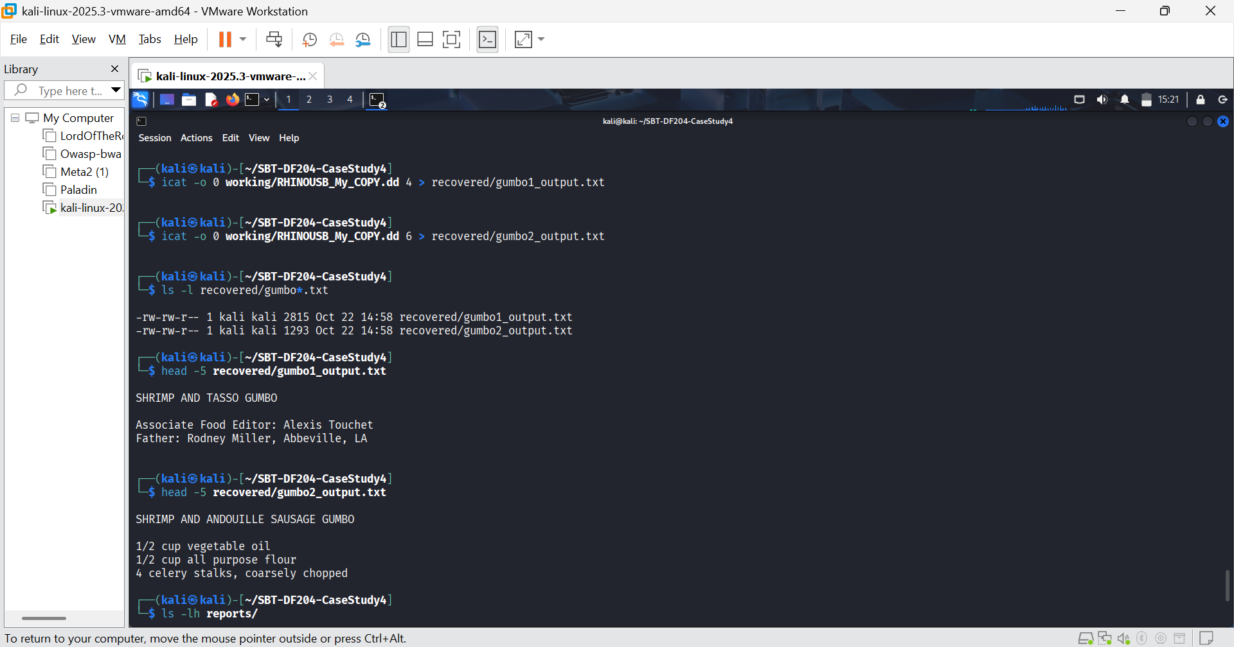FIGURE 7: I extracted the gumbo files
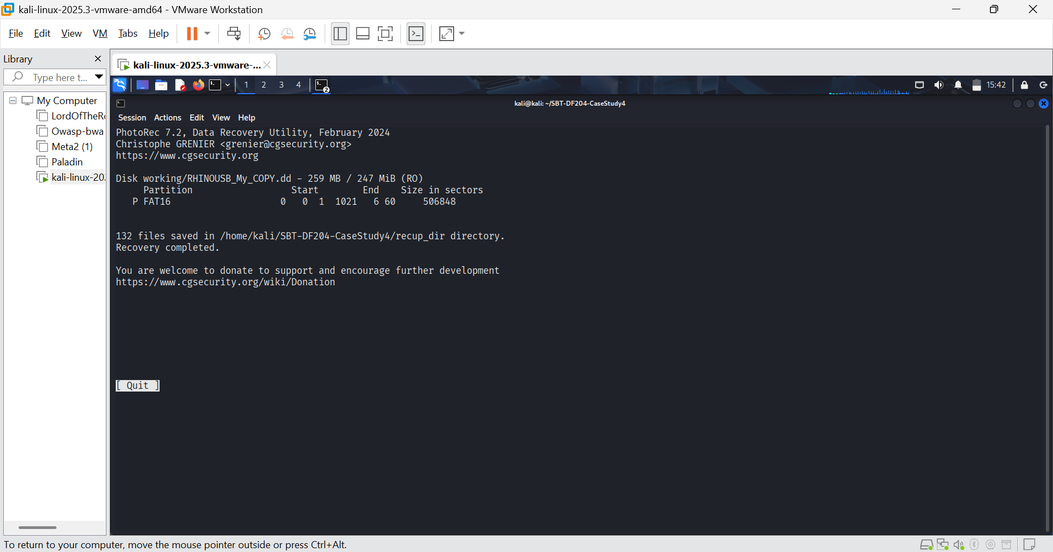FIGURE 8: photorec session saved.
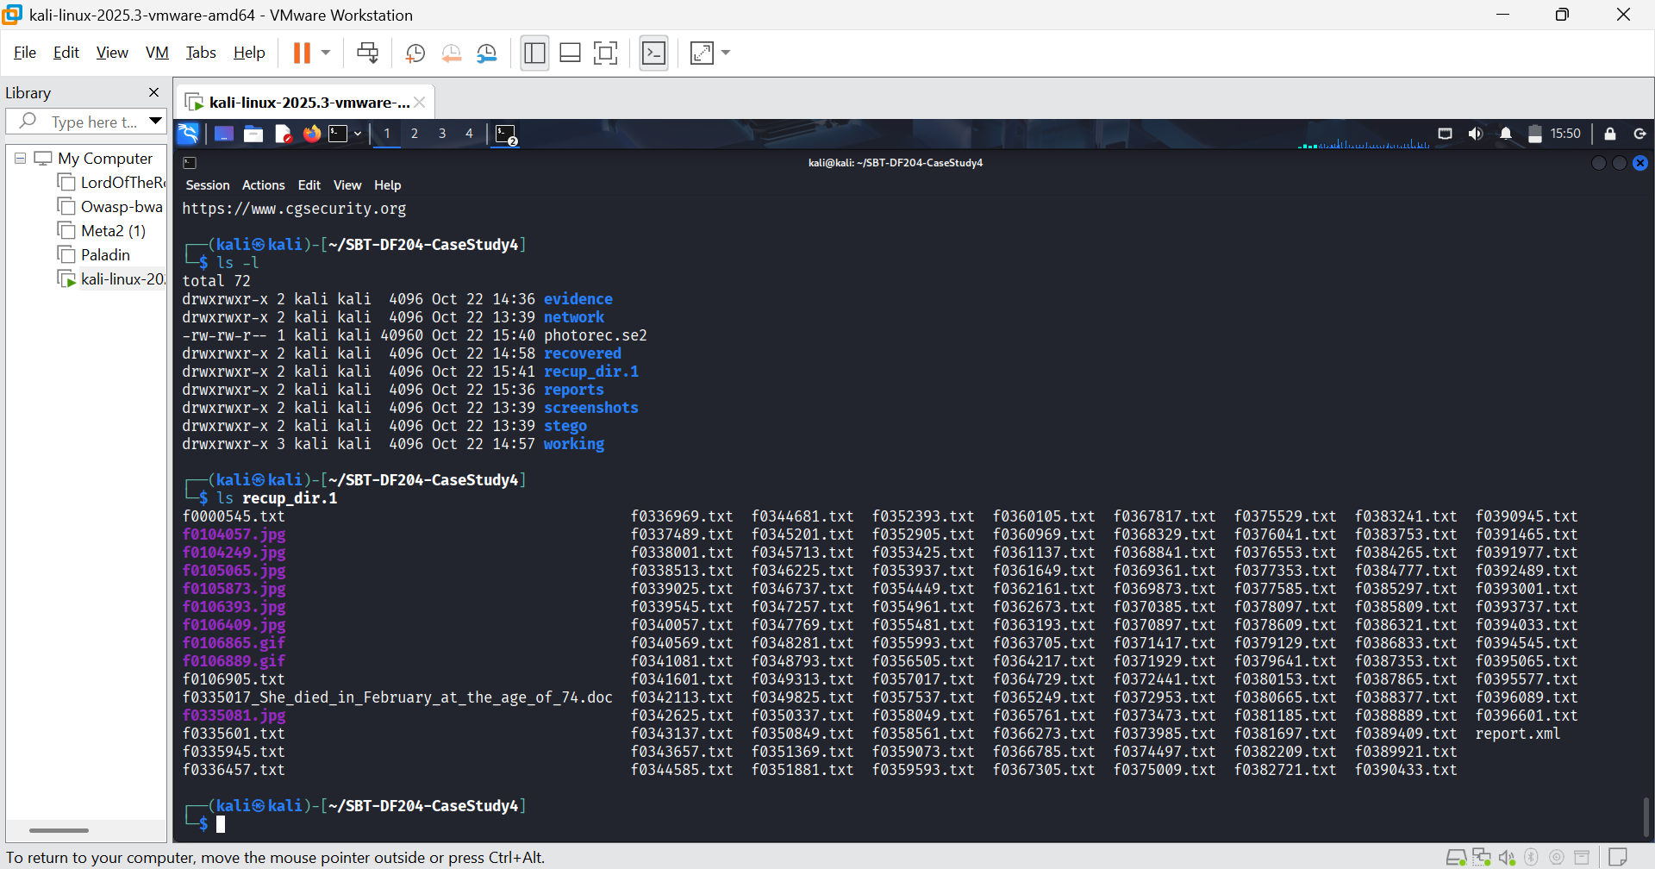FIGURE 7: The recovered file list.
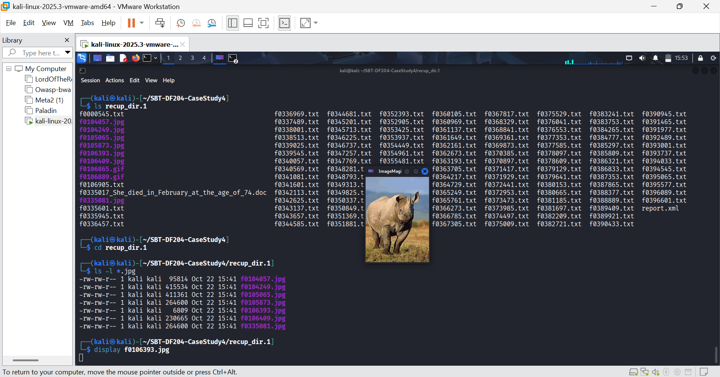 FIGURE 8: I listed all jpg files and displayed a photo.
Filename | Rhino? | What it is
f0104057.jpg | No | Alligator
f0104249.jpg | No | Crocodile
f0105065.jpg | No | Crocodile
f0105873.jpg | No | Lizard hatchling
f0106393.jpg | Yes | Rhino
f0106409.jpg | Yes | Rhino with calf
f0335081.jpg | No | Lizard hatchling
f0106865.gif | Yes | Rhino
f0106889.gif | Yes | Rhino

STEGANOGRAPHY
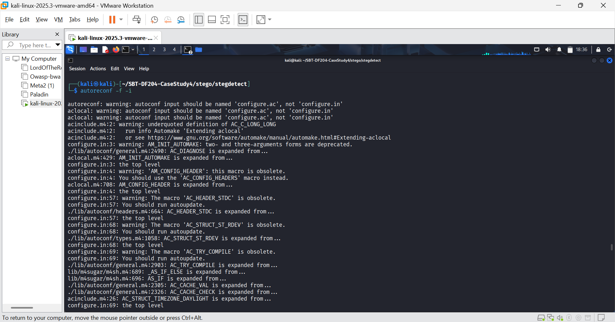FIGURE 8: Trigger builds
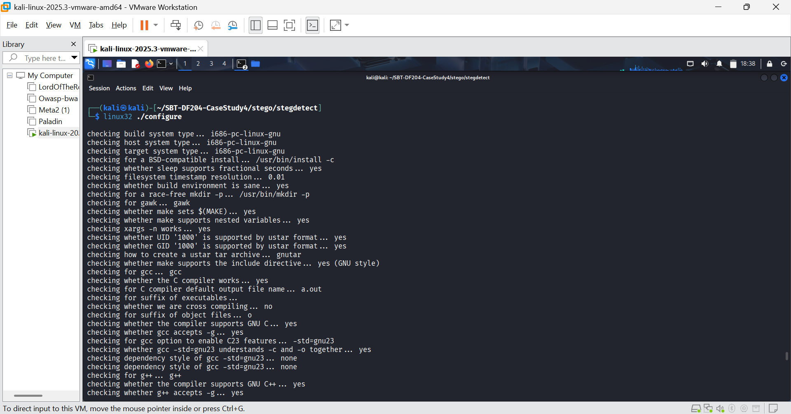FIGURE 9: Compilation environment
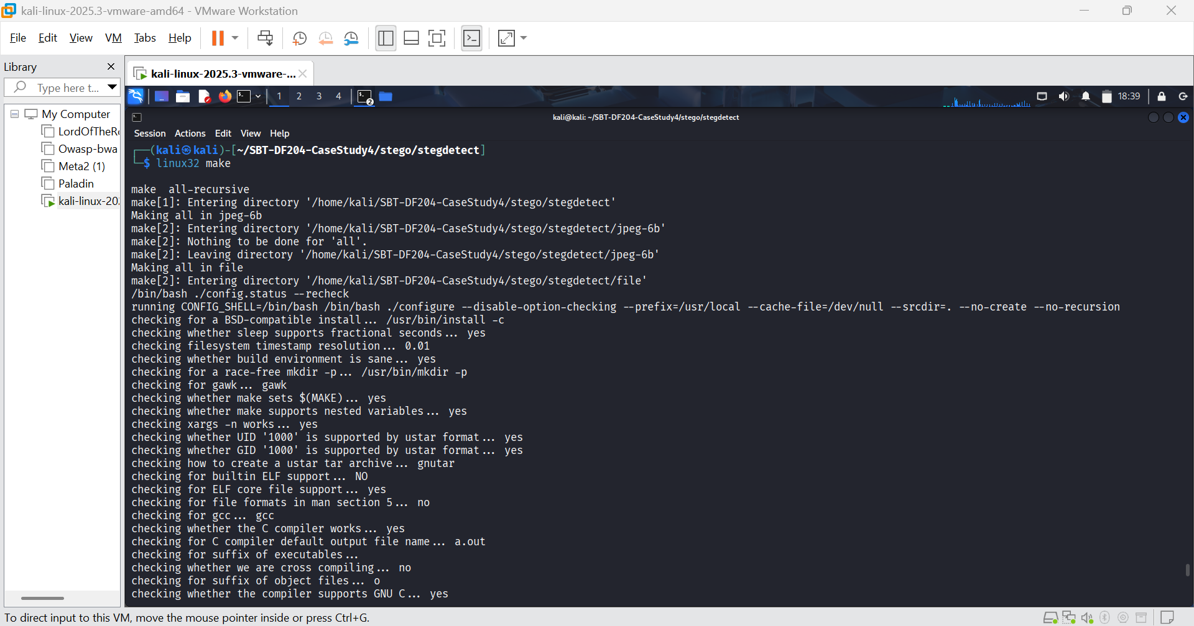FIGURE 10: Compiled source code to steg detect executable
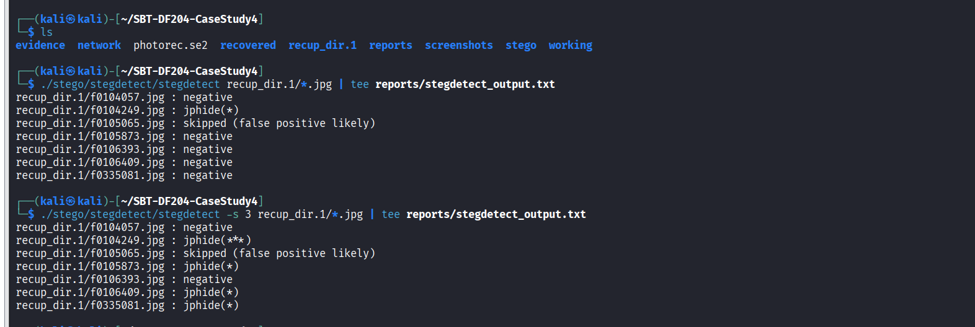FIGURE 11: The tool used to hide the photos is jphide
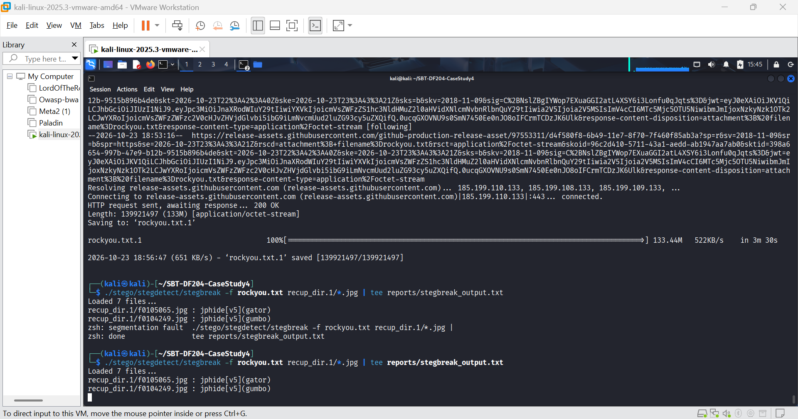FIGURE 12: Payloads cracked using steghide tool.

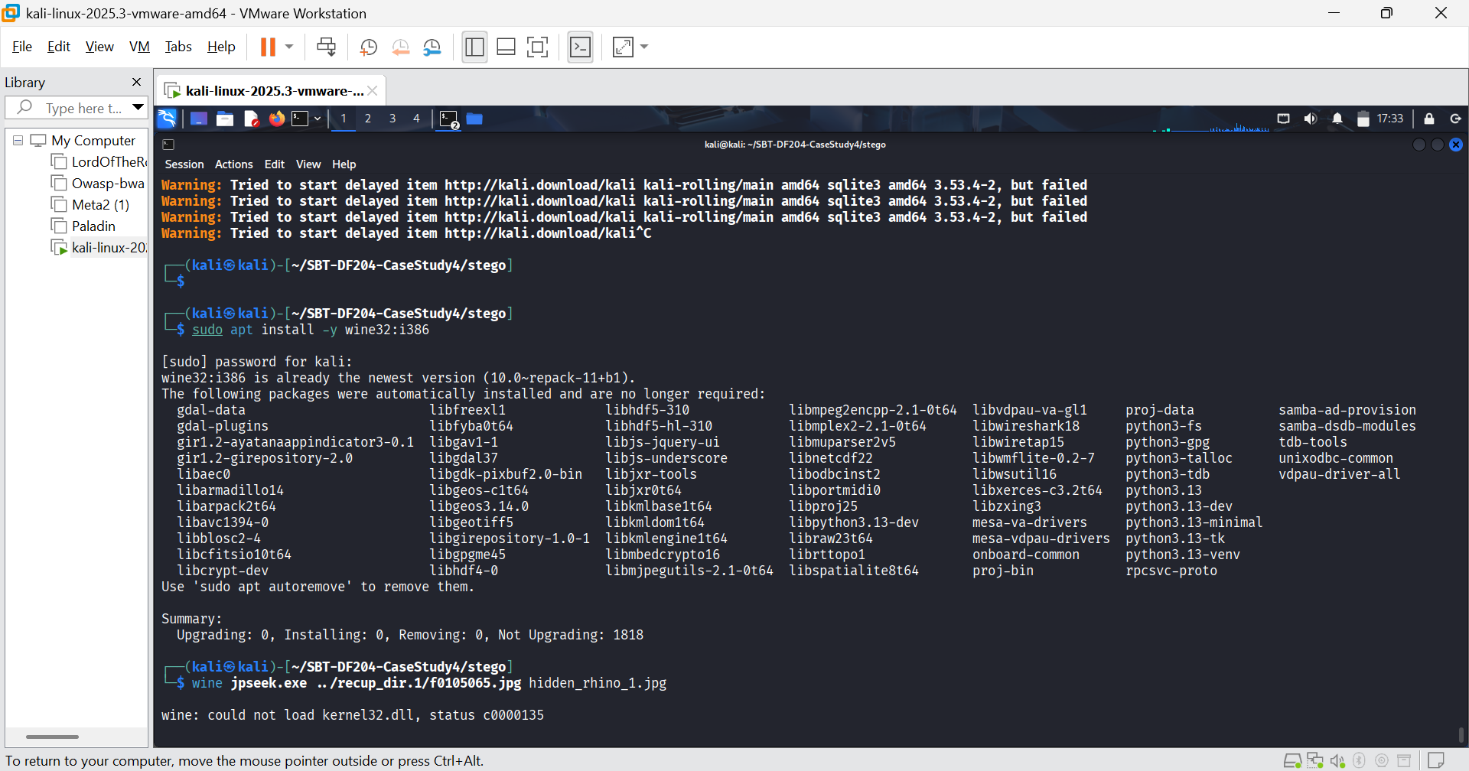FIGURE 13: Failed due to kernel32.dll loading errors and RPC service failures on the modern Kali Linux host.
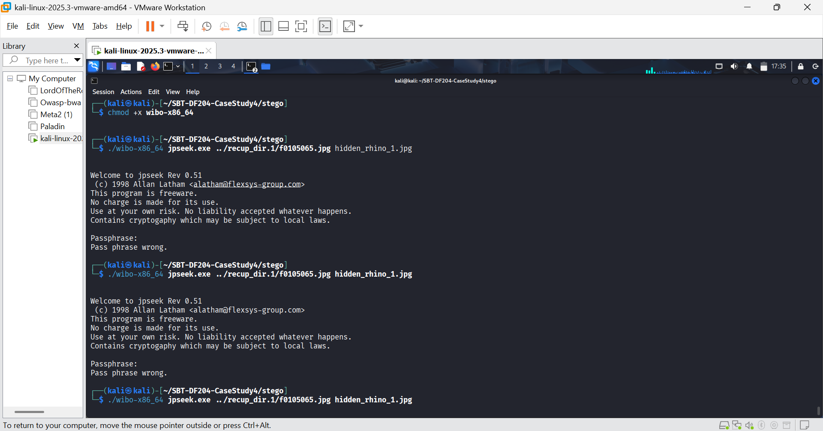FIGURE 14: Wibo successfully executed the binary and displayed the program header, but failed to pass the interactive Passphrase: prompt to the executable, resulting in a "Pass phrase wrong" error without accepting user input.
Inference and Limit (What it means):
The use of steganography tools confirms the presence of hidden data structures within the JPEGs. However, the extraction phase was limited by the legacy nature of the jpseek tool and compatibility issues with modern 64-bit Linux environments. The candidate passwords (gator, gumbo) could not be cryptographically verified by jpseek. Despite the extraction failure, the presence of JPHide signatures in these files is a direct observation that supports the suspect's diary entry: "I 'hid' the photos."

FTP TRAFFIC
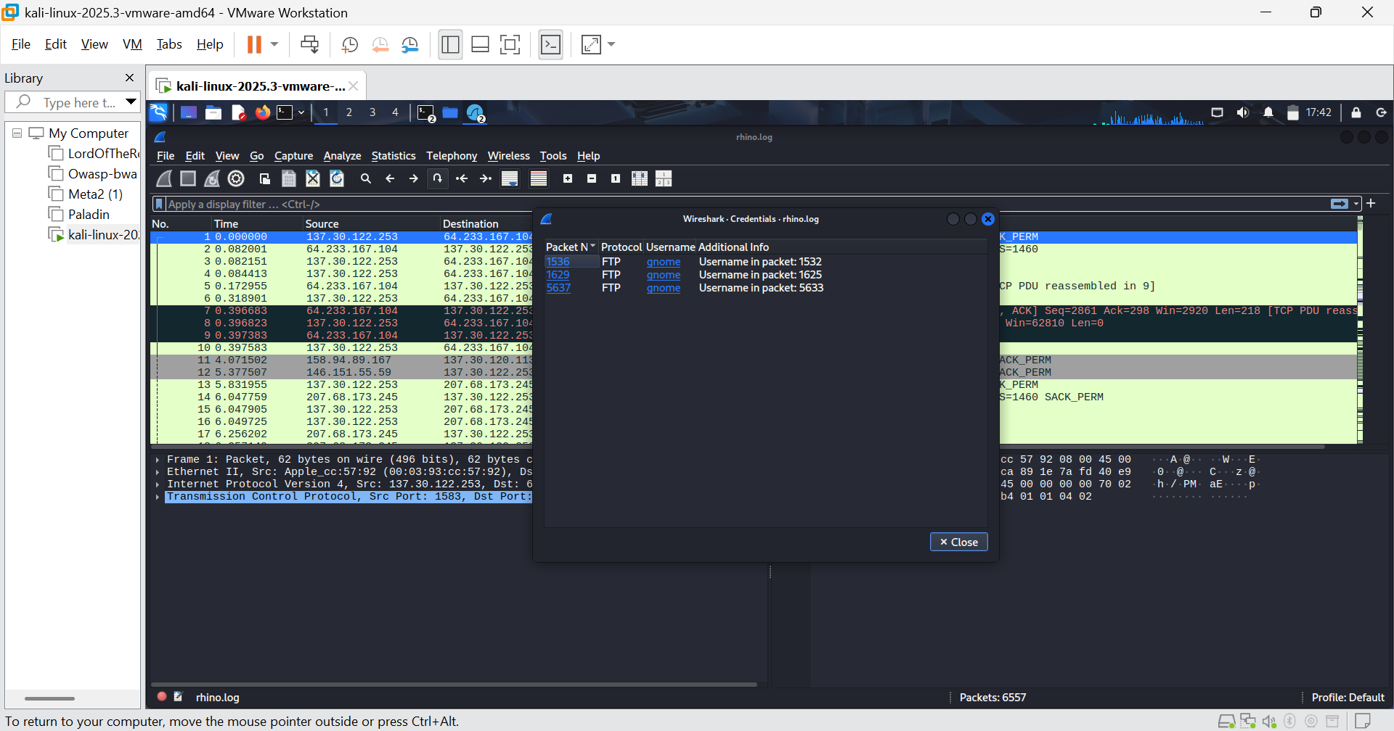FIGURE 15: I launched wireshark and navigated to the credentials.
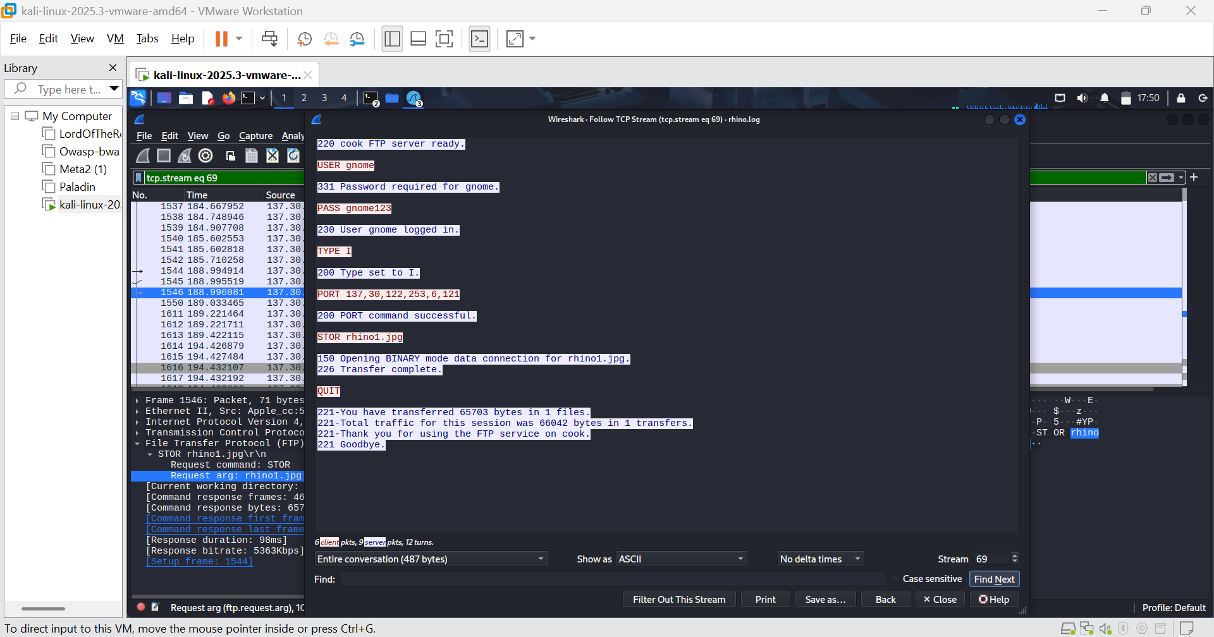FIGURE 16: rhino1.jpg traffic. Username “gnome”, password “gnome123”
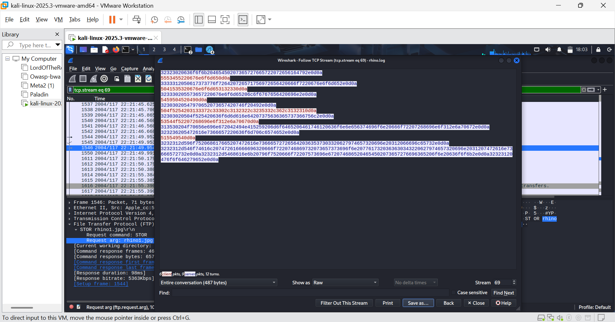FIGURE 17: Changed from ASCII to raw and saved it
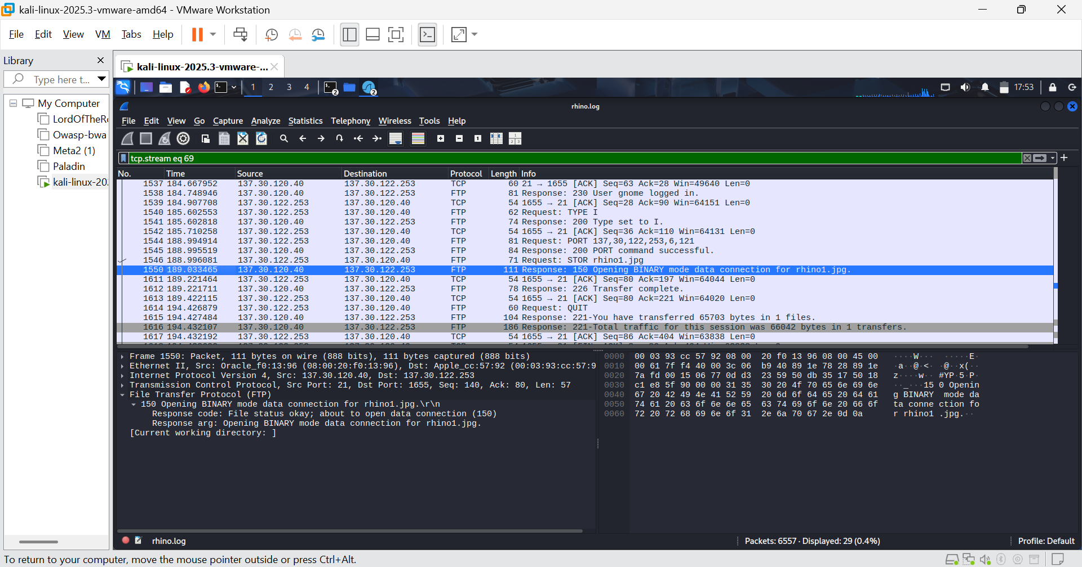FIGURE 18: Server waiting for suspect’s PC o send photo.

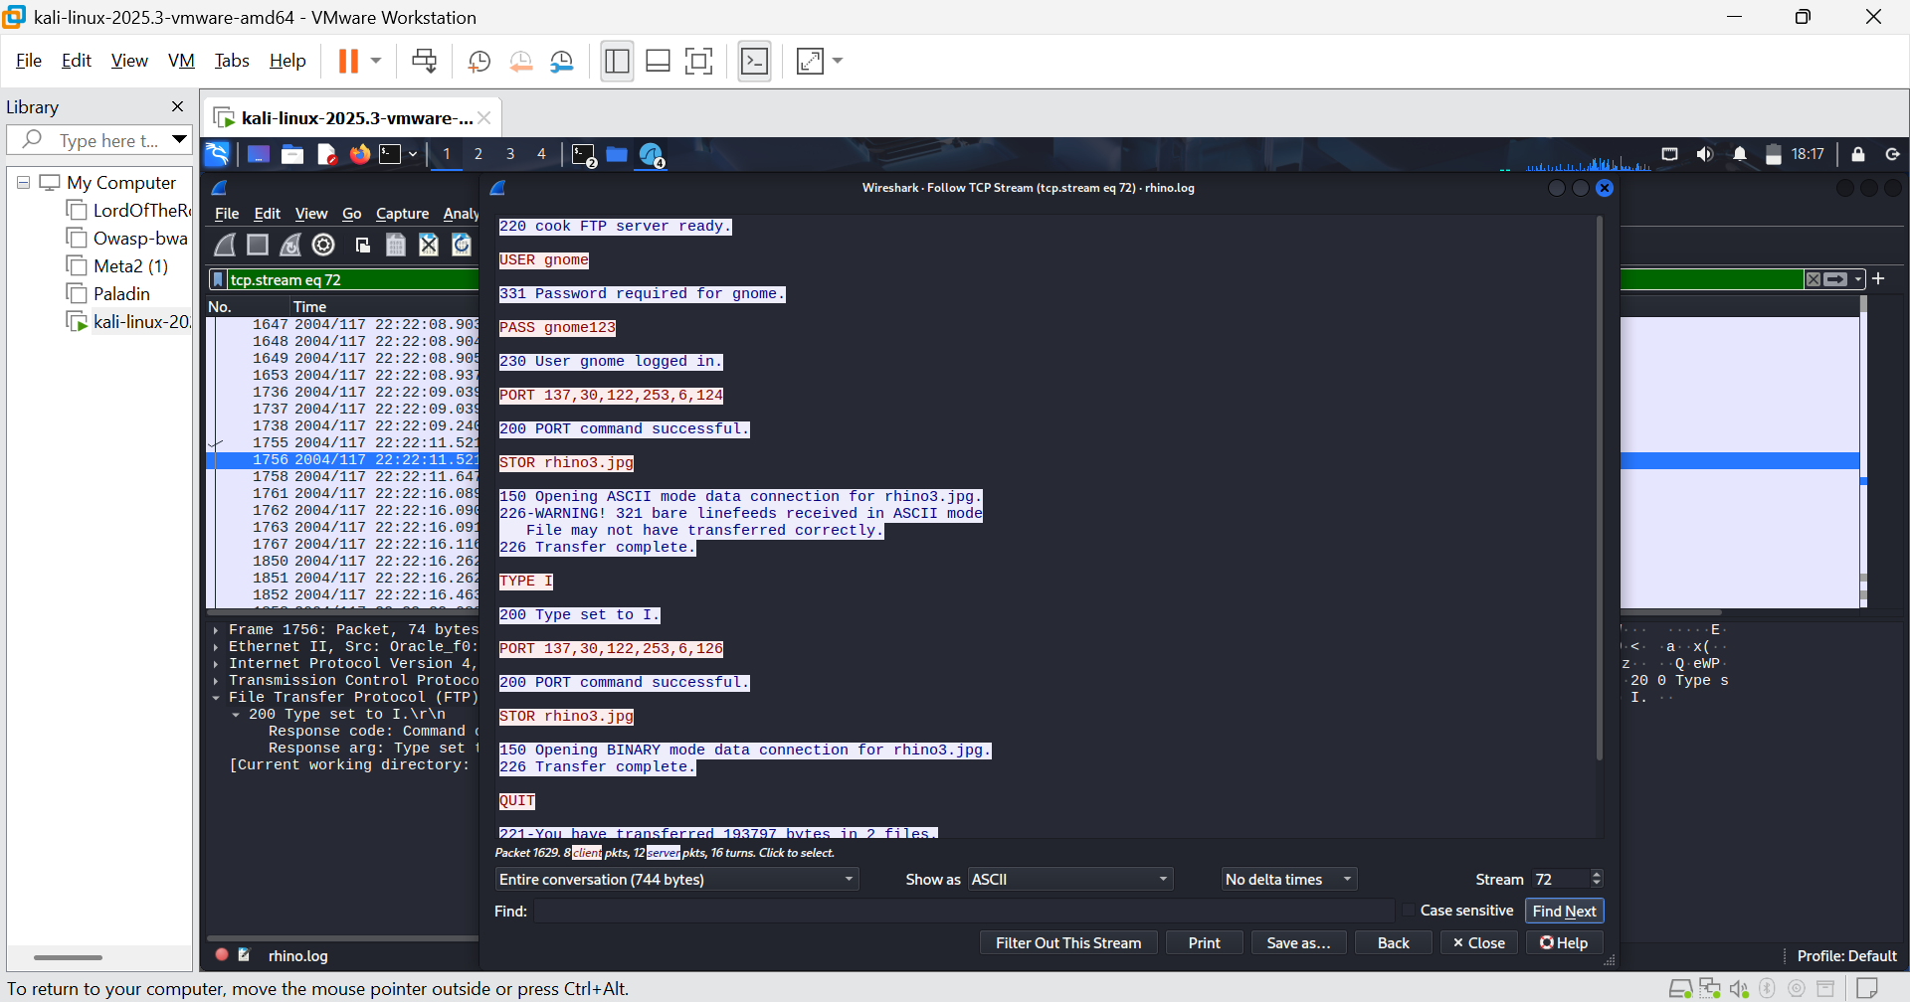FIGURE 19: rhino3.jpg packet.
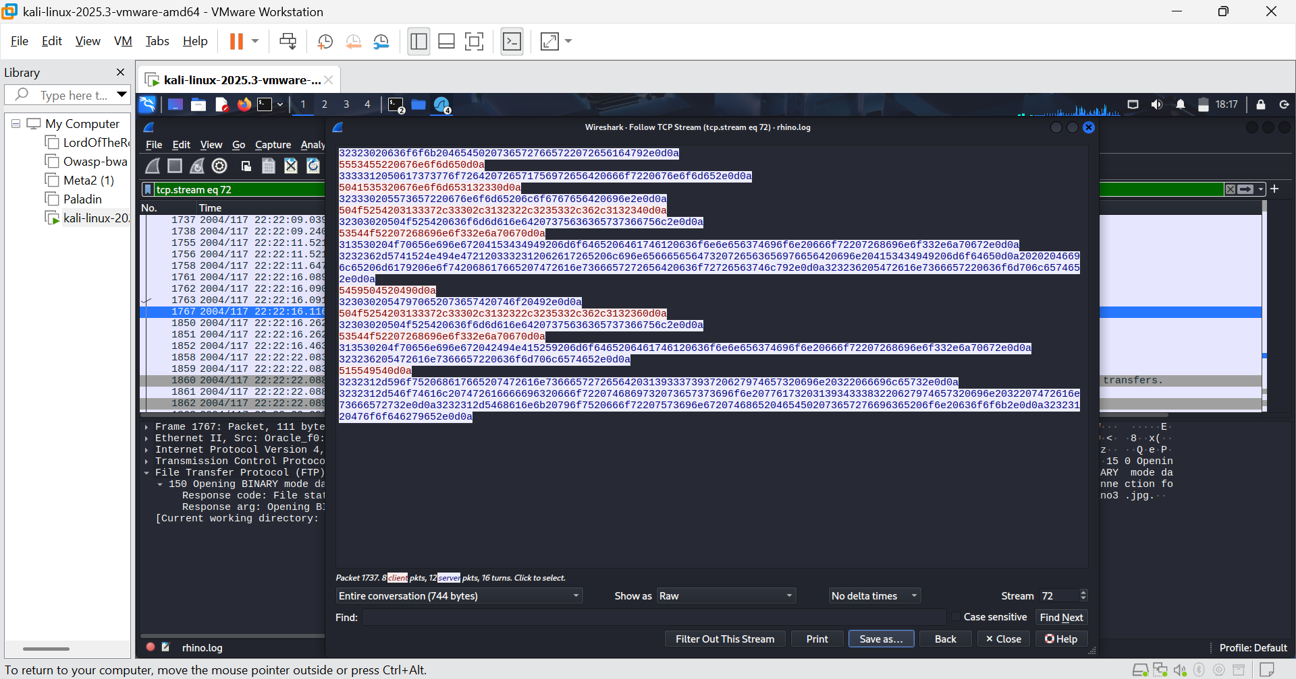FIGURE 20: Change to raw and saved.

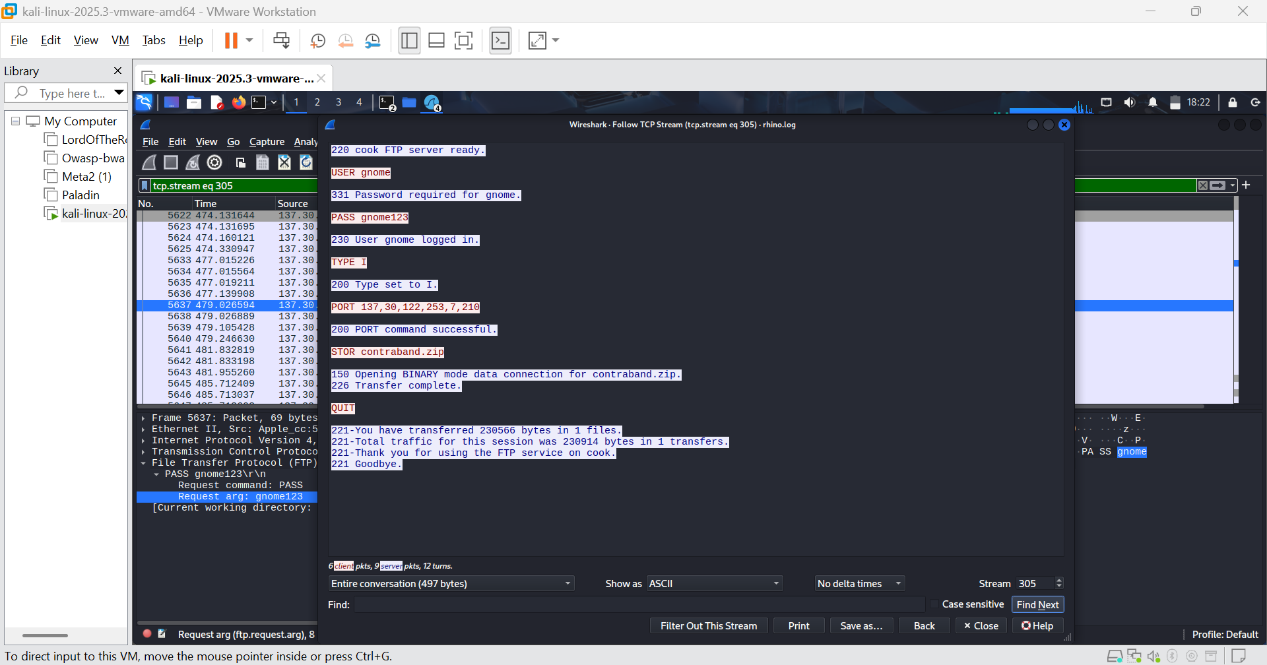FIGURE 21: The third ftp session
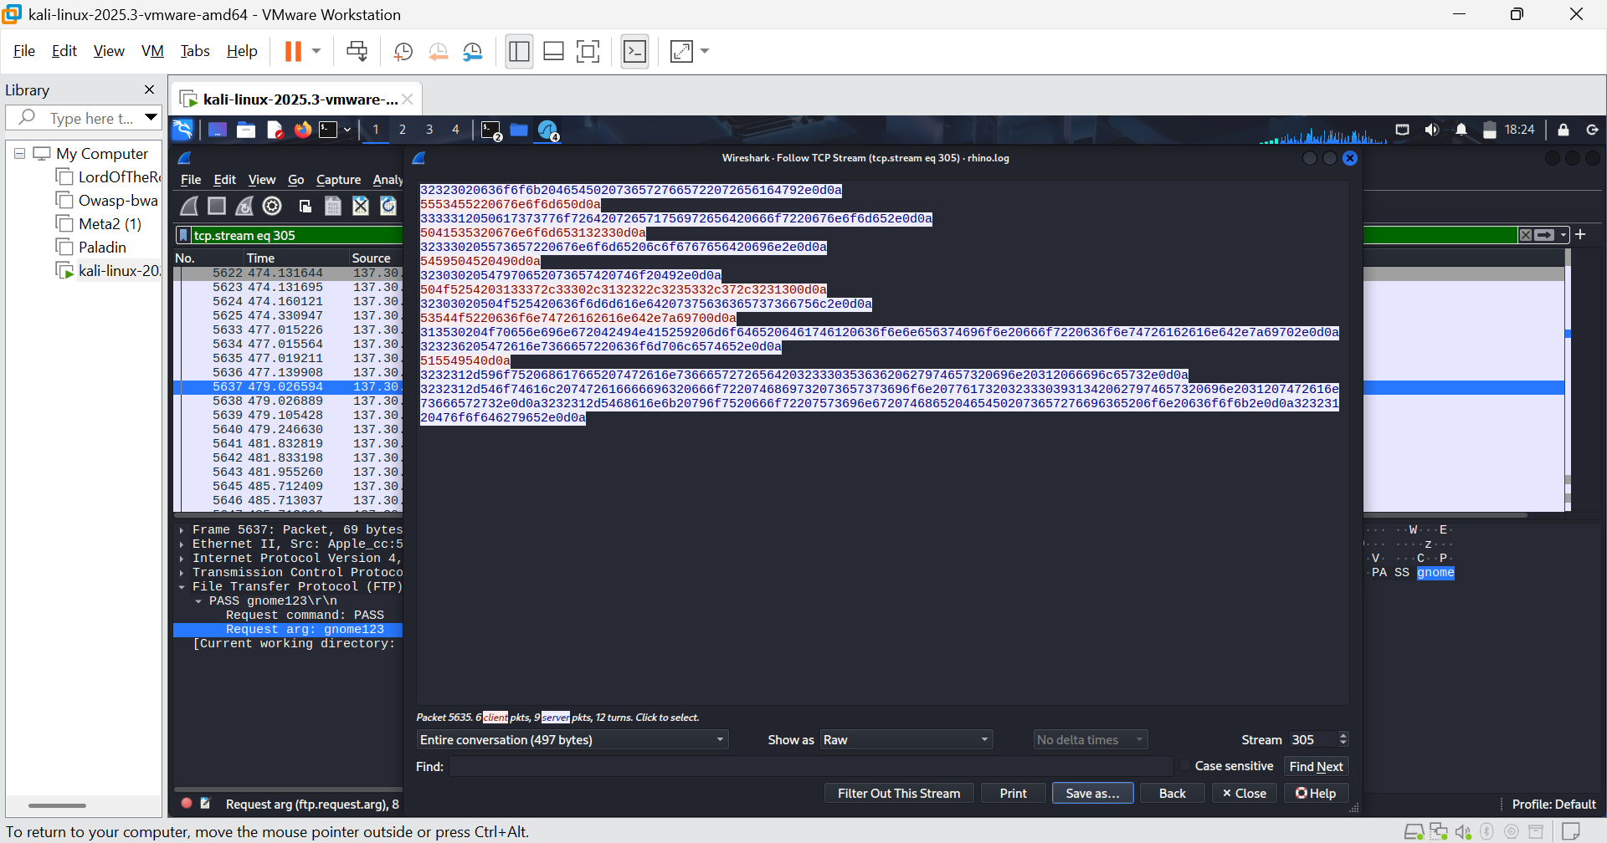FIGURE 22: Also changed to raw and saved
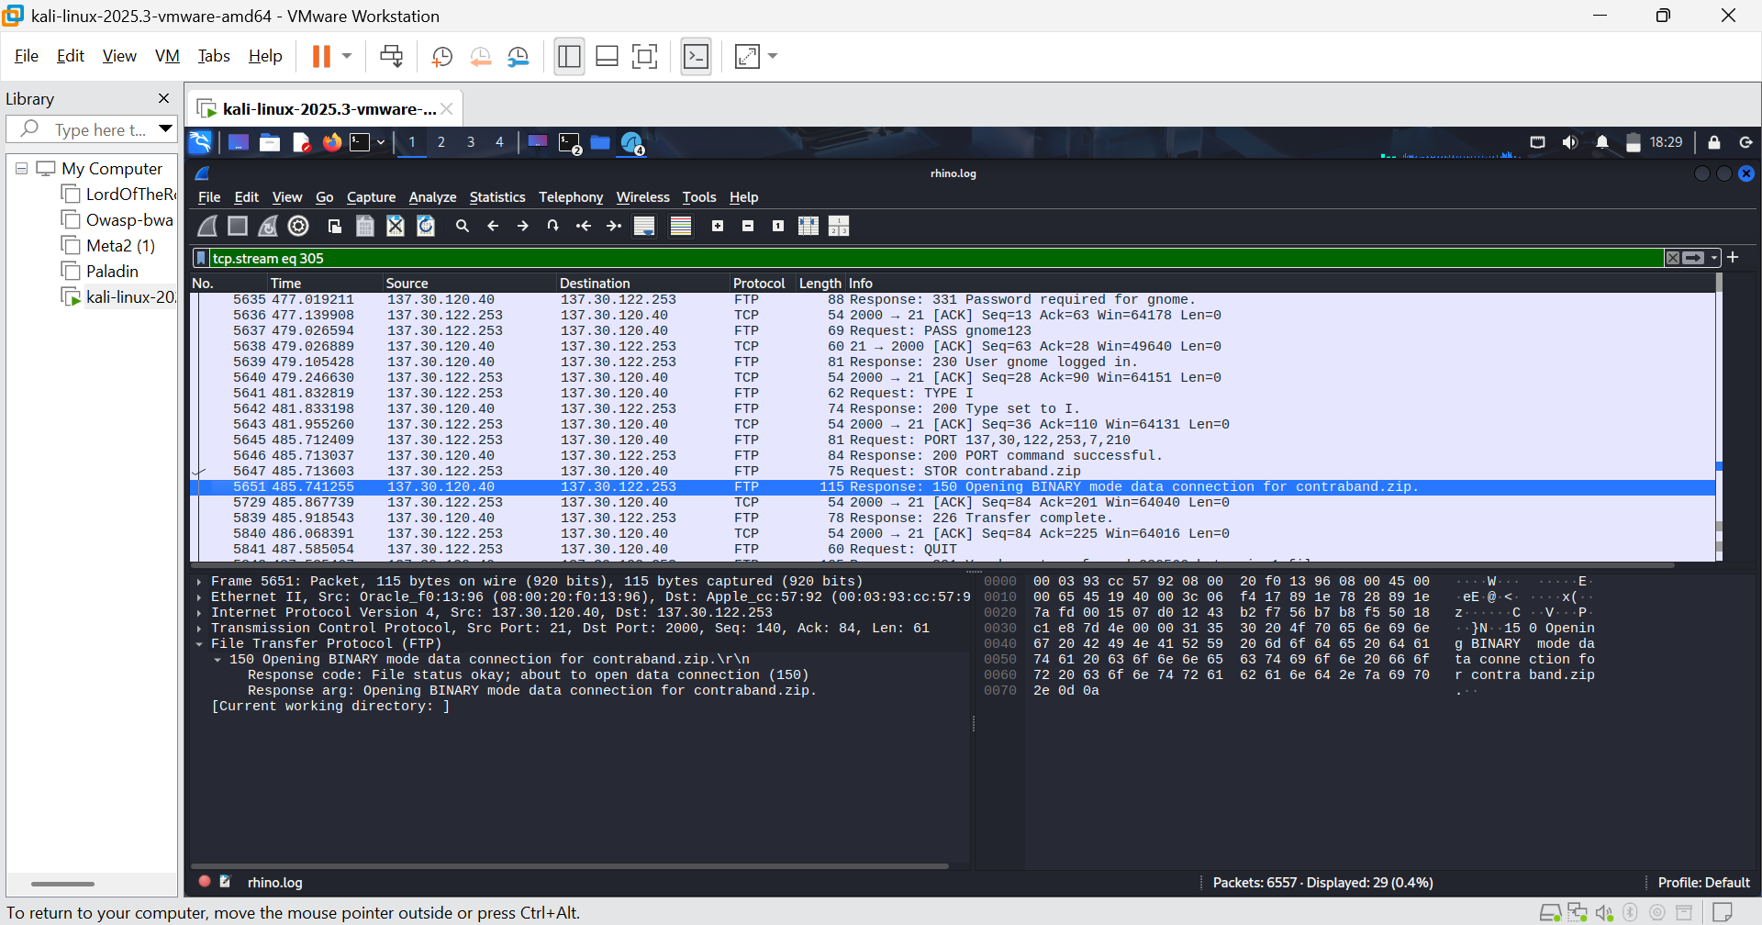FIGURE 23: Packet 5651 shows server ready to upload
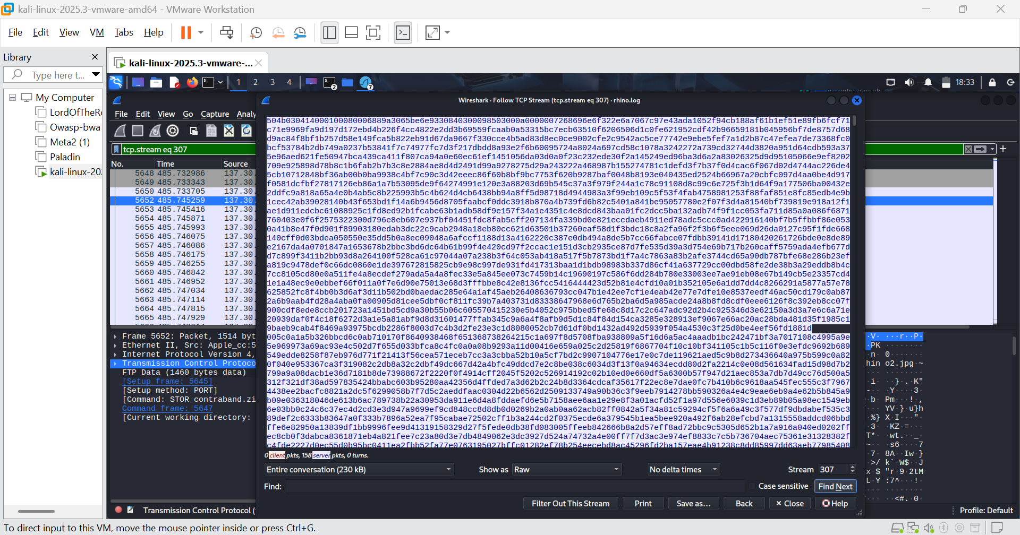FIGURE 24: packet 5652 with the .zip magic number
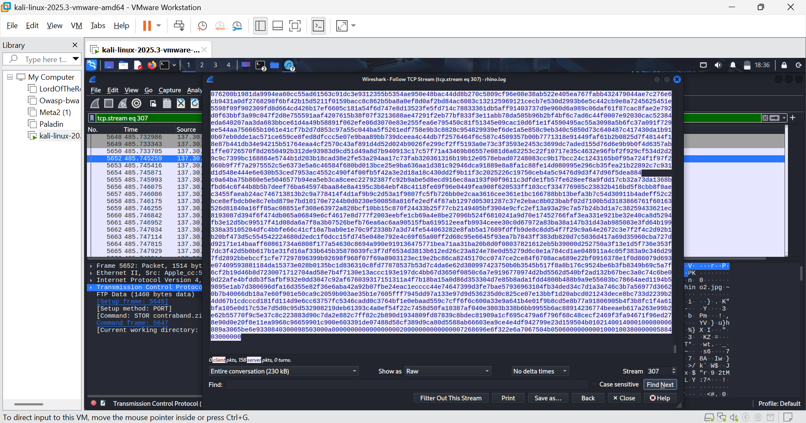FIGURE 25: .zip trailer.
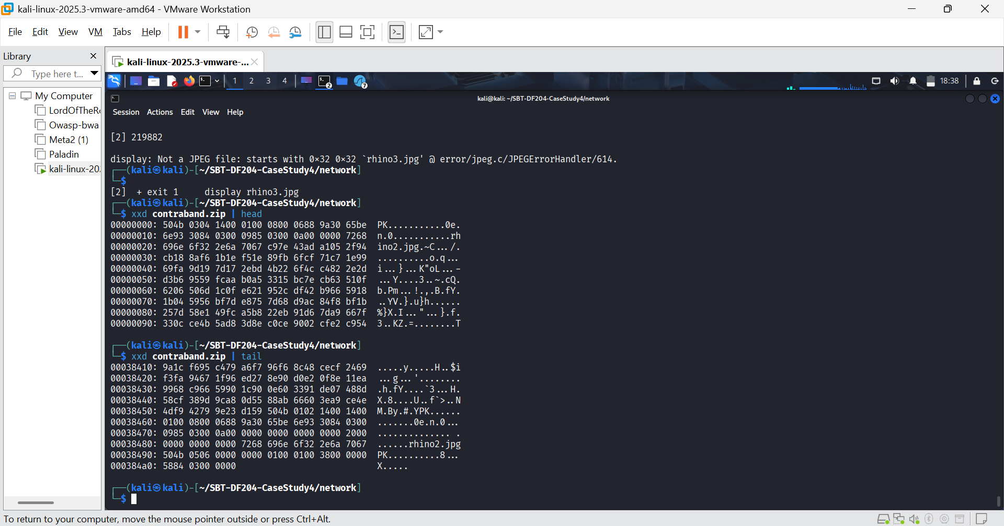FIGURE 26: Magic number of the zip file.
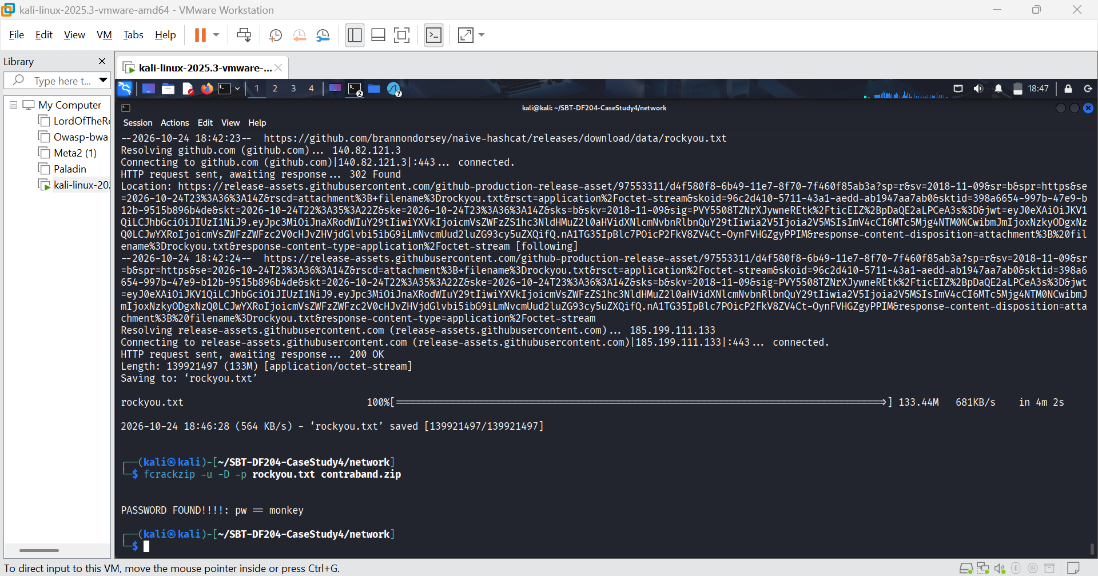FIGURE 27: Password cracked
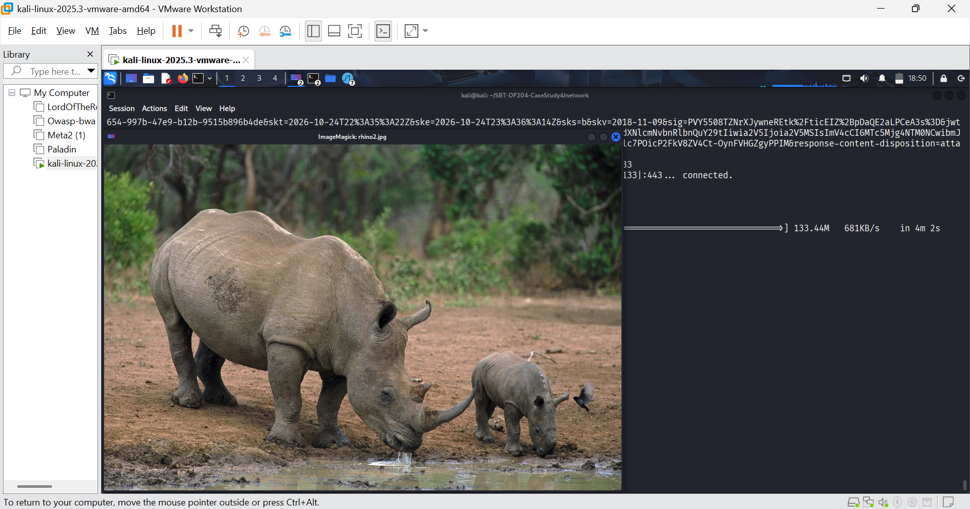FIGURE 28: rhino2.jpg
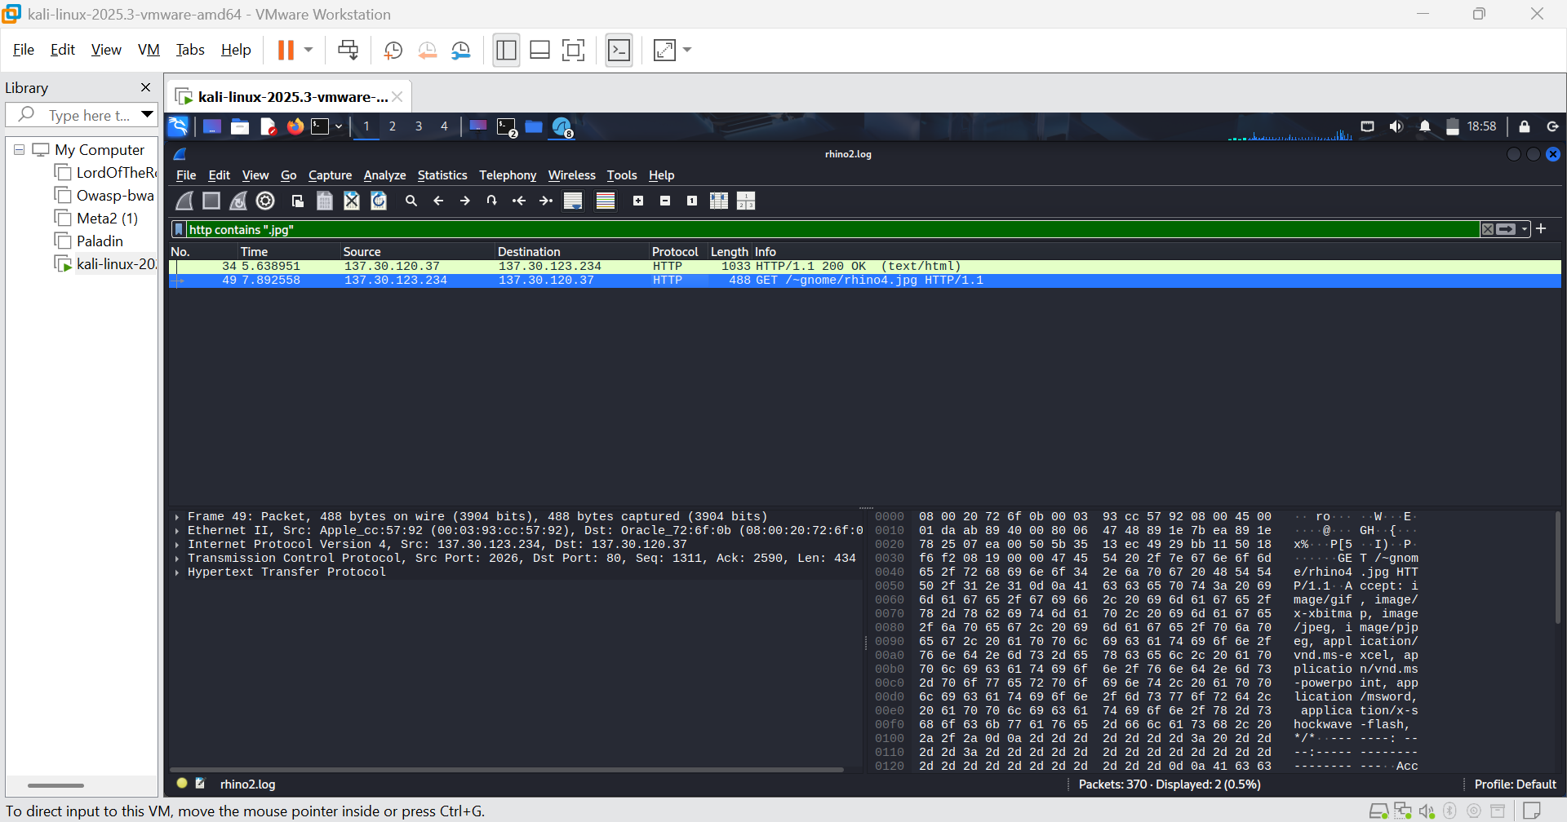FIGURE 29: Suspect’s http request to download .jpg
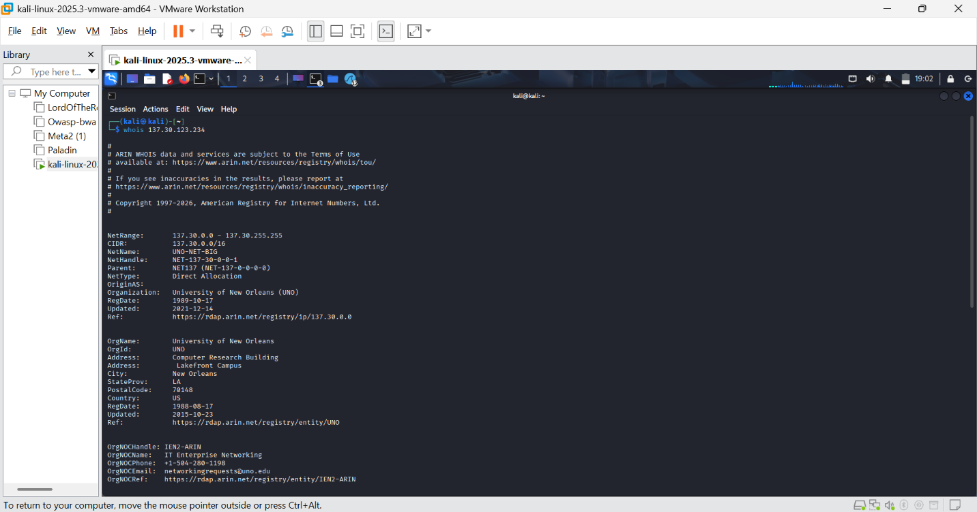 FIGURE 30: The IP owner
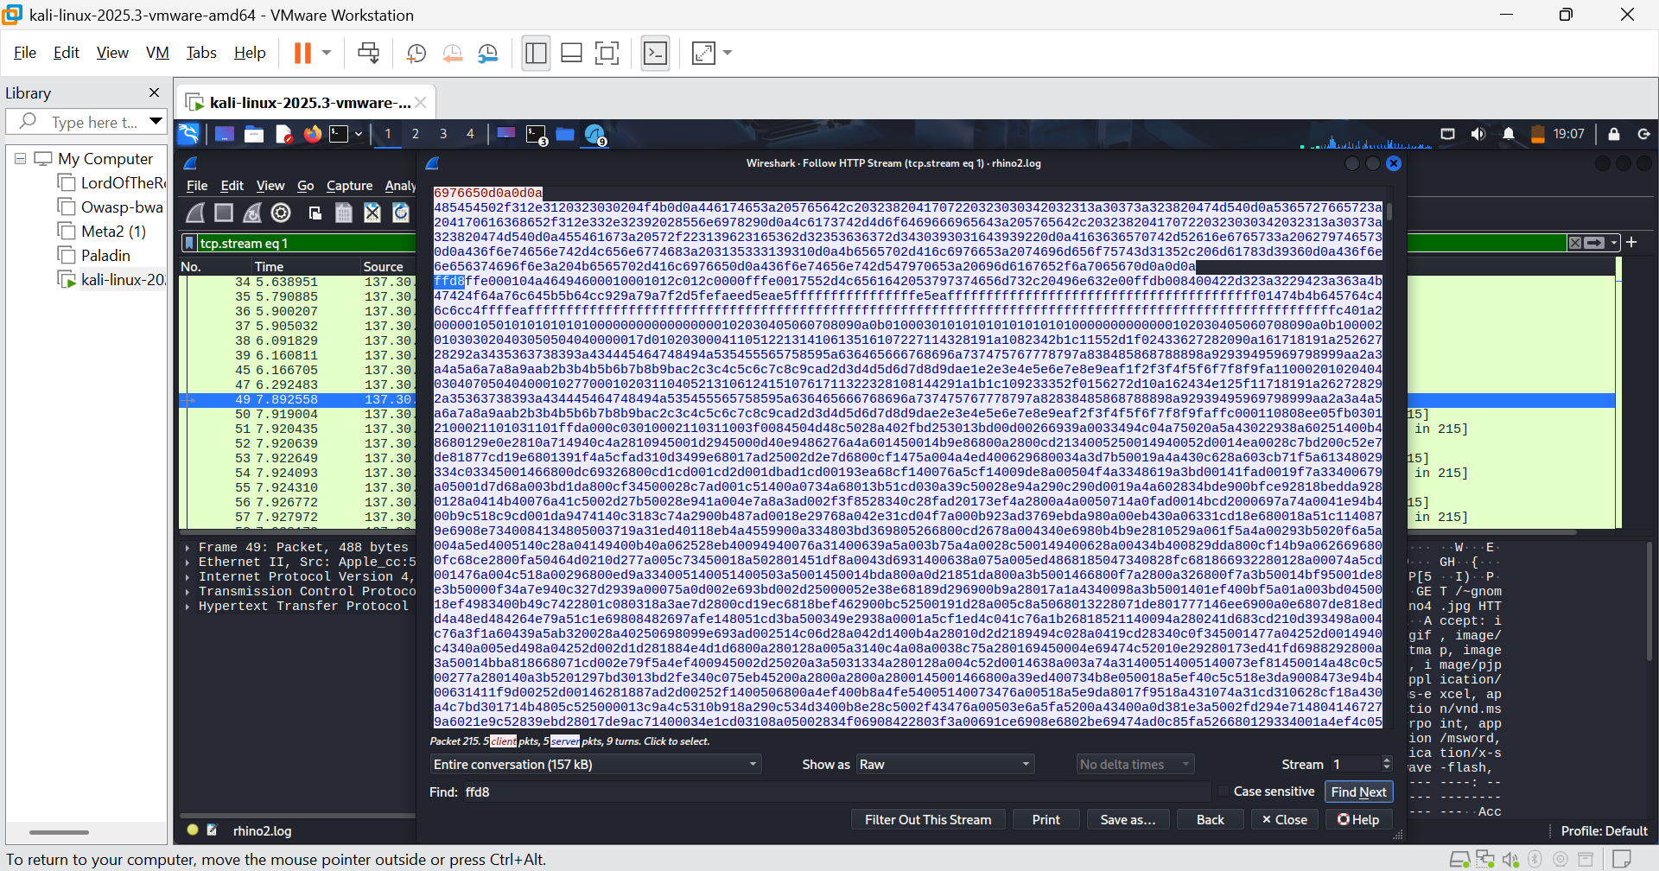FIGURE 31: rhino4.jpg magic number
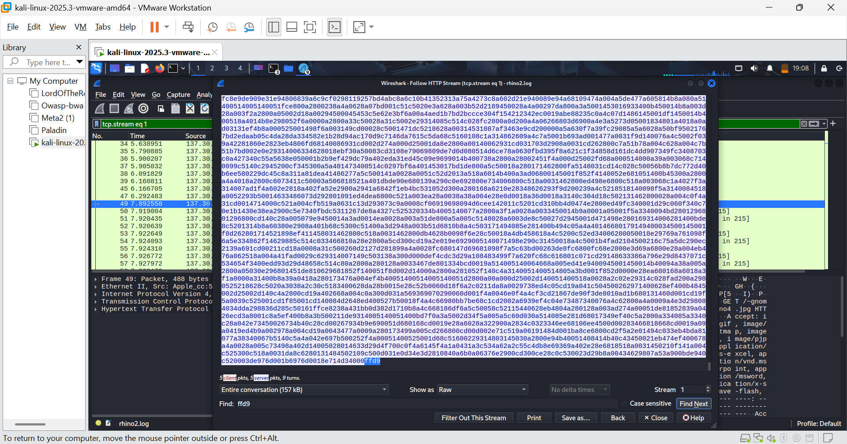FIGURE 32: End of rhino4.jpg
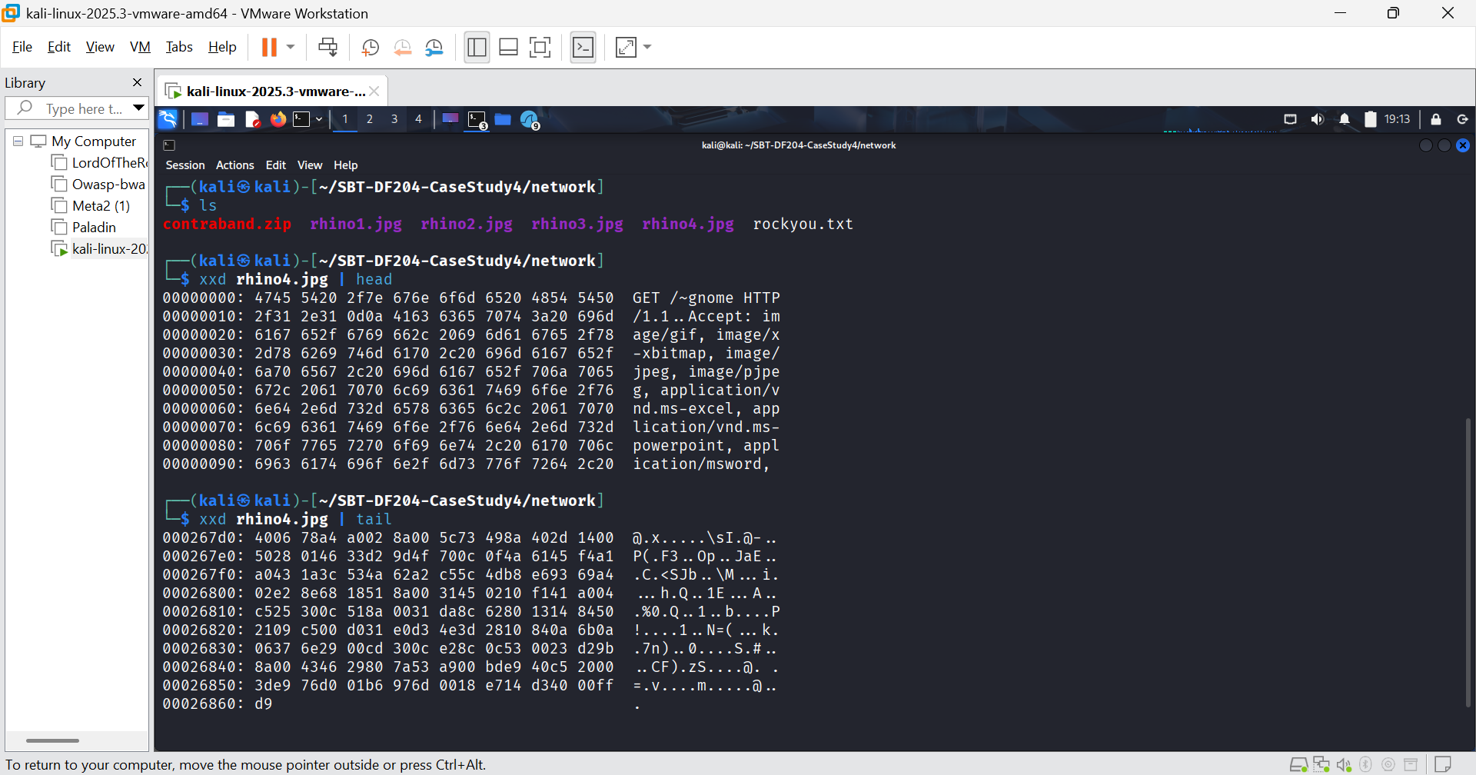FIGURE 33: Verification of rhino4 magic number.
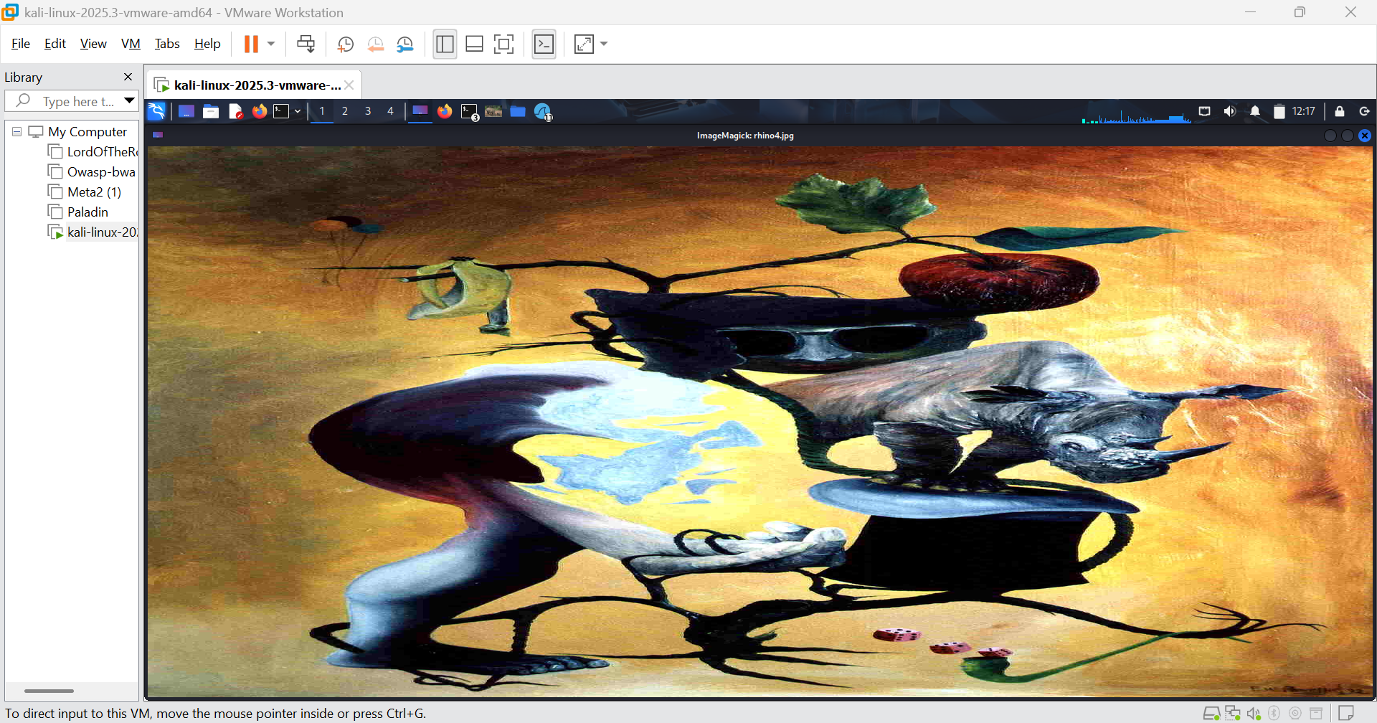FIGURE 34: rhino4.jpg
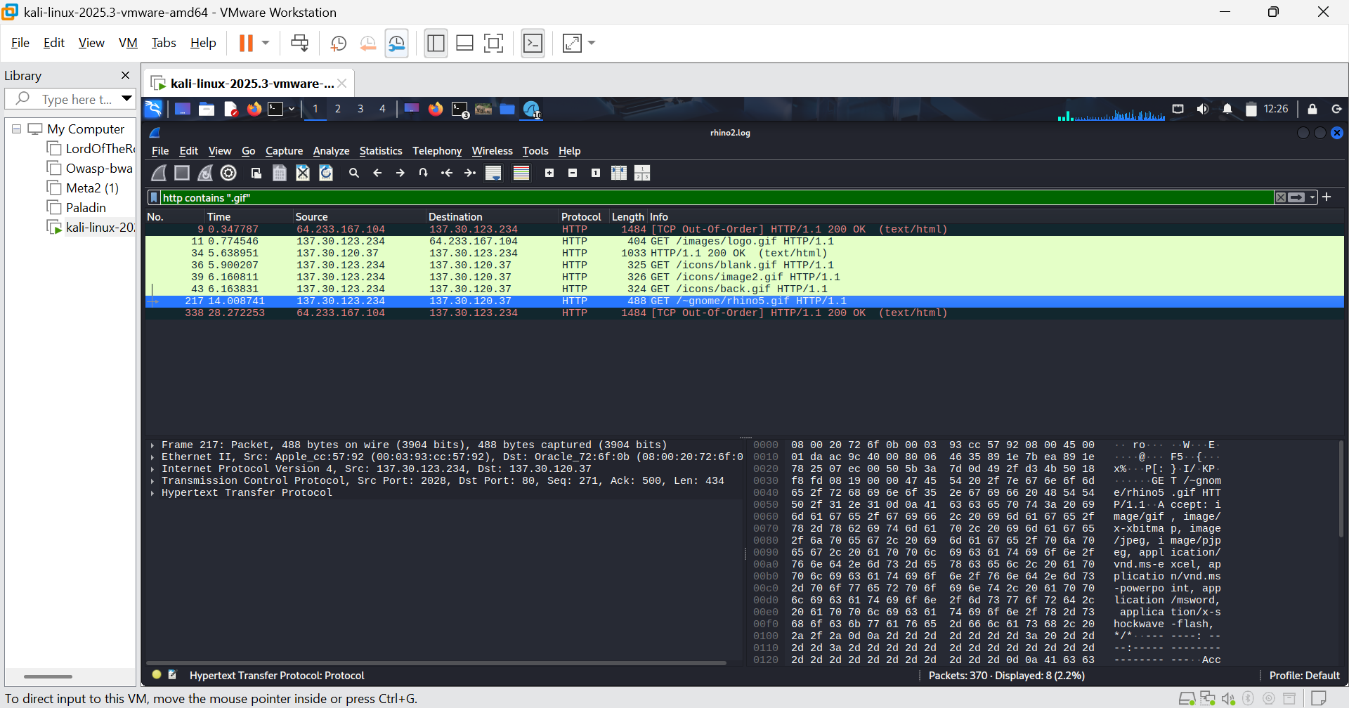FIGURE 35: Someone requested to download rhino5 image
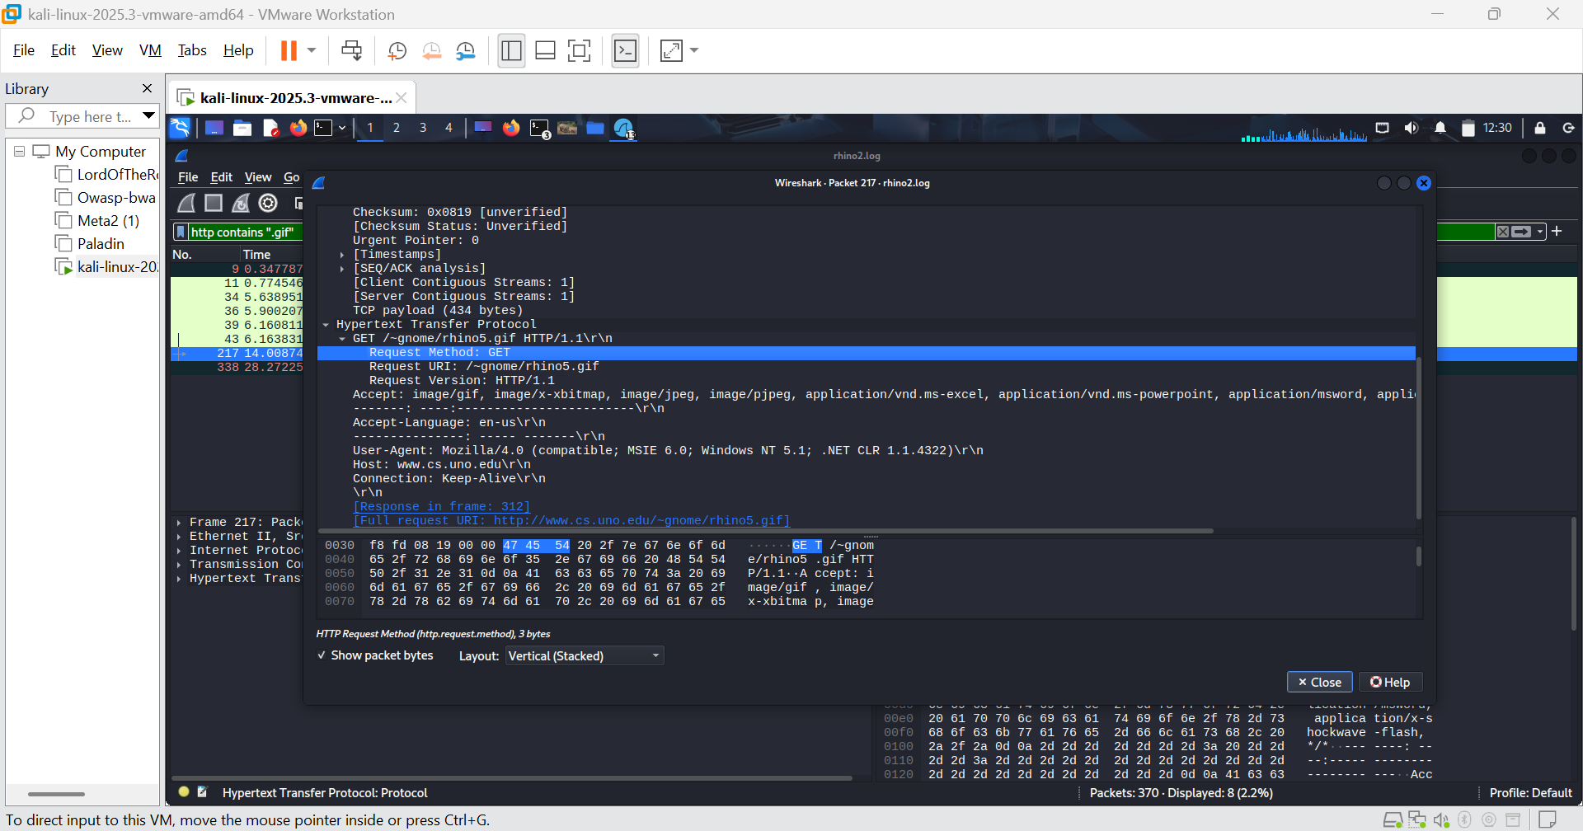FIGURE 36: rhino5 hosted by cs.uno.edu
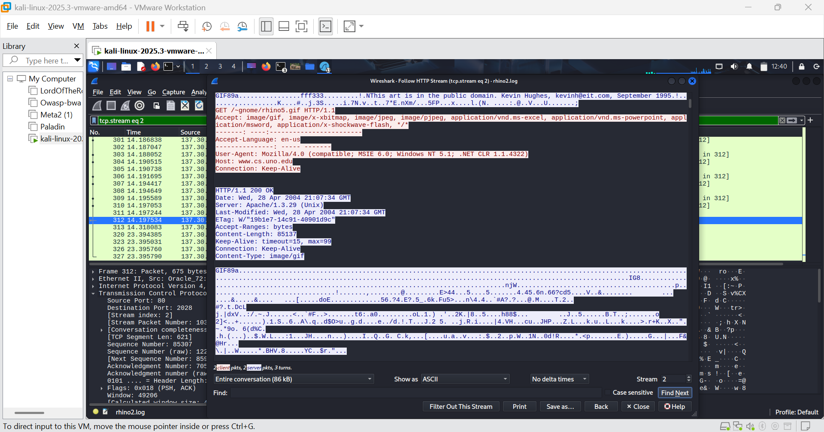FIGURE 37: Request, response and magic number of rhino5 packets
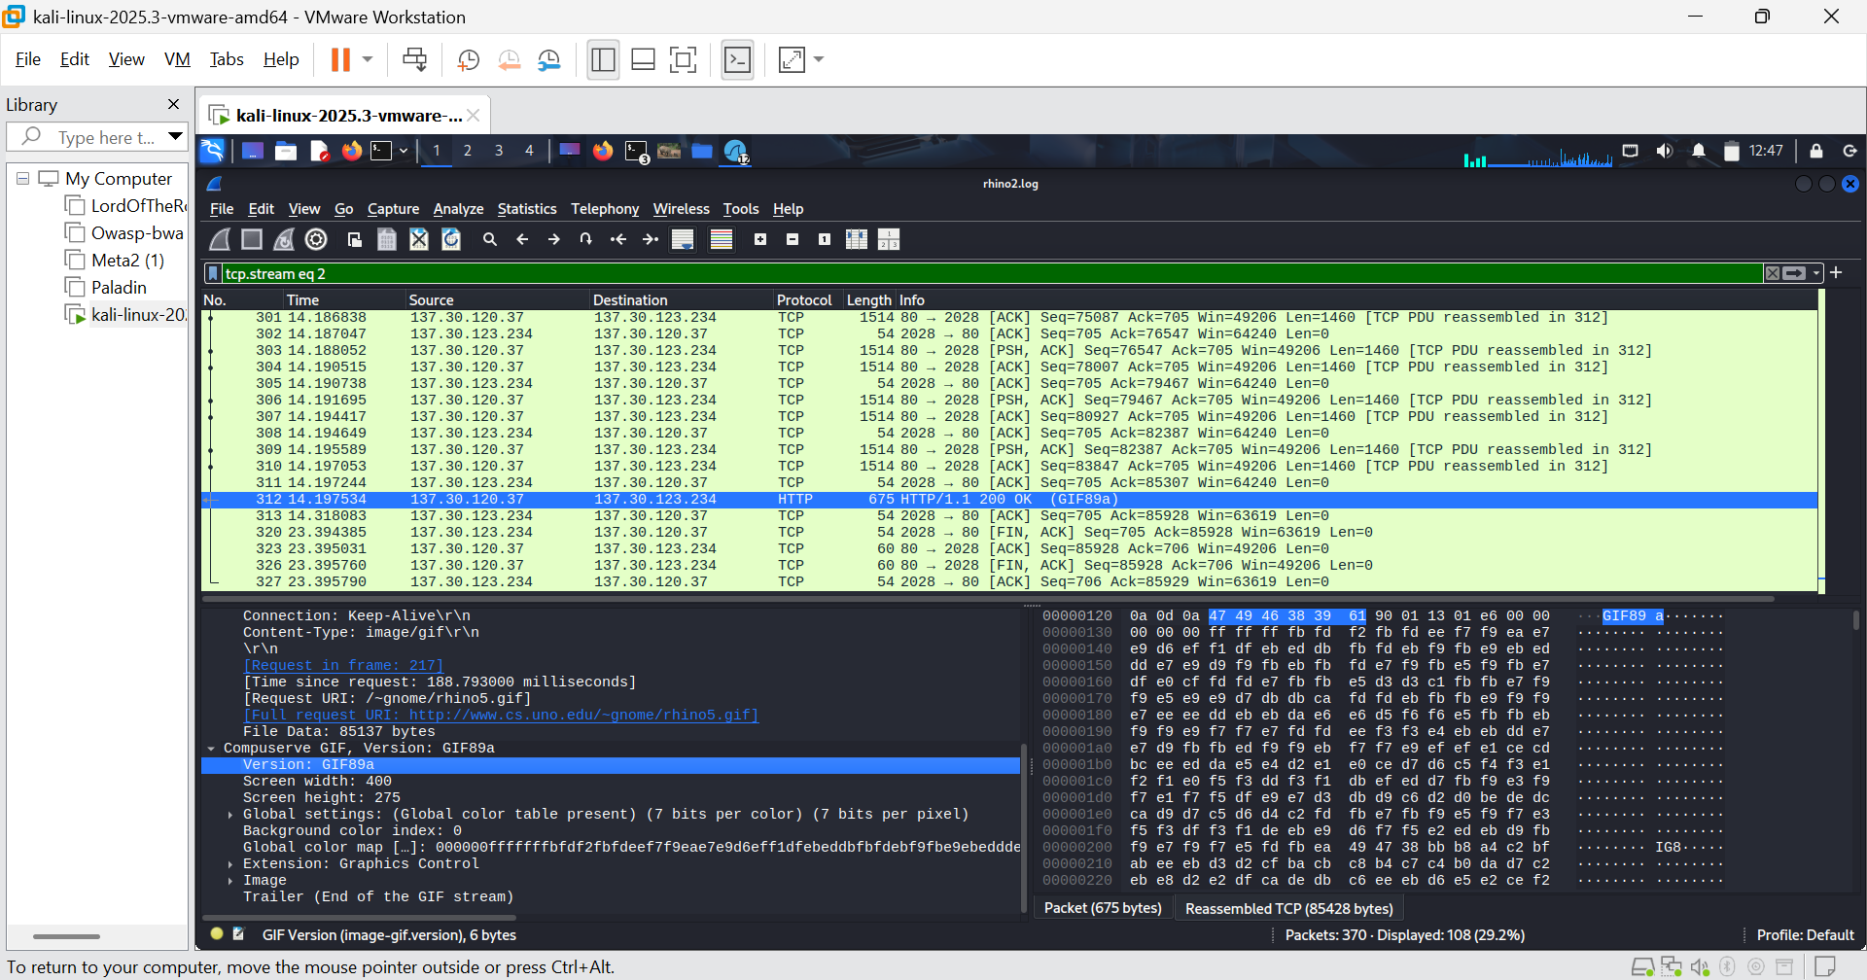FIGURE 38: The rhino5 image
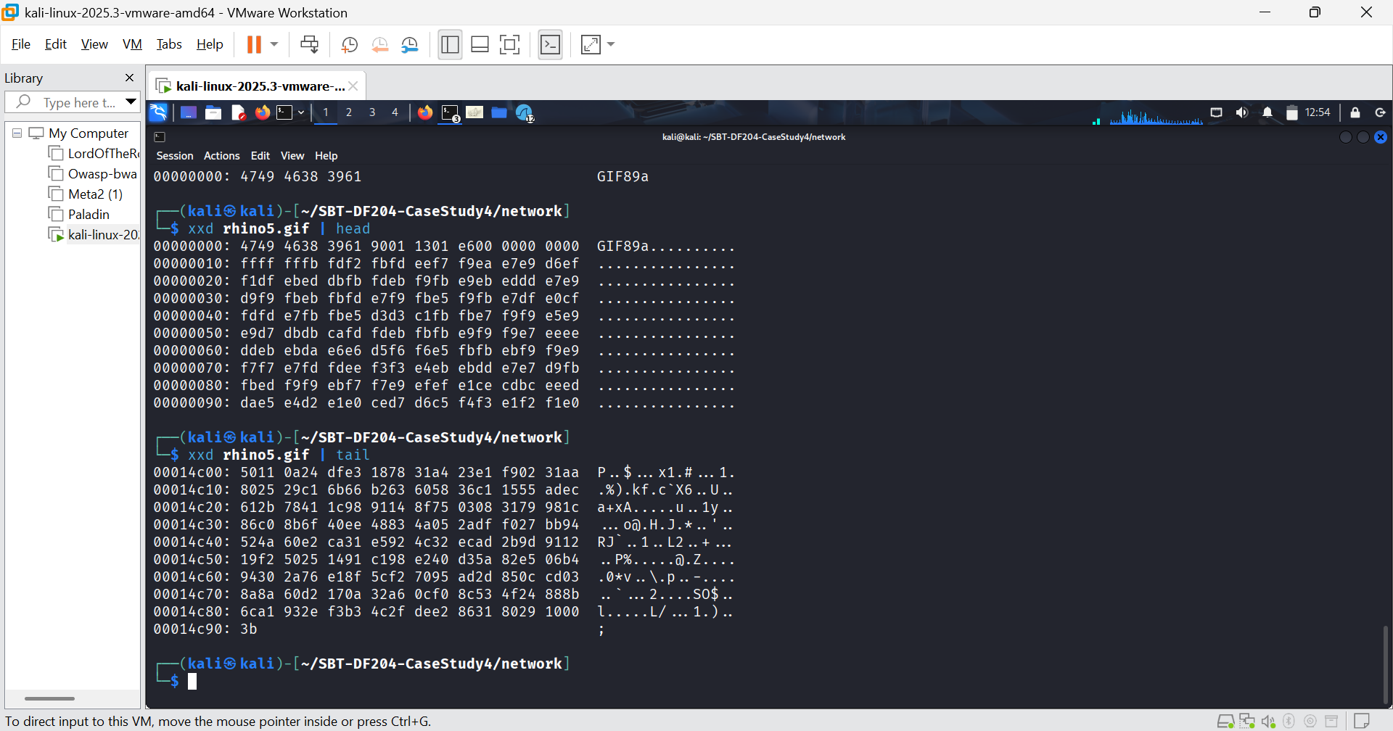FIGURE 39: rhino5 magic number
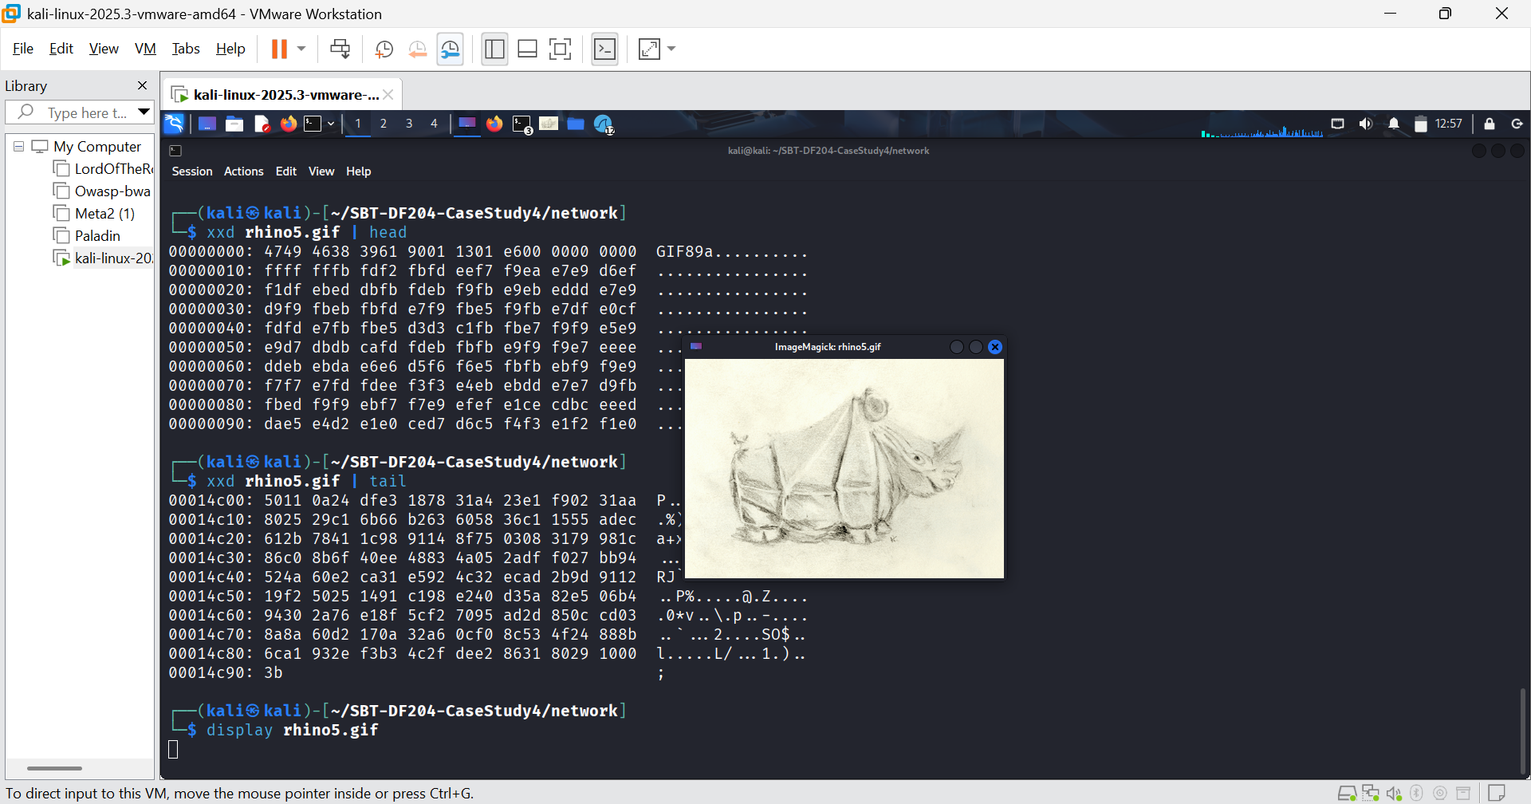FIGURE 40: rhino5 image.
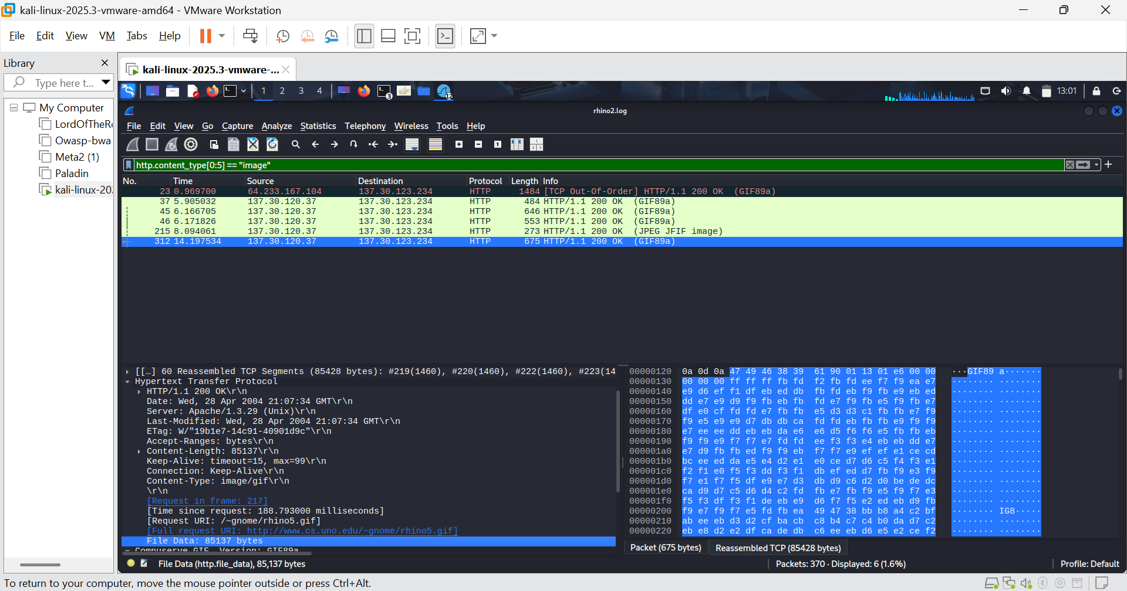FIGURE 41: Packets containing images
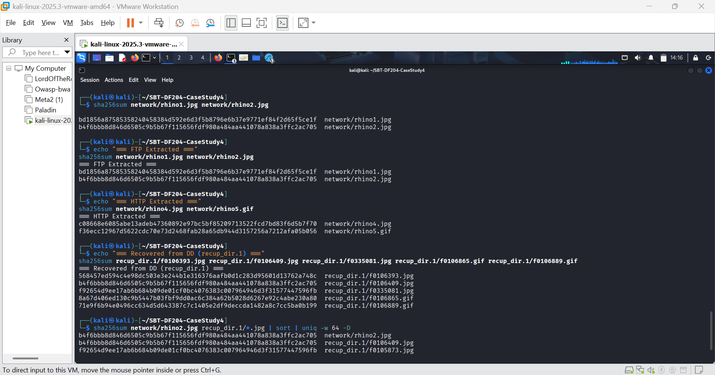FIGURE 42: Hashes verification
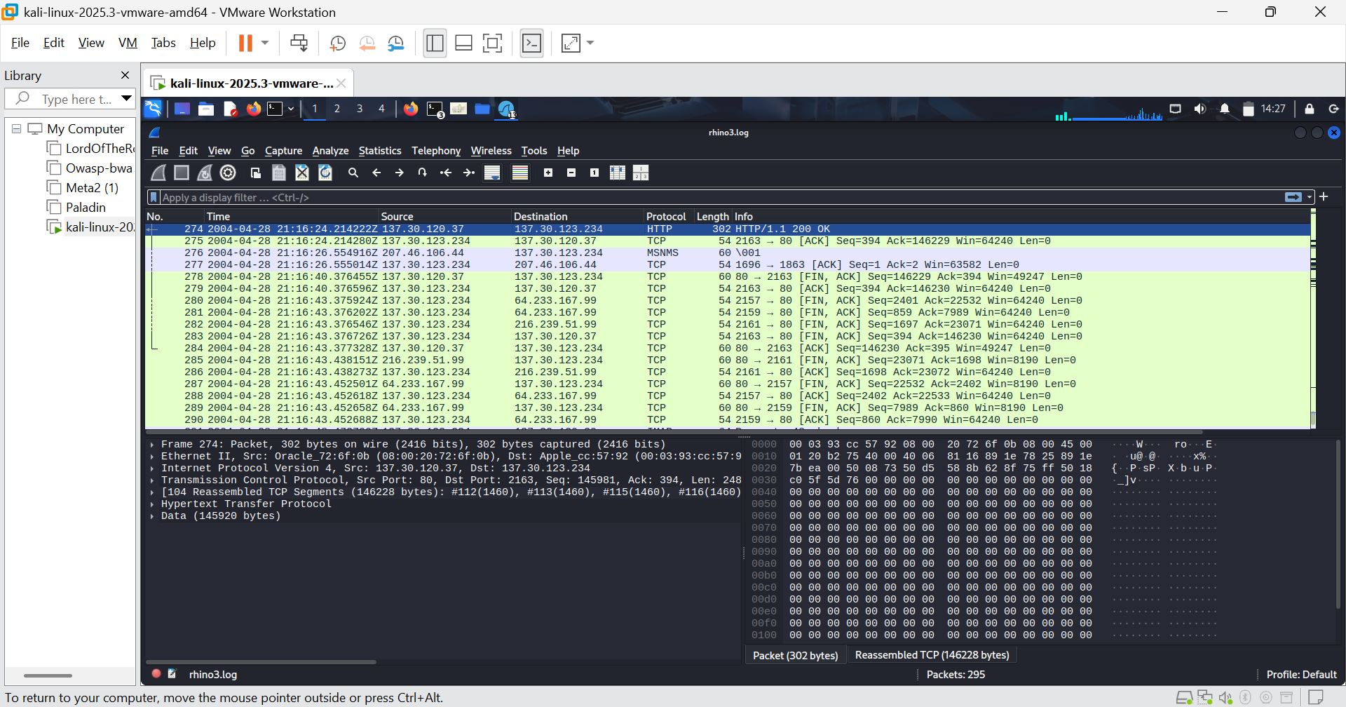FIGURE 43: rhino3.log (Pkt 274)
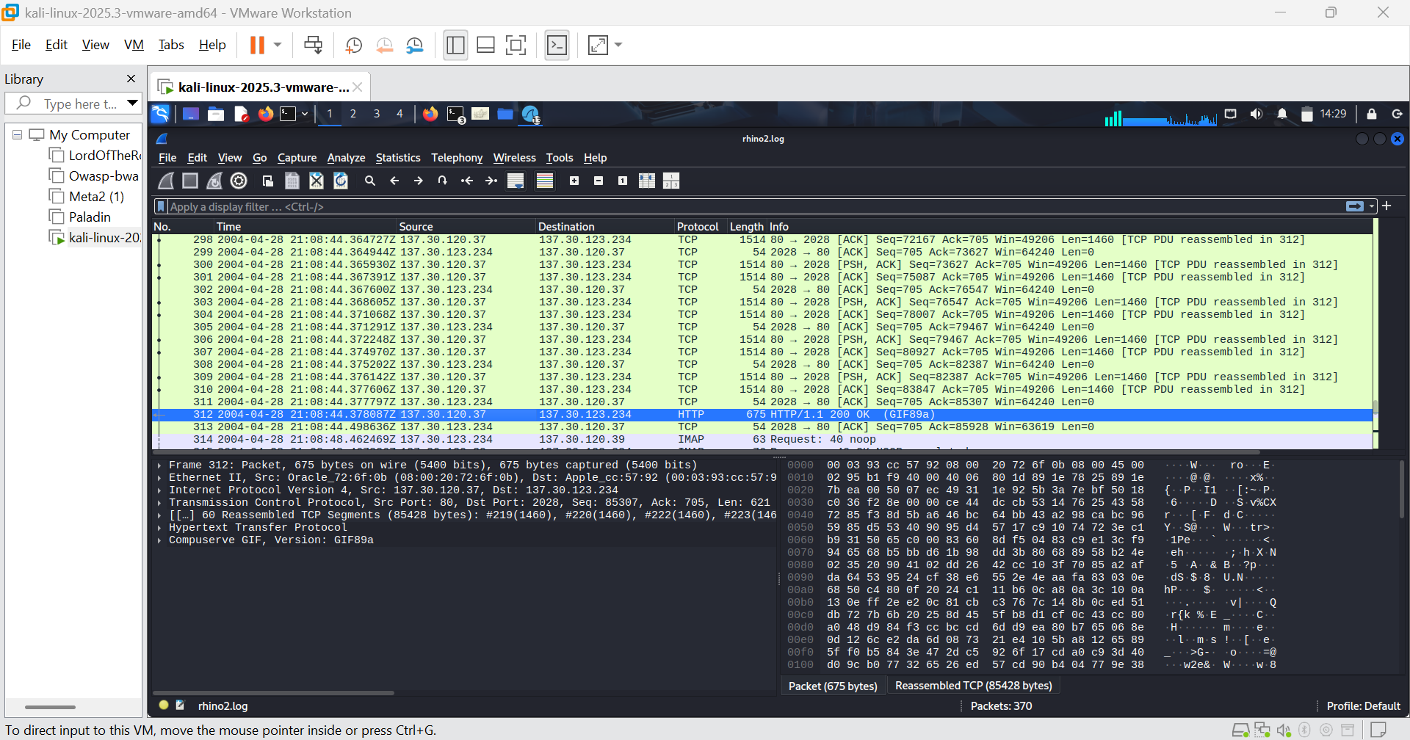FIGURE 44: rhino2.log (Pkt 312)

Evidence log
Evidence ID | Tool and method | Source record, stream, or path | Observed fact | Screenshot or appendix reference
E01 | sha256sum, chmod | RHINOUSB.dd, rhino*.log | Originals hashed, permissions set to -r--r--r--. Working copy hash matches original. | Figure 2
E02 | mmls, fsstat, fls | RHINOUSB_My_COPY.dd | mmls empty. fsstat shows FAT16. fls shows $OrphanFiles. | Figure 4 and 5
E03 | icat, sha256sum | Inodes 8101620/21 | FAT0 and FAT1 extracted. Hashes matched exactly, no tampering. | Figure 6 and 7
E04 | photorec | RHINOUSB_My_COPY.dd | 132 files recovered. Valid JPEGs/GIFs verified via file and display. | Figure 8
E05 | stegdetect, stegbreak | recup_dir.1/*.jpg | Found jphide payloads. Passwords gator/gumbo cracked. | Figure 12
E06 | Wireshark (Follow TCP Stream) | rhino.log (Stream 69) | Extracted rhino1.jpg in Raw mode. Valid JPEG (ffd8/ffd9). | Figure 16,17 and 18
E07 | Wireshark, fcrackzip, unzip | rhino.log (Stream 307) | Extracted contraband.zip. Cracked password monkey. Extracted rhino2.jpg. | Figure 26 -27
E08 | Wireshark (Export Packet Bytes) | rhino2.log (Pkt 49/312) | Extracted rhino4.jpg and rhino5.gif in Raw mode. Validated magic numbers. | Figure 29 - 40
E09
E10

Timeline
Stage | UTC timestamp | Evidence ID | Source artifact | Observed fact | Interpretation and limit
Media preservation | 2026-10-22 11:35:00 | E01 | RHINOUSB.dd | SHA-256 recorded: | Integrity baseline established, original preserved read-only.
FS Review | NA | E03 | fsstat / fls | FAT16, Cluster 4096B, $OrphanFiles present. | Layout confirmed. fls -d empty indicates erased directory entries, supporting carving.
Recovered Content | E04 | February 2024 | recup_dir.1 | Recovered f0106409.jpg | Deleted rhino image content existed on the USB. Deleter unknown.
FTP Transfer | E06 | 2004-04-26 22:21:49 | rhino.log (Pkt 1551) | STOR rhino1.jpg (65,703 bytes) | Upload occurred from 137.30.122.253. Identity unknown.
FTP Transfer | E07 | 2004-04-26  22-26-46 | rhino.log (Pkt 5652) | STOR contraband.zip (Encrypted) | Upload of ZIP occurred. Host/user identity unknown.
HTTP Transfer | FIGURE 44 | 2004-04-28  21-08-44 | rhino2.log (Pkt 312) | GET rhino5.gif (85,137 bytes, 200 OK) | Download of rhino image confirmed. Viewer identity unknown.
HTTP Transfer | Figure 43 | 2004-04-28  21:16:24 | rhino3.log (Pkt 274) | GET rhino.exe (MZ header, 200 OK) | Download of a disk-partitioning utility. Intent not proven by download alone.
Corroboration | Figure 24 | NA | Cross-Artefact | Hash b4f6bbb8... matches rhino2.jpg (FTP) and f0106409.jpg (Disk). | The deleted file on the USB was the exact same file uploaded via FTP.

