Title Page
- Lab Title: iOS Forensics
- Student Name: Hauwa Haruna Yahaya.
- Student ID: FWSD/2025/11219.
- Course Name: Mobile and IoT Forensics Case Study
- Instructor Name: Aminu Idris.
- Date of Submission: 04/1/2026

Executive Summary

Lab Objectives

Tools and Resources Used

Methodology

Setting Up The Environment
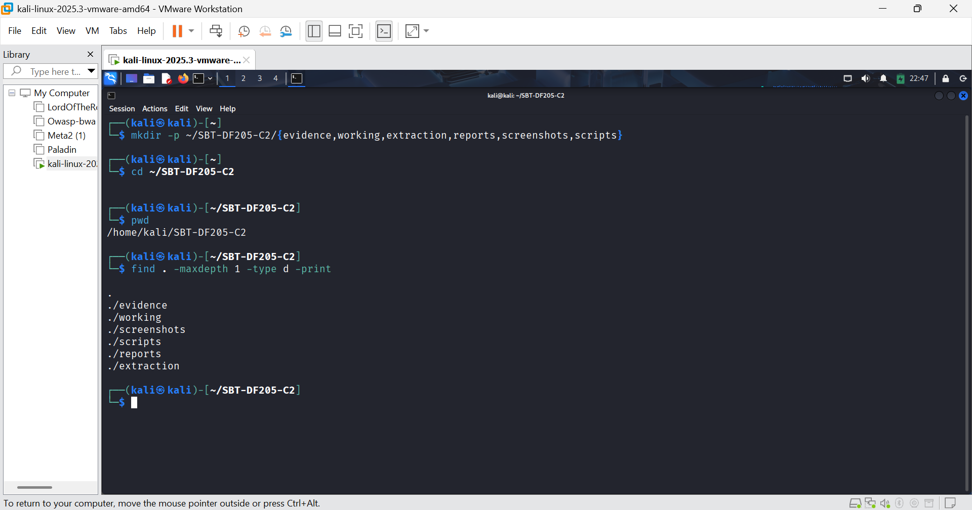FIGURE 1: I set up the work environment.
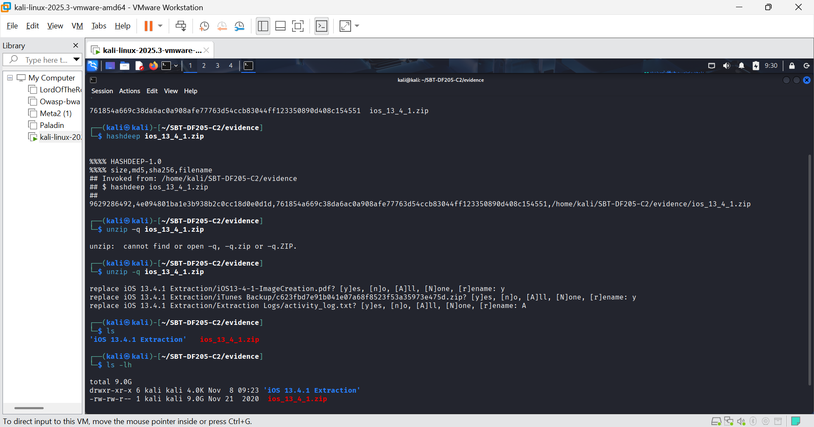FIGURE 2: I obtained the file hashes and unzipped it.
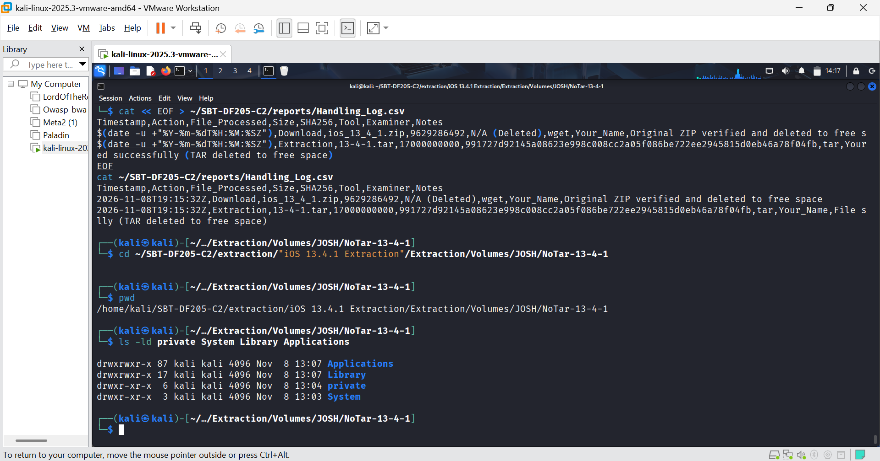FIGURE 3: File systems extracted

Establish the Device Model, iOS Version and Build

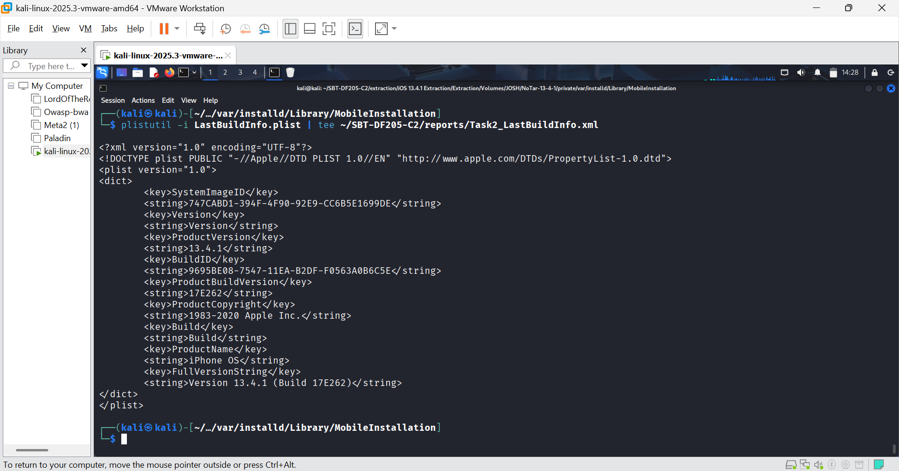FIGURE 4: Full Version String: Version 13.4.1 (Build 17E262).

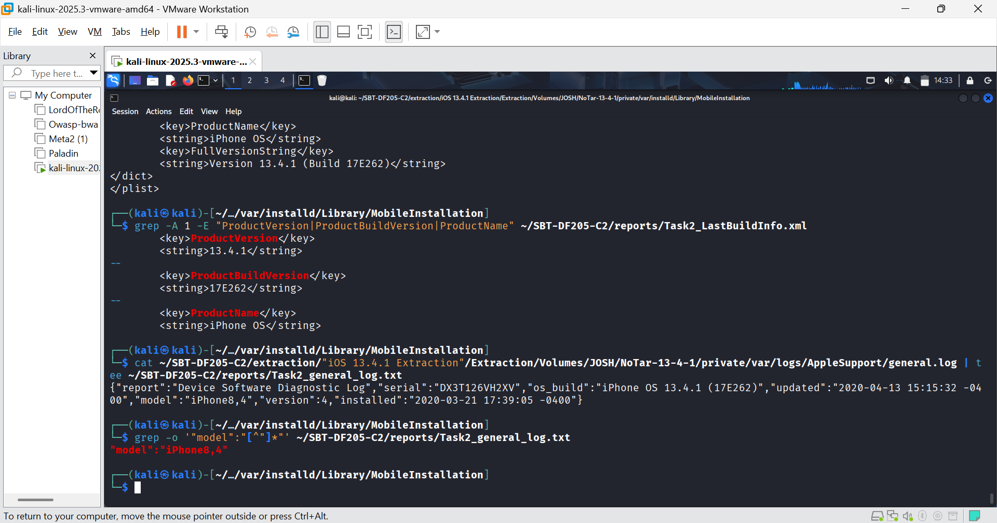FIGURE 5: iOS Version is 13.4.1, Build Number is 17E262, Product Name is iPhone OS, Device Model Identifier is iPhone8,4, Serial Number is DX3T126VH2XV and Device Install Dateis 2020-03-21 17:39:05 -0400.
Interpretation:
- Phone8,4 is the hardware identifier for the iPhone SE (1st Generation).
- The device is running the exact version of iOS we expected from the lab instructions.
- The device was installed on March 21, 2020.

Examine Accounts3.sqlite to Identify Account Associations
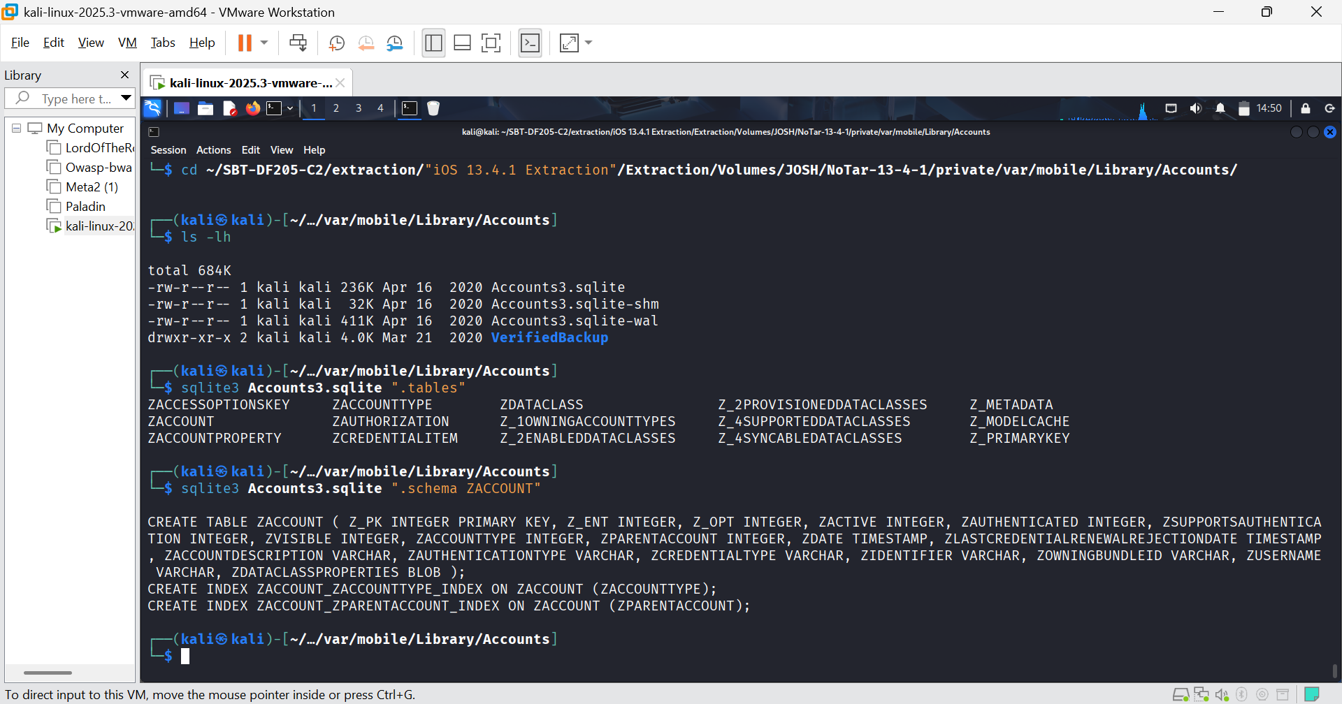FIGURE 6: I navigated to the accounts directory and inspected the schema of Accounts3.sqlite

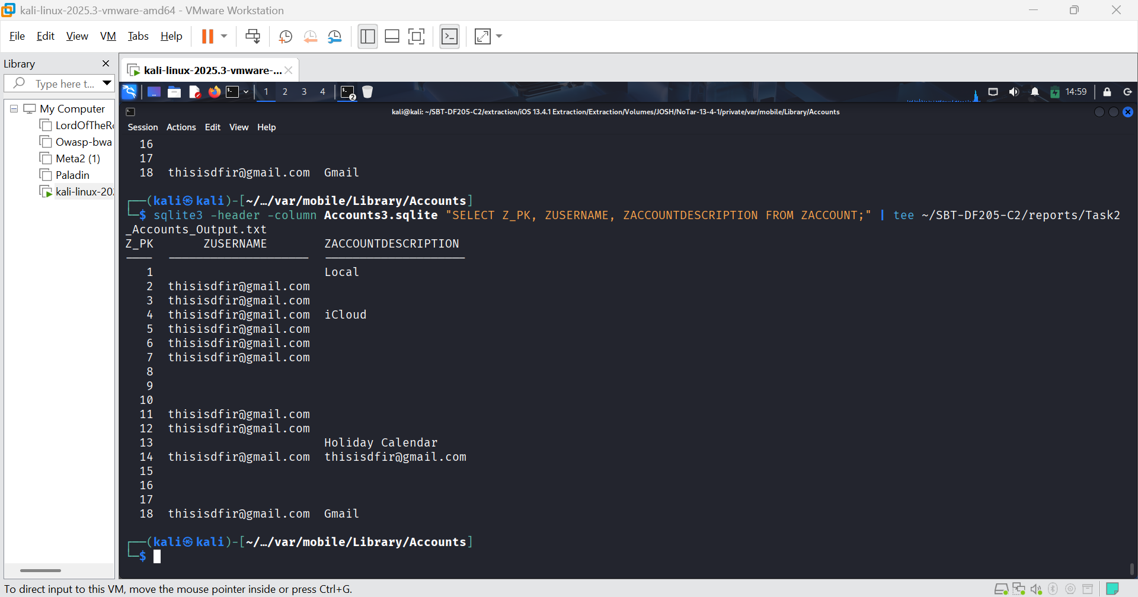FIGURE 7: 3. Querying the ZACCOUNT table for account types and usernames.
Interpretation:
The query returned 18 rows from the ZACCOUNT table. The critical finding is:
- Z_PK = 4: The ZUSERNAME is thisisdfir@gmail.com and the ZACCOUNTDESCRIPTION is iCloud. This is the primary iCloud account associated with the device.
- Other Entries: The same email address (thisisdfir@gmail.com) also appears for Gmail, Holiday Calendar and other internal services. This is normal, iOS uses a single Apple ID for multiple services (iCloud, App Store, Mail, etc.). The Local account (Z_PK=1) has no username, which is the default on-device account.

Two Supported Settings
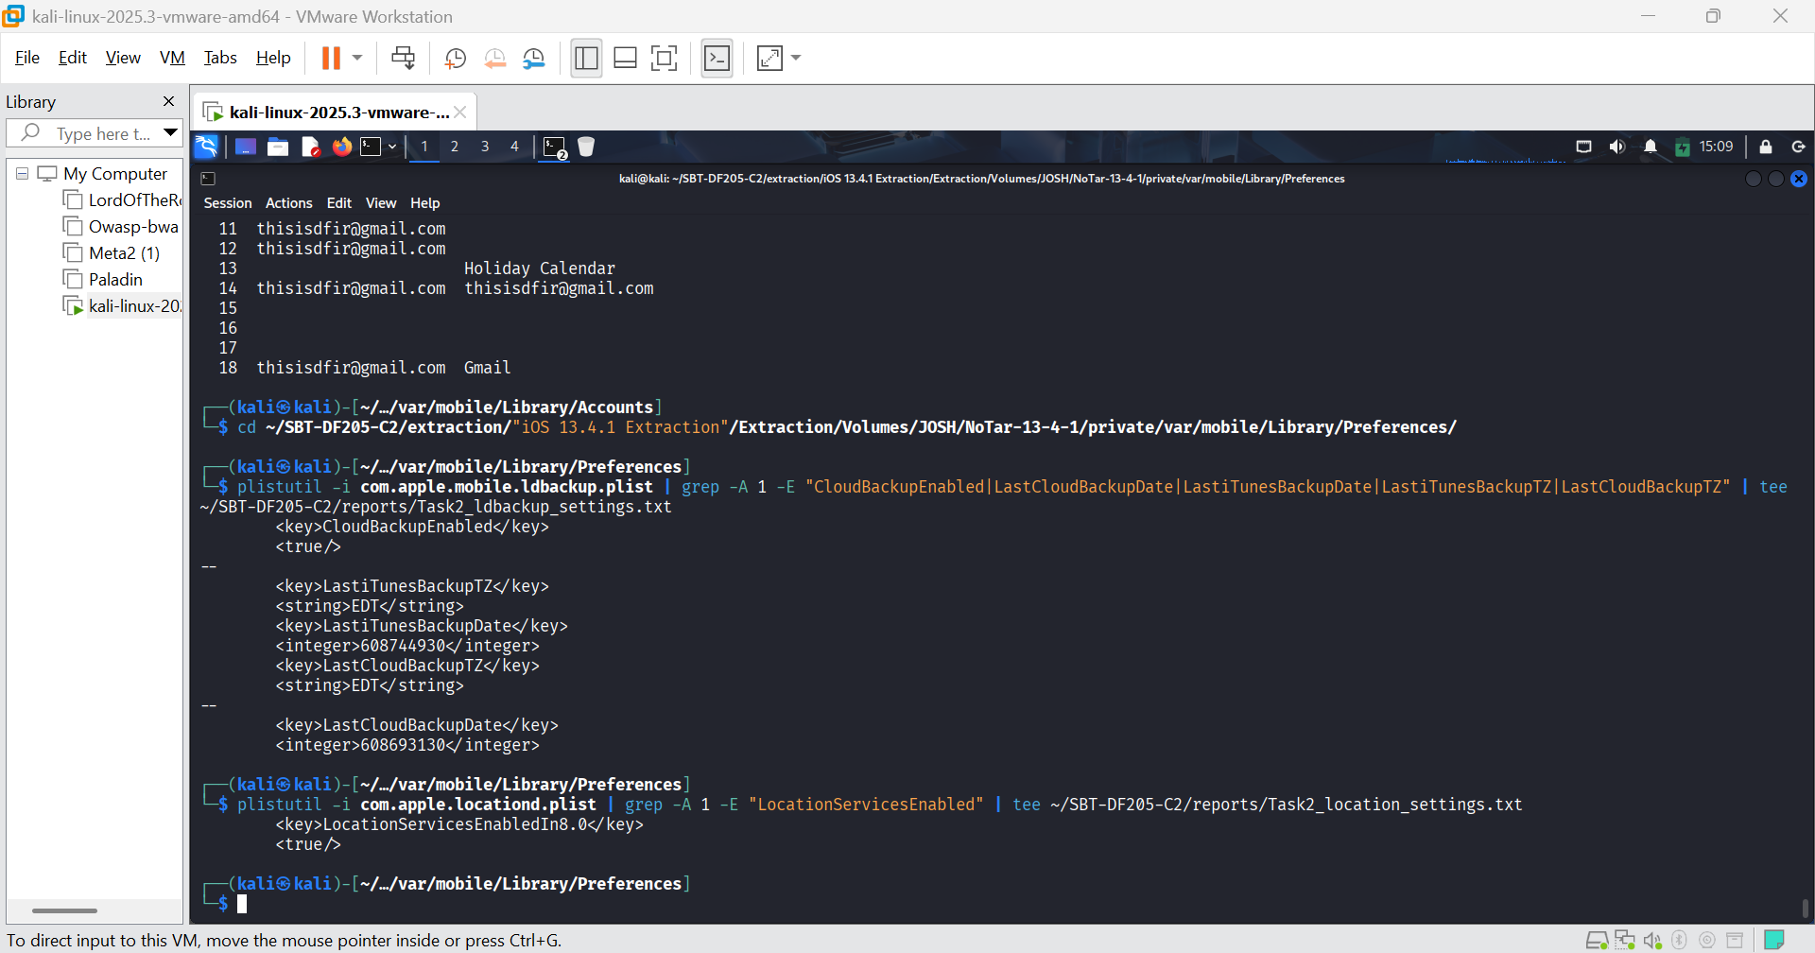 FIGURE 8: Cloud backup status and location services status
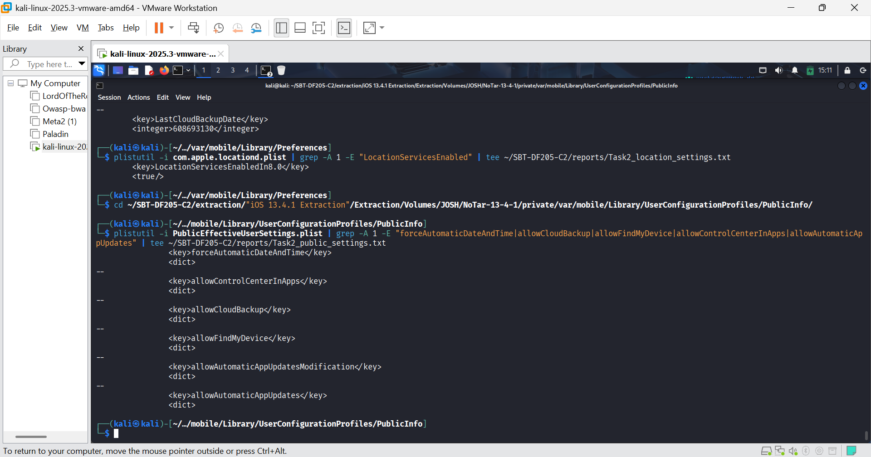FIGURE 9: I checked the System Settings file to corroborate with figure 8
Interpretation:
I have identified two supported settings and distinguished between stored configuration and activity:
Setting 1: iCloud Backup
- Stored Configuration: CloudBackupEnabled is <true/>. This means the user had iCloud backups enabled.
- Proof of Activity: The last iCloud backup occurred at timestamp 608693130 (Apple Cocoa Core Data timestamp).
Setting 2: Location Services
- Stored Configuration: LocationServicesEnabledIn8.0 is <true/>. This means Location Services were enabled on the device.
- Proof of Activity: To prove location services were actually used, we would need to find actual location records (e.g., in locationd caches or Frequent Locations).
Corroboration (PublicEffectiveUserSettings.plist):
- The allowCloudBackup and allowFindMyDevice keys are present. We need to see their inner <true/> or <false/> values to confirm. However, the ldbackup.plist already gives us the definitive answer for backup.
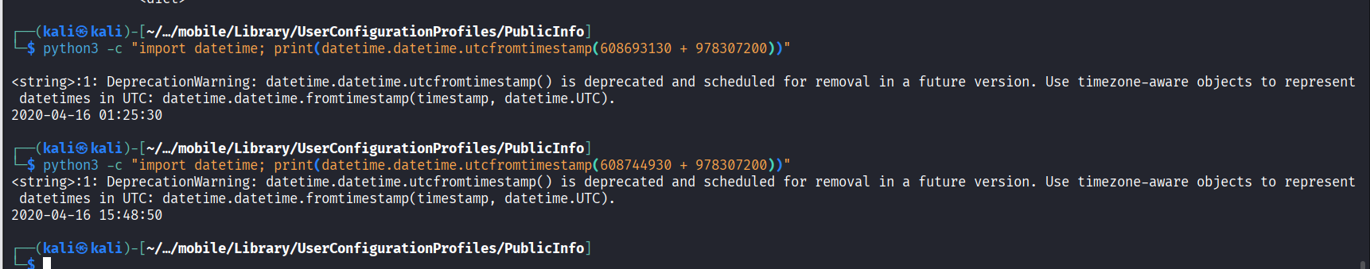FIGURE 10: Conversion of the timestamp using python. I also converted the last iTunes backup date as well (608744930) for comparison.
Interpretation of the Converted Dates:
- Last iCloud Backup (608693130):
- UTC: 2020-04-16 01:25:30
- Local (EDT, UTC-4): 2020-04-15 21:25:30
- Meaning: The last iCloud backup occurred on the evening of April 15, 2020.
- Last iTunes Backup (608744930):
- UTC: 2020-04-16 15:48:50
- Local (EDT, UTC-4): 2020-04-16 11:48:50
- Meaning: The last iTunes backup (via computer) occurred on the morning of April 16, 2020.

Task 3: Messages, Contacts and Calls
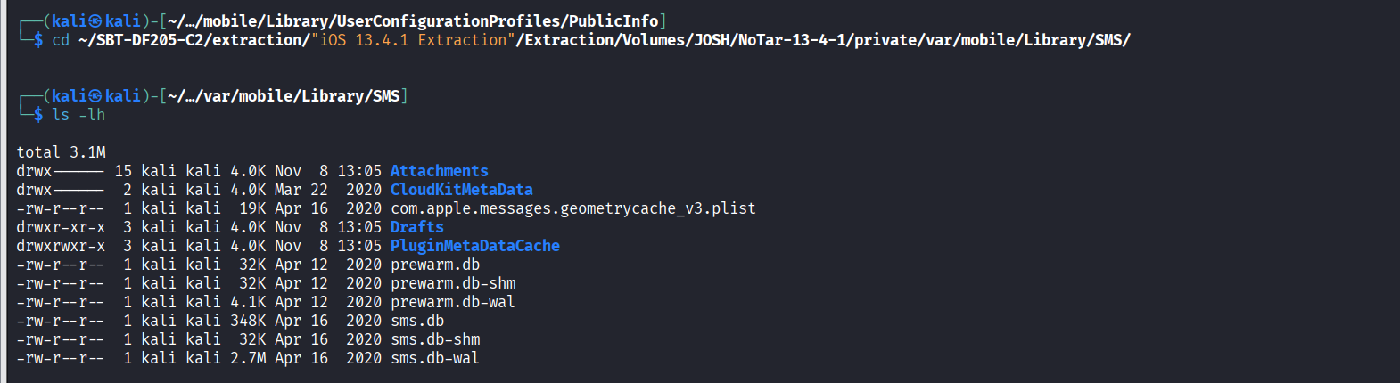FIGURE 11: I navigated to the sms directory
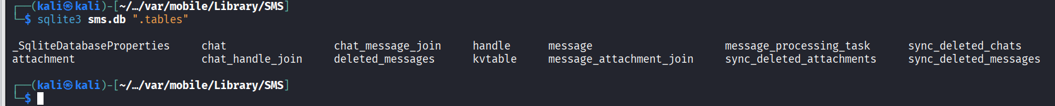FIGURE 12: sms.db schema
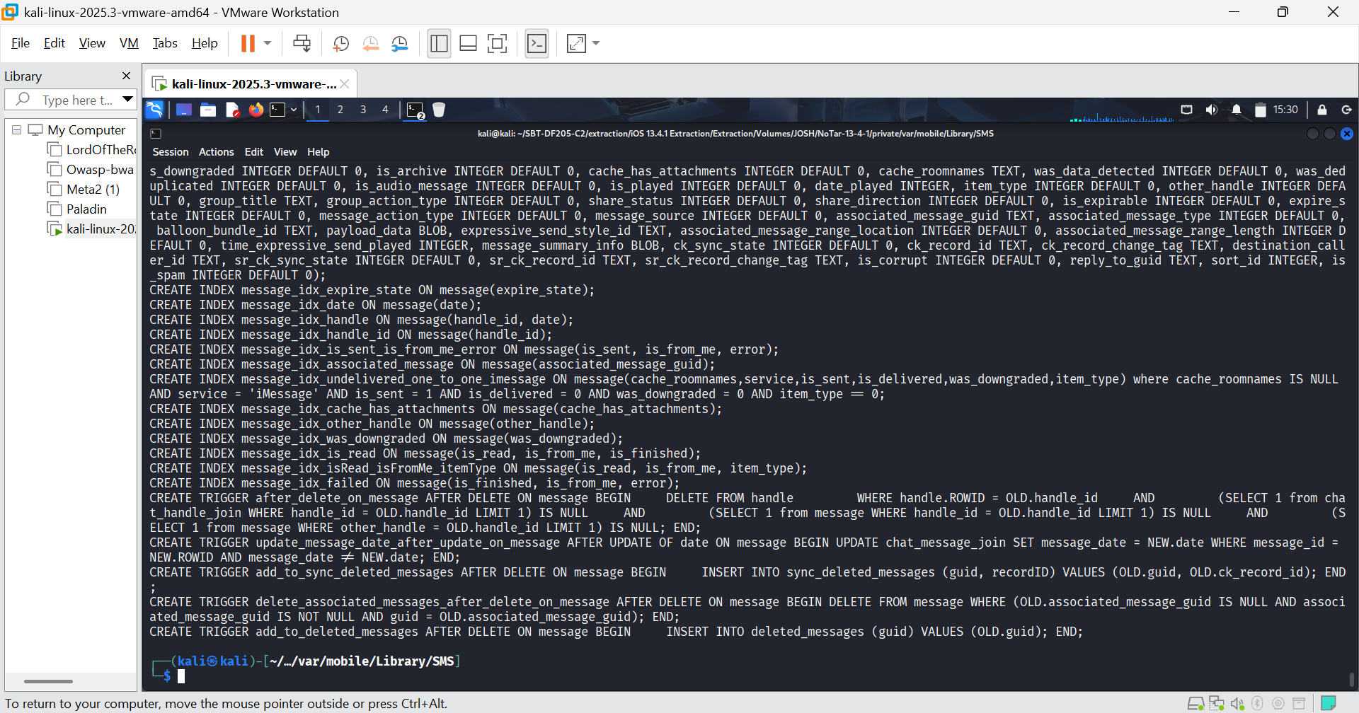FIGURE 13: main messages table
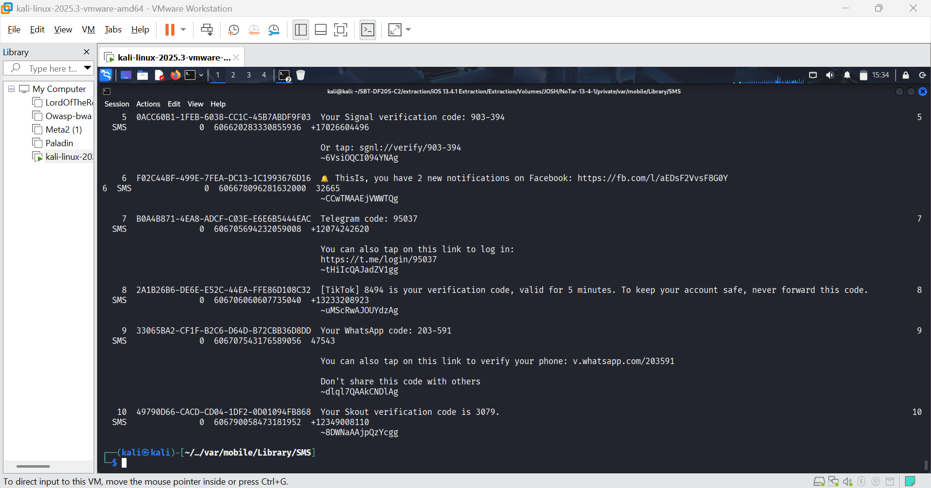FIGURE 14: Extracted messages, showing record IDs, participants, content, direction, service type, and raw timestamps. I used the command sqlite3 -header -column sms.db "SELECT m.ROWID, m.guid, m.text, m.handle_id, m.service, m.is_from_me, m.date, c.chat_identifier FROM message m JOIN chat_message_join cmj ON m.ROWID = cmj.message_id JOIN chat c ON cmj.chat_id = c.ROWID ORDER BY m.date ASC LIMIT 10;" | tee ~/SBT-DF205-C2/reports/Task3_Messages.csv
Interpretation:
ROWID 5 through 9
- ROWID 5: Signal verification code (handle_id = 5, SMS, is_from_me = 0, date = 606620283330855936).
- ROWID 6: Facebook notification (handle_id = 6, SMS, is_from_me = 0, date = 606678096281632000).
- ROWID 7: Telegram code (handle_id = 7, SMS, is_from_me = 0, date = 606705694232059008).
- ROWID 8: TikTok verification code (handle_id = 8, SMS, is_from_me = 0, date = 606706060607735040).
- ROWID 9: WhatsApp code (handle_id = 9, SMS, is_from_me = 0, date = 606707543176589056).

Convert the Timestamps and Reconstruct the Conversation
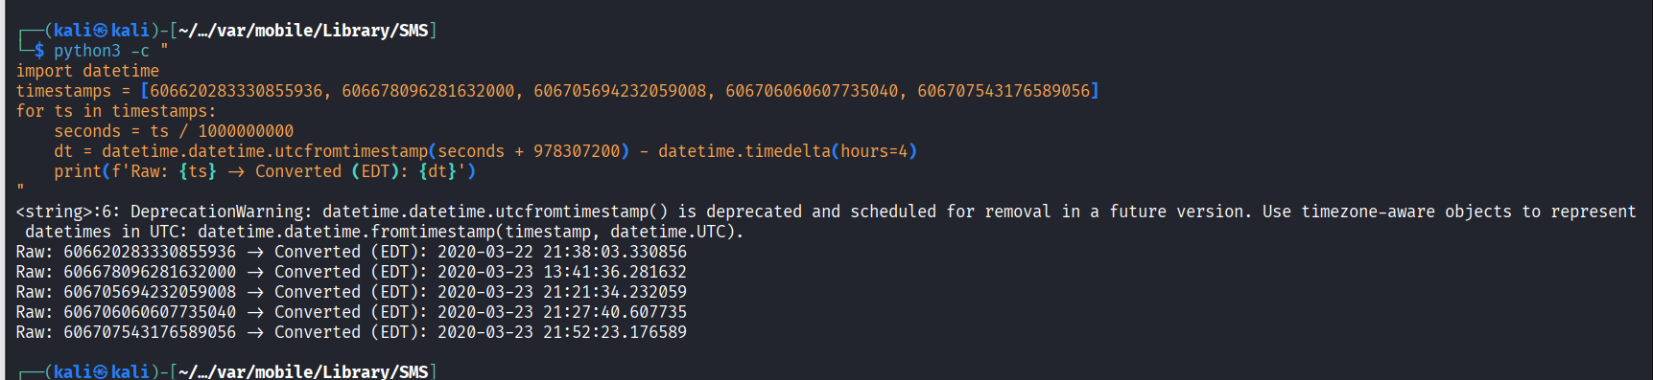FIGURE 15: Timestamps converted.
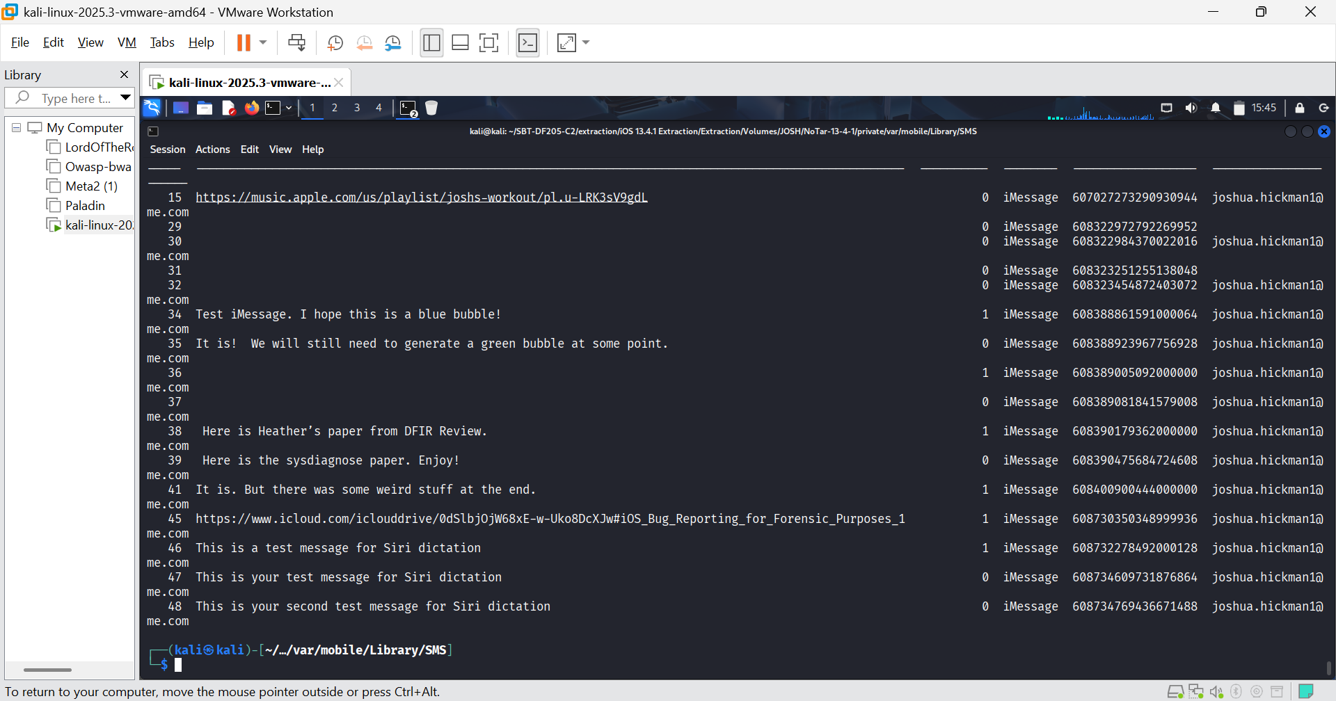FIGURE 16: I extracted conversations with joshua.hickman1@me.com:
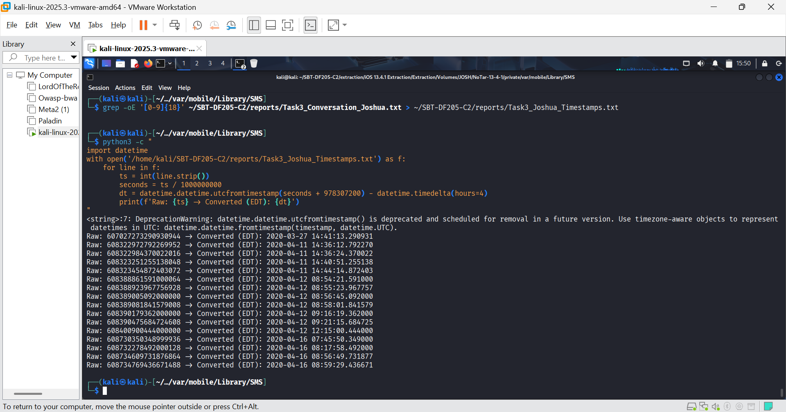FIGURE 17: I converted timestamps of the conversation to human readable format

Task 3.2: Trace One Message Attachment Record to Its Local File
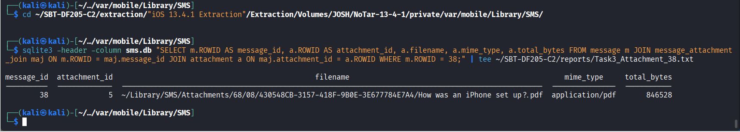FIGURE 18: Attachment information for message ROWID 38.
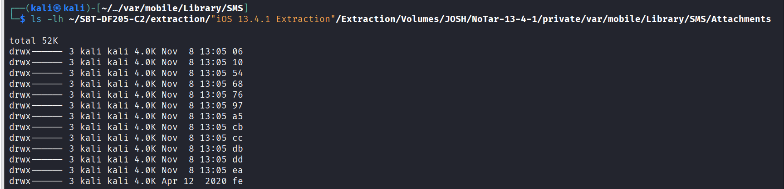FIGURE 19: Location of the actual file on the file system.
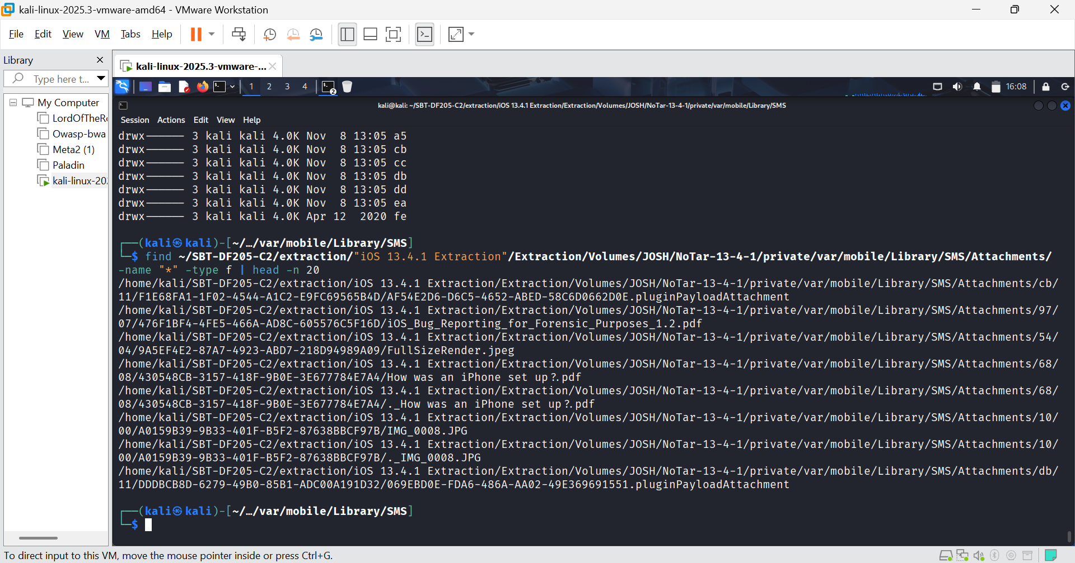FIGURE 20: File exists.
Interpretation:
- Message ROWID 38: This message was sent by the user (direction 1) and contains an attachment.
- Attachment ID 5: The database links message 38 to attachment 5.
- Filename: ~/Library/SMS/Attachments/68/08/430548CB-3157-418F-9B0E-3E677784E7A4/How was an iPhone set up?.pdf
- MIME Type: application/pdf (It is a PDF document).
- Size: 846528 bytes (approx. 826 KB).
- File System Verification: The find command successfully located the exact file on the extracted file system. The file is present and accessible.

Task 3.3: Contacts and Call Logs
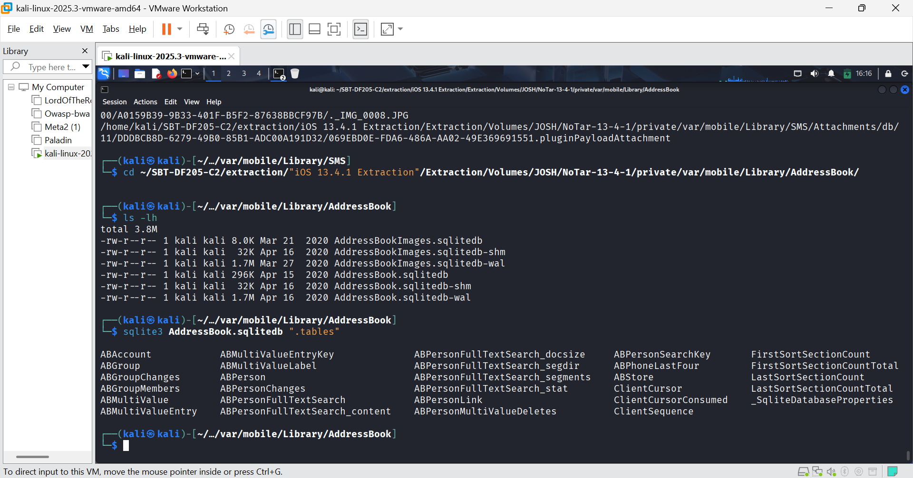FIGURE 21: The address book schema
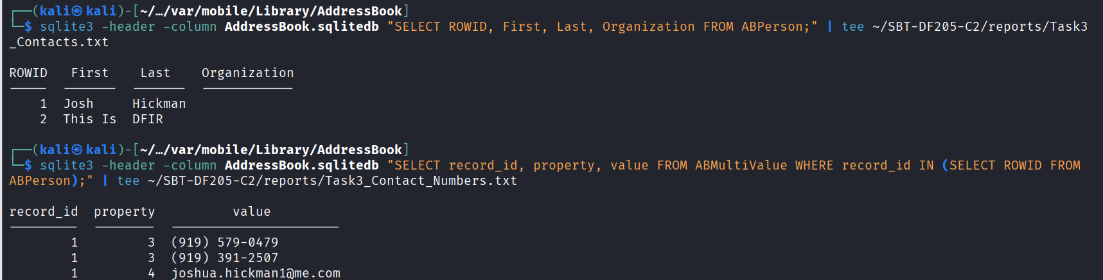FIGURE 22: I queried the ABPerson to find the contacts. I also queried the ABMultiValue table to get phone numbers/emails for the contacts.
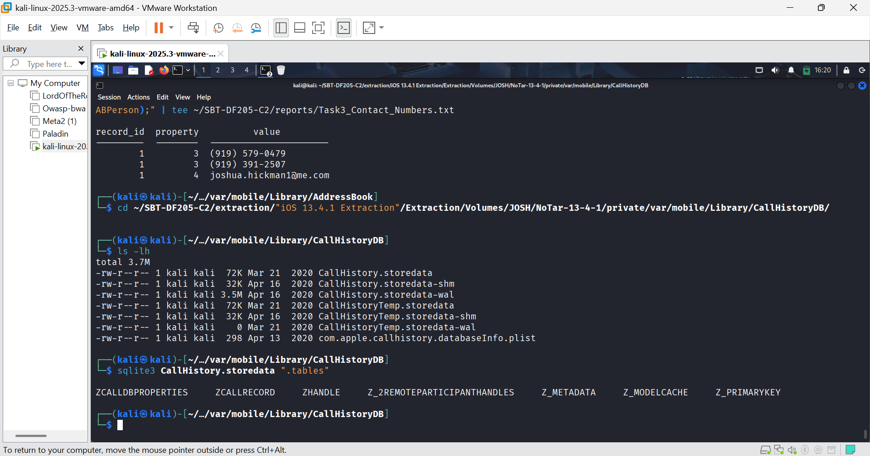FIGURE 22: I examined the call history
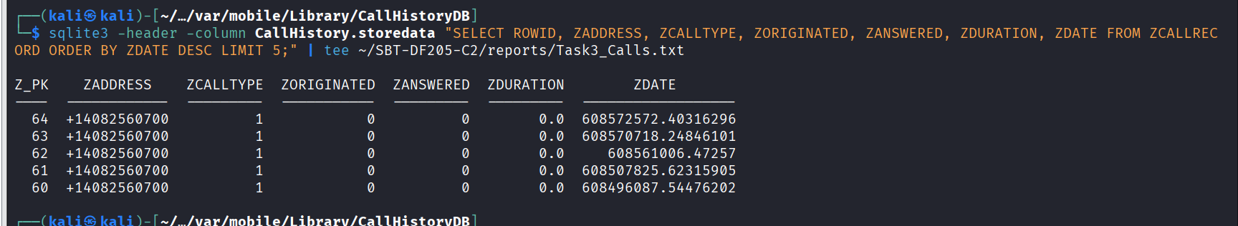FIGURE 23: I extracted calls.
Interpretation:
- Contacts (AddressBook.sqlitedb):
- RowID 1: Josh Hickman. Linked to phone numbers (919) 579-0479, (919) 391-2507 and email joshua.hickman1@me.com.
- RowID 2: This Is DFIR. (No phone numbers or emails found in the ABMultiValue table for this contact).
- Associating Identifiers:
- We can directly associate the iMessage conversation (chat_identifier = joshua.hickman1@me.com) to Josh Hickman (RowID 1).
- In the CallHistoryDB, the number +14082560700 appears frequently. We can't link this to a contact because it's not saved in the AddressBook. We can note this as an unsaved number.
- Call History (CallHistory.storedata):
The query returned 5 recent calls. The columns mean:
- ZADDRESS: The phone number.
- ZCALLTYPE: 1 = Regular Phone Call, 2 = FaceTime.
- ZORIGINATED: 0 = Incoming, 1 = Outgoing.
- ZANSWERED: 0 = Not Answered (Missed), 1 = Answered.
- ZDURATION: Duration in seconds (0.0 means missed).
- ZDATE: Apple Cocoa Core Data timestamp (seconds since 2001-01-01).

Task 3.4: Convert Call Timestamps
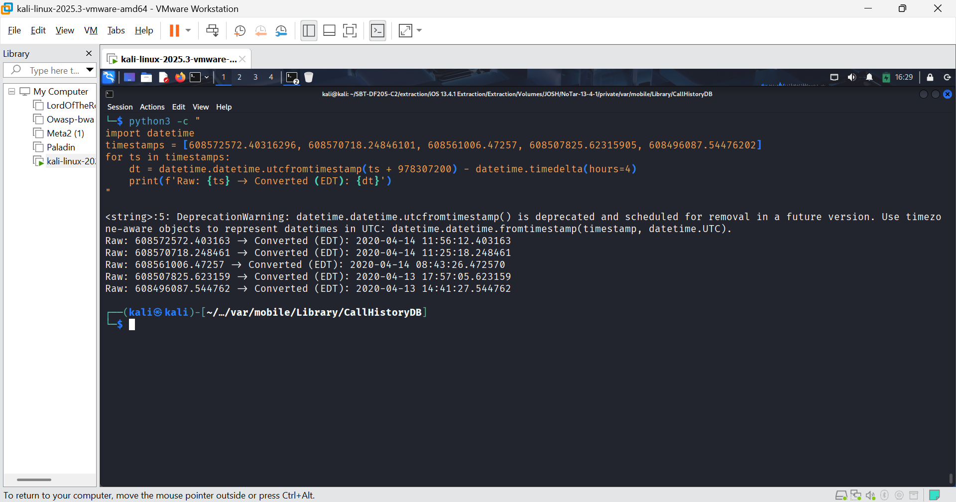FIGURE 24: Call timestamps conversion.
Interpretation of the Call Timestamps:
The conversion confirms that the 5 recent calls were all incoming missed calls from +14082560700 between April 13 and April 14, 2020.

Task 4 Safari and calendar
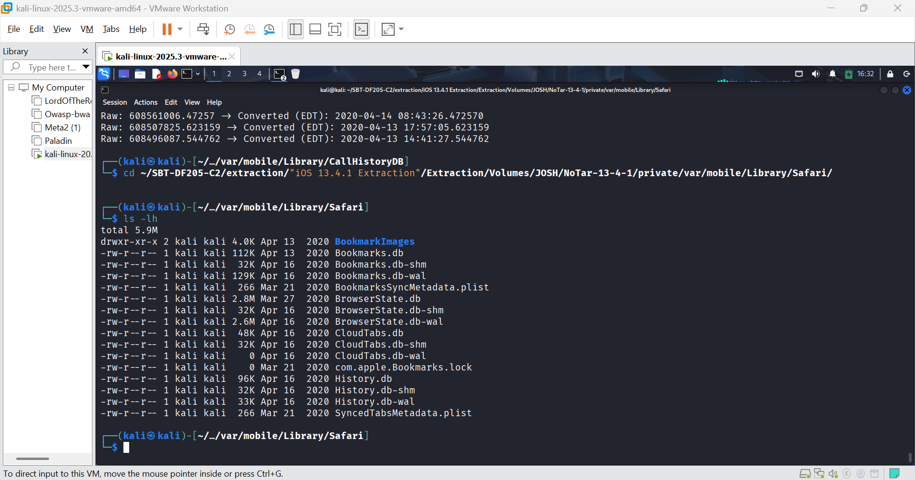FIGURE 25: Safari directory databases
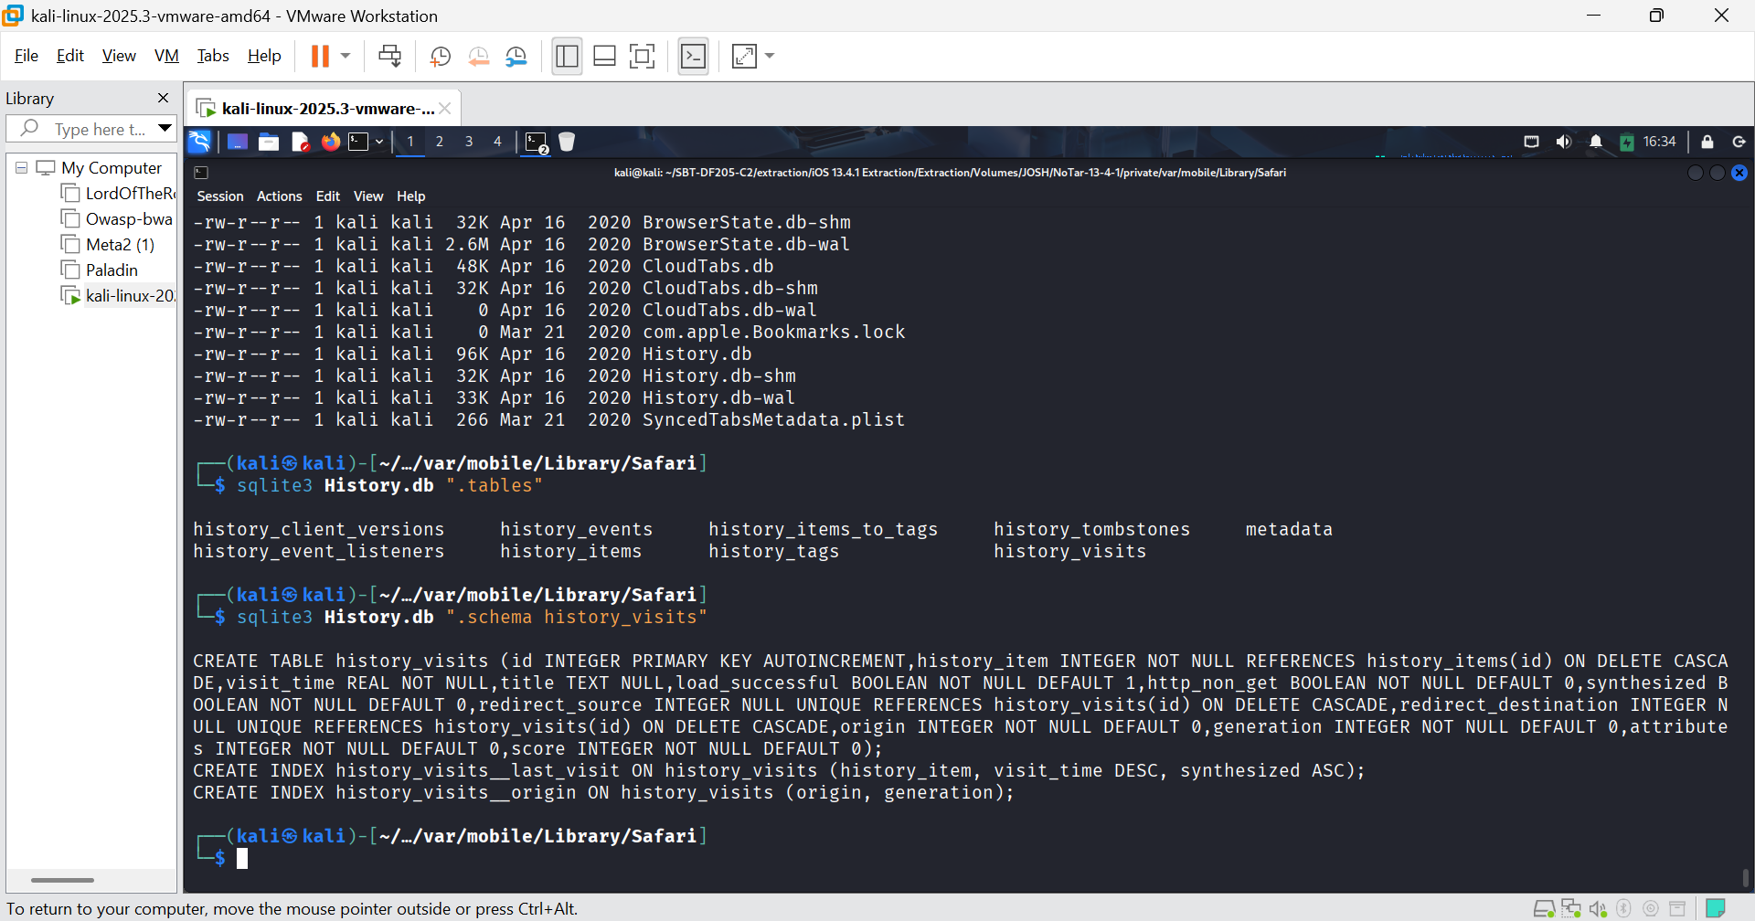FIGURE 26: History.db schema
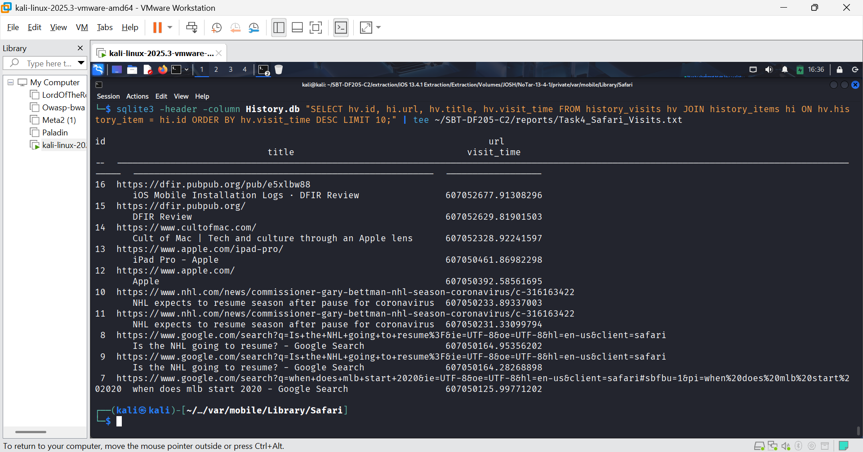FIGURE 26: Visits
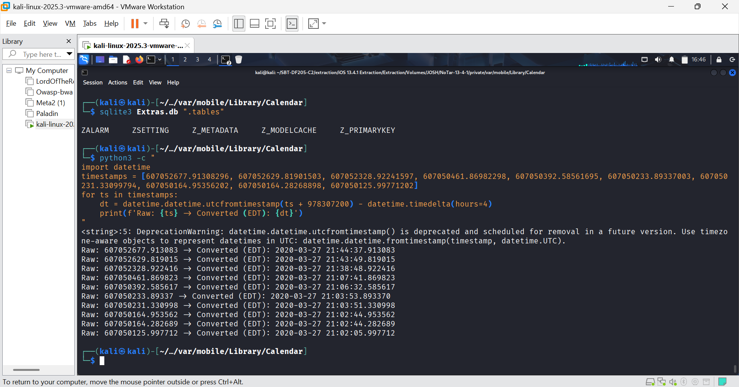FIGURE 27: Safari timestamp conversion.
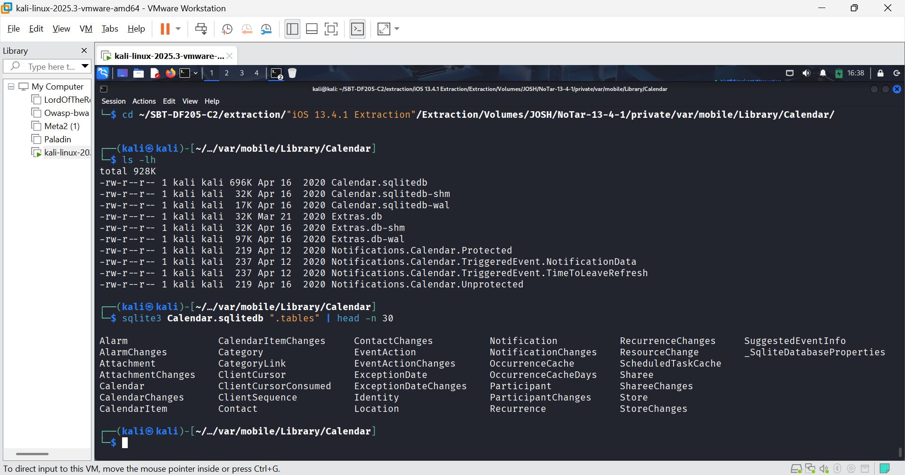FIGURE 28: Calendar directory databases
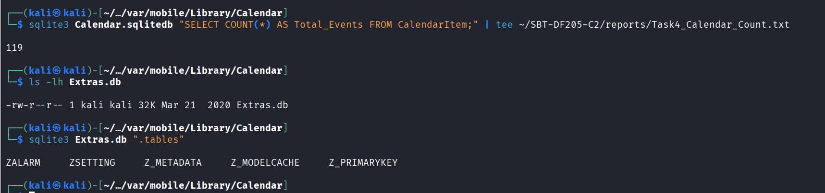FIGURE 29: Row counts of CalendarItem table is 119. Extras.db database inspection.
Interpretation:
- Safari History (History.db):
- I successfully extracted 10 recent visits. These are the key searches and websites the user visited around March 27-28, 2020:
- Google Searches: "when does mlb start 2020", "Is the NHL going to resume?"
- News/Info: NHL news, Apple iPad Pro, Apple homepage, Cult of Mac, DFIR Review, iOS Mobile Installation Logs.

- Calendar (Calendar.sqlitedb):
- Total Events: The CalendarItem table contains 119 events. (This contradicts the slides which said "there isn't any data to look at"; the dataset has been updated).
- Extras.db: Contains ZALARM and ZSETTING tables.
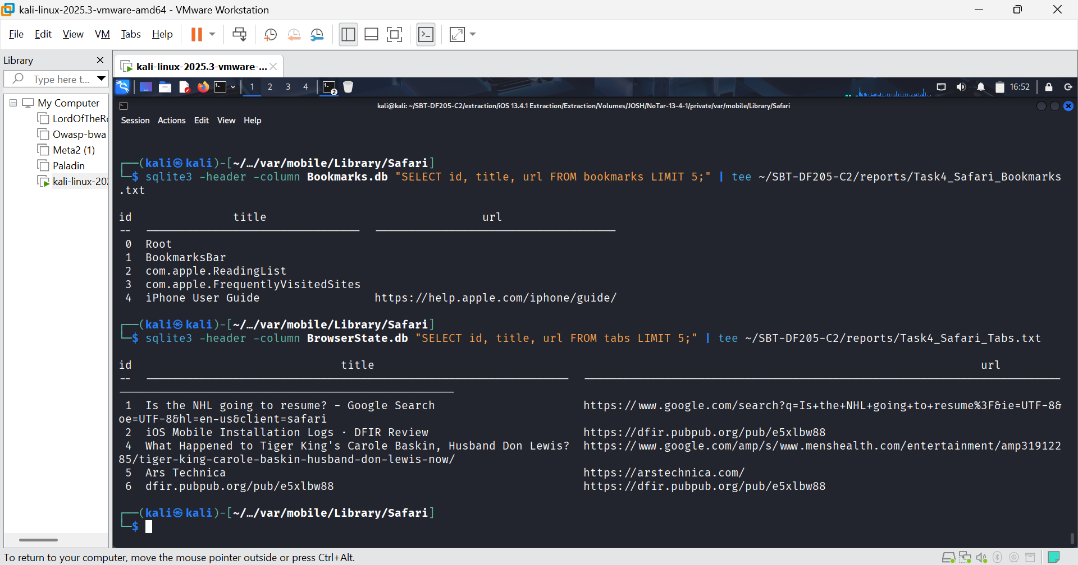FIGURE 30: I queried the Bookmarks.db and BrowserState.db to show these are separate records.
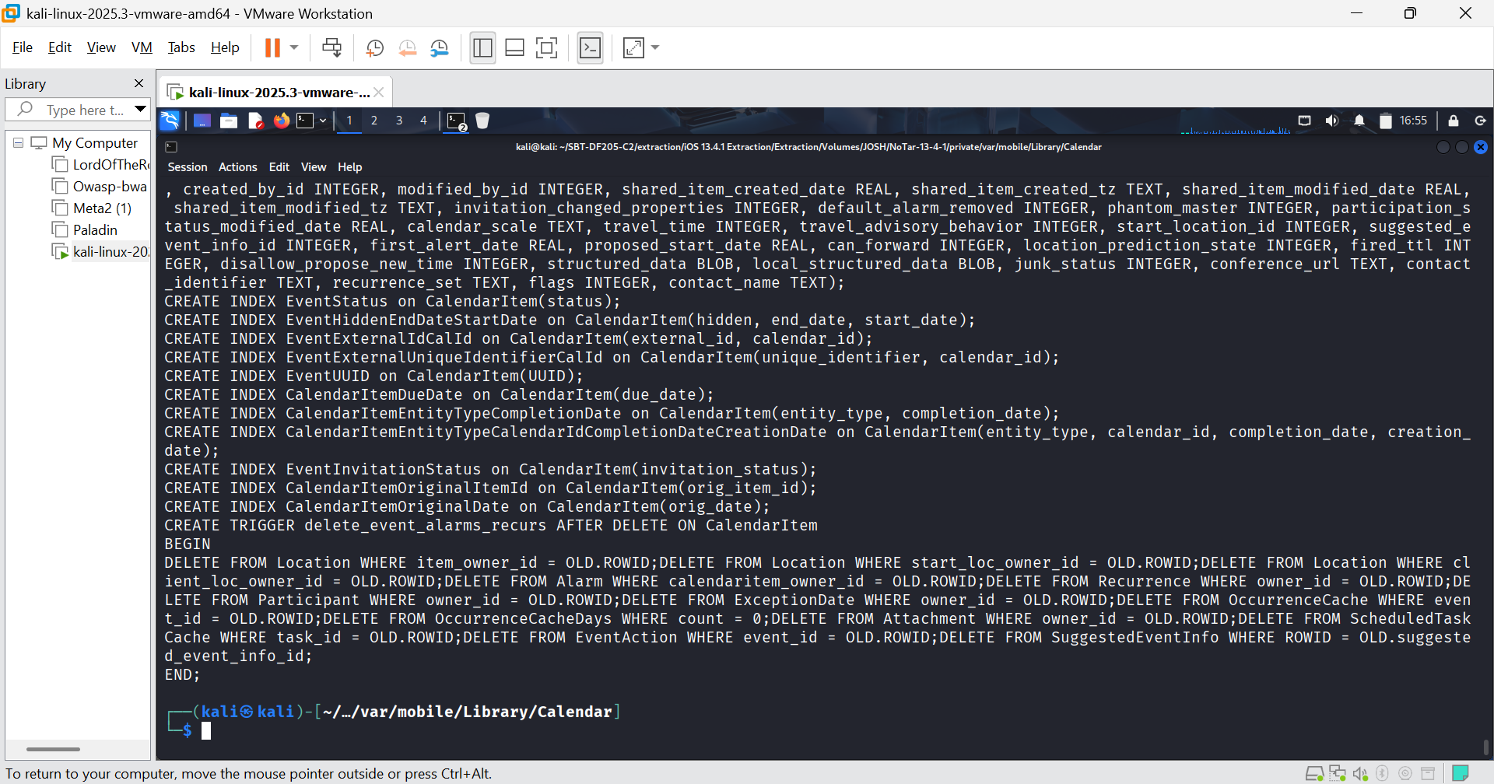FIGURE 31: Relevant columns in calendar item using the command sqlite3 Calendar.sqlitedb ".schema CalendarItem" | head -n 20
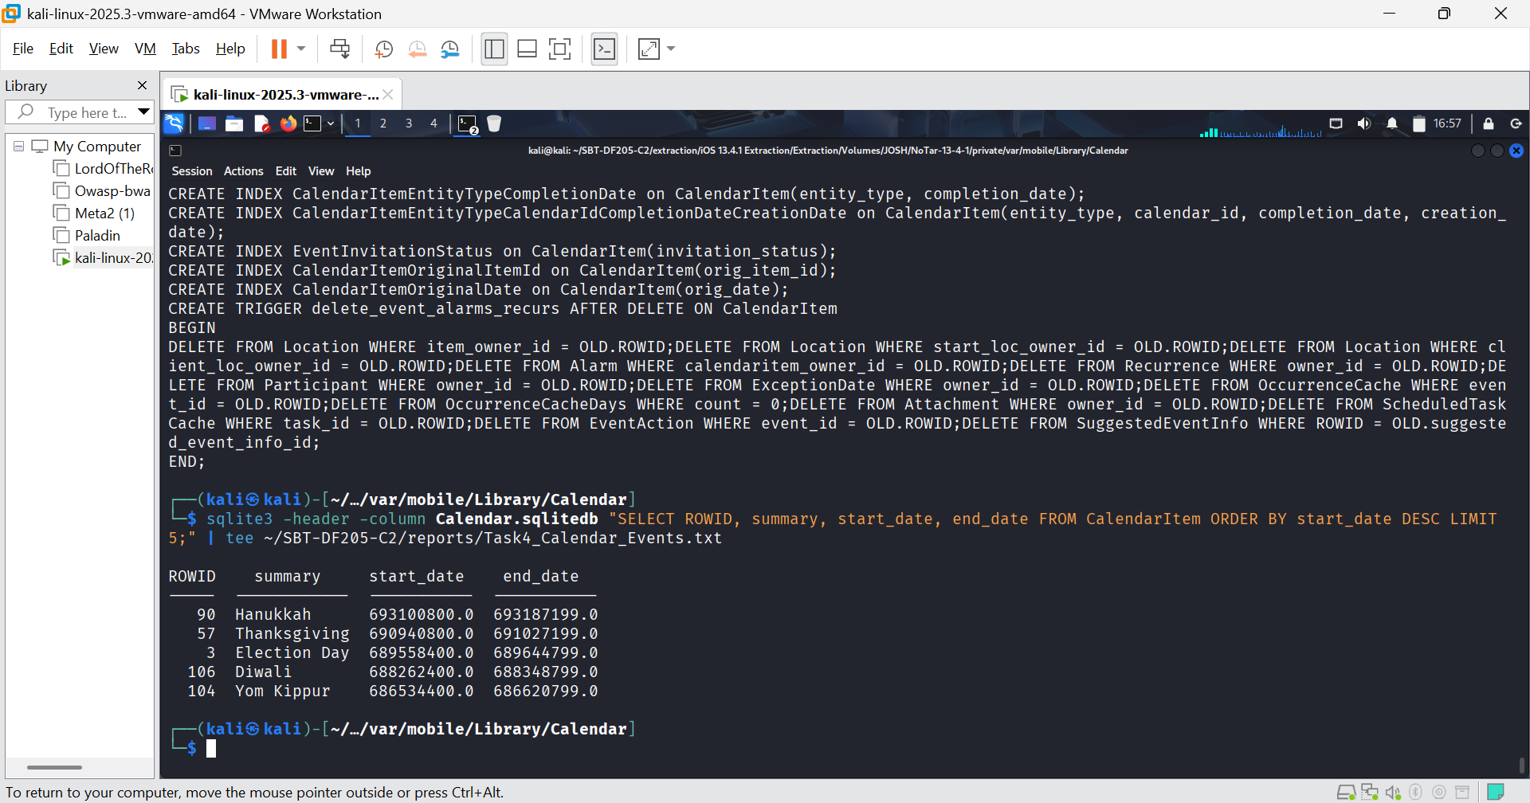FIGURE 32: Sample of events
Interpretation:
- Safari Visits (History.db):
All 10 visits occurred on March 27, 2020, between 21:02 and 21:44 EDT. The user was searching for:
- MLB 2020 start dates
- NHL season resumption
- Apple iPad Pro
- DFIR Review articles

Distinction Between Record Types:
- History (Visits): These are actual pages the user loaded. We found 10 visits.
- Bookmarks: These are saved URLs. The Bookmarks.db shows bookmarks like the "iPhone User Guide". These are not proof of a visit on that date, they are saved shortcuts.
- Open Tabs (BrowserState.db): These are pages that were open in the browser. Notice that the open tabs include "Is the NHL going to resume?" and "iOS Mobile Installation Logs", which matches the history. It also includes "What Happened to Tiger King's Carole Baskin..." which is not in the history query. This means the user had that tab open but may not have actually loaded/visited it in the recorded history.
- Calendar (Calendar.sqlitedb):
- The CalendarItem table has 119 entries. The top 5 are all-day holiday events (Hanukkah, Thanksgiving, Election Day, Diwali, Yom Kippur). These are likely default holidays synced to the device, not user-created appointments.
- The start_date and end_date are in Cocoa Core Data format (seconds since 2001-01-01 and they clearly represent future dates (e.g., Hanukkah 2021).
While the table is not empty, it contains only default/synced holidays, not user-created appointments.

Task 5: Media Analysis
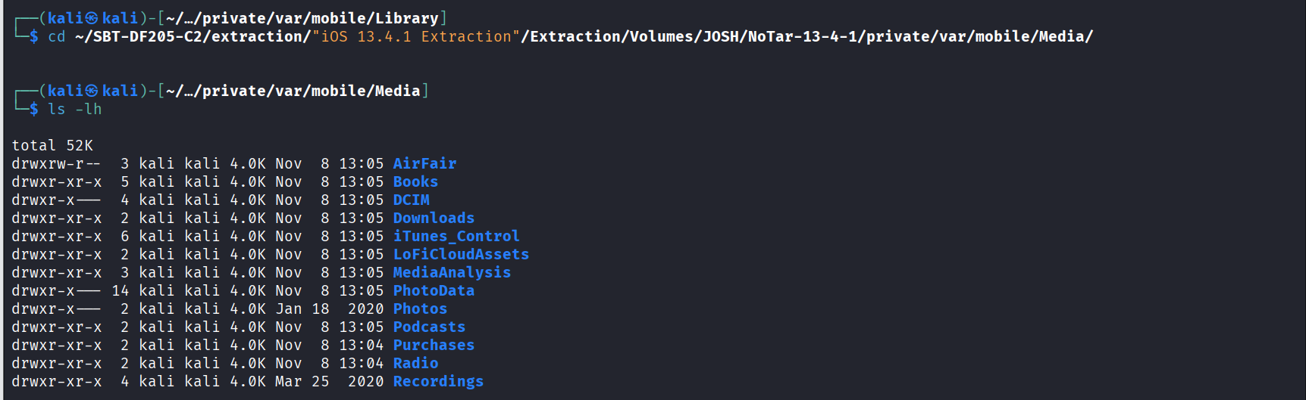FIGURE 33: I navigated to the media folder to verify the PhotoData and DCIM directories
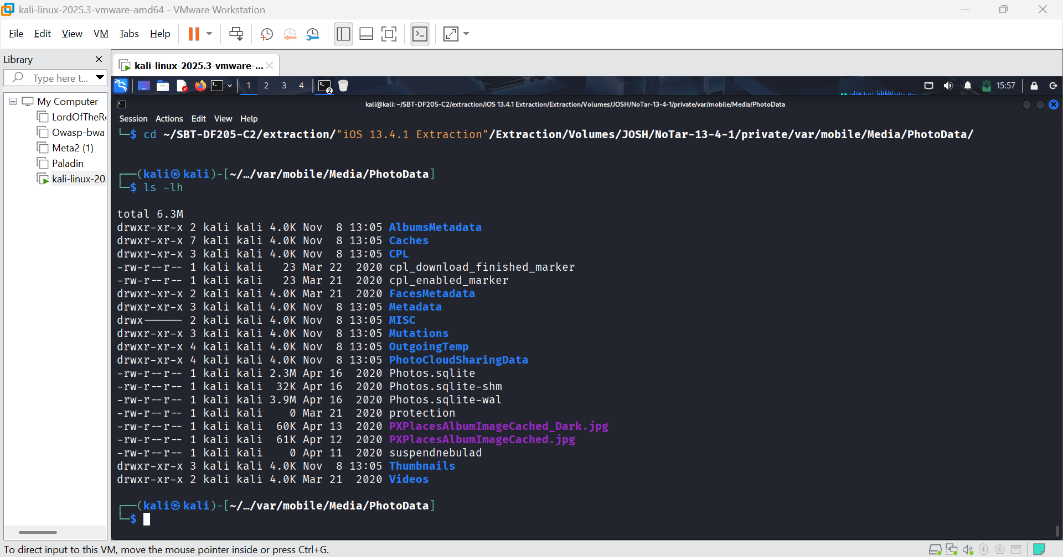FIGURE 34: I navigated to PhotoData and verify the Photos.sqlite database
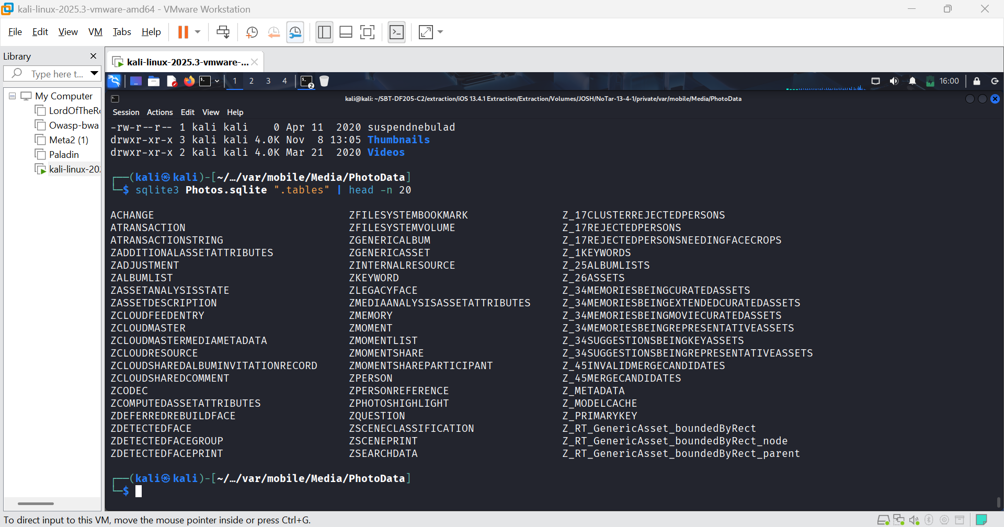FIGURE 35: I inspect the table schema
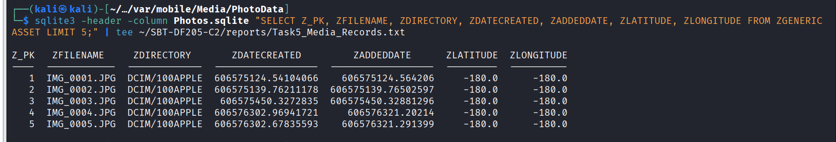FIGURE 36: I extracted 5 records
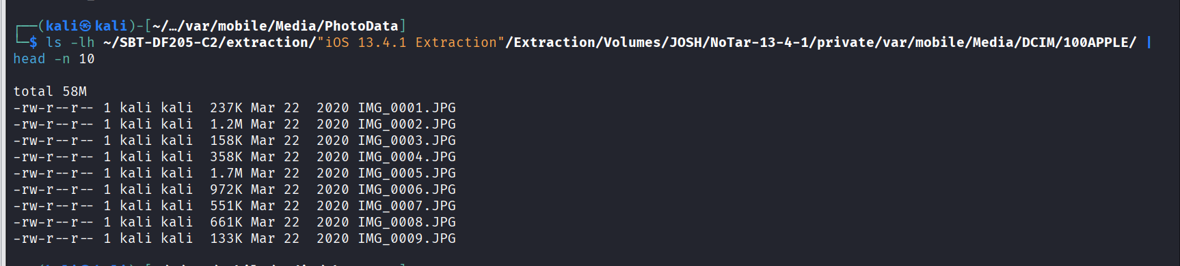FIGURE 37: I located the actual media files in the DCIM folder
Interpretation:
- Media Records (Photos.sqlite):
We have 5 records from ZGENERICASSET:
- Z_PK 1-5: Filenames IMG_0001.JPG to IMG_0005.JPG.
- Directory: All are in DCIM/100APPLE.
- GPS: ZLATITUDE and ZLONGITUDE are both -180.0. This is a placeholder value indicating no GPS data was recorded for these photos (likely because location services were off or the camera didn't have a GPS fix).
- Timestamps: ZDATECREATED and ZADDEDDATE are in Cocoa Core Data format (seconds since 2001-01-01).
- . File System Verification:
The ls -lh command confirms the files exist in DCIM/100APPLE/ with the exact filenames. The file sizes match what we expect from a camera roll.

Task 5.2: Convert Media Timestamps and Distinguish Captured vs. Imported
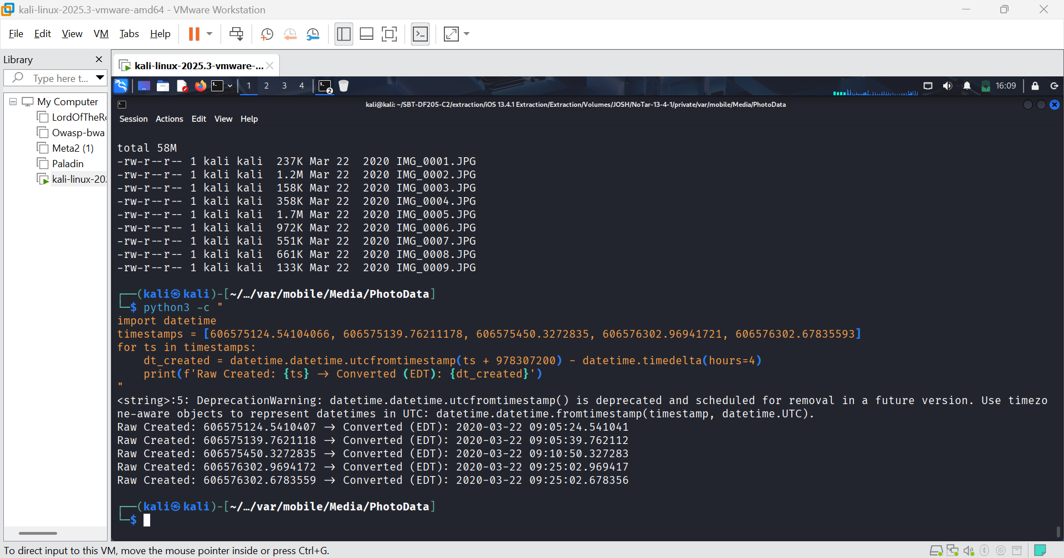FIGURE 38: I converted the ZDATECREATED and ZADDEDDATE timestamps.

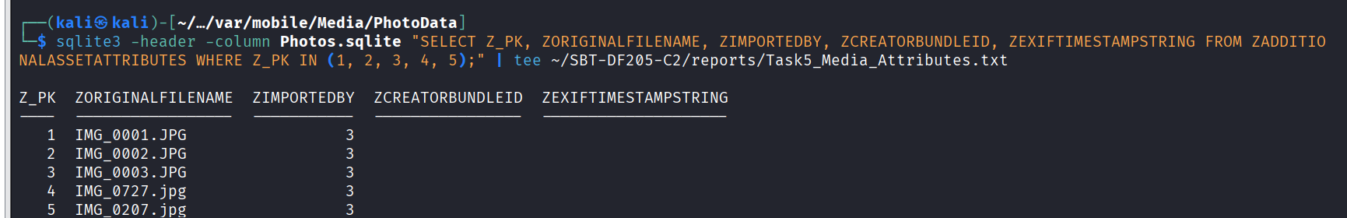FIGURE 39: 2. I checked to see if the media was captured by the camera or imported.
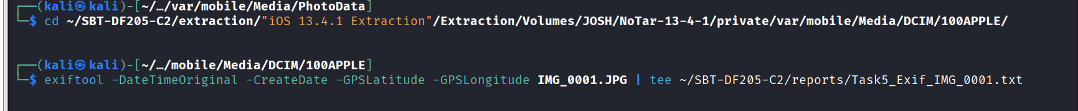FIGURE 40: I checked the EXIF data of IMG_0001.JPG to corroborate the database timestamps.
Interpretation:
- Timestamps:
All 5 photos were created and added on March 22, 2020, between 09:05 and 09:25 EDT. The difference between ZDATECREATED and ZADDEDDATE is negligible (milliseconds), which is typical for photos taken directly with the camera.
- Origin:
ZIMPORTEDBY = 3 indicates these were imported or saved from a Third Party Application, not captured by the native camera.
However, the original filenames are IMG_0001.JPG, IMG_0002.JPG, etc. These are standard camera roll filenames. This suggests they may have been captured by the camera and later imported/synced. I will need to verify the schema.
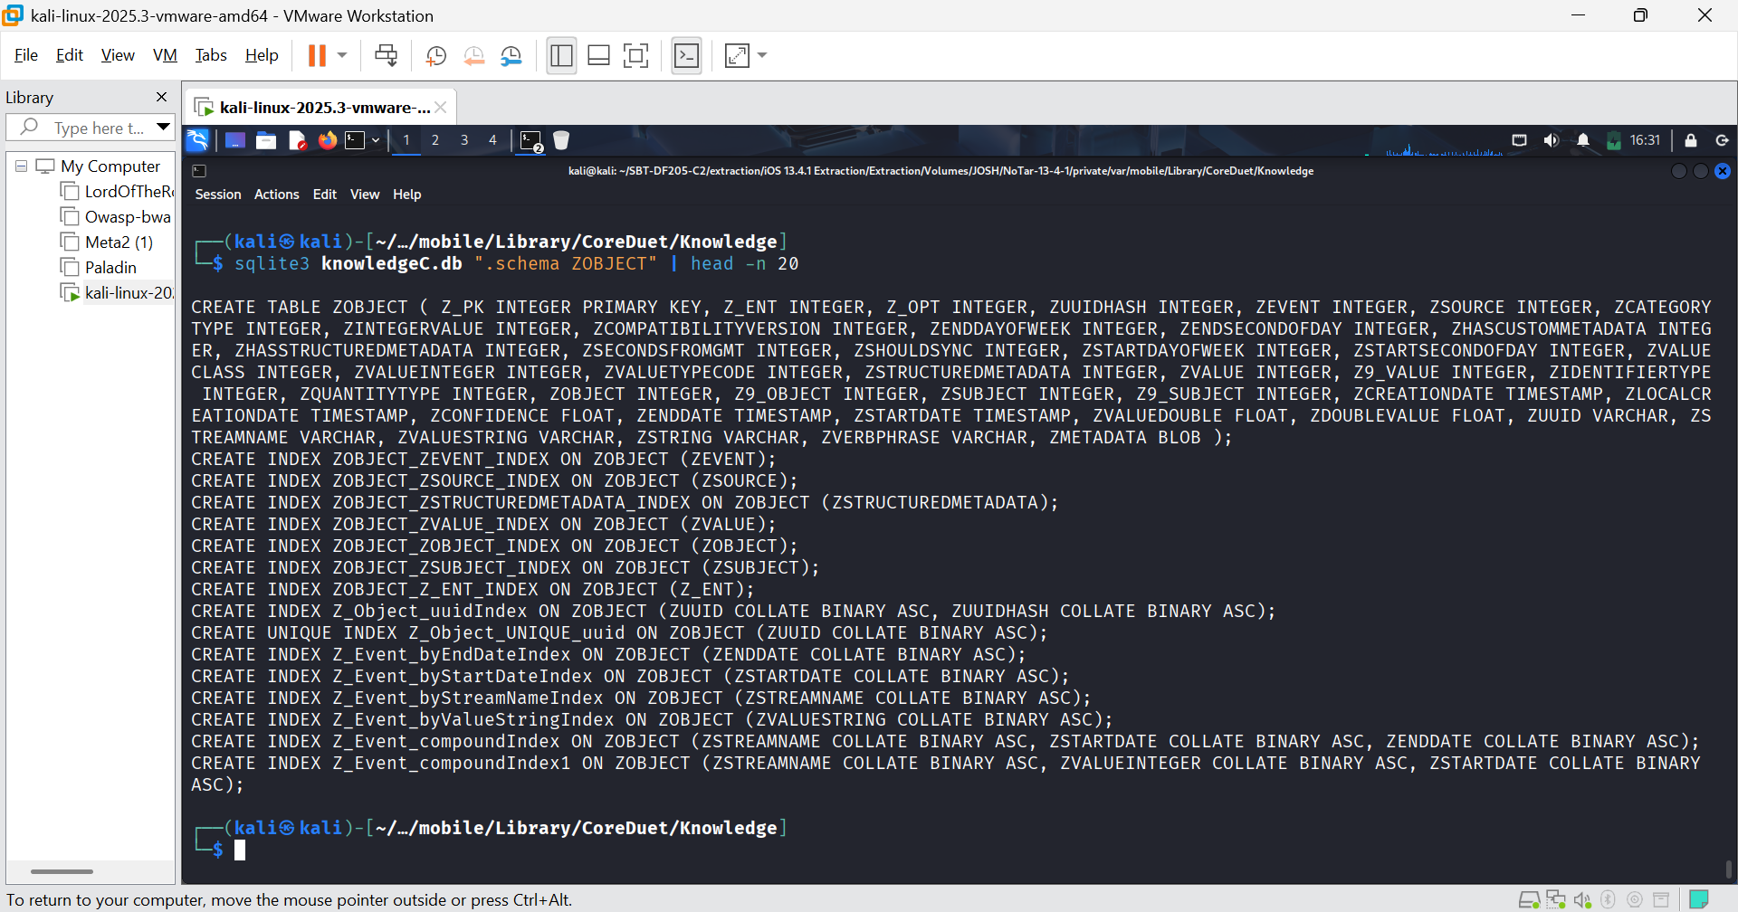FIGURE 41: I navigated to the knowledge directory and inspected the ZOBJECT schema.
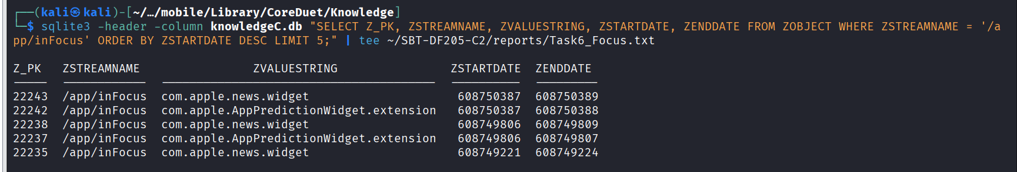FIGURE 42: I extracted 5 records 3 of application focus (/app/inFocus).
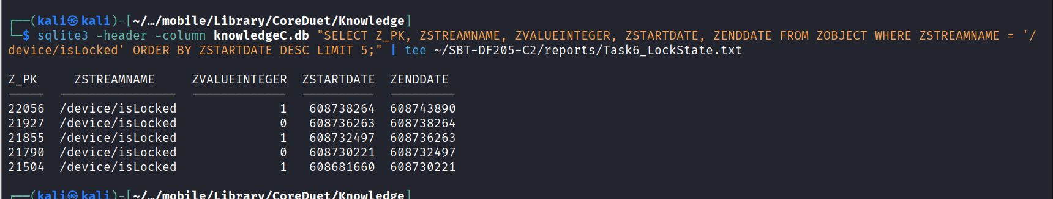FIGURE 43: I checked for device lock/unlock records (/device/isLocked).
Interpretation:
- Application Focus (/app/inFocus):

- The top 5 records are all widgets (com.apple.news.widget, com.apple.AppPredictionWidget.extension).
- Timestamps: ZSTARTDATE and ZENDDATE are in Apple Cocoa Core Data format (seconds since 2001-01-01). They are very short intervals (1-3 seconds), typical for widget updates.
- Raw value 608750387: Converted (EDT, UTC-4) = 2020-04-16 09:19:47 EDT.
- Device Lock State (/device/isLocked):
- ZVALUEINTEGER = 1 means Locked. 0 means Unlocked.
- Record 21504: Device was locked from 608681660 to 608730221. (Approximately 2020-04-10 23:34 to 2020-04-16 09:03).
- Record 21790: Device was unlocked from 608730221 to 608732497. (Approximately 2020-04-16 09:03 to 09:41).
- Record 21855: Device was locked again from 608732497 to 608736263.
Correlating with other evidence
- Unlock start: 608730221 -> 2020-04-16 07:43:41 EDT (approx).
- The Siri dictation message (ROWID 46) was at 2020-04-16 08:17:58 EDT.
- The widget focus (608750387) was at 2020-04-16 09:19:47 EDT.
This shows the user unlocked the phone around 07:43, sent a message at 08:17 and was looking at widgets at 09:19.
Task 7 Health and location evidence
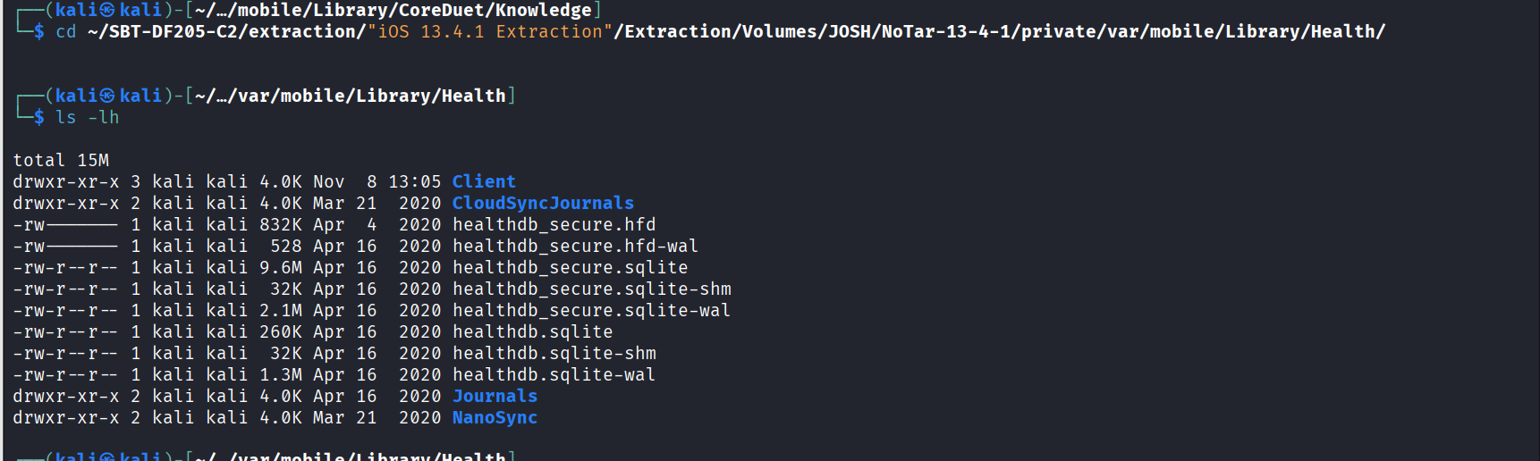FIGURE 44: I located the health databases.

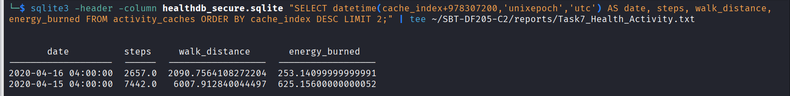FIGURE 44: I extracted 2 activity samples from healthdb_secure.sqlite (Activity Cache)
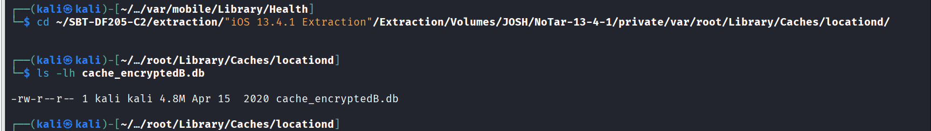FIGURE 45: I located the location database
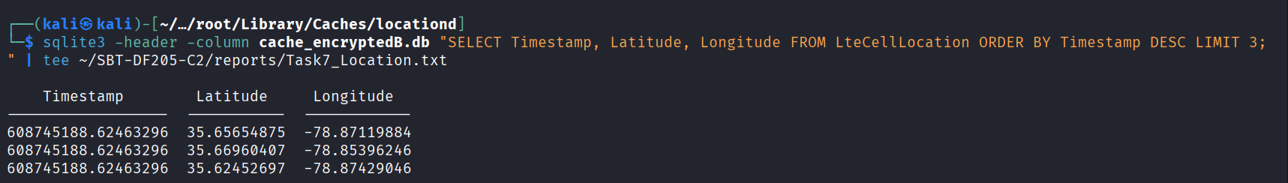FIGURE 46: I extracted 3 location records from the locationd cache.
Interpretation:
- Health Data (healthdb_secure.sqlite):
- 2020-04-15: 7,442 steps, 6,007 meters walked, 625 calories burned.
- 2020-04-16: 2,657 steps, 2,090 meters walked, 253 calories burned.
- This shows the user was active, but activity dropped on April 16 (likely because they were on the phone sending the messages we found earlier that morning).
- Location Data (cache_encryptedB.db):
- Raw Timestamp: 608745188.62463296 (Cocoa Core).
- Coordinates: 35.65654875, -78.87119884, 35.66960407, -78.85396246, 35.62452697, -78.87429046.
- These coordinates are clustered around Holly Springs, North Carolina (same area as the photo in the slides, 35.66076667, -78.87922833). This confirms the device was in that area on April 16.

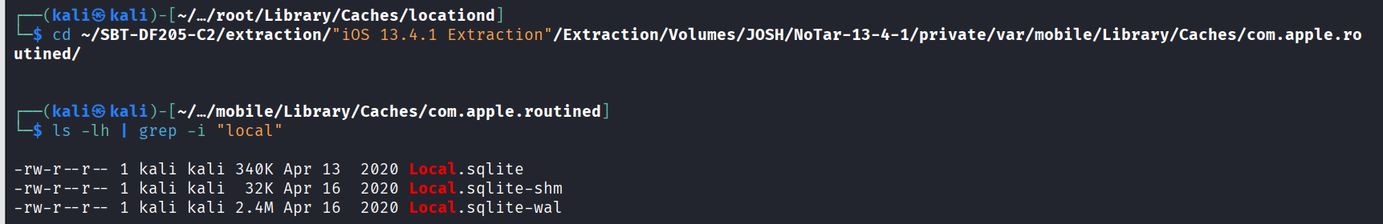FIGURE 46: I navigated to the frequent locations folder.
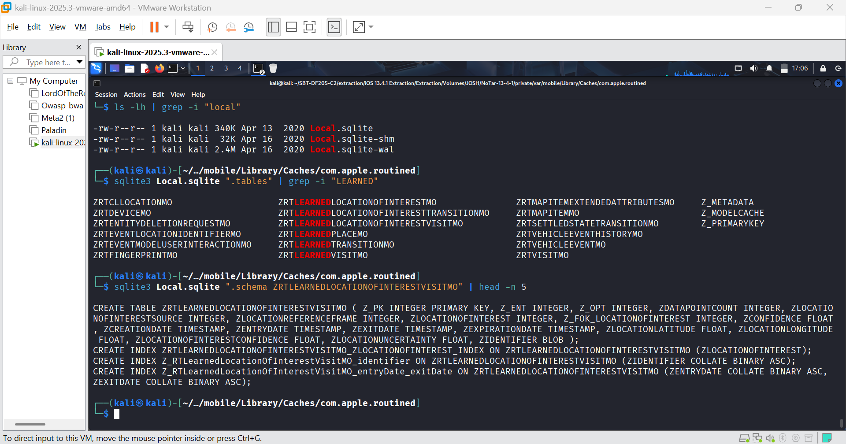FIGURE 47: local.sqlite schema
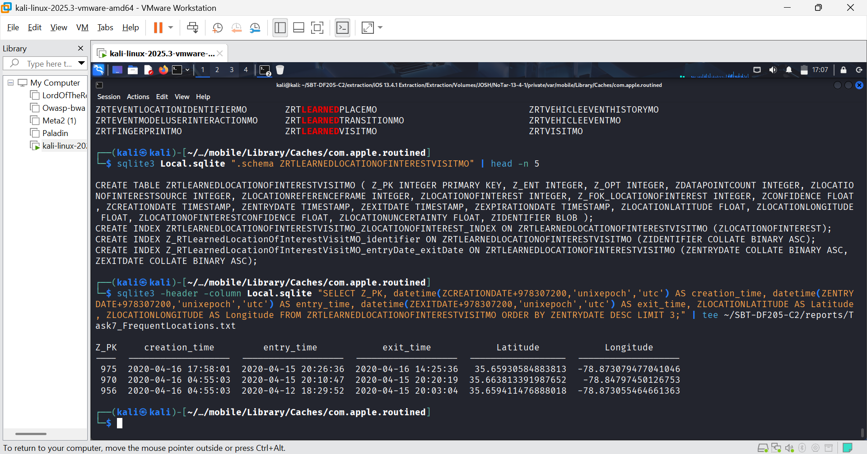FIGURE 48: I extracted 3 learned visits.
Interpretation:
- The ZRTLEARNEDLOCATIONOFINTERESTVISITMO table shows actual visits with entry and exit times, not just creation times.
- Visit Z_PK 975: From 2020-04-15 20:26:36 to 2020-04-16 14:25:36 at coordinates 35.6593, -78.8730.
- Visit Z_PK 956: From 2020-04-12 18:29:52 to 2020-04-15 20:03:04 at coordinates 35.6594, -78.8730.
Comparison with Media/Activity Evidence:
- The Health Data (healthdb_secure.sqlite) showed activity on 2020-04-15 (7,442 steps, 6,007 meters) and 2020-04-16 (2,657 steps, 2,090 meters).
- The Learned Visit Z_PK 975 shows the user was at a location (35.6593, -78.8730) from the evening of April 15 to the afternoon of April 16.
- This correlates perfectly with the Health data (the user was active in that area) and the iMessage and KnowledgeC activity on April 16 (the user was at this location while sending the Siri dictation test messages).
- Distinction: The LteCellLocation records (from cache_encryptedB.db) are raw cell tower/Wi-Fi reference points (e.g., 35.6565, -78.8712). The Learned Visit is a higher-level inference by iOS that the user stayed at a location for a period of time. The coordinates are very close (within ~300 meters), confirming the device was in the Holly Springs, NC area.

Task 8: Timeline and Conclusions
- 2020-03-22 13:05:24 UTC: Photo IMG_0001.JPG created (Imported by 3rd party app). Field: ZGENERICASSET.ZDATECREATED. Epoch/Unit: Cocoa Core 2001 (seconds). Raw Time: 606575124.54104066.
- 2020-03-22 13:10:50 UTC: Photo IMG_0003.JPG created (Imported by 3rd party app). Field: ZGENERICASSET.ZDATECREATED. Epoch/Unit: Cocoa Core 2001 (seconds). Raw Time: 606575450.3272835.
- 2020-03-27 18:41:13 UTC: Received iMessage with Apple Music playlist URL from joshua.hickman1@me.com. Field: message.date. Epoch/Unit: Cocoa Core 2001 (nanoseconds). Raw Time: 607027273290930944.
- 2020-03-27 20:02:05 UTC: Visited Google search "when does mlb start 2020". Field: history_visits.visit_time. Epoch/Unit: Cocoa Core 2001 (seconds). Raw Time: 607050125.99771202.
- 2020-03-27 20:02:44 UTC: Visited Google search "Is the NHL going to resume?". Field: history_visits.visit_time. Epoch/Unit: Cocoa Core 2001 (seconds). Raw Time: 607050164.95356202.
- 2020-03-27 21:44:37 UTC: Visited DFIR Review article on iOS Mobile Installation Logs. Field: history_visits.visit_time. Epoch/Unit: Cocoa Core 2001 (seconds). Raw Time: 607052677.91308296.
- 2020-04-12 12:54:21 UTC: Sent iMessage "Test iMessage..." to joshua.hickman1@me.com. Field: message.date. Epoch/Unit: Cocoa Core 2001 (nanoseconds). Raw Time: 608388861591000064.
- 2020-04-12 13:16:19 UTC: Sent PDF attachment "How was an iPhone set up?.pdf". Field: message.date. Epoch/Unit: Cocoa Core 2001 (nanoseconds). Raw Time: 608390179362000000.
- 2020-04-14 12:43:26 UTC: Missed incoming call from +14082560700. Field: ZCALLRECORD.ZDATE. Epoch/Unit: Cocoa Core 2001 (seconds). Raw Time: 608561006.47257.
- 2020-04-16 11:43:41 UTC: Device unlocked. Field: ZOBJECT.ZSTARTDATE (isLocked=0). Epoch/Unit: Cocoa Core 2001 (seconds). Raw Time: 608730221.
- 2020-04-16 12:56:49 UTC: Received iMessage "This is your test message for Siri dictation". Field: message.date. Epoch/Unit: Cocoa Core 2001 (nanoseconds). Raw Time: 608734609731876864.
- 2020-04-16 12:59:29 UTC: Received iMessage "This is your second test message for Siri dictation". Field: message.date. Epoch/Unit: Cocoa Core 2001 (nanoseconds). Raw Time: 608734769436671488.
Correlations, Interpretations, and Limitations
Three Correlations:
First, there is a clear correlation between Safari searches and an iMessage link on March 27, 2020. At 18:41 UTC, the user received an iMessage containing an Apple Music workout playlist link. Shortly after, between 20:02 and 21:44 UTC, the user was browsing sports news (MLB/NHL) and DFIR articles. This establishes a chronological sequence of communication followed by web browsing.
Second, there is a correlation between device unlock and Siri dictation on April 16, 2020. KnowledgeC activity shows the device was unlocked at 11:43 UTC. Shortly after, at 12:56 and 12:59 UTC, the user received iMessages confirming "Siri dictation" test messages. This correlates the device state directly with the messaging activity.
Third, there is a correlation between frequent location and health activity on April 15-16, 2020. The Health database shows high activity on April 15 (7,442 steps). The Learned Visit (Z_PK 975) shows the user was stationary at coordinates 35.6593, -78.8730 from 20:26 UTC on April 15 until 14:25 UTC on April 16. This correlates physical activity with a specific location in Holly Springs, NC.
Two Alternative Interpretations:
The first alternative interpretation is that the "test message" iMessages sent and received on April 12 and April 16 could be automated scripts or app testing, not manual user typing. The evidence establishes that the messages were sent and received, but it does not prove manual entry by a human.
The second alternative interpretation concerns the location data. The records from LteCellLocation indicate the general area of Holly Springs, NC. However, they could be from a cell tower handoff rather than a precise GPS fix. The evidence establishes the device was in the area, but not the exact street address.
What the Evidence Establishes, What Remains Uncertain and Gaps:
The evidence establishes that the device owner (Josh Hickman) was active on the device between March 22 and April 16, 2020. They communicated via iMessage, sent a PDF attachment, browsed the web for sports and DFIR topics, and were physically located in Holly Springs, NC.
What remains uncertain is whether the "test messages" were manually typed by the user or generated by an automation script. We also could not verify the photo timestamps via EXIF data because the exiftool output was empty.
To resolve these gaps, further evidence would be required, specifically the Sysdiagnose logs (to check for automation frameworks or Siri usage logs) and the original unencrypted EXIF data from the photos (to validate the ZDATECREATED timestamps).

