Title Page
- Lab Title: Investigating Harassment Email Traffic With Wireshark
- Student Name: Hauwa Haruna Yahaya.
- Student ID: FWSD/2025/11219.
- Course Name: Computer Forensics Case Studies
- Instructor Name: Aminu Idris.
- Date of Submission: 03/10/2026

Executive Summary
This investigation analysed the network traffic capture nitroba.pcap to determine whether the available evidence supports attribution of two harassment emails sent to Lily Tuckrige's Yahoo Mail account to a student in Chemistry 109. Using Wireshark and tshark, the analysis identified two HTTP POST requests originating from a single device (MAC 00:17:f2:e2:c0:ce, internal IP 192.168.15.4) that submitted threatening messages to lilytuckrige@yahoo.com via sendanonymousemail.net and willselfdestruct.com on 22 July 2008. The same device was observed logged into the Gmail account jcoachj@gmail.com, which plausibly corresponds to roster student Johnny Coach.

Lab Objectives
The objective of this lab is to perform a methodical forensic review of a packet capture in a simulated harassment investigation, applying Wireshark and tshark to identify client and server endpoints, correlate HTTP traffic with reported message content, extract identity evidence from cookies, match that identity against a supplied class roster and produce a defensible attribution assessment that clearly distinguishes observed facts, reasonable inferences and evidentiary limitations.

Tools and Resources Used
- Kali Linux 2025.3
- Wireshark 4.x
- tshark 4.6.6 (command-line packet filtering and field extraction)
- capinfos
- sha256sum

Methodology

Lab Folder Structure and Evidence Preparation
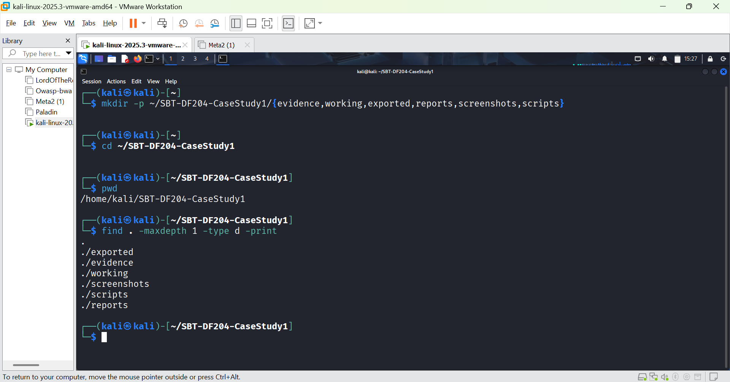FIGURE 1: Lab folder structure.

Forensic working copy
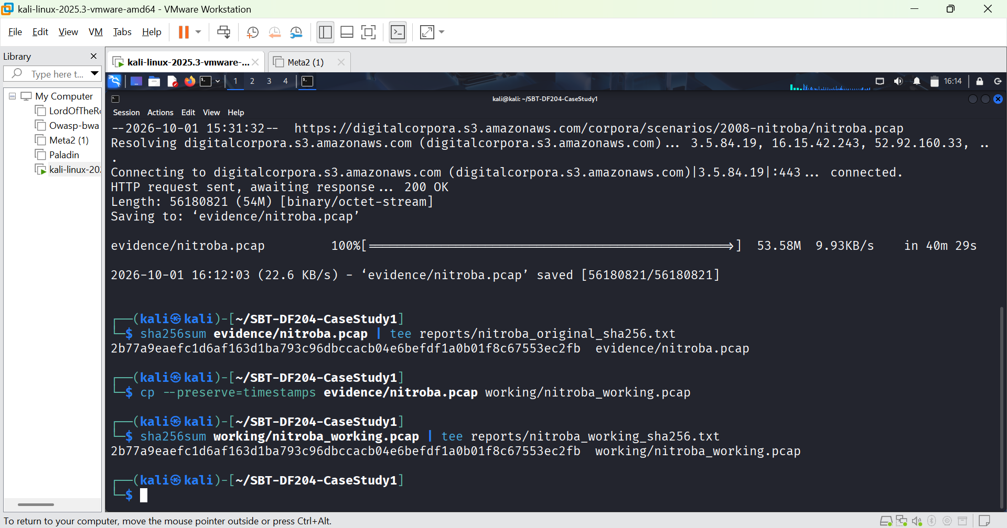FIGURE 2: Original and working copies.
FIGURE 3: File sizes and download date

Mini Evidence and Chain-of-Custody Worksheet
Field | Student Entry
Case/lab identifier | SBT-DF204-CaseStudy1-HauwaHarunaYahaya
Trainee Name | Hauwa Haruna Yahaya
Date and time started | 01/10/2026 5:00pm WAT
Evidence file name(s) | Nitroba.pcap
Source or generation method | Downloaded from digitalcorpora.org
Original SHA256 | 2b77a9eaefc1d6af163d1ba793c96dbccacb04e6befdf1a0b01f8c67553ec2fb
Workin-copy SHA256 | 2b77a9eaefc1d6af163d1ba793c96dbccacb04e6befdf1a0b01f8c67553ec2fb
Analysis workstation | Kali linux
Notes on any changes | Working copy created, original preserved

PART A - Inventory
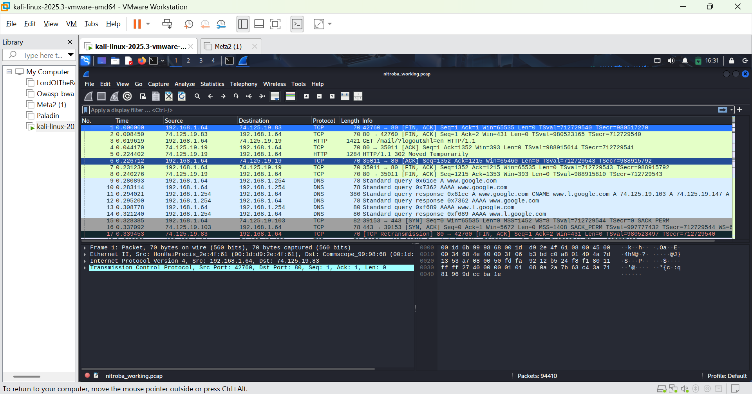FIGURE 4: Wireshark interface showing total number of packets as 94410.
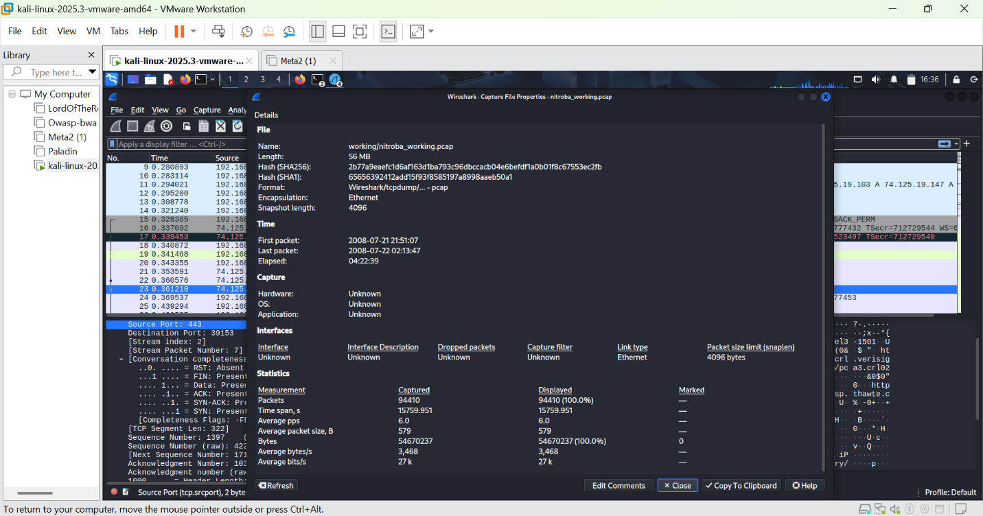FIGURE 5: File properties.
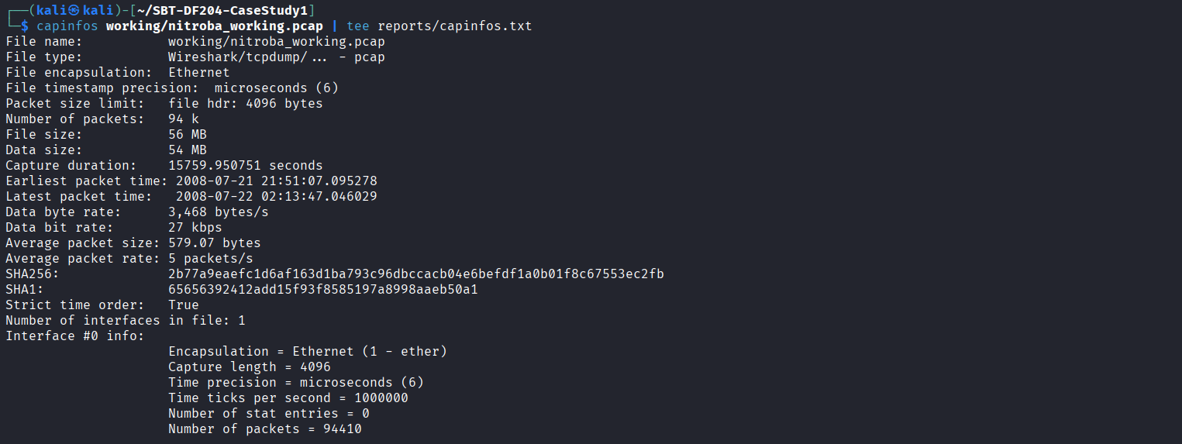FIGURE 6: File information on tshark
Capture duration: 15,759.950751 seconds (4 hours 22 minutes 39 seconds)
Earliest packet : 2008-07-21 21:51:07.095278
Latest packet: 2008-07-22 02:13:47.046029
Time zone: EDT (-0400)
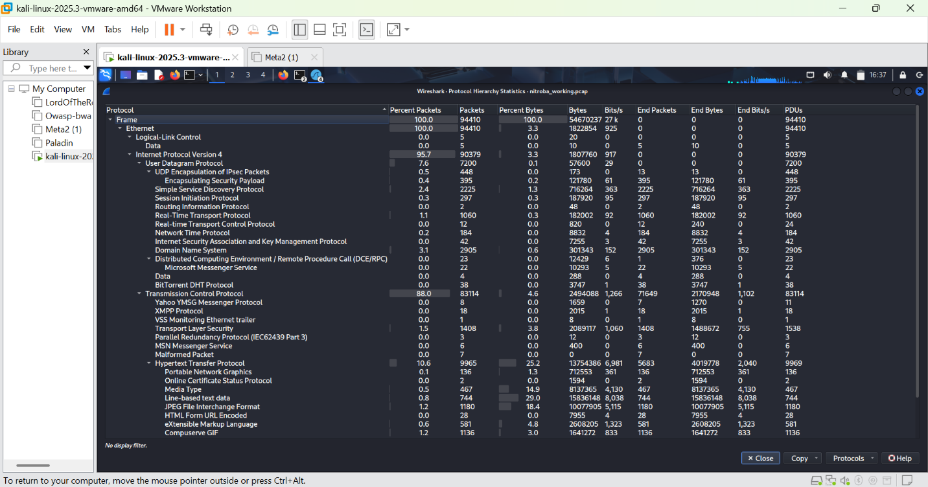FIGURE 6: Protocol hierarchy in wireshark
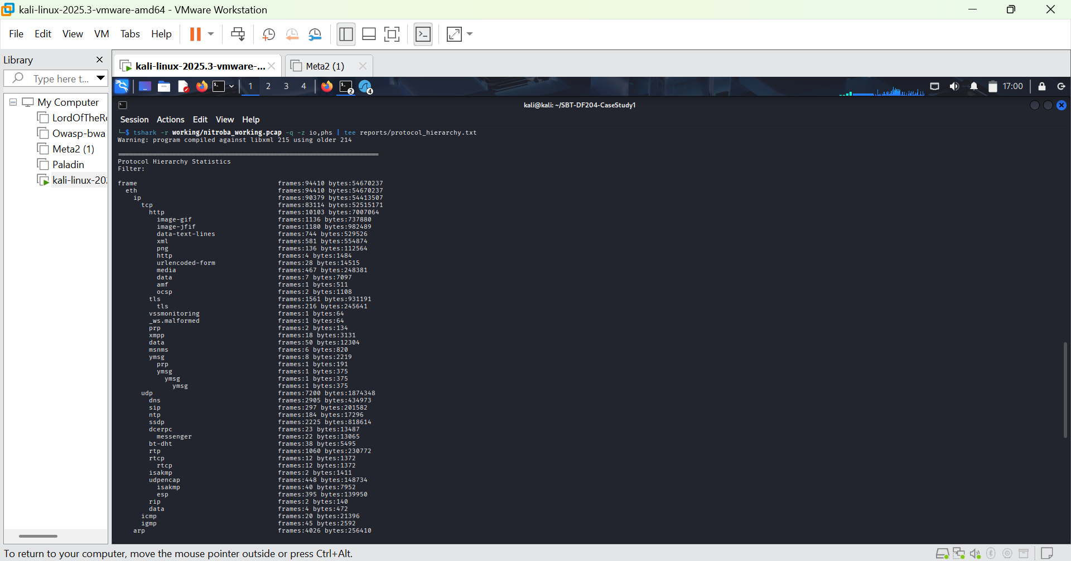FIGURE 7: Protocol hierarchy in tshark
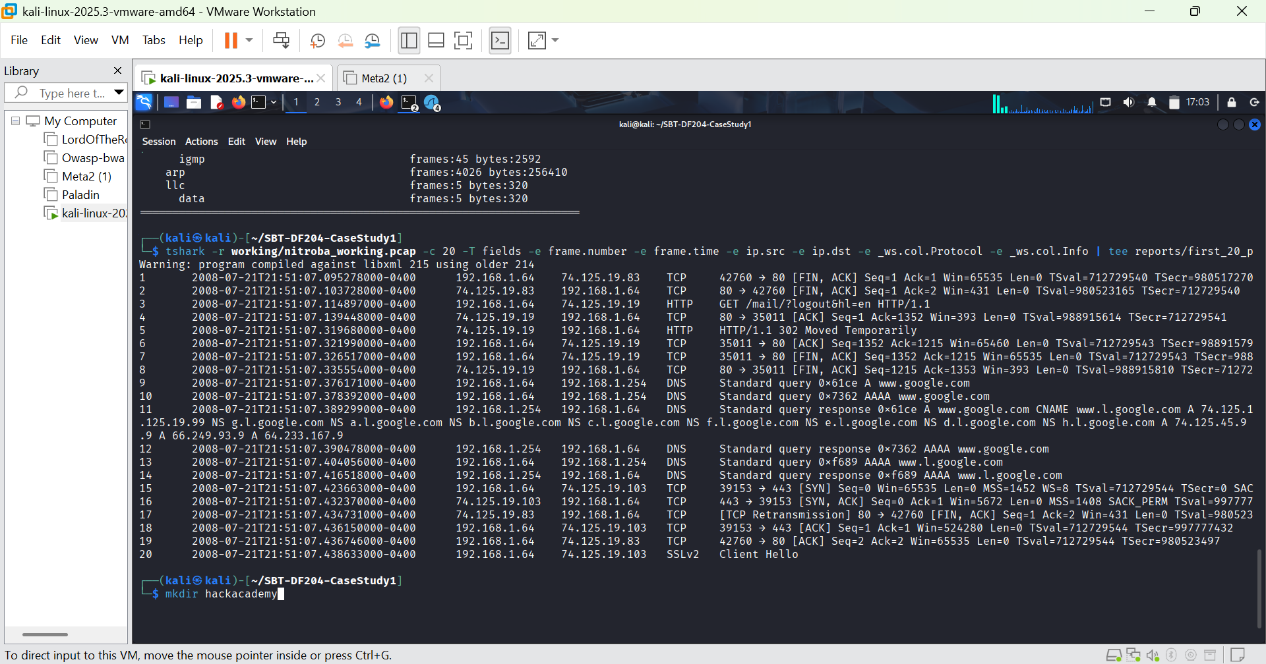FIGURE 8: First 20 packets
Client:192.168.1.64 - This is the internal device
Gateway: 192.168.1.254 - The router
Google Mail: 74.125.19.83, 74.125.19.19 - Gmail servers

PART B - Identify HTTP Traffic and Web Services
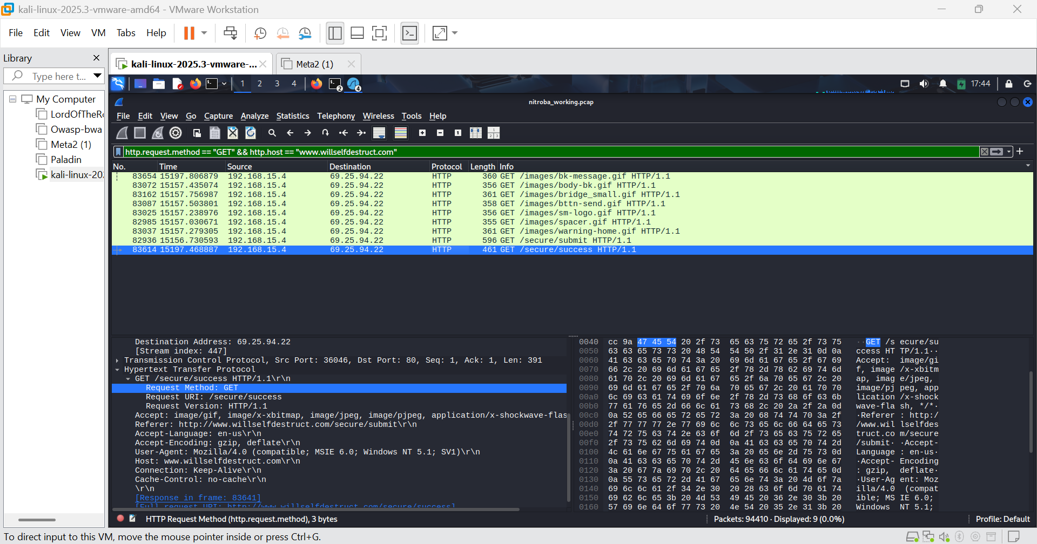FIGURE 9: http requests in wireshark
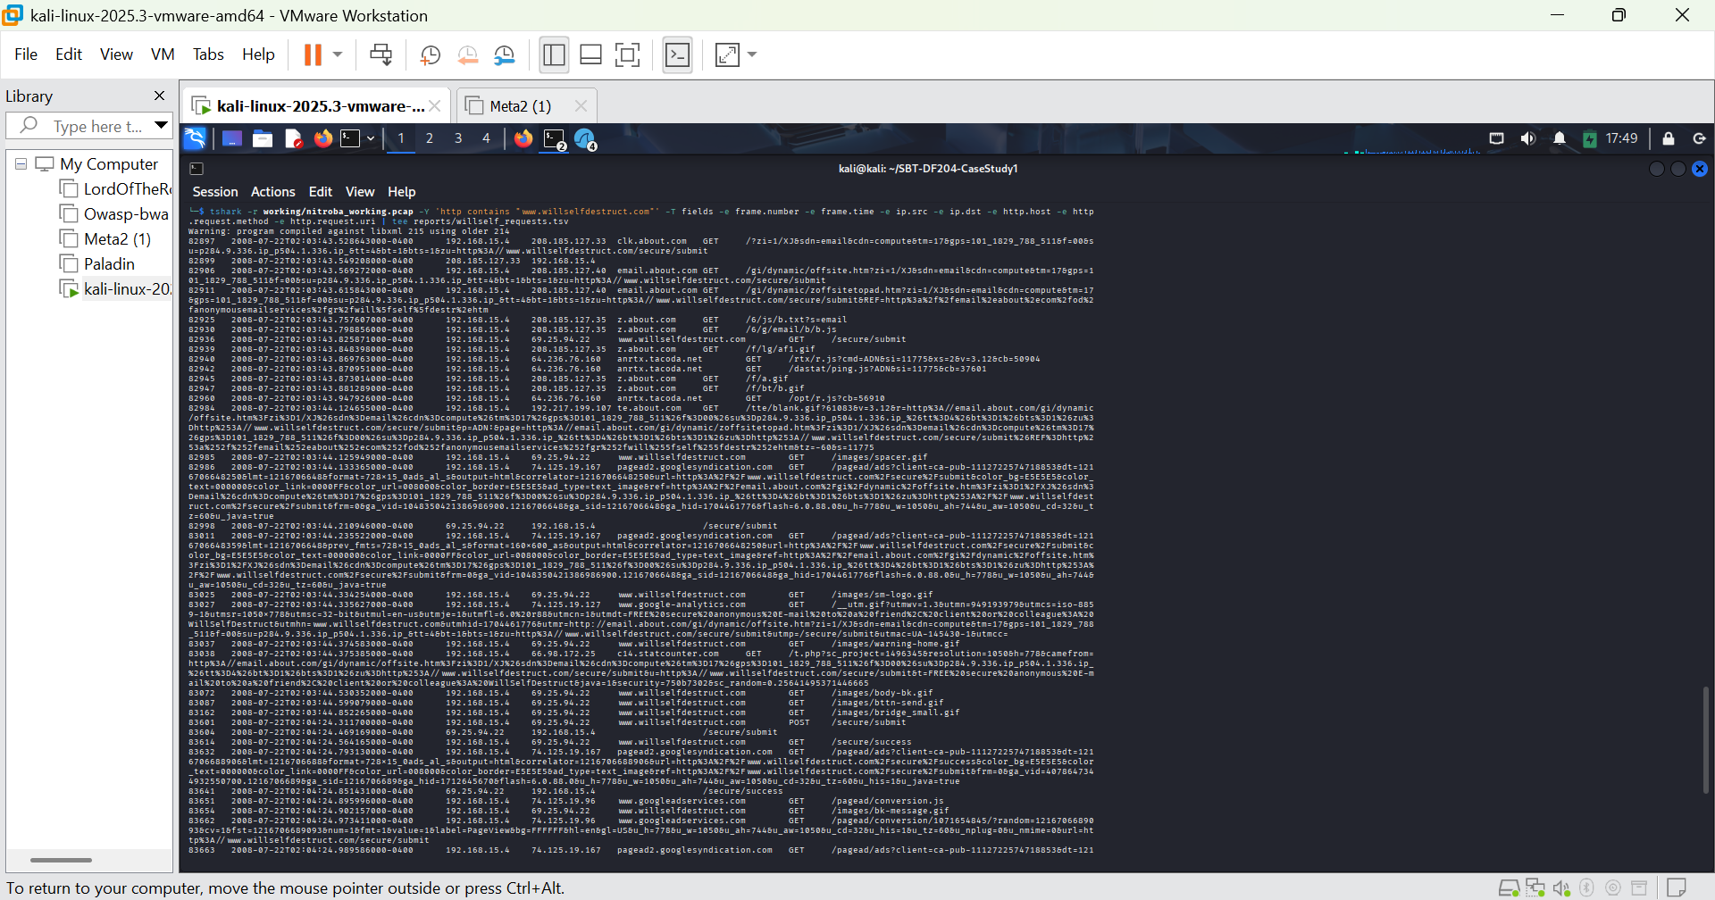FIGURE 10: http requests in tshark.
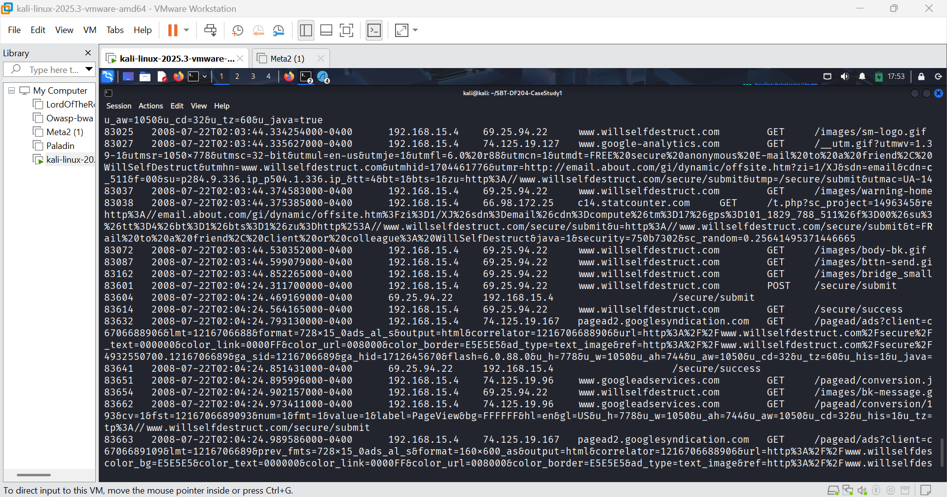FIGURE 11: Zoomed from figure 10
At 02:04:24 EDT on 22 July 2008, the client at 192.168.15.4 sent an HTTP POST to www.willselfdestruct.com at IP 69.25.94.22, to the URI /secure/submit.
The server responded 158 milliseconds later (frame 83604), and then the client immediately loaded /secure/success (frame 83614). This is the sequence of a successfully submitted form.
In Part A, the client was 192.168.1.64. But here, the client is 192.168.15.4.

Part B - Findings Summary
Service Hostname: www.willselfdestruct.com
Service IP: 69.25.94.22
First request to service: Frame 82936 at 02:03:43.825871 EDT
Client IP at time of service: 192.168.15.4
Client MAC: 00:17:f2:e2:c0:ce (Apple)
POST to /secure/submit: Frame 83601 @ 02:04:24.311700 EDT
Server response: Frame 83604 @ 02:04:24.469169 EDT
Success page: Frame 83614 @ 02:04:24.564165 EDT
Time from page load to submit: 40.5 seconds

Part C - Locate the Client and Device

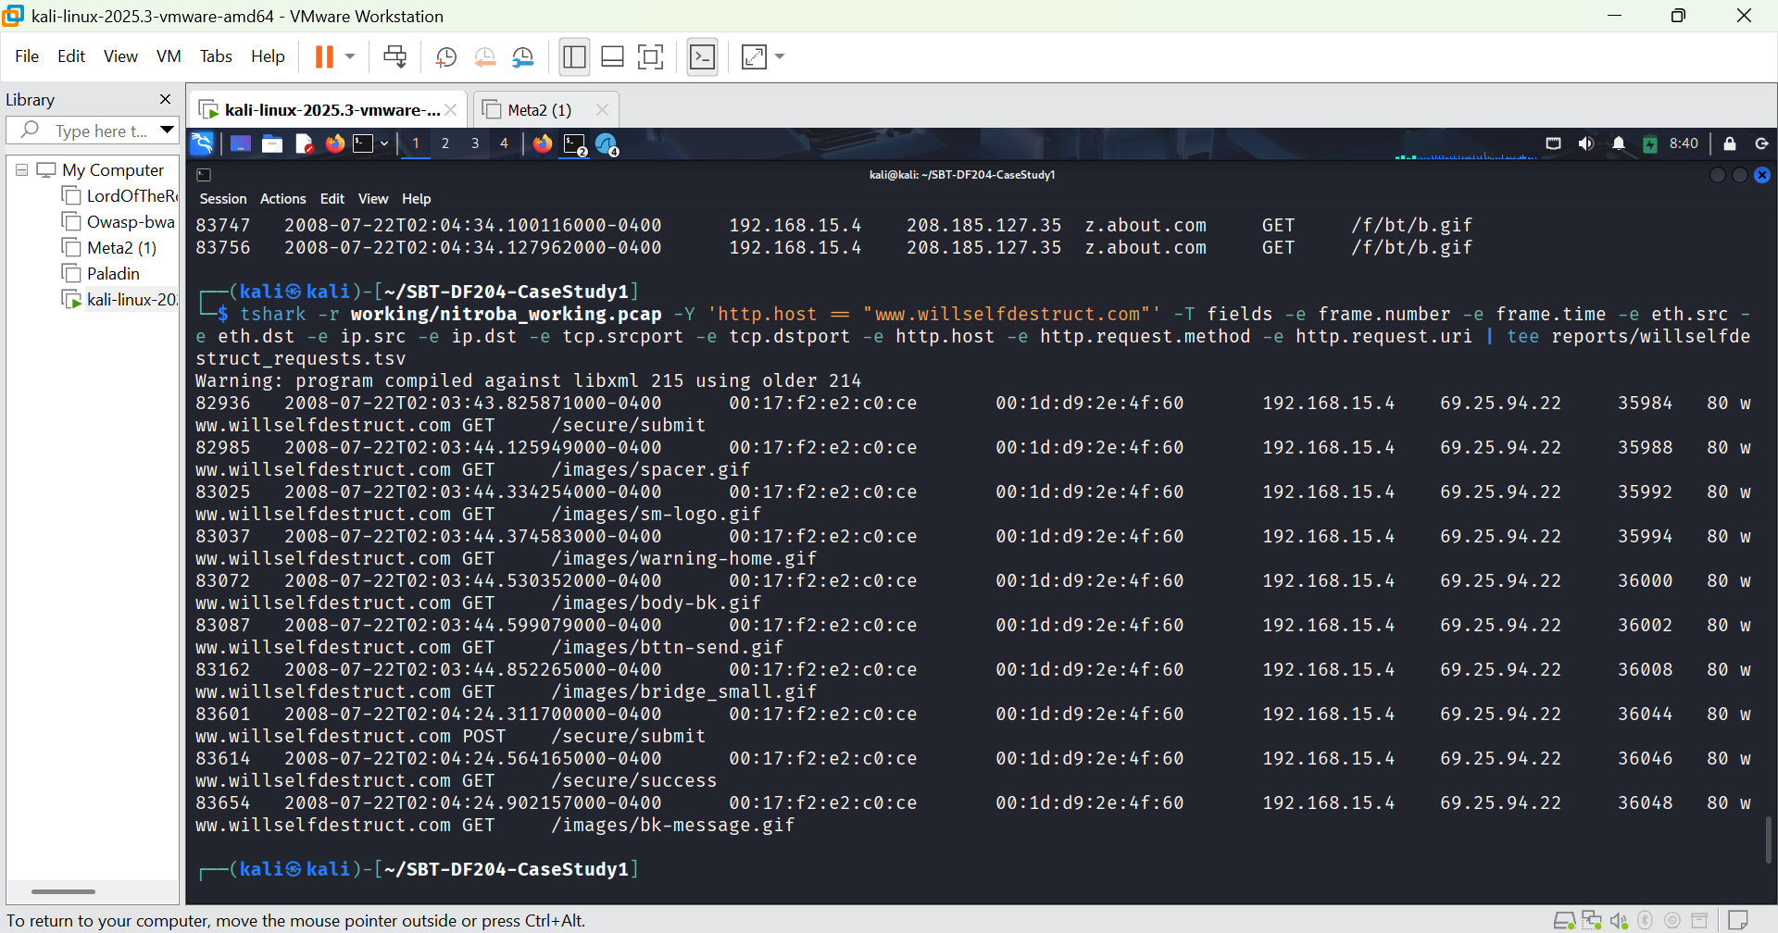FIGURE 12: Post packet details.

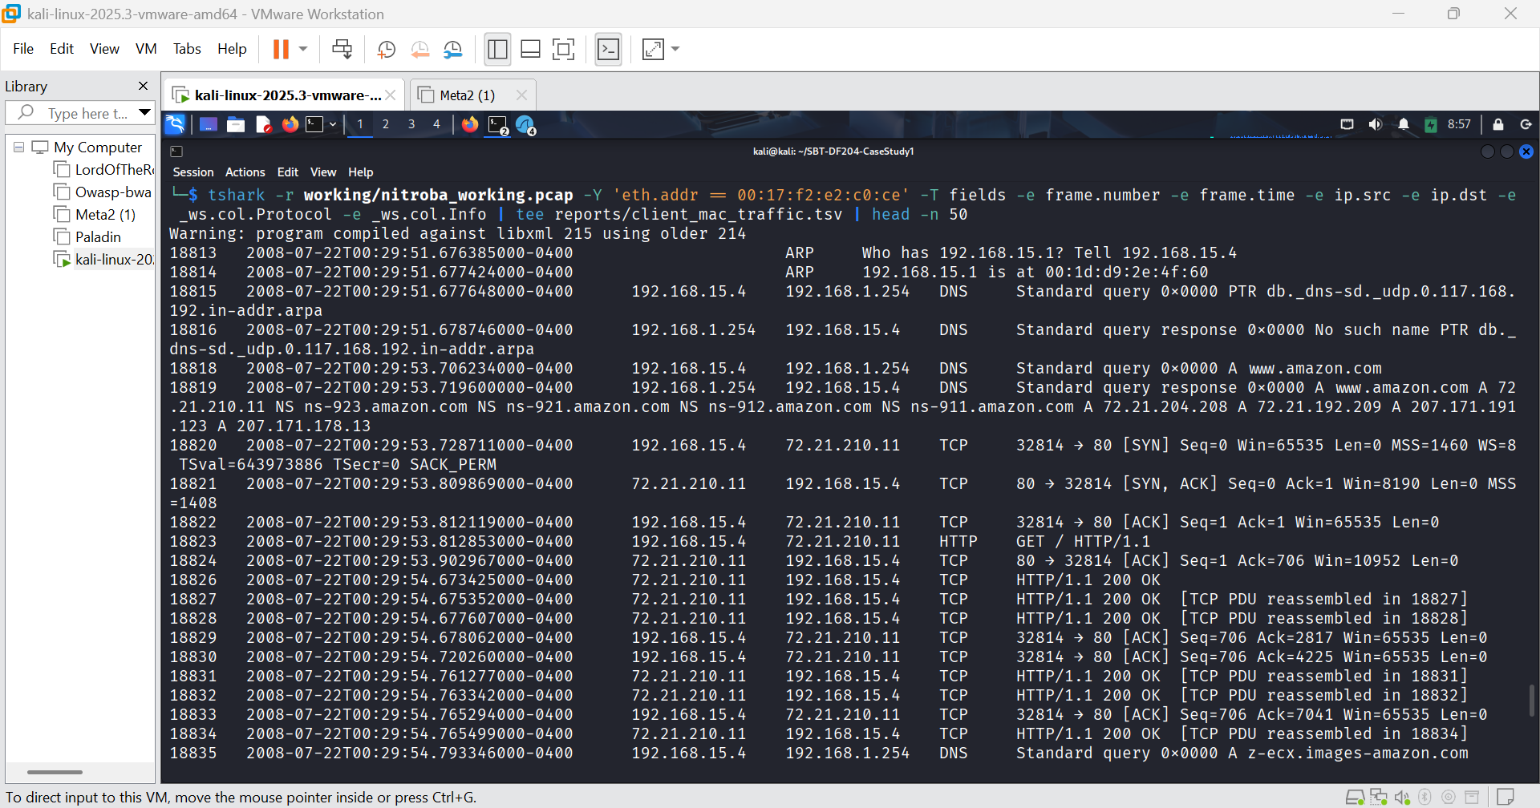FIGURE 13: First 50 packets from the device
Key Findings
Client IP: 192.168.15.4
Server IP: 69.25.94.22
Client MAC: 00:17:f2:e2:c0:ce
Server MAC (gateway): 00:1d:d9:2e:4f:60
Client Port (POST): 36044
Server Port: 80
First contact with service: Frame 82936 at 02:03:43.825871 EDT
Form submission (POST): Frame 83601 at 02:04:24.311700 EDT
Success page loaded: Frame 83614 at 02:04:24.564165 EDT

Part D - Correlate the Harassment Message
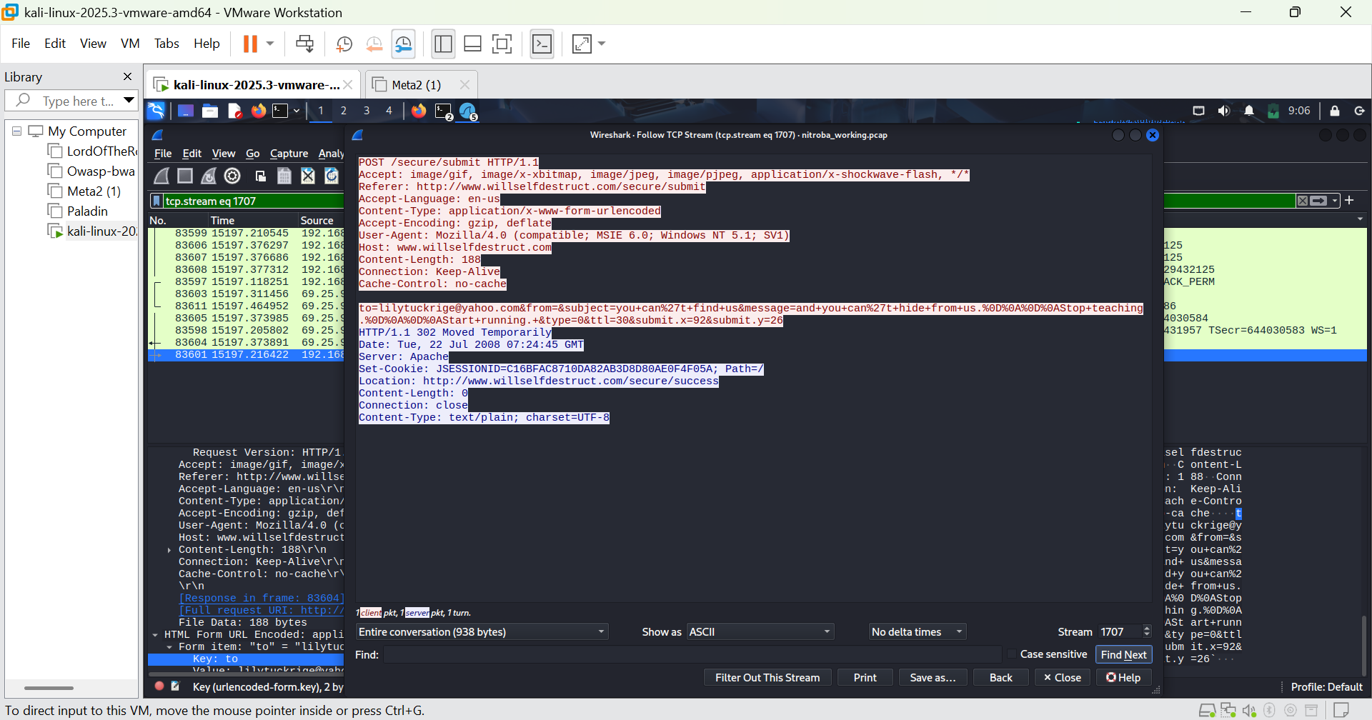FIGURE 14: TCP stream for frame 83601
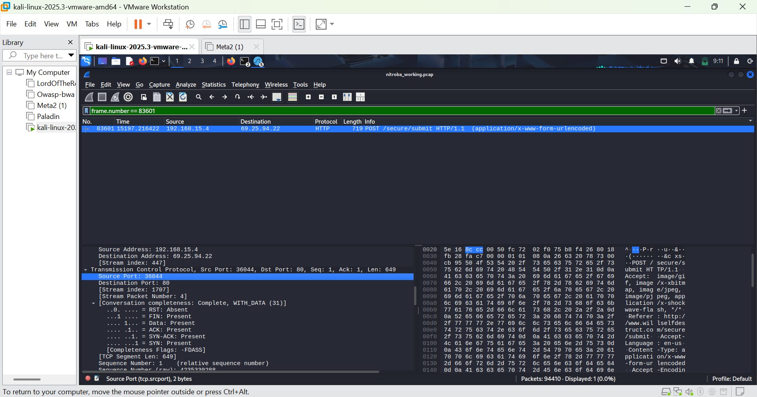FIGURE 15: I identified the stream index as 1707.
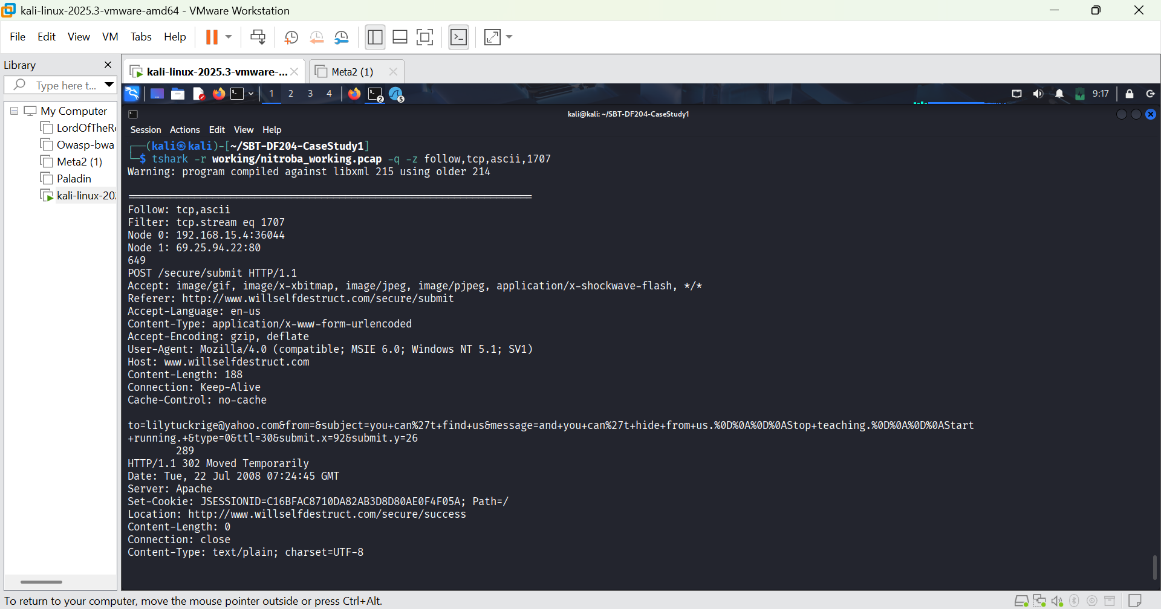FIGURE 16: Following the TCP stream, it can be seen that a message was sent to lilytuckrige at yahoo.com with the subject ‘you cant find us’ and message ‘you cant hide from us’.
FIGURE 17: About 87 seconds before the willselfdestruct.com submission, the same device sent the victim's email to a different anonymous email service ‘sendanonymousemail.net’ with frame number ‘80614’.
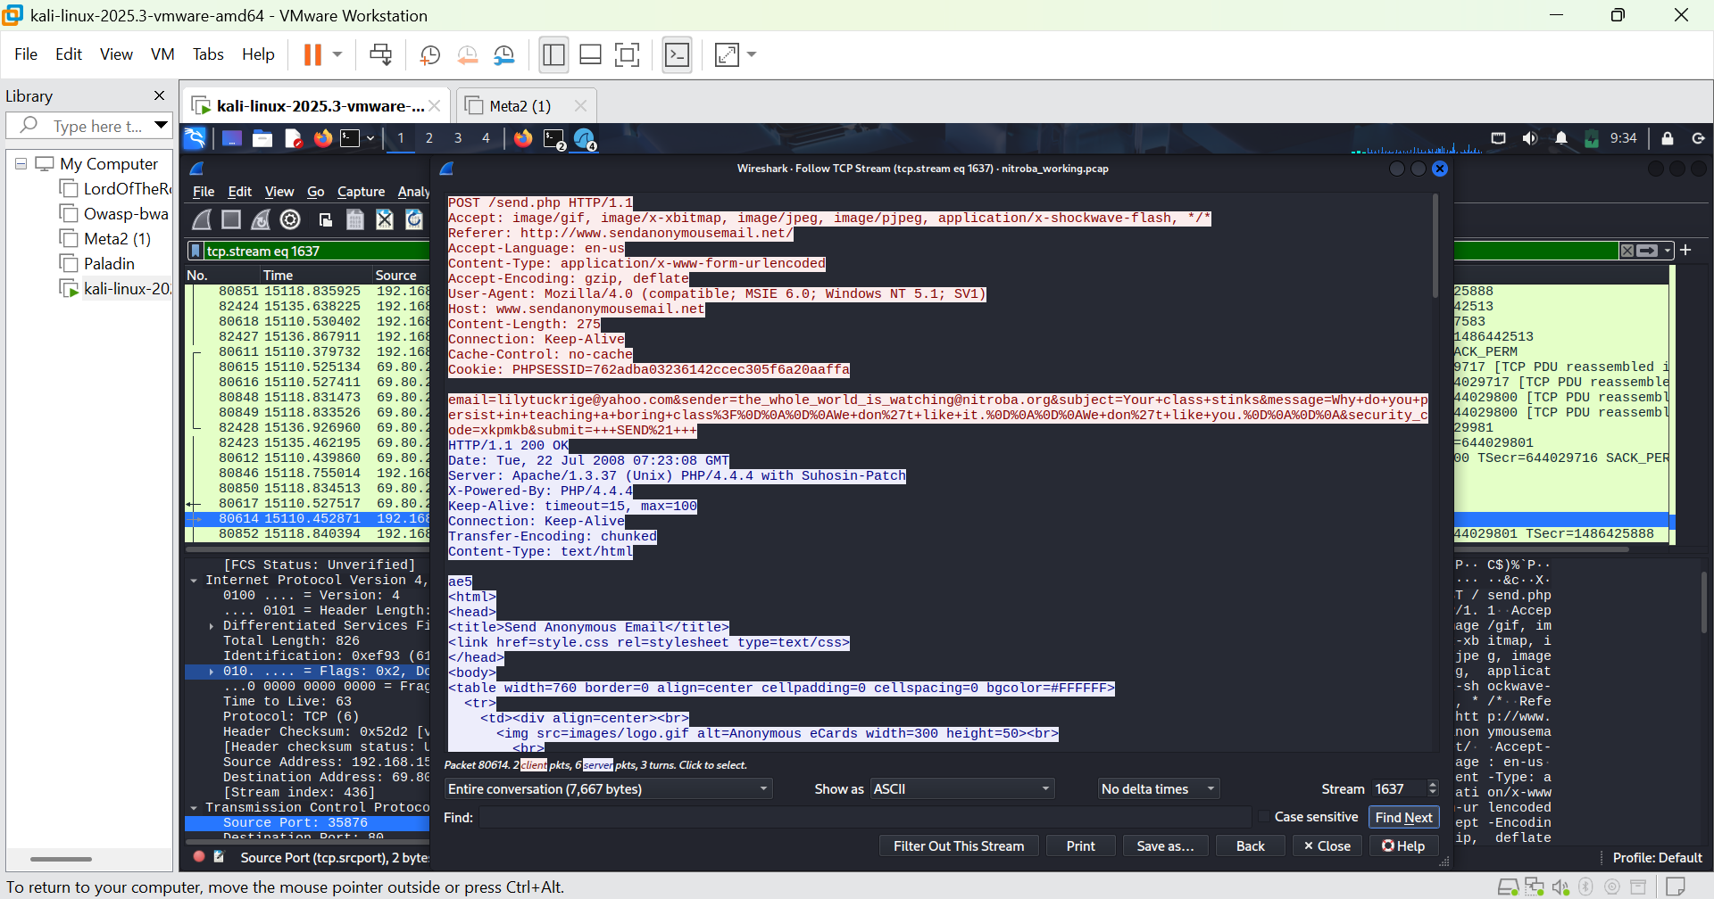FIGURE 18: TCP stream for frame number 80614. A message was sent to lilytuckrige@yahoo.com from ‘the_whole_world_is_watching@nitroba.org’ with the subject ‘your class stinks’ and message ‘ why do you persist in teaching a boring class. We don’t like you.’

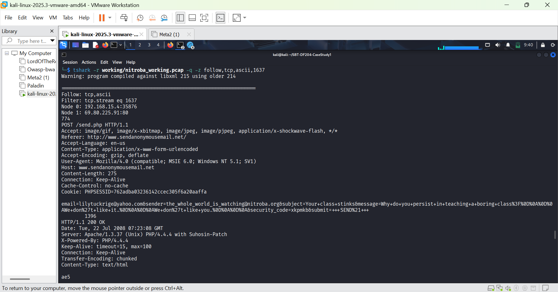FIGURE 19: tshark esuivalent of the above tcp stream
Two Messages, Same Device, Same User-Agent

Part E - Identity Evidence via Cookies
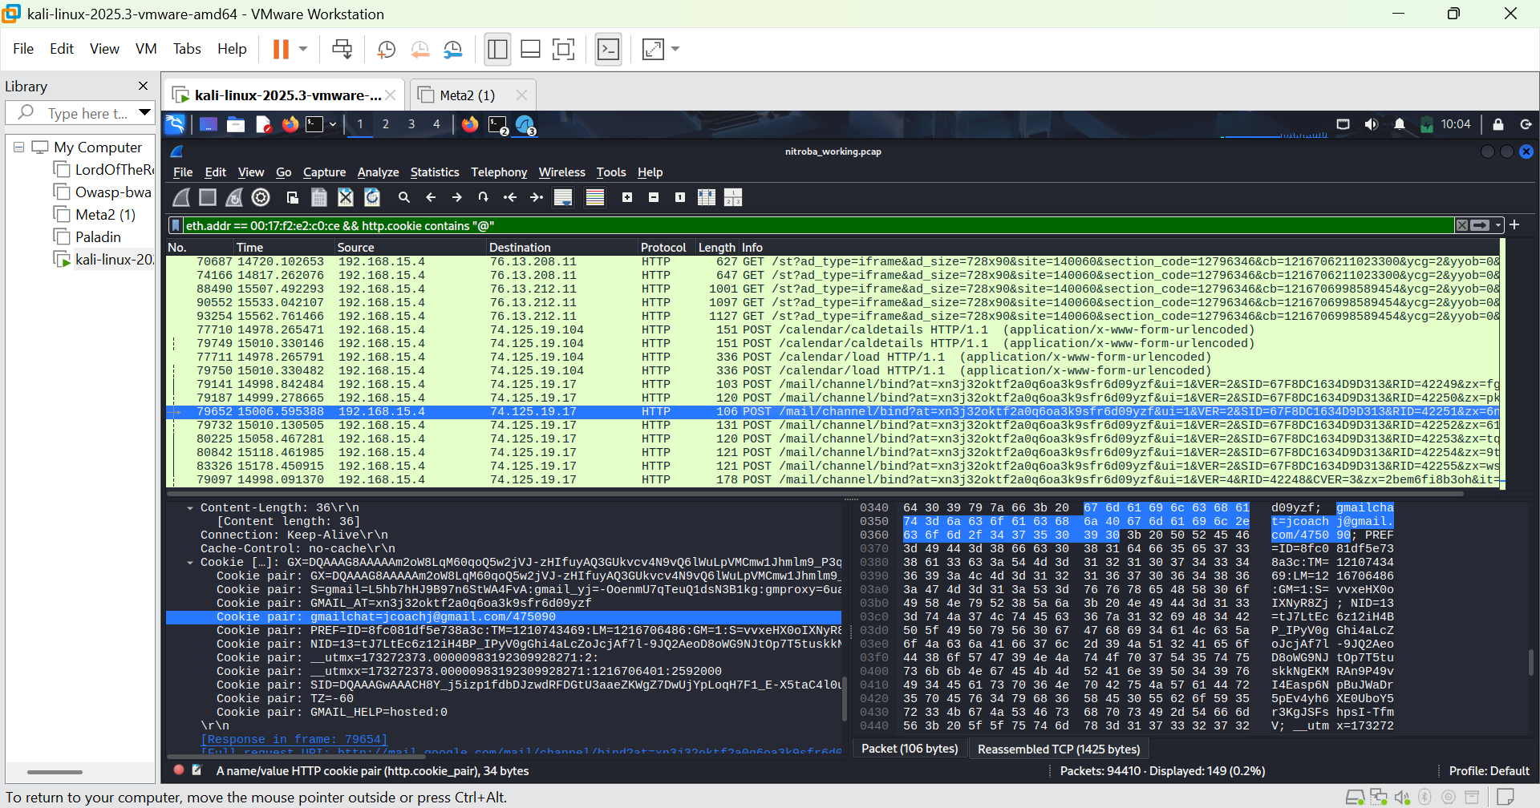FIGURE 20: The suspect device is logged into gmail as jcoachj@gmail.com
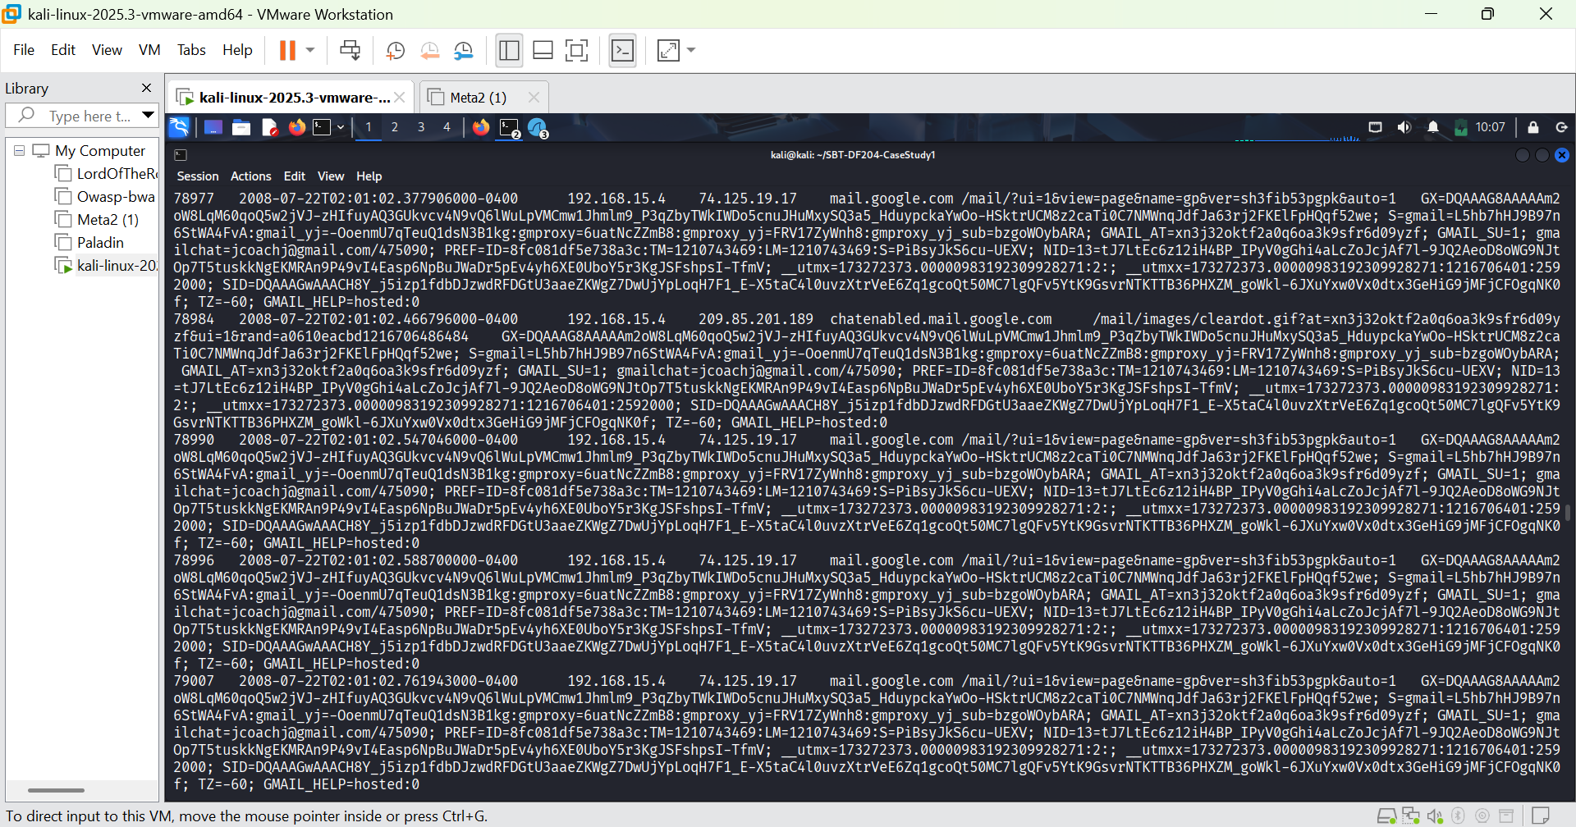FIGURE 20: I used the command ‘tshark -r working/nitroba_working.pcap -Y 'eth.addr == 00:17:f2:e2:c0:ce && http.cookie contains "@"' -T fields -e frame.number -e frame.time -e ip.src -e ip.dst -e http.host -e http.request.uri -e http.cookie | tee reports/identity_cookies.txt’ to find the cookie pair.

Part F - Matching the Identity to the Roster
The Chem 109 roster is provided in the scenario narration document, retrieved from digitalcorpora.org. It is external to the PCAP and is used here only for comparison
Amy Smith, Burt Greedom, Tuck Gorge, Ava Book, Johnny Coach, Jeremy Ledvkin, Nancy Colburne, Tamara Perkins, Esther Pringle, Asar Misrad, Jenny Kant
The device (MAC 00:17:f2:e2:c0:ce, IP 192.168.15.4) was observed with an active Gmail session using the account jcoachj@gmail.com. This is evidenced by the gmailchat cookie in frame 78977 at 02:01:02.377906 EDT.

Supporting evidence:
- Frame 78977, HTTP cookie to mail.google.com
- Cookie value: gmailchat=jcoachj@gmail.com/475090
- Same device MAC as the harassment messages
The Chem 109 roster includes a student named Johnny Coach. The Gmail username jcoachj corresponds to ‘J. Coach’, a reasonable match for Johnny Coach.
Basis:
- Username structure: first initial + last name.
- Roster contains Johnny Coach
- This is inferential not conclusive
No other roster name plausibly matches the username jcoachj. Surname and initial uniquely align with Johnny Coach.

Evidence ID | Packet or item | Finding | Why it matters | Screenshot or appendix
E01 | nitroba.pcap (original file) | SHA-256: 2b77a9eaefc1d6af163d1ba793c96dbccacb04e6befdf1a0b01f8c67553ec2fb | Establishes evidence integrity and chain of custody | Figure 2
E02 | Capture file summary (capinfos) | 94410 packets, duration 15,759.95 s, first packet 2008-07-21 21:51:07.095278 EDT | Establishes scope, time zone and content of the capture | Figure 6
E03 | Frame 83601 | POST to willselfdestruct.com /secure/submit, time 02:04:24.311700 EDT | Direct evidence of harassment message number 2 | Figure 14 and 16
E04 | Frame 83601 (Ethernet + IP) | Client MAC 00:17:f2:e2:c0:ce, Client IP 192.168.15.4, Server IP 69.25.94.22 | Links the harassment message to a specific device | Figure 12
E05 | Frame 80614 | POST to sendanonymousemail.net /send.php, time 02:02:57.548149 EDT, recipient lilytuckrige@yahoo.com | Direct evidence of harassment message number1 (earlier message) | Figure 18 and 19
E06 | Frame 78977 | HTTP Cookie to mail.google.com containing gmailchat=jcoachj@gmail.com/475090, time 02:01:02.377906 EDT | Links the device to a specific Gmail identity | Figure 20 and 21

Conclusion
A specific device (MAC 00:17:f2:e2:c0:ce) sent two harassment messages, the same device was logged into jcoachj@gmail.com, jcoachj plausibly maps to Johnny Coach on the roster.

