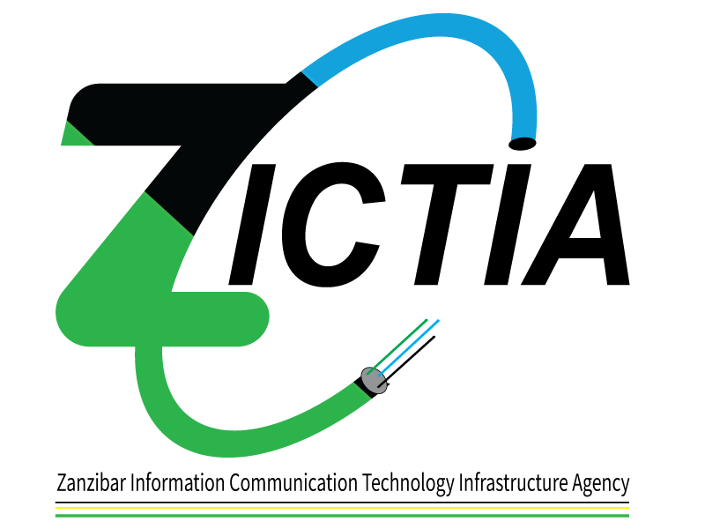

**PUBLIC NOTICE**

Zanzibar Information Communication Technology Infrastructure Agency (ZICTIA) would like to notify the public of the withdrawal of the Newspaper tender notice placed on **15th September, 2021**. The notice reflected

**Supply of Fiber Equipment** tender no: SMZ/P0116/G/NCB/2021-2022/22 and;

**Supply of Wooden Poles and its tension hooks in a Framework Contract tender no:** SMZ/P0116/G/NCB/2021-2022/25