**NPGIS对于各种地图的接入方式总结**

|  |  |  |
| --- | --- | --- |
| **日期** | **修改说明** | **修改人** |
| 2015.4.20 | 创建 | 樊旭丹 |
| 2015.4.24 | 增加PVA,PVD 接入方法说明,修改文档格式 | 李世岗 |
| 2015.7.16 | 新增跨网段地图配置 | 李世岗 |
| 2015.7.21 | 增加PVA接入NPGIS Server天地图配置 | 樊旭丹 |

# 现场提供地图

## 提供PGIS 4326

### 获取相关参数

在PGIS地图展示页面，按F12，找到**EzMapAPI.js**文件，获取相关参数。

#### 获取地图服务地址

搜索： EzServerClient.GlobeParams.MapSrcURL

找到如下内容：

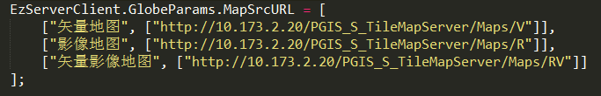

图片中包括矢量地图URL,影像地图URL和矢量影像地图URL,根据需求配置。

#### 获取地图中心点

搜索：EzServerClient.GlobeParams.CenterPoint



#### 地图最小/最大层级/偏移量获取

最小层级： EzServerClient.GlobeParams.MapInitLevel



最大层级： EzServerClient.GlobeParams.MapMaxLevel



偏移量:EzServerClient.GlobeParams.ZoomOffset



#### 地图范围获取

EzServerClient.GlobeParams.MapFullExtent



### 示例代码

* 注意：minZoom 类型的标注为需要改动的地方

var mapContainer = document.getElementById("mapId");

var map = new NPMapLib.Map(mapContainer, {

minZoom: 11,// 初始值：zoomOffset + 地图最小层级，根据实际情况调整

maxZoom: 19, // zoomOffset + 地图最大层级

projection: "EPSG:4326"//投影方式：4326

});

//图层参数

var opts = {

centerPoint: [116.99267, 36.66586],//中心点坐标

fullExtent: [116.71416, 36.48037, 117.27471, 36.84609],//地图范围

minLevel: 11,// 初始值：zoomOffset + 地图最小层级，根据实际情况调整

maxLevel: 19,// zoomOffset + 地图最大层级

zoomOffset: 0 // 默认0

};

var url = "http://10.48.1.227:9080/PGIS_S_TileMapServer/Maps/default"

layerSLYX = new NPMapLib.Layers.EzMapTileLayer(url, "矢量影像地图", opts);

map.addLayers([layerSLYX]);

注意：地图的最小层级根据具体的需要做调整

## 提供ArcGIS 4326

### 获取相关参数

从服务地址

<http://192.168.60.242:6080/arcgis/rest/services/shanghaiBaseMap/MapServer>

获取相关参数

#### 获取最小/最大层级

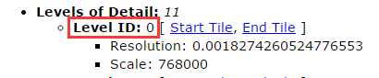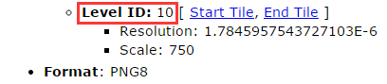

#### 最大范围

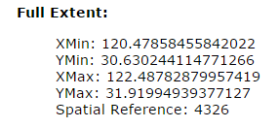

#### 分辨率数组

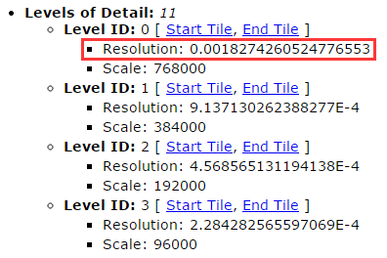

#### 切片大小

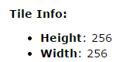

#### 切片原点



#### 投影方式



### 示例代码

* 注意：minZoom 类型的标注为需要改动的地方

var mapContainer = document.getElementById(mapId);

var map = new NPMapLib.Map(mapContainer, {

minZoom: 0,//最小缩放级别

maxZoom: 10,//最大缩放级别

restrictedExtent: [120.21702921092, 29.953534077485, 122.55613455809, 32.292639424656]//

});

var extent = [120.47858455842022, 30.630244114771266, 122.48782879957419, 31.91994939377127];//最大范围

var url = 'http://192.168.60.242:6080/arcgis/rest/services/shanghaiBaseMap/MapServer';//服务地址

var baseLayer = new NPMapLib.Layers.ArcgisTileLayer(url, 'Aerials', {

isBaseLayer: true,

resolutions: [

0.0018274260524776553, 0.0009137130262388277,

0.0004568565131194138, 0.0002284282565597069,

0.00011421412827985346, 0.00005710706413992673,

0.000028553532069963364, 0.000014276766034981682,

0.000007138383017490841, 0.0000035691915087454205,

0.0000017845957543727103

],//分辨率数组

tilePixels: 256,//切片大小

origin: [-400, 399.9999999999998],//切片原点

fullExtent: extent, //最大范围

projection: 'EPSG:4326',//投影方式

zoomOffset: 0 //偏移量，控制从第几级开始显示地图

});

map.addLayers([baseLayer]);

# 现场不提供地图

## 天地图在线地图（需联网） 4326

天地图是经纬度坐标（4326），以下以上海市为例

### 使用拾位器获取上海市的中心点

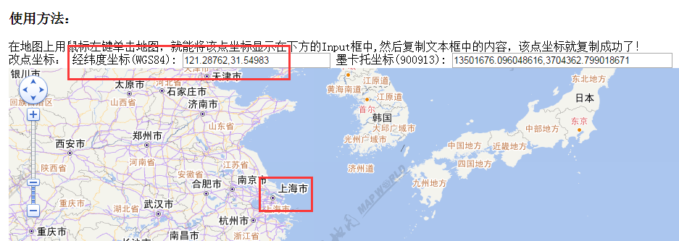

121.28762,31.54983

### 代码示例

* 注意：minZoom 类型的标注为需要改动的地方

var mapContainer = document.getElementById("mapId");

map = new NPMapLib.Map(mapContainer, {

minZoom: 10,//最小级别，可根据需要设置

maxZoom: 18//最大级别

});

//图层参数

var opts1 = {

mapType: 'EMap',

centerPoint: [121.28762,31.54983],//中心点坐标，使用拾位器获得

fullExtent: [-180, -90, 180, 90],//固定值，不可改动

topLevel: 0,//固定值，不可改动

bottomLevel: 18,//固定值，不可改动

isBaseLayer: true,

mirrorUrls: ["http://tile4.tianditu.com/DataServer",

"http://tile5.tianditu.com/DataServer",

"http://tile6.tianditu.com/DataServer"],//固定值，不可改动

zoomOffset: 0//固定值，不可改动

};

var opts2 = {

mapType: 'ESatellite',

centerPoint: [121.28762,31.54983], //中心点坐标，使用拾位器获得

fullExtent: [-180, -90, 180, 90], //固定值，不需改动

topLevel: 0, //固定值，不可改动

bottomLevel: 18, //固定值，不可改动

isBaseLayer: false,

mirrorUrls: ["http://tile4.tianditu.com/DataServer",

"http://tile5.tianditu.com/DataServer",

"http://tile6.tianditu.com/DataServer"],//固定值，不可改动

zoomOffset: 0//固定值，不可改动

};

var url = "http://tile1.tianditu.com/DataServer";//固定值，不可改动

var layerSLYX = new NPMapLib.Layers.TDMapLayer(url, "ditu", opts1);

var layerBZ = new NPMapLib.Layers.TDMapLayer(url, "biaozhu", opts2);

map.addLayers([layerSLYX, layerBZ]);

## 天地图离线地图 4326

天地图是经纬度坐标（4326），以下以上海市为例

### 示例代码

* 注意：minZoom 类型的标注为需要改动的地方

var mapContainer = document.getElementById("mapId");

map = new NPMapLib.Map(mapContainer, {

minZoom: 13, //最小级别，根据实际切片的级数来确定

maxZoom: 16, //最大级别，根据实际切片的级数来确定

restrictedExtent: [116.85704040528,33.551647186279,117.10835266114,33.725025177002], //抓图工具设置的抓图范围

projection: "EPSG:4326"

});

//图层参数

var opts1 = {

mapType: 'EMap',

centerPoint: [116.98269653321, 33.6383361816405],//抓图工具设置的中心点

fullExtent: [-180, -90, 180, 90], //固定值，不可改动

topLevel: 0, //固定值，不可改动

bottomLevel: 18, //固定值，不可改动

isBaseLayer: true,

mirrorUrls: ["http://192.168.60.242:1080/Cache/suzhou/vec_c/"],//切片所在位置

zoomOffset: 0,

isLocalMap: true

};

var opts2 = {

mapType: 'ESatellite',

centerPoint: [116.98269653321, 33.6383361816405], //抓图工具设置的中心点

fullExtent: [-180, -90, 180, 90], //固定值，不可改动

topLevel: 0, //固定值，不可改动

bottomLevel: 18, //固定值，不可改动

isBaseLayer: false,

mirrorUrls: ["http://192.168.60.242:1080/Cache/suzhou/cva_c/"],//切片所在位置

zoomOffset: 0,

isLocalMap: true

};

var url = "http://tile1.tianditu.com/DataServer";//固定值，不可改动

var layerSLYX = new NPMapLib.Layers.TDMapLayer(url, "ditu", opts1);

var layerBZ = new NPMapLib.Layers.TDMapLayer(url, "biaozhu", opts2);

map.addLayers([layerSLYX, layerBZ]);

## 高德地图在线地图 （需联网）900913

高德地图是墨卡托坐标（900913），比较特殊。以下以上海市为例。

### 使用拾位器获取上海市的中心点

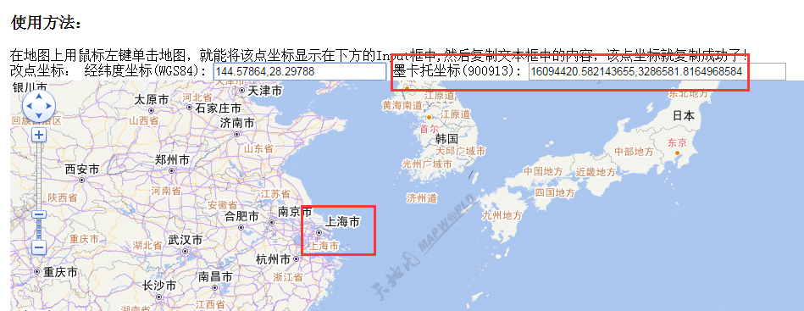

16094420.582143655,3286581.8164968584

### 代码示例

* 注意：minZoom 类型的标注为需要改动的地方

var mapContainer = document.getElementById("mapId");

map = new NPMapLib.Map(mapContainer, {

minZoom: 5,

maxZoom: 18,

projection: "EPSG:900913",//固定值，不可改动

displayProjection: "EPSG:4326"//固定值，不可改动

});

//图层参数

var opts = {

centerPoint: [16094420.582143655,3286581.8164968584], //中心点坐标，使用拾位器获得

fullExtent: [-20037508.3427892, -20037508.3427892, 20037508.3427892, 20037508.3427892], //固定值，不可改动

isBaseLayer: true

};

var url = ["http://webrd01.is.autonavi.com/appmaptile??lang=zh_cn&size=1&scale=1&style=7", "http://webrd02.is.autonavi.com/appmaptile??lang=zh_cn&size=1&scale=1&style=7", "http://webrd03.is.autonavi.com/appmaptile??lang=zh_cn&size=1&scale=1&style=7", "http://webrd04.is.autonavi.com/appmaptile??lang=zh_cn&size=1&scale=1&style=7"];//固定值，不可改动

var layerSLYX = new NPMapLib.Layers.GaoDeLayer(url, "ditu", opts);

map.addLayers([layerSLYX]);

## 高德地图离线地图 900913

高德地图是墨卡托坐标（900913），比较特殊。以下以上海市为例。

### 示例代码

* 注意：minZoom 类型的标注为需要改动的地方

var mapContainer = document.getElementById("mapId");

var map = new NPMapLib.Map(mapContainer, {

minZoom: 10, //最小级别，可根据需要设置

maxZoom: 17,//最大级别

projection: "EPSG:900913",//固定值，不可改动

restrictedExtent: [11756895.710823, 3374126.8928473, 11958383.717383, 3505904.3296109] //抓图工具设置的抓图范围

});

var url = 'http://192.168.60.242:1080/cache/chongqing_gaode/'; //切片所在位置

var baseLayer = new NPMapLib.Layers.GaoDeLayer(url, 'Aerials', {

isBaseLayer: true,

tilePixels: 256, //固定值，不可改动

isLocalMap: true,

centerPoint: [11856895, 3405904], //抓图工具设置的中心点

zoomOffset: 0 //固定值，不可改动

});

map.addLayers([baseLayer]);

# PVA 接入方法

地图配置文件： module/common/js/npmap-config.js

## 总配置

serviceType：地图类型，现支持 arcgis、pgis、mapworld、googlemap、gaodemap

Baselayer：服务URL

## NPGIS Server天地图地图服务配置

下面以服务地址为<http://localhost:8080/netposa/NPGIS/services/haikouTiandi/MapServer>

的海口天地地图配置说明PVA 配置方法：

### Baselayer

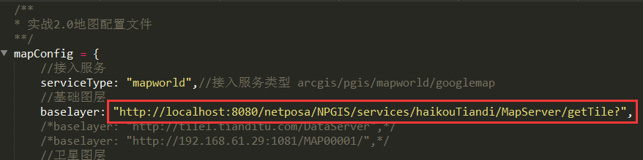

注：

* 首先要通过GIS组提供的地图下载工具下载天地图切片，然后按照NPGIS Server部署文档部署NPGIS Server天地图服务。

<http://localhost:8080/netposa/NPGIS/services/haikouTiandi/MapServer>

* Baselayer的值为NPGIS Server天地图地图服务地址+”/getTile?”

### Map参数配置

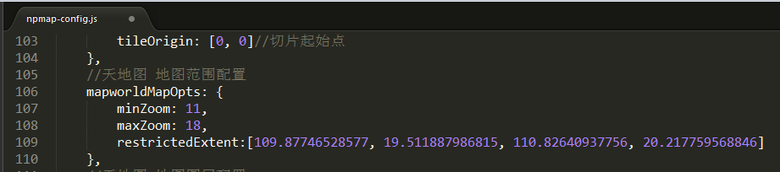

minZoom、maxZoom、restrictedExtent三个参数分别从

<http://localhost:8080/netposa/NPGIS/services/haikouTiandi/MapServer>页面读取

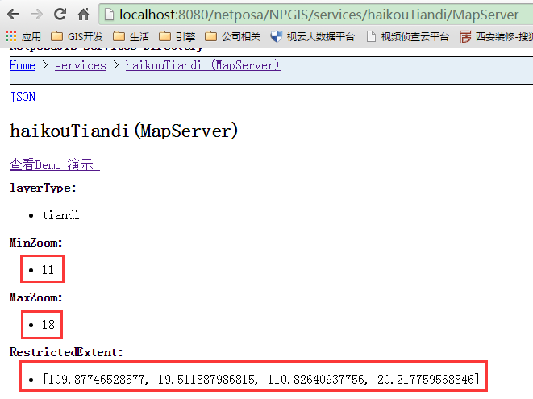

### Layer参数配置

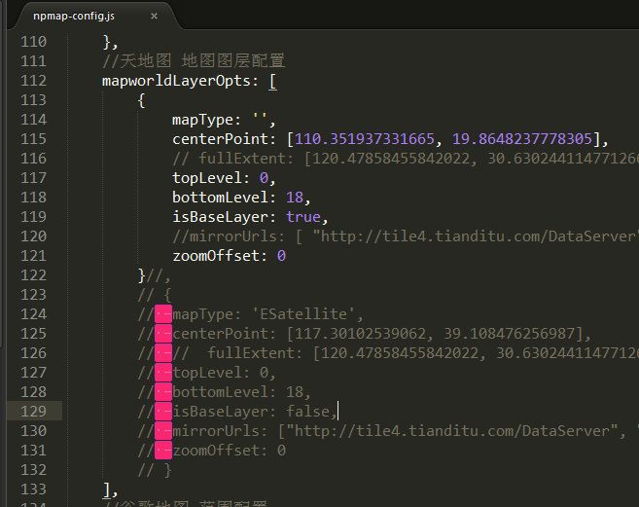

注：

* 注释掉mapworldLayerOpts的第二个节点，以及第一个节点的fullExtent、mirrorUrls。注意第一个节点后的逗号也要注释。
* centerPoint的值按照地图服务页面配置。

<http://localhost:8080/netposa/NPGIS/services/haikouTiandi/MapServer>

### 地图初始化方法修改

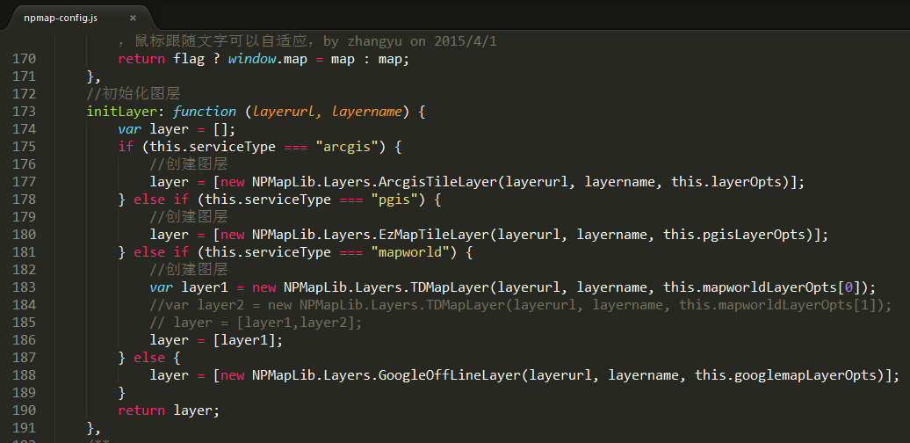

注：

* 注释掉

//var layer2 = new NPMapLib.Layers.TDMapLayer(layerurl, layername, this.mapworldLayerOpts[1]);

// layer = [layer1,layer2];

* 新增一行

layer = [layer1];

## Arcgis 服务配置

mapZoomAndExtentOpts:{

minZoom: 0, //地图允许展示的最小级别

maxZoom: 10, //地图允许展示的最大级别

restrictedExtent:[120.21702921092, 29.485713008051, 123.02395562752, 32.292639424656]

},

//arcgis 地图图层配置

layerOpts: {

isBaseLayer: true,

resolutions: [

0.0018274260524776553, 0.0009137130262388277,

0.0004568565131194138, 0.0002284282565597069,

0.00011421412827985346, 0.00005710706413992673,

0.000028553532069963364, 0.000014276766034981682,

0.000007138383017490841, 0.0000035691915087454205,

0.0000017845957543727103

],

tilePixels: 512, //切片大学

origin: [-400, 400], //切片其实点

projection: 'EPSG:4326', //投影方式

centerPoint: [112.53929,37.84696], // 中心点

zoomOffset: 0 //偏移量，控制从第几级开始显示地图

},

## PGIS 配置

//pgis 地图范围和级别范围设置

pgisMapOpts: {

minZoom: 11,//最小图层级别

maxZoom: 19,//最大图层级别

maxResolution:2,//最大分辨率,

projection: "EPSG:3785",//投影方式

originCenter: [111.677695, 40.836575],//中心点

resolution: 0.0009765625,//初始分辨率

fullExtent: [110.65879, 38.82641, 112.6966, 40.84674],

maxExtent: [110.65879, 38.82641, 112.6966, 40.84674]

},

//pgis 地图图层配置

pgisLayerOpts: {

type: "png",//图片格式

maxZoomLevel: 19,//最大图层级别

resolutions: [2,1,0.5,0.25,0.125,0.0625,0.03125,0.015625,0.0078125,0.00390625,0.001953125,0.0009765625,0.00048828125,0.000244140625,0.0001220703125,0.00006103515625,0.000030517578125,0.0000152587890625,0.00000762939453125,0.000003814697265625,0.0000019073486328125,9.5367431640625e-7,4.76837158203125e-7],

maxResolution: 2,

units: "Lat-66",//单位

tileOrigin: [0, 0]//切片起始点

},

## 天地在线地图

//天地图 地图范围配置

mapworldMapOpts: {

minZoom: 10,

maxZoom: 17

},

//天地图 地图图层配置

mapworldLayerOpts: [{

mapType:'EMap',

centerPoint: [121.46256,31.23398],

topLevel: 0,

bottomLevel: 18,

isBaseLayer: true,

mirrorUrls:["http://tile0.tianditu.com/DataServer","http://tile1.tianditu.com/DataServer","http://tile2.tianditu.com/DataServer","http://tile3.tianditu.com/DataServer","http://tile4.tianditu.com/DataServer","http://tile5.tianditu.com/DataServer","http://tile6.tianditu.com/DataServer"],

zoomOffset: 0

},{

mapType:'ESatellite',

centerPoint: [121.46256,31.23398],

topLevel: 0,

bottomLevel: 18,

isBaseLayer: false,

mirrorUrls:["http://tile0.tianditu.com/DataServer","http://tile1.tianditu.com/DataServer","http://tile2.tianditu.com/DataServer","http://tile3.tianditu.com/DataServer","http://tile4.tianditu.com/DataServer","http://tile5.tianditu.com/DataServer","http://tile6.tianditu.com/DataServer"],

zoomOffset: 0

}],

## 天地地图离线地图

mapworldMapOpts: {

minZoom: 10,

maxZoom: 17

},

//天地图 地图图层配置

mapworldLayerOpts: [{

mapType:'EMap',

centerPoint: [121.46256,31.23398],

topLevel: 0,

bottomLevel: 18,

isBaseLayer: true,

mirrorUrls:["/map/vec_c/"],

zoomOffset: 0

},{

mapType:'ESatellite',

centerPoint: [121.46256,31.23398],

topLevel: 0,

bottomLevel: 18,

isBaseLayer: false,

mirrorUrls:["/map/cva_c/"],

zoomOffset: 0,

isLocalMap: true

}],

## 高德在线地图

## 高德离线地图

## 和业务相关的地图配置

### 地图标注默认Zoom

settings:{

// 地图标注默认放大级别(value需要根据实际情况配置)

markZoom:4

},

### 全景小地图默认打开图层

fullviewZoom: 6,

### 双击摄像机定位地图级别

dbclcikCameraMapZoom: 6,

### **视野**范围**内搜索**

viewSearchZoom: 6,

### 聚合颜色 提供两种颜色"red"、"blue"

clusterColor: "red",

### 框选限制

selectZoom: 6,

# PVD 接入方法

地图配置文件地址:assets/scripts/vim/map/mapConfig.js

## Arcgis 配置

module.exports = {

/**********聚合点默认图片路径**********/

'customNormal': '/assets/images/map/custom_Normal.png',

'cluster1': '/assets/images/map/map-cluster-1.png',

'cluster2': '/assets/images/map/map-cluster-2.png',

'cluster3': '/assets/images/map/map-cluster-3.png',

'cluster4': '/assets/images/map/map-cluster-4.png',

/**********地图类型**********/

'layerType': 'ArcgisTileLayer',

/**********底图服务地址**********/

// 'url': '/map/ArcgisTileLayer',

'url': 'http://192.168.60.242:6080/arcgis/rest/services/shanghaiBaseMap/MapServer',

/**********地图允许展示的最大缩放级别**********/

'minLevel': 0,

/**********地图允许展示的最小缩放级别**********/

'maxLevel': 10,

/**********地图中心点**********/

'CenterPoint': '121.4832066789972, 31.27509675427127',

/**********分辨率数组**********/

'resolutions': '0.0018274260524776553, 0.0009137130262388277,0.0004568565131194138, 0.0002284282565597069,0.00011421412827985346, 0.00005710706413992673,0.000028553532069963364, 0.000014276766034981682,0.000007138383017490841, 0.0000035691915087454205,0.0000017845957543727103',

/**********地图显示的限制范围(需要限制范围时再定义)**********/

'restrictedExtent': [13423402.728774, 3562204.3833067, 13657893.035257, 3796407.4379399],

/**********切片大小**********/

'tilePixels': 256,

/**********切片类型**********/

'Tiletype': 'png',

/**********切片原点**********/

'origin': '-400, 399.9999999999998',

/**********单位（米）**********/

'Units': 'm',

/**********地图层级偏移量**********/

'zoomOffset': 0,

/**********地图区域范围**********/

'extent': '119.47858455842022, 29.630244114771266, 123.48782879957419, 32.91994939377127',

/**********显示的坐标系**********/

'DisplayProjection': 'EPSG:4326',

/**********地图真实的坐标系**********/

'projection': 'EPSG:4326',

/**********聚合点配置**********/

'conflux': {

/**********是否显示聚合点**********/

'enble': true,

/**********撒点层级**********/

'maxZoom': 6,

/**********点击聚合点的跳转层级**********/

// 'selectZoom': 6,

/**********聚合距离（像素）**********/

'distance': 80

}

};

## PGIS 配置

module.exports = {

'customNormal': '/assets/images/map/custom_Normal.png',

'cluster1': '/assets/images/map/map-cluster-1.png',

'cluster2': '/assets/images/map/map-cluster-2.png',

'cluster3': '/assets/images/map/map-cluster-3.png',

'cluster4': '/assets/images/map/map-cluster-4.png',

'DisplayProjection': 'EPSG:900913',

'projection': 'EPSG:3785',

'layerType': 'PGIS',

'maxLevel': 20,

'minLevel': 12,

'url': '',

'CenterPoint': '112.53929,37.84696',

'extent': '110.4375,34.51562,114.25,40.5625',

'MaxResolution': 2,

'resolutions': '2,1,0.5,0.25,0.125,0.0625,0.03125,0.015625,0.0078125,0.00390625,0.001953125,0.0009765625,0.00048828125,0.000244140625,0.0001220703125,0.00006103515625,0.000030517578125,0.0000152587890625,0.00000762939453125,0.000003814697265625,0.0000019073486328125,9.5367431640625e-7,4.76837158203125e-7',

'NumZoomLevels': 20,

'tilePixels': 256,

'Tiletype': 'png',

'origin': '0,0',

'Units': 'Lat-66',

'ZoomLevelSequence': 2,

'zoomOffset': 0

};

## 离线天地地图

module.exports = {

'customNormal': '/assets/images/map/custom_Normal.png',

'cluster1': '/assets/images/map/map-cluster-red-1.png',

'cluster2': '/assets/images/map/map-cluster-red-2.png',

'cluster3': '/assets/images/map/map-cluster-red-3.png',

'cluster4': '/assets/images/map/map-cluster-red-4.png',

'conflux': {

'enble': true,

'maxZoom': 14,

'selectZoom': 14,

'distance': 120

},

minLevel: 10,

maxLevel: 16,

'layerType': 'TiandiMap',

'labelYOffset': 2,

'IElabelYOffset': -2,

"restrictedExtent":[116.58693388281, 38.543688869141, 118.08656767188, 40.287768458984],

'tiandiMapopts1': {

mapType: 'EMap',

centerPoint: [117.336750777345,39.4157286640625],

fullExtent: [-180, -90, 180, 90],

topLevel: 0,

bottomLevel: 18,

isBaseLayer: true,

isLocalMap: true,

url: '/vec_c/',

zoomOffset: 0

},

'tiandiMapopts2': {

mapType: 'ESatellite',

centerPoint: [117.336750777345,39.4157286640625],

fullExtent: [-180, -90, 180, 90],

topLevel: 0,

bottomLevel: 18,

isLocalMap: true,

isBaseLayer: false,

url: '/cva_c/',

zoomOffset: 0

},

CenterPoint: '117.336750777345,39.4157286640625'

};

## 在线天地地图配置

module.exports = {

'customNormal': '/assets/images/map/custom_Normal.png',

'cluster1': '/assets/images/map/map-cluster-red-1.png',

'cluster2': '/assets/images/map/map-cluster-red-2.png',

'cluster3': '/assets/images/map/map-cluster-red-3.png',

'cluster4': '/assets/images/map/map-cluster-red-4.png',

'conflux': {

'enble': true,

'maxZoom': 14,

'selectZoom': 14,

'distance': 120

},

minLevel: 10,

maxLevel: 16,

'layerType': 'TiandiMap',

'labelYOffset': 2,

'IElabelYOffset': -2,

"restrictedExtent":[116.58693388281, 38.543688869141, 118.08656767188, 40.287768458984],

'tiandiMapopts1': {

mapType: 'EMap',

centerPoint: [117.336750777345,39.4157286640625],

fullExtent: [-180, -90, 180, 90],

topLevel: 0,

bottomLevel: 18,

isBaseLayer: true,

isBaseLayer: false, mirrorUrls: ['http://tile0.tianditu.com/DataServer', 'http://tile1.tianditu.com/DataServer', 'http://tile2.tianditu.com/DataServer', 'http://tile3.tianditu.com/DataServer', 'http://tile4.tianditu.com/DataServer', 'http://tile5.tianditu.com/DataServer', 'http://tile6.tianditu.com/DataServer'],

zoomOffset: 0

},

'tiandiMapopts2': {

mapType: 'ESatellite',

centerPoint: [117.336750777345,39.4157286640625],

fullExtent: [-180, -90, 180, 90],

topLevel: 0,

bottomLevel: 18,

isLocalMap: false,

isBaseLayer: false,

mirrorUrls: ['http://tile0.tianditu.com/DataServer', 'http://tile1.tianditu.com/DataServer', 'http://tile2.tianditu.com/DataServer', 'http://tile3.tianditu.com/DataServer', 'http://tile4.tianditu.com/DataServer', 'http://tile5.tianditu.com/DataServer', 'http://tile6.tianditu.com/DataServer'],

zoomOffset: 0

},

CenterPoint: '117.336750777345,39.4157286640625'

};

## 和业务相关的地图配置

# 地图配置过程中出现的问题总结

1. PGIS 地图在内网部署，PVA /PVD 在专网部署

解决方法：PGIS 地图通过授权PVD 所在的机器可以访问内网PGIS 地图。PVD nginx 通过代理配置使专网可以访问PGIS 地图。PVA nginx 中代理配置地图访问PVD 的地图地址。

详细配置如下：

Pva : pva.conf 新增配置如下

location ^~ /pgisservice/ {

proxy_pass http://PVD_Service/pgisservice; # PVD 地图地址

proxy_cookie_path /pva/ /;

proxy_redirect default;

proxy_set_header Host $host:$server_port;

proxy_set_header X-Real-IP $remote_addr;

proxy_set_header X-Forwarded-Host $host:$server_port;

proxy_set_header X-Forwarded-Server $host:$server_port;

proxy_set_header X-Forwarded-For $proxy_add_x_forwarded_for;

}

Pvd: nginx.conf 配置

location ^~ /pgisservice/ {

proxy_pass [http://PGIS](http://pgis/)_Service/; # PGIS地图地址

proxy_cookie_path /pva/ /;

proxy_redirect default;

proxy_set_header Host $host:$server_port;

proxy_set_header X-Real-IP $remote_addr;

proxy_set_header X-Forwarded-Host $host:$server_port;

proxy_set_header X-Forwarded-Server $host:$server_port;

proxy_set_header X-Forwarded-For $proxy_add_x_forwarded_for;

}