地图服务配置

# PGIS地图服务参数配置

首先在pgis网站地图页面上获取EzMapAPI.js文件，打开此文件，进行如下配置

* "projection":"EPSG:900913",//地图投影坐标。
* "layerType":" PGIS ",//地图服务类型；PGIS：pgis服务，ArcgisTileLayer：arcgis服务。
* "maxLevel":10,//最大地图层级 pgis需要配置。MapMaxLevel的值
* "minLevel":0,//最小地图层级。
* "zoomOffset":0//地图层级偏移量,一般为0
* "url":"http://192.168.60.242:6080/arcgis/rest/services/shanghaiBaseMap/MapServer",//地图服务地址。EzServerClientURL的值
* "CenterPoint":"4016230.6782721,13163793.707059",//地图中心点。MapFullExtent的中心点。
* "extent":"119.47858455842022,29.630244114771266,123.48782879957419,32.91994939377127",//地图范围。
* "MaxResolution":2,//最大分辨率。
* "resolutions":"2,1,0.5,0.25,0.125,0.0625,0.03125,0.015625,0.0078125,0.00390625,0.001953125,0.0009765625,0.00048828125,0.000244140625,0.0001220703125,0.00006103515625,0.000030517578125,0.0000152587890625,0.00000762939453125,0.000003814697265625,0.0000019073486328125,9.5367431640625e-7,4.76837158203125e-7",//分辨率层级,一般此数组都是固定的。
* "tilePixels":256,//切片尺寸大小，MapUnitPixels的值
* "Tiletype":"png",//切片格式，一般都为png
* "origin":"-400,399.9999999999998",//切片原点，一般为”0,0”。
* "Units":"Lat-66",//地图单位，pgis中一般不会变。

注：extent的值要先通过MapFullExtent的值往外扩两度，比如MapFullExtent 为[111.65879,40.82641,111.6966,40.84674],可先设置extent为[110.65879,39.82641,112.6966,41.84674],然后调整到整个地图范围，调试模式下，执行map.getExent()方法获取参数。然后在将值赋给extent。

# ArcGIS地图服务参数配置

## 获取地图服务的url

### 确保arcgis服务已经启动

1.进入windows的资源管理器，点击服务按钮

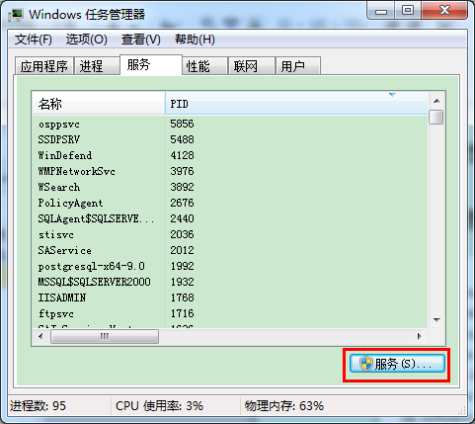

2.确保arcgis license 和 arcgis server已经启动，若没启动，先选中，点击左上角的启动此服务。

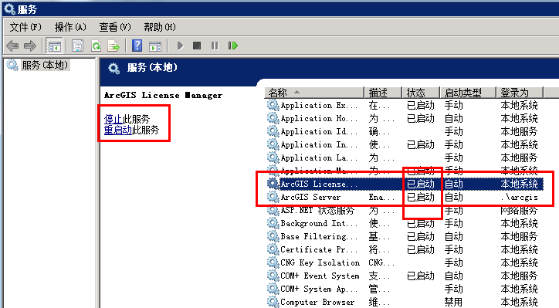

### 获取服务的url

进入manager找到服务的管理界面，找安装者拿到用户名和密码，输入用户名密码，进入管理界面。

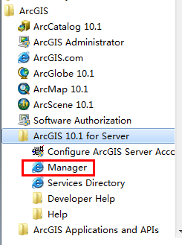

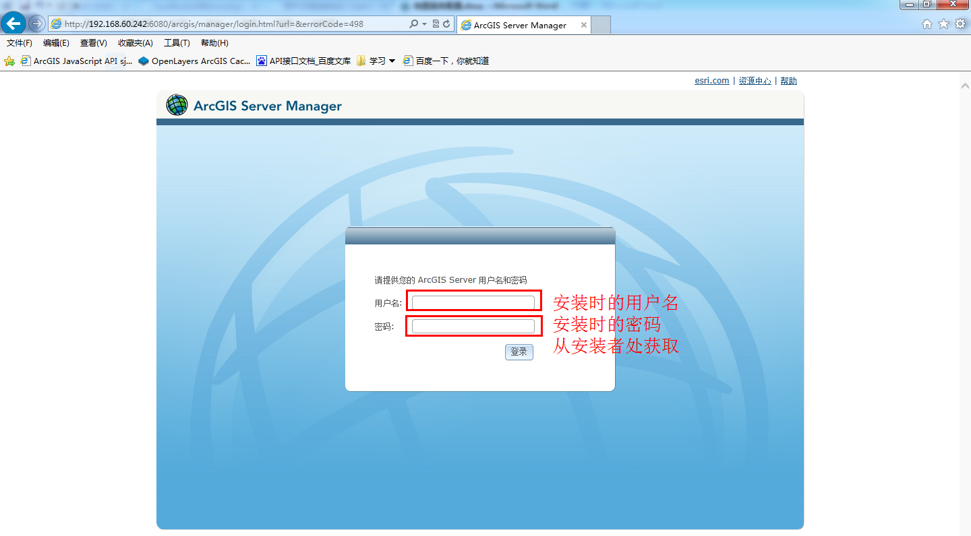

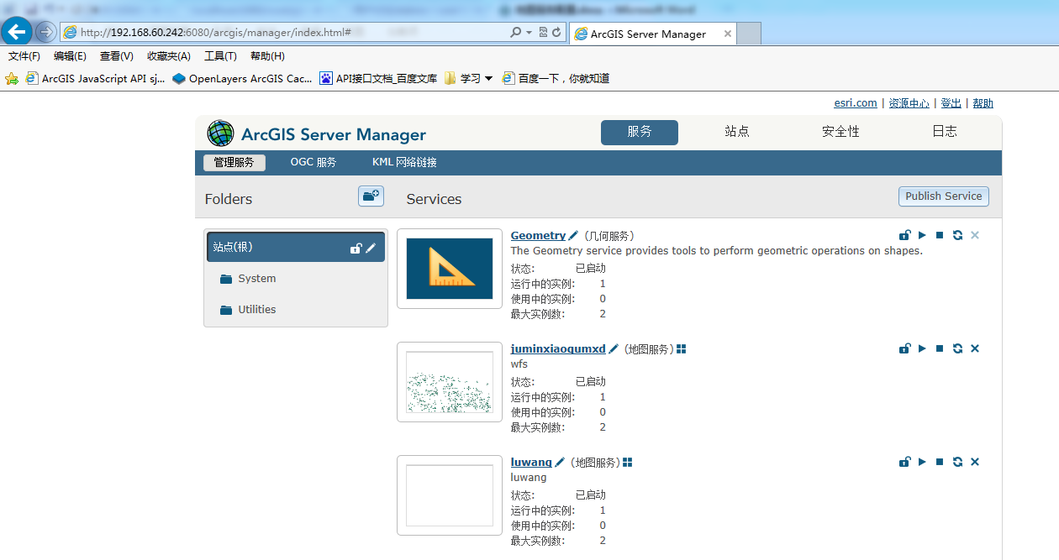

2.找到需要接入的地图服务，点击地图服务左边的服务名称，进入该服务

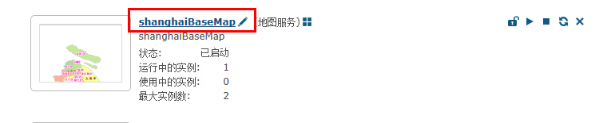

3.点击服务能力，进入REST URL，该url就是要接入的url，url里面的参数就是地图配置所需的参数。

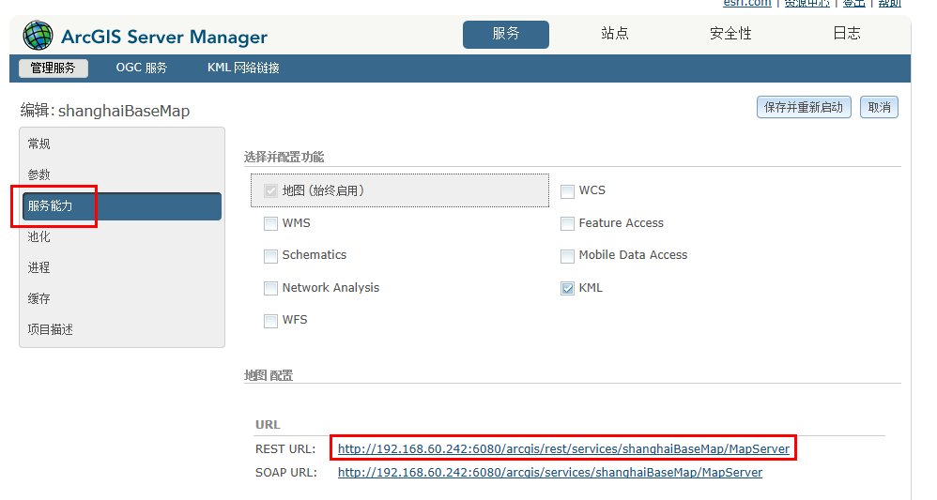

4.含有详细分辨率数组的即是切片服务，反之不是切片服务。

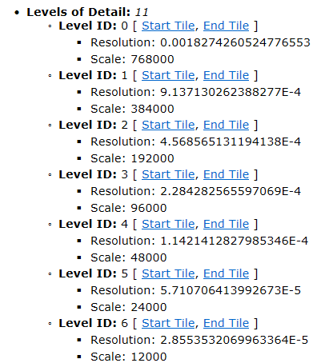

6. 也可以通过点击ArcGIS JavaScript预览地图服务，查看是否是切片服务。

地图服务左上方是如下导航条的是切片服务。

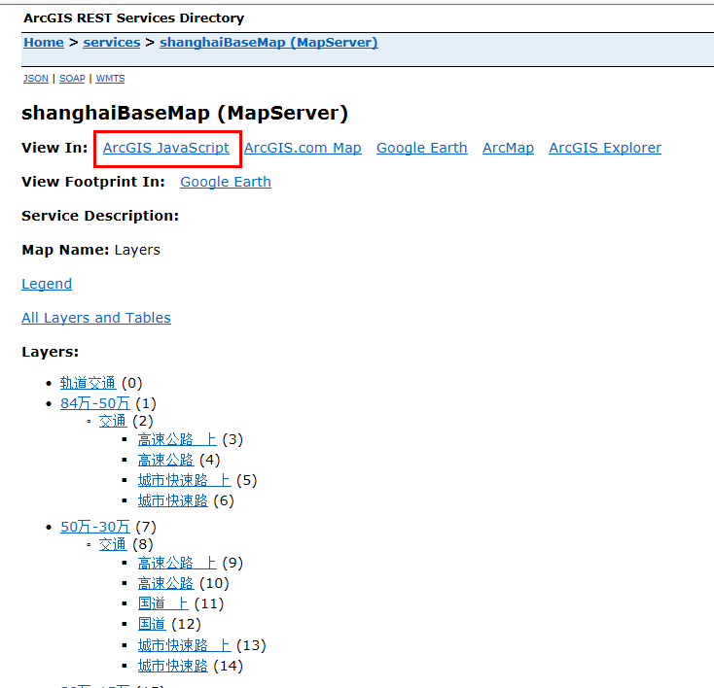

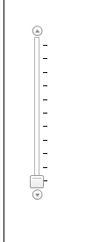

如下图所示导航的不是切片服务。

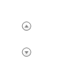

## 根据地图服务的url配置mapconfig.js文件

* baseLayer：含有大量参数信息的页面所对应的url即是地图服务接入的url

<http://192.168.60.242:6080/arcgis/rest/services/shanghaiBaseMap/MapServer>

* "projection":"EPSG:4326",//地图投影坐标Spatial Reference

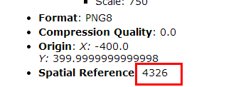

* "layerType":"ArcgisTileLayer",//地图服务类型；PGIS：pgis服务，ArcgisTileLayer：arcgis服务
* "maxLevel":10,//最大地图层级,Levels of Detail,最后一级级数
* "minLevel":0,//最小地图层级，Levels of Detail,第一级级数

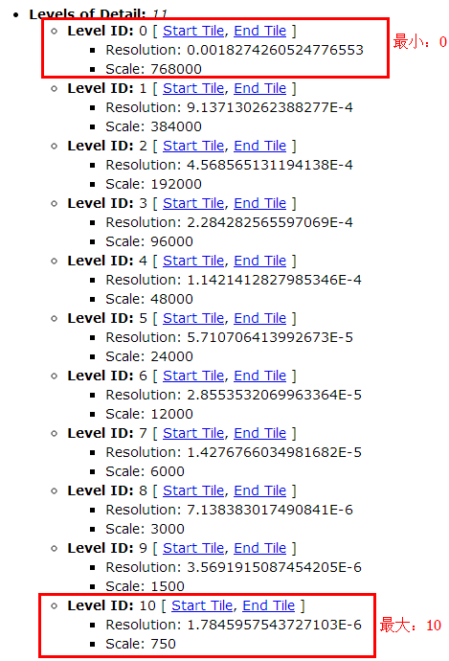

* "url":"http://192.168.60.242:6080/arcgis/rest/services/shanghaiBaseMap/MapServer",//地图服务地址

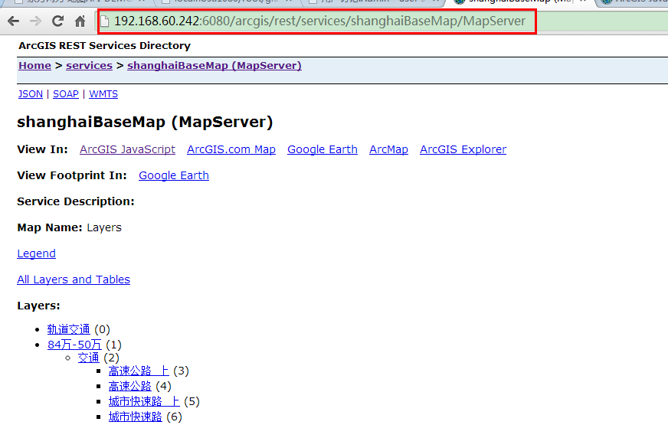

* "CenterPoint":"4016230.6782721,13163793.707059",//地图中心点，获取Full Extent的中心点(XMin+XMax)/2,(YMin+YMax)/2
* "extent":[120.47858455842022,30.630244114771266,122.48782879957419,31.91994939377127],//地图范围 Full Extent的值 ”XMin,YMin,XMax,YMax”

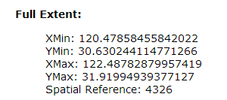

* "MaxResolution":0.0018274260524776553,//最大分辨率Levels of Detail第一级的reslution的值

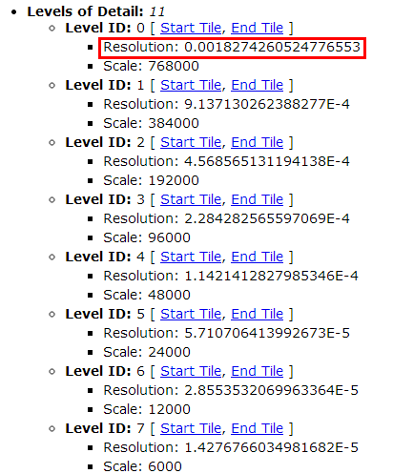

* "resolutions":[0.0018274260524776553, 0.0009137130262388277,0.0004568565131194138, 0.0002284282565597069,0.00011421412827985346, 0.00005710706413992673,0.000028553532069963364, 0.000014276766034981682,0.000007138383017490841, 0.0000035691915087454205,0.0000017845957543727103],//分辨率层级, Levels of Detail,中的level中的reslution中的级别。

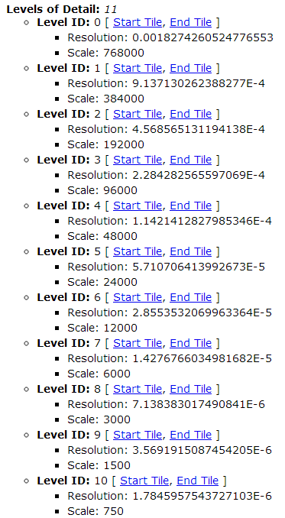

* "tilePixels":256,//切片尺寸大小。

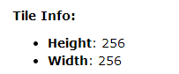

* "Tiletype":"png",//切片格式。Format的值，但是配置时只配置后缀，比如PNG8，pngXX配置为png；jpg、JPG、JPGXX配置为jpg

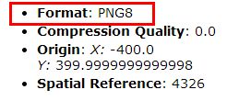

* "origin":[-400,399.9999999999998],//切片原点 origin的X，Y值

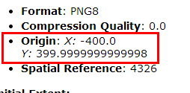

* "Units":" Lat-66",//地图单位 如4326，则为Lat-66，900913则为m
* "zoomOffset":0//地图层级偏移量