3.0

A=1, B = 1, C = 1

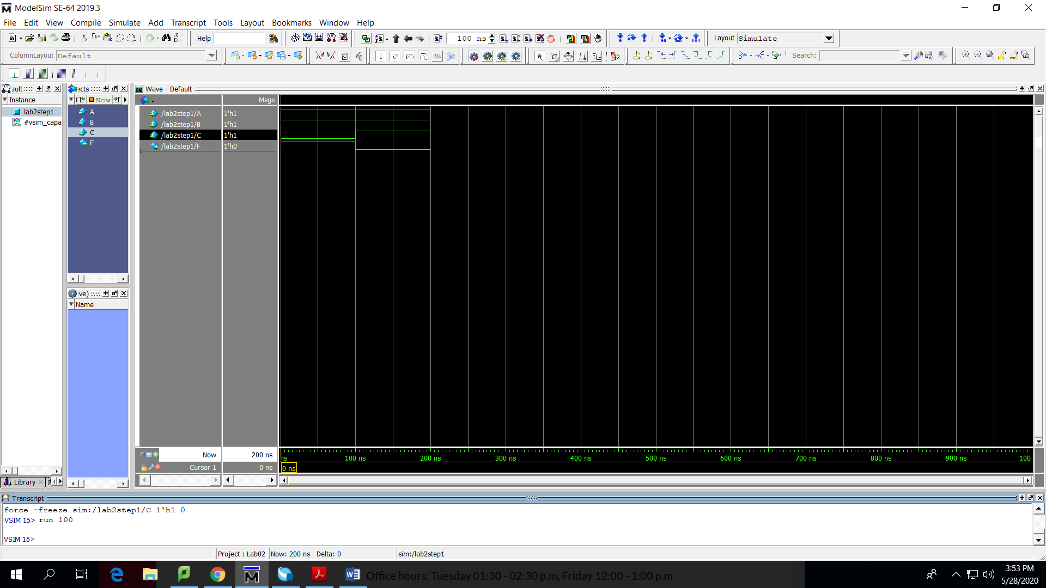

A=1, B = 1, C = 0

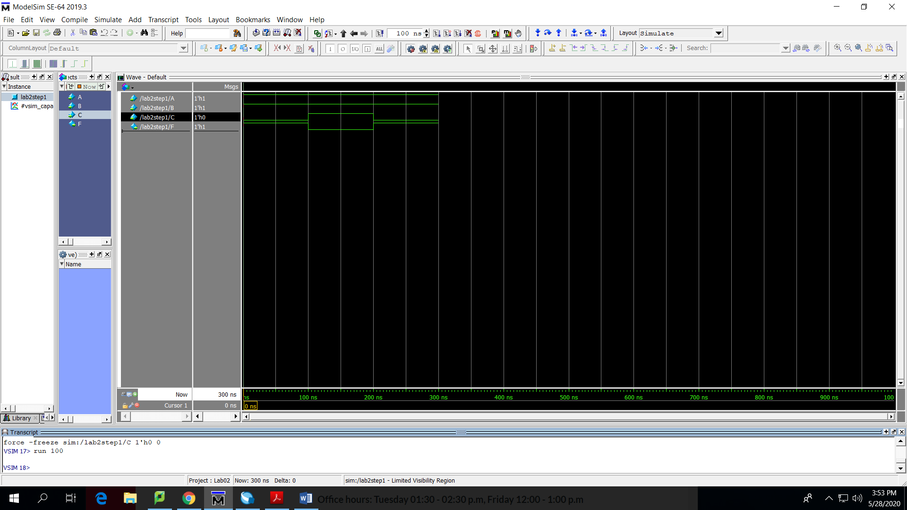

A=1, B = 0, C = 1

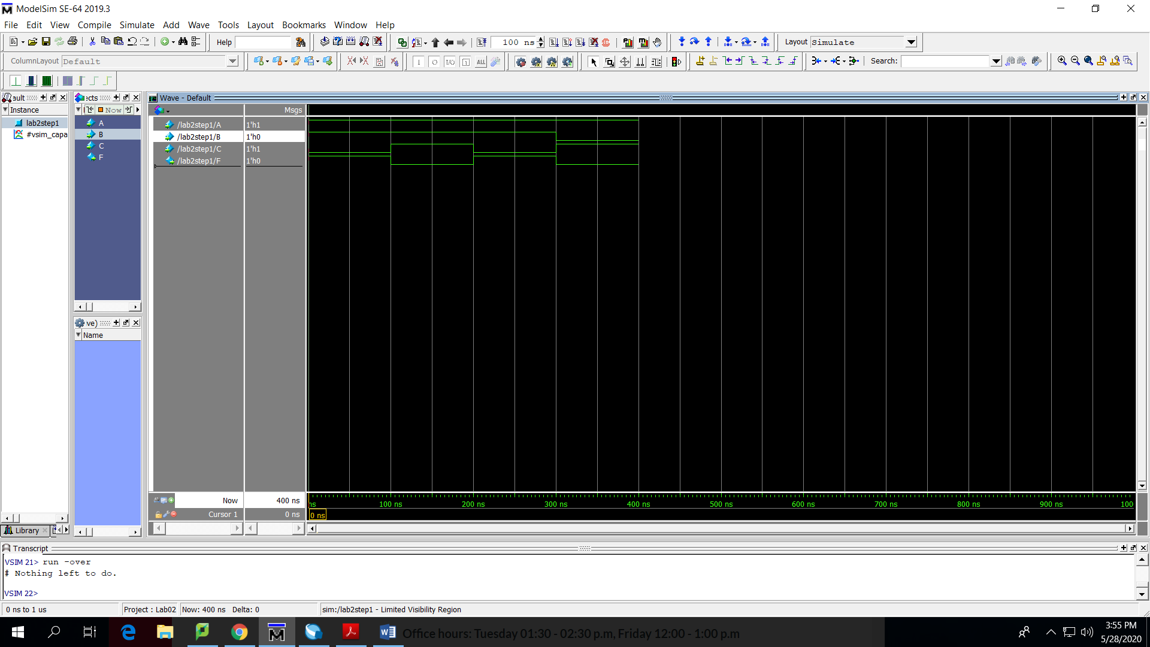

A=0, B = 1, C = 1

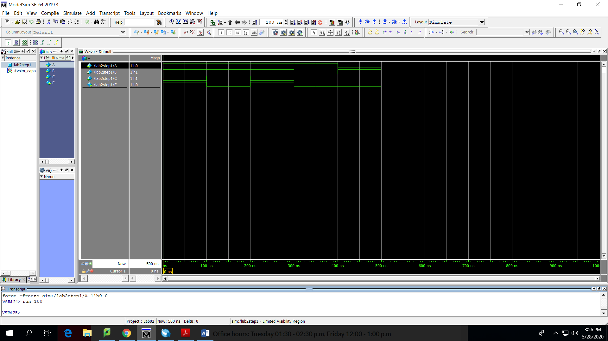

A=0,B=0,C=1

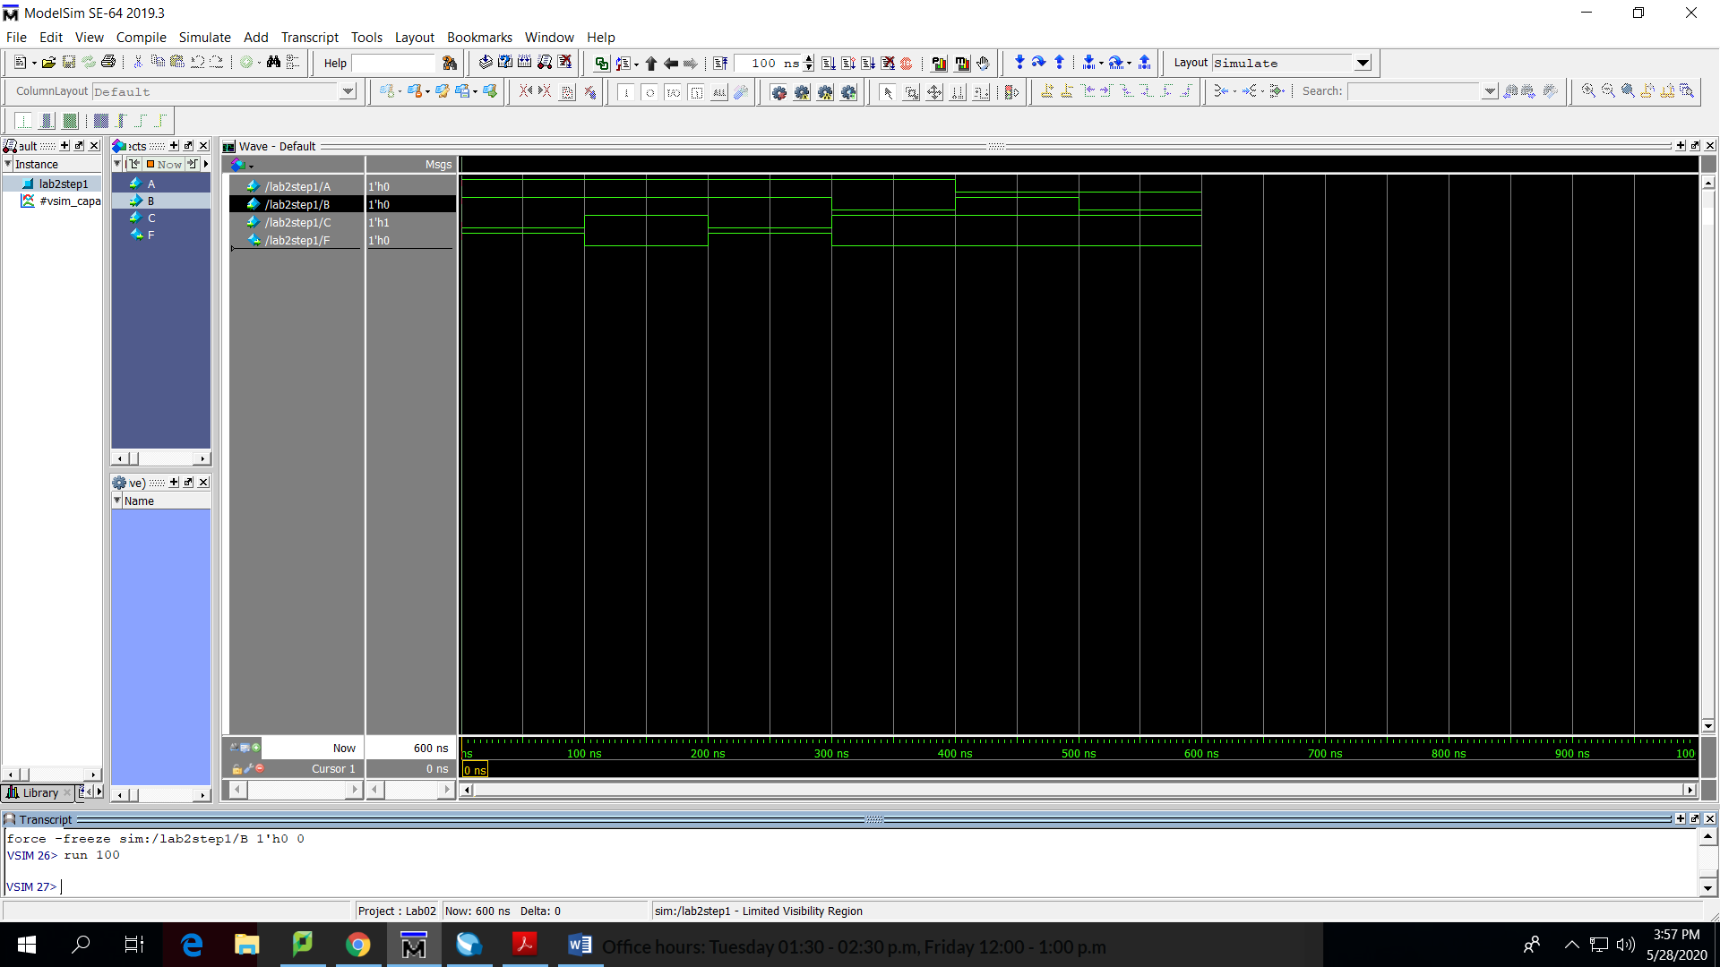

A=0,B=1,C=0

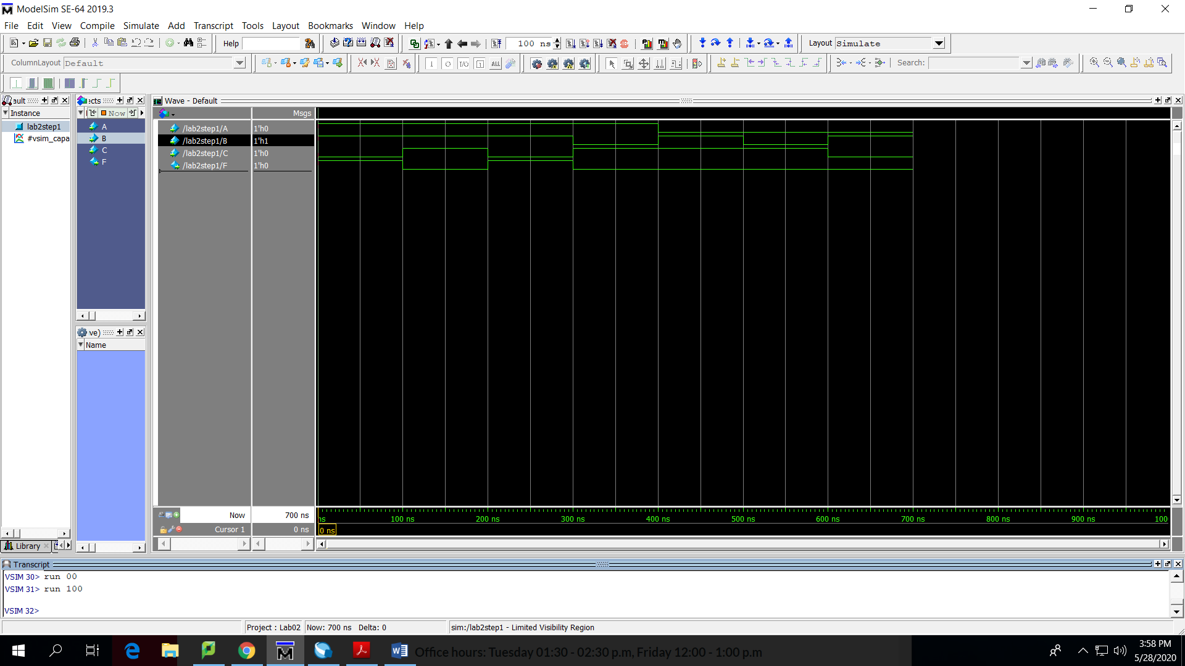

A=1,B=0,C=0

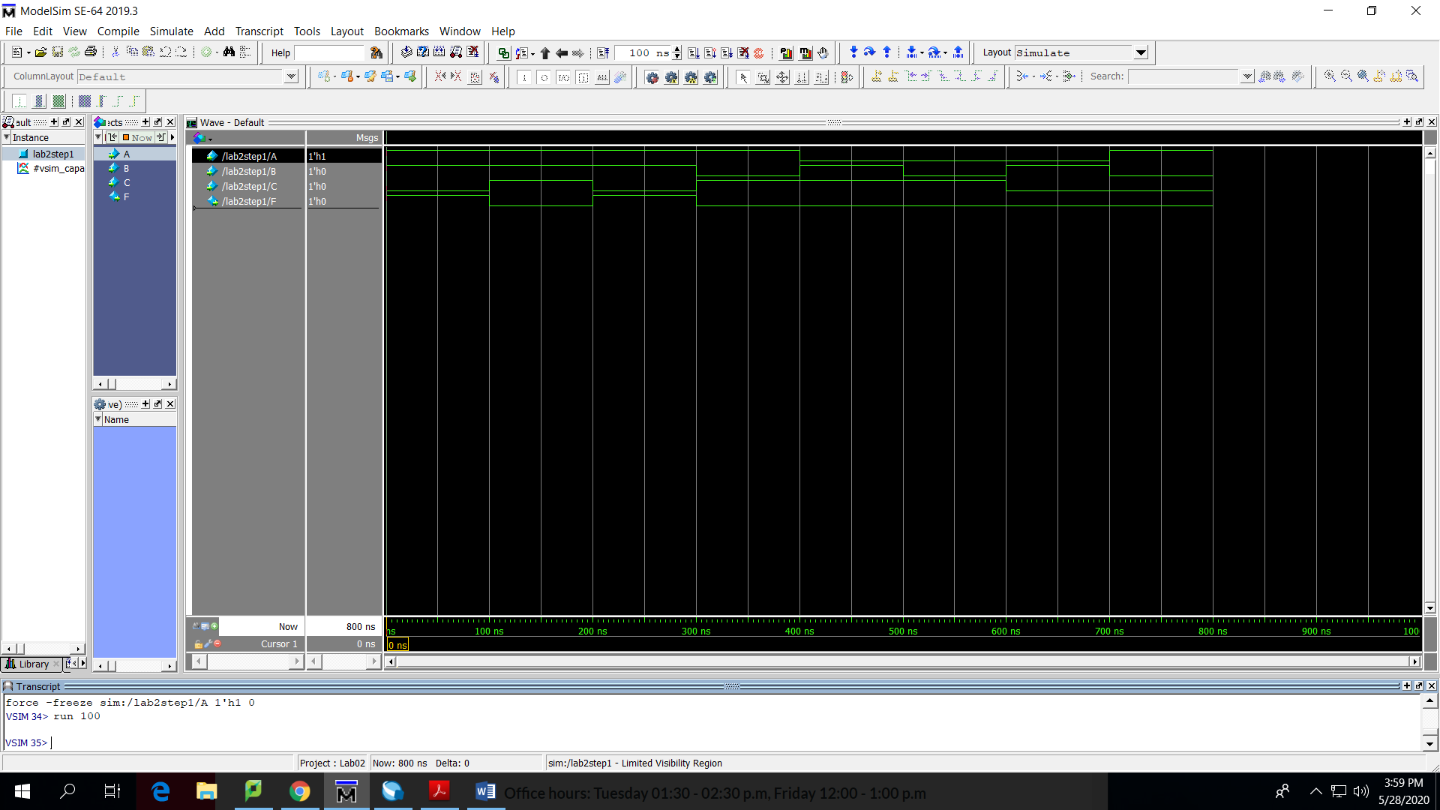

A=0,B=0,C=0

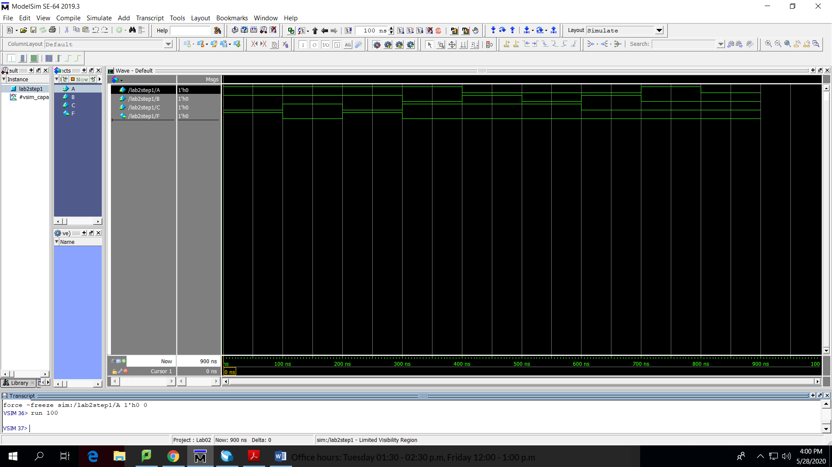

4.0

***Logic0***

Cabbage0=1,Goat0=1,Wolf0=1

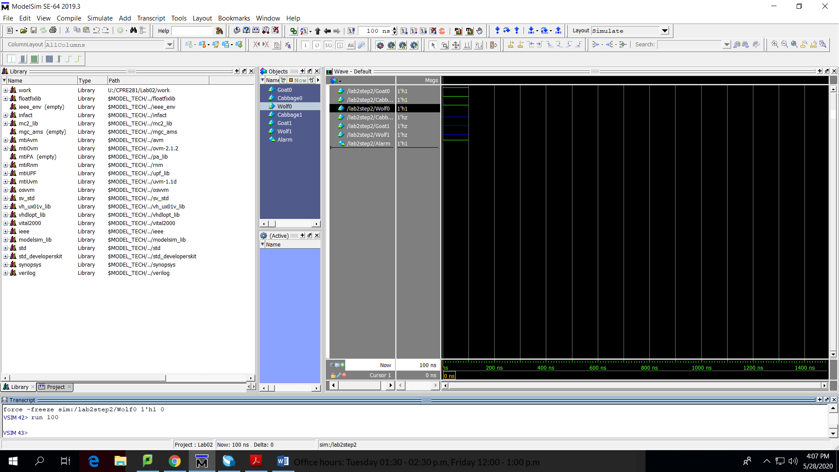

Cabbage0=1,Goat0=0,Wolf0=1

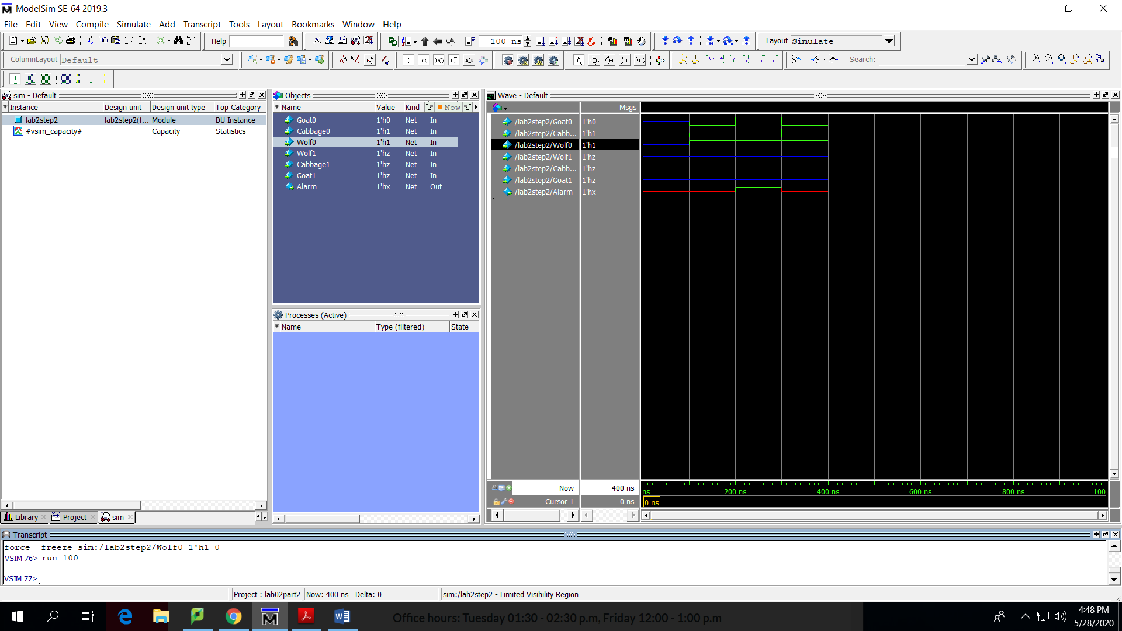

Cabbage0=0,Goat0=0,Wolf0=1

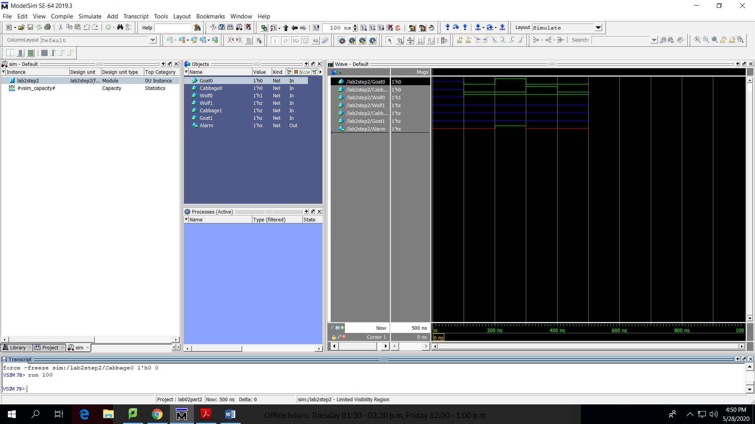

Cabbage0=0,Goat0=1,Wolf0=1

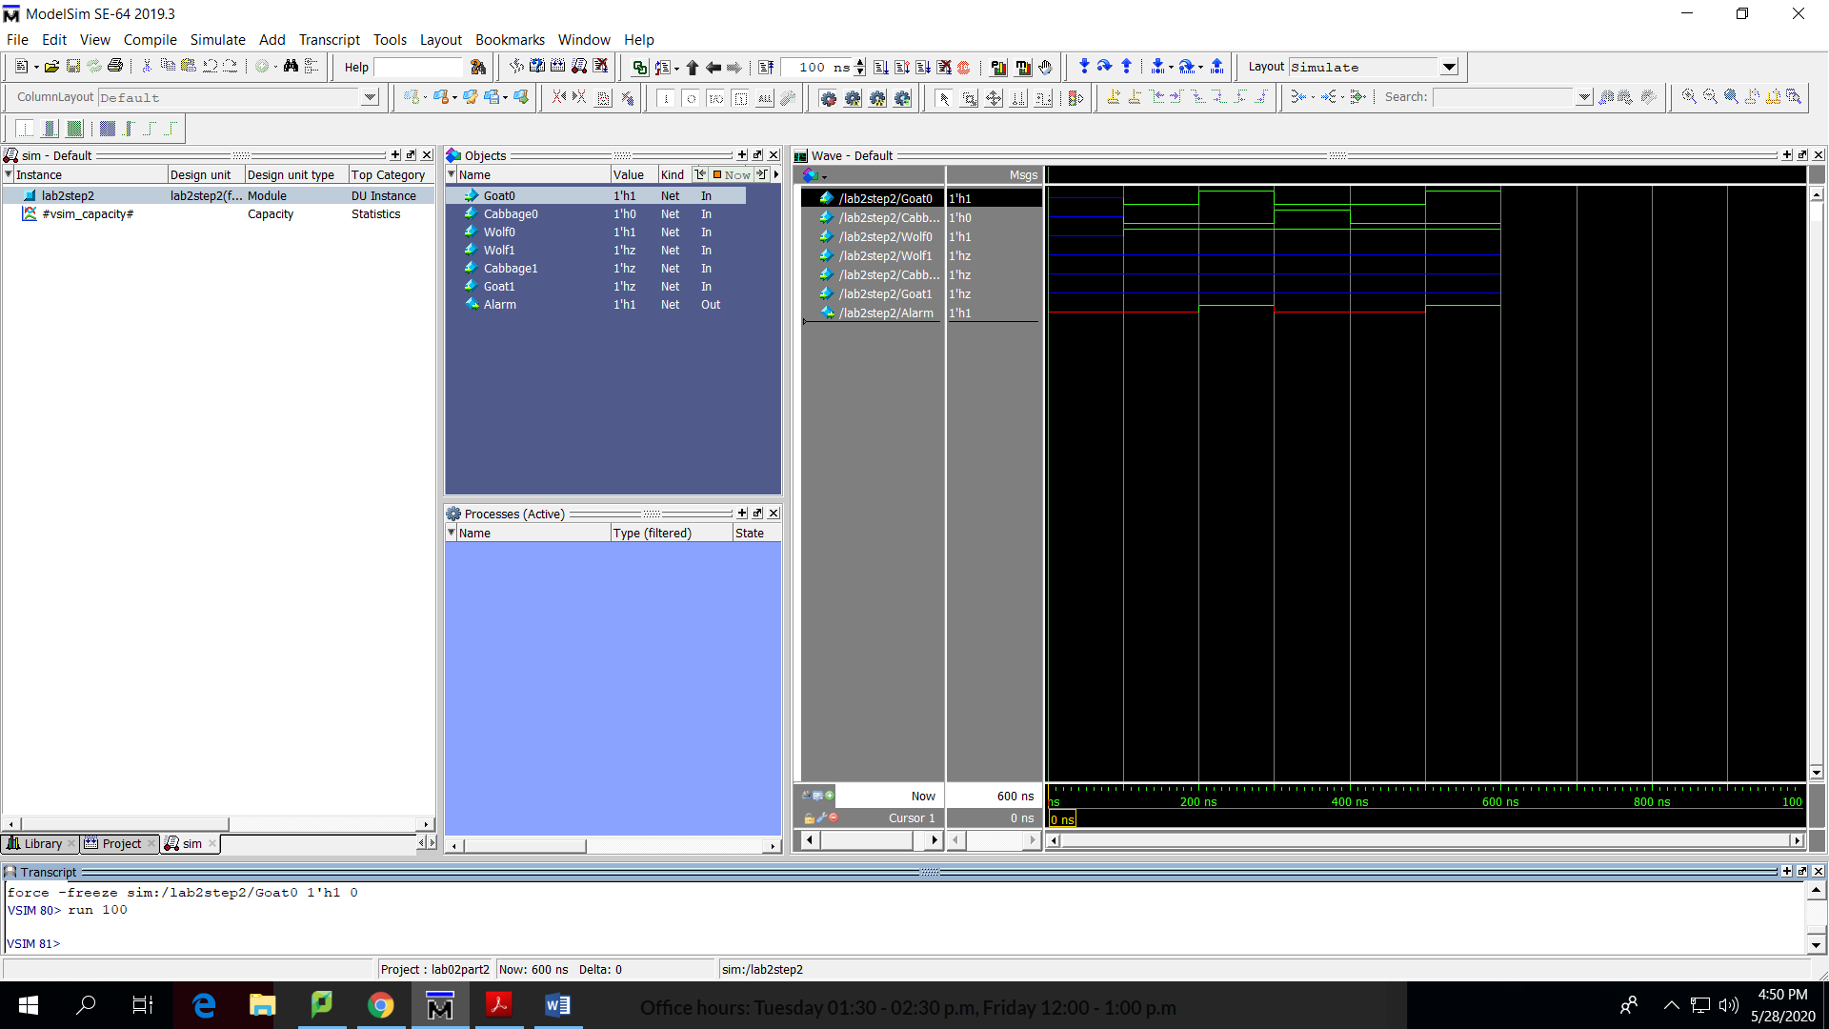

Cabbage0=1,Goat0=1,Wolf0=0

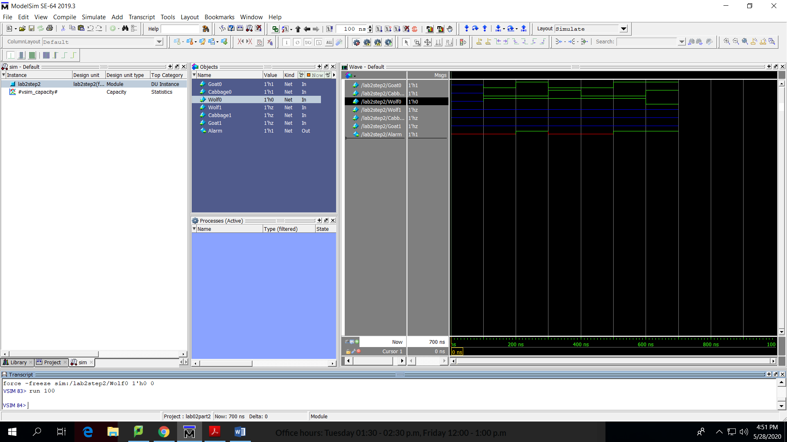

Cabbage0=1,Goat0=0,Wolf0=0

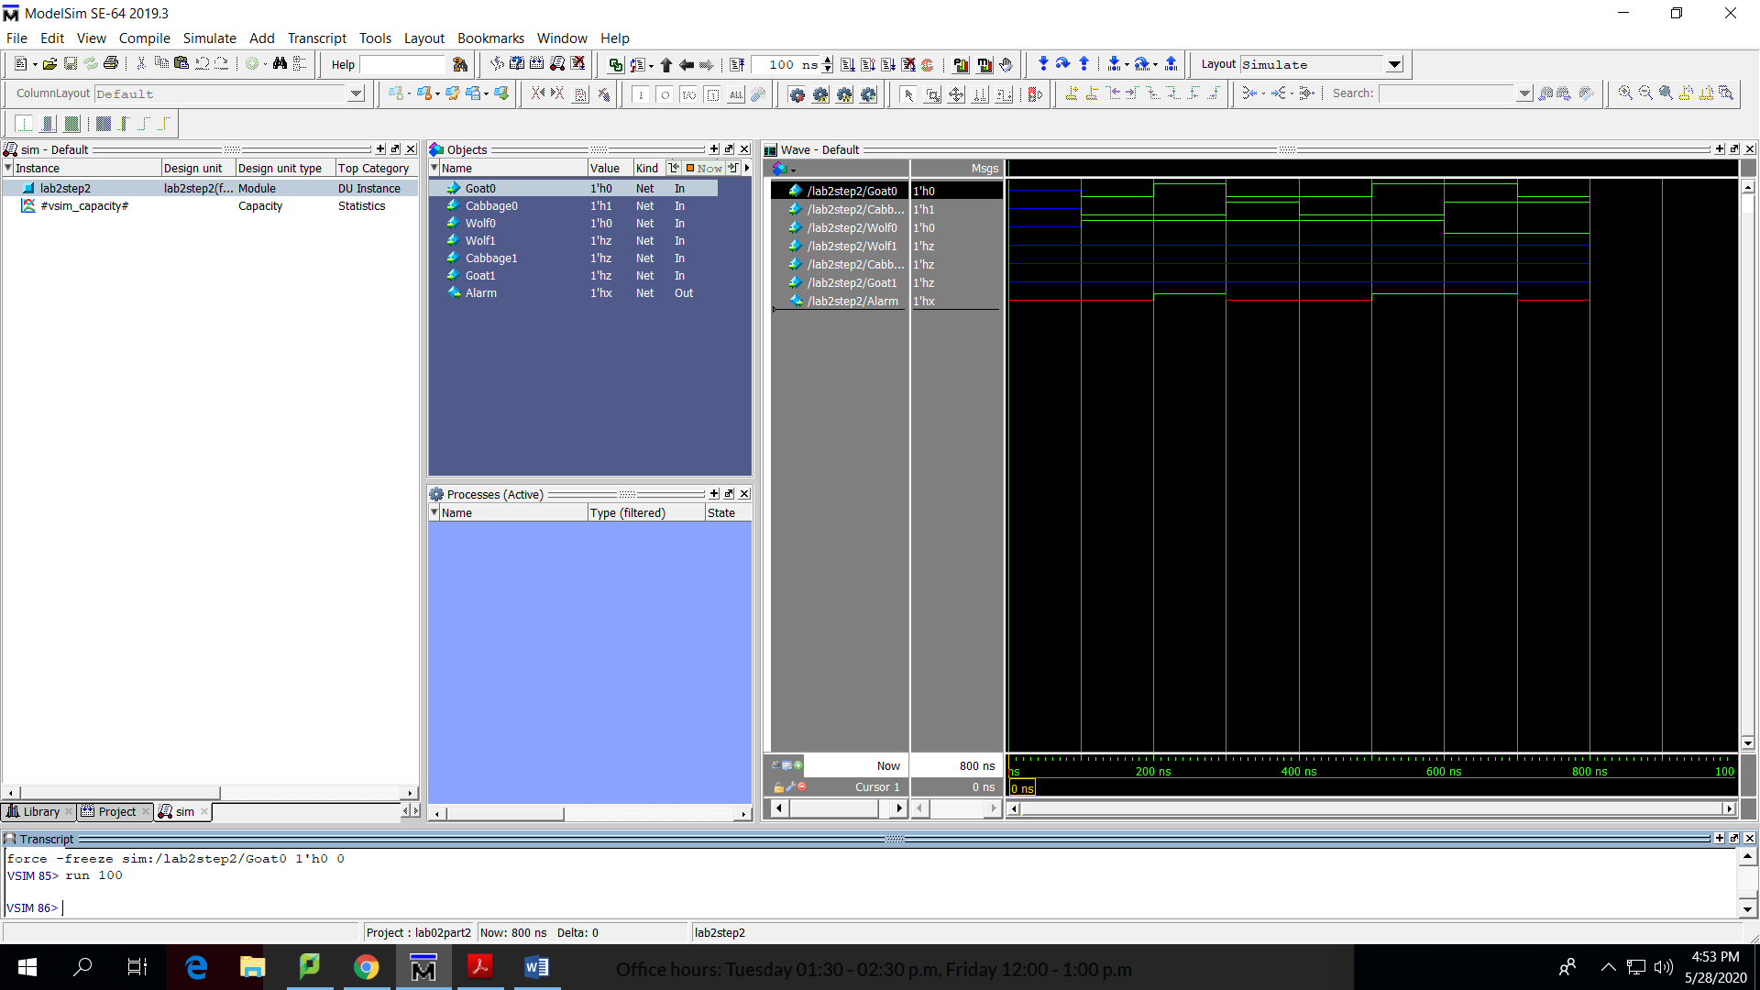

Cabbage0=0,Goat0=1,Wolf0=0

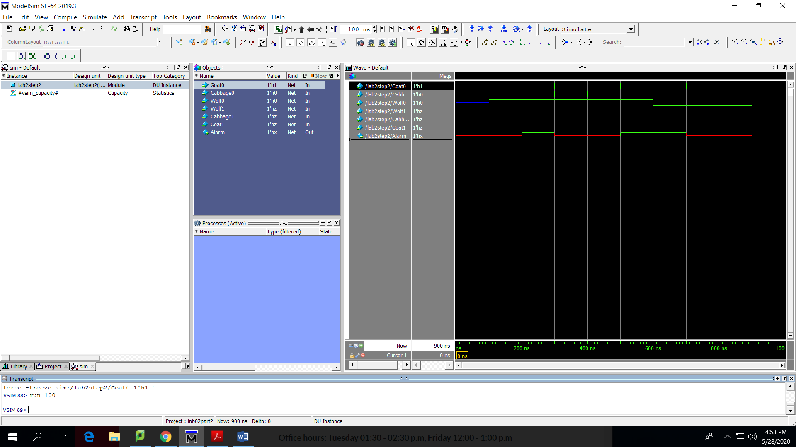

***Logic1***

Cabbage1=1,Goat1=1,Wolf1=1

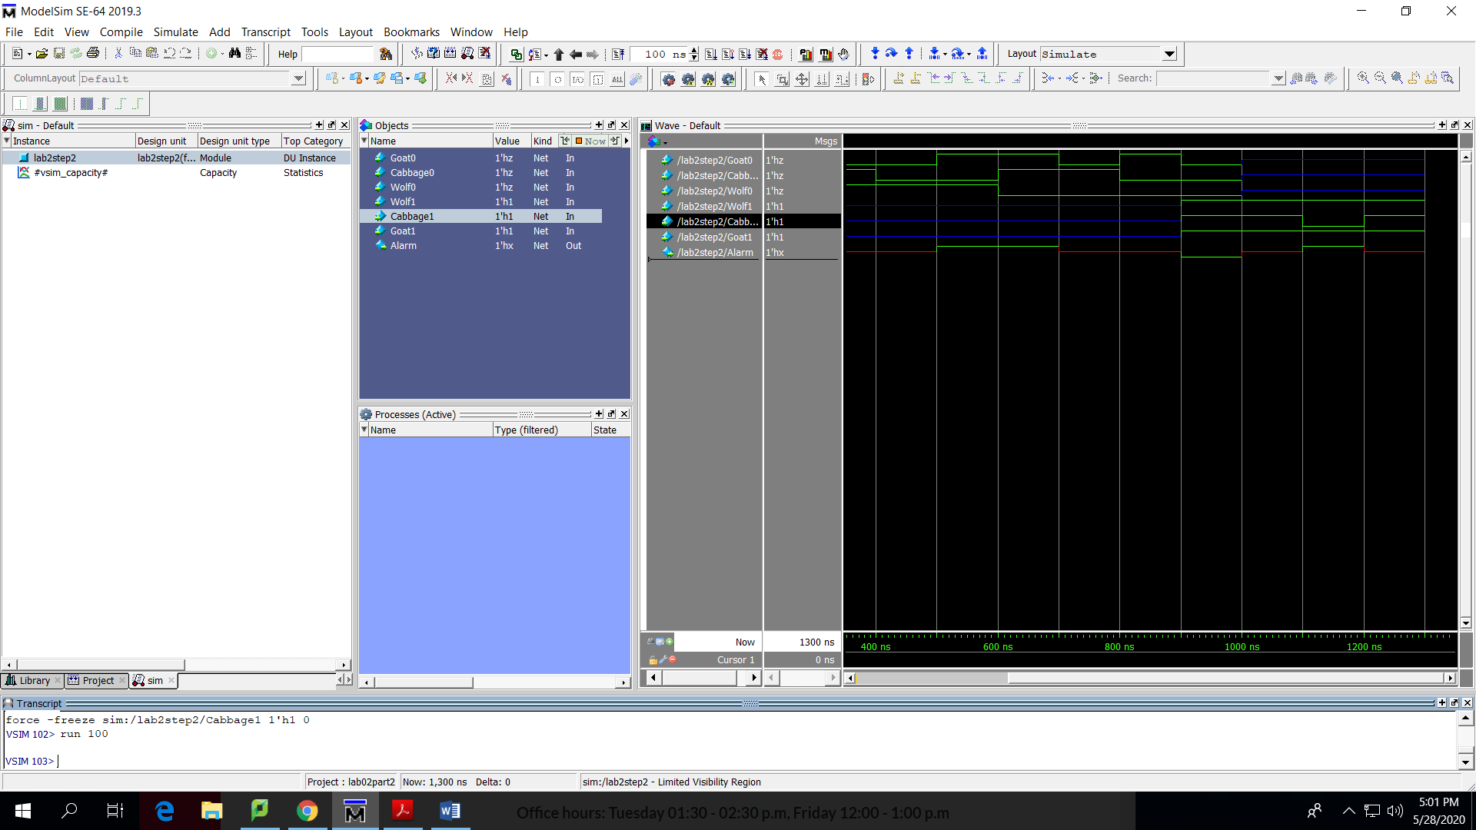

Cabbage1=1,Goat1=0,Wolf1=1

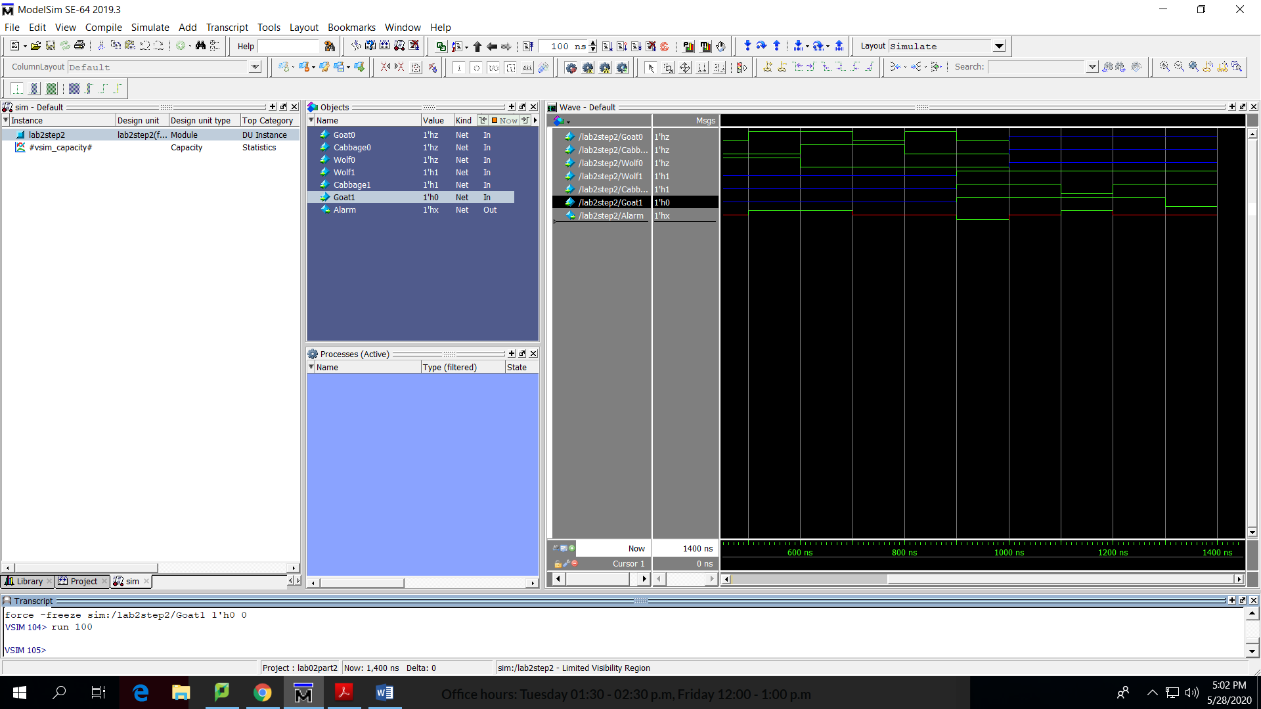Cabbage1=0,Goat1=1,Wolf1=1

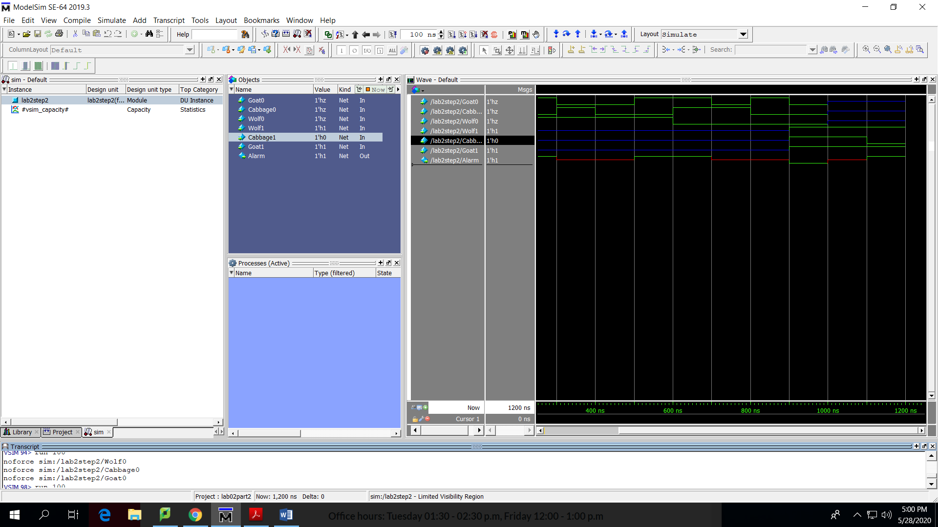

Cabbage1=1,Goat1=1,Wolf1=0

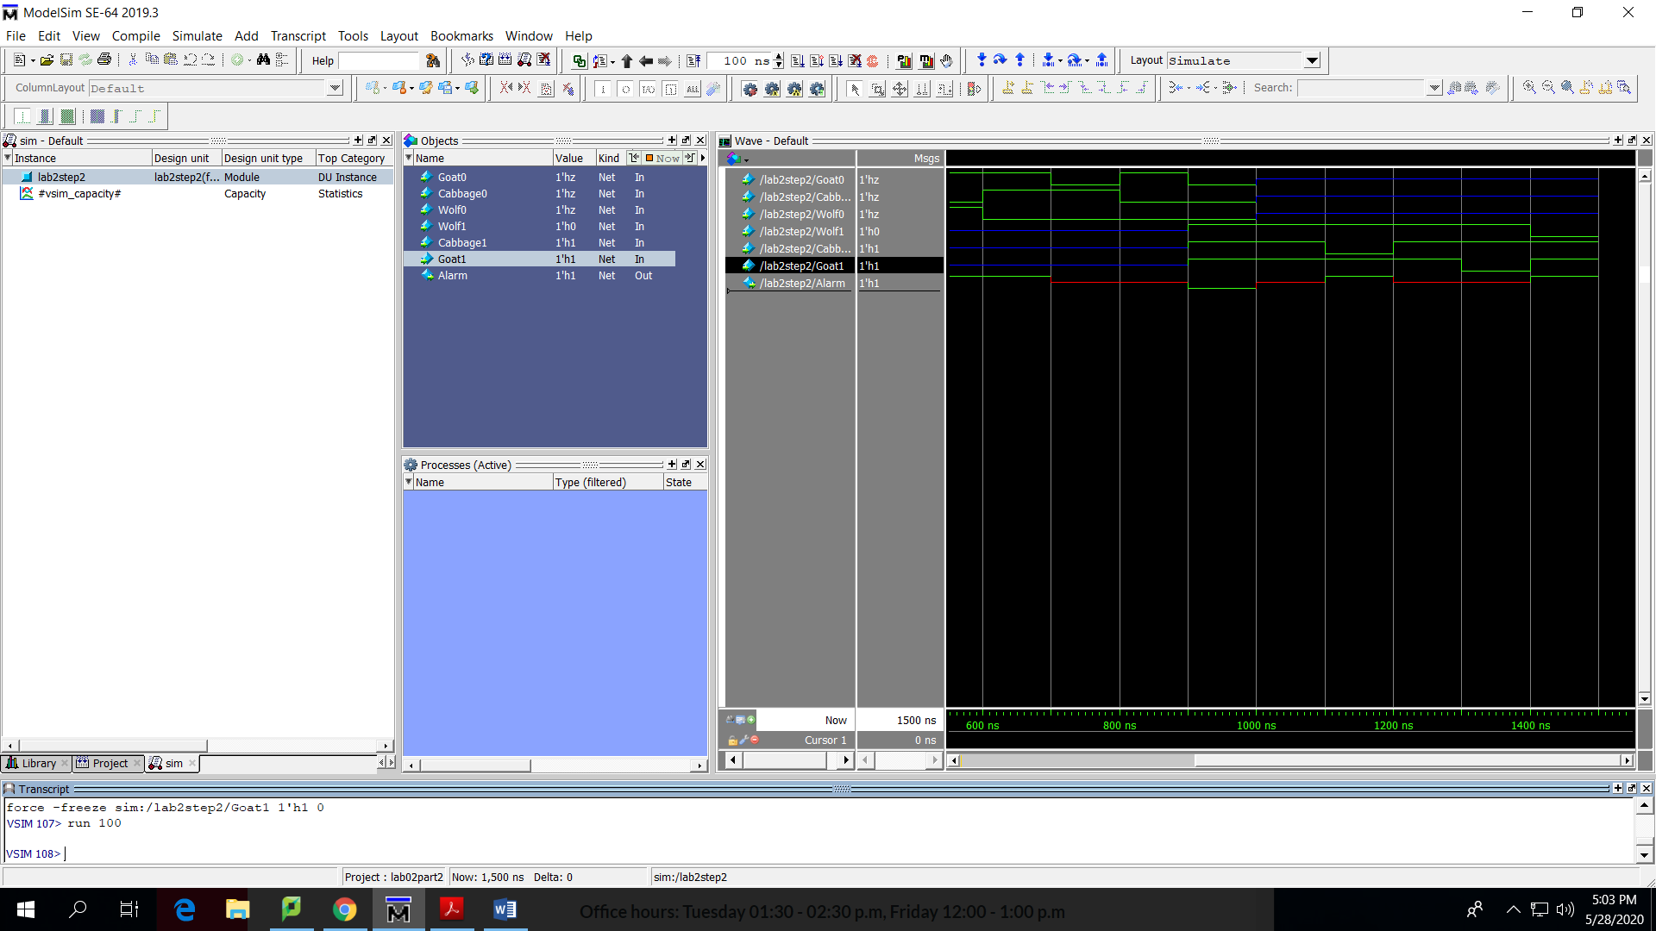

Cabbage1=0,Goat1=0,Wolf1=1

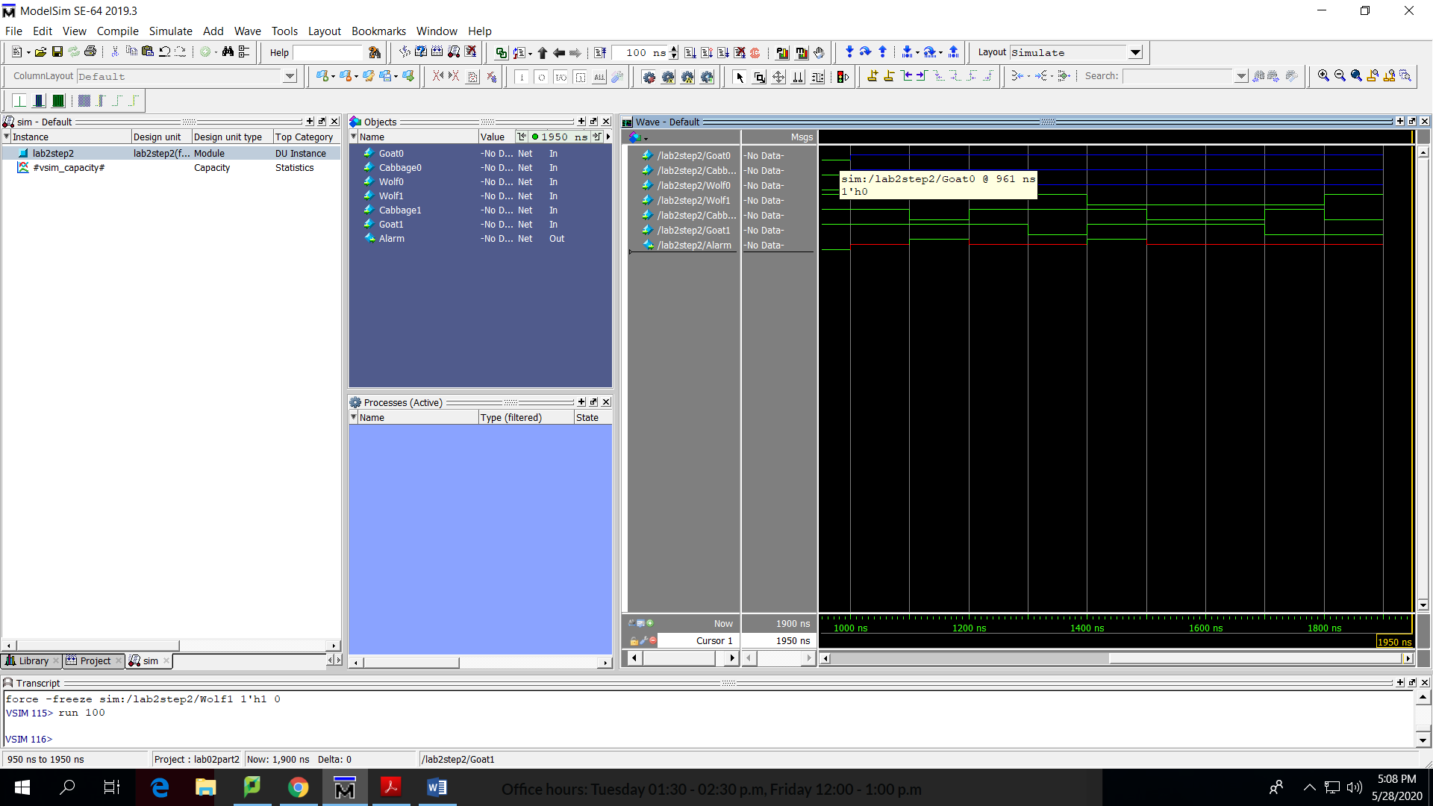

Cabbage1=0,Goat1=1,Wolf1=0

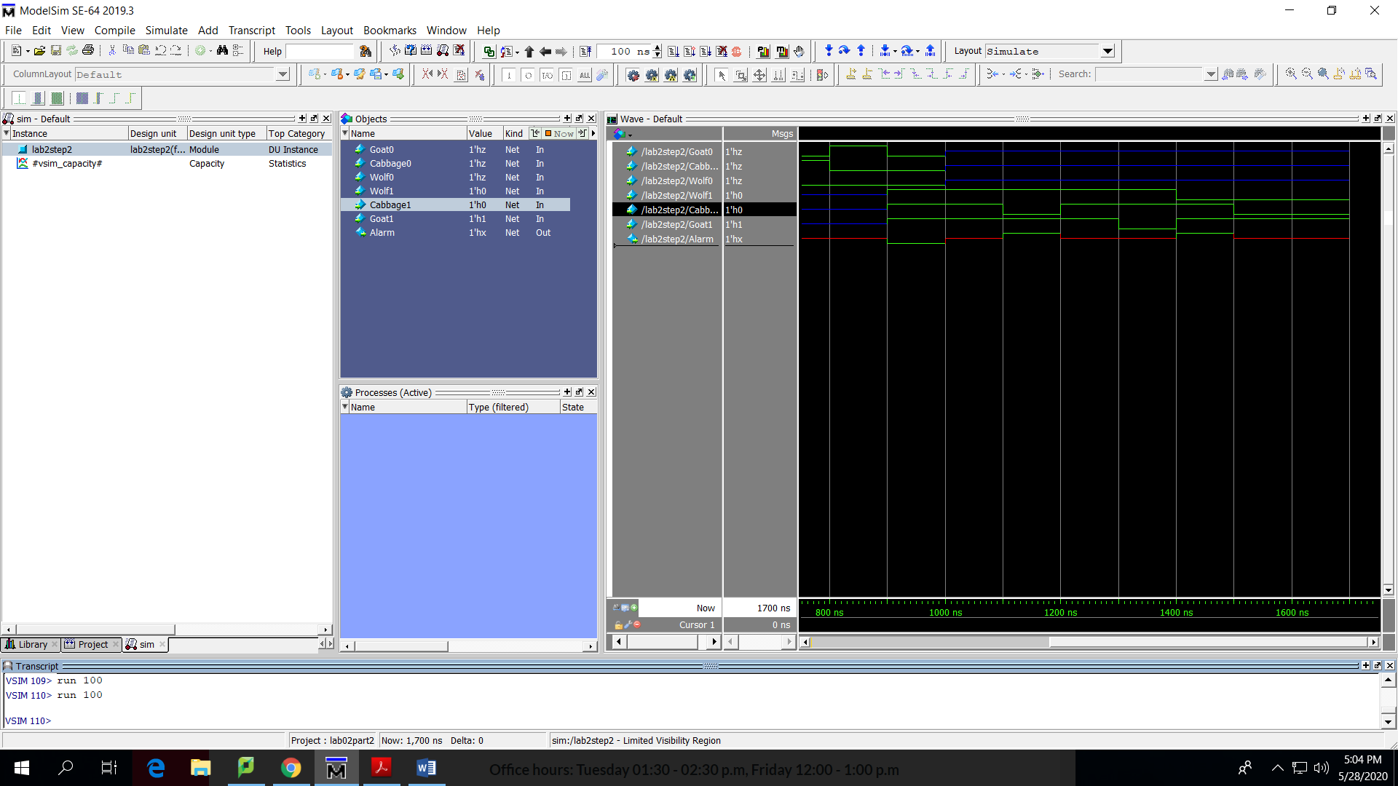

Cabbage1=1,Goat1=0,Wolf1=0

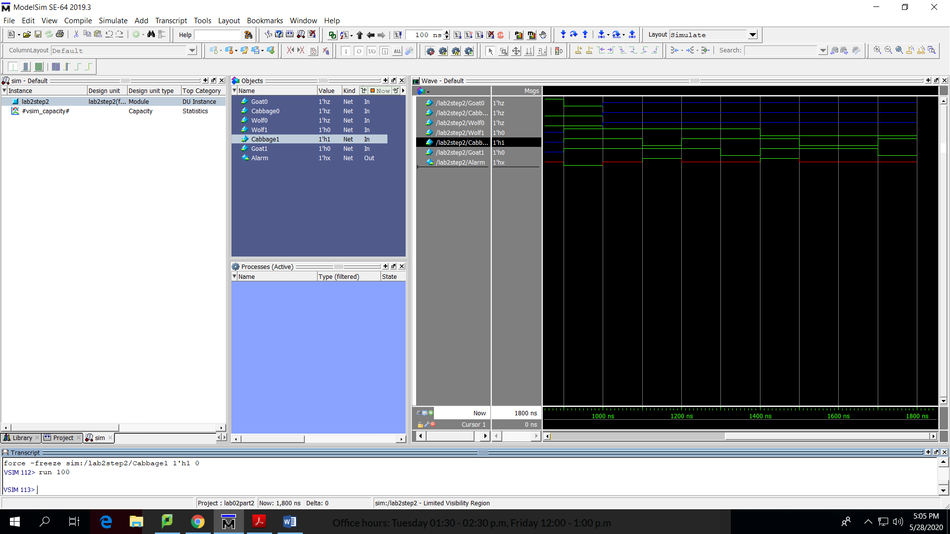

Cabbage1=0,Goat1=0,Wolf1=0

